Effect of volume of inoculum and fermentation medium on the production of protease by Penicillium chrysogenum

Hamid Mukhtar, Ali Nawaz and Ikram-ul-Haq

Institute of Industrial Biotechnology, GC University, Lahore-54000, Pakistan
alinawazgcu@yahoo.com

Abstract: In this study the effect of inoculum size and volume of fermentation medium was analyzed for locally isolated strain of Penicillium chysogenum taken from Institute of industrial biotechhnology GC University Lahore for production of protease. All the experiments were conducted using 250 ml flasks using submerged type of fermentation. It was revealed that 2 % size of incoulum was proved best yelding 12.71 U/ml of protease enzyme. 50 ml of the fermentation medium was found to be best while using 250 ml flask to obtain the optimum yield 12.81 U/ml of the enzyme. Inoculum size and volume of fermentation both proved to have great effect on the optimum yield of the enzyme.
[Hamid Mukhtar, Ali Nawaz and Ikram-ul-Haq. Effect of volume of inoculum and fermentation medium on the production of protease by Penicillium chrysogenum. N Y Sci J 2014;7(7):34-36]. (ISSN: 1554-0200). http://www.sciencepub.net/newyork. 5

Keywords: Protease, inoculum size and optimum yield.

- Introduction
Hydrolases which cleave peptide bonds are generally known as protease, peptidases, proteinases or proteolytic enzymes. Protease is found in all forms of organisms regardless of kingdom (Rao et al., 1998). Proteases are amongst the most studied proteins. It is through detailed characterization of the structure and function of several proteases that they are also used as models in explaining the basics of enzyme function (Wang, 2002). The fungi are group of organisms that are of great practical and scientific interest to biotechnologists. Many molds synthesize and excrete large quantities of proteases into surrounding medium. Microbial proteases are extracellular and account for approximately 40% of the total worldwide enzyme sale (Godfrey and West 1996).
Microorganisms can be cultured either in closed systems or continuous flow systems. In closed or batch system, a volume of a suitable medium is inoculated and growth takes place until terminated by exhaustion of an essential nutrient or accumulation of toxic products of metabolism (Mohsin and Salih, 2001). A homogeneous distribution of organisms, nutrients and wastes is achieved in a liquid medium by agitation. Agitation of culture volumes in laboratory is usually carried out by means of a rotary shaker. Agitation of a liquid culture by shaking or stirring results in submerged growth. Submerged fermentation has several advantages such as good homogenization of the medium due to use of soluble substrates. Microbial cells are grown in a fixed volume of liquid medium in a closed vessel. No microorganisms, fluid, or nutrients are added or removed from the culture during the incubation period. Oxygen is needed for aerobic respiration of some microorganisms, which can be easily provided during submerged fermentation (Odebunmi and Owalude, 2007).
Filamentous fungi in submerged culture may grow as a nearly homogeneous suspension of hyphae (filamentous growth) or as discrete pellets (pellet growth). Pellets vary in form from the extremes of loose flocculent pellets to compact, spherical ones. One factor that can determine whether filamentous or pellet growth occurs is inoculum size. If a medium is inoculated with a very large number of propagules (spores), limited growth from each propagule can produce considerable biomass and exhaust nutrients. On the other hand, small inoculum size will result in proper and extensive growth before appreciable nutrient utilization occurs (Carlile et al., 2001).
The present work was undertaken for the production of protease by Penicillium chrysogenum in submerged fermentation. There are certain requirements for the growth of microbes in submerged fermentation. Different cultural conditions such as volume of fermentation medium and size of spore inoculum were determined for the production of protease in submerged fermentation.

Material and methods
2.1 Microorganism and Maintenance
The mould culture of Penicillium chrysogenum was taken from the culture bank of Institute of Industrial Biotechnology, GC University Lahore. The culture was maintained on potato-dextrose- agar (PDA) slants at 4°C.
2.2 Inoculum preparation
The slants of five days old cultures were wetted by adding 10ml of 0.005 % sterilized solution of monoxal O.T. (Diacetyl ester of sodium sulphosuccinic acid) to the slants. The spores were scratched by sterile wire loop to break clumps and obtain homogeneous spore suspension.
2.3 Fermentation medium
The fermentation was carried out in 250 ml Erlenmeyer flask containing fermentation medium consisting of (% w/v): soybean meal, 1.0; glucose, 1.0; polypeptone, 0.5; yeast extract, 0.1; KH₂PO₄, 0.1; NaCl, 0.1. The cotton-plugged flasks were then subjected to sterilization in an autoclave (Model: KT-40L, ALP Co., Ltd. Japan) at a pressure of 15-lbs/inch² (121°C). The production medium was then cooled at room temperature and was inoculated with 1ml of conidial suspension as prepared earlier. The flasks were then placed in the incubator shaker (Model: 10X400-XX2C, SANYO, GallenKamp PLC, UK) rotating at the speed of 200 rpm at 30°C for 72 hours. After 72 hours of incubation, the contents of the flasks were filtered using Whattmann filter paper # 44 and the filtrate was used for the assay of protease.

2.4 Mycelial dry weight

After fermentation the fermented broth was filtered, using preweighed Whattman filter paper # 44. It was washed with water thrice and then dried at 95°C over night in a hot air oven.

2.5 Assay of protease
The activity of protease was assayed by the method of McDonald and Chen (1965). To 1ml of the enzyme extract in the test tube, 4.0 ml of 1.0% casein was added. The enzyme sample was incubated at 35°C for one hour. The residual protein was precipitated by adding 5ml of 5% TCA (Trichloroacetic acid). The precipitates were allowed to settle for 30 minutes. The contents of the tube were centrifuged at 5000 rpm for 5 minutes. One milliliter of supernatant was mixed with 5ml of alkaline reagent.Then 1ml of 1N sodium hydroxide was added to make the contents of the tube alkaline. After 10 minutes, 0.5ml of Folin and Ciocalteau reagent was added; as a result, blue colour was produced. The tubes were left for 30 minutes to get maximum development of blue colour. The optical density of the mixture was read at 700 nm on Spectrophotometer.
One unit of protease is defined as the amount of enzyme required to produce an increase of 0.1 in optical density under optimal defined conditions.

- Result and discussion
Different sizes of spore inoculum ranging from 1-5% (v/v) were studied for the production of protease by Penicillium chrysogenum (Fig.1). It was found that maximum amount of protease (12.71 U/ml) was produced when 2% (v/v) spore inoculum was used to inoculate the basal medium in the shake flasks. However, further increase in the size of inoculum resulted in the lower yield of protease. The spore inoculum less than 2% also gave less yield of protease. Similar results have also been reported by Haq et al., (2004) who studied the biosynthesis of protease by Penicillium griseoroseum using 2 % (v/v) of spore inoculum.
The size of spore inoculum greatly influences the production of protease by Penicillium chrysogenum during fermentation. Size of inoculum determines the formation of filamentous or pellet growth of the organisms in shake flasks. Penicillium chrysogenum yield pellet growth with a small inoculum (1% to 2%). Pellets were formed due to clumping of spores, that is why, even a massive inoculum results in relatively few points of propagation. Highest yield, which was obtained at a level of 2% (v/v) of spore inoculum, was due to the fact that it produced specific quantity of mycelium, which in turn produced optimal level of enzyme. The decrease in enzyme production by increasing the size of spore inoculum was due to the reason that the mycelia started to consume rapidly most of the substrate in a rapid fashion for its growth purposes. Moreover, toxins are also produced in the fermented broth by the death of older cells. All these facts resulted in the lower yields of enzyme during fermentation (Carlile et al., 2001). This might be due to the equal distribution of nutrients available in media to the amount of spores present in particular percentage of inoculum which leads to the rapid and enhanced growth of cell mass as well as product formation. Our results are in correspondence with Banker et. al., (2009) and contrary to Irfan et. al., (2011) who reported optimum inoculum percentage as 3% (V/V).

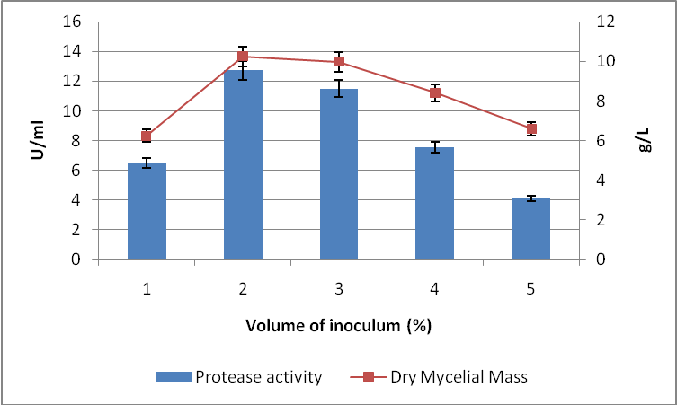
Figure 1: Effect of volume of inoculum on the production of protease by Penicillium Chrysogenum

Incubation period = 72h; Incubation temperature = 30°C; Initial pH = 7.0
Each value is a mean of three replicates. Y- error bars indicate the standard error from mean.

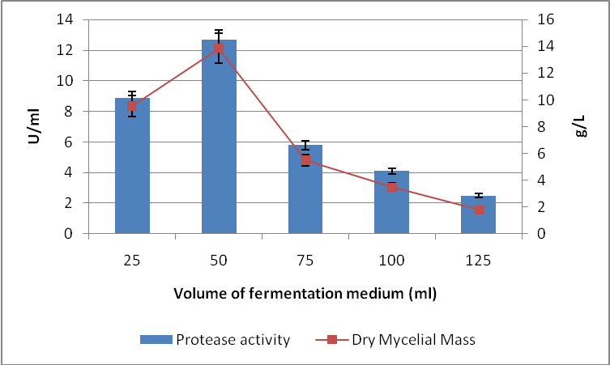
Figure 2: Effect of volume of fermentation medium on the production of protease by Penicillium Chrysogenum

Different volumes of fermentation medium in shake flasks were evaluated for the production of protease by Penicillium chrysogenum (Fig. 2). The volume of medium was ranged from 25-125ml in 250ml Erlenmeyer flasks. The amount of enzyme synthesis was considerably increased when the volume of fermentation medium was increased from 25ml of fermentation medium (8.86 U/ml) to 50ml of fermentation medium (12.68 U/ml). It was also observed that there is a sudden decrease in the protease biosynthesis when the volume of fermentation medium was increased from 50ml to 75ml and decreased gradually by further increasing the volume of fermentation medium above 75ml, and reached minimum (2.5 U/ml) when 125ml per 250ml Erlenmeyer flasks was used.
Incubation period = 72h; Incubation temperature = 30°C; Initial pH = 7.0
Each value is a mean of three replicates. Y- error bars indicate the standard error from mean.
The reason lies in the fact that as the volume of medium increased, oxygen supply to the microorganism in the shake flasks was decreased which directly affected the growth of the microorganism and corresponding yield of the proteolytic enzymes. It was also due to the fact that increased volume of the medium resulted in the decreased agitation and recirculation of the media ingredients which in turn resulted in the decreased supply of nutrients to the organism and hence, less growth and less enzyme production (Carlile et al., 2001). It might be due to the decreased rate of oxygen supply to the organism due to the increased volume of the medium in fermenter.

References

Bankar SB, Mahesh VB, Rekha SS and Laxmi A. Optimization of Aspergillus niger fermentation for the production of glucose oxidase. Food Bioprocess Technology. 2009; 2: 344-352.
- Carlile MJ, Watkinson SC and Goody GW. The Fungi. 2nd Ed. Academic Press London. 2001; 475.
- Godfrey T and West S. Industrial Enzymology, 2nd ed., Macmillan Publishers Inc., Newyork. 1996; 30-35.
- Haq I, Mukhtar H and Riaz N.. Protease biosynthesis by mutant strain of Penicillium griseoroseum and cheese formation. Pakistan Journal of Biological Sciences. 2004; 7 (9): 1473-1476.
- Irfan M, Irfan U, Razaq Z, Syed Q and Nadeem M. Utilization of agricultural wastes as a substrate for carboxymethyl cellulose production from Aspergillus niger in submerged fermentation. International Journal of Agro Veterinary and Medical Sciences. 2011; 5(5): 464-471.
- McDonald CE and Chen LL. Lowry modification of the Folin reagent for determination of proteinase activity. Annalytical Biochemistry. 1965; 10:175.
- Muhsin TM and Salih TH. .Extracellular proteae activity of fungi isolated from ruminants. Mycopathologia.. 2001; 150(2):49-52.
- Odebunmi EO and Owalude SO. Kinetic and thermodynamic studies of glucose oxidase catalysed oxidation reaction of glucose. Journal of Applied Science and Environmental Management. 2007.;11(4) 95 – 100.
- Rao MB, Aparna M, Tanksale MSG and Deshpande VV. Microbiology and Molecular Biology Reviews. 1998; 62(3): 597-635.
- Wang L. Enhanced production of heterologous protein by recombinant Aspergillus niger through bioprocessing strategies in submerged culture. Ohio LINK ETD. 2002; 196-197.

6/13/2014

