A New Method to Calculate The Temperature of MBR T_{urm} = 2.7k

Zhang Dongsheng

17 Pontiac Road, West Hartford, CT 06117-2129, U.S.A.
Emails: zhangds12@hotmail.com; zds@outlook.com

Preface: Author demonstrated already that our Universe has been a real Schwarzschild black hole (BH) in Reference [1], and the expansive law of standard model of our universal “Big Bang” could much better be in accordance with the expansive law of our Universe as a Cosmo-BH. Then, we may apply the new formulas of BH- theory proposed by author and the standard model of our universal “Big Bang” to find out the temperature of MBR (Microwave background Radiations) T_{urm} = 2.7k.
[Zhang Dongsheng. A New Method to Calculate The Temperature of MBR T_{urm} = 2.7k. N Y Sci J 2014;7(3):84-87]. (ISSN: 1554-0200). http://www.sciencepub.net/newyork. 13

Key Words: temperature of MBR; the expansive law of our Universe; the evolution of standard model of our universal “Big Bang”; the general laws of BHs;

《1》。The evolution of standard model of our universal “Big Bang”

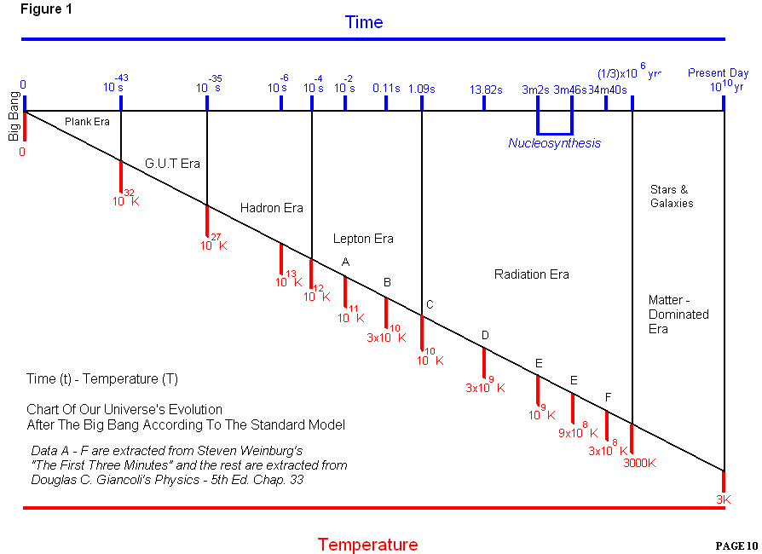

Figure 1. The relationship between T and t in the evolution of standard model of our universal “Big Bang” ^{[10]}
T----the radiation tempertature of our Universe; t----the characteristic time;

Figure 1 shows the relationship between T and t in the evolution of standard model of our universal “Big Bang”. Data in figure 1 are originated from References [2] and [3], t----the characteristic time of our Universe, T----the universal (radiation energy) temperature. The relationship between t and T can be expressed with formulas (1a) and (1b).
From the beginning of ‘the Big Bang’ time t = 10^{—44}s to the end of Radiation Era, i.e, t ≈ 385000 yrs, the formula may be:
Tt^{1/2}= k₁ ^{[3][4]} (1a)
From t ≈ 385000yrs to the present of t = 1.37×10¹⁰ yrs, it was the Matter- dominated Era, the formula may be:
Tt^{2/3}= k₂ ^{[3][4]} (1b)
It must be pointed out, formulas (1a) and (1b) stemmed from observational data; they had some error, (1a) was more precise. However, the error of (1b) had much more error, because in the ‘matter-nominated Era’, due to matter -particles separating from radiation energy, the temperature of radiation was lowered much more than the particles’. Besides, the contract of large particles must produce stars and nuclear fusion, and emit a large amount of heat into universal space. Therefore, it would be very difficult to estimate and measure precisely the radiation temperature T in the Universe.

《2》。Our Universe would have been a real Schwarzschild (gravitational) Cosmo-BH, so, the laws of its birth、growth、decline and death could completely accord with the laws of BHs.
1*；In References [1], i.e, <The The Originative Blackhole- Cosmogony>, author completed the BH-theory; proposed many new formulas. It was strictly proved that our Universe would have been a real Schwarzschild (gravitational) BH; proved that our Universe was born from countless Planck particles--m_{p} = M_{bm}— virtual minimum BH; and proved that the expansion of our Universe was just the expansions caused from the combinations by those countless m_{p} = M_{bm}. ^{[1]}
2*；Some general formulas on the radius R_{b} of any BH
M_{b}T_{b} = (C ³/4G) × (h /2πκ) ≈ 10²⁷gk ^{[6]} (2a)
m_{ss} = κT_{b} /C^{2 [4]} (2b)
m_{ss} M_{b} = hC/8πG = 1.187×10⁻⁻¹⁰g² ^{[1]} (2c)
GM_{b}/ R_{b} = C ²/2 ^{[1][4]} (2d)
m_{ss} = M_{bm} = (hC/8πG)^{1/2} = m_{p} = 1.09×10^{—5}g^{[5] [1]} (2e)
Data of parameters of m_{p} = M_{bm},
R_{bm}≡L_{p} ^{[5]}≡(Gh/2πC³ )^{1/2}≡1.61×10^{—33}cm (2f)
T_{bm} ≡T _{p} ^{[5]}≡0.71× 10³²k (2g)
(2a) is the famous Hawking formula of temperature T_{b} on R_{b}; (2b) is the energy transformation on R_{b} of Hawking radiation m_{ss}.
(2c) is a new geneeal formula on R_{b} newly derived by author from (2a) and (2b), it let BH theory go to perfection. (2d) is Schwarzschild special solution to the Equation of the General Theory of Relativity, it defined the necessary condition of BH existence.
M_{b} –- mass of a BH, R_{b}–-radius of the Event Horizon of a BH, T_{b}–- temperature on Event Horizon R_{b} of a BH, m_{ss} –- mass of a Hawking quantum radiation, h—Planck constant = 6.63×10^{—27} gcm²/s , C–-light speed =3×10¹⁰cm/s, G–- gravitational constant = 6.67 ×10^{—8}cm³/s²*g, κ—Bolzmann constant =1.38× 10^{—16}g*cm²/s²*k, m_{p}–-Planck participle, L_{p}-- Planck length, T_{p}---Planck temperature, M_{bm}— mass of virtual minimum BH, L_{p} = R_{bm} —Planck length；T_{p}=T_{bm}—Planck temperature； Compton time t_{c} = Schwarzschild time t_{sbm} , so，
t_{sbm} = R_{bm}/C =1.61×10⁻⁻³³/3×10¹⁰ =
0.537×10^{—43}s, (2h)
_{bm} = 0.6×10⁹³g/cm³ (2i)
3*; The parameters of our Universe as a Cosmo-BH, ^{[1]}
Owing to the age A_{u} = 1.37×10¹⁰yrs of our Universe measured precisely by modern obcervational instrument, then, the radius R_{u} of our Universe as a BH, R_{u} = CA_{u}, and from (2d),
R_{u}= R_{b} = CA_{u} = 1.3×10²⁸cm； (2j)
M_{u} = M_{b} = 8.8×10⁵⁵g ≈ 10⁵⁶g； (2j)
ρ_{u}=3/(8πGA_{u}²)=0.958×10⁻⁻²⁹g/cm³ (2j)
Owing to M_{u} originated from N_{u} × m_{p}, and m_{p} = M_{bm} = 1.09×10^{—5}g，so, N_{u} = M_{u}/m_{p}.
N_{u} = M_{u}/m_{p} = 8.8×10⁵⁵g/1.09×10^{—5}g = 8×10⁶⁰ ≈10⁶¹ (2k)
Also N_{u} = R_{u}/R_{bm} = 1.3×10²⁸/1.61×10^{—33} = 8× 10⁶⁰ ≈10⁶¹ (2l)
(2k) = (2l) shows our Universe must be a real BH and in accordance with formula (2d).

《3》。The heat history of our Universe^{[5]} . This paragraph is wholly quoted from p.56 of§3.6 of References[5], the demonstrations are omitted.
About 35 minutes later from the ‘Big Bang’, our Universe could go on a stably expansive process in accordance with Hubble law, and the radiation temperature T of our universe would continously decrease along with its expansion. Before the end of Radiation Era, the radiation (energy) composition and matter composition were coupled together through Compton effect; then, the whole Universe had the same temperature T, because it was in the condition of heat balance, and was not daiphanous. However, After the end of Radiation Era, when the temperature T of the Universe lowered into T ≈ 4000k, protons and electrons would integrate to hydrogens, matter particles could separate from radiations, and both had different temoerature. The whole Universe became daiphphanous. ^{[5]}
Let T_{r} be the radiation temperature, and T_{m} be the temperature of matter particles, after the Universe expanded to size R, then,
T_{r} ∝ 1/R (3a)
T_{m} ∝ 1/R² (3b)
It is said, if their mixture had a same temperature before, after the Universe expanded to some size R, then T_{r} > T_{m}.

《4》。Finding the radiation temperature T_{r}= 4720k at the Universal age of t_{r} = 385000 yrs, i.e., at the end of ‘Radiation Era’. The real temperature T_{urm} of Microwave background Radiations (MBR ) at present is T_{urm}= 2.7k；
1*; From (1a)，Tt^{1/2}= k₁，
∴T_{bm} (t_{sbm})^{1/2} = T_{r}(t_{r})^{1/2}, and,
T_{r} = T_{bm}(t_{sbm}/t_{r})^{1/2}=0.71×10³²k(0.537×10^{—43} /385000×3.156×10⁷)^{1/2} = 4720k (4a)
2*; From t_{r} =385000yrs to A_{u} = 1.37×10¹⁰ yrs，applying (1b) in the whole matter -dominated Era up to the present, get a calculated temperature of MBR T_{ucm},
From (1b), T_{r}t_{r}^{2/3}=T_{ucm}A_{u}^{2/3}；
4700 (385000)^{2/3} = T_{ucm} (1.37×10¹⁰)^{2/3} ;
∴ T_{ucm1} = 4720(385000/1.37×10¹⁰)^{2/3=0.667}= 4720(2.8×10⁻⁻⁵)^{2/3}=4.36k (4b)
Owing to T_{ucm1}(4.36k) > T_{urm} (2.7k); it can be seen, the error of T_{ucm1}(4.36k) is too bigger than T_{urm} (2.7k), it does not tally with the actual situation. For finding the precise temperature of MBR T_{ucm2}，it is needed to change the exponential number of (1b),
Let T_{ucm2} = 4720(385000/1.37×10¹⁰)^{0.712}= 2.71k ， so, (1b) of T_{r}t_{r}^{2/3 = 0.667} = k₂ should be changed into (4c),
∴T_{r}t_{r}^{0.712} = k₂ (4c)
Above calculated results show that (4b)，T_{r}t_{r}^{2/3=0.667} = k₂ is not actual, only (4c) is more precise. However, for finding the precise T_{urm} theoretically, a new method should be adopted in 3*and 4* paragraphs below.
It is known that (1b) expresses the common expansions of radiation energy and matter particles together in the Matter-dominated Era. However, according to (3a) and (3b), to radiation energy, Rt = k₃, but the exponential number of (4c) is bigger than (4b)’s, i. e.. 0.712 > 0.667. Then, (4c) is more precise than (4b) shows in the Matter-dominated Era, radiation energy should have more expansion.
At the end of radiation Era, the space (=1/2R_{R}) occupied by radiation energy should be about equal to the space (1/2R_{R}) of matter particles, but from that time to the present, from R_{R} to R_{u}, the expansion of matter particles should be much less than R_{u}/2, then, the expansion of radiation energy must be much more than R_{u}/2. The final result may let T_{ucm2}(2.71k) < T_{ucm1}(4.36k).
3*；Finding the whole size R_{R} (radius) of the Universe at t_{r}=385000 yrs of the end of radiation Era. Finding a ‘mini BH’--M_{r} at t_{r}=385000 yrs, radius R_{r} of M_{r}, numbers N_{r} of M_{r}, density _{r} of M_{r}.
From (2j), M_{u} = 8.8×10⁵⁵g≈10⁵⁶g，R_{u} = 1.3×10²⁸cm；N_{u} = 10⁶¹ Planck particles m_{p}=M_{bm}=1.09×10^{—5}g are known numbers. If let m_{p}=M_{bm} =1.09×10^{—5}g be called as ‘mini BH’ in the Planck Era, then, in the expansive process of 1.37×10¹⁰ yrs, our Universe had different size and numbers of ‘mini BHs’ at every instant to form the whole Universe M_{u}. Then,
R_{r} = Ct_{r} = 3×10¹⁰×385000×3.156×10⁷ = 3.645×10²³cm；
M_{r} = C² R_{r}/2G = 2.46×10⁵¹g;
N_{r} = M_{u}/M_{r} = 10⁵⁶/2.46×10⁵¹ = 3.6×10⁴
_{r} = 3M_{r}/4πR_{r}³ = 1.2×10^{—20}g/cm³;
Owing to the density _{r} of M_{r}‘mini BH’should just be the same density of M_{u} at that time, so, R_{R} is，
R_{R} = (3M_{u}/4π_{r})^{1/3} = 1.26×10²⁵cm; (4d)
4*; Finding the temperature T_{ucm} of MBR at present,
From above mentioned, at t_{r} = 385000 yrs
of the end of Radiation Era, the space of radiation energy = the space of matter particles = R_{R}/2. From (2d), M_{b} ∝ R_{b}. From (3a), T_{r} ∝ 1/R. So, T_{r} R = Const。 Suppose the expansoin of matter particles may be neglected in the period from t_{r} to the present, then, the expansion of radiation energy would be from R_{R}/2 to present R_{u} = 1.3×10²⁸cm. (the space R_{R}/2 of matter particles may be neglected, because R_{R}/2 << R_{u}/2 ）。Thus, from (3a), T_{ucm} can be got。
∴T_{ucm} = T_{r}R_{R}/2R_{u} = 4720×0.63×10²⁵/1.3× 10²⁸ = 2.3k (4e)
Above calculated temperature of MBR T_{ucm} (2.3k) is smaller than the actual temperature of MBR T_{urm}( 2.7k)，i.e., T_{ucm} < T_{urm}. The actual reasons may be: 1; the matter particles could really have some small expansion due to the universal pressure and temoerature lowered. 2; A large amount of heat caused from the nuclear fusion in stars, it would increase in some temperature of MBR.

《5》。Some conjectures;
1*；On the end time of Radiation Era t_{r} =385000 yrs ，the radiation temperature T_{r} = 4720k. From (2b)，m_{ss} = κT_{b} /C², find mass m_{ne} of corresponding particles,
m_{ne} = κT_{r} /C² =1.38×10^{—16}×4720/9×10²⁰ =7.23×10^{—34}g (5a)
What could be m_{ne} = 7.23×10^{—34}g？the upper limit of a electrical neutrino _{e} = 9.1×10^{—33}g，the corresponding mass of a photon =4.2×10^{—33}g，mass of an electron = 9.11× 10^{—28}g，the upper limit of a µ-neutrino = 4.8× 10^{—28}g。It can be seen, m_{ne} should be the various neutrinos. They might be the smallest matter-particles in the Universe, and to couple with radiation before the end of Radiation Era. After that time, radiations would unsolve the coupling with neutrino m_{ne}, then, the Universe could become daiphanous. Therefore, radiations would continuously expand up to the present to obey Hubble’s law. On the other side, the matter particles could continuously contract up to form galaxies, stars, planets, etc. Owing to the nuclear fusion caused in stars, on some planets the intelligent living things could be evolved out.
2*；mass of a proton m_{p} = 1.67×10^{—24}g, then，
m_{p}/m_{ne} = 1.67×10^{—24}/7.23×10^{—34}g = 2.3×10⁹ ≈ 10⁹ ：1 (5b)
The proportion of 10⁹ ：1 may be just the same proportion of photon numbers /baryon numbers in the Universe.

Author:
Zhang Dongsheng
17 Pontiac Road, West Hartford, CT 06117-2129, U.S.A.
1957年毕业于北航，即现在的北京航空航天大学
Email: zhangds12@hotmail.com; zds@outlook.com

References
- Zhang Dongsheng：< The Originative Blackhole-Cosmogony > http://www.sciencepub.net/academia/aa2013suppl/007_21397aa0501s_280_347.pdf
- Giancoli, Donglasc. Physics, Principles With Application, 5th Edition, Upper Saddle River. NJ. Prentice Hall, 1998,
- S. Weinberg: <The First Three Minutes>. Published by Basic-books, A Division of HarpperCollins Publisher,Inc. Second Edition, 1993.
- Su Yi:《An Introduction to New Astronomy》. Science & Technology Publishing HouseOf Central University, Wuhan, China. 2000. 3.
- He Xiang-tao.：《Observational Cosmology.》 Science Publishing House. Beijing, China. 2002
- Wang Yonjiu: <Physics of Black Holes> Publishing House of Hunan Normal University.
- Hunan, China. 2002.

3/19/2014

