**Offline handwritten Arabic character recognition using develop hierarchical sparse method**

Ramadhan Abdo Musleh Alsaidi 1, Hong Li 1, YantaoWei 2, Rokan Khaji1

1. School of Mathematics and Statistics Huazhong University of Science and Technology, Address Wuhan, 430074, China

2. Department of Information Technology Central China Normal University Wuhan, 430079, China

[saidi52@gmail.com](mailto:saidi52@gmail.com)

**Abstract:** This paper introduces a novel technique to enhance the recognition rate of offline handwritten Arabic characters within low computation time based on develops Hierarchical Sparse Method. The developed principles of this algo- rithm are described as scaling and k-mean techniques. Whereas the technique of scaling level is used to avoid the dominance of attributes in greater numeric ranges over those in smaller numeric ranges, k-mean technique is used to ob- tain an efficient template selection method included in the derived kernel for developing the object recognition performance. The results of experiments include comparing the developed algorithm with other existing techniques**.**

.

[Kharkwal G, Mehrotra P, Rawat YS. **Taxonomic Diversity of Understorey Vegetation in Kumaun Himalayan Forests.** *N Y Sci J* 2014;7(3):38-45]. (ISSN: 1554-0200). <http://www.sciencepub.net/newyork>. 7

**Keywords:** Offline handwriting Arabic character; scaling; k-mean; Hierarchical Sparse Method; IFN/ENIT database.

**1. Introduction**

The pattern The great rank of Arabic script appearing through several aspects, for example, Arabic characters adopted to use in many languages like Arabic, Malay, Persian, Urdu, Jawi and Pishtu, (more than a half of a billion people), in addition to all Muslims (almost ¼ of (the) peoples on the earth) can read Arabic this because it is the language of Al-Quran, the holy book of Muslims. Moreover, the study area of recognizing Arabic character is still vacant due to limited studies and therefore, further research is required. On the other hand, it is important to note that spoken Arabic is varies from one country to another, but the Arabic writing has a standardized version for official communication across the Arab world. The standard Arabic writing occasionally called Modern Standard Arabic (MSA). Despite Arabic is one of the most widely used languages in the world, demand for a robust Optical Character Recognition (OCR) for this language could be with great commercial and economic valuables. Script recognition can be either online or offline. If the scripts recognition take place during the user input is refer to online and to offline if the scripts were recognized after the finishing of writing. (It is online if recognizes scripts during the user input. While offline script recognition, by opposition, recognizes the input data after the writing is completed).

Many works have been proposed for Arabic handwriting recognition. Most of these works are for whole word recognition while, a few for isolated character recognition. Recognition of Arabic characters represents an important goal, not only for the Arabic speaking countries, but also for Urdu speaking Indians, Curds and Persians. In this work, we specifically concerned with Arabic offline handwritten characters recognition. Moreover, to the best of knowledge, in the former years some work has been devoted to improving Arabic offline handwritten characters recognition. Al-Yousefi and Udpa[1] introduced a statistical approach for the recognition of Arabic hand-written isolated characters using moments of the horizontal and vertical projections of the primary character. Abuhabiba. et al.[2] improved an off-line character recognition. An algorithm was developed, which yields skeletons that reflect the structural relationships of the character components. In other study [3], the author’s extracted moment based features in order to recognize handwritten Arabic character. They used genetic algorithm for feature selection and use SVM to evaluate the classification error for the chosen feature subset. Khedher and Abandah described the main characteristics of the Arabic writing and provided statistics for PAWs and letter forms [4]. Sari et al. described the general characteristics of Arabic text and used morphological features of the Arabic character such as turning points, holes, ascenders, descanters, and dots for segmentation and recognition [5]. Pechwitz et al. have collected a database of handwritten Arabic names for Tunisian towns and published statistics about the size of this database in words, parts of Arabic words (PAWs), and characters [6]. Menasri et al. identified letter body alphabet for handwritten Arabic character; they classified Arabic character into root shapes and optional tails. Multiple Arabic characters that only differ in the existence and number of dots are mapped to the same root shape. This alphabet also includes common vertical ligatures of joined character [7]. Malas et al. provided statistics about frequencies of Arabic character and letter pairs [8]. Abandah et al. (2009) suggested an approach for text feature extraction to achieve high recognition accuracy of handwritten Arabic character. However, the reported recognition rates for Arabic character need more improvements to be practical [9]. In novel study [10], the authors extract moment based features in order to recognize handwritten Arabic letters. They use genetic algorithm for feature selection and use SVM to evaluate the classification error for the chosen feature subset. Rashad Al-Jawfi[2009] introduced a new network based on LeNet architecture was designed to recognize a set of handwritten Arabic character[11]. Rawan Ismail Zaghloul, introduced a multilevel classifier based on pattern recognition techniques [12]. Finaly in one of the poular studies [13], the authors described hybrid feature extraction for offline handwritten character recognition. The proposed technique was considered as a hybrid of structural, statistical and correlation features.

**Motivation**

Many deficiencies accompanied previous research, such as data is few and it does not cover all the character cases. In contrast, this work uses data set of offline handwritten Arabic character images (OHACI) which carefully selected from IFN/ENIT-database with some modification that may be used in training and testing for Arabic (OCR). It covers the various forms of Arabic alphabet in most positions (i.e.alone, beginning, medial, and end). The database includes 209992 samples of Arabic letters written by 411 different writers. Moreover, this work deals with the problem of overlap between the characters when writing and making it more difficult to distinguish characters. In the other hand, the advantage of developed methodology with respect to Hierarchical sparse methods can be summarized as; firstly, the hierarchical algorithms use template set as a dictionary in the sparse coding operation to develop a dictionary. In opposition, the developed method proposed an efficient template selection process involved in the derived kernel for improving the object recognition performance based on k-mean technique. The major advantage behind this approach is to consider not only the label information of the training images, but also the elimination of redundant information. For scaling process, the main benefit is to avoid attributes in greater numeric ranges dominating those in smaller numeric ranges. In summary, this develop aim is to achieve high accuracy with low computational complexity for object recognition.

This paper is organized in 5 sections. Section 2 is devoted to the discussion of the essential background of Arabic character. Section 3 introduces the basic concept of Hierarchical sparse coding, scaling and k-mean technique. It also describes the feature of extraction process that is used in this research. Section 4 includes the implementation of proposed method and the report of experimental results. Finally, the conclusion remarks are given in Section 5.

**2. Some Characteristics of Arabic Character**:

This section provides a comprehensive list of characteristics of the Arabic characters with figures to illustrate the concepts. We aim to introduce a source for researchers to start with. These characteristics will be presented as argued in [13,14].

As we mention above Arabic alphabet is the script used for writing several languages of Asia and Africa. The calligraphic style of the Arabic cursive is distinguished from other languages in many ways. Arabic text is written from right to left in both handwritten and printed forms, with the alphabet having 28 basic characters. Furthermore, sixteen Arabic letters have between one to three dots. Position and number of these dots differentiate between the otherwise similar characters. Moreover, some letters (like ك أ ئ ؤ) can have a zigzag-like stroke (Hamza ء). These Hamza and dots are sometimes called secondaries and they are located above the letter primary part as in ALEF(أ), or in the middle like JEEM (ج), or below like BAA(ب). Written Arabic text is cursive in both handwritten and printed-machine text (The details of the letter secondaries are illustrated in Table 1)

Table 1. Samples showing variations secondaries character.

|  |  |  |
| --- | --- | --- |
| NO | Secondary Type | Example |
| 1 | No Secondary | ء و ه ل م ع ط ص س رد ح ى ا |
| 2 | One Dot | ن ف غ ض ظ ذ ز خ ب ج |
| 3 | Two Dots | ق ي ت ة |
| 4 | Three Dots | ث ش |
| 5 | Zigzag | ك أ ئ ؤ |
| 6 | Vertical Bar | ط |
| 7 | Vertical Bar and a dot | ظ |
| 8 | Long Stroke | كـ |

Within a word, some letters connect to the preceding and/or following characters, and some do not connect as show in table. Clearly, the above six characters (و, ز, ر, ذ, د, ا), if appeared in a word, will cause the word to be divided into blocks of connected components called subwords. Thus a word can have one or more subwords. Subwords are also separated by spaces, but usually shorter than the one between words. So, this issue needs to be considered to avoid segmenting a word into two parts.

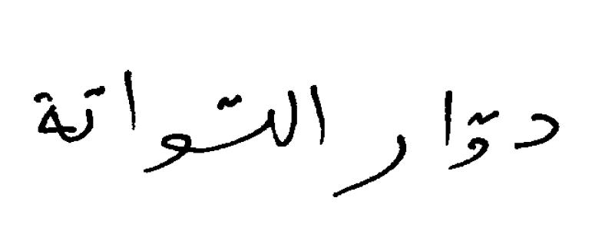

Figure 1. Example of characters causing word divided.

Table 2: Different forms of characters depending on its position in the word.

|  |  |  |  |  |  |
| --- | --- | --- | --- | --- | --- |
| Character Name | Isolated | Initial | Middle | Final | #Forms |
| Alif ألف | ا | - | - | ـا | 2 |
| Ba’ باء | ب | بـ | ـبـ | ـب | 4 |
| Ta’ تاء | ت | تـ | ـتـ | ـت | 4 |
| Tha’ ثاء | ث | ثـ | ـثـ | ـث | 4 |
| Jeem جيم | ج | جـ | ـجـ | ـج | 4 |
| H’a’ حاء | ح | حـ | ـحـ | ـح | 4 |
| Kha’ خاء | خ | خـ | ـخـ | ـخ | 4 |
| Dal دال | د | - | - | ـد | 2 |
| Thal ذال | ذ | - | ـ | ـذ | 2 |
| Rai راي | ر | - | - | ـر | 2 |
| Zai زاي | ز | - | - | ـز | 2 |
| Seen سين | س | سـ | ـسـ | ـس | 4 |
| Sheen شين | ش | شـ | ـشـ | ـش | 4 |
| Sad صاد | ص | صـ | ـصـ | ـص | 4 |
| Dhad ضاد | ض | ضـ | ـضـ | ـض | 4 |
| Tta’ طاء | ط | طـ | ـطـ | ـط | 4 |
| Dha’ ظاء | ظ | ظـ | ـظـ | ـظ | 2 |
| A’in عين | ع | عـ | ـعـ | ـع | 4 |
| Ghain غين | غ | غـ | ـغـ | ـ | 2 |
| Fa’ فاء | ف | فـ | ـفـ | ـغ | 4 |
| Qaf قاف | ق | قـ | ـقـ | ـق | 4 |
| Kaf كاف | ك | كـ | ـكـ | ـك | 4 |
| Lam لام | ل | لـ | ـلـ | ـل | 4 |
| Meem ميم | م | مـ | ـمـ | ـم | 4 |
| Noon نون | ن | نـ | ـنـ | ـن | 4 |
| Ha’ هاء | ه | هـ | ـهـ | ـه | 4 |
| Waw واو | و | - | - | ـو | 2 |
| Ya’ ياء | ي | يـ | ـيـ | ـي | 4 |
| Hamza همزة | ء أ ئ ؤ | - | ـئـ | ـأ ـإ ئ ؤ | 2 |
| Ya’Lainh ياء لينة | ى | - | - | ى | 2 |
| Ta’Mrbotah تاءمربوطة | ة | - | - | ـة | 2 |
| LamAlif لام ألف | لا لأ لإ | - | - | ـلا ـلأ ـلإ | 2 |

The shape of an Arabic alphabetic depends on its position in the word; every alphabetic up to four different shapes depending on the position of the letter in the word: whether it is isolated letter, connected only from right (initial form), connected only from left (ending form), or connected from both sides (medial form) (The details of the character shapes are shown in Table 2.).

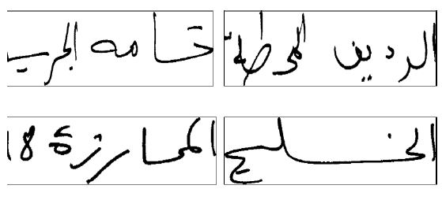

Some letters, in a word may overlap vertically wit especially in Arabic handwritten, may overlap with their neighboring characters forming what is called “ligature”. Figure2 illustrates some ligature examples. These include: presence of baseline (i.e. Arabic letters are ‘normally’ connected on an imaginary line called baseline).

**3. A summary of Hierarchical sparse coding Method (HSCM)**

In this part, we will give a brief introduction to the Hierarchical sparse coding Method. Who cares is encouraged to consult for a more detailed treatment. The classic HSCM feature detector, as described in [15], is essentially combining the hierarchical architectures with the sparse coding technique. As far as proposed layered model, at each layer of hierarchy, it concerned two components that were used are sparse coding and pooling operation. While the sparse coding was used to solve increasingly complex sparse feature representations, the pooling operation by comparing sparse outputs was used to measure the match between a stored prototype and the input sub-image. It is recommended that value of the best matching should be kept and discarding the others. In simple words, this approach defines a nonlinear mapping from the lower layer to the upper layer. The nonlinear mapping approach has been defined as a nonlinear mapping function  as:



Here, the fundamental nonlinear mapping function consists of a chain of processes i.e. where denotes pooling operation (Pooling operation can be taken as average, max, and energy, however, in this particular study, we are only concerned about max pooling) and g denotes sparse coding function which uses to solve optimization problem

 (1)

as: 

Where *x* is a column signal, *D* is the dictionary, is the  pseudo-norm which counts the non-zero entries and s is the sparse representation of *x*. The significance of this relation is based on the fact that function f is able to map a set of feature vectors from the lower layer to a single feature vector at the upper layer.

To avoid attributes in greater numeric ranges dominating those in smaller numeric ranges we do **scaling**

Scaling is a technique used for two goals. First, to avoid numerical difficulties during the calculation. Second, to avoid attributes in greater numeric ranges dominating those in smaller numeric ranges. This process is done through using this formula



Where *V* is original value,  is low bound of the template value,  is upper bound of template value, and  is scaled value. Note that, this work concerning linearly scaling each attribute to the range [-1; +1] or [0; 1].



**Template selection**

In HSCM, the templates are randomly sampled. Certainly, these templates often not fully reflect the structure characteristics of the object to be recognized. This developed considers the hierarchical with three-layer architecture. Hence, two template sets need to be constructed.

1. Selecting the first layer templates

* An initial template set, Pu, is created, where Pu is a large pool of image patches of size u randomly obtained from cropped images that hold the instance of the object to be recognized.
* We adopted the K-means algorithm to cluster all the image patches into |T u| clusters. Note that the image patches in Pu are previously transformed into vectors.
* Taking the clustering centers as the first layer templates.

In this manner, a small number of templates can be constructed. In this phase, size of the template is determined experimentally. In general, the first patch templates should be large enough to cover basic elements of the objects, e.g., corners of the eyes.

(ii) Selecting the second layer templates

1. Sample a large number of candidate templates, denoted by. They are obtained randomly from the cropped image set C in which the objects fill most of the images.
2. Compute the score of each candidate template in Pv by

, where  is within-class scatter, is between-class scatter and  is a criterion for template selection.

In this case, the label information of the training images is uesed.

1. Rank the candidate templates in descending order according to their scores. Consequently, we rewrite Pv as



Where is the ith image patch in 

1. The ith image patch is selected as a template, if the correlation coefficients between the ith image patch and the selected templates are all smaller than a given threshold T. The correlation coefficient of two image patches is defined by



where

It is easy to find that the correlation coefficient is related to candidate templates and training images. In addition, T can be determined experimentally. You can find detail Information in [16].

The proposed developed in this paper is decomposed into the several following steps:

First step: deals with the defining of template sets of size by randomly extracting  sub-image patches of size  from each gray-scale input images.

**Second step**: deals with the concatenating of sub-images into a single matrix, as given:



Where  is the  candidate and . Here is the dimension of each feature vector after transformed into vectors and is the total number template from all class.

In the same way we can construct the second layer template set  but with deferent size  as:



i.e. signals of dimension .

Third step: we applied scaling and k-mean as



It is noteworthy to mention that the output templates (,) from this step is characterized by small dimensions and smaller numeric ranges. While the best size of the template is determined experimentally, the training set is denoted by, where  is the  training image and .

Fourth step: Initial sparse coding this step include three process

1. Taking a training image.
2. Generation image pieces of size  using following relation:



Computation related to the sparse representation of each piece. In othe rwords, we solve Eq. (1) as



Note that function  is an implementation of the Batch Orthogonal Matching Pursuit (BOMP)[17] and  is a vector contains many zeroes elements.

We can then write feature vector  as a linear combination of the entries in  as: .

Finally we get: 

Fivth Step: Localized pooling step:



Thus, the first layer neural response of training image  at a given candidate template is denoted by.

Sixth step: Sparse coding:

This step includes four processes are given as follow:

1. Replacement of the dictionary  by  (i.e. since we are dealing with a hierarchy we used the output of the upper layer).
2. Taking a gray-value input image.
3. Decomposition of image  into pieces of image patch of size  by applying the following relation:

 

1. Calculation related to the sparse representation for every pieces  by applying:



Again at the end of sparse coding we get:



The final step is related to the computation of a global maximum over all scales of  as:

.

Here,  represented a new feature. Applied these procedures to both training and testing, we get new set of features and recognition is performed in this new feature space. The introduced method is summarized in Fig. 3.

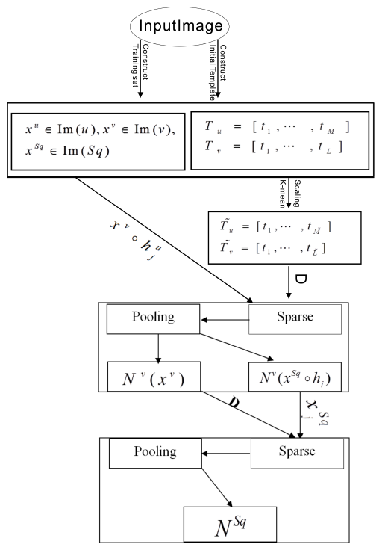

Figure 3. Architecture of the developed model.

**4. Experiments and results**

## 4.1 The database:

1. In this work, we use IFN/ENIT database [5, 17]. IFN/ENIT is the first database of Arabic handwritten script accessible to the scientific community. The total number of binary images of handwritten text is 26,459 with its ground truth information. Those images were labeled according to 946 name classes, and they were written by 411 writers. The database is arranged into four sets, a, b, c, and d, in order to conduct fourfold cross validation experiments. To make IFN/ENIT database suitable to our task each word image need to be segmented into its original characters. Therefore, we manually segmented all words images. The collection for beginning, middle, end and isolated letter forms as follows:
2. – Read the character labels from the ground truth file associated with the image.
3. – Define the boundaries of each character by hand.
4. – Assign the label for each character segment.
5. – Save each character as an independent image with its label.
6. – Group characters which have the same label in one folder.

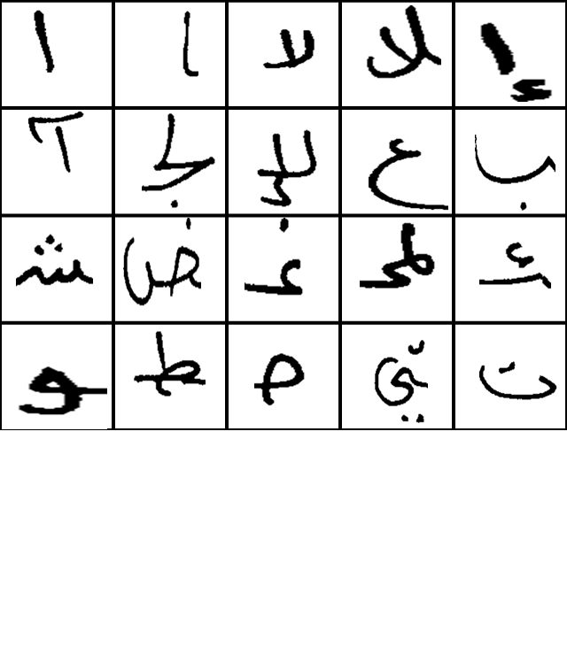

1. Figure 4. Twenty instances from the set of training examples for Arabic character.

An efficient segmentation stage is required in order to divide a cursive word or subword into its constituting characters, but it is difficult -at the time being-. Therefore in this work we used previous approach for segmentation to avoid errors that may appear from an automatic character segmentation process.



1. Figure 5. Example of segmentation.

## 4.2 Results of Experiments

In this research, proposed method on Offline handwritten Arabic character recognition was adopted. The developed recognition algorithm has been tested using training data and testing data from two distinct vocabularies. There are 209201 samples in total. We randomly chose 50% of the samples for each class from the reference data as training samples, and the remaining 50% as testing samples. Two tests were conducted using the same data.

The first, letters were distributed on the basis of their place in the word; total categories in this test became 113 classes. The second, every character was compiled regardless of its place in the word in one category, the total categories in this test was 38. For every test, we used the developed method as a feature extraction step for a classification algorithm; we adopted Support Vector Machines (SVM). The performance of the proposed method is significantly affected by the following parameters: patch size (u,v), number of elements in each linear combination (L), size of the available training set (Tr), selections of template size (Te) and number of clustering for each layer (Cl1, Cl2). After carefully scrutinizing the above experiments, we find the optimal parameters values used to achieve this accuracy are: L = 3; u = 14; v = 25; Te = 5; Cl1 = 500 and Cl2 = 700. Table 3 shows the main information of the previously methods, their results on one hand and those obtained using the developed method on the other and. Despite each method has different data but aiming at the same target.

It is right that the accuracy found in this work is modest, but when we compared it to the challenges faced by this experiment, the result becomes acceptable. To the best of our knowledge, we can highlight the most important of these challenges as follows:

1. Through this work we dealt with a lot of data, so the extent of errors increased.

Table 3: comparison between the proposed method and some previous works.

|  |  |  |
| --- | --- | --- |
| Info.  Method | Accu | Class |
| Neural Network (10) | 58% |  |
| Discrete Wavelet transform (1) (19) | 52.14 | Isolated |
| Discrete Wavelet transform (1) (19) | 26.36 | All Form |
| Artificial Neural Network (20) | 52.1% |  |
| Probabilistic Model(21) | 59.2% | All Form |
| Developed Method | 63.75% | All Form |
| Developed Method | 63.75% | Isolated |

1. Some of those who participated in the writing of these letters did not abide by the rules of the Arabic writing of the letters, which caused more errors.
2. An essential difference between Latin scripts and Arabic is the fact that many letters only differ by dots, but the primary stroke is exactly the same. This makes a task to differentiate between letters very hard.
3. Moreover, the study deals with the problem of overlapping between the characters that makes it difficult to distinguish characters.

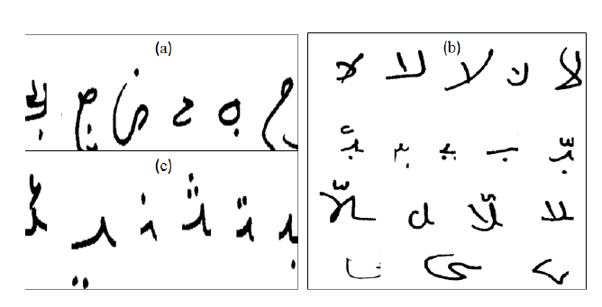

Figure 5: (a)Some letters did not abide by the rules of the Arabic writing. (b)Every line contains same character for different writers. (c)Some letters only differ by dots.

See Figure 8 for a sample of Arabic handwritten text that illustrates the above mentioned challenges.

# 5 Conclusion

1. In this research, we present a novel technique based on developed hierarchical sparse coding to effectively construct new feature for characters. Through experiment, the method has been proved to be accurate at 63:75%. After the above experiments, we concluded that the recognition of Arabic handwritten character is hard not only because of the handwriting ambiguity but also because of the similarity between characters according to their position in a word. Consequently, to design a handwriting Arabic character recognition system with an accuracy rate of 100% is hard –at this time- because even human beings are not capable to recognize every handwritten script without any a doubt. Finally, we hoped that the developed system will be a step towards a hierarchical approach to robustly solve the aforementioned problem. Now, it remains for further research to build on this foundation and work towards automatic segmentation and recognition of offline Arabic words.

hierarchical (taxonomic) diversity would be higher in an area in which the species are divided amongst many genera as opposed to one in which most species belong to the same genus, and still higher as these genera are divided amongst many families as opposed to few. The families, genera and species ratio was observed maximum in the pine forest as compared to the oak forest in the present study (Table 4), indicating diverse taxonomic vegetation in the pine forest.

**Corresponding Author:**

Dr. RAMADHAN ABDO MUSLEH ALSAIDI

School of Mathematics and Statistics

Huazhong University of Science and Technology

Wuhan, 430074, China

E-mail: [saidi52@gmail.com](mailto:saidi52@gmail.com)

**References**

1. Al-Yousefi H., Udpa S. Pattern Analysis and Machine Intelligence, IEEE Transactions on14, 853 (1992).
2. Abuhaiba, I., Mahmoud, S. A. and Green, R. J. (1994). Recognition of handwritten cursive arabic characters, Pattern Analysis and Machine Intelligence, IEEE Transactions on 16(6): 664–672.
3. Abandah, G. and Anssari, N. (2009). Novel moment features extraction for recognizing handwritten arabic letters, Journal of Computer Science 5(3): 226..
4. Khedher, M. and Abandah, G. (2002). Arabic character recognition using approximate stroke sequence, Third Int’l Conf. on Language Resources and Evaluation (LREC 2002), Arabic Language Resources and Evaluation–status and prospects workshop.
5. Sari, T., Souici, L. and Sellami, M. (2002). Off-line handwritten arabic character segmentation algorithm: Acsa, Frontiers in Handwriting Recognition, 2002. Proceedings. Eighth International Workshop on, IEEE, pp. 452–457.
6. Pechwitz, M., Maddouri, S. S., M¨argner, V., Ellouze, N., Amiri, H. et al. (2002). Ifn/enit-database of handwritten arabic words, Proc. of CIFED, Vol. 2, Citeseer, pp. 127–136.
7. Menasri, F., Vincent, N., Augustin, E. and Cheriet, M. (2007). Shape-based alphabet for off-line arabic handwriting recognition, Document Analysis and Recognition, 2007. ICDAR 2007. Ninth International Conference on, Vol. 2, IEEE, pp. 969-973.
8. Malas, T. M., Taifour, S. S. and Abandah, G. A. (2008). Toward optimal arabic keyboard layout using genetic algorithm, Proc. 9th Int’l Middle Eastern Multiconf. on Simulation and Modeling (MESM 2008) pp. 50–54.
9. Abandah, G. and Khundakjie, F. (2004). Issues concerning code system for arabic letters, Dirasat Engineering Sciences Journal 31(1): 165–177.
10. Al-Jawfi, R. (2009). Handwriting arabic character recognition lenet using neural network., Int. Arab J. Inf. Technol. 6(3): 304–309.
11. Zaghloul, R. I., AlRawashdeh, E. F. and Bader, D. M. (2011). Multilevel classifier in recognition of handwritten arabic characters, Journal of Computer Science 7(4): 512.
12. Ayyaz, M. N., Javed, I. and Mahmood, W. (2012). Handwritten character recognition using multiclass svm classification with hybrid feature extraction, Pak. J. Engg. & Appl. Sci. Vol 10: 57–67.
13. Zeki, A. M. and Zakaria, M. S. (2008). Challenges in recognizing arabic characters, International Islamic University Malaysia (IIUM), Kuala Lumpur, Malaysia, National University of Malaysia (UKM), Bangi, Selangor, Malaysia.
14. Amin, A. (1997). Arabic character recognition, Handbook of character recognition and document image analysis pp. 397–420.
15. Alsaidi, R. A. M., Li, H., Wei, Y., Khaji, R. and Tang, Y. Y. (2013). Hierarchical sparse method with applications in vision and speech recognition, International Journal of Wavelets, Multiresolution and Information Processing 11(02).
16. Li, H., Wei, Y., Li, L. and Yuan, Y. (2012). Similarity learning for object recognition based on derived kernel, Neurocomputing 83: 110–120.
17. Rubinstein, R., Zibulevsky, M. and Elad, M. (2008). Efficient implementation of the k-svd algorithm using batch orthogonal matching pursuit, CS Technion.
18. M¨argner, H. El Abed, M. Pechwitz, et al., Actes du 9`eme Colloque International Francophone sur l’Ecrit et le Document (2006), pp. 259–264.
19. Lawgali, A., Bouridane, A., Angelova, M. and Ghassemlooy, Z. (2011). Handwritten arabic character recognition: Which feature extraction method, International Journal of Advanced Science and Technology 34: 1–8.
20. Aburas, A. A. and Rehiel, S. A. (n.d.). Jpeg for arabic handwritten character recognition: Add a dimension of application, Advances in Robotics, Automation and Control ISBN pp. 78–953.
21. Xiu, P., Peng, L., Ding, X. and Wang, H. (2006). Offline handwritten arabic character segmentation with probabilistic model, Document Analysis Systems VII, Springer, pp. 402

3/1/2014