Impacts Of Land Uses Changes on Soil Fertility, Carbon and Nitrogen Stock under Smallholder Farmers in Central Highlands of Ethiopia: Implication for Sustainable Agricultural Landscape Management Around Butajira Area

Getahun Haile, Fisseha Itanna, Feyera Senbeta, Lalisa Alemayehu and Mulugeta Lemenhi

Corresponding author: Getahun Haile, Email address: getahun_h@yahoo.com, tele 0912057770
Fisseha Itanna, email: fissehai@yahoo.com, Addis Ababa University
Feyera Senbeta, email: feyeras@yahoo.com, Addis Ababa University
Lalis Alemayehu, Lalisa222@yahoo.com, Forestry Research Center
Mulugeta Lemenhi, Email: elerhoi@yahoo.com, Wondo Genet College of Forestry

Abstract: Landuses/land cover changes from natural forests to farmland, open grazing and eucalyptus woodlots, and subsequent changes in soil physical and chemical properties are widespread in Ethiopia. Thus, assessing land use-induced changes in soil properties are essential for addressing issues of agro-ecosystem transformation and sustainable land productivity. The aim of this study was to examine the impact of land use/land cover changes on soil properties, SOC and TN stock around Butajira area, Southern Ethiopia. The types of land uses considered on this study were: enset, cereal farms, grazing land, and Eucalyptus camaldulensis woodlots. Seven households having all the above mentioned land uses adjacent to each other were selected. For the purpose of this study, the selected household and land use types were considered as replication and treatments, respectively. 28 soil pits were dug i.e. one soil pit was dug at each land uses hence a total of eighty four soil samples were collected at three depths, namely 0-15cm, 15-30cm, and 30-45cm for chemical analysis. In addition, undisturbed soil samples were collected from same pits but opposite sides for soil bulk density and moisture content determination. Standard soil analytical procedures were followed in carrying out soil analysis. The results of the present study showed that land use changes induced significant differences on soil properties as reflected by the changes in bulk density, MC, pH, OC, TN and available P and OC and TN stock. Soil bulk density was significantly higher in the cereal farms compared to enset farms reflecting compaction of soil due to intensive tillage. Moreover, soil MC was significantly lowest under Eucalyptus woodlots compared to enset. Likewise, soil pH was lowest in woodlots and cereal as compared to other land uses. Soil under enset farms had higher OC, TN, available P, carbon and nitrogen stock as compared to other land uses. OC total N stock were shown a trend of enset farm > eucalyptus woodlots > grazing land > cereal at 0-45 cm. Lowest OC and TN under cereal land showed the severity of land degradation under this land utilization, where higher soil nutrients, OC and TN under enset suggested its importance in addressing in nutrient soil nutrient and carbon depletion Besides, woodlots and grazing land had higher OC, TN, SOC, and TN stock as compared to cereal. Therefore, future restoration of soil should focus on strategies that improving the soil nutrient content and carbon storage under cereal land for enhancing sustainable land management, thereby improving the livelihood of agrarian community However, fast growing nature of eucalyptus species could have led to soil acidiﬁcation and depletion of moisture. Thus, current strategies of planting fast growing eucalyptus woodlots in response scarcity of forest products, might have associated with soil degradation issues. Hence, there is a need to develop proper land use policy and sustainable soil management and cropping practices to combat the on ongoing soil degradation and improve soil fertility in the study area.
[Getahun Haile, Fisseha Itanna, Feyera Senbeta, Lalisa Alemayehu and Mulugeta Lemenhi. Impacts Of Land Uses Changes on Soil Fertility, Carbon and Nitrogen Stock under Smallholder Farmers in Central Highlands of Ethiopia: Implication for Sustainable Agricultural Landscape Management Around Butajira Area. N Y Sci J 2014;7(2):27-44]. (ISSN: 1554-0200). http://www.sciencepub.net/newyork. 4

Key words：Land use, soil physical and chemical properties, soil degradation, Ethiopia

1. Introduction
Soil degradation in the form of plant nutrient depletion is the major environmental problems in the highlands of Ethiopia. Among Sub-Saharan countries, Ethiopia is the most seriously affected country by land degradation [World Bank, 1998]. Previous studies have shown negative nutrient balance mainly C, N and P indicating the soil could be mined [Stoorvogel and Smaling, 1990]. The overwhelming land degradation in Ethiopia have been caused due to land use changes, including deforestation, over grazing, and improper cultivation of agricultural land which lead to accelerated soil erosion and associated of soil nutrient status deterioration [FAO, 1986; Hurni, 1988]. Furthermore, widespread poor agriculture activities, including intensive tillage, complete removal of crop residues, low levels of fertilizer application, use of animal manure as a source of fuel in place of using it for soil fertility, lack of appropriate soil conservation practice and cropping system are also a contributing factors [Abebayehu and Eyassu,2011; Eyasu, 2002; Haileslassie et al., 2005]. Besides, land use changes and widespread poor agricultural practice the human factors of poverty, insecure land tenure and high population pressure have acted more indirectly as driving forces for land degradation [Eleni.,2013].
Obviously, land use can influence soil chemical and physical properties because of different anthropogenic activities, namely tillage, livestock trampling, harvesting, planting, application of fertilizer etc. Research have showed that linkage between land uses and soil properties, particularly in relation to soil nutrients and carbon storage[Solomon, 2002; Nega and Heluf,2013;Agbede, 2010]. Land use has evolved or vanished because of regional differences in soil properties, climate, population density, economic opportunities, cultural practices, and socio-economic factors. In Ethiopia, several studies[Yimer et al., 2007;Yimer and Abdelkadir, 2010; Awdenegest et al.,2013; Lemenih,2004; Alemayehu and Sheleme, 2013;Yihenew and Getachew,2013; Fikadu et al, 2013] have considered the effects of land use and their management on soil properties. For example, Yimer et al. [2007] compared croplands, forestlands and grazing lands and found that significant changes on selected physical and chemical in the highlands of Ethiopia. Another study conducted by Lemenih, [2004] reported that land use changes significantly influences soil proprieties such as available P and K, exchangeable bases and CEC in Sothern highlands of Ethiopia. Yimer and Abdelkadir, [2010] also reported that higher contents of SOC and total N under closed grazing land compared to farm land and open-grazing in Central Rift Valley area of Ethiopia. Another study by Alemayehu and Sheleme,[2013] found comparable higher OC, TN under grassland as compared to cereal farms, whereas they found higher available P under enset farms than pasture land or cereal farms in Southern Ethiopia. Similar study by [Yihenew and Getachew, 2013; Mesfin, 2013] also reported that conversion of natural forest into human-managed land uses (crop land, grazing land and eucalyptus plantation) had more deleterious effects on soil moisture content, pH, soil organic carbon, total nitrogen, and exchangeable potassium in Northwestern Ethiopia. In contrast, Fikadu et al [2013] found no significant differences among land uses on soil chemical properties in Southern Ethiopia.
Restoration efforts have been taking place to recuperate of degraded farmlands, particularly, through reconversion of former degraded farmlands into eucalyptus woodlots. Indeed, restoration of degraded lands is a subject that is receiving considerable attention today in many parts of the world. Various studies have been considered the effects of planting fast growing plantation on soil properties. Nevertheless, the evidence from these studies is mixed. For instance, several studies [e.g.Yeshanew et al,.2003; Abiyu et al., 2011, Lalisa et al., 2010; Lemma,2006; Lemenih et al. 2004; Zerfu,2002;] were reported a positive impacts of conversion of degraded farmlands into fast growing exotic plantation on soil properties, whereas the results by [Solomon et al., 2002; Woldeamlak and Stroosnijder, 2003 Girmay and Singh, 2012] showed that negative impacts on soil properties.
Generally, land use changes and their associated management can influence soil properties in localized area, though the amount of changes could be varied depending upon land use /cover and human management. More importantly, the outcome from these studies may be imperative in designing a sound land use for sustainable agricultural landscape management. Therefore, being Ethiopia is a large country with large biophysical and socio-economic setting, these previous studies is less adequate to describe the extent of soil degradation associated to land use/land cover changes in the country.
Furthermore, these previous studies fail to consider the effects of land that are solely manage by smallholder individual farmers except one study by Lalisa et al., [2010] who reported remarkable difference on soil chemical properties among land uses that have been managed by small holder farmers. Nonetheless, this study still fail to take into account the effects of grazing land that have managed by individual farmers and hence expected to have different effects on soil properties compared to communal grazing land. In addition, here different sampling strategies was used as the households and the compared land uses were considered as replication and treatment, respectively to minimize the possibility of material transfer among the different land use types.
In recent years, farmers have begun planting fast gowning exotic tree in the form of eucalyptus woodlots on former cropland in response to scarcity of forest products and economic opportunity. These tree planting have managed at a household level and cannot be compared with an enterprise or government plantations, which have cared for well and hence expected to have different effects on soil properties. Thus, there is a need to know the changes in soil properties when they are under farm household management and little have done in this area. The aim of the present study were, therefore (1) to assess the impact of land uses and their management on soil physical and chemical properties; (2) To assess the overall relationships of some selected soil physical and chemical properties (3) assess the soil carbon and total N stock under different management. Therefore, such localized comparison of the possible linkage between land use changes and soil properties could be necessary to identify land uses that are favorable for improved nutrients and soil carbon storage and responsible for nutrient and soil carbon depletion. The out puts of this study could help for development of an appropriate land use planning and sustainable land resources management, and thereby for improvement of the livelihood of the agrarian community

2 Methods

2.1Description of the study area
This study was conducted at the Meskan district in the area called Mekicho in Gurage Zone, SNNP Regional State, Ethiopia. This area is 5 km NW away from the Wereda (the district capital) Butajira town, which is 133 km south of Addis Ababa (Fig. 1). Gurage Zone, which is part of the Southern Nation, Nationalities, and People Region, is located in the western part of central Ethiopia.

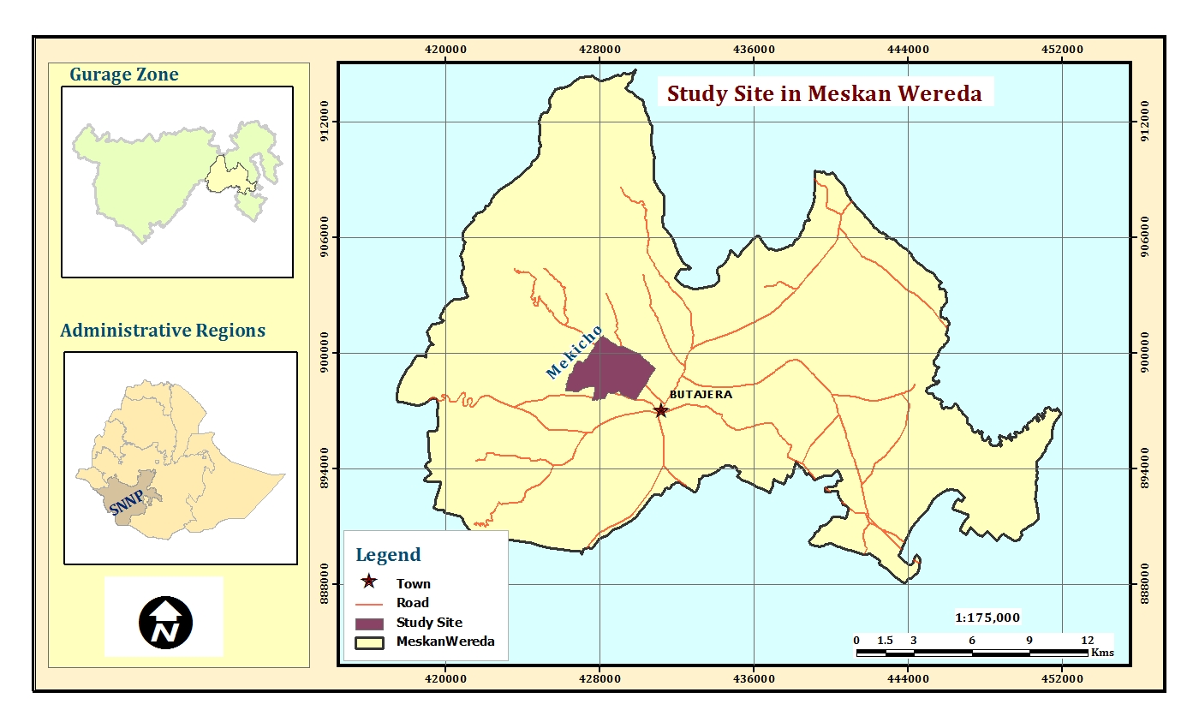

Figure1. Location Map of the Study Area

In terms of topography, Meskan Wereda has diverse topography that consists of plain (55%), sloppy (35%) and mountainous (10%).

2.2 Climate and soil resources
The position of ITCZ (Inter tropical Convergent Convergence Zone), that divides the humid tropical air mass to the south from the dry northeast, highly determines the climate of Ethiopia. As part of the land escapes of Ethiopia, ITCZ can influence climate of the study area. The study area receives the small rains in March to May and the big rains during June to September with higher concentrations of the rain observed in July and August. According to climatic record near the study area, the mean annual rainfall in the district is 1058 mm whereas the mean daily maximum and minimum temperatures are 27.7 °C and 6.5°C, respectively[National Meteorology Services Agency,2005]. The main crop-growing season begins towards the end of June and continues up to the end of October. The District has altitude ranging from 1800-3500 m asl. The altitude of the specific study site is 2100 m asl.
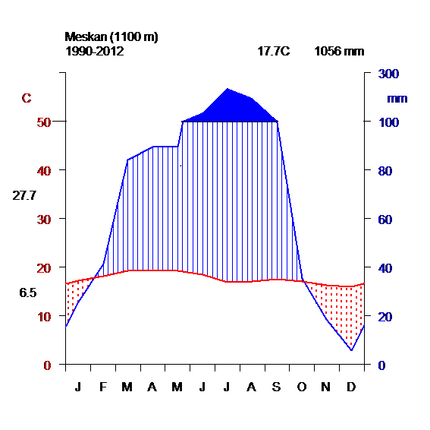

Figure 2. Mean monthly rainfall (mm) and temperature (oC) of Meskan District

The study areas, received highest temperature during February and March while coolest in November and December. The soils of the area may closely relate to their parent materials and their degree of weathering. The study area is geographically located in Central Rift Valley of Ethiopia. The main parent materials are basalt, ignimbrites, lava, gneiss, volcanic ash, and pumice [ Zewdie, 2004; Itanna, 2005]. Though no detailed soil study has so far been conducted in the study area, the dominant soil types of Meskan district includes eutric Cambisols, chromic Luvisols, pellic Vertisols chromic Vertisols, eutric Fluvisols and Leptosols [FAO, 1996). The specific soil types of the study sites is eutric Cambisols that is the dominant soil of the study area.

2.3 Dominant land use /cover of the study area
The population density of Meskan District, which is approximately about 250 people's km⁻². The average land holding per household head is less than 0.5 ha, which is one of the acute factors exerting a profound influence on land use/cover changes and land use intensification, resulted in severe land degradation in the area. Farmers practice diversified land use types as risk aversion strategies. The major land uses land/ cover in the study area includes cultivated land, natural vegetation, grazing land and plantation forest of exotic species mainly eucalyptus are the dominant land use/cover in the area. Eucalyptus camaldulensis is dominantly growing in Weyna dega agro ecological Zone, whereas Eucalyptus globulus is most common in dega agro-ecological Zone. The common annual crops grown in the areas includes wheat (Triticum spp.), teff (Eragrostis tef) and barley (Hordeum vulgare) and maize (Zea mays), and perennial crops such as enset(Ensete ventricosum). Teff is a ﬁne stemmed tufted endemic annual grass to Ethiopia. The grains of the crops used as main ingredient in the Ethiopian traditional flat bread called injera. Enset is a perennial, banana-like crop which native to Ethiopia that produces psuedostem and a starchy belly corm pulped for food, feed and fiber. Enset based land use is one of the dominant agricultural practices used for feeding about 13-15millions people in the Central and Southern Highlands Ethiopia[Tilahun and Mulugeta,2005].

2.4 Description of studied land use and experimental design
Seven households were selected all having four types of adjacent land use(enset farms cereal farms, open grazing land and Eucalyptus camaldulensis) on the same soil types, same landscape (slope) position and climate. Private owners own all the four land use types. The rationale behind selecting households each having four adjacent land uses to minimize the possibility of material transfer, mainly plant litter, through erosion/deposition (i.e., potential nutrient translocation) between the different land uses. For the purpose of this study, seven households were used as replications, while the four land use types and their management compared as treatment. According to the information obtained from local elders enset land have been in place over 50 year after converted from natural vegetation. Eucalyptus woodlots and grazing land are within the range of 15-20 and 30-40 years age, respectively. The description of each land use type presented as follows. Cereals farms are relatively large sized plots compared to other land uses. The dominant annual crops in cereal land use are teff, wheat and maize. Teff is small sized annual crops that need intensive land preparation. Farmers seems aware of their poor soil condition of their farm field, as a result they grow these crops by applying inorganic fertilizer like Urea and DAP either by mixing or independently. Enset are perennial crops often intercropped with maize. This land use is located closed to homestead, which have received large amount of fresh manure and household wastes. Pastureland is former cropped land that was converted into open grazing land. In this study, small-scale woodlots refer to small-sized plantations of Eucalyptus camaldulensis had established on degraded farmlands. Farmers have begun to convert unproductive cereal lands with trees(especially Eucalyptus) as trees demand less nutrients and due to economic reasons. It could also be because of the potential of trees to draw nutrients from the deeper soil layer that are not accessible to shallow rooted annual crops..

2.5. Soil sampling, sample preparation and analysis
Twenty-eight soil profile pits (four land use * seven replication) were dug and sampled in the enset farms, cereal farms, grazing land and eucalyptus woodlots. We collected soil samples from three depths: 0 to 15 cm, 15 to 30 cm, and 30 to 45cm. Eighty four soil samples (four land use * three soil depth classes * seven replication) were collected for chemical analysis: Soil sampling from different depths was done by inserting a core sampler into the wall of the pits; the lowest first and the top soil at last to avoid contamination between the two layers. Approximately, 1 kg of sample from each soil depth were and sent to laboratory then air-dried at room temperature, crushed, homogenized, and passed through a 2mm sieve before laboratory analysis. Total nitrogen content was determined following the Kjeldahl method [Jackson, 1958]. The available phosphorus content of the soil was analyzed using 0.5 M sodium bicarbonate extraction solution (pH=8.5) following the method of [Olsen et al., 1954].The organic carbon determinations was made following the wet oxidation method of [Walkley and Black, 1934].The soil pH was measured using pH meter in 1:2.5 soils to water solution ratio. For bulk density and moisture content determination undisturbed soil samples were collected with a manual core sampler of 5 cm ht * 3 cm diameter from three soil depth of 0-15 cm, 15-30cm and 30–45cm from same pits, but opposite sides. Soil-water content determined by standard procedures described for the gravimeter method after oven drying to a constant weight at 105ºC [Anderson and Ingram, 1993] for 30 hrs. Bulk density was determined using core method after oven drying wet undisturbed soil samples at temperature of 105◦C for 30 hours. Bulk density was calculated by dividing the weight of oven-dried soil with the volume of the core. All the chemical and physical analyses done at Holetta soil-testing laboratory, Ethiopia
Calculation of carbon stocks Soil carbon stock (Mg C ha⁻¹) for each sample depth was computed using the following equation.
Carbon stock [Mg ha-1] = [% C * BD * Depth in (m) * 10⁴ m² ha⁻¹]/100 (equation 1)
BD=bulk density (g/cm3) of each sample depth, where percentage C was the Walkley-Black carbon (Walkley - Black 1934). A total N (Mg ha-1) stock also computed using a similar equation. Subsequently, C and TN stock in each soil layer thickness was summed up to determine total C stock contained up to 45 cm depth for each land-use type

2.6 Statistical analysis
The results on the physical, chemical properties and soil carbon and total N stock of the various land uses practices were subjected to one-way analysis[SPSS Inc, 2006]. When the analysis of variance (ANOVA) showed significant differences (at ≤ 0.05) among the various land uses and soil depths for each parameter, a mean separation for each parameter was made using Turkey’s pair wise comparisons. Pearson correlation test was employed to examine the relationships between some soil properties. The soil properties analyzed and compared were bulk density, moisture content, pH, OC, total N, available P, soil organic carbon and total nitrogen stock in the soils of each land use category in 0-15 cm, 15-30 cm, and 30-45cm depth layer. In order to made normal distribution the field data for available P was log transformed and reported after back transformed.

3. Results and discussion

3.1. Soil Physical Properties in relation to land use and soil depth
Results of soil moisture content and bulk density are presented in Tables 1 and figure 3 for land use and soil depth, respectively. Soil bulk density was significantly differed (P < 0 .05) among land use at surface layer (0-15cm), while bulk density did not show any significant difference among land uses at 15-30cm and 30-45cm (Table 1). In contrary by [Fikadu et al 2013, Birru et al., 2013] found that no significant difference in bulk density among land uses in the high lands of Ethiopia.

Table 1. Mean ± SEM of soil MC (%) and BD (g cm-3) the soil of in relation to land use.
Property | D(cm) | Enset | Cereal | Grazing land | woodlots | ANOVA
MC(%) | 0-15cm | 31.42±1.96a | 29.24±2.59ab | 26.04±2.13ab | 22.51±1.64b | *
 | 15-30cm | 30.32±0.91b | 33.41±2.52b | 31.72±2.52b | 27.72 ±1.51b | ns
 | 30-45cm | 31.59±1.26b | 34.57±2.08b | 32.02±2.08ab | 28.18±1.58b | ns
BD(g cm-3) | 0-15cm | 1.07±0.04a | 1.23±0.05b | 1.18±0.04ab | 1.15 ±0.05ab | *
 | 15-30cm | 1.15±0.06b | 1.13±0.05b | 1.13±0.02b | 1.11±0.03b | ns
 | 30-45cm | 1.23±0.06c | 1.35±0.04c | 1.22±0.04c | 1.24±0.05c | ns
Values followed by the same letters in a row are not significantly different at P < 0.05; or 0.01* significantly different at p < 0.05; ** significantly different at p = 0.01 ns denotes not significantly different.

The bulk density was lowest under enset farms (1.07±0.04 g/cm3), while it was highest under cereal farms (1.23±0.05g cm-3) (Table 1). This result goes well with similar studies by [Haileslassie et al. 2005; Abebayehu and Eyasu,2011] who found that lowest bulk density under enset land as compared to cereal farms. Similar study by [Abiyu et al, 2011, Yechale, 2011] reported that significant higher bulk density under grazing land as compared to other land uses in Northern and Central highlands of Ethiopia, respectively. Similar study by [Lemenih et al.,2005] also reported that significant higher bulk density under farmlands as compared to other land uses in the high lands of Ethiopia. In contrary, study by Zerfu [2002] reported that conversion of farmland to eucalyptus plantation and vice- versa was not caused significant change on soil bulk density in the Amahara Regional State of Ethiopia.

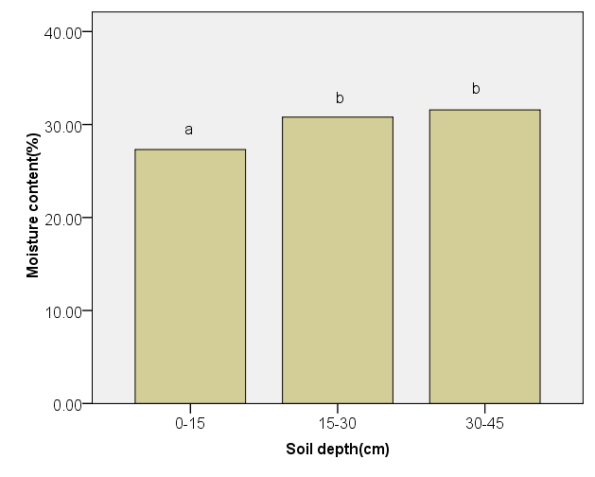
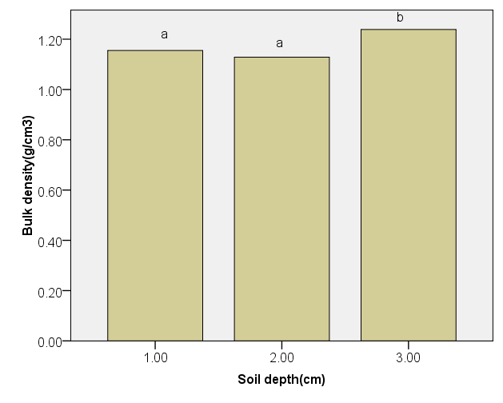

Figure 3. Distribution of soil moisture % and bulk density (gm/cm3) across soil depth.

Error bars represent standard error. Different letters denote significant difference between (P <0.05) while same letters denote no significant difference between (P <0.05).
Soil bulk density was significantly (p<0.05) vary across soil depths (Figure 3). Higher bulk density (1.24±0.02g cm⁻³) was observed at 30-45cm, while soil at 0-15cm and 15-30 cm had a similar lowest bulk density of (1.16±0.02 g/cm³) and 1.13±0.02 g/cm³, respectively (Figure 1). This result agrees with studies by [Awdenegest et al, 2013; Ahukaemere et al., 2012] who reported that increasing trend of bulk density across soil depth in Ethiopia and Nigeria, respectively.
Soil moisture was significantly differ (P=0 .05) among land use at surface layer (0-15cm), whereas, soil moisture content was not shown any significant difference(p=0.05) among land uses both at 15-30cm and 30-45cm soil depth (Table 1).
Soil moisture content was lowest under eucalyptus woodlots (22.51±1.64 %), while it was highest under enset farm(31.42±1.96%) at 0-15cm (Table 1). This is in harmony with study by Fikadu et al.,[2013] who reported that significant lower moisture content under Eucalyptus saligna plantation as compared to other land uses around Wondo Genet area Southern, Ethiopia. This results also agrees with similar study by [Mesfin, 2013] who reported that lowest soil moisture content under eucalyptus camaldulensies plantation as compared to other land uses in Mizewa Watershed of Lake Tana Basin of Northwestern, Ethiopia. Similar study by Tilashwork et al.,2013] were also reported lowest soil moisture under eucalyptus plantation compared to other land uses in Ethiopian.
Furthermore, soil moisture(%) was significantly (p=0.05) vary among soil depths (Table1). Surface soil had significantly lowest moisture content of (27.30±1.19%), while sub surface soil had a similar highest values (30.79±0.94%) at 15-30cm and (31.56±0.87%) at 30-45cm soil depths, respectively(Figure 3).

3.2 Soil chemical properties in relation to land use and soil depth
Soil chemical properties of the soils under the different landuses and soil depth are present in Tables 1 and figure 4, respectively.
The results reported showed that soil pH significantly (p<0.05) differed among land use types at surface layer (Table 2). However, soil pH did show any significant difference among land uses both at 15-30 cm and 30-45cm soil depth (Table 2). Woodlots and cereal soil had the lowest pH value of (5.63±0.01) and (5.78 ±0.01), respectively, while enset land had highest pH values (6.31±0.15) as compared to other land uses types(Table 2). This results agrees with studies by [Hailes-ilassie et al. 2005, Alemayehu and Sheleme, 2013] who reported that higher pH values under enset land than cereal land uses in Central and Southern Ethiopia, respectively. Similar results was also reported by [Amusan et al,2006] a significant low soil pH in soils under the continuous arable cropping land as compared to other land uses in Nigeria. Another study by [Olowolafe and Alexander,2007] also reported that, low pH under eucalyptus plantation as compared to other land uses in Nigeria. Similar study by Lemenih et al, 2005) also reported that significantly lower pH under Eucalyptus saligna plantation compared to natural forest or cultivated lands or Cupressus lusitanica plantation in the highlands of Ethiopia. This results also goes well with several other studies [Lalisa et al. 2010; Yihenew and Getachew,2013; Yitaferu et al.,2013] who reported that lowest soil pH under eucalyptus plantation and woodlots as compared to other land uses in the high lands of Ethiopia. Zerfu [2002] showed that a high content of active acidity, while low pH soil under eucalyptus globulus plantation in Amhara Regional State of Ethiopia. Abbasi and Rasool,2005 also reported that a significant difference on soil pH among land use types in Rawalakot Azad of Jammu and Kashmir.

Table 2. Mean ± SEM of soil OC (%) TN (%) available P (ppm), pH (H2O) in relation to land use.
Property |  | Depth(cm) | Enset | Cereal | Grazing | Woodlots | ANOVA
pH  OC(%) |  | 0-15  15-30  30-45  0-15 | 6.31± 0.15a  6.66± 0.64a  6.18± 0.11c  3.09± 0.13a | 5.78± 0.11b  5.73± 0.19a  5.96± 0.2c  1.50± 0.12b | 6.09± 0.04ab  6.09± 0.01a  6.19± 0.01c  2.31± 0.25c | 5.63± 0.01b  5.48± 0.01a  5.72± 0.21c  2.14±0.19bc | *  ns  ns  **
 |  | 15-30 | 2.46± 0.16a | 1.49± 0.14b | 1.63±0.14b | 1.75± 0.12b | **
 |  | 30-45 | 1.90± 0.23a | 1.18± 0.10b | 1.23± 0.10b | 1.47± 0.04ab | *
TN(%) |  | 0-15 | 0.26± 0.01a | 0.13± 0.02b | 0.20± 0.02a | 0.19± 0.01ab | **
 |  | 15-30 | 0.20± 0.01a | 0.12± 0.01b | 0.13± 0.01b | 0.15± 0.01b | **
 |  | 30-45 | 0.16±0.05a | 0.11± 0.02b | 0.11± 0.01b | 0.13±0.01ab | *
P(ppm) |  | 0-15 | 22.52±1.70a | 17.63±1.69a | 15.73±1.95a | 15.80±2.00a | ns
 |  | 15-30 | 20..97±1.49a | 11.72± 1.53b | 15.13±1.94b | 15.68±1.90b | *
 |  | 30-45 | 15.52±2.07b | 13.01± 1.24b | 14.22±1.21b | 14.70± 0.92b | ns
Values followed by the same letters in a row are not significantly deferent at P <.05; or 0.001* significantly different at p < 0.05; ** significantly different at p = 0.001 ns denotes not significantly different.

Soil pH did not show any significant (p<0.05) differences across soil depth (Table2). However, soil pH was increased with increasing soil depths(figure 4). Similar results were reported by [Malo et al.,2005] who indicated that an increasing soil pH with increasing soil depth.
The soil organic C content was significantly affected by land use type (p = 0.001) in 0-15 cm and(p=0.05) in 15-30cm (Table 2). The organic C content was lowest for cereal farms (1.50±0.12), while pastureland(2.31±0.25) and woodlots (2.14± 0.19%) had a similar relatively higher values at 0-15cm(Table 2). Enset farms had the highest OC(3.09±0.13%) at 0-15cm. Likewise, the organic carbon content was higher for enset farms(2.46±0.16%), while OC was the lowest under cereal farm(1.49±0.14), grazing land (1.63±0.14%) and woodlots (1.75±0.12%) at15-30cm(Table2). Furthermore, enset farms had the highest OC content(1.90±0.23%), whereas cereal farms(1.18± 0.10) and grazing land(1.23± 0.10) had a similar lowest values in the sub-surface layers of 15-30 and 30-45 cm depths, respectively(Table 2).
The total N content was significantly affected by land use type (p = 0.001) in 0-15 cm and 15-30cm and(p=0.05) in 30-45 cm (Table 2).Total N content was found to be the lowest under cereal farms (0.13±0.02%), while enset farms (0.26±0.01) and grazing land(0.20±0.02%) had a similar highest value at 0-15cm (Table 2). More importantly, total N content was found to be the lowest under cereal farm (0.12±0.01) and grazing land (0.13±0.01), while enset farms (0.26±0.01) and woodlot (0.15± 0.01) had a similar highest value at 15-30 cm. In addition, the TN content was lowest for cereal farms (0.11± 0.02) and grazing land(0.11± 0.01%) while enset farms had the highest TN (0.16±0.05) at 30-45cm(Table 2).
Similar results were reported by [Amusan et al,2006] a significant low organic matter content and available P in soils under the continuous arable cropping as compared to other land uses in Nigeria.
A significant difference (p = 0.001) was observed among the land uses in total N content at 0-15cm and 15-30cm and p=0.05) at 30-45cm(Table 2).
This result agrees with similar studies by [Emiru and Gebrekidan,2013; Lalisa et al. [2010]] who reported that a significant difference on OC and TN among land use in Western and Central Ethiopia. This result goes well with similar results by [Tilahun and Mulugeta,2005; Hailes-ilassie et al., 2005] who reported that significantly higher total N under enset land use as compared to cereal farms in Ethiopia. Another study by Boke, 2004 cited in Alemayehu and Sheleme, 2013] also reported that higher content of organic carbon and total nitrogen under enset land use as compared to grassland in Southern Ethiopia. Similar studies conducted in Ethiopia by [Yimer et al., 2008] and in Nigeria by [Onweremadu,2007] also found highest total N content in pasturelands as compared to cultivated lands. However, this result disagree with studies by[Alemahehu and Sheleme,2013] who found that higher OC under grassland as compared to enset land Ethiopia.
Enset farm had much higher available P (20.97±1.49ppm), while cereal farms (11.72±1.53ppm), grazing land (15.13±1.94ppm) and woodlots (15.68±1.90) had a similar lowest value at 15-30cm, respectively(Table 2). Aalthough, no statistically significant (p<0.05) differences in available P among land uses, enset soils had also higher available P(22.52±1.70) followed by to cereal farm (17.63±1.69 ppm), woodlots (15.80±2.00 ppm) and grazing land (15.73±1.95ppm) at 0-15cm (Table 2). Likewise, enset land had the highest available P of(15.52±2.07 ppm) followed by woodlots(14.70±0.92 ppm), grazing land (14.22±1.21ppm) and cereal fams(13.01±1.24ppm) (Table 2). It was observed that the available P was significantly affected by land use type (p= 0.001) at 15-30 cm, while it was not affected by land uses at 0-15cm and 30-45cm, respectively (Table 2).
This result agrees with similar studies by [Emiru and Gebrekidan,2013; Yechale and Solomon, 2011; Alemayehu and Sheleme, 2013] who found that land use significantly changes the available P in Ethiopia. This results contradictory with studies[Birru et al.2013; Mulugeta, 2004; Lemma, [2006] who found no significant difference in available P among land uses in the high lands of Ethiopia. This results is in agreement with similar studies by [Aticho and Elias, 2011; Alemayehu and Sheleme, 2013; Boke, 2004 cited in Alemayehu and Sheleme, 2013] who found higher available P under enset land use as compared to other land in Ethiopia.

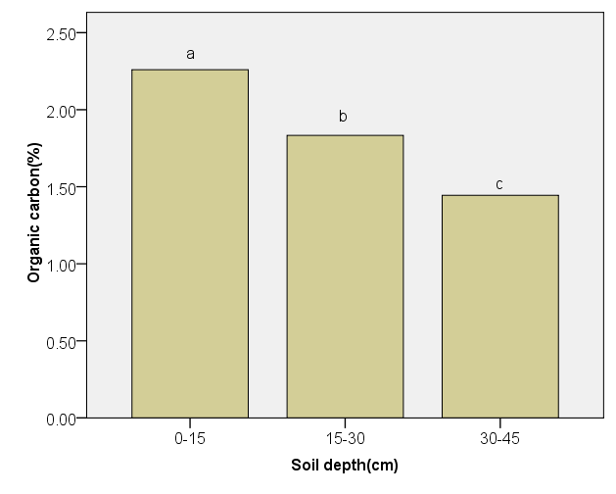

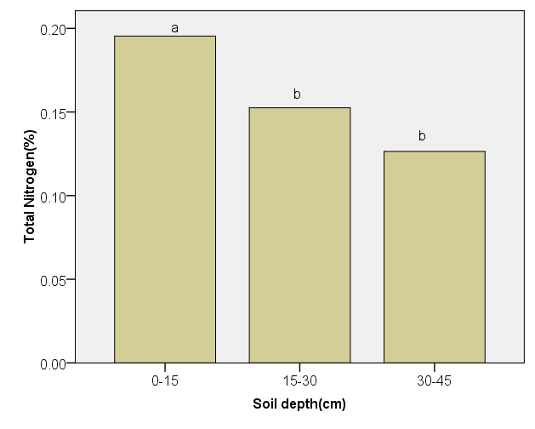
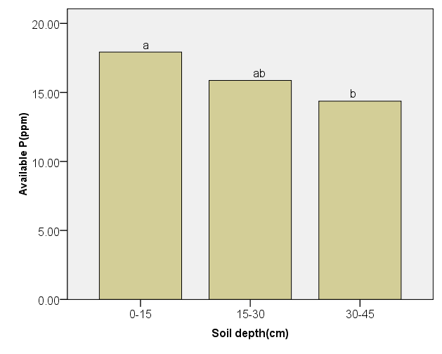

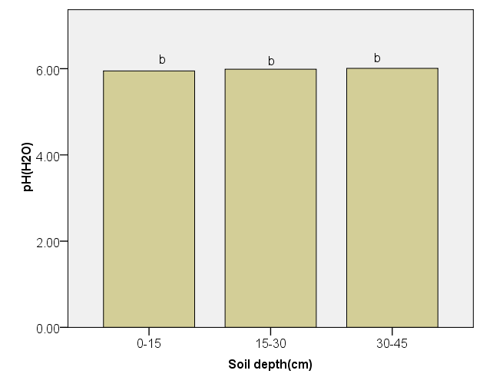

Figure 4. Distribution of soil OC%, TN%, pH and available P(ppm) across soil depth.

Error bars represent standard error. Different letters denote significant difference between (P <0.05). Same letters denote no significant difference between (P <0.05).
As showed in (Figure 4) OC and TN were significantly different across different soil depths at (P=0.001). However, available phosphorus and pH did not show any significant difference (p<0.05) across soil depth (Figure 4).
OC content was higher (2.61± 0.21%) was at 0-15cm followed by 1.83±0.10 % at 15-30cm and 1.49±0.13%) at 30-45cm (Figure 4). TN content was higher (0.20± 0.01%) at 0-15cm, while similar low values of TN (0.15± 0.01%, 0.13±0.01%) was found at 15-30cm and 30-45cm, respectively (Figure 4). This result agrees with studies by [Yifru and Taye, 2011; Lalisa et al. 2010; Yimer and Abdelkadir, 2011] who found a decreasing trend of organic carbon and total N content with increasing soil depths in Central highland of Ethiopia.
Available P did not show any significant difference across soil depth. however surface layer had relatively higher available P of (17.50±1.09 ppm) followed by 16.40 ±1.14ppm and 14.90±0.83 at 15-30cm 30-45cm, respectively.

3.3 Relationships between selected soil physical and chemical properties
The correlation matrix for physical properties and chemical properties were presented in (Table 3). Positive correlation was observed between OC and TN at correlation coefficient(r) of 0.973**). TN and available P showed a positive correlation at correlation coefficient of r(0.406*). This results agrees various studies in Ethiopia[ Fikadu, et al, 2003; Lalisa et al., 2010; Mulgeta,2004; Yimer and Abdelkadir,.2011] who reported linear relationship between OC, and TN and available P. Available P also showed a positive relationship with pH (r = 0.483**) (Table 3). Negative correlation was observed between BD and MC (%) at correlation coefficient (r) of (-0.398**) in surface layer(Table3). This results is in line with similar study by (Fikadu et al.,2013) who reported that negative correlation between bulk density and moisture contents.

Table 3. The correlation matrix for soil properties in surface layer(0-15cm) soil depth
 | pH | OC (%) | TN (%) | P(ppm) | MC (%) | BD (g/cm3)
pH | 1
OC(%) | .272 | 1
TN(%) | .295 | .973** | 1
P(ppm) | .483** | .340 | .406* | 1
MC(%) | -.162 | .222 | .171 | -.142 | 1
BD(g/cm3) | .082 | -.300 | -.228 | .191 | -.398* | 1
Notes: * significant at 5%, ** significant at 1%.

3.3 Soil organic carbon and total N stock in relation land uses
Results of soil carbon stock are presented in Tables 4 and figure 5 for land uses and soil depths, respectively.
The organic carbon stock was lowest for cereal farms (27.58±2.2 Mg ha-1) and highest for enset (49.41±2.0 Mg ha-1) with relatively higher values in pastureland(41.03±5.19 Mg ha-1) and woodlots (37.17±4.03 Mg ha-1) at 0-15cm. Furthermore, enset farms had the highest carbon stock (43.09±4.91 Mg ha-1), while cereal farms (25.34±2.58 Mg ha-1), grazing land (27.33±2.36 Mg ha-1) and eucalyptus woodlots) 29.15±2.17 Mg ha-1) had a similar lowest values at 15-30cm (Table 5). Likewise, higher soil organic carbon was observed under enset farms (34.86±4.17 Mg ha-1), while cereal farm (23.72±1.89 Mg ha-1) and grazing land (21.74±1.79 Mg ha-1) had the lowest values at 30-45cm(Table 5). A significant (p=0.05) difference was observed between land uses in soil carbon stock in all considered soil depths (Table 5).
Total nitrogen stock was found least under cereal farms (2.49±0.26 Mg ha-1), while woodlots (3.23±0.32 Mg ha-1) and grazing land (3.63±0.45 Mg ha-1) had a similar relatively higher total nitrogen stock at 0-15cm (Table 6). Enset land had the highest total nitrogen stock of (4.11±0.15Mg ha-1) at 0-15cm (Table 6). Furthermore, total nitrogen stock was higher under enset farm(3.55±0.41 Mg ha-1), while cereal farm (2.12±0.18 Mg ha-1), grazing land(2.27±0.2 Mg ha-1) and woodlots(2.47±0.20 Mg ha-1) had a similar low total nitrogen stock at 15-30cm (Table 5). In addition, cereal farms(2.13±0.18 Mg ha-1) and grazing land(1.92±0.15 Mg ha-1) had a similar lowest values, while enset farm had the highest values(2.94±0.36 Mg ha-1) at 30-45cm (Table 6). A significant difference(p= 0.001) was observed among the land uses in total N carbon stock at 0-15cm and (P<0.05) at 15-30cm and 30-45cm.
Total carbon stock within 0-45cm was higher for enset (127.36±11.09 Mg ha-1) followed by woodlots (92.55±7.66 Mg ha-1) and grazing land (90.30±9.34 Mg ha-1) and cereal land(76.64±6.71 Mg ha-1).Likewise enset land had higher total nitrogen stock of (10.66±0.62 Mg ha-1) followed by woodlots(8.04±0.66Mg ha-1) and grazing land(7.82±1.05Mg ha-1) and cereal farm(6.74±0.62Mg ha-1). This estimate is within the range of earlier finding by [Mulugeta and Itanna, 2004] who reported that SOC stock ranging (42.9 -234.6 Mg ha-1) for Andosols, Nitosols and solanchak for 0-60cm depth in Southern Ethiopia.
This results agreed similar study by [Girmay and Singh,2012] found that ex-closure had the highest soil organic carbon of (43 Mg ha-1) followed by plantation (36 Mg ha-1), grazing land (33Mg ha-1) and cereal land 26Mg ha-1) at 0-20 cm. Similar study by Sing et al.,2010] found that forest land had significantly higher SOC and TN stock(221±13.7 Mg ha-1, 18±2.2 Mg ha-1) followed by traditional agro-forestry(166.8±13.7 Mg ha-1, 16.4±1.26 Mg ha-1) and agricultural lands(149.5±9..46Mg ha-1, 15±1.2 Mg ha-1) in the Central Rift Valley of Ethiopia.

Table 4. Mean ± SEM of soil carbon stock (Mg C ha-1) in relation to land use types
Property |  | depth(cm) | Enset | Cereal | Grazing | Woodlots | ANOVA
OC(Mg/ha) |  | 0-15cm | 49.41±2.01a | 27.58±2.24b | 41.03±5.19ab | 37.17±4.03ab | *
 |  | 15-30cm | 43.09±4.91a | 25.34±2.58b | 27.53±2.36b | 29.15±2.17b | *
 |  | 30-45cm | 34.86±4.17a | 23.72±1.89b | 21.74±1.79b | 26.23±1.46ab | *
Total  TN(Mg/ha)  Total |  | 0-45 cm  0-15cm  15-30 cm  30-45cm 0-60cm | 127.36±11.09  4.11±0.15a  3.55±0.41a  2.94±0.36a  10.66±0.62 | 76.64±6.71  2.49±0.26b  2.12±0.18b  2.13±0.18ab  6.74±0.62 | 90.30±9.34  3.63±0.45ab  2.27±0.45ab  1.92±0.15b  7.82±1.05 | 92.55±7.66  3.23±0.32ab  2.47±0.20 b  2.34±0.14ab  8.04±0.66 | **  *  *
Values followed by the same letters in a row are not significantly deferent at P <.05 or p=0.001 values followed by different letter are Significantly different at p < 0.05; * Significantly different at p = 0.001 ns denotes not significantly different.

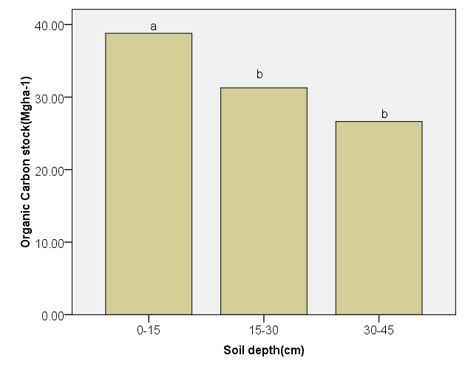

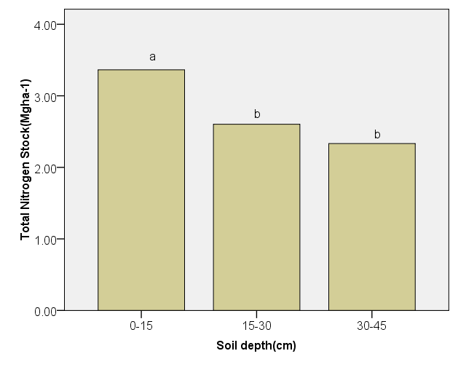

Figure 5.Total Soil carbon and Total Nitrogen stock (Mg ha-1) across soil depth.
Error bars represent standard error. Different letters denote significant difference between (P <0.05). Same letters denote no significant difference between (P <0.05).
Surface soil had highest soil organic carbon stock (56.10±3.56 Mg C ha⁻¹) and TN stock (4.86±0.31 Mg ha-1), while subsurface soil had similar low of soil organic carbon (45.17±3.31Mg C ha⁻¹, 38.26±3.08 Mg ha-1) and total nitrogen stocks of (3.77±0.27 Mg ha⁻¹, 3.35±0.24Mg ha-1), at 15-30cm and 30-45cm, respectively (Figure5). A significant (p=0.001) difference was observed across soil depths in soil carbon stock and total nitrogen stock. The surface layer (0–15cm) contributed 39% to the total (0-45cm) SOC stock for the Enset, 36% for the cereal farms, 45.44 % for the grazing and 40.16 % for eucalyptus woodlots. The surface layer (0–15cm) contributed 38.56 % to the total (0-45cm) Total nitrogen stock for the Enset, 36.94 % for the cereal farms, 46 % for the grazing and 40.17 % for eucalyptus woodlots. Thus, OC total N stock were shown a trend of enset farm > eucalyptus woodlots > grazing land > cereal at 0-45 cm.

4 Discussions

4.1 Soil physical properties
The results of this study showed that bulk density varied greatly in response to land uses and their managements. Cereal farms had a greater soil bulk density as compared to enset farm at surface layer. Increased bulk density under cultivated lands was also reported by several studies[Yechale and A. J. Solomon,2011; Khormali et al.,2009; Lemenih et al. 2005; Yihenew and Getachew,2013]. Frequent tillage for growing for small sized annual crops, particularly teff (Eragrostis tef) may be a contributing factors.
The highest bulk density in the cereal land use may also be a reflection of low organic carbon. Tillage could be reduced organic carbon by destroying soil aggregate thereby exposing organic carbon for decomposing agent[Solomon,2002]. Several studies could also noticed the influences of tillage on bulk density and organic carbon[Akamigbo,1999; Onweremadu et al.2009 cited in Ahukaemere et al.,2011]. A linear relationship between OC and bulk density was reported by [Mulugeta 2004; Fikadu et al 2013] from the high lands of Ethiopia.
Soil compaction in cereal land may eventually affect infiltration rate if such kind of intensive tillage could have continued and this in turn aggravates erosion hazard, which finally leads to high soil erosion and land degradation, which are the main soil degradation agent in the high lands of Ethiopia [Hurni, 1993; Hawando, 1997]. This was reflected by the inverse relationship between bulk density and moisture content (r=-0.398**).
Furthermore, a similar bulk density under grazing land and woodlots as compared to other land uses can be explained by the equal exposure of these land to free grazing. Normally, shortage of grazing land is very acute in the study area and the farmers often use to graze their animals on farmlands after harvest and inside woodlots. The lowest bulk density under enset farmlands may be due limited tillage and livestock trampling unlike other land uses.
A significantly higher bulk density in soil of 30-45cm as compared to soil in 0-15cm and 15-30cm. The increasing trend of soil bulk density with increasing soil depth may be due the weight of the overlying soil. Decreasing soil organic carbon content with increasing soil depth may also be a contributing factor. This result agrees with similar results reported by [Birru et al 2013] who found that higher bulk density of (1.24 g cm⁻³) in subsurface (20-40cm) as compared to (1.11 g cm⁻³) in surface (0-20cm) in highlands of Ethiopia. Similar increasing trend of bulk density with increasing soil depths were also reported by [Awdenegest et al, 2013 and Ahukaemere et al., 2012] in Ethiopia and Nigeria, respectively.
Soil bulk density is an important soil quality indicator since it affects aeration and infiltration rate and restrict root penetration when it is beyond critical limit. Therefore, it has a long -term implication for the good state of soil. Miller and Donahue, [1997] reported that for good plant growth, bulk densities should be below 1.4 g cm⁻³ for clays soils. Therefore, the value obtained here showed that the current utilization of cereal farms is in good state with regard to bulk density
The observed lowest moisture content under eucalyptus woodlots may be attributed due to nature of the species.It is fast growing and various species with high moisture and nutrient uptake. Sanginga and Swift[1992] explained that mono-crop of eucalyptus species has a general trend of high uptake for soil moisture as well as nutrients. This is in agreement with several findings [Fikadu et al,.2013; Tilashwork et al.,2013; Mesfin,2013]
On the other hands, the highest moisture content under enset farm may be attributed due its funnel like leaves and spongy root systems form mate-like structure in the root zone that may minimizes soil erosion and run-off, which ultimately improve the water storage[Tsgaye,2002; Amede and Diro, 2005]

4.2 Soil chemical properties
The results of this showed that the chemical properties (OC, TN and available P) significantly changes in response to land use and their management.
The results reported show that soil pH significantly varied among land uses. Soil pH under was significantly higher under enset farm as compared to woodlots and cereal farms. The higher soil pH under enset soil could be attributed due to higher values of exchangeable bases. The content of exchangeable base Ca2+, Mg2+ may be changed due to the application of large amount of household refuses and wood/biomass ash. In addition, branches and residual waste are also a contributing factors. Pitman, [2006] and Misra et al., [1993] found that wood ash provides considerable amount of Ca2+, Mg2+ and K+. Similar study by [Alemayehu and Sheleme, 2013] also reported higher values of exchangeable Ca²⁺, Mg²⁺, and K⁺ under enset field in Ethiopia.
However, woodlots and cereal land had sibilantly lower soil pH. The lower exchangeable base may be a contributing factors for lowest soil pH under woodlots. This results agrees with similar studies by [Muluneh, 2011, Zewdie, 2008] who found a decreasing trend of Ca2+ and Mg2+ with increasing age of eucalypts globulus plantation in the high lands of Ethiopia. Similar study by Olowolafe and Alexander, 2007 was also reported a lower Ca2+ and Mg2+ under eucalyptus camaldulenisis plantation in Nigeria. Thus, fast growing nature of the species and its voracious nutrient uptake may causes the changes.
The lower level of pH under cereal land may be attributed due to the long-term application of chemical fertilizer mainly urea which may rise the carbonate level. In addition, continuous total biomass removal may also be attributed to observed changes in pH[Saikh et al.,1998b].
On the other hand, the relatively higher pH under burning of the grass biomass as the grazing land serve as threshing ground during harvesting producing ash which at least temporarily increases the concentration of the base cations (Islam, Weil, 2000). The increasing concentration the exchangeable Na⁺ due to livestock urine, which have added daily to open grazing land by cattle may also be a contributing factors[Lalisa et al., 2010].
Though not significant difference on soil pH across soil depth, an increasing trend of pH with increasing soil depth indicated may also be caused due to the increased content exchangeable bases (Ca^{2+,} Mg²⁺ and K⁺) with increase in depth as a results of leaching within a soil profile [Mohammed et al., 2005].
The results reported showed that OC and TN greatly varied among land uses. Enset farm had significantly higher OC and TN, carbon and total nitrogen stocks as compared to other land uses. This results agreed with studies by [Abebayehu and Eyassu,2011].
The high organic C, total N under enset soil can be attributed to its man agement and location. Large amount of household wastes, livestock waste, wood and dung ash and other decomposable materials are often thrown to the enset, which in aggregate changes nutrient and carbon storage through time. Proximity of enset for home may contributed to easy manual transportation of household refusal, stall manure and enset by-products on daily basis [Bekunda, 1999; Elias, 2000]. The increasing social favarism towards enset have also a contributing for high application organic fertilizer. Bouajila and Sanaa, [2011] indicated that application of manure and household wastes caused a significant changes on the content of soil organic carbon and total nitrogen. Thus, these external inputs may promotes the concentration of total N and organic. As internal inputs, the presence of different types of plants (fruits, vegetables, herbs and shrubs and other tree species) are grown inside and /around enset farm, the leaf and other plant remains all add up to the high C content.
The observed strong positive correlation between organic carbon and total nitrogen suggested that that the contribution of OC to total N was high. Richards and Wolton,[1976] suggested that livestock urine and dung as the good potential sources for N.
Similar study by [Brandt et al., 1997; Tsegaye, 2002; Tilahun. and Mulugeta[2005 ] reported that the application of large amount of organic manure and crop residue, including the nutrients coming from outfield in terms of feed and mulch. Besides this, the funnel the morphology of enset leaf and root could have minimizes soil erosion and nutrient saving [Tsgaye,2002; Amede and Diro,2005].
Higher OC and TN under grazing land, particularly in surface layer may be due to the growing habit of the grasses i.e. the grasses frequently develop juvenile leaves, which add to the N and C content of the soil. Although the majority of the above ground biomass have removed by intensive free grazing, the below ground biomass mainly root may add higher organic carbon and nitrogen into the soils of grazing lands. It is known that grass roots decompose faster than tree roots and hence contribute higher organic matter to soils [Guo and Gifford, 2002; Rhodes et al., 2000], which could have faster fine root turnover and decay. Livestock waste may also be another possible nutrient sources in grazing land as the animals stay the whole day in the grazing land and their waste remains out there especially in the rainy season when they totally confined on grazing land, then it becomes solubilized by rain water and mixes with the soil. In addition, grazing land served as heaping sites and threshing ground during at the time of crop harvesting which could be contributing factors for observed higher OC and TN.
This study findings confirmed effectiveness of grazing land as restoration measures soil of degraded farmlands as reflected by better OC and TN as compared continuously cropping lands. Previous studies have shown higher OC and TN under grazing land as compared to cereal farms though grazing land were established on former farmlands farmers abandon because of poor productivity[Lalisa et al.,2010] signaling the great need for soil amelioration activities
Likewise, eucalyptus woodlots had also higher OC and TN, carbon and nitrogen stock than cereal land.
Previous studies have reported the positive impacts of trees on soil of degraded lands particularly OC and N [Young, 1989]. Similar study by [ Bekele et al, 2006; Lemenhi et al., 2005] were reported the positive impacts of fast growing exotic trees on organic carbon and total nitrogen. Birru et al 2013; Yitaferu et al., 2013 also found no significant negative impacts on soil following conversion of former cropland into eucalyptus in Ethiopia. This results is in harmony with studies by[Zerfu,2002; Mulugeta,2004a] who reported that planting degraded farmlands with eucalyptus species increased the OC, while planting eucalyptus on newly cleared forestland decreased the OC and total N. On the other hand,[Chen et al., 2004; Tilashwork et al.,2013, Zewdie, 2008] indicated that reforestation with eucalyptus decreased soil chemical properties, notably organic carbon, total nitrogen, phosphorus and potassium decreased as a result of reforestation with Eucalyptus.
On the other hand, the relatively higher OC and TN content under woodlots could due to absence of leaf litter removal by land users. Similar study by[Zewdie,2008] was reported the negative impacts of litter removal under eucalyptus globulus plantation in the high lands of Ethiopia on soil properties.
Furthermore, the frequency of nutrient removal through the wood harvest low compared to annual crops because eucalyptus the long gestation period of trees [Zewdie,2008]. Above all trees are very efficient biomass generators, which can adding more nutrient to the soil, through nutrient cycling and minimizing soil erosion as compared to annual crops [Haigh et at., 1994].
The high nutrient content OC and TN under eucalyptus woodlots may also be due to proximity of woodlots to living quarter, hence they may serve as a toilet. The addition of cattle and / or bird excrement(dung dropping) may also be contributing factors. In addition, the shrubby and herbaceous undergrowths that frequently die and decomposed may also changes the nutrient contents.
The results of this study showed that cereal land had significantly lower organic carbon and nitrogen stock. This is consistent with the finding of various studies [Mulugeta and Itanna,,2004, Yimer et al.,2007; Sombroek et al.,1993 and Teissen et al.,1994 cited Lemenih et al, 2005].
The OC total N stock were shown a trend of enset farm > eucalyptus woodlots > grazing land > cereal at 0-45 cm.
This result is in agreement with the finding of [ Lemenih et al, 2005] who reported that significant difference among land use on SOC and TN stock in the order of:natural forest > Cupressus lusitanica> Eucalyptus saligna> farmlands. Similar study by Lal et al., 1999 and Smith et al., 2000 cited in Haiqing et al., 2007) suggested that conversion of former farmlands into grassland for soil carbon sequestration.
The lower OC and TN stock under cereal farms indicates the severity of degradation, whereas the higher OC and TN stock under enset followed by woodlots and grazing land may indicates that the importance of such restoration measures in addressing soil nutrient and carbon and nitrogen stock depletion in the area. Importantly, grazing land may be an effective means of soil carbon sequestration in the upper layer, while eucalyptus woodlots could be also effective at surface and subsurface layers.
Thus, farmers should scale up planting enset crops for enhancing soil nutrients and C sequestration. Besides, converting degraded agricultural land onto pasture land may enhance soil nutrient storage. planting fast growing exotic trees in the form of woodlots could be also an excellent option for restoration of degraded. In the present study, eucalyptus woodlots showed positive effects on soil carbon stock within the age 15-20 year though, they were established on degraded farmlands. The finding of the present study agrees well with several studies from the high lands of Ethiopia [Mulugeta, 2004; Lemma, 2006; Zerfu, 2002 Lalisa et al.,2010] which reported that the conversion of abandoned farm land to plantation increase soil carbon. This results disagree with [Solomon et al., 2002; Woldeamlak and Stroosnijder, 2003 ] who reported that conversion of former farmlands into fast growing plant decrease the SOC.
Furthermore, Enset land had higher available P as compared to other land uses.This may be attributed due to the application household waste in the form of wood and crop biomass ash, which is daily cleaned from the kitchen daily and thrown out to the enset soil over several decades. Crop biomass and ashes could have adequate P source comparable to that of highly soluble commercial P fertilizer [Pitman, 2006]. In addition, bone remains from slaughtered animals can be also possible sources of P in the enset. Slaughtering animal have been common in Gurage culture during celebration of Meskele festivity every year.
On other hand, the relatively higher available P under cereal land as compared to grazing land and woodlots in surface layer may be attributed due to the continuous application of phosphorus fertilizer(DAP) for the past three decades. Similar results were reported by [Wakene and Elufe,2004; Alemayehu and Sheleme, 2013; Woldeamlak and Stroosnijder, 2003] who found higher available P in surface layers in cereal land owing to annual leftover of P from fertilizer application.
On the other, the observed high available P in the surface layer as compared to subsurface layer indicates that large amount of external inorganic fertilizers temporarily remain in the top surface soil compared deeper soil layer.
Thus, it is clear from the finding reported in this study that enset land use is the best land use in improving soil nutrients storage as was reflected by the good state of OC, TN and AP. The results of this study also showed that OC could be an important sources in contributing to the pool of TN and available P as reflected by the strong positive correlation between them. Thus, organic amendment like addition animal manure and household waste may be used as mechanism for improving the nutrients contents of degraded tropical soils.
Nevertheless, the lower OC and TN, organic and total nitrogen stock under cereal land attributed due to frequent and intensive tillage. It is obvious that intensive tillage enhance oxidation of organic carbon thereby could have led into depletion of TN. This results is in agreement with other studies [Mulugeta, 2004; Yimer and Abdelkadir, 2010; Yifru A and Taye B.2011; Wakene and Heluf. 2004; Eshetu et al, 2004; Ahukaemere et al.,2011; Nega and Heluf.2013 ].
Accordingly, the lower OC, TN, available P, carbon and total nitrogen under cereal farms reflect the severity of land degradation under this land utilization types. The low nutrient contents and carbon and nitrogen storage observed under cereal land may be due to inappropriate land use practice such as over cultivation, removal of crop reside and continues cropping of small sized annual crops without adequate external inputs. For example, frequent plowing and intense utilization of farmlands is common in the study area. Such an intensive plowing exposes the available organic matter to moisture, aeration and other decomposing agents, which could be facilitating the fast degradation and mineralization of the available organic matter thereby reducing the soil C and N[Solomon et al.,2002]. Continuous cropping of small sized crop and complete removal crop residues could also aggravate depletion of SOM and soil nutrients. On top of this, biomass removal and continuous growing of small-sized annual crop with reduced input through plant remains could be another contributing factors[Lalisa et al., 2010; Haileslassie et al., 2005]. Farmer have often completely remove biomass of crop from fields during harvesting through mowing close to surface. In addition, livestock freely grazed on crop residue remains after harvest until the next plowing time. Coupled to this, frequent plowing, which means intense utilization of farmlands due to land shortage is another factor for the diminishing quality of the farmlands as the crops remove substantial amount of nutrients [Murage et al., 2000; Mulugeta et al., 2005b, Solomon, 2002] with minimal return rate every year. Further, low fertilizer application due to economic reasons and risk aversion could also be another factor for the observed low nutrient and carbon storage [Mulugeta, 2004].
Finally, the results reported showed that OC, TN, carbon and nitrogen stock were higher in surface layer as compared to subsurface layers. Obviously, OC and TN accumulated in surface soil where large amount of root biomass, eternal inputs like human and animal wastes and other plant debris and inorganic fertilizers temporarily remain in the top surface soil as compared to deeper soil horizon.
As illustrated in Table 3 there were significant and positive correlation existed among soil nutrients such as OC, TN and available P. This results indicated that OC is important in contributing to the pool of TN and available P. Thus, organic amendment may be used as mechanism for improving the nutrients contents of degraded tropical soils.Subsequently, enset farms are found in good soil state in term of vital soil nutrients and followed by eucalyptus woodlots and pastureland, while cereal land is the least.
Therefore, reducing intensive cultivation, and integrated use of inorganic and organic fertilizers could replenish the degraded soil quality in the case of cereal land for sustainable agricultural production and productivity in the study area. Nevertheless, soil under eucalyptus woodlots had lower pH and moisture content as compared to enset land and grazing land, respectively. Thus, farmers are advised to plant eucalyptus on marginal land, which are not suitable for agriculture may also be an alternative for restoration of degraded land and generating income and wood products.
Our results provide strong evidence that in appropriate cereal –cereal farming system can caused soil degradation, including depletion of plant nutrients and carbon and depletion. Furthermore, in comparison to other lands uses, eucalyptus land use could have led to depletion of soil moisture and soil acidification while cereal land also causes soil compaction and soil acidification.
Therefore, development of sustainable land use practices is imperative to minimize the extent of ongoing soil quality degradation and for sustainable land resources in the future. Above all, as most of the smallholder farmers are dependent on natural fertility of soil, steps should be taken to improve soil nutrients and carbon sequestration using appropriate land use types and nutrient management. One of the strategies is planting enset on degraded land. Enset planting is win-win strategies for improving agricultural productivity and soil carbon sequestration. In addition, converting degraded farmlands into grazing land and eucalyptus woodlots can also be an alternative option for restoration plant nutrients and carbon sequestration. Nevertheless, eucalyptus land use may have ecological disadvantage with regard to soil moisture content and soil reaction. Therefore, farmers are advised to plant eucalyptus on unproductive lands and wasteland.
We may conclude depending on the intensity of land use activities exercised land use owned and managed by individual smallholders are likely to improve and degrade soil nutrients and carbon storage. Based on the present finding enset land use types is the best land use practices as reflected by improved soil nutrients, carbon storage and it is one of security crops feeding millions. It is also help to complain return of carbon-credits in the future.

4 Conclusions and Recommendation
The results of this study showed that land use changes and their associated management can causes a significant changes in bulk density, soil moisture, pH, OC, TN, available P, carbon and total nitrogen stock. Bulk density of cereal farms was higher as compared to enset land due to frequent tillage. Enset land had significant higher soil pH, OC, TN, available P, carbon and nitrogen stock than other land uses. OC total N stock were shown a trend of enset farm > eucalyptus woodlots > grazing land > cereal at 0-45 cm.
Eucalyptus woodlots had low moisture content and soil pH as compared to other land uses owing to high moisture demanding of fast growing nature of eucalyptus species. In view of this evidence, due regard should be given for appropriate site selection. Eucalyptus woodlot may be an alternative option for restoration of soil nutrient and carbon storage of degraded farmlands. However, its consequences of soil acidification and moisture depletion cause should be re-cognized at the local and national level. Further as the evidence of the current study is based on woodlots ranging between 15-20 ages. Thus, the long term effects of Eucalyptus on soil degradation should investigated in the future. Based on this findings, there is a need to develop proper land use policy and sustainable soil management and cropping practices to combat the on ongoing soil degradation and improve soil fertility in the study area.
Therefore, it is clear from the results found in this study, enset land is an appropriate land use for improving soil properties as reflected higher amount of OC, TN and soil carbon and total nitrogen stock. This study finding also confirms that grazing and woodlots are an alternative land use for maintaining OC and TN and for storing TN and SOC stock as compared to cereal farm. However, soil under cereal land showed leas OC, N, P and carbon and nitrogen stock. Hence, there is a deficit of the very essential nutrient elements particularly N and carbon. Therefore, the following agronomic measures are recommend: minimizing frequent plowing, incorporation of residues, use of integrated soil nutrients management such use of organic and inorganic organic fertilizers, planting legume as rotation crops and incorporation of nitrogen fixings fodder species particularly in cereal land. In addition, intensifying widely adopt agro-forestry systems such as enset based which could be an option for improving soil nutrient and C storage. To replenish the degraded soil quality and enchasing sustainable agricultural production and land management there is a need for appropriate land use policy.

Acknowledgements
We are very grateful for all assistances we have got from the community around Butajira area. We also thank the Addis Ababa University for financially supporting this study. Our special thanks also goes to Alemayehu Teffera and Kebede Hailu for their support during the soil analysis. We appreciate the assistance of Tsegaye Dessalign during the soil sample collection in the field. We are also very grateful to the 4 anonymous reviewers and the editorial team for the valuable comments.

References
- Abbasi, M.K., Rasool, G., 2005: Effects of different land use types on soil quality in the hilly area of Rawalakot Azad Jammu and Kashmir. Acta Agric. Scand. Sect-B Soil Plant Sci., 55, 3: 22−228.
- Abebayehu A and Eyassu E.2011. Soil nutrient Stock Evaluation under different land use types in the smallholder farming systems of Jimma Zone, Ethiopia International Journal of Agricultural Research 6(9);707-713
- Abiyu A, Lemenih M, Gratze G, Aerts R, Teketay D, and Glatzel G.2011.Status of Native Woody Species Diversity and Soil Characteristics in an Exclosure and in Plantations of Eucalyptus globules and Cupressus lusitanica in Northern Ethiopia, Mountain Research and Development, 31(2):144-152
- Agbede, T. M. (2010). Tillage and fertilizer effects on some soil properties, leaf nutrient concentrations, growth and sweet potato yield on an Alfisol in southwestern Nigeria. Soil & Tillage Research, 110(1), 25-32.
- Ahukaemere. C.M, Ndukwu. B.N and Agim.L.C.2011. Soil quality and soil degradation as Influenced by Agricultral Land Use types in the Humid Environment, Int.J.Forest. Soil and Erosion,2(4):175-179
- Akamigbo, F.O.R., 1999. Influence of land use on soil properties of the humid tropical agro-ecology of Southeastern Nigeria. Niger Agric J. 30: 59-76.
- Alemayehu K and Sheleme B.2013. Effects of different land use systems on selected soil properties in South Ethiopia Journal of Soil Science and Environmental Management Vol. 4(5), pp. 100-107
- Amede, T. and M. Diro.2005.Optimizing Soil Fertility Gradients in the Enset (Ensete ventricosum) Systems of the Ethiopian Highlands: Trade-offs and Local Innovations. In Bationo et al., Improving Human Welfare and Environmental Conservation by Empowering Farmers to Combat Soil Fertility Degradation. African Highlands Initiative (Ahi), Working Papers 151-10
- Amusan, A. A; Shitu A. K; Makinde, W.O and Orewole O.2006. Assessment Of Changes In Selected Soil Properties Under Different Land Use In Obafemi Awolowo University Community, Ile-Ife, Nigeria EJEAFChe, 5 (1), p 1178-1184
- Anderson J.M. and Ingram J.S.I. (E.ds).1993. Tropical Soil Biology and Fertility, A hand book of Methods CABI publisher 2nd ed. 221p.
- Awdenegest.M,Melku. D,and Fantaw.Y.2013. Land Use Effects on Soil Quality Indicators: A Case Study of Abo-Wonsho Southern Ethiopia Applied and Environmental Soil Science 784989, 9 pages
- Birru Y, Tadele A and Anteneh A.20123. Expansion of Eucalyptus Woodlots in the Fertile Soils of the Highlands of Ethiopia: Could It Be a Treat on Future Cropland Use? ournal of Agricultural Science; Vol. 5, No. 8; 2013 ISSN 1916-9752 E-ISSN 1916-9760
- Bojo, J. and D. Cassels. 1995. Land degradation and rehabilitation in Ethiopia. AFTES working paper No.17. World Bank, Washington D.C., 48pp.
- Boke S.2004. Soil phosphorus fractions as influenced by different cropping systems in Andosols and Nitosols in Kembata-Tembaro and Wolayta Zones, SNNPRS. MSc Thesis. Alemaya University, (AU). P. 131
- Bekunda, M.1999.Farmers’ response to soil fertility decline in banana-based cropping systems of Uganda. Managing African Soils no. 4. IIED-London. 17 p.
- Chen C.R., Xu Z.H. and Mathers N. J. 2004. Soil carbon pools in adjacent natural and plantation forests of subtropical Australia. Soil Science Society of America Journal 68: 282-291
- Eleni Y, Wolfgang W, Michael EK, Dagnachew L, Günter B.2013. Identifying Land Use/Cover Dynamics in the Koga Catchment, Ethiopia, from Multi-Scale Data, and Implications for Environmental Change. ISPRS Int. J. Geo-Inf. 2013, 2, 302-323
- Eshetu Z, Giesler R, Ho ¨gberg P. 2004. Historical land use affects the chemistry of forest soils in the Ethiopian highlands. Geoderma 118:149–165.
- Eyasu E. 2002. Farmers perceptions of soil fertility changes in and management. Institute for sustainable development, Addis Ababa, Ethiopia p. 252
- Elias and Eyasu 2000. Soil enrichment and deletion in Southern Ethiopia. Pp 65-82. In: Hillhorst, T. and Muchena, F. (editors). Nutrients on the move: Soil fertility dynamics in African farming systems. 146p
- FAO,194. Provisional Soil Map of Ethiopia. Land Use Planning Project, Addis Ababa, Ethiopia
- FAO.1986.Ethiopian highland Reclamation Study, Final report (Volume I andII).FAO: Rome.
- FAO/World Bank. 1998. Soil Fertility Initiative. FAO/World Bank Cooperative Program. Addis
- Fikadu G Abdu A, Mulugeta L and Aramde F.2013. Effects of Different Landuses on Soil Physical and Chemical Properties in Wondo Genet Area, Ethiopia New York Science Journal 2012;5(11)
- G. Girmay and B. R. Singh. 2012. Changes in soil organic carbon stocks and soil quality: land-use system effects in northern Ethiopia, Acta Agriculturae Scandinavica, Section B - Soil & Plant Science, DOI:10.1080/09064710.2012.663786
- Grepperud, S., 1996: Population pressure and land degradation: the case of Ethiopia. Journal of Environmental
- Guo, L. B., and Gifford, M. 2002. Soil carbon stocks and land use change: a meta analysis. Global Change Biology, 8, 345-360.
- Haigh, M.J., Gentcheva-Kostadinova, S.Y. and Zheleva. 1994. Evaluation of forestation for the control of accelerated run off and erosion on reclaimed coal-spoils in South Wales and Bulgaria, pp 127-149. In: Environmental Restoration Opportunities Conference (Munich) Proceedings Arlington, American De-fence Preparedness Association.
- Haileslassie, A., Priess, J., Veldkamp, E., Teketay, D., Lesschen, J.P. 2005. Assessment of soil nutrient depletion and its spatial variability on smallholders’ mixed farming systems in Ethiopia using partial versus full nutrient balances. Agric. Ecosyst. Environ., 108: 1−16.
- Haiqing C, Sven M, Norbert B, and Karl S.2007.Soil organic-carbon and total nitrogen stocks as affected by different land uses in Baden-Wrttemberg (southwest Germany), J. Plant Nutr. Soil Sci. 2009, 172, 32–42
- Hawando T. 1997. Desertification in Ethiopia High Lands. RALA report No 200. Norwegian Church AID, Addis Ababa, Ethiopia.
- Hurni, H. 1993. Land degradation, famines and resource scenarios in Ethiopia. In: Pimentel D. (ed). World Soil Erosion and Conservation. Cambridge University Press: Cambridge. pp. 27–62.
- IPCC, 2003. Good Practice Guidance for Land Use. Land-Use Change and Forestry. IPCC National Greenhouse Gas Inventories Programme. Kanagawa, Japan.
- Itanna F. 2005. Sulfur distribution in ﬁve Ethiopian Rift Valley soils under humid and semi-arid climate. Journal of Arid Environments 62: 597–612.
- Jackson, M. L. 1958. Soil chemical analysis (pp. 183-204). New Jersey: Prentice Hall, Inc.
- K. Bouajila and M.Sanaa.2011. Effects of organic amendments on soil physico-chemical and biological properties.. J. Mater. Environ. Sci. 2 (S1) 485-490
- Khormali, F., M. Ajami, S. Ayoubi, Ch. Srinivasarao and S.P. Wani, 2009. Role of deforestation and hillslope position on soil quality attributes of loess-derived soils in Golestan province, Iran.Agriculture, Ecosystems and Environmental., 134: 178-189.
- Lal, R. 2002. Soil carbon dynamics in cropland and rangeland. Environmental Pollution, 116, 353362.
- Lalisa A, Herbert H, Monika S.2010. Effects Of Land Use Types On Soil Chemical Properties In Smallholder Farmers Of Central Highland Ethiopia. Ekológia (Bratislava)Vol. 29, No. 1, p. 1–14,
- Lemenih, M., 2004. Effects of Land Use Changes on Soil Quality and Native Flora Degradation and Restoration in the Highlands of Ethiopia, Doctoral Thesis, Swedish University of Agricultural Sciences, Uppsala, Swede
- Lemenih, M., Lemma, B. and Demel, T. 2005. Changes in soil carbon and total nitrogen following reforestation of previously cultivated land in the highlands of Ethiopia. Ethiopian Journal of Science 28, 99-108
- Lemma.2006: Impact of Exotic Tree Plantations on Carbon and Nutrient Dynamics in Abandoned Farmland Soils of Southwestern Ethiopia Doctoral thesis Swedish University of Agricultural Sciences Uppsala
- Malo, D.D., Schumacher, T.E., and Doolittle, J.J. 2005. Long-term cultivation impacts on selected soil properties in the northern Great Plains. Soil & Tillage Research. 81: 277-291
- Mesfin A,2013.Impacts of land use system on soil properties and fertility status in the Mizewa watershed of lake Tana Basin, Northwestern Ethiopia. Commerce, economics & management 3: 120-124.
- Misra, K.M., Ragland, W.K., Baker, J.A., 1993: Wood ash composition as a function of furnace temperature. Bio-mass Bio-energy, 4, 2: 103−116.
- Mohammed, A. P., le Roux, A. L., Barker, C. H., and Heluf, G. 2005. Soils of Jelo Micro-Catchment in the Chercher highlands of eastern Ethiopia: I. Morphological and physiochemical properties. Ethiop Journal of Natural Resources, 7(1), 55-81
- Mulugeta, L., Karltun, E.,and Olsson, M. 2005b. Soil organic matter dynamics after deforestation along a farm ﬁeld chronosequence in southern highlands of Ethiopia. Agricul-ture. Ecosystems and Environment, 109,9-19
- Muluneh M.2011. Eucalyptus plantations in the highlands of Ethiopia revisited: A comparison of soil nutrient status after the first coppicing in Southwest Ethiopia Master Thesis - Mountain Forestry program pp-60
- Murage, W.E., Karanja, K.N., Smithson, C.P., Woomer, L.P., 2000: Diagnostic indicators of soil quality in productive and non-productive smallholders’ ields of Kenya’s Central highlands. Agric. Ecosyst. Environ., 79: 1−8.
- National Meteorological Services Agency of Ethiopia. 2005. Addis Ababa. National Meteorological Services Agency of Ethiopia: Ethiopia.
- Negash M.2013.The indigenous agroforestry systems of the south-eastern Rift Valley escarpment, Ethiopia: Their biodiversity, carbon stocks, and litterfall, Doctoral Thesis, University of Helsinki University of Agricultural forestry p 1-75
- Nega E and Heluf G.2013.Effect Of Land Use Changes And Soil Depth On Soil Organic Matter, Total Nitrogen And Available Phosphorus Contents Of Soils In Senbat Watershed, Western Ethiopia ARPN Journal of Agricultural and Biological Science VOL. 8 p 206-2012
- Olowolafe, E.A.! And Alexander M.J.2007. Effects Of Eucalyptus Camaldulensis Plantation On Mineland Soils On The Jos Plateau, Nigeria, Nigerian Journal of Botany, Vol20(2),361-372
- Olsen, S.R., Cole, C.V., Watanabe, F.S., Dean L.A.. 1954. Estimation of Available Phosphorous in Soils by Extraction with Sodium Bicarbonate. U.S Dep. Agri. Cir. 939. USDA, Washington D.C.
- Onweremadu, E.U., 2007: Availability of selected soil nutrients in relation to land use and landscape position. International Journal of Soil Science, 2, 2: 128−134.
- Pitman, M.R., 2006: Wood ash use in forestry – a review of the environmental impacts. Forestry, 79, 5: 563−588.
- Rhodes, C.C., Eckert, E.G., Coleman, C.D., 2000: Soil carbon diferences among forest, agriculture and secondary vegetation in lower montane Ecuador. Ecol. Appl., 10, 2: 497−505.
- Richards, I.R., Wolton, K.M., 1976: A note on properties of urine excreted by grazing animal. J. Sci. Food Agric., 27, 5: 426−428.
- Saikh, H., Varadachari, C. and Ghosh, K. 1998b. Effects of deforestation and cultivation on soil CEC and contents of exchangeable bases: a case study in Simlipal National Park, India. Plant and Soil. 204: 175-181.
- Sanginga, N., & Swift, M. J. 1992. Nutritional effects of eucalyptus litter on the growth of maize (Zea maysAgric. Ecos.vszems Environ., 41, 55-65.
- Sing B.R, Wele A. D and Lal R.2010. Soil carbon sequestration under chronosequences of agroforestry and agricultural lands in Southern Ethiopia paper presented on 2010 19th World Congress of Soil Science, Soil Solutions for a Changing World p. 63-66
- SPSS Inc., 2006: Statistical Package for Social Sciences for Windows. Release 16.0.0. SPSS Inc., Chicago.
- Stoorvogel, J.J. and J.M. Smaling. 1993 Research on soil fertility decline in tropical environments: integration of spatial scales. Nutr Cycl Agroecosyst 50:151-158.
- Tilahun A. and Mulugeta D.2005.Optimizing Soil Fertility Gradients in the Enset (Ensete ventricosum) Systems of the Ethiopian Highlands: Trade-offs and Local Innovations. In Bationo et al., Improving Human Welfare and Environmental Conservation by Empowering Farmers to Combat Soil Fertility Degradation.
- Tilashwork Chanie, Amy S. Collick, Enyew Adgo, C. Johannes Lehmann, Tammo S. Steenhuis.2013. Eco-hydrological impacts of Eucalyptus in the semi humid Ethiopian Highlands: the Lake Tana Plain. J. Hydrol. Hydromech., 61, 21–29
- Tsegaye A, Adgo E, G. Selassie Y.2012.Impact of Land Certification on Sustainable Land Resource Management in Dryland Areas of Eastern Amhara Region, Ethiopia Agr Sci; Vol. 4, No. (12) 221-268
- Wakene Negassa and Heluf Gebrekidan. 2004. Impact of Different Landuse Systems on Soil Quality of Western Ethiopian Alfisols. A Paper presented on International Research on Food Security, Natural Resource Management and Rural Poverty Reduction through Research for Development and Transformation in Tropentag 2004, October 57, 2004, Berlin, Germany
- Walkley, A., and Black, C. A. 1934. An examination of Digestion method for determining soil organic matter and proposed modification of the proposed modification of the chromic acid titration method. Soil Sci, 37, 29-38.
- Woldeamlak, B., and Stroosnijder, L. 2003. Effect of agroecolo-gical land use succession on soil properties in Chemoga watershed, Blue Nile basin, Ethiopia. Geoderma, 111,8598.
- Yechale K and A. J. Solomon R. 2011. Effect of land use/land cover change on soil properties in the hare river watershed, Ethiopia Journal of environmental science 5:69-74
- Yeshanew A, Wolfgang Z, Georg G and Demel T. 2003. Changes in soil organic carbon, nitrogen and sulphur stocks due to the conversion of natural forest into tree plantations (Pinus patula and Eucalyptus globulus) in the highlands of Ethiopi. World Resource Review 15, 462-482.
- Yifru A and Taye B.2011, Effects Of Landuse On Soil Organic Carbon and Nitrogen In Soils Of Bale, Southeastern Ethiopia.Tropical and Subtropical Agroecosystems, 14: 229 – 235
- Yihenew, G. S., and Getachew, A. 2013. Effects of different land use systems on selected physico-chemical properties of soils in Northwestern Ethiopia Journal of agricultural science, 5(4), 112-120
- Yimer, F., Ledin, S., Abdulakdir, A., 2007: Changes in soil organic carbon and total nitrogen contents in three adjacent land use types in the Bale Mountains, southeastern highlands of Ethiopia. For. Ecol. Manag., 242: 337−342.
- Yimer, F., Ledin, S., Abdulakdir, A., 2008: Concentrations of exchangeable bases and cation exchange capacity in soils of cropland, grazing and forest in the Bale Mountains, Ethiopia. For. Ecol. Manag., 256: 1298−1302.Jackson, M. L. 1958. Soil chemical analysis (pp. 183-204). New Jersey: Prentice Hall, Inc.
- Yimer. F. and Abdelkadir. A.2011. Soil Property Changes Following Conversion Of Acacia Woodland Into Grazing And Farmlands In The Rift Valley Area Of Ethiopia. Land Degrad. Develop. 22: 425–431
- Yitaferu B, Abewa A, Amare T. 2013 Expansion of Eucalyptus Woodlots in the Fertile Soils of the Highlands of Ethiopia: Could It Be a Treat on Future Cropland Use? Agri Science 2013;. 5, (8): 97-107
- Zerfu Hailu. 2002. Ecological Impact Evaluation of Eucalyptus saligna Plantations in Comparison with Agricultural and Grazing LanduseTypes in the Highlands of Ethiopia. PhD.Thesis. The Institute of Forest Ecology Vienna University of Agricultural Sciences pp 302.
- Zewdie E. 2004. Characterization and genesis of some soils of the Ethiopian Rift Valley showing andic properties. Ethiopian Journal of Natural Resources 6: 215–235.
- Zewdie M. 2008. Temporal changes of biomass production, soil properties and ground flora in Eucalyptus globulus plantations in the central highlands of Ethiopia. Doctoral thesis. Swedish University of Agricultural Sciences Uppsala. 41-59 p.

1/25/2014

