Application and key technologies of cryogenic insulation cylinders

Xiao-Jie Wu ¹, Gui-Lin Cai ², Wei Zhang²

^{1.}Department of Air Force Service College, Xuzhou, Jiangsu 221000, China
^{2.} University of Defence and Technology, Changsha, Human 410073, China
jillwu2009@gmail.com

Abstract: This paper introduces the development and application of cryogenic insulation cylinders, and analyzes the current cryogenic insulation cylinder insulation, support, filling and lossless storage research status and development direction of key technologies, can provide reference for Chinese cryogenic insulation cylinder manufacturer.
[Xiao-Jie Wu, Gui-Lin Cai, Wei Zhang. Application and key technologies of cryogenic insulation cylinders. N Y Sci J 2014;7(1):124-128]. (ISSN: 1554-0200). http://www.sciencepub.net/newyork. 17

Keywords: Cryogenic insulation cylinders; filling technology; thermal insulation performance; lossless storage

1. Introduction
With the popularity of low-temperature technology, cryogenic liquid gradually infiltrated from the earliest high - technology applications to civilian life in the field of production and industry. Expand the field of application of cryogenic liquids has also led to the design and manufacture of cryogenic containers toward diversification improvements. Stationary cryogenic containers tend to scale, portable cryogenic storage containers tend intensive. Suitable for industrial production and a civilian cryogenic storage equipment for small and medium cryogenic dewar insulation cylinder is based on the structure, combined with large-scale cryogenic storage and transportation equipment technology evolved.
Cryogenic insulation cylinders, also known as welding insulation cylinder, special welding cylinders are used to store liquid oxygen, liquid nitrogen, liquid argon and other low-temperature liquefied gas. Conventional cryogenic insulation cylinder working pressure ≤ 3.5MPa, size or volume less than ≤ 1000L, international market prices generally between $ 1000 and $ 5000. Cryogenic insulation cylinder type can be designed from the establishment or horizontal. Specifications, the current domestic market more to see there 60L, 160L, 175L, 180L, 200L, 210L, 335L, 410L and 450L.
Cryogenic insulation cylinder has a safe, reliable, easy to use, high load and can be repeated filling, etc., have been used to replace traditional Dewar and high-pressure steel cylinders. With the increasing demand for low temperature insulation cylinders, cylinders for cryogenic insulation insulation properties, filling techniques and lossless storage requirements are also increasing. Daily evaporation rate is low, add a large amount of storage for a long time at low temperature insulation cylinder increasingly favored by the market.

2. Cryogenic Insulation Cylinder Structure And Main Process Specifications
Cryogenic insulation cylinder assembly complete, can be divided into inner, seven major portion of the housing, insulation, support systems, infusion systems, pressurization system and vaporization system, storage, transportation, liquid and gas for the four functions. For a general vertical low temperature insulated container (Figure 1) through all of the outlet pipe at the top dispensing head together. Horizontal container for cryogenic insulation, the basic distribution head office is located in the former head outside. A typical configuration of the gas using cryogenic insulation cylinder valve, vent valve, and out of fluid valves, pressure control valve and pressure regulator combination.

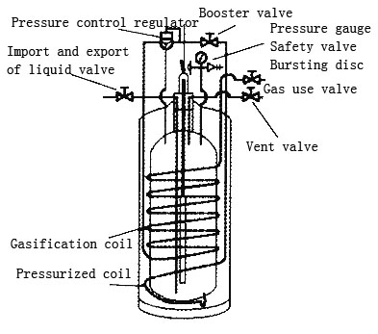
Fig.1 A typical low-temperature insulation cylinder

Cryogenic insulation cylinder contents and shell is made of austenitic stainless steel, both inside and outside the cylinder connected by pipe welding neck, from the fixed support role. An adsorbent disposed between the inner and outer cylinder vacuum laminated, usually low temperature adsorbent activated carbon, palladium oxide and a zeolite composition, but for the storage of cryogenic cylinder of liquid oxygen, not using activated carbon.
Specific manufacturing processes or require cryogenic insulation cylinder can refer to a 1999 U.S. Department of Transportation DOT 4L-1999 welding insulation cylinder." Vent volume can be calculated by reference to U.S. Compressed Gas Association CGAS a 1.1 " Pressure Relief Device Standards Part I: compressed gas cylinders " requirement to perform. Domestic manufacturing cryogenic insulation cylinder manufacturers should refer to the following national standards :
GB150 steel pressure vessel
GB/T228 metal tensile test method
GB/T229 metal Charpy notched impact test method
GB/T232 metallic materials - Bend test
GB/T1804 General tolerances tolerances for linear and angular dimensions without individual tolerance
GB/T3280 stainless steel cold-rolled steel
GB/T4237 stainless steel hot-rolled steel
GB7144 cylinders color logo
GB/T9251 cylinder hydraulic test methods
GB/T12137 tank tightness test methods
GB15384 cylinder model naming
GB15385 hydraulic cylinder burst test methods
GB/T18442 cryogenic insulation pressure vessels
GB/T18443 cryogenic pressure vessel insulation test methods

Table 1. Specification of DURA-CYL welded insulation cylinder s of Chart America

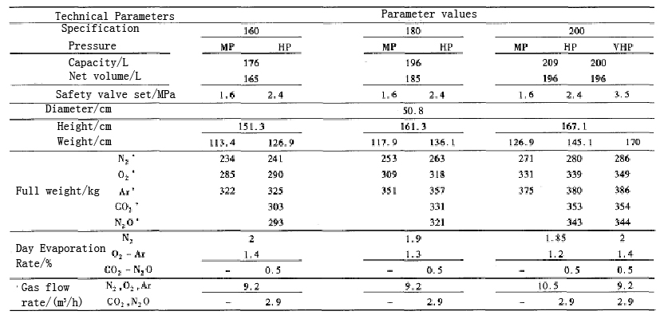

JB4708 steel pressure vessel welding procedure qualification
JB4730 nondestructive testing of pressure vessels
JB4744 mechanical properties of welded steel pressure vessel products test plate test
JB/T6896 air separation plant surface cleanliness

3. Domestic Development And Application Of Cryogenic Insulation Cylinders
In the early 1980s, Hangzhou Institute of oxygen has started to design and manufacture 200L moveable vertical cryogenic insulation cylinders which named CD-200 in China. Full rate of ≤ 95%, the maximum working pressure of 1.4MPa, and common pressure is 0.98MPa - 0.3MPa, the maximum supply capacity is 20m³/ h, daily evaporation rate is LO ≤1. 45%, LN ≤ 2.1%, the storage medium for the high purity liquid oxygen, liquid nitrogen or liquid argon. Empty containers weighing about 170kg, dimensions of the container (diameter × height) 585 × 1540mm.
Currently, high-performance cryogenic insulation cylinder manufacturers also often have international influence of cold storage and transportation companies, mainly the United States Chatwin Company (Chart Industries Inc.), American Taylor Wharton (Taylor-Wharton), etc., and each company has themselves internationally competitive products. Domestic manufacturers of cryogenic insulation cylinder are CIMC Sanctum Cryogenic Equipment Co,Ltd., Sichuan Air Separation Corporaton, Beijing Tian Hai, Ningbo Mingxin, Shenyang Aerospace Stars and so on.
The following describes the company's main cryogenic storage tank cryogenic insulation products, as shown in Table 1, Table 2.
Table 2. Specification of LNG cylinders of Taylor-Wharton^{[4]}

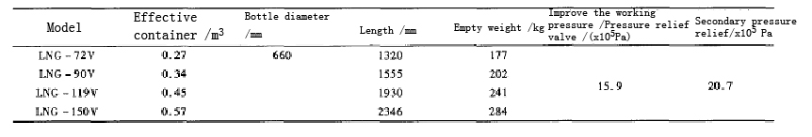

Table 3. Main applications of cryogeni cinsulated cylinders

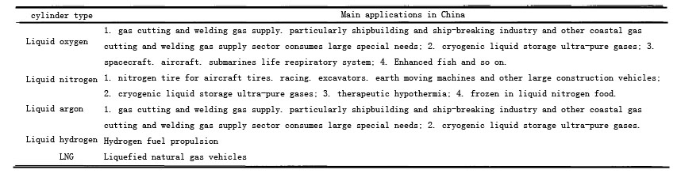

4. Key Technology Cryogenic Insulation Cylinders
4.1 Insulation Properties
Currently cryogenic insulation cylinder industrial production more than double simplified structure of the high vacuum multi-layer insulation, both inside and outside Simplified stainless steel inner container containing LN, LO:, LAr, LNG and other liquefied gases. The total heat leak typical cryogenic insulation cylinder composed of four parts : neck tube heat leakage, insulation heat leak, drain pipes and hot bottom support. In order to reduce the leakage of heat, cold insulation cylinder only by the majority of the neck tube connects the inner and outer parts of the cylinder. Nevertheless, a variety of heat leakage pathways through the neck of the still missing heat to more than 50% of the total leakage of heat. This requires the neck to ensure the strength requirements based on the neck to minimize heat leakage. Analysis of heat transfer neck and neck trying to reduce the size and heat leakage has important engineering significance, but also one of the research focused on low-temperature insulation cylinder insulation technology.
Thermal insulation layer leakage is through high vacuum multi-layer heat leakage. In order to maintain the mezzanine vacuum, reducing the residual gas thermal conductivity, low sorbent usually put a little match in the sandwich. Mezzanine absolute pressure temperature should not be higher than 5X10⁻² Pa. Cryogenic cylinder vacuum interlayer spacing is small, in general, multi-layer insulation material are wrapped over, many technical challenges faced when evacuated, and replacement materials such as gas discharge gas. Effectively improve the evacuation process is crucial ideal vacuum degree of ownership. Suitable vacuum process may be evacuated during intermittently with dry, high purity nitrogen gas and high purity carbon dioxide interlayer displacement rinse to effectively replace the interlayer difficult pumping gas ; Secondly, the vacuum process temperature was increased^{[8]}.
Currently on the market advanced 175L liquid nitrogen cryogenic insulation cylinders El evaporation rate can be less than 1.9 %. El absolutely evaporation rate is low.An important indicator of the performance of thermal insulation cylinder comprehensive consideration, but also represents the manufacturing.Plant high vacuum multi-layer nature of the production process.

4.2 Support Structure
Large volume tanker or tank container use more support tube / columns and support structures hanging pull belt. The low-temperature insulation cylinder is different. Cryogenic insulation in vertical cylinders, mainly through the neck hanger supported within the cylinder. The inner cylinder is suspended in the movement and transportation process, prone to wobble and rotation ; impact force when filling the cryogenic liquid within the cylinder is easy to cause shaking. The maximum stress occurred mainly in the neck and the head tube junction.
In the horizontal cylinders cryogenic insulation, the use of front and rear fixed axial support structure within the cylinder. Moving or transportation process, prone to oscillation of the inner cylinder ; especially for full horizontal cryogenic cylinder of liquid, due to the bending load caused by the weight of the liquid cryogenic support arm also can not be ignored. The maximum stress occurred mainly in the neck and the front head tube junction.
Support tube cryogenic insulation between the inner and outer cylinders both have sufficient strength, can withstand the cold after the reservoir shrinkage deformation test, and also bear a certain inertia loads during the move. Typically one end fixed and the other end of the support structure is not fixed. For stress analysis of structural innovations and non- fixed end fixed end support is also key cylinder cryogenic insulation performance enhanced.

4.3 Filling Technology
Filling technology is currently filling of emissions and emission-free filling. Traditional means of the gas discharge space is filling the space above the liquid through the discharge valve installed in the exhaust gas to the vapor space within the cryogenic cylinder to reduce the pressure within the cylinder to accelerate the rate of filling. Because of the simple emission filling operation, easy to control, the use of the project. But also has its place emissions raise their shortcomings. Fill in filling liquid discharge volume loss, and many dangerous cryogenic liquids, such as liquefied natural gas (LNG), as soon as it is heated to ambient temperature gasification, the volume will increase to about 600 times the liquid, and when gas concentrations in the air up to 5 % to 15% is flammable, so even a small amount of fluid leakage can also cause a lot of burning, filling the visible emission of dangerous goods and valuable media does not apply. Due to the structure of the low temperature insulation cylinder small size, relative diameter is not large, so the filling process can easily produce emissions harsh noise, pollution, working conditions, and long filling time. Long operation, the operator great harm.
Given the unfavorable factors raise the traditional discharge, the current low number of enterprises have started to invest in emission-free insulation cylinder filling technology research. Domestic, for example, Changzhou, China launched a special investigation applicable emission-free vehicle bottle filling cylinders cryogenic insulation products, filling time is short, about conventional emission filling time is 1/ 4. No filling of the discharge emission filling overcome multiple deficiencies and achieve a higher rate and shorter filling full time, but there is a higher technical barriers. At present, the domestic research on emission- filling technique is still in its infancy, but its application and promotion is inevitable.
In addition to emission- filling technology research cryogenic insulation cylinders become one of the important topics related to prevention of excessive single-tube filling cryogenic insulation cylinder is a new research direction. Anti excess filling achieve important for lossless storage cryogenic insulation cylinders.

4.4 Lossless Storage
Because of the low boiling point of cryogenic liquid, latent heat of vaporization of small, low-temperature liquefied gases need to pay to get a larger price. Therefore, the effective storage of cryogenic liquids has important economic value. Especially for expensive gas, high purity gases and harmful gases such as liquefied gas, in order to avoid the loss of storage due to external impurity and purity gases leaking into the impact of gas, the use of non-destructive methods of storage is the most ideal.
Since the temperature of the cryogenic liquid and the ambient temperature of 120K or more away, so the heat of the storage process is extremely sensitive to leakage into. As the heat gradually leak into when the liquid temperature is higher than the pressure inside the container corresponding to the saturation temperature of the liquid will evaporate quickly lead to the increase of the pressure vessel when the pressure exceeds the safety pressure limit, the valve off, the gas mass storage was relief.
When cryogenic insulation cylinders need to go through before use. When asked about the long transport to reach the destination, its length when asked lossless storage directly affect safety. Accurately predict when destructive cryogenic liquid storage asked, tank temperature and pressure rise process, research cryogenic insulation cylinder lossless storage time under different initial states and its influencing factors are also one of the key technical insulation cryogenic cylinders.

5. Summary and Outlook
The status of the application and the current low-temperature insulation cylinder structure and type of domestic and international market mainstream products, cryogenic insulation cylinders were reviewed and summarized. With cryogenic liquids play an increasingly important role in the economic areas that can predict the low temperature insulation cylinder with its transportation and flexible, easy to use, reliable performance, and many other advantages, more widely used in national production.
For low-temperature insulation cylinder technology prospects in the adiabatic performance, support structure, filling storage of technical and non-destructive, given the following recommendations:
(1) strengthen the theory or model of heat leak and neck support strength analysis, helps to improve insulation performance cryogenic insulation cylinders ;
(2) the use of reasonable evacuation process is to maintain the heating vacuum and effective means to improve the life of the vacuum ;
(3) Anti excess emission- filling technology can replace conventional emission filling techniques.

Corresponding Author:
Xiao-Jie Wu
Department of Air Force Service College,
Xuzhou, Jiang Su 221000, China
E-mail: jillwu2009@gmail.com

References
- http://www.chartchina.com/produetcn1.htm
- Fan Guanghan. Development of CD-200 type 200 rises pure cryogenic containers [J]. Low Temperature and Specialty Gas, 1986 (2): 54-57.
- Wei Wei, Rong-Shun Wang. State of development of LNG transport vessel abroad [J]. Cryogenics and Superconductivity, 2005,33 (2) :39 -43
- http://www.taylor-wharton.com/LNGFuelTanks, 2004.
- Bi Longsheng. Cryogenic container application Developments and Prospects (I) [J]. Vacuum and Cryogenics, 1999 (3).
- Bi Longsheng. Cryogenic container application Developments and Prospects (II) [J]. Vacuum and Cryogenics, 1999 (4)
- Bi Longsheng. Cryogenic container application Developments and Prospects (III) [J]. Vacuum and Cryogenics, 2000 (1).
- Gejun Long, yellow hair new. Mobile vacuum multilayer insulation several problems of small and medium design and manufacture of cryogenic liquid storage tanks should be controlled. Cryogenic Technology, 2003 (6): 2l-22.

12/9/2013

