Estimation of Risk of Needle Stick Injury and the Level of Awareness of Prophylaxis among the students, House Officers and Supporting Staff of Dentistry.

Mirza Arsalan Baig ¹ Saira Baloch² and Mohammad Muslim³

¹*Oral and Maxillofacial Surgery Department, Liaquat University of Medical and Health Sciences, Jamshoro, Pakistan.
²Medical Research Centre, Liaquat University of Medical and Health Sciences, Jamshoro, Pakistan.
³Department of Science of Dental Materials, Liaquat University of Medical and Health Sciences, Jamshoro, Pakistan.
arsalanmirza@outlook.com

Abstract: Objectives: To estimate the risk of needle stick injury their frequency, nature and level of awareness of prophylaxis among the students, house officers and supporting staff of dentistry. Methods: A descriptive type of cross sectional study survey was conducted at Maxillofacial Surgery Department, Liaquat University of Medical and Health Sciences, Jamshoro from April 2012 to April 2013. Sample size comprising of Six hundred thirteen individuals including maxillofacial surgeons, general dentists, house officers and undergraduate students working at Liaquat University hospital. A specifically designed questionnaire was administered to each individual focusing on number, nature, and predisposing factors for Needle stick injury. Collected data was analysed by using SPSS17. Results: Response rate was 99.02 % (n=607). Females were 52.38% (n=318). Since entering their clinical year, 59.80% (363/ 607) experienced a total of 776 Needle stick injuries. Most frequently involved instrument was local anesthetic dental syringe needle (62.24%; n=483) while extracting tooth, aspiration syringe needle (26.41%; n=205), suturing needles (9.14%; n=71), and surgical blades (2.19%; n=17). Most of needle stick injuries took place while recapping needles (33%; n=87), surgical procedures (27.7%; n=73), and drawing blood samples (26.2%; n=69). Majority (41.23%) of the injured individual were beginners (3rd year BDS Students). 42.5% (n=112) attributed NSI to stress, 37.6% (n=99) to over work, and 19.7% (n=52) to carelessness. Conclusion: Needle stick injuries are very common in dental practitioners especially in beginners. Most of these are sustained while recapping needle and working at surgical procedures in stressful and overworked circumstances. Needle stick injuries can be prevented through the adoption of safety measures, their risk can be avoided giving awareness regarding safer practices in the work environment or by using needle-free devices/ engineered needles.
[Mirza Arsalan Baig Saira Baloch and Mohammad Muslim. Estimation of Risk of Needle Stick Injury and the Level of Awareness of Prophylaxis among the students, House Officers and Supporting Staff of Dentistry. N Y Sci J 2014;7(1):120-123]. (ISSN: 1554-0200). http://www.sciencepub.net/newyork. 16

Keywords: Needle sticks injury, risk, awareness, prophylaxis

1. Introduction
Relatively inexperienced and less knowledgeable students of dentistry and supporting staff while handling the sharp objects and their disposal, are exposed to high risk for needle stick injury (NSI) and its consequences. (Jepsen MP, 2003) To estimate the risk of needle stick injury their frequency, nature and level of awareness of prophylaxis among the students, house officers and supporting staff of dentistry

2. Methodology
A descriptive type of cross sectional study survey was conducted at Maxillofacial Surgery Department, Liaquat University of Medical and Health Sciences, Jamshoro from April 2012 to April 2013. Sample size comprising of Six hundred thirteen (n=613) individuals including, maxillofacial surgeons, general dentists, house officers and undergraduate students (3rd year and final year) were working at Liaquat University hospital. A specifically designed questionnaire comprising twelve items related to the objectives was developed and was administered to each individual focusing on number, nature, predisposing factors, awareness level regarding prophylaxis and post-exposure management for Needle stick injury. Collected data was analysed by using SPSS17

3.Result
Response rate was 99.02 % (n=607). Gender wise distribution of respondents was, males were 47.62% (n=289) and females were 52.38% (n=318).[Figure-1]

Figure 1: Gender wise distribution of respondents.

Since entering their clinical year, 59.80% (363/ 607) experienced a total of 776 Needle stick injuries. [Figure 2]

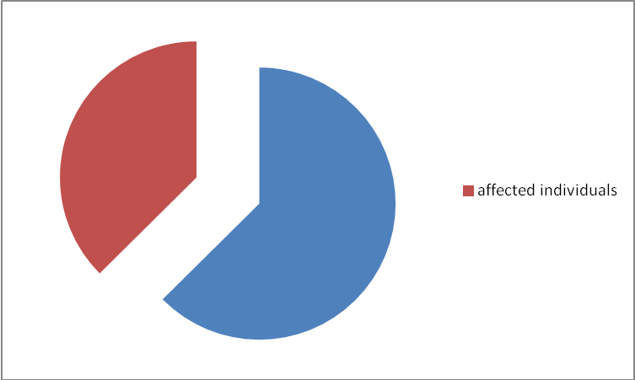
Figure 2: Incidence of needle stick injury among respondents.

Among respondents 49.09 %( n =298) were beginners (undergraduate students) followed by supporting staff 3.45% (n =21), house officers 17.62 % (n =107) and dental surgeons 29.81% (n =181). [Figure 3] Majority of the injured individual, were undergraduate students (beginners) (40.49%; 147/363), followed by supporting staff (3.85%; 14/363), house officers (11.84%; 43/363) and dental surgeons (38.29%; 139/363). [Figure 3]

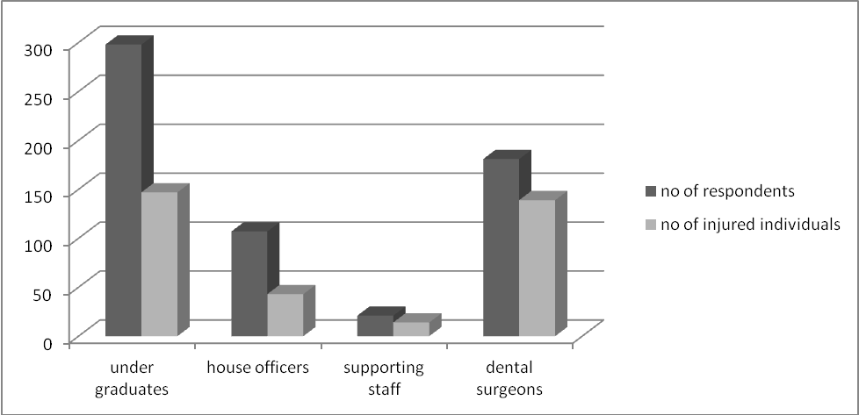
Figure 3: Distribution of respondents and injured individuals.

Among needle stick injured individuals (n=363) total number of needle stick injuries were 776. Majority of them injured once were 64.18% (n=233), followed by twice were 17.63% (n=64), thrice were 11.57% (n=42) and more were 7.16% (n=26). [Figure 4]
Most of needle stick injuries took place while recapping needles in teeth extraction (33%; n=87), surgical procedures (27.7%; n=73), and drawing blood samples (26.2%; n=69). [Figure 4]

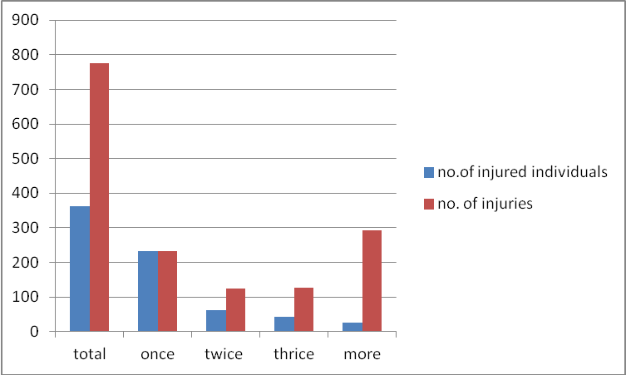
Figure 4: Distribution of no. of individuals and no. of injuries according to frequency of needle stick injuries

Figure 4: percentages of procedure associated with needle stick injuries.

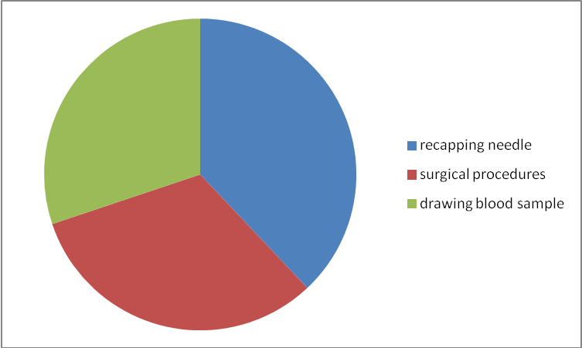
Figure 5: frequency of related cause of needle stick injury

Regarding cause of needle stick injury 42.5% (n=112) reported it’s due to stress followed by 37.6% (n=99) due to over work, 8.26% (n=30), due to carelessness and 4.68% (n=17) due to unskilled in handling of instruments.[Figure 5]
For the injury recalled by each individual, 69.69% (253/363) involved individuals injured themselves. [Figure 6]

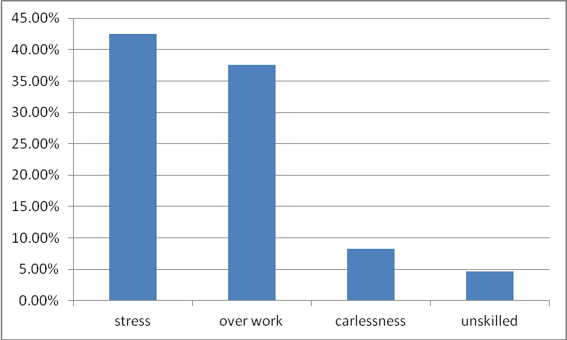
Figure 6: frequency of self-inflicted injuries

Overall, 75.77 % (588/776) of all needle stick injuries went unreported, most of which were because the injured student did not know about the reporting system.
Only (35.6%-245/688) students reported that they never or rarely practiced recapping, most of them (86.7%- 232/267) practiced recapping. HBV vaccination coverage was 92% (452/267) of all Needle stick injuries, 3.2% (24/767) of needles had been used on patients with HBV infection, 2.1% (16/767) with HCV infection. Only 56.2% (150/267) students knew about post exposure prophylactic procedure.
DO YOU KNOW ABOUT THE POST EXPOSURE PROPHYLXIS PROCEDURE?

4. Discussion
Needle tick injuries are the obscure problems in health care workers. (Bilski B, 2005: Smith AJ, 2001: Smith DR, 2006). In our study, 52% (267/ 513) of the students reported at least one Needle stick injury, most of which occurred in maxillofacial surgical ward or OPD intravenous injections or local anesthesia. (Bilski B , 2005)
In other studies, it has been shown that lack of experience in many procedures, insufficient training, work overload and fatigue leads to occupational sharp injuries. (10-12) in this study, of the student, 82% (219/267) did not report these Needle stick injuries. The most common reason for under-reporting was the personnel's lack of knowledge that all injuries had to be reported. Other reasons are based on a background of insufficient knowledge or poor practices. The observed high level of under-reporting suggests that students need education on prevention, especially focusing on the importance of reporting all Needle stick injuries and the possibilities of prophylaxis after exposure to Needle stick injury. (Smith AJ, 2001: Smith DR, 2006: Patterson JM, 2003: Shiao JS, 2002: Kohn WG, 2003: Thomas DL, 1996: Tarantola A, 2003: Rogers B, 2000: Goldmann DA, 2002: Grady GF, 1978: A Mehta, C, 2010).
These data show that the students need to be provided structured education for the improvement of occupational safety. (Mario S, (2010): Rahul Sharma 2010). In our study, 92% (452/267) of the students reported having received doses of vaccine for HBV and most students (99.4%) reported gloving during wound suturing. Meaner et al reported that 50% of medical students in Strasbourg did not use gloves. The results of this study show that the way of educating about Needle stick injuries should be updated so that health care workers realize the significance of occupational exposure of Needle stick injury and other protection strategies for blood-borne infections. We need further evaluation of the effectiveness of improved education in the institution and hospitals.

Conclusion
The Poor use of post-exposure procedures and insufficient knowledge regarding sharps and instruments handling leave dental students at high risk for career and life altering consequences from a needle stick injury.

Recommendations
The proper work practices and continuing Education Seminars and workshops have prime importance in creating awareness in dental staff. Hepatitis B vaccination and adherence to recommended post-exposure practices are strategies that can influence the outcome and impact of needle stick injury.

Corresponding Author:
Dr. Mirza Arsalan Baig
Lecturer
Oral and Maxillofacial Surgery Department, Liaquat University of Medical & Health Sciences (LUMHS), Jamshoro, Pakistan.
E-mail: arsalanmirza@outlook.com

References
- Jepsen MP, Smith E. Needlestick injuries among medical students at the University of Co-penhagen. A questionnaire study in 2001. Ugeskr Laeger 2003 May 26;165(22):2273
- Bilski B. Needlestick injuries in nurses- the Poznan study. Int J Occup Med Environ Heaith 2005;18:251-4
- Smith AJ, Cameron SO, Bagg J, Kennedy D. Management of needlestick injuries in general dental practice. Br Dent J 2001; 190:645-50.
- Smith DR, Smyth W, Leggat PA, Wang RS. Needlestick and sharps injuries among nurses in a tropical Australian hospital. Int J Nurs Pract 2006;12:71-7
- Patterson JM, Novak CB, Mackinnon SE, Ellis RA. Needlestick injuries among medical students. Am J Infect Control 2003;31:226-30
- Shiao JS, Mclaws ML, Huang KY, Guo YL. Student nurses in Taiwan at high risk for needlestick injuries. Ann Epidemiol 2002;12:197-201
- Kohn WG, Collins AS, Cleveland JL, Harte JA, Eklund KJ, Malvitz DM, et al . Guidelines for infection control in dental health-care settings-2003. MMWR Recomm Rep 2003;52:1-61
- Thomas DL, Gruninger SE, Siew C, Joy ED, Quinn TC. Occupational risk of hepatitis C infections among general dentists and oral surgeons in North America. Am J Med 1996;100:41-5
- Tarantola A, Golliot F, Astagneau P, Fleury L, Brucker G, Bouvet E, et al . Occupational blood and body fluids exposures in health care workers: Four-year surveillance from the Northern France network. Am J Infect Control 2003;31:357-63
- Rogers B, Goodno L. Evaluation of interventions to prevent needlestick injuries in health care occupations. Am J Prev Med 2000;18:90-8
- Goldmann DA. Blood-borne pathogens and nosocomial infections. J Aller Clin Immunol 2002; 110:S21-6.
- Grady GF, Lee VA, Prince AM, Gitnick GL, Fawaz KA, Vyas GN, et al . Hepatitis B immune globulin for accidental exposures among medical personnel: Final report of a multicenter controlled trial. J Infect Dis 1978;138:625-38
- A Mehta, C Rodrigues, T Singhal, N Lopes, N D'Souza, K Sathe, FD Dastur .Interventions to reduce needle stick injuries at a tertiary care centre: 2010 : 28 : 1 : 17-20
- Mario S, Friedrich H, Joanna S, Joerg B, Yoonhee C, Dominique A, Shane K. Biomedicine International (2010) 1: 41-49
- Rahul Sharma, SK Rasania, Anita Verma, and Saudan Singh. Study of Prevalence and Response to Needle Stick Injuries among Health Care Workers in a Tertiary Care Hospital in Delhi, India. Indian J Community Med. 2010 January; 35(1): 74–77.

1/9/2014

