The principles of ecotourism management in protected region of Karkheh

Seyedeh Masoumeh Mousavi¹ (Corresponding author), Dr. Behzad Saeidpour²

^{1.} Environment and Criminal law, Expert Environment University
^{2.} Prof, Environment University
Mosavi_fm@yahoo.com

Abstract: With the increase of population and pressures of machine life, the people attempt that by finding a good opportunity goes to the nature and makes them comfortable that is suffering from urban life. Tourism can be the source of social and economical graces for the countries. If these graces are not consistent with sustainable environment principles, it can change into a big challenge. The protected area of Karkheh is one of the examples with various talents to attract tourism. This region is located in Khuzestan beside Karkheh River with a pretty view. As any development in the land should be consistent with the environment, planning process is necessary for ecotourism by ecological evaluation for the sustainability of environment. In this paper, it is Karkheh protected region is investigated with potential talents of tourism for environment sustainability. GIS was used in this paper to evaluate ecological power and based on the effective efficiency, in analysis and data management and by FAO model by emphasis on ecotourism, the priority of the region was achieved to predict the required development and a model for correct planning and management in Karkheh protected area.
[Seyedeh Masoumeh Mousavi, Behzad Saeidpour. The principles of ecotourism management in protected region of Karkheh. N Y Sci J 2014;7(1):66-73]. (ISSN: 1554-0200). http://www.sciencepub.net/newyork. 9

Keywords: Informal employment, minimum wages, partial least squares approach, MIMIC models

1. Introduction
The God has always emphasized recreation and reminded itand knew it effective as a source to increase the mental happiness in people.
Ecotourism is considered an activity in tourism industry and it can be said that tourism is nature based with knowledge about natural environment and is managed as it is sustainable ecologically (Zahedi, 2006).
Urbanization process and regularity of work space developed the inclination to ecotourism namely in industrial communities and created deep concerns regarding the unduly operation of environment and natural resources. This attitude that is the requirement of a healthy society depending upon healthy environment, it is unavoidable reality and as ecotourism is of great strategic importance, created a kind of environmental challenge for planners as they are obliged to find a way that tourists can visit natural attractions without destroying them (Lopez. L, 2002). Generally, the development of tourism should be consistent with environment. One of the important applications of protected region of Karkheh is ecotourism and if it is based on the power and recognition of the problems and advantages of the mentioned region, we can take a step to the sustainable development.
Karkheh protected region is located in Khuzestan province with the area of 13995 hectare beside Karkheh river. This region besides having pretty views, various soil texture, rare plantation and animal species have considerable tourism attractions (Environment institution, 2007).Yellow deer is an unique and pretty species of Iranian mammals and its main habitat in Karkheh protected area. In the past years due to natural and unnatural events, tourism attractions of this region are ignored and lost its economical and income aspects. The imposed 8-year war was one of the most important destructive factors in this region. This factor caused that besides losing many vegetation and animal species, insecurity is occurred and lost many habitats of various species and led into the migration of various species (Albodoyrich, 1994).
On the other hand, due to the high density of population in Khuzestan province and the lack of recreation spaces, using Karkheh protected area caused that the region is changed newly. Environmental pollutions of development of industries, the destruction of habitats, the immigration of nomads are various samples of direct interference of human being and greediness in using natural resources and its destruction (Etemad,1984).
Karkheh protected region is one of the most important regions under the protection of environment with valuable animal and vegetation species but unfortunately, despite all unavoidable attractions of this region, there was no organized plan to use it (Musavi, 2008).
To guarantee the protection of Karkheh region and the development of this region based on the functions consistent with the environment in a plan for sustainable tourism in this region it is necessary. In this paper, the following aims are considered:
- Determining the position of protected fields of Karkheh based on evaluation of ecological power
- Providing the map of ecologic resources of the region by GIS
- Zoning the region by FAO model and with emphasis on ecotourism in the region
- Using the comments of tourists and giving management solutions to develop ecotourism to reduce bad outcomes in the Karkheh protected region.
In the following chart, the research operation is shown.

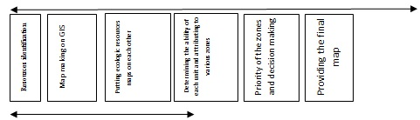

Ecological power evaluation

Materials and methods
The current paper is descriptive, analytical and scientific research and in descriptive studies section to evaluate the ecological power of Karkheh protected region, at first the data were collected via library studies including the study of books, papers and translation of the texts of the topic, then in scientific, analytical section, the basis of the work is using evaluation models of ecological power of IUCN guidance to localize the ecotourism development in protected regions and including some areas were with the coordination of the lecturers and by GIS, started the map making of various ecological regions of the study location including (climate, geology, vegetation, wild life habitat, etc) as the basis of ecotourism. Then, by FAO model, with emphasis on tourism power of region priority was achieved for the prediction of the required development and finally, the regions with ecotourism capabilities were separated of the regions without the capability and finally in this paper, by providing the questionnaire, we investigated the comments of some of the tourists to achieve some information as (visit time, age composition, distance, the needs of tourists level, the satisfaction of visitors, etc) to provide a good basis to present management solutions for sustainable ecotourism and it is attempted to formulate the best solutions for the management of ecotourism environment in the study location and presented a model for correct planning and management in the protected area of Karkheh for the application of ecotourism and increasing the knowledge of local communities and the authorities of the region of the results,operation of the mentioned region as sustainable and dynamic for present and future generations.
Conclusion and results
*The results of investigating the ecological and natural view of Karkheh protected region:
In resources identification stage, the required parameter in evaluation of environment ability is studied consistent with the goals and the following results were achieved by providing the maps of these parameters:
Yellow deer is one of the important species of mammals in wild life of Karkheh and the results of the study showed that due to the shallow water of Karkheh habitat, the vulnerability of the mammals is increased (map 1 shows the distribution of yellow deer) and the study showed that the population of Shengs had less vulnerability and their natural enemies were limited. The condition of the birds of the region was better than the mammals and long forests and the location of birds in the tree caused the security. Cutting the trees, the interference of shepherds and wood breakers and unduly hunting were the negative factors of the region that should be controlled. In social economical region, increase of population was one of the threatening factors of the region that caused the unduly use of natural resources of the region. The investigation of the neighboring land use of Karkheh area showed that the maximum land was consisting of forest land of 73% of the area of the region that besides the internal uses of the region, has the same border with various use and it is threatened.
The same border of these regions with cultivation land is the threatening factors of protected area and in most of the parts of cultivation parts were developed to inside the protected regions.
In sum, the most important contradictions of the region are as:
- The contradiction of development of cultivation land
- The contradiction between the live stock and protected area
- The contradiction between cutting the trees and deforestation with reducing habitat values
- Illegal hunting
- The contradiction of using gravel and sand of the river bed
- The contradiction of constructing the roads, access roads around and inside the protected region

Table 1: The characteristics of environmental units
Area (Km²) | Wild life | Evaporation | Rainfall | Temperature | Dominant vegetation type | Land use | Land resources | Protected region
3.086 | Ecologic species | 3500 | 250 | 22 | Bush | Forest | 5.1 | Karkheh
2.303 | Ecologic species | 3500 | 250 | 24 | Bush | Forest | 5.2 | Karkheh
1.333 | Ecologic species | 3500 | 250 | 22 | Bush | Forest | X.1 | Karkheh
(Musavi, 2008, formulating the principles of ecotourism management criteria of the protected regions)

Table 2: The characteristics of environmental units after zoning
Decision making | Zoning | Area (Km²) | Wild life | Evaporation | Rainfall | Temperature | Dominant vegetation type | Land use | Land resources | Protected region
2 | 2, 3 | 3.086 | Ecologic species | 3500 | 250 | 22 | Bush | Forest | 5.1 | Karkheh
3 | 2,3 | 2.303 | Ecologic species | 3500 | 250 | 24 | Bush | Forest | 5.2 | Karkheh
1 | 1,2, 3 | 1.333 | Ecologic species | 3500 | 250 | 22 | Bush | Forest | X.1 | Karkheh
 |  | (Musavi, 2008, formulating the principles of ecotourism management criteria of the protected regions)

*The results of evaluation and zoning of the region
In this section, the evaluation of the capability and zoning of Karkheh protected area is done by GIS and the region is divided into four regions and ecotourism use was defined in various zones based on the characteristics of each zone and the result was presented as map 2: The map of separating the zones with ecotourism was presented.
In this section, the regions with capability were separated of the regions without capability and the use of ecotourism is presented in the form of four zones:
- Controlled tourism of level 1 that is virgin zone and this zone is of great importance ecologically and protective and the visits in this region should be in the presence of environment guards or experts and it is instructive.
- Controlled tourism level 2 that is scientific virgin zone that tourism activities should be at minimum and with the presence of guards or guide and the visits should be instructive and should be done with minimum noise and no residence in this region is acceptable.
- Tourism capability one that is extensive use and the land of this region can be attributed to extensive recreation.
- Tourism capability 2that is called concentrated use region and the land of this region can be attributed to concentrated recreation and in terms of area, little percent is given to the total area and based on the density of the visitors and development effects should be by management and supervised region.
*The results of questionnaires collection
The questionnaire was provided as multi-choice questions and open. The statistical population were most of the visiting people and employed guards in the region and the following data were achieved of the questionnaire:
- Most of the visiting people were located around Khuzestan and showed that the advertisement regarding the identification of this region was low.
- Most of the visitors take a trip in the end of winter and the early Farvardin and they should have a true planning to have the least damage to this region in this time of year.
- The observation of the region wild life is attractive for the visitors, thus the best facilities should be provided to watch the wild life in the location that both visitors can best use and wild life feel secure.
- The familiarity of visiting people of Karkheh region is average. It is required that some plans are taken to increase the familiarity of the visitors from this region via providing brochures and the identification of the region.
- From the view of visitors, the need to welfare facilities is more felt, the authorities of the region should plan to make the facilities better in the region.
- Most of the visitors are inclined to pay more money in case of better facilities in the region, this is good for the authorities to give more services.
- It is recommended to create some places for better establishment of visitors in the region by observing all the ecological principles such as creating the camps.
- According to the survey of the above questionnaires, the visitors believe that environmental and tourism plans should be educated to them and in protected regions, there should be some guides to better use the nature and the visitors should use these regions as best and they believe that this region with all unique characteristics is not supported by the authorities.
Based on the results of the investigation of ecological view, power evaluation, zoning and the data of the questionnaires in the protected region Karkheh was achieved for the development of ecotourism, we can take some decisions for better management in the region and the criteria achieved in this study are as:
- Data-based management: tourism is a kind of people management and the required data should be provided in the region and these data can be collected by questionnaire or check list of field observations.
- Power evaluation: The power of each region should be defined for each use to be consistent with the goals of sustainable development.
- Determining the tourism contradictions with other regions activities: This investigation is necessary of tourism sustainability and is unique in terms of the management of the regions or protected habitats.
- Determining the goals of the region: Each region has some unique conditions and it is required that for each region, special goals are formulated. Here determining beneficiaries is necessary. The dependency of the region to tourism or its importance in protection area should be defined. Tourism as the local economy foundation or the surrounding community's activities, development scale, development resources should be considered.
- Tourism consistency with the region structure: Tourism has no contradiction with other uses (considering the evaluation of the ecological power of the region)
- Guiding the methods of creating infrastructure facilities: This stage is used to reduce the tourism environment outcomes and is necessary to keep all the values of the region.
- Continuous supervision on the progress and avoiding the destructive environmental and human effects: all the parameters that caused some problems in natural system should be supervised pollutions (water, soil and ecosystems), activities outcomes, the effects of tourism facilities, internal and external contradictions) Determining the physical development is necessary for recreation and it is the only choice for the meaning of sustainable operation of Karkheh protected region and the regions with physical development capability should be determined.
- The participation of local societies in the management of ecotourism in Karkheh protected region: Using the forces of the related organizations to attract the attention of people is important. These groups can introduce the protected area as natural component of social environment and encourage the local people to consider this region as useful center for themselves and others as the participation of various groups can be useful. The local person who lives in the nature and in the proximity of protected regions has low income and ecotourism can be economical for this type of people.
Another advantage of ecotourism for them is that they can be changed to effective execution factors in protection of natural regions and as their welfare depends upon protecting the environment, they attempt more.
Ecotourism can create economical alternatives for local people to reduce unduly use of resources in protected regions (via creating job opportunities, selling the equipments or other productions)
- Informing: As ecotourism, protecting the environment are related to each other, it is required to attempt that by publishing the journals, holding seminars and the like and informing the tourists regarding the values of the regions help the planners.
- Planning to improve the capabilities of ecotourism in the region: It is required that for effective management and development of tourism activities in the protected region, financial, economical resources are given to that the authorities of the region can provide some of tourism activities as constructing various buildings, restaurants, handicrafts stores, birds watching tours and other required goods to support the tourist. Giving the priorities with the feed can be changed into an automatic mechanism in the protected region.

Conclusion
Any development in region 1 of the protected region should be determined based on the strategies of the region and in this management plan, some of the special considerations are considered and the main solutions are as follow:
- Performing comprehensive plan of tourism in the region based on the high power of the Karkheh protected region to develop sustainable tourism
- Considering the capacity of the region: Tourism demand to a region is not uniform all the year and the peak demand in Karkheh protected region is in the end of year and Farvardin (based on the results of questionnaires), if tourism services demands in the region are not fulfilled based on the capacity of the tourism, cause some disorder, inconsistency and unduly use and have some bad outcomes for the visitors and the region.
- Considering the social-cultural considerations: some of the activities or tours can be contradicted with the local people beliefs, construction of some places as residential can cause unwanted immigration. The increase of great number of non-local people in the form of tourist or services providers and their cultural differences in a local culture can be contradicted to the living methods of local people and have many outcomes on local culture.
- Exact studies of locating for the establishment of tourism facilities namely in capable parts without the facilities and equipments, it should be considered that location of the establishment of the facilities shouldn’t be on this view that tourism places are located in the place with the best view and these places should be based on the exact comparison of the choices. This locating besides residential areas is about wastewater elimination, etc and it should be managed.
- The coordination between the organizations related to tourism in the Karkheh protected region, taking unit policies and common management between cultural heritage organization and tourism and environment protection office of Khuzestan province, formulating the rules and legal tools in keeping the wildlife of the protected region, historical and ancient regions, local people rights, the management of sensitive habitats.
- Creating adequate facilities for the local people that to perform the tourism plan; their activity was avoided as can be replaced by their previous incomes.
- Attracting people participation to use sustainable tourism plan
- Using various specializations including economical sciences, sociology, architecture, engineering, geography and biology in tourism plan to increase the good effects and reducing the bad effects.
- Establishing environment management system in the region and its continuous monitoring.
- Introducing Karkheh protected region with all unique characteristics in the form of a special site in internet.
- Region management due to social and economical reasons shouldn’t change in physical development.
- The main infrastructures such as parking, water resources, wastewater collection, solid materials, sanitary and security facilities should be determined based on good and correct locating.
- Based on the development of various vegetation and animal species outside the borders of Karkheh protected region, attaching these regions to the location is recommended.
- Restricting the inconsistent use and activities with the protection such as agriculture plan, removing gravel and sand of the river, etc.
- Avoiding the domestic live stock grazing in the region (namely in scientific and virgin zones) and encouraging the husbandry performers for immobile husbandry.
- The control of private sector investment for developing the study region and it is required that the authorities, government board apply some cases for the development of ecotourism and protection of Karkheh protected region and all the protected regions.
- Performing macro studies of ecotourism between environment organization and guidance ministry.
- Creating and teaching management periods and the guide of tourism trips by the experts of environment protection organization.
- The scientific and practical investigation of delegating some parts of ecotourism industry to private sector by the authorities by considering this fact that no damage should be on protect ting the natural protected regions.
- Doing environmental evaluations and providing the ID of the region and required advertisements in Iran and abroad by guidance ministry and the associated organs.

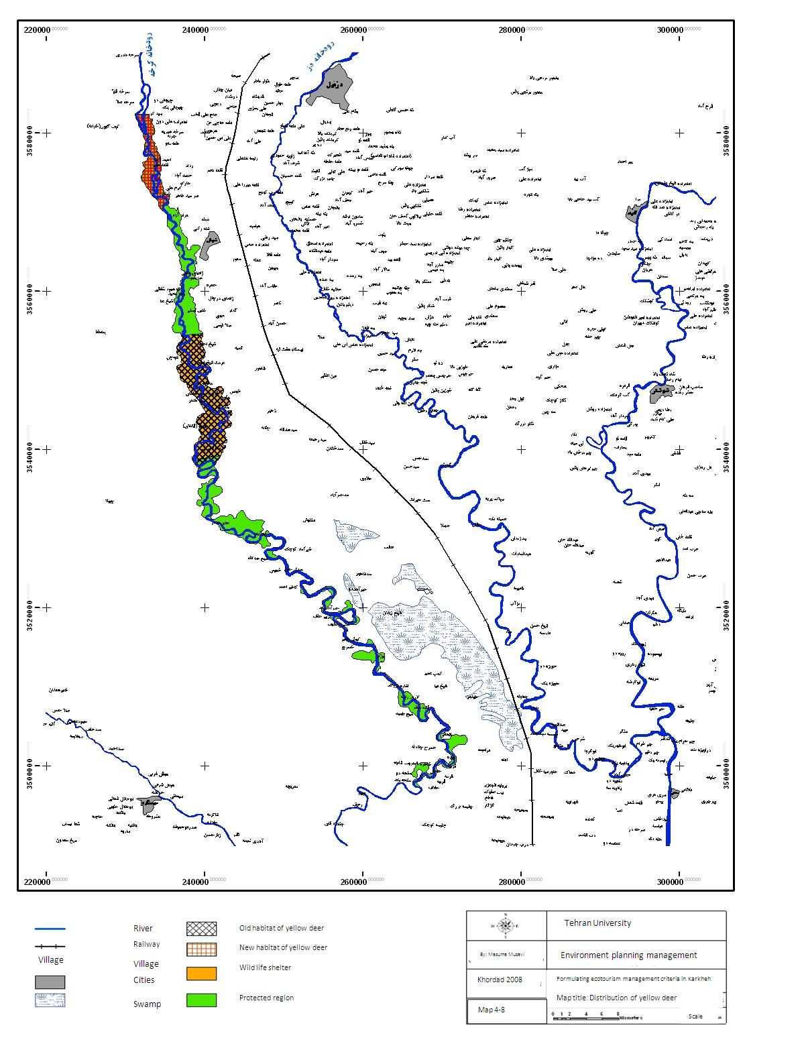

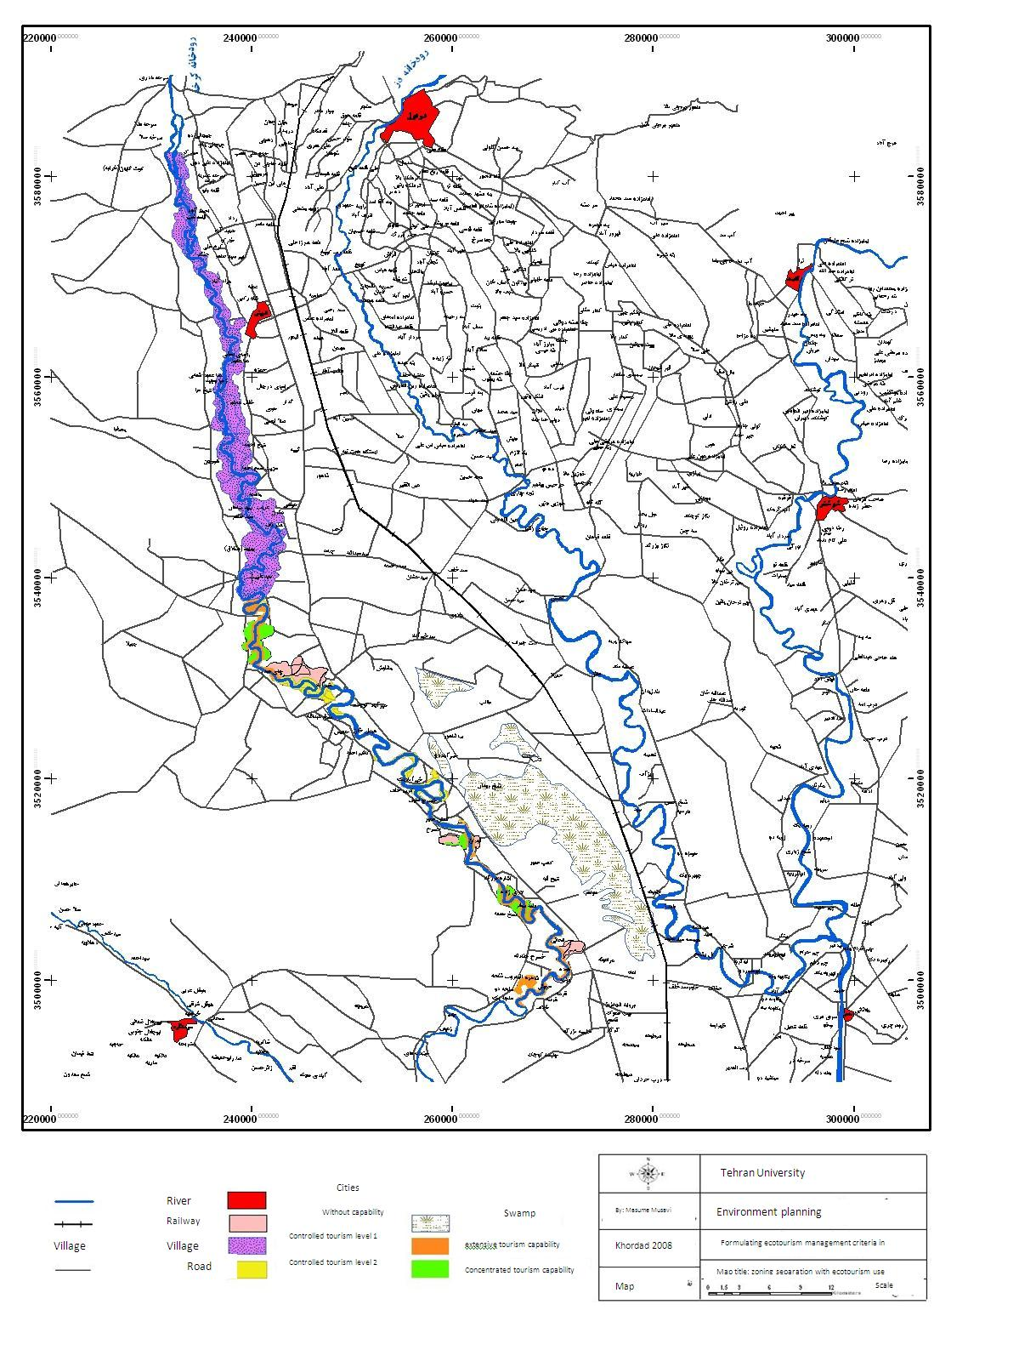

References:
- Albodoyrej, H., 1994, The Id of Karkheh protected region, Headquarter of protected region of Khuzestan province.
- Environment institution, 2007, feasibility studies of ecotourism use in Dez and Karkheh protected regions.
- Etemad, A., 1984, the field guide of Iran mammals, environment protection organization publications.
- Zahedi, sh.2006, sustainable tourism and ecotourism (based on the environment), Allameh Tabatabyi University publications.
- Liaqati, M, 2010. The review of characteristics and recreation model in urban tourism (Tehran case study), environment study journal. No.55.
- Majnonian, H. 2004, Environmental planning of Londvil wildlife shelter. Environment protection organization publications.
- Makhdum, M. 1999, the foundation of land monitoring, Tehran University publications.
- Makhdum, M., 1991, the evaluation of ecological power of Gilan and Mazandaran region for Urban, rural, industrial and tourism development, environment study journal. Population. No.16.
- Consulting engineers of Royan, 2002, comprehensive plan of Karkheh protected region.
- Musavi, M., Formulating the principles of ecotourism management of the protected regions (case study of Karkheh), MA thesis.2008. Tehran University.

1/3/2014

قل سيرو في الارض فانظرو كيف بدأ الخلق ثم الله ينشيء النشاء الاخره ان الله كل شيء قدير

