Age effect of male on male mating ability and progeny production in D. melanogaster

Abolhasan Rezaei, M. S. Krishna

Drosophila stock center, Department of Studies in Zoology, University of Mysore, ‎Manasagangotri, Mysore - 560 006. Karnataka, India‎
drosokrish@gmail.com, rezaei54@gmail.com ‎

Abstract: Age effect of male on male mating ability and progeny number has been studied in D. melanogaster. It was noticed that male at young age had inseminated more females and had produced greater number of progeny than middle aged and old males. Thus these studies suggest that in D. melanogaster remating of male increases male fitness. Further male at young age has greater fitness than middle and old aged males.
[Abolhasan Rezaei, M. S. Krishna. Age effect of male on male mating ability and progeny production in D. melanogaster. N Y Sci J 2014;7(1):33-38]. (ISSN: 1554-0200). http://www.sciencepub.net/newyork. 4

Keywords: male mating ability, D. melanogaster, male age, progeny number.

1. Introduction
All biological processes directly related to reproduction plays an important role in determining fitness. The fitness consists many components such as mating latency, mating time, duration between mating, fertility, fecundity, productivity, viability and longevity, etc. collectively, these processes determined the fertility component of fitness, where fertility is defined in its broadest sense (Turner and Andersson, 1983). The sexual behaviors of various species of Drosophila, with particular reference to their basic courtship patterns, genetic control, role of stimuli, and contributions of the 2 sexes to variations in mating activity and repeated mating, have been extensively studied (Parsons, 1973, Banerjee and Singh, 1977; Gromko and Pyle, 1978; Casares et al., 1998).The role of fertility differences to selection has been demonstrated repeatedly in different species of Drosophila (Turner and Andersson, 1983). One aspect of fertility that has only recently received attention only recently is multiple mating (review of Drosophila research in Gromko et al., in press). Once thought to be mostly a laboratory phenomenon in Drosophila, multiple mating has been reported in natural populations of several species (reviewed in Gromko et al., in press; Loukas et al., 1981), and at very high rates (e.g., Levine et al., 1980). Rates of multiple insemination sometimes differ among populations of a species, as for example they do among the three populations of D. pseudoobscura studied (Anderson, 1974; Cobbs, 1977; Levine et al., 1980).
Remating is common in many species of Drosophila under both natural and laboratory conditions. Multiple mating in Drosophila bears a direct relation to fitness (Koref- Santibanez, 2001). Remating time of male and female in different species of Drosophila has been studied. (Singh and Singh, 2002; Karif-Santibanez, 2001). Remating and sperm storage are specific features that can play important roles in determining female fecundity, male mating success. Remating reduces the maternal survival (Levine et al., 1980; Partridge and Farquhar, 1981; Nicholas et al., 2008). Markow et al., (1978) have found that females are able to distinguish between mated and unmated males and those that had a previous mating experience, showing preference for virgin males. These results are not surprising, since multiple insemination may be sensitive to both population densities and environmental conditions.
It has been widely demonstrated that males of different species of Drosophila can inseminate more than 1 female, and the mating ability of males is influenced by genetic and other factors (Prakash, 1967; Singh and Chatterjee, 1987; Sanchez Prado and Blanco lizana, 1989; Singh and Singh, 1999). According to Gromko, (1992), multiple mating is widely believed to be advantageous to males, and selection by males can produce a correlated response in females. In Drosophila and other organisms, the importance of male size in courtship and mating has also been studied (Hegde and Krishna, 1997).
Age in male insects may effect reproductive activities including success in intersexual encounters, sperm procedure and female fecundity. However, the importance of male age on sexual behavior is not straight forward, and in most cases, only 1 or a few aspects of male fitness like success in intermale competition, fecundity, fertility, and longevity have been studied (Somashekar and Krishna, 2011). In fact, male remating is also a strategy for improving the fitness of individuals of polygamous populations. This is because in species of Drosophila in each mating, male transfers ejaculatory substances which includes accessory gland proteins and sperms to the mated female. Acps in mated female includes egg laying or oviposition and also facilitates fertilization of sperm into the eggs. Therefore males inseminating more females contribute more progenies to its next generation compared to the male which inseminate less females. In Drosophila, the influence of female remating on fitness has been studied (Sisodia and Singh, 2004). The further influence of male size on male remating components has been largely ignored. Therefore the present investigation has been undertaken in D. melanogaster to study age effect of male on mating ability and progeny production.

2. Materials and Methods:
Progenies of 50 isofemale lines of D. melanogaster collected at Mysore, India were mixed together to establish outbred population. Twenty males and twenty females per bottle were cultured at 22ºC±1ºC with a relative humidity of 70% using wheat cream agar medium in 12L:12D cycle for 3 generations to the acclimatize to laboratory condition. At 4th generation, eggs were collected from this stock using Delcour’s procedure (Delcour, 1969‎). Eggs (100) were transferred separately into a vial containing wheat cream agar medium. When adults start emerging from these vials, virgin females and unmated males were isolated within 3 hours of their eclosion and were aged as required for the same laboratory condition.
Longitudinal study includes the analysis of same individual male at young, middle and old age. To study this 2-3 days old male along with virgin of 5-6 days old female were introduced into a mating chamber and observed for an hour. If the pair did not mate within an hour, it was discarded, if mating occurred mate female was individually aspirated into a new vial containing wheat cream agar medium for every 24hrs. This was continued until the death of the female. The progeny emerged from the eggs of mated female was recorded. The mated male was allowed to mate with a 2nd virgin female (5-6d old). If mating occurred with the 2nd female, they were allowed to complete copulation and mated female was transferred to new vial to record progeny number as described above. This process was repeated, and number of females inseminated by each male in 1hr and progeny produced from them was recorded as the male mating ability.
Soon after recording male mating ability for 2-3 days the mated male was individually aspirated back to the new culture and allowed for ageing (27-28 days). When this male attained 27-28 days, they were individually used to record male mating ability and progeny number as described above. After recording this, once again mated male was aspirated again into a new culture vial containing wheat cream agar medium and allowed them to age (52-53d old). When they attained the age of 52-53 days, these mated males were individually subjected for analysis of male mating ability and progeny number as described above. Fifty trials were continued separately for both outbred and Conton-S populations. One way ANOVA followed by Tukey’s post hoc test was carried out on male mating ability and progeny number. General Linear Model (repeated measures) has also been applied on male mating ability and progeny number.

3. Results
The mean male mating abilities at young, middle and old age of outbred and Conton-S experimental socks of D. melanogaster are given in figure 1. The outbred strain inseminated more females compared to that of Conton-S stocks. In both the stocks young males at age had inseminated more females compared to males at middle and old age. The mean male mating ability data subjected to one-way ANOVA followed by Tukey’s post hoc test showed significant differences in the mean male mating ability among the 2 strains, among males of the 3 age classes, and also interactions stocks and male age (Table 1). Tukey’s post hoc test showed that males of the Conton-S stocks had inseminated significantly fewer females compared to males of the outbred stocks.
The results of the GLMs (repeated measures) age and male mating ability with the 1st and 2nd females are provided in Table 2 and figure 1. A negative relation between the male age and male mating ability and also between male age and progeny number suggests that males at young age inseminated more females in a given unit a time and produced greater number a progeny than those of males at middle aged and old age (Figure 2, Tables 3 and 4). The result was found to be similar in both the experimental stocks.

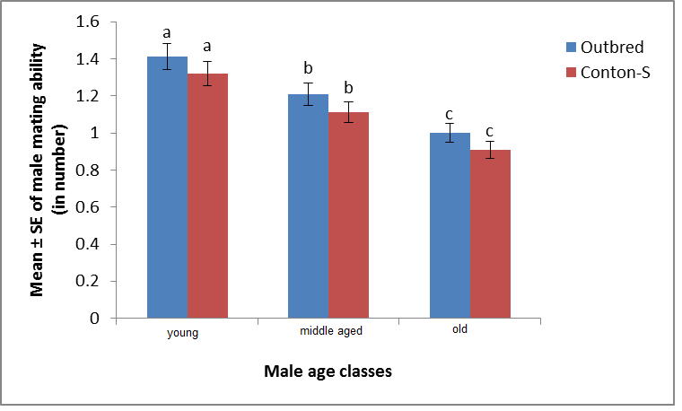
Figure 1: Age effect of male on male mating ability in D. melanogaster.

Table 1. One way ANOVA of male mating ability in Drosophila melanogaster
Experimental stocks | Parameter | Source | Type III Sum of Squares | df | Mean square | Sig.
Outbred | Male mating ability | Age | 6.253 | 2 | 0.161 | 19.459**
 |  | Error | 23.620 | 147
 |  | Total | 29873.12 | 150
 |  | Age | 6.212 | 2 | 0.154 | 18.459**
Conton-S | Male mating ability | Error | 23.611 | 147
 |  | Total | 29873.00 | 150
** Significant at p < 0.001.

Table 2. General linear model (repeated measures) between male age, male mating ability of D. melanogaster.
Experimental Stocks | Parameter | Type III Sum of Squares | df | Mean square | F
Outbred | Source male mating ability | 6.250 | 1 | 6.250 | 42.241**
 | Male mating ‎ability × ‎male age ‎linear | 0.003 | 1 | 0.003 | 0.017**
 | Error (male mating ability) linear | 7.250 | 49 | 0.250
 | Source male mating ability | 5.251 | 1 | 4.213 | 41.040**
Conton-S | Male mating ‎ability × ‎male age ‎linear | 0.001 | 1 | 0.001 | 0.011**
 | Error(male mating ability) linear | 6.250 | 49 | 0.212
** Significant at p < 0.001.

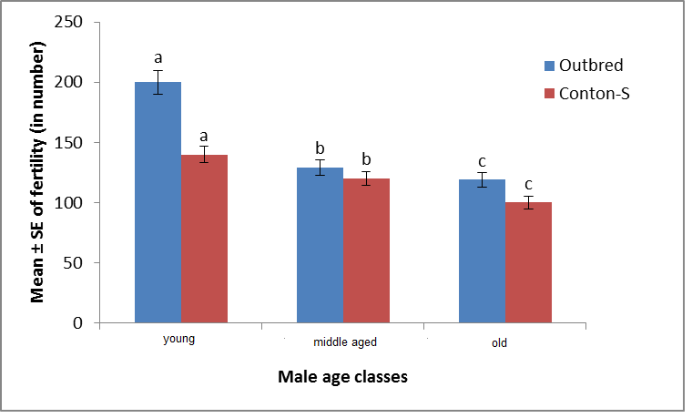
Figure 2: Progeny production of female mated with male at young, middle and old age of D. melanogaster.

Table 3. One way ANOVA of fertility in Drosophila melanogaster
Experimental stocks | Parameter | Source | Type III Sum of Squares | df | Mean square | F-Value
Outbred | Fertility | Age | 326727.213 | 2 | 163363.607 | 42.825**
 |  | Error | 560751.560 | 147 | 3814.636
 |  | Total | 46390343 | 150
Conton-S | Fertility | Age | 312727.210 | 2 | 163323.124 | 42.235**
 |  | Error | 560231.521 | 147 | 3802.213
 |  | Total | 46391221 | 150
** Significant at p < 0.001

Table 4. General linear model (repeated measures) between male ages and fertility of D. melanogaster.
Experimental Stocks | Parameter | Type III Sum of Squares | df | Mean square | F
Outbred | Source fertility | 265946.490 | 1 | 265946.490 | 65.477**
 | Fertility × ‎male age ‎linear | 57713.070 | 1 | 57713.070 | 17.868**
 | Error (fertility) linear | 199021.010 | 49 | 4061.653
Conton-S | Source fertility | 265923.125 | 1 | 265923.412 | 65.412**
 | Fertility × ‎male age ‎linear | 547112.071 | 1 | 54711.071 | 20.345**
 | Error (fertility) linear | 199121.12 | 49 | 4012.321
** Significant at p < 0.001

4. Discussion
Reproductive capacity is particularly a good index of fitness in organisms that go through repeated cycles of rapid population growth and it has evolved as a way for species to maximize their potential for survival. Reproductive success of females depend on number of eggs laid and male reproductive success depends of the number of females he could inseminate. Fecundity is the most obvious trait that influences the reproductive ability of female and is usually considered as female fitness component, and it has been analyzed in different species of Drosophila. It shows that fecundity is influenced by mating flies, age, body size, environmental factors, genotype and also fecundity enhancing substances (FES).The fecundity of virgin females is more when compared to mated female (Partridge et al., 1986; Gillot, 2003; Roopashree et al., 2001).
The primary function of mating is the transfer of sperm to females, since each mating offers an opportunity to father offspring. Males can generally increase their fitness by mating with many mates, and high mating rates are thus typically associated with high male reproductive success. Males of D. melanogaster, like most male insects, provides no parental care to offspring following female insemination (Thornhill and Alcock, 1983). Male fitness is therefore related to the number of females inseminated and prevention of females from re-mating (Parker, 1970; Jones and Elgar, 2004; Jones et al., 2007). In the present study, mating ability of male at young, middle aged, old age was studied in two experimental stocks of D. melanogaster (Fig. 2, Table 3 and 4). It was noted that the outbred stock had inseminated more number of females in a given unit of time than Conton-S stock. This shows the existence of interstocks variation in male mating ability. This confirms findings of an earlier study on interpopulational variations in male mating ability in D. bipectinata (Guru Prasad et al., 2008). Since the male’s mating ability is a fitness character, the observed variations in male mating ability among the different geographic populations experimental stock suggest interactions of these stocks with heterogeneous environments. Among the two experimental stocks studied, the outbred stock had produced greater progeny number than the Conton-S. It was also noticed females that mated with males at young age had produced greater number of progeny than females that mated with either middle aged or old males. Our study supports widely accepted view that males which inseminate more females produces more progeny than those that of males that inseminate less number of females (Gromko, 1992). Our study also confirms the earlier works that male remating increases male fitness in different species of Drosophila (Singh and Singh, 2000; Krishna and Hegde, 1997; Curu Prasad et al., 2008). Thus these studies in D. melanogaster male at young age had inseminated more females and had produced greater number of progeny than male at middle and old age.

Acknowledgement:
The authors are grateful to the Chairman, Department of Studies in Zoology, University of Mysore, and Drosophila stock center, University of Mysore for providing facilities to carry out this work.

Corresponding Author: Dr. M. S. Krishna
Drosophila stock center, Department of Studies in Zoology, University of Mysore,
‎Manasagangotri, Mysore - 560 006. Karnataka, India‎
Email, drosokrish@gmail.com

References:
- Anderson WW. Frequent multiple in-semination in a natural population of Drosophila pseudoobscura. Amer Natur 1974;108, 709-711.
- Banerjee R, Singh BN. Population and behaviour genetics of Drosophila bipectinata. Proc. Indian Nat Sci Acad.B 1997; 63: 399-410.
- Bonduriansky R. The evolution of male mate choice in insect: a synthesis of ideas and evidence. Biological reviews of the Cambridge philosophical society 2001; 76: 305-339.
- Casares P, MC Carracedo, B Del Rio, R Pinerio, L Garcia-Florez, Barros AR. Disentangling the effects of mating propensity and mating choice in Drosophila. Evol 1998; 52: 126-133.
- Cobbs G. Multiple inseminations and male sexual selection in natural populations of Dro-sophila pseudoobscura. Amer Natur 1977; 111: 641- 656.
- Delcour J. A rapid and efficient method of egg collecting. Dros Inf Ser ‎‎1969; 44: 133-134.
- Jones TM, Elgar MA. The role of male age, sperm age and mating history on fecundity and fertilization success in the hide beetle. Proc Roy Soc Lond B Biol 2004; 271: 1311–8.
- Jones TM, Featherston R, Paris D, Elgar MA. Age-related sperm transfer and sperm competitive ability in the male hide beetle. Behav Ecol 2007; 18: 251–8.
- Hegde SN, Krishna MS. Size assortative mating
in Drosophila malerkotliana. Anim Beh 1997; 54: 419-426.
- Gillott C. Male accessory gland secretions: Modulators of Female Reproductive Physiology and Behavior. Annu. Rev. Entomol 2003; 48: 163-184.
- Gromko MH. Genetic correlation of male and female mating frequency: evidence from Drosophila melanogaster. Anim. Behav 1992; 43: 176-177.
- Gromko MH, DW Pyle. Sperm competition, male fitness and repeated mating by female Drosophila melanogaster. Evol 1978; 32: 588-593.
- Gromko MH, D G Gilbert and Richmond R C. Sperm transfer and use in the repeat mating system of Drosophila. In R. L. Smith (ed.), Sperm Competition and the Evolution of Animal Mating Systems. Academic Press, N.Y. In press.
- Guru Prasad BR, SN Hegde, MS Krishna. Positive relation between male size and remating success in some population of Drosophila bipectinata. Zool Stud 2008; 47: 651-659.
- Koref- Santibanez S. Effects of age and experience on mating activity in the sibling species Drosophila pavani and Drosophila gaucha. Behavior Gene 2001; 31: 287-297.
- Levine L, M Asmussen, O Olvera, JR Powell ME Delarosa, VM Salceeda, MI Gaso, J Gujman, and Anderson WWW. Population genetics of Mexican Drosophila. V.A. high rate of multiple inseminations in a natural population of Drosophila pseudoobscura. Am Nat 1980; 116: 493-503.
- Levine L, M Asmussen, O Olvera, JR Pow- Ell, ME, Delasora V M, Salceda M I, Gaso J, Guzman, and Anderson WW. Population genetics of Mexican Drosophila. V. An extremely high rate of multiple insem-ination in a natural population of Drosophila pseudoobscura. Amer Natur 1980; 116: 493-503.
- Markow TA, M Quaid, Kerr S. Male mating experience and competitive courtship success in D. melanogaster.Nat 1978; 276: 821-822.
- Nicholas KP, FG Laura and A Deborah, Roach. Mating frequency and inclusive fitness in Drosophila melanogaster. The American naturalist 2008; 171: 10-21.
- Parsons PA. Behavioral and ecological genetics: a study in Drosophila. Oxford, UK: Clarenden Press 1973.
- Parker GA. Sperm competition and its evolutionary consequences in the insects. Biol Rev 1970; 45: 525-567.
- Prakash S.Association between mating speed and fertility in Drosophila robusta. Gene 1967; 57: 655-663.
- Partridge L, and Farquhar M. Sexual activity reduces lifespan of male fruit flies. Nat 1981; 294: 580-582.
- Partridge L, K Flower, S Trevitt and Sharp W. An examination of the effects of males on the survival and eggproduction rates of Drosophila melanogaster. J Insect Physiol 1986; 32: 925-929.
- Roopashree S, K Ravi Ram, and Ramesh SR. Genotype environment interaction and fecundity in Drosophila. Dros inf serv 2001; 84: 93-95.
- Somashekar K, Krishna MS. Evidence of female preference for older males in Drosophila bipectinata. Zool Stud 2011; 50: 1-15.
- Singh BN, S Chatterjee. Variation in mating propensity and fertility in isofemale strains of Drosophila ananassae. Gene 1987; 73: 237.
- Singh BN, SR Singh. Mating success in Drosophila ananassae: evidence for greater variation in receptivity of females compared to male mating ability. Curr Sci 1999; 77: 1200-1203.
- Singh SR, Singh BN. Male remating in Drosophila ananassae: evidence for interstrain variation in remating time and shorter duration of copulation during second mating. Zool Sci 2001; 17: 389-393
- Sisodia S, Singh BN. Size dependent sexual selection in Drosophila ananassae. Gene 2004; 121: 207-217.
- Sanchez Prado JA, Blanco Lizana G. Mating patterns of different Adh genotypes of Drosophila melanogaster. I. differences in mating ability. Gene 1989; 78: 219-224.
- Singh SR, BN Singh and Hoenigsberg HF. Female remating, sperm competition and sexual selection in Drosophila”. Gene Mol Res 2002; 1(3): 178-215.
- Turner ME and Anderson WA. Multiple mating and female fitness in Drosophila melanogaster. Evol 1983; 37: 714-723.
- Thornhill R, Alcock J. The Evolution of Insect Mating Systems. Nat 2001; 564 pages.

12/29/2013

