Evaluation of the Diagnostic Accuracy of Transvaginal Ultrasound and Sonohysterography in Detecting Uterine Cavity Lesions with Respect to Pathological Diagnosis in Women with Postmenopausal Bleeding

Hanaa Farouk M.D.⁽¹⁾, Ola Bahgat M.D.⁽²⁾, Howida Ahmed M.D.⁽²⁾, Mohamed Abd – El Azim M.D ⁽³⁾

¹Obstetric and Gynecology and ²Radiology Departments, Faculty of Medicine for girls – Al-Azhar University, Egypt.
³Pathology Department, Faculty of Medicine Al-Azhar University, Egypt.
hana_73@windowslive.com

Abstract: Objective: To compare the diagnostic accuracy of transvaginal ultrasound (T VS), saline sonohysterography (SIS) with respect to pathological diagnosis in detecting uterine cavity abnormalities associated with abnormal uterine bleeding among postmenopausal women. Study Design: Prospective cross sectional study. Place and duration of study: the present study conducted at Gynecological and Diagnostic Radiological department at AL Zahraa University Hospital, from May 2010 to Septemper 2011. Methodology: Fifty women complaining of postmenopausal bleeding were included transvaginal ultrasound, sonohysterography were done followed by endometrial biopsythen findings of both TVS and SIS were compared with Histopatholgical results. Results: Histopathologic correlation was obtained in the 50 patients who underwent successful transvaginal ultrasound, sonohysterography, by means of subsequent endometrial biopsy. Endometrial pathologic conditions were present in 49 cases of 50 patients (98%). Diffuse pathologic conditions were demonstrated in 20 patients (40%) they included hyperplasia in 15 cases (30%), diffuse atrophic endometrium in 2 cases (4%) and endometrities in3 cases (6%). Focal pathologic conditions were demonstrated in 29 patients (58%): they included endometrial carcinoma in 4 cases (8%), endometrial polyp in 11cases (22%), submucous fibroid in 7cases (14%), mural fibroid in 6cases (12%)and liomyosarcoma in one case (2%). Conclusion: TVS had high accuracy in detecting endometrial hyperplasia. However, saline Sonohystrography (SIS) combined with endometrial biopsy seems to be superior to transvaginal sonography in detecting uterine abnormalities in postmenopausal women with abnormal uterine bleeding including polypoid lesions, intramural myoma, endometrial atrophy and may reduce demand for hysteroscopy.
[Hanaa Farouk, Ola Bahgat, Howida Ahmed, Mohamed Abd – El Azim. Evaluation of the Diagnostic Accuracy of Transvaginal Ultrasound and Sonohysterography in Detecting Uterine Cavity Lesions with Respect to Pathological Diagnosis in Women with Postmenopausal Bleeding. N Y Sci J 2013;6(12):203-213]. (ISSN: 1554-0200). http://www.sciencepub.net/newyork. 32

Keywords: Postmenopausal bleeding, Uterine cavity, transvaginalultrasaound, saline sonohystergraphy, endometrialpathology.

1. Introduction
Postmenopausal bleeding is a common complaint, with most cases caused by benign etiologies such as fibroid, endometrial polyps, or atrophy. Endometrial cancer is considered a relatively rare cause of abnormal bleeding estimated to account for 10% of postmenopausal bleeding⁽¹⁾. Determining the proper diagnosis for the cause of postmenopausal bleeding and planning the treatment accordingly are essential, it is necessary to distinguish organic causes of abnormal uterine bleeding, including endometrial polyps, uterine fibroid, endometrial hyperplasia and endometrial cancer which require surgery from functional causes, which are treated medically⁽²⁾.Timely diagnosis of cancer is imperative because early detection and treatment are associated with higher disease – free survival and lower morbidity. Gynecologists and Radiologists are often faced with a wide array of diagnostic tools in the evaluation of postmenopausal bleeding, including; transvaginal ultrasound (TVUS), saline infusion sonohysterography (SIS), endometrial biopsy, dilatation and curettage, and hysteroscopy. What would be an efficient, cost- effective, and patient – friendly diagnostic approach without missing cancer ? this has been the subject of much research⁽³⁾. Hysteroscopy was accepted as the gold standard for determining the cause of endometrial pathologies presenting with abnormal uterine bleeding⁽⁴⁾. Although invasive procedures are valuable in finding the cause of abnormal uterine bleeding, they are costly and uncomfortable and can have complications⁽⁵⁾. The non invasive diagnostic technique of choice in the diagnosis of abnormal uterine bleeding in postmenopausal women should be easily applicable and enable one to determine which invasive technique (ie, endometrial sampling, dilatation and curettage and hysteroscopy) is appropriate. Transvaginal ultrasonography is one highly applicable non invasive method meeting some of these criteria, it has a high sensitivity for detecting endometrial pathology and assessment of endometrial thickness⁽⁶⁾.However, the accuracy of TVUS in the diagnosis of focal endometrial lesions is limited⁽⁷⁾. Sonohysterography with saline infusion emerged as a minimally invasive procedure in triaging women with abnormal uterine bleeding with the use of (SIS) single- layer evaluation of the endometrial lining is possible, which gives detailed information to distinguish between local and diffuse lesions. It also provides information about the localization and extent of subendometrial lesions affecting the uterine cavity and enables the appropriate choice of surgery this method is reported to be highly sensitive and specific, particularly in diagnosing the cause of abnormal uterine bleeding in premenopausal women⁽⁸⁾.Recently, Moschos et al reported combining SIS with endometrial biopsy under direct transvaginal sonographic visualization. They found that it is superior to blind endometrial biopsy in diagnosing pathology when results were correlated to a final outcome obtained on hysteroscopy, dilatation and curettage, hysterectomy specimen, or1- year follow up in women without final pathology the addition of endometrial sampling to SIS my thus render it a much more powerful tool⁽⁹⁾.The aim of this work was to compare the diagnostic accuracy of transvaginal ultrasound, saline infusion sonohysterography with respect to pathological diagnosis in the detection of uterine cavity abnormalities associated with abnormal uterine bleeding among postmenopausal women.
Methodology:
This is prospective cross- sectional study conducted at Gynecological and Diagnostic Radiological department at AL Zahraa University Hospital from May 2010 to September 2011fifty women complaining of postmenopausal bleeding were included in this study. Transvaginal ultrasound, sonohysterography were done followed by endometrial biopsy then findings of both TVS and SIS were compared with histopathological results.
Inclusion criteria: postmenopausal women with postmenopausal bleeding.
Exclusion criteria:
1. Coagulation disorders as thrompocytopenia, Von Willebrand disease and oral anti coagulant therapy.
2. Hypothyroidism or Hyperthyroidism
3. Liver diseases
4. Evidence of PID, Pyometraor hematometra and symptoms suggestive lower genital tract infection
5. Any cervical abnormalities (cervical stenosis which prevent access to the uterine cavity) or cervical infection and cervical cancer
All participants provided verbal consent after concised explanation about the procedures. Every patient underwent the following;
- History taking, general examination searching for signs of anaemia, hypertention, hypo or hyper thyriodism, purpra, liver disease.
- Gynecological examination; PV, bimanual examination, speculum examination, and sometimes per rectal examination for assessment of size and direction of the uterus and examination of the adnexa for any abnormalities and any cervical pathology.
- Laboratory investigations.
- Transvaginal sonography, sonohysterography and histopathological examination.
Transvaginal Ultrasonography was done using7.5 Mhzendovaginal probe fitted to ZONARE diagnostic ultrasound system (Mountain view C A 94043). Preparation: Each patient was asked to empty her urinary bladder before the examination started, then asked to lie in supine position with her knees flexed and abducted the tip of the vaginal probe covered by coupling gel and introduced into a protective sterile glove using one of its fingers and tightening it around the probe by the others. Care was taken to avoid trapping of air bubbles which create unwanted artifacts on the covered transducer tip before its insertion into the vagina.
Technique:
The transducer was introduced gently into the posterior fornix and scanning was started first in the sagittal then transverse planes to obtain images in varying directions, the following maneuovers could be employed:
- Tilting or angulations of the probe by its handel so as to point the tip to different directions.
- Pushing and pulling the whole probe to bring deeper or closer organs into the focal length.
- Rotation of the transducer.
The following points were considered thoroughly on examination:
- Imaging the uterus including the fundal portion.
- Evaluating both adnexal regions, and lateral areas of the pelvis.
- Evaluating Cul – de-sac.
The uterus was concentrated upon during the sonographic examination it was imaged in its sagittal and transverse planes covering the entire uterus. Double layer thickness of the endometrium was measured in the med sagittal plane from the anterior to the posterior endometrial – myometrial interfaces the endometrial echo was considered abnormal on TVUS when atrophy, poor definition or thickening were depicted also, when endometrial thickness measured 5 mm or more or there was intracavitary lesions (ie endometrial polyps or submucous fibroid).Lesions entirely within the uterine cavity and observed as hyperechogenic were considered to be endometrial polyp, whereas those related to the myometrium reaching the cavity by pushing the endometrium and being isoechogenic or hypoechogenic when compared with myometrium were considered to be uterine fibroid.
Sonohysterography:
After the TVUS assessment had done a sterile vaginal speculum used to expose the cervix after direct inspection, the uterine cervix was cleansed with povidine –iodine solution 10%a sterile 5-f rigid H S G catheter with 4 ml occlusive balloon used in all patients except 2 cases who had marked cervical incompetence to whom a 12- f Foleys catheter was applied. It was flushed with sterile saline solution before being inserted through the cervical canal to prevent echogenic artifact of air inside the catheter which lead to obscure the endometrium. The catheter then introduced into the cervical canal its balloon was fitted snugly with the external so after its inflation then vaginal speculum was carefully removed while the catheter was left in place, then the vaginal probe inserted into the fornix from behind the catheter after that 5 to 40 ml of sterile saline was injected to expand the uterine cavity, transverse and longitudinal images of the distended cavity were obtained by TVUS and photographed. Five to 10 ml saline solution proved to be sufficient to distend the cavity. In the SIS procedure saline separates the endometrium and appeared as anechogenic area within the endometrial cavity which was examined in its sagittal and coronal planes the endometrial thickness surrounding the anechoic fluid was measuredcare was taken to exclude the adjacent hypoechoic myometrium and any fluid within the cavity.
The study recorded on ultrasound films the entire procedure took from 10-20 minutes after which the catheter and the probe were removed. all patients were instructed to report any symptoms of fever, lower abdominal pain or vaginal bleeding following the procedure. In the sonohysterography procedure, the endometrium was observed as an echogenic because it was full of saline surrounding the uterine cavity, a symmetric and flat endometrialshape was considered to be normal. lesions entirely within the endometrial cavity, surrounded by saline except for their endometrial roots and observed mostly to be more hyper echogenic compared with the endometrium were considered endometrium polyps. lesions that were deeper in the endometrial line image, showing less or the same echogenicity as compared with the myometrium, filling partly to the endometrial line when the saline was applied and not reaching the parts near the myometrium wear considered sub mucous fibroid. The SIS findings were considered to be pathologic (hyperplasia or cancer) when the endometrium surrounding the echogenic saline was asymmetric, irregular and thick (more than 4 mm) and the border between the endometrium and myometrium was intact. Specimens obtained with D&C were subjected to histopathology examination and were compared with the pre diagnosis achieved with TVUS and SIS separately using the pathology results as reference. The sensitivity, specificity, positive predictive value (PPV), negative predictive value (NPV) and diagnostic accuracy of TVUS and SIS procedures for all endometrial pathologies were determined.

3. Results:
A total of 50 women with postmenopausal bleeding were prospectively evaluated by TVS and SIS between May 2010 and September 2011 majority of the patients belonged to age group 62 – 73 years (56%). The mean BMI was 26+4.25.Regarding endometrial thickness, 3 cases were immeasurable (5%), 20 cases (40%) had endometrial thickness 5-7mm, 12 cases (25%) had 8-10mm thickness, 10 cases (20%)had 11-13mm thickness and 5 cases (10%) had 14mm or more endometrial thickness as shown in table (1). The pathological results of the specimens obtained indicated that 15 of the 50 women (30%) had endometrial hyperplasia, 2 (4%) had endometrial atrophy, 4 (8%) had endometrial carcinoma, 11 (22%) had endometrial polyp, 7 (14%) had sub mucous fibroid, 6 (12%) had intramural fibroid and 1 (2%)had normal biopsy. comparison of the pathological results with those of the TVS and SIS procedures are summarized in tables 3 and 5. Diagnosis of endometrial hyperplasia was more accurate with TVS with specificity and PPV 100% and accuracy 96.6% as shown in table (6). Diagnostics accuracy of each imaging method in the diagnosis of endometrial atrophy, endometrial carcinoma, endometrial polyp, sub mucous fibroid and intramural fibroid with respect to endometrial biopsy as the gold standard is given in table 4 and 6. Concerning endometrial atrophy sensitivity was 100% for each method, while specificity, PPV, and accuracywere100% for SIS and 97.9%, 66.7%and83.35%for TVS respectively table 4 and 6.For polypoid lesions SIS revealed sensitivity 100% versus 90.9% for TVS, specificity 97.6% for SIS versus 97.5%, PPV 100% versus 90.9% table 4 and 6. Regarding uterine fibroid, both methods revealed the same sensitivity, specificity, PPV and diagnostic accuracy, while SIS had higher specificity, PPV and accuracy in detecting intramural fibroid 100 %, 100% and 100% versus 97.7%, 85.7% and 98.8 % for TVS respectively table 4 and 6. Concerning the detection of endometrial carcinoma, although both methods demonstrated the same specificity and PPV100 %for both, SIS had higher sensitivity and diagnostic accuracy 75% and 87.5% versus 50% and 75% for TVS table 4 and 6. The prediagnosis by TVS and SIS proved to be consistent with the pathology results in 41 of 50 women (82%) by TVS and 44 of 50 women (88%) by SIS. However, in nine women (18%), the TVS diagnosis was inconsistent with the pathological results and in six women (12%), the SIS diagnosis was inconsistent with the pathological results these results are described in table 7 and 8.

Table (1): Patients demography and clinical characters (No =50)
Clinical characters | Number | Percentage
Age (year)  49 -61  62-73 | 22  28 | 44 %  56 %
BMI (mean + SD) | 26 +4.25
Endometrial thickness (mm)  - Immeasurable  - 5 – 7 mm  - 8 – 10 mm  - 11 – 13 mm  - > or = 14 mm | 3  20  12  10  5 | 5 %  40 %  25 %  20 %  10 %

Table (2): Analysis of endometrial findings according to sonohyserography and transvaginal ultrasound.
Findings | Saline infusion sonohysterography (SIS) No= 50 |  | Transvaginal ultrasound (TVUS) No=50
 | Number | Percentage | Number | Percentage
Endometrial hyperplasia | 18 | 36 % | 14 | 28 %
Endometrial polyp | 12 | 24 % | 10 | 20%
Fibroid | 13 | 26 % | 12 | 24 %
Endometrial carcinoma | 3 | 6 % | 2 | 4 %
Atrophic endometrium | 2 | 4 % | 3 | 6 %
No abnormalities found | 2 | 4 | 9 | 18 %

Table (3): Comparison of Sonohysterography findings with pathological findings.
Findings | Sonohysterography results No =50 |  | Pathological results No =50
 | No. | % | No. | %
Endometrial hyperplasia | 18 | 36 | 15 | 30
Endometrial Atrophy | 2 | 4 | 2 | 4
Endometrial carcinomas | 3 | 6 | 4 | 8
Endometrial polyp | 12 | 24 | 11 | 22
Submucous fibroid | 6 | 12 | 7 | 14
Intramural fibroid | 6 | 12 | 6 | 12
NAD | 3 | 6 | 1 | 2

Table (4):Diagnostic parameters of sonohysterography.
Findings | Sens. | Spec. | +PV | -PV | Accuracy
Endometrial hyperplasia | 100.0 | 91.4 | 83.3 | 100.0 | 95.7
Endometrial Atrophy | 100.0 | 100.0 | 100.0 | 100.0 | 100.0
Endometrial carcinomas | 75.0 | 100.0 | 100.0 | 97.9 | 87.5
Endometrial polyp | 100.0 | 97.6 | 100.0 | 97.6 | 95.85.0
Submucous fibroid | 85.7 | 100.0 | 100.0 | 97.7 | 92.85
Intramural fibroid | 100.0 | 100.0 | 100.0 | 100.0 | 100.0

Table (5): Comparison of ultrasonography findings with pathological findings.
Findings | Ultrasonography results No =50 |  | Pathological results No =50
 | No. | % | No. | %
Endometrial hyperplasia | 14 | 28 | 15 | 30
Endometrial atrophy | 3 | 6 | 2 | 4
Endometrial carcinoma | 2 | 4 | 4 | 8
Endometrial Polyp | 10 | 20 | 11 | 22
Submucous fibroid | 6 | 12 | 7 | 14
Intramural fibroid | 7 | 14 | 6 | 12
No abnormalities | 8 | 16 | 1 | 2

Table (6):Diagnostic parameters of transvaginal ultrasound.
 | Sens. | Spec. | +PV | -PV | Accuracy
Endometrial hyperplasia | 93.3 | 100.0 | 100.0 | 97.2 | 96.65
Endometrial atrophy | 100.0 | 97.9 | 66.7 | 100.0 | 83.35
Endometrial carcinoma | 50.0 | 100.0 | 100.0 | 95.8 | 75.0
Endometrial Polyp | 90.9 | 97.5 | 90.9 | 97.5 | 95.75
Sub mucous fibroid | 85.7 | 100.0 | 100.0 | 97.7 | 92.85
Intramural fibroid | 100.0 | 97.7 | 85.7 | 100.0 | 98.85

Table (7):Analyze the results of the nine cases whose TVS findings were inconsistent with final pathological results.
Participant number | TVS findings | Pathological results
1 | Endometrial atrophy | Focal endometrial hyperplasia
2 | Intramural fibroid | Sub mucous fibroid
3 | Normal | Liomyosarcoma
4 | Normal | Endometritis
5 | Normal | Endometritis
6 | Normal | Endometrial carcinoma
7 | Normal | Endometritis
8 | Normal | Focal endometrial hyperplasia
9 | Normal | Endometrial carcinoma

Table (8):Analyze the results of the six cases whose SIS findings were inconsistent with final pathological results.
Participant number | SIS findings | Pathological results
1 | Endometrial polyp | Endometrial carcinoma
2 | Endometrial hyperplasia | Sub mucous fibroid
3 | Endometrial hyperplasia | Liomyosarcoma
4 | Endometrial hyperplasia | Endometrities
5 | Normal | Endometritis
6 | Normal | Endometritis

 | Fig. (1): Longitudinal image of Solitary endometrial polyp in a 55 years-old woman with postmenopausal bleeding. Saline infusion sonohysterography shows solitary fundal echogenic polypoid mass outlined by the anechoic saline.
Fig. (2A): Multiple polyps in a 61 years-old woman with abnormal bleeding. Saline infusion sonohysterography shows multiple polypoid masses outlined by the anechoic saline. A, Longitudinal image. | Fig. (2B): Multiple polyps in a 61 years -old woman with abnormal bleeding. Saline infusion sonohysterography shows multiple polypoid masses outlined by the anechoic saline.B, transverse image.
Fig. (3A): Endometrial polyp diagnosed histopatholgicaly) in 57 year-old woman with post menopausal bleeding A, a well defined smooth-marginated homogenous hyper-echoic intra cavitery mass (3.2x2.4x2.5 cm) arising from the posterior wall of the uterus. | Fig. (3B): Colour Doppler demonstrated flow within the stalk strengthening the diagnosis of endometrial polyp.
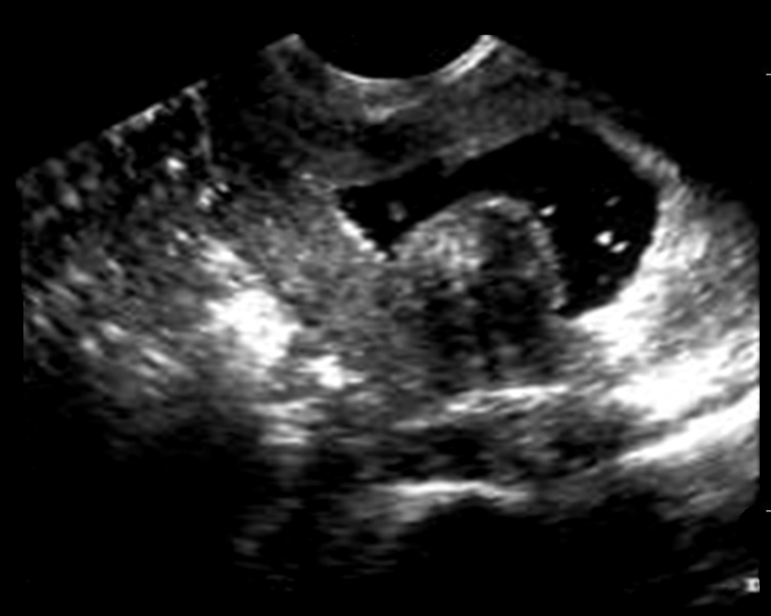
Fig. (4A): 58-year-old female with uterine bleeding. A, Sonohysterogram showed a submucosal fibroid, manifested by broad-based heterogenous soft tissue projection in the uterine cavity with visualization of a thin echogenic endometrial lining. | Fig. (4B): Color Doppler interrogation shows the peripheral vascularity.
 | 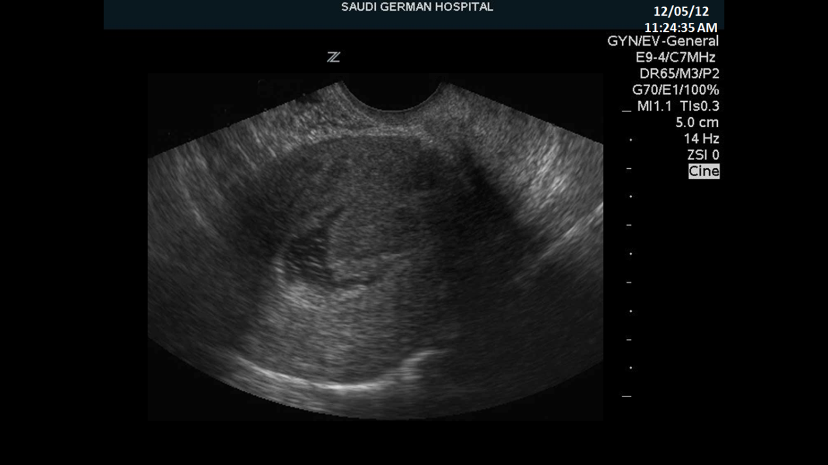
Fig. (5A): 56-year-old patient with post menopausal bleeding (diagnosed hystopathologicaly as endometrial cancer and superficial myometrial invasion). A, sagittal transvaginal US scan. | Fig. (5B): On sagittal sonohysterography a 3-cm lobulated mass has a poorly defined margin between the endometrium and adjacent myometrium.
Fig. (6A): Endometrial hyperplasia in a 53-year-old woman with post menopausal bleeding A, Sagittal transvaginal US scan shows the endometrium with a thickness of 17 mm. | Fig. (6B): Endometrial hyperplasia in a 53-year-old woman with post-menopausal bleeding. B, Sagittal sonohysterogram shows diffuse thickening due to hyperplasia.
Fig. (7): Endometrial atrophy in a 71-year-old woman with post menopausal bleeding, Sagittal sonohysterogram shows diffuse atrophy.

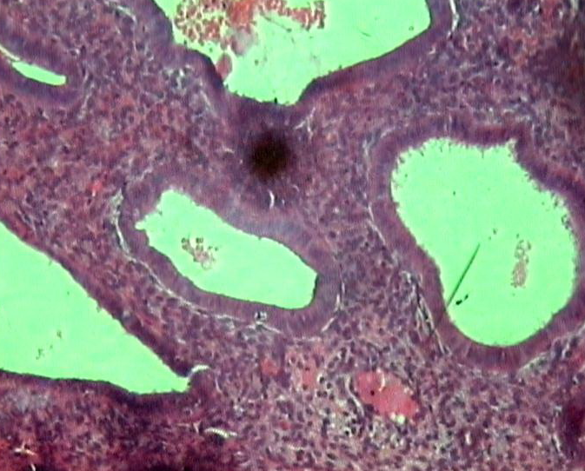

Endometrial biopsy (D& C) showed: Increased gland stromal ratio, cystically dilated gland lined by columnar epithelium with elongated regular basal nuclei, the stroma is compact and contained thin walled blood vessels and inflammatory cells (simple endometrial hyperplasia H & E X 300).
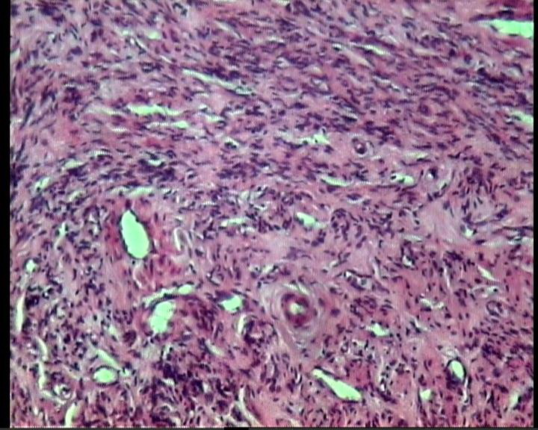 | 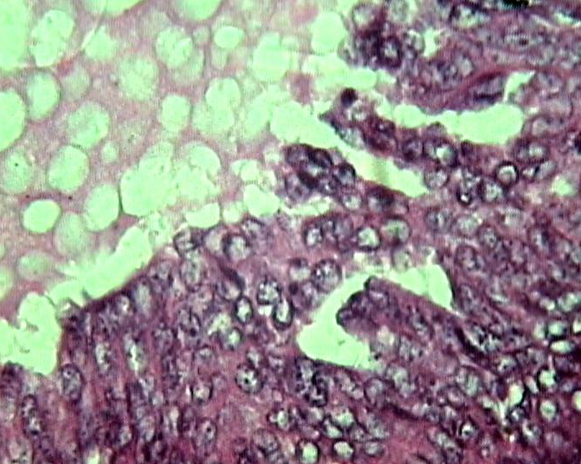
Endometrial biopsy (D&C) showed: Broad bundels of mature smooth muscle cells that run at various angeles so that, some bundeles are visible in longitudinal section and other in cross section, there is some fibrous tissue between the bundeles of muscle cells, blood vesseles are also seen (Liomyoma H&E X200). | Endometrial biopsy (D&C) showed: Malignant back to back glands lined by malignant cells (Endometrial adenocarcinoma H & E X300)
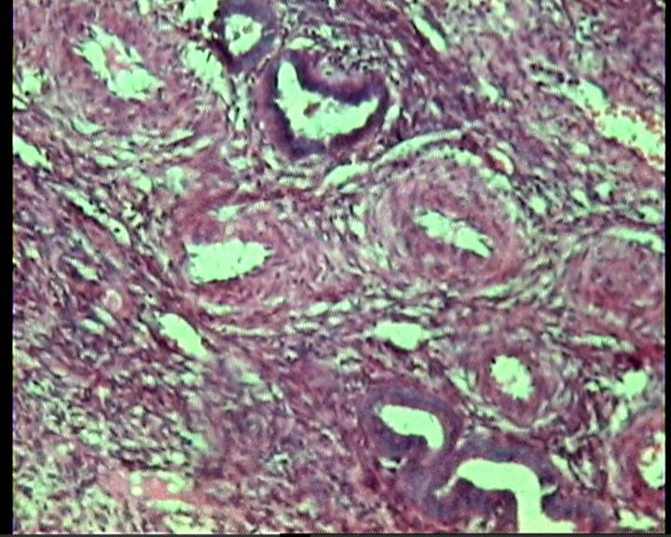
Endometrial biopsy (D & C) showed: Stroma with spindle cells, atrophied endometrial glands and thick walled blood vessels (Endometrial polyp H & E X 200).

4.Discussion
Evaluation and management of postmenopausal bleeding is evolving continuously with the advent of newer imaging modalities. Endometrium is more difficult to be measured in postmenopausal women due to diffuse endometrial border⁽¹⁰⁾.The correct diagnosis of a women with abnormal uterine bleeding is the most significant step in management. Knowing in advance the structure and localization of the focal lesion in the uterine cavity causing uterine bleeding also helps in the selection of a surgical intervention and prediction of the length of the operation and potential complications. For example, a sub mucous fibroid with an excessive intramural component the time for hysteroscopic resection will be relatively longer and the possibility of a complications will be higher thus our study aimed to compare the pre diagnosis obtained through easily administered in expensive, and none invasive methods that do not lead to complications and not require anaesthesia, easily accepted by women like transvaginal ultrasound (TVU) & saline infusion sonography (SIS) with the pathological results of the specimen obtained through invasive method that still considered to be a gold standard as dilatation and curettage (D & C)⁽¹¹⁾. Although TVUS allows close examination of the uterus and ovaries, it is of limited value in the evaluation of the uterine cavity⁽¹²⁾. The diagnostic accuracy of TVUS has been considered to be moderate in detecting intrauterine pathology; the sensitivity and specificity of TVUS for all lesions of the uterine cavity presenting with abnormal uterine bleeding have been reported in various publications to range from 68% to 95% and 70% to 96%respectively^{(13,14)}.In the present study we analyzed very pathological lesion alone and we found that, sensitivity, specificity, PPV, NPV and accuracy in detecting endometrial hyperplasia by TVUS was (93.3%, 100%, 100%, 97.2, and 96.65%) respectively table (6) while, sonohysterographic results were (100 %, 91.4 %, 83.3 %, 100 %, and 95.7 %) respectively table (4).Although TVUS has been found to have high sensitivity and specificity, PPV, NPV and accuracy in detecting endometrial hyperplasia, SIS was more effective in detecting other lesions than TVUS this results were consistent with Yildizhan B.et al.⁽¹⁵⁾ in their study, TVUS had higher sensitivity, specificity in detecting endometrial hyperplasia (90 %, 94 %) but SIS was more effective in detecting other lesions in their study TVUS failed to discriminate between endometrial, polyp, and sub mucosal myoma. Regarding endometrial polyp, the most important limitation in detecting intra cavitary polyp by TVUS that it may miss focal intracavitary lesion so, in our study the sensitivity, specificity, PPV, NPV and accuracy for TVUS in detecting endometrial polyp were (90.9 %, 97.5 %, 90.9 %, 97.5 % and 95.7) respectively table(6).These diagnostic parameters were, higher with SIS as sensitivity, specificity, PPV, NPV and accuracy were (100 %, 97.4 %, 100 %, 97.6% and 95.85%) respectively in detecting endometrial polyp table (4)these results in agreement with Erdem et al.⁽¹⁶⁾ who reported sensitivity, specificity and PPV (70.5%, 90.2 %, 87.8) respectively in detecting endometrial polypby TVUS while, (80 %, 92%, 90.5%) in detecting endometrial polypby SIS and one of the important finding observed in their study that SIS provides realistic information about the location and size of polyp in the cavity. In the current study, although TVUS and SIS results in detecting uterine fibroid were equal in detecting sub mucosal fibroid with sensitivity, specificity, PPV, NPV and accuracy were (85.7%, 100%, 100 %, 97.7 % and 92.8%) for both table (4 & 6), sonohystrographic diagnostic parameters in detecting intramural fibroid were higher as sensitivity, specificity, PPV, NPV, and accuracy were (100 %, 97.7 %, 85.7%, 100 % and 98.8) respectively by TVUS and (100 %, 100 %, 100 %, 100 % and 100%) respectively by SIS table (4 & 6)but TVUS could not reveal the relationship of fibroid to the uterine cavity by the same degree as SIS could, this results coincide with Bradley et al.⁽¹⁷⁾ who reported in their study sensitivity, specificity, PPV, and NPV in detecting uterine fibroid by TVUS were (95.8 %, 95 %, 85 %, 98 %) respectively and (91.6 %, 98.7 %, 95.6 %, 97.5 %) by SIS respectively. Endometrial carcinoma was in fact the main form of malignancy presented in our study, pathologically it was seen in 4 cases of 5 cases (2 cases diagnosed by TVUS and3 cases diagnosed by SIS) with sensitivity, specificity, PPV, NPV and accuracy were (50 %, 100 %, 100 %, 95.8 % and 75.5%) by TVUS respectively and (75 %, 100 %, 100 %, 97.9 % and 87.5%) respectively by SIS table (4 & 6) we believe that the relatively lower degree of sensitivity of SIS can be attributed to interpreting blood clotting and artifacts caused by the breaks in the endometrium. All of 4 cases had an endometrial thickness > or = 14 mm as showed in table (1).Most authors^{(18,19)}, who previously studied endometrial thickness as a predictor of endometrial pathology did not give a cut – off value of endometrial thickness for the diagnosis of each pathologicalentity affecting the endometrium this interpret why endometrial thickness was not used in the current study as a predictor of the type of endometrial disease on TVUS. Although, different studies did not prove whether the amount of endometrial thickness correlated with histological diagnosis^{(20,21)}, inour study we found that the thickest sonographic endometrial measurements were in cases of endometrial carcinoma. Endometrial malignancy was considered in the current study, when asymmetrical or heterogeneous endometrial thickening was seen. If disruption of the endometrial – myometrial interface was elicited, an invasive process was considered. This is in accordance with Cohen et al.⁽²²⁾ who reported that, a thick endometrium of variable echogenicity mostly echogenic, a lobular endometrium and loss of sub endometrial halo were different sonographic appearance for endometrial malignancy in their study. Concerning endometrial atrophy, the present study demonstrated that TVS and SIS had the same sensitivity (100%) however SIS was superior in specificity, PPV, and accuracy (100%, 100%, and 100%) respectively table (4) and (97.9%, 66.7% and 83.35%) by TVS respectively table (6)the presence of a poorly defined endometrium in one case made the detection of the exact state of the endometrium not clear enough on TVS after saline injection, all anatomical details were quite apparent and endometrial atrophy was easily diagnosed. this is inconsistent with Cullinan et al.⁽²³⁾who emphasized that if a thin endometrium was seen on TVS, no further investigation would be needed. However, if the endometrial lining was poorly defined or appeared thickened, SIS would be done as, a single layer of the endometrium was seen it was possible to determine if endometrial atrophy or focal areas of a symmetrical endometrial thickening existed. our result regarding endometrial atrophy also in agreement with Banu B et al.⁽²⁴⁾in their study they reported that each of the methods was determined to have (100%) sensitivity in the detection of endometrial atrophy with respect to pathological diagnosis. However SIS had (85.7%) PPV and TVS had (84.6%) PPV.

Conclusion:
In conclusion, in our study TVS had high diagnostic accuracy in detecting endometrial hyperplasia. However, as an easy to perform, safe and well – tolerated procedure yielding high diagnostic accuracy, saline infusion sono-hysterography seems to be superior to transvaginal sonography in detecting uterine abnormalities among postmenopausal women with abnormal uterine bleeding, including polypoid lesions, intramural myoma endometrial atrophy with respect to endometrial biopsy as the gold standard. Endometrial atrophy is an important finding that may be established by means of routine US or subsequent sonohysterography in a postmenopausal woman with an anteroposterior diameter of the endometrium of 4 mm or less.

References
- Lidor A, Ismajovich B, Confino E, et al. Histopathological findings in 226 women with postmenopausal uterine bleeding. Acta Obstet Gynecol Scand 1986; 65: 41-43.
- Brenner PF. Differentialdiagnosis of abnormal uterine bleeding. Amj Obtet Gynecol 1996; 175: 766-769.
- Skaznik-Wikiel ME, Jelovsek JE, AndrewsB, et al. Accuracy of endometrial thickness in postmenopausal women. Menopause 2010; 17: 104-108.
- Clark TJ, Voit D, Gupta JK, et al. Accuracy of hystroscopy in the diagnosis of endometrial cancer and hyperplasia: a systematic quantitative review. JAMA 2002; 288: 1610-1621.
- Clark TJ. Outpatient hysteroscopy and ultrasonography in the management of endometrial disease. Curr Opin Obstet Gynecol 2004; 16: 305-311.
- Smith-Bindman R, Kerlikowske K, Feldstein VA, et al. Endovaginalultrasoun to exclude endometrial cancer and other endometrial abnormalities. JAMA 1998; 280: 1510-1517.
- Farquhar C, Ekeroma, Furness S, et al. A systematic review of transvaginal ultra-sonography, sonohysterography and hysteroscopy for the investigation of abnormal uterine bleeding in premenopausal women. ActaObstet Gynecol Scand 2003; 82: 493-504.
- de Kroon CD, de Bock GH, Dieben SW, et al. Saline contrast hysterosonography in abnormal uterine bleeding: a systematic review and meta- analysis.BJOG 2003; 110: 938-947.
- Moschos E, Ashfaq R,McIntire DD,etal.Saline -infusion sonography endometrial sampling compared with endometrial biopsy in diagnosing endometrial pathology.ObstetGynecol 2009; 113: 881-887.
- Choudry A, shukr I, khan S, et al. Acceptability and accuracy of saline infusion sono-hysterography in women with postmenopausal bleeding.Jornalof the college of physicians and surgeons Pakistan 2010; 20: 571-575.
- Erdem M, Bilgin U, Bozkurt N, et al.Comparison of transvaginal ultrasonography and saline infusion sonohysterography in evaluting the endometrial cavity in pre- and post-menopausal women with abnormal uterine bleeding. Menopause: The Jornal of the North American Menopause society. 2007; 14: 846-852.
- Krampl E, Bourne T, Hurlen H, et al.Transvaginal ultrasonographysonohystrography andoperative hysteroscopy for the evaluation of abnormal uterine bleeding. ActaObstetGynecolScand2001; 80: 616-622.
- Dijkhuizen F, brolmann H, potters A, et al.The accuracy of transvaginal ultrasonography in the diagnosis of endometrial abnormalities. Obstet Gynecol 1996; 87: 345-349.
- Vercellini P, Cortesi I, Oldani S, et al. The role of transvaginal ultrasonographyand outpatient diagnostic hysteroscopy in the evaluation of patients with menorrhagia. 1997; 12: 1768-1771.
- Yildizhan B, Yildizhan R, Ozkesici B et al. Transvaginal ultrasonography and saline sonohysterographyfor the detection of intrauterine lesions in pre – and postmenopausal women with abnormal uterine bleeding. Journal of International MedicalResearch 2008; 36: 1205-1213.
- Erdem M, Bilgin U, Bozkurt N, et al.Comparison of transvaginal ultrasonography and saline infusion sonohysterography in evaluting the endometrial cavity in pre- and postmenopausal women with abnormal uterine bleeding.Menopause: The Jornal of the North American Menopause society. 2007; 14: 846-852.
- Bradley LD, Falcone T, Magen A. Radiographicimaging techniques for the diagnosis of abnormal uterine bleeding. Obstet Gynecolclin 2000; 27: 245 -276.
- Lin M, Gosink B, Wolf S, et al. Endometrial thickness after menopause: Effect of hormone replacement. Radiology 1998; 183: 443 – 449.
- JorizzoJ, Riccio G, Chen M, et al.Spectrum of endometrial hyperplasia and its mimics on saline hysterosonography. AJR Am J Roentgenol2002; 179: 385 -389.
- Osmers R, Volksen M, Schauer A: vagino-sonography for early detection of endometrial carcinoma ?Lancet 1990; 335: 1569 – 1571.
- Granberg S, WiklandM, KarlssonB, et al. Endometrial thickness as measured by endovaginal ultrasonography for identifying endometrial abnormality.Am J Obstet Gynecol 1994; 166: 53 -58.
- Cohen L, Valle R, Shapira J, et al. Sono-hysterography for distinguishing endometrial thickning from endometrial polyps in postmenopausal bleeding. Ultrasound in Obstetrics and Gynecology1994; 4: 225- 229.
- CullinanJ, Fleischer A, Keppler D, et al. Sonohysterography: a technique for endometrialevaluation. Radio Graphics 1995; 15: 501 – 504.
- BanuB, Ziya G, Halden G, etal.Comparison of diagnostic accuracy of saline infusion sonohysterography, transvaginalsonography and hysterography in post menopausal bleeding. ArchGynecolObstet 2010; 284: 111 -117.

12/11/2013

الملخص العربى
تقييم دقة أشعة الموجات الفوق صوتية المهبلية والأشعة الفوق صوتية المهبلية المصحوبة بحقن محلول الملح المعقم فى إكتشاف آفات التجويف الرحمى فى حالات النزييف الرحمى لدى السيدات بعد إنقطاع الطمث مع مراعاة التشخيص الباثولوجى.
يعد النزيف الرحمى الشاذ هو الشكوى الشائعة فى فترة ما بعد إنقطاع الطمث؛ فى معظم هذه الحالات أسبابها ليست خطيرة مثل الورم الليفى الحميد، السليلات أو ضمور بطانة الرحم. يعتبر السرطان الرحمى سببا نادراً نسبيا فى حدوث هذا النزيف فهو يمثل فقط 10% من هذه الأسباب ومن الضرورى التفرقة بين الأسباب العضوية المسببة للنزيف الرحمى من الأسباب الأخرى التى تعود الى خلل وظيفى حيث أن الأسباب العضوية تحتاج تدخل جراحى كما فى حالات الورم الليفى، السليلات والسرطان الرحمى بينما الأسباب الوظيفية تعالج بالعقاقير لذلك يعد التشخيص الدقيق لسبب النزييف أمر ضرورى لتخطيط طريقة العلاج. يواجه الإختصاصيون بأمراض النساء والمتخصصون باستخدام الطاقة الإشعاعية غالباً عدد كبير من الأدوات التشخيصية لتقييم النزييف الرحمى والتى تتضمن أشعة الموجات الفوق صوتية المهبلية والأشعة الفوق صوتية المهبلية المصحوبة بحقن محلول الملح المعقم، أخذ عينة من بطانة الرحم، عملية توسيع عنق الرحم وكحت لبطانة الرحم وكذلك المنظار الرحمى. ويبقى السؤال عن الطريقة التشخيصية الكافية الفعالة والمقبولة للمريضة بدون فقدها تشخيص السرطان الرحمى موضوع للدراسة فى معظم الأبحاث. يجب أن تكون الأساليب الغير توسعية المختارة فى تشخيص النزيف الرحمى سهلة التطبيق، وتساعد فى تحديد الوسيلة التوسعية المناسبة بعد ذلك كاستخدام المنظار الرحمى أو أخذ عينة من بطانة الرحم أو توسيع لعنق الرحم مع كحت لبطانة الرحم وبالرغم من تتطابق أشعة الموجات الفوق صوتية المهبلية مع بعض هذه الخصائص من حيث سهولة تطبيقها، وعدم إجتياحها للانسجة ولحساسيتها العالية فى إكتشاف الباثولوجى فى بطانة الرحم و تقييم سمكها إلا أن دقته فى تشخيص آفات بطانة الرحم الموضعية (البؤرية) محدودة.
الهدف من الدراسة:
هو تقييم الدقة التشخيصية لأشعة الموجات الفوق صوتية المهبلية والأشعة الفوق صوتية المهبلية المصحوبة بحقن محلول الملح المعقم فى تحديد آفات تجويف الرحم لدى السيدات الآتى تعانيين من نزيف رحمى بعد إنقطاع الطمث آخذين فى الإعتبار نتائج التشخيص الباثولوجى.
طريقة البحث وإختيار المرضى إشتملت هذه الدراسة على خمسين سيدة تراوحت أعمارهن بين 49 إلى 73 سنة تعانين من نزيف رحمى بعد إنقطاع الطمث وتتراوح مدة إنقطاع الطمث لديهنَ من 1 إلى 10 سنوات ولا تتعاطين أى علاج هورمونى بديل. تم عمل الموجات الفوق صوتية لهنَ أولا عن طريق المهبل و تبين أنها طريقة فعالة للفحص المبدئى الشامل وتمكن من القياس المباشر لسمك بطانة الرحم ثم يتم حقن محلول الملح المعقم داخل التجويف الرحمى مع مراعاة إستمرار التصوير أثناء الحقن ويعتبر هذا الفحص من الفحوصات الدقيقة لتشخيص التغيرات داخل جدار الرحم أو فى بطانته كما أن حقن محلول الملح يسهل ويساعد فى تحديد مكان وسبب وطبيعة الأفة التى تم إكتشافها عن طريق الأشعة الفوق صوتية وبعدها يتم أخذ عينة من بطانة الرحم للتشخيص النهائى عن طريق الباثولوجى ومقارنته بنتائج كلا من الطريقتين السابقتين.
ومن خلال هذه الدراسة تبين لنا أنَ هذا الفحص مع كونه بسيط وسهل إلا أنه مؤثر ومهم فى تقييم التغيرات المصاحبة لبطانة الرحم بعد إكتشافها عن طريق السونار المهبلى ولقد نجح هذا الفحص فى تشخيص كل انواع الأفات سواء كانت موضعية أو منتشرة فى بطانة الرحم محققا بذلك نسبة حوالى 88% توافقا مع التشخيص الباثولوجى كما حققت نسبا عالية فى الحساسية والنوعية التشخيصية حيث كانت الحساسية 100% والنوعية التشخيصية 91% فى حالة التولد المفرط وكانت 100% و 97% فى حالة السليلات وكانت 100% و 100% فى حالة الورم الليفى الحميد و كانت 75% و 100% فى حالة الورم السرطانى الرحمى على التوالى.
ومقارنة بالفحص بالأشعة الفوق صوتية المهبلية والذى يعتبر أيضا إجراء ناجح وشديد الحساسية فى تشخيص الكثير من أمراض بطانة الرحم حيث كانت نسبة الحساسية والنوعية التشخيصية 93% و100% فى حالة التولد المفرط وكانت 90% و97% فى حالة السليلات و كانت 100% 97% فى حالة الورم الليفى الحميد وكانت 50% و100% فى حالة الورم السرطانى الرحمى على التوالى.
أظهرت هذه الدراسة أنً أشعة الموجات الفوق صوتية المهبلية حققت نجاحا كبيرا فى تشخيص آفة الرحم المنتشرة وخاصة التولد المفرط وبالرغم أنه أيضا أعطى نتائج مرضية فى تشخيص الأورام الليفية الحميدة إلا أنه لم يحدد حجم الورم أو إمتداده داخل التجويف الرحمى بنفس الدقة التى توصلت إليها الأشعة الفوق صوتية المهبلية المصحوبة بحقن محلول الملح المعقم.
وقد خلصنا من هذه الداسة أن إستخدام أشعة الموجات الفوق صوتية المهبلية مصحوبا بحقن محلول ملح معقم فى تصوير تجويف الرحم هو الأفضل لكونه سهل, آمن, لايحتاج مخدر, مقبول وغير مكلف للمريضة. كما يعتبر طريقة أولية لإكتشاف وتشخيص الآفات المسؤلة عن نزيف الرحم فى فترة ما بعد إنقطاع الطمث مع التاكيد على أهمية وضرورة أخذ عينة وتحليلها باثولوجيا للتأكد من التشخيص وقد تؤدى هذه الطريقة الى تقليل إستخدام المنظار الرحمى.

