Combination effects of tillage systems and organic manures on some physio-chemical properties of calcareous soil and faba bean productivity

El-kotb, H.M.A.

Soils, Water and Environment Research Institute.ARC, Giza, Egypt.
drhasskotb@yahoo.com, hasskotb@gmail.com

Abstract: A field study was carried out during the two successive winter seasons of (2009/2010 and 2010/2011) at El-Nubaria Agricultural Research Station, (ARC), El-Behera Governorate, Egypt. This study aims to investigate the effect of two tillage systems, minimum (Tm) and conventional (Tc), and also to study the effect of two organic manures FYM (F), Compost (M) in compare with and no addition (C) on some physio-chemical properties of calcareous soil, productivity and NPK uptake of faba bean cultivar, (Vicia faba L., var. Egypt 1). In general, all of soil parameters under study showed significant response to tillage systems and to organic manures addition. The results revealed that tillage methods had significantly effects on the physical and chemical properties of soil i.e., increase both of hydraulic conductivity and total porosity. As well as, decreasing in bulk density, organic matter content and EC of soil under conversional tillage method (Tc) compared to minimum tillage method (Tm). Also, the results indicated that organic manures can be used successfully to improve the physical and chemical properties of the soil whereas; they cause decreasing in bulk density, pH and EC. On the other hand, its cause increasing organic matter content, total porosity and hydraulic conductivity of soil. Faba bean productivity and NPK uptake were significantly responded to tillage systems and organic manures. Conventional tillage and addition manures (Tc) + (M) or (F) cause enhance yield and NPK uptake of faba bean in compare to minimum tillage without addition manures (Tm) + (C).
[H.M.A. El-kotb. Combination effects of tillage systems and organic manures on some Physio-chemical properties of calcareous soil and faba bean productivity. N Y Sci J2013:6(12):193-202]. (ISSN: 1554-0200). http://www.sciencepub.net/newyork. 31

Keywords: Tillage system; manures; calcarous soil; Faba bean; yield and NPK uptake.

1. Introduction
Faba bean (Vicia faba L.) is an important legume crop in Egypt and many parts of the world. Its seeds exhibit high levels of protein (28–36 % of seed dry matter). And it is popular breakfast food and also used as vegetable green or fresh canned.
Also, it is an important crop for improvement soil through using as break crop in cereal rotation to keep the soil fertile and then, improve soil productivity through nitrogen fixation. Calcareous soils are common in arid and semi-arid region, these types of soils are having poor in mineral and organic colloids and subsequently they are low fertility i.e., suffer shortage in both macro- and micronutrients and these soils having alkaline reaction.
The no-tillage practice is carried out worldwide for erosion control and to maintain soil fertility. From an economic point of view, the use of minimum tillage and no-tillage practices provides significant energy savings (compared to conventional tillage) in on-farm use of fuel and in machine operation (Zenter et al., 2004). Soil plowing and rearrangement with clean surface from preceding crop residues and weeds is a technique, which aims at a creation of better physical conditions for growth. Nevertheless, it causes reversible changes as water loss and organic matter decline. No and minimum tillage are considered as alternative techniques for tilling the soil. Despite no tillage disadvantages, as bulk density and soil compaction, which may negatively influence nutrients uptake with poor performance of root growth (Herridge and Holland, 1992), it is advantageous over conventional tillage in some cases, as conservation tillage (Francis, 1986). To escape from no tillage disadvantages and save time for sowing a crop, reduced tillage may be used as an important alternative (Khalil, 1997; Nawar and Khalil, 2004). Alvarez and Steinbach (2009) observed that aggregate stability and water infiltration rate were higher in soils subjected to limited tillage systems than under plow tillage. Much of the yield increase was due to an increase in soil water in the 0-30 cm soil layer with no-tillage and minimum tillage. Maintaining and improving soil quality is crucial if agricultural productivity and environment quality are to be sustained for future generations (Reeves, 1997). The adoption of limited tillage systems leads to soil improvement but also generates the necessity of increased nitrogen fertilizers to sustain crop yields (Alvarez and Steinbach, 2009).
Soil organic matter is often considered as a key index of soil quality as it determines numerous factors influencing crop productivity. Application of organic manures has various advantages such as increasing soil physical and chemical properties as water holding capacity, organic carbon content apart from supplying good quality of nutrients. The addition of organic sources could increase the yield through improving soil productivity and higher fertilizer use efficiency. Organic fertilizers are frequently considered the most important amendments for soil reclamation and improvement, especially for calcareous soils. Organic fertilizers are a source of plant nutrients and make best positive changes in the soil properties. Many investigators indicated that the application of organic fertilizer increased the nutrient contents in the soil, their uptake and consequently increased the productivity of crops (Ali and Mahmoud 2012).The application of organic material helps the microorganisms to produce polysaccharides, which improve the soil structure. Organic manures not only act as a source of plant nutrients and energy for microorganisms but also influence the availability of native nutrients. In addition organic manure improves water holding capacity and permeability of the soil (Hussain et al., 2004). Azza et al. (2011) reported that organic matter makes its greatest contribution to soil productivity. It provides nutrients to the soil, improves its water holding capacity, and helps the soil to maintain good tilth and thereby better aeration for germinating seeds and plant root development.
Composting is a biological decomposition process during which microorganisms convert raw organic materials into relatively stable humus-like material. During decomposition, microorganisms assimilate complex organic substances and release inorganic nutrients (Metting, 1993). Compost plays an important role in improving soil organic matter, nitrogen content, P₂O₅ concentration and exchangeable cations. Furthermore, it decreases soil pH, which results in increasing solubility of nutrients and nutrient availability to the plants that enhance plant growth and development (Wafaa et al., 2004). The application of compost has been shown to positively affect the structure, porosity, water holding capacity, nutrient content and organic matter content of the soil (Smith, 1996) and to improve plant growth, crop yield and quality. Weber et al.(2007) reported that the continuous release of nitrogen from compost into the soil improves not only the soil fertility, but also the conditions of organic matter mineralization. There is considerable evidence in the literature dealing with the increase phosphorus solubility following organic material application (Sanyal and De Datta, 1991). Moreover, Astier et al. (2006) observed that green manure and tillage had a significant effect on maize grain yield, and N and P uptake, with conventional tillage with vetch as green manure performing better than no-tillage. Also, soil organic C and total N were significantly higher under no-tillage than under conventional tillage. Responses of faba bean growth to tillage operation were investigated in different studies.

2. Materials and Methods
This research work was carried out in the calcareous soil at El-Nubaria Agricultural Research Station, (ARC), El-Behera Governorate during the two successive seasons of 2009/2010 and 2010/2011. Two field experiments, i.e., one experiment each season, were carried out to study effect of the combination between tillage systems, (Conventional and Minimum tillage) and organic manures addition on some physio-chemical properties of soil, productivity and NPK uptake of broad bean (Vicia faba L., var. Egypt 1). The experiment was laid out in split plot design with four replicates. Tillage treatments were laid as the two main plots, they were conventional tillage (Tc): three passes and minimum tillage (Tm): one pass through the upper layer of soil. Manure treatments of Farm yard manure: (F) and Compost: (M) at rate 10 tons/fed., as well as no-manure addition Control: (C) were assigned to sub-main plots. The sub-main plot area was 10.5 m² (3m width and 3.5 m in length). N-fertilizer was added as ammonium nitrate (33.5 % N) with recommended dose of 20 Kg N fed⁻¹, while, P-fertilizer as mono-superphosphate (15% P₂O₅) was applied at the rate of 22.5 Kg P₂O₅ fed⁻¹ and K-fertilizer as potassium sulfate (48% K₂O) was added at the rate of 24 Kg K₂O fed⁻¹. Organic manures were mixed with the soil before planting while; potassium fertilization was applied after 25 days from planting.
At harvest, ten plants from each sub-plot were taken randomly, and threshed. Grain and straw were dried using an electrical oven on 70 ºC until constant weights obtained. Then weighted to obtain their dry weights and transferred to grain and straw yield in kg/fed. The grain and straw were ground and packed for chemical analysis to determine N, P and K. The total N was determined using micro-kjeldahl apparatus (Chapman andPratt, 1961). Phosphorus was determined according to Jackson (1973). Potassium being evaluated flame photometrically.
Undisturbed and disturbed surface (0-30 cm) of soil samples were collected to determine some physical and chemical characteristics of the investigated soil, according to the methods described by Page et al. (1982) and Klute (1986). Statistically analyses of data were carried out and calculated according to Little and Hills (1978). Table (1) shows some physical and chemical properties for the experimental field, calculated as average of the two seasons, and table (2) shows some properties of farmyard manure (F) and compost (M), calculated as average two seasons.

Table (1): Some physical and chemical properties of the experimental field.
Particle size distribution  (%) |  |  | Textural class | CaCO₃ (%) | Organic matter (%) | PH  (1:2.5) | ECe ds/m  (1:2.5) | B.D  (g/cm³) | T.P  (%) | H.C  (cm/hr)
Sand | Silt | Clay
68.91 | 16.57 | 14.52 | Silt loam | 18.40 | 0.97 | 8.14 | 8.25 | 1.32 | 40.45 | 1.01

Table (2) : Some properties of the used organic manures.
Organic manures | OM  (%) | pH | EC  (dS/m) | Total C  (%) | Total N  (%) | C/N  Ratio | Total P  (%) | Total K  (%) | Total Fe  (mg/kg) | Total Mn  (mg/kg) | Total Zn  (mg/kg)
FYM | 38.25 | 7.66 | 2.87 | 25.92 | 1.31 | 19.79 | 0.45 | 1.02 | 236 | 259 | 149
Compost  (plantresidues) | 47.50 | 7.50 | 2.75 | 26.20 | 1.60 | 16.38 | 0.75 | 1.50 | 315 | 265 | 128

3. Results and Discussion
- Effects of tillage systems and organic manures on physio-chemical properties of soil:
A-Physical properties:
-Bulk density (BD, g/cm³):
Bulk density (BD) is a ratio of oven dried weight of soil to its volume. Higher value of Bulk density means more weight per unit volume. So, when more soil was packed in the same volume, the soil became more compact and defective from agriculture point of view. Due to less pore space these soils were impermeable to water. On decrease of the value of bulk density soil became more porous and effective for root respiration and water permeability.
Data related to soil bulk density as mentioned in Table (3) and Fig (1-A) depicted that tillage methods i.e, conventional tillage (Tc) and minimum tillage (Tm), and organic manures of Farm yard manure (F) and Compost (M), had significantly effects on the bulk density of soil. In case of tillage methods, the highest value of bulk density 1.29 g cm⁻³ was observed with (Tm). Mean increase in bulk density was 12 % in case of (Tm) as compared to (Tc). Diaz-Zorita (2000) and Naveed et al., (2010) reported that bulk density of soil in 3 cm to 20 cm layer was significantly increased when the intensity of tillage system was decreased.
On the other hand, the results showed significant decreasing trend in bulk density with addition of organic manures. Organic manures, significantly decreases the bulk density of soil as compare to control. The less mean value was 1.15 g cm⁻³ in case of (M) followed by 1.2 g cm⁻³ in case (F), (11.54% and 7.69 % decrease) with application of (M) and (F), respectively. The findings of Shirani et al. (2002) and Naveed et al., (2010) were in conformity of this finding who reported that manure application significantly decreases the bulk density. (Naeem et al., 2007) reported that organic matter decreases the bulk density of soil. This effect can occur either directly by "diluting" the soil with a less dense material, or indirectly through greater aggregate stability. Indirect effects seem to be the most important and are not dependent on soil textural class.
The interactive effect of tillage methods with organic manures on bulk density Fig (1-A) show statistically significant. Maximum value of bulk density (1.34 g m⁻³) was observed with (Tm) under (C) no-manures addition and minimum value of bulk density (1.05 g m⁻³) was observed with (Tc) under (M) addition.

Table (3) Individual and combination effects of tillage systems and organic manures on some physio-chemical properties of soil. (average of 2009/2010 and 2010/2011 seasons).
Parameters of soils | Chemical properties |  |  | Physical properties
 | PH  (1:2.5) | ECe  (dS/m) | O.M  (%) | Bulk density  (BD,g/cm³ ) | Total porosity (TP,%) | Hydraulic conductivity (K,cm/hr)
Tillage Systems(T):
Tc | 7.99a | 5.41b | 1.19b | 1.15b | 45.93a | 1.17a
Tm | 7.65a | 6.43a | 1.29a | 1.29a | 39.01b | 1.01b
organic manures (OM):
C | 8.03a | 7.08a | 0.99c | 1.30a | 40.52c | 0.88b
F | 7.95b | 5.90b | 1.34b | 1.20b | 43.19b | 1.17a
M | 7.94b | 4.79c | 1.41a | 1.15c | 44.91a | 1.20a
Interaction effect(T x OM):
Tc C | 8.1a | 6.70b | 0.90d | 1.25b | 44.46c | 0.92d
Tc F | 7.95b | 5.34c | 1.30b | 1.15c | 45.93b | 1.25b
Tc M | 7.93b | 4.20d | 1.36ab | 1.05d | 47.40a | 1.33a
Tm C | 7.96b | 7.45a | 1.07c | 1.34a | 36.58f | 0.84e
Tm F | 7.94b | 6.46b | 1.37ab | 1.26b | 40.45e | 1.11c
Tm M | 7.95b | 5.38c | 1.45a | 1.25b | 42.41d | 1.07c
Tc= Conventional tillage, Tm= Minimum tillage , C=No-manures addition, M=Compost, F=Farm yard manure

-Total porosity (TP,%):
The data pertaining to total porosity (TP,%) of soil after harvest was listed in Table (3) and Fig(1-B), which showed that both of the two factors under study had significant effects on the total soil porosity %. Total soil porosity, calculated from bulk and real density, showed contrary trend of bulk density. Tillage practices showed that (Tm) had minimum total porosity (39.01 %) followed by (Tc) (45.93 %). with mean decrease in total porosity was equal to 15.07 % in compared to (Tc).
As regard to, organic manures significantly increasing in the concentration of total porosity (%) were noticed in soil as compared to no application (C). The maximum mean value of total porosity (44.91%) was recorded with applications of (M) followed by (43.19 %) in case of application of (F) against the minimum value of total porosity (40.52 %) in no application (C). So the increase in total porosity (%) as compared to (C) were equals to (10.83 %) and (6.59 %) for (F) and (M), respectively as compared to (C). This result may be related to bulk density which decreased the total soil porosity values as increased with increasing total carbon contents, (Gonzalez and Cooperband, 2003).
The interactive effects between both of the used tillage systems and addition of organic manures on total porosity (%) Fig (1-B) showed significant trends. Maximum total porosity (47.40 %) was observed when (M) was applied with (Tc), while minimum value of total porosity (36.58 %) was observed with (Tm) under no manure (C).
-Hydraulic Conductivity (K,cm/hr):
Data regarding soil hydraulic conductivity (K) after harvesting were presented in Table (3), and Fig (1-C) which revealed that both tillage methods and organic manures had significant effects on soil hydraulic conductivity (K). As regards tillage, the maximum value of (K) (1.17 cm/hr) was observed with Tc followed by (1.01 cm/hr) in (Tm) with increment (15.84 %) as compare to (Tm), indicating that conventional tillage increases the field hydraulic conductivity.
It is also depicted that, organic manures (F) or (M) significantly increased (K) of soil as compare to no addition (C). The higher value of (K) (1.20 cm/hr) was observed with (M) followed by (1.17 cm/hr) with (F) application. While, the lowest value (0.88 cm/hr) was recorded in case of no-manure addition (C). Increment (%) in hydraulic conductivity of (36.36 %) and (32.95 %) were recorded with (M) and (F), respectively. These findings are in conformity with those of Zachman et al., (1987) and Shirani et al., (2002) who reported that manures application improved hydraulic conductivity.
The interactive effects of treatments Fig (1-C) showed that maximum value (K) (1.33 cm/hr) was recorded when the (M) was applied in (Tc) against the minimum value (0.84 cm/hr) in case no-manure application (C) with (Tm).

(A)

Fig (1): The combination effects of tillage systems and organic manures on BD,TP % and K of soil .

B-Chemical properties:
- pH:
Soil pH is a valuable indicator for soil quality because its affect a wide range of soil properties and different mechanisms e.g., nutrient availability and activity of micro-organisms. In this study all the treatments have favored pH decline as compared to initial pH of the soil. Data showed in Table (3) which illustrated in Fig (2-A) depicted that tillage methods have non-significantly effects on pH of soil. Tillage practices showed that (Tm) had minimum pH (7.65) followed by 7.99 (Tc). Blevins and Frye. (1993) reported that lack of soil mixing due to no tillage decreases pH of surface soil, particularly if fertilizers are used. While, organic manures (F) and (M) have significantly affects on pH of soil compared with no-addition (C).Whereas, organic manures slightly decreased pH of soil. The decreased in soil pH was calculated to be 0.08 and 0.09 units by applying (M) and (F), respectively in compared to with (C). El-hady and Abo-sedera1 (2006) reported that application of compost slightly decreased the pH values of the soil. Soil pH often decreases with organic fertilizers due to effects of nitrification.
The interactive effects of treatments Fig (2-A) showed that maximum value of soil pH (8.10) was recorded at no addition of manures (C) with (Tc) while, the minimum value (7.93) recorded in case of application of (M) with (Tc). Also, non significant trends between the most of interaction treatments were noticed.

Fig (2) The combination effects of tillage systems and organic manures on pH, ECe and O.M % of soil.

-Electrical conductivity of soil (ECe):
ECe of the soil indicates concentration of soluble salts in the soil solution. The changes in soil ECe are given in Table (3) and (Fig 2-B) which revealed that both tillage methods and organic manures had significant effect on soil ECe. In case of tillage methods, the lowest value of ECe 5.41 was recorded with (Tc). Mean decrease in ECe was 19 % in case of (Tc) as compared to (Tm). As regard to manures addition effects, ECe of soil recorded significantly decrease with addition of organic manures as compared to no-manures addition (c). The decrement values in soil ECe were calculated to be (1.18) and (2.29) units by applying (F) and (M), respectively compared to no addition (C).
The interactive effect of tillage systems with organic manures Fig (2-B) on ECe showed significant effects. Maximum value of ECe was observed with (C + Tm) and minimum value of ECe was observed with (M + Tc). Among the possible reasons may be the improvement in porosity and hydraulic conductivity, which resulted in enhancing the leaching of salts. Sharma et al. (1982) also reported decrease in ECe.
- Organic content (O.M %) in soil:
The data pertaining to O.M (%) of soil after harvest is listed in Table (3) and Fig (2-C), which showed that both of the two factors under study had significant effects on O.M % in soil. Organic manures addition significantly influenced O.M (%) of soil as compared to no-addition (C). The maximum value of soil O.M (1.41 %) was recorded with application of (M) followed by (1.34 %) in case of application of (F) while the minimum value of O.M (0.99 %) was noticed with no-addition (C). So the increments per cent of soil O.M were (42.4 and 35.4 %) with (M) and (F), respectively as compared to no-addition (C). Shirani et al., (2002) concluded that manures addition increased soil O.M contents significantly.
Tillage practices of (Tm) showed that maximum soil O.M were (1.29%) followed by (Tc) (1.19%). The increment of O.M content of (Tm) was (8.40%) compared to (Tc). Carter et al., (2002) noted contradictory found that in soil samples with significant differences and were not evident among treatments for exchangeable ions and organic carbon in the plow layer depth.
The interactive effect of tillage systems with organic manures on soil O.M (%) Fig (2-C) showed mostly significant trends. Maximum soil O.M (1.45%) was observed with (M + Tm) and minimum soil O.M (0.90%) was observed with (Tc + C).
2-Effects of tillage systems and manures on grain, straw and biological yields of faba bean:
In general, data in Table (4) and Fig (3) showed that the both factors under study had significant effects on grain, straw and biological yields of faba bean. It is clear that organic manures addition gave a significant increases in grain, straw and biological yields as compared with the control (no-manure addition).

Table (4) Individual and combination mean effects of tillage systems and manures addition on grain, straw and biological yields of faba bean (average of 2009/10 and 2010/2011 seasons).
Parameters |  | Grain yield  (Kg/fed) | Straw yield  (Kg/fed) | Biological yield  (Kg/fed)
Tillage Systems(TS)
Tc |  | 856.93a | 1421.37a | 2223.00a
Tm |  | 712.13b | 1366.07a | 2133.50b
Organic manures(M)
C |  | 506.52c | 773.86c | 1280.38c
F |  | 819.11b | 1617.52b | 2436.62b
M |  | 1027.96a | 1789.78a | 2817.74a
Interaction effect(TS x M )
Tc C |  | 548.17d | 773.97d | 1322.15d
Tc F |  | 909.18b | 1457.26c | 2366.43c
Tc M |  | 1113.43a | 1866.98a | 2980.42a
Tm C |  | 464.86e | 773.75d | 1238.61d
Tm F |  | 729.04c | 1777.78ab | 2506.81bc
Tm M |  | 942.48b | 1712.58b | 2655.06b
T_{c} = Conventional tillage, Tm= Minimum tillage , C= No-manures addition, M=Compost, F=Farm yard manure

Zeidan et al. (2001)indicated that seed and straw yields of faba bean were significantly increased by organic fertilization. The higher mean values were 1027.96, 1789.78 and 2817.74 kg/fed. of grain, straw and biological yields , respectively as affected by (M) as well as 819.11, 1617.52 and 2436.62 kg/fed. of grain, straw and biological yields, respectively as affected by (F) While, the lowest mean values were recorded in case of without addition (C) and they were 506.52,773.86 and 1280.38 kg/fed for grain, straw and biological yields, respectively. Abdel-Wahab and Said (2004) reported that application of compost or its extract to faba bean led to a significant increase in plant height, number of branches, pods and seeds/plant, seed index, seed yield / ha and crude protein content of seeds. El-Fakhrani (1999) reported that organic manures play a direct role in sustaining soil fertility through various processes and mechanisms i.e. providing nutrients after decomposition and acting as an energy source for soil organisms, increasing the soil cation-exchange capacity and thereby improving nutrient retention against leaching, building soil structure which increase the infiltration rate of water and the water use efficiency.

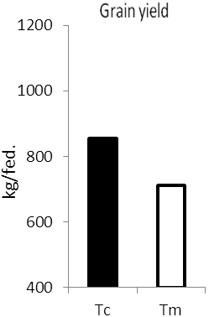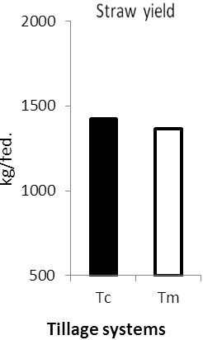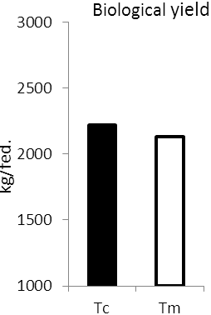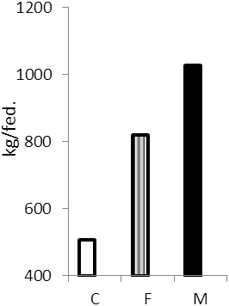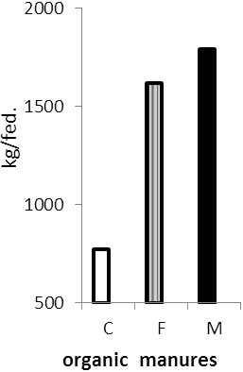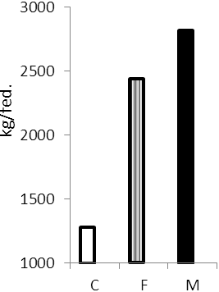
Fig (3) Means of individual effects of the tillage systems and manures addition on
grain, straw and biological yields.

As regards tillage effect, the maximum mean values were 856.93, 1421.37 and 2223.00 (kg/fed.) for conventional tillage (Tc) followed by 712.13, 1366.07 and 2133.50 (kg/fed.) with (Tm) for grain, straw and biological yields, respectively. Grain and biological yields were observed increased significantly in case of (Tc) than those with (Tm) while, straw yield were observed increased non-significantly. EL-Douby el al., (1996)Nawar and Khalil (2004) observed a tendency for increase in seed yield, 100-seed weight and number of pods/plant of faba bean with tillage, compared to no tillage systems.
The interactive effect of tillage systems with organic manures on grain, straw and biological yields , Table (4)showed mostly significant trends. Maximum values of 1113.43, 1866.98 and 2980.42 (kg/fed.) for grain, straw and biological yields, respectively were observed with (Tc + M). While, the minimum values 464.86, 773.75 and 1238.61 (kg/fed.)for grain, straw and biological yields, respectively were observed with treated soil with (Tm + C).
3-Effect of tillage systems and organic manures addition on N, P and K uptake by faba bean:
Data of the combination effects of tillage systems and organic manures addition on N, P and K uptake by grain and straw of faba bean plants are presented in Table (5) and Fig (4). Concerning the effect of organic manures sources, the obtained data revealed that, N, P and K uptake by grain and straw were increased significantly by (F) and (M) applications compared to (C). Also, N, P and K uptake by grain and straw were increased significantly by (M) application compared to (F) application.

Table (5) Individual and combination mean effects of tillage systems and manures addition on N, P and K uptake (kg/fed.) by grain and straw of faba bean (average of 2009/10 and 2010/11 seasons).
Parameters | N uptake (Kg/fed) |  |  | P uptake (Kg/fed) |  |  | K uptake (Kg/fed)
 | Grain |  | Straw | Grain | Straw | Grain |  | Straw
Tillage Systems(TS):
Tc | 30.77a |  | 18.21a | 2.98a | 2.32a | 2.08a |  | 4.51a
Tm | 24.14b |  | 16.47b | 2.42b | 2.15b | 1.62b |  | 4.38a
Organic manures(M):
C | 18.71c |  | 11.57c | 1.69c | 1.28c | 1.29c |  | 2.20c
F | 28.00b |  | 18.90b | 2.87b | 2.50b | 1.83b |  | 5.00b
M | 35.66a |  | 21.54a | 3.58a | 2.93a | 2.43a |  | 6.12a
Interaction effect(TS x M ):
Tc C | 21.08d | 11.25c |  | 1.80d | 1.39c | 1.43c |  | 2.32d
Tc F | 32.26b | 16.37b |  | 3.27b | 2.33b | 2.22b |  | 4.66c
Tc M | 38.96a | 21.79a |  | 3.86a | 3.24a | 2.60a |  | 6.53a
Tm C | 16.34e | 11.89c |  | 1.47d | 1.16c | 1.16d |  | 2.09d
Tm F | 23.73c | 21.45a |  | 2.48c | 2.67b | 1.43c |  | 5.34b
Tm M | 32.35b | 21.28a |  | 3.30b | 2.62b | 2.26b |  | 5.71b
Tc= Conventional tillage, Tm= Minimum tillage , C=No-manures addition, M=Compost, F=Farm yard manure
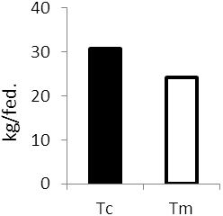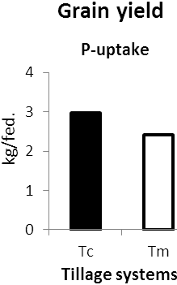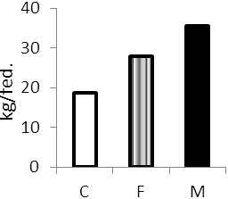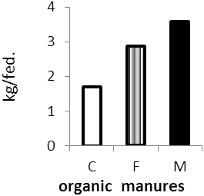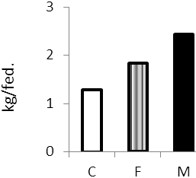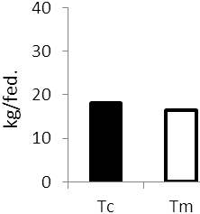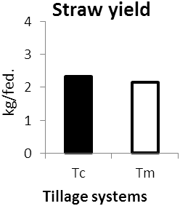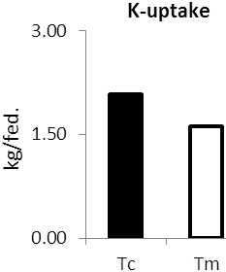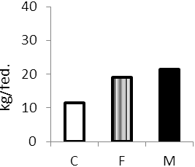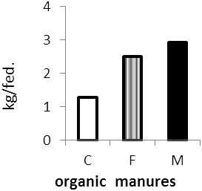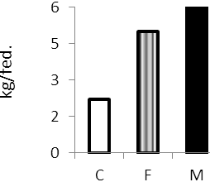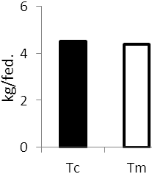
N- uptake

Fig (4) Individual mean effects of tillage systems and manures addition on
N, P and K uptake(kg/fed.) by grain and straw of faba bean.

Zeidan et al. (2005) and Yassen et al. (2010) found that organic fertilizers application significantly enhanced N, P and K uptake of grain and straw yield. The enhancing of N, P and K uptake of grain and straw yield may be found as a result of enhancing the total nitrogen also available phosphorus and potassium of soils were improved by the combined use of organic sources of nutrients which reported by Bharadwaj and Omanwar (1994).
As regards tillage effect, N, P and K uptake of grain and N and P uptake of straw were observed increased significantly in case of (Tc) as compare to (Tm) while K uptake of straw were observed increased in non-significant trend. The increments of uptake as % of (Tm) were 27.47, 23.14 and 28.40 % for grain yield while for straw yield the increments of uptake were 10.57, 7.91 and 2.97 % for N, P and K, respectively. Conventional tillage (Tc) reduces the soil mechanical resistance to plant-roots penetration, leading to deeper rooting system, which increases the uptake of growth resources, especially from the soil deeper layers and consequently, increased seed yield and uptake.
The interactive effect of tillage systems with manures addition on N, P and K uptake of grain and straw yields were found statistically significant. The treatment of (Tc + M) recorded the maximum values of N, P and K uptake i.e., 38.96, 3.86 and 2.60 (kg/fed.) for grain and 21.79, 3.24 and 6.53 (kg/fed.) for straw, respectively. While, the treatment of (Tm + C) recorded the minimum values ofN, P and K uptake i.e., 16.34, 1.47 and 1.16 (kg/fed.) for grain and 11.89, 1.16 and 2.09 (kg/fed.) for straw, respectively.

References
Abdel-Wahab, A.F. and Said, M.S. 2004. Response comparison with the positive control-with no significant of faba bean to bio and organic fertilization under differences – were obtained owing to the biofertilization calcareous soil conditions. Egypt. J. Appl. Sci. with the combined inoculum of Rhizobium and Candida 19 (1) : 305 – 320.
Ali, E.A. and Mahmoud, A.M. 2012. Effect of Combination Between Organic and Mineral Fertilization on Productivity of Some Safflower Genotypes World Journal of Agricultural Sciences 8 (2): 134-140, 2012 ISSN 1817-3047.
Alvarez R. and Steinbach H.S. 2009. A review of the effects of tillage systems on some soil physical properties, water content, nitrate availability and crops yield in Argentine Pampas. Soil Tillage Res 104: 1-15.
Astier M, Maass JM, Etchevers-Barra JD, Pena JJ, de Leon GF (2006) Short-term green manure and tillagemanagement effects on maize yield and soil quality in an Andisol. Soil Tillage Res 88: 153-159.
Azza R. Ahmed; Bayoumi M.A.; Khalil H.M. and Awaad M.S., 2011. Role of bio and organic fertilization on sustaining nitrogen requirements for rice production. J. Soil Sci. and Agric. Eng., Mansoura Univ., Vol.2 (1): 43 - 57, 2011.
Bharadwaj, V. and Omanwar, P. K., 1994. Long term effects of continuous rotational croppingand fertilization on crop yields and soil properties II. Effects on EC, pH organicmatter and available nutrients of soil. J. of the Ind. Soc. of Soil Sci., 42 : 387-392.
Blevins, R.L., and Frye, W.W., 1993. Conservation tillage: An ecological approach to soil management. Adv. Agron. 51,33-78.
Carter, M.R., Saderson, J.B., Ivany, J.A. and White, R.P. 2002. Influence of rotation and tillage on forage maize productivity, weed species and soil of a fine sandy loam in the humid climate of Atlantic, Canada. Soil and Tillage Res. 67: 85-98.
Chapman, H.D. and pratt, P.F., 1961. Methods of Analysis for Soil, Plant and Water. DIV. Agric. Sci.,Univ. of Calif.
Diaz-Zorita, M. 2000. Effect of deep tillage and nitrogen fertilization interactions on dry land corn (Zea mays L.) productivity. Soil and Tillage Res. 54: 11-19.
EL-Douby, K.A., EL-Habbak, K.E., Seif EL-Nasr F.M. and Basal, S.A. 1996. Effect of tillage system and plant density under different phosphorus fertilization levels on the productivity of faba bean (Viciafaba L.). Ann. Agric. Sci., 34: 907–918.
El-Fakhrani, Y.M. 1999. Combined effect of P-fertilization and organic manuring on barley production in sandy soils. Fayoum J. Agric. Res. & Dev., 13(2): 81-97.
El-hady O.A. and Abo-sedera1 S.A. 2006. Conditioning Effect of Composts and Acrylamide Hydrogels ona Sandy Calcareous Soil. II-Physico-bio-chemical Properties of the Soil International journal of agriculture & biology 1560–8530/2006/08–6–876–884
Francis, C.A. 1986. Distribution and Importance of Multiple Cropping, pp:1–20. Multiple Cropping Systems, Chapter 1.
Gonzalez, R.F. and Cooperband, L.R. 2003. Compost effects on soil chemical properties and field nursery production. J. Environ. Hortic., 21: 38-44.
Herridge, P.F. and Holland, J.C.1992. Production of summer crops innorthern New South Wales. I. Effect of tillage and double croppingon growth, grain yield and N-levels of six crops. Australian J. Agric.Res., 43: 105–122.
Hussain, N., M. Abid and I. Raza, 2004. Respose of wheat (triticum aestivum) to phosphorous in the presence of Farmyard manure, INduc J. Plant Sci., 3:298-302.
Jackson, M.L., 1973. Soil Chemical Analysis. Prentice-Hall, Englewood Cliffs. New Jersey.
Khalil, H.E. 1997. Evaluation of agronomic and economic aspects of sunflower under soil tillage practices and phosphorus application. Adv. Agric. Res., 2: 67–78.
Klute, A. 1986."Methods of Soil Analysis Part I. Physical and mineralogical Methods". 2nd ed., Agron. Madison, Wisconsin, U.S.A.
Little, T. M and Hills, F. J., 1978. Design and analysis. P:115-124 John wiky and sons. New Youk.USA.
Metting, F.B. 1993. Soil microbial ecology. Application in agricultural and environmental management. Marcel Dekker, New York.
Naeem, A., fayyaz-ul-hassan and ghulam qadir 2007 . Effect of subsurface soil compaction and improvement measures on soil properties. International journal of agriculture and biology.1560–8530/2007/09–3–509–513
Naveed Iqbal Khan, Asmat Ullah Malik, Farah Umer and Irfan Bodla, M. 2010 . Effect of tillage and farm yard manure on physical properties of soil. International Research Journal of Plant Science (ISSN: 2141-5447) Vol. 1(4) pp. 075-82, October, 2010
Nawar, A.I. and Khalil, H.E. 2004. Evaluation of some agronomic and economic aspects of faba bean (Vicia faba L.) under different soil tillage systems and bio-and chemical phosphorus fertilization. Adv. Agric. Res., 9: 593–666.
Page, A.L., Miller R.H. and Keeny D.R., 1982. "Methods of Soil Analysis Part II:“Chemical and Microbiological Properties ". 2nd Ed. Am. Soc.Agron. Madison, Wisconsin, U.S.A.
Reeves, D.W. 1997. The role of soil organic matter in maintaining soil quality in continuous cropping systems. Soil Tillage Res 43:131-167.
Sanyal, S.K. and De Datta, S.K. 1991. Chemistry of phosphorus transformations in soil, Adv. Soil Sci. 16 (1991) 1–120.
Sharma, D.P., Mehta, K.K. and Yadav, J.S.P. 1982. Effect of reclamation practices on soil properties and crop growth on farmers field. J. Ind.Soc. Soil Sci., 29: 356–60.
Shirani H., Hajabbasi, M.A. Afyuni, M. and Hemmat, A. 2002 . Effect of Farm yard manure and tillage system on soil physical proportion and corn yield in central Iran. Soil and Tillage Research. 68: 101-108.
Smith, W.H. 1996. Utilizing composts in land management to recycle organics. In: M. deBertoldi, P. Sequi, B. Lemmes, and t. Papi (Eds.), the science of composting, Part 1. Blackie, Glasgow, pp. 413-422.
Wafaa, .T. El-Etr ; Laila, K.M. Ali and Elham, I. El-khatib 2004. Comparative effect of bio – compost on growth, yield and nutrients content of pea and wheat plants grown on sandy soils. J. Agr. Res., 82 (2): 73-94.
Weber, J. Karczewska, A. Drozd, J. Licznar, M. Licznar, S. Jamroz, E. and Kocowicz, A. 2007. Agricultural and ecological aspects of a sandy soil as affected by the application of municipal solid waste composts, Soil Biol. Biochem. 39 (2007) 1294–1302.
Yassen, A.A., Khaled, S.M. and Zaghloul, M. 2010. Response of wheat to different rates and ratios of organic residues on yield and chemical composition under two types of soil. Journal of American Science, 6(12): 885-864.
Zachman J.E., Linden, D.R. and Clap C.E. 1987. Micro porous infiltration and redistribution as affected by earth worms, tillage and residue. Journal of American Soil Science Society. 51:1580-86.
Zeidan, M.S., Hozayn, M. and El-Krammany, M.F. 2005. Effect of different organic fertilizer sources and levelson growth and yield of wheat (Triticum aestivum L.) in sandy soil Egypt. J. Agric. Res., 2(2): 643.
Zeidan, M.S., Kabesh, M.O. and Saber, M.S.M. 2001. Utilization of biofertilizaers in field crop production. 14- Effect of organic manuring and biofertilization on yield and yield composition of two faba bean varieties cultivated in a newly reclaimed soil. Egypt. J. Agron., 23 pp. 47-57.
Zenter R.P., Lafond G.P., Derksen D.A., Nagy C.N., Wall D.D. and Mayb W.E. 2004. Effects of tillage systems and crop rotation on non-renewable energy use efficiency for a thin black Chernozem in the Canadian Prairies. Soil Tillage Res 77: 125-136.

12/22/2013

