Energy saving, environmental benefits, economic returns and Performance evaluation study of HPS and LED lighting systems in Roadways

Ahmed Mohamed Ibrahim ¹, ’Mohamed Mehanna ², Mohamed Abd-elmonem ³

^{1.} Faculty of Engineering, Al-Azhar University, Nasr City, Cairo-Egypt.

mohamed.pee@gmail.com

Abstract: A new Light-Emitting Diode (LED) Lighting system is proposed as an optimized solution for existing and future roadway lighting system in comparison to High Pressure Sodium (HPS) lighting system (While the CF lighting system brought out of the competition) due to the LED high quality, life time and Light Output efficacy in comparison to HPS. Also environmental, economical and visual spectrum performance benefits which make the LED technology as a revolution of lighting system specially in roads lighting.

[Mohamed Abdelmonem. Energy saving, environmental benefits, economic returns and Performance evaluation study of HPS and LED lighting systems in Roadways Forests. N Y Sci J 2013;6(12):169-173]. (ISSN: 1554-0200). http://www.sciencepub.net/newyork. 27

Keywords: Energy saving; economic returns; environmental benefits; Lighting; Rood Lighting; HPS; LED.

1. Introduction
As oil and gas reserves decrease and the demand for energy increases, energy conservation is an urgent priority, however the most of generation of electricity in Egypt by oil and gas fuel we need to save energy more than others for both economical and environmental reasons. while The annual cost of public lighting in Egypt exceeds 2.5 billion pounds as per 2010/2011 EEHC Energy Conservation Committee.
Thus, use of energy-efficient technology is required in roadway lighting to mitigate the effects of the energy crisis. Light-emitting diodes (LEDs) are light sources that have been developed as an energy-efficient alternative to high-intensity discharge (HID) street lighting.[1]
The use of LEDs as a light source in roadway lighting can potentially save energy costs and reduce the frequency of maintenance.
So more of studies have performed to compare LED lighting systems with other lighting systems including HPS lighting system and compact fluorescent (CF) lighting systems. Most of these studies are published in IES, IEEE and U.S department of energy associations including demonstration and new construction economical and environmental benefits due to the revolution of LED technology which is developed quickly more than expected in comparison to other ordinary light sources.
The human visual benefits were studied and achieved about 2.5 years simple payback period by considering the human eye sensitivity to luminaire spectral power density with the photopic and scotopic spectral which showing that the S/P value for the LED source is about a factor 2.65 greater than the HPS source. [2] [3]
One of LED lighting application is roadways lighting and The rapid development of light emitting diodes (LEDs), especially their increasing luminous efficacy makes them viable street light source offering potential for energy savings lighting system. LEDs also provide other advantages such as reduced maintenance costs, longer service life, the possibility to control the illumination levels through step 10w or less and dimming methods and also reduced light pollution. However, LED lighting still has some disadvantages.[2] [3]
The lack of standardization, temperature dependence and high capital price of the LED luminaires, restrict their application and wider adoption in road lighting applications. Also, the technical data provided by the seller or manufacture of the luminaire is often inadequate for some comprehensive comparison.
Beside the human visual, lances light distribution, high lumen output and long life time of LED the energy saving about 50 percent is the top advantage for The risk of global oil depletion thus the rise of pricing.
This study could be a completion for Similar study are performed to make a comparison between CF, LED and HPS and published for the same author in the same journal previously this previous study brought the CF lighting system out of the competition and explained this in the main master thesis which showing the benefit of LED as following:
After carrying out the roadway study and technical assessment on LED road lighting system with HPS and compact fluorescent (CF) lamp roadway lighting systems, there are some findings on the comparison of these road lighting systems.
The utilization factor: It’s higher for LED due to lenses light concentrated distribution provide advantages of LED space longer than HPS and CF which mean less number of poles and installing cost for LED than HPS than CF respectively. Also the advantage of better uniformity for LED than HPS and CF lighting systems which mean higher quality for LED than HPS than CF respectively with less number of luminaires.
Also the light distribution is enhanced by choosing the category II full cut-off for both LED and HPS while the CF have not the classification categories for that the compact fluorescent lamps are not commonly manufactured for roadway lighting it’s may be for outdoor area lighting but not for street lighting.
The life time: It’s longer for LED 60,000hrs which is much longer than HPS (22,000hrs) and CF (8,000hrs) systems which effect positively for LED in re-lamping cost.
Light Output Ratio (LOR): It’s for LED lamp is closed to 100% (no diffuser) while LOR for HPS is 78% and 65% for CF which mean less losses in lighting from lamp to luminaire.
Step power rating: LED allows to set by 10 watt and less incremental give us good power rating choice for less losses of light than exactly needed.
Luminaire Efficacy (lm/watt): It’s about 89.3, 67.7, 44.3 lm/watt for LED, HPS and CF respectively which mean more light output for each watt in LED more than HPS and more less light output for CF which is the worst for all.
Dimming option : Dimming is a LED feature that can be very useful in road lighting, as it allows for reduced illumination levels from 100% to 3% by reducing the drive current and thus reduced energy consumption, when daylight can provide a lot of the light.
Vision impact: The visual spectrum effect of LED economically effect is not covered in this study but it was studied previously.[3] which is determined for LED about 2.5 years simple payback period in comparison to HPS.[3]
Capital Cost: HPS lamp lighting system has lower capital cost than LED while CF capital cost is the higher than both however the capital cost for each luminaire is the lower for CF but through the large number of luminaire to achieve the standard lighting requirements.
Running Cost: LED lamp lighting system is the lower running cost of the three lighting systems through the study period for less power consumption, re-lamping and maintenance cost.
Payback period: The simple payback period is 4.2 years and about 5.0 years if investment rate is 7% this payback period will decrease gradually with the by increasing of LED output efficacy which already reach 130 lumen/watt and expected to increase more in the future.
Also the payback period will decreased by the time by enhancement of life time of LED to be more than 60,000 hrs which already increased by some manufactures to more than 100,000 hours. while the initial costs of the luminaires in this previous project reflected the pricing at the beginning of 2013 and performance levels, and should be viewed in that context with respect to decisions being made today.[4]
However, these values subject to slight interpretation/modification according to the following issues:
- The choice of luminaire photometric can be vary from designer to other depending on available date and experience/knowledge of the local and international market.
- The technology of LED manufacturing is developed with months to better in compared with HPS and CF lamps technology which almost fixed.
- It was difficult to precisely define constant price of a luminaire for all manufactures in Egypt but for all manufacturers the capital cost is reduced gradually very quickly by the time.
The study which will be presented now is one of the popular method used in design road way lighting system which is IES standard RP-8-00 luminance method. which compare between 267w LED (XIL LEDway-CREE) and 250w (288w including ballast) HPS luminaires (PR525-Ruud, CREE) in express roadway wide 14.0 m to achieve the luminance(L) requirements of RP-8-00 standard and evaluation of the lighting performance, quality, energy saving, environmental benefits and economic returns based on the end of 2013 pricing using Dialux simulation software by actual technical date submitted by Ruudlighting manufacturer.[5]

2. Material and Methods
The following data for the road way used for this comparison study using IES RP-8-00 Luminance method.
Table-1. Case study roadway data.[6] [7]
Road Way Data
Road class (IES RP-8-00) | Expressway
Width (m) | 14.0
No. of lanes | 4
Lanes Width (m) | 3.5
Road surface | R3
Q0 | 0.07
Av. no. of op. hours per day | 12

Table -2. Case study Lighting design criteria
Lighting Design Criteria | HPS | LED
Supplier | Ruud | Ruud-Cree
Arrangement | Single row | Single row
Pole Spacing (m) | 41.0 | 67.0
Mounting Height (m) | 14.0 | 14.0
Tilting angle | 0.0 | 0.0
Overhang (m) | 1.0 | 1.0
Luminaire Wattage | 288.0 | 267
Lamp Flux (Lumen) | 31,875.0 | 25,188.0
Luminaire Flux (Lumen) | 23,070.0 | 25,188.0
LOR | 72% | 100%
Luminaire Effecacy (Lm/watt) | 80.1 | 94.3
Photometric Category | II-M-F.C | II-M-F.C
Maintenance factor | 0.68 | 0.68
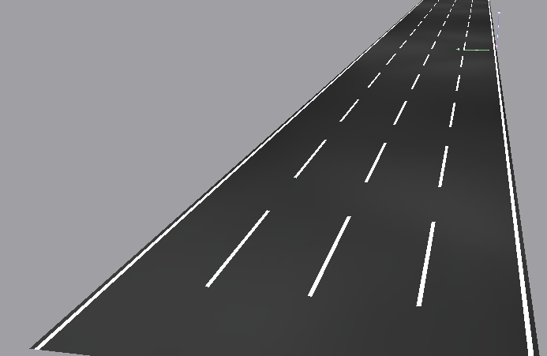
Figure 1.Case study Roadway

3. Results
This following results as per Dialux simulation software and actual technical data provided by manufacturer.

Table -3. Case study calculation results. .[6] [7]
Results and Comparisons | HPS | LED | Standard IES (L method)
Lav [cd/m2] | 0.8 | 0.8 | ≥ 0.8
Lav/Lmin | 2.6 | 2.2 | ≤ 3.0
Lmax/Lmin | 4.9 | 5.0 | ≤ 5.0
Lv max/Lav | 0.2 | 0.2 | ≤ 0.3

Table 4. Analysis of results [8] [9]
Results conclusions | HPS | LED
Poles nos. per km | 24.4 | 14.9
power consumption per km (Kwatt/km) | 7.0 | 4.0
Elec. Tariff Price (L.E) | 0.4 | 0.4
Road energy consumption (kwh/km/year) | 30,767 | 17,455
Energy Saving by using LED instead of HPS | 43%
Consumption Running cost (LE/year/km) | 12,676 | 7,191
Replacing price (LE) | 600.00 | 2,800.00
Life time (hour) | 22,000 | 60,000
Replacing cost (LE/km/year) | 2,914 | 3,051
Total Running Cost (LE/km/year) | 15,589 | 10,242
Supply/Install price (LE) | 4,500 | 9,500
Total capital cost (LE/km) | 109,756 | 141,791
LED Payback period (simple) (years) | 6.0 | -
Return on Investment - RoI | 16.7%
Internal Rate of Return -IRR | 10.6%
LED Payback period (7% annual interest) (years) | 8.0 | -

4. Discussions
The study results showing energy consumption reduction by 43% which mean CO2 emission reduction by the same percent in similar countries which have main fuel for electricity generation by diesel and gas. Also Return on Investment - ROI is 16.7% and Internal Rate of Return - IRR (10yearrs) is 10.6% but the main parameter effect in this study is the capital installation cost of LED in comparison to HPS luminaires which rapidly decreased by the time and this will decrease the achieved simple payback period 6.0 years to less period.[10]

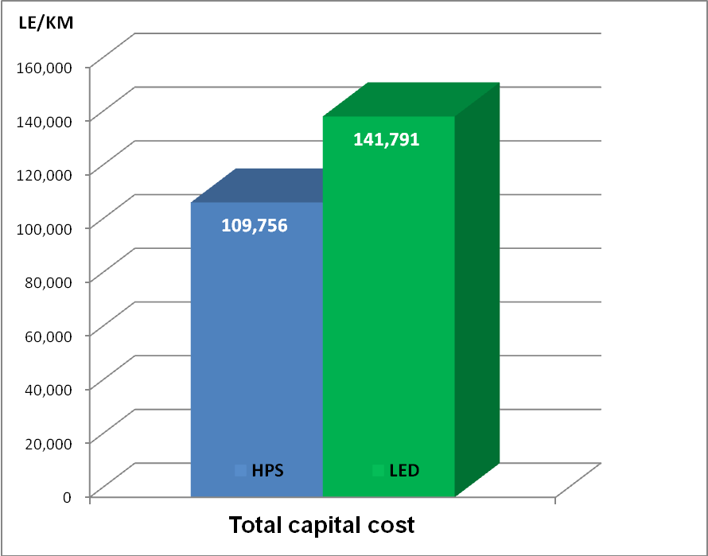
Figure 2.Capital cost comparison (LE/Km/year).

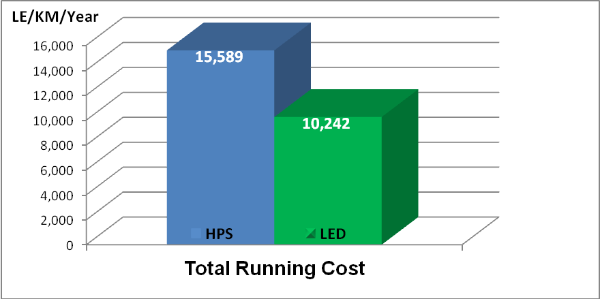
Figure 3. Running cost comparison (LE/Km/year)

Figure 4.Payback period chart.

5. Conclusion
LED technology has developed dramatically over the last few years to be expected as the future of lighting systems in over the world.
The best commercially available LEDs currently have efficacies of 130 lm/W (which is two times that of a typical CF lamp and close and above to that of a HPS) which reduce the energy consumption for lighting roads and CO2 emission. Also life time of LED lamps close to 100,000 hours which is four times for HPS. [11] [12]
The SSL industry has set itself a target of attaining LED efficacy levels of 200 lm/W, higher overall light output and competitive prices by 2020. If these targets are attained SSL could become the general-lighting system of choice and the overall efficiency of lighting could rise considerably.
Not many companies in the world meet the qualitative standards in the production of LED lamps.
Only about 10 experienced manufacturers are able to produce high-quality LED street lamp with the highest quality standards to not to be worse than other types of existing lamps. Also the new installation of roadways lighting by new LED luminaires type may be energy efficient lighting system if the selection of luminaire made carefully.

Corresponding Author:

Eng. Mohamed Abdelmonem

Department of Electrical Engineering
Faculty of Engineering - Al-Azhar University
Nasr city, Cairo, Egypt

E-mail: mohamed.pee@gmail.com

References
- DOE, Final Report Prepared in Support of the U.S. DOE Solid-State Lighting Technology Demonstration Gateway Program, 2010.
- L. T. M. P. D. L. H. D. Anne-Mari Ylinen, Road Lighting Quality, Energy Efficiency, and Mesopic Design – LED Street Lighting Case Study, New york, NY: IES/LEUKOS, 2011.
- F. U. o. J. d. F. (. NIMO - Modern Lighting Res. Group, An experimental comparison between different technologies arising for public lighting: LED luminaires replacing high pressure sodium lamps, Juiz de Fora,Brazil: IEEE, 2011.
- Comparison Study between using HPS, LED and C.F Lamps in Roadway Lighting, New York Science Journal 2013.
- Cree lighting applications and case study http://www.cree.com.
- IES 2000. RP-8-00. Roadway Lighting. Illuminating Engineering Society of North America, New York, NY.
- Lighting research center, 21 union street, http://www.lrc.rpi.edu.
- American National Standards Institute and IES. 1983. American national standard practice for roadway lighting, ANSI/IES RP-8-1983. New York: Illuminating Engineering Society of North America.
- Lighting engineering applied Calculations, R. H. Simons and A. R. Bean.2001.
- Tarek M. Zarif, LC, PE Lighting courses and publications. http://www.mep-ls.com/
- Commission Internationale de l'Éclairage. 1990. Calculation and measurement of luminance and illuminance in road lighting. CIE publication 30.2-1982. Paris: Bureau Central de la CIE.
- DOE, Final Report Prepared in Support of the U.S. DOE Solid-State Lighting Technology Demonstration Gateway Program, 2010.

12/2/2013

