**Phytotoxicity of silver nanoparticles on *Vicia faba* seedlings**

Essam Ahmed Abdel-Azeem 1* and Badr Awad Elsayed 2

1. Botany and Microbiology Department, Faculty of science, Al-Azhar University, Cairo, Egypt

2. Chemistry Department, Faculty of science, Al-Azhar University, Cairo, Egypt

*[essam_1616@hotmail.com](mailto:essam_1616@hotmail.com)

**Abstract:** Silver engineered nanoparticles (AgNPs) are one of the most widely used nanoparticles and expected to enter natural ecosystem. Here, we examined the effect of different sizes of AgNPs (65, 50 and 20 nm) on germination percent, root growth, Mitotic Index (MI) and chromosomal aberrations at 50 ppm for time intervals (6, 12 and 24 hrs) in *Vicia faba*. As compared to the control (untreated), the results clearly revealed that the germination percent not affected after treatments whereas root length, mitotic indices as well as chromosomal morphology much more affected. As the nanoparticle size decreased, the mitotic index and root growth values were found to be decreased with the increasing in duration of treatment (hrs), at the same time, the numbers of aberrant cells were observed to be increased. Cytological changes were observed viz. disturbed chromosomes at metaphase and anaphase, laggards, fragments, bridges, chromosome stickiness and micronuclei (Mn). Our findings suggest that seed germination of the tested plant is resistance to AgNPs whereas root length as well as mitotic cell cycle were susceptible to both size particles and duration of treatment.

[Abdel-Azeem EA and Elsayed BA. **Phytotoxicity of silver nanoparticles on *Vicia faba* seedlings.** *N Y Sci J* 2013;6(12):148-156]. (ISSN: 1554-0200). <http://www.sciencepub.net/newyork>. 24

**Keywords:** AgNPs; germination; root growth; mitosis; aberrant cells; *Vicia faba*

**1. Introduction**

Nanoparticles possess exceptional physical and chemical properties which led to rapid commercial production. Silver nanoparticles (AgNPs) are one of the most widely used engineered nanoparticles (ENPs) due to their antimicrobial potential and safety associated with human and environmental use. AgNPs have been used to create new consumer products, drugs, various food and medical products. The interaction of NPs with cell, uptake, mechanism of action, distribution, excretion, toxicological endpoints and its releasing control remain unanswered.

Nanoparticles can lead to a wide variety of toxicological effects on human[1], environment[2], bacteria[3] and aquatic organisms[4]. There have been only few reported studies on vascular plants showed that AgNPs have detrimental effects on plant growth[5]. Stmapoulis *et al.*[5] reported that 100 nm AgNPs at 100 and 500 mg/L resulted in 41% and 57% decreases in the biomass and respiration rates, respectively of *Cucurbita pepo*, as compared to control plants. Gubbins *et al.*[6] showed that AgNPs could inhibit the growth of *Lemna minor*. Kumari *et al.*[7] and Pulate *et al.*[8] investigated that AgNPs had cytotoxic and genotoxic impacts on *Allium cepa* meristems. They showed that different concentrations AgNPs induced different types chromosomal aberrations such as chromosomes stickiness, chromatin bridge, chromosomal breaks, disturbed metaphase and micronuclei (Mn). The frequency of aberrant cells was increased with the increase AgNPs concentrations and duration. Regarding (MI) values, results also revealed that the mitotic indices were decreased by increasing both concentration and time intervals as compared to the control[7&8].

Patlolla *et al.*[9] studied the genotoxic effects of different concentrations of engineered AgNPs of diameter size (60 nm) on *Vicia faba* root-tip meristems. The authors recorded that different treatments significantly increased frequency of mitotic abnormalities and decreased (MI) as compared to untreated. Liyan Yin *et al.*[10] found that silver nanoparticles, in general, had no effect on germination rate whereas significantly reduced root growth at (6 nm) than for (20 nm). Many authors have reported that different sized Ag nanoparticles have different toxicities which may be size and shape dependent and can penetrate the cell walls[11&12]. Nanometer-sized particles have shown special toxicity and are usually more toxic than larger one[13]. Particles having less than (50 nm) diameter proved to be highly toxic [14]. Although there have been some attempts to determine the toxic effects of AgNPs in microbes, mammalian and human cell lines, there little informations on plants which play a vital role in ecosystems.

Studies on potential toxicity of NPs to ecological terrestrial test species are still lacking[24]. Phytotoxicity studies reported both positive and negative effects of nanoparticles on higher plants, on seed germination, root elongation, cell division, growth and metabolic processes [18,19]. Thus, the aim of this investigation was to increase our understanding to the effects of nano-sized particles on *V. faba* and try to answer the big question of our research: **Does the germination rate, root growth, cell division, and clastogenic abnormalities sized dependent nano-particles**?**.**

**2.** **Materials and Methods**

Silver nanoparticles (AgNPs) were supplied from Department of Chemistry, Faculty of science, Al-Azhar University, Nasr City, Cairo, Egypt. The size distribution obtained by Transmission Electron Microscope (TEM) were 65 nm ± 8.4 (Fig. 1), 50 nm ± 4.1 (Fig. 2) and 20 nm ± 7.8 (Fig. 3).

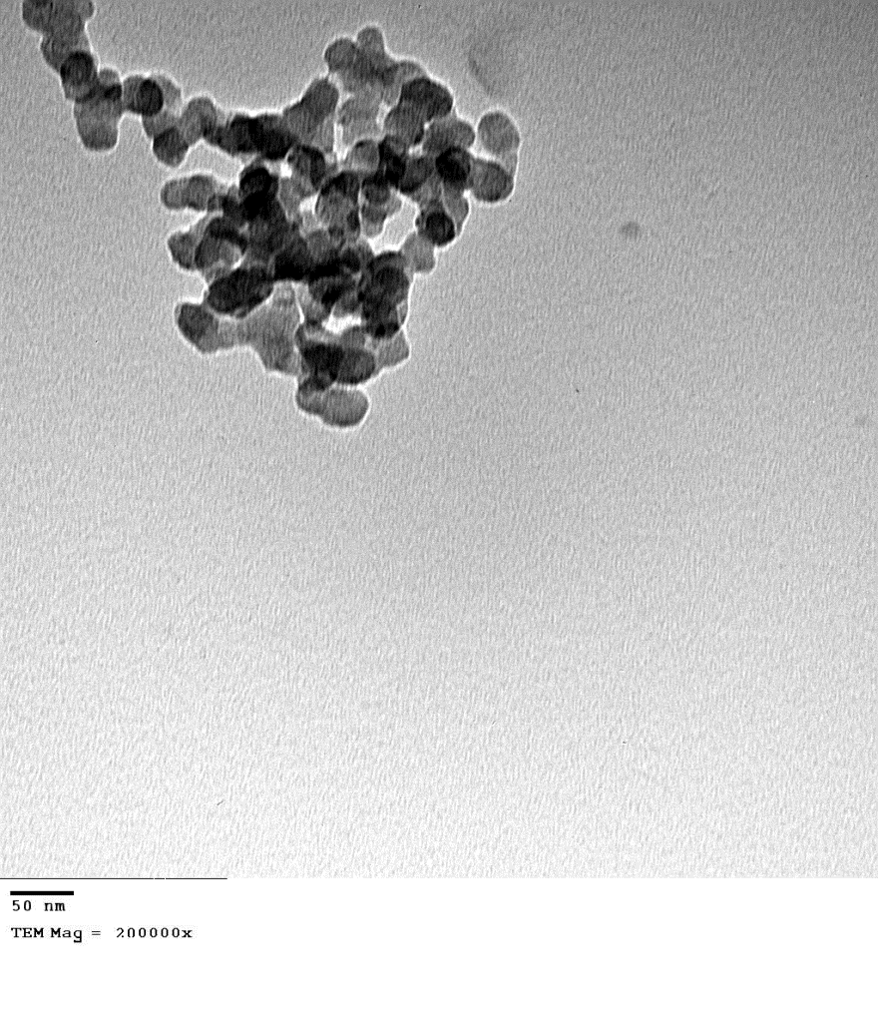

Figure 1. The size of silver nanoparticles (AgNPs) under TEM (65nm ± 8.4).

**2.1. Preparation of silver nanoparticles**

Silver nanoparticles were prepared using reagents of analytical reagent grado. Silver nitrate (AgNo3) [Aldrich] was used as received. Aqueous solutions (10-2M) of silver nitrate salt was used as stock solution. Glucose (BDH), distilled water was used throughout the experiment. The electronic spectrum was recorded using an Infinity Gold Mattson, Unicam, UK FTIR spectrophotometer after taking the solutions in a 1cm quartz cuvette Silver nanoparticles were prepared by dissolving 0.2gm of sugar in 3.9ml water and then 1 ml (10-2M) of silver nitrate was added to it, so that the final volume of the solution is 4 ml. The solution was heated on a hot water bath, in the temperature range 70-75ºC until the solution turned pale yellow indicating the formation of silver nanoparticles (Fig. 4). U.V. & vis. spectra of silver nanoparticles showed a peak at 420 nm and Fluorescence peak at 472 nm when excited with 350 nm of optical source[36].

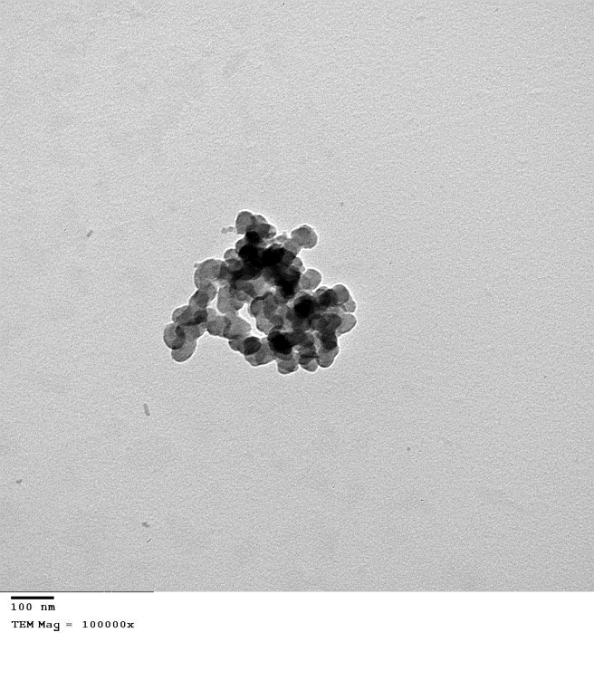

Figure 2. The size of silver nanoparticles (AgNPs) under TEM (50nnn ± 4.1).

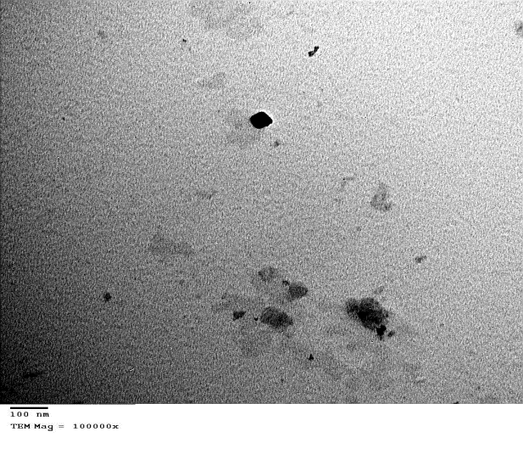

Figure 3. The size of silver nanoparticles (AgNPs) under TEM (20nm ± 7.8).

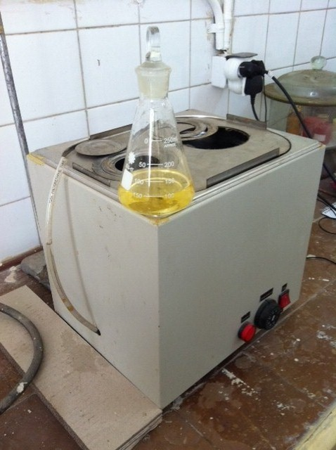

Figure 4. Pale yellow AgNPs.

**2.2. Seedlings of *Vicia faba* as test materials**

Seeds of *Vicia faba* L.( var. Giza 6) were obtained from the Crop research Institute, Giza, Cairo, Egypt and were used in the present investigation. *Vicia faba* having six pairs (2n=12) of relatively large chromosomes that is excellent for assessing chromosomal aberrations (CA) and validated by the International program on Chemical Safety (IPC,SWHO).

**2.3. Germination rate (%), root growth (cm), and mitotic study**

Seeds of *Vicia faba* (broad bean) of equal sizes were sterilized by soaking in 10% sodium hypochlorite for 10 minutes, soaked in distilled water at 26ºC for 24 hrs and then allowed to germinate in Petri dishes of equal sizes. One piece of filter paper and 5ml of50 ppm of tested nano-sized particles (65, 50, 20 nm) in distilled water were put in each Petri dish. Seeds were then transferred into the filter paper, with 10 seeds per dish and 1 cm or larger distance between each seed. Distilled water was used for the control (untreated) experiments. All the treatments and related controls were divided into two groups. For the germination rate and root growth investigation, seeds of the first group were allowed to germinate for one week then seed germination percent was calculated and seedling root length was measured. At least, four replicates were carried out for each treatment and related control. A seed was considered to have germinated when radicle emerged from the seed coat. The germination rate (%) was calculated as the proportion of the seeds that germinated to total number of seeds multiplied by 100.

For mitotic study, the above treatments with AgNPs were carried out for time intervals (6, 12, 24 hrs) then the root meristems for each treatment as well as the control were detached at length of (1.5-2.0 cm) then fixed in Carnoy's fixative (1:3 v/v aceto-ethanol) for 24 hrs then washed with distilled water, hydrolysed in (1n HCL) at 60ºC for (6-7 min). After hydrolysis, the root tips were thoroughly washed with distilled water several times and then stained using Feulgen stain squash technique. After complete staining (45-60 minutes), the dark stained tips containing the meristem were transferred to clean slides then separated from the rest of the roots. Actic acid (45%) was used for squash preparation. At least, four temporary slides were prepared for each treatment and control. Semi-permanent slide was prepared by putting one drop of 1:1 (Glycerol: 45% Acetic acid) around the covering slide then keeping in refrigerator for short time (3-4 hrs) until examination. The mitotic index (MI) was calculated for each treatment and related control as the number of dividing cells to the total number of examined cells (dividing and non-dividing), multiplied by 100[38]. Numbers and types of chromosomal aberrations were recorded in all treatments as well as the control. Total percent of aberrant cells was calculated for each treatment and related control as the number of total aberrant cells to the number of dividing cells multiplied by 100[39].

**2.4. Statistical analysis of obtained data**

Means and standard deviations were derived from four repeated samples of each treatment and related control. The data obtained from the various treatments were statistically analyzed using the t-test at two levels (0.05 and 0.01).

Microphotographs were taken from selected semi-permanent slides, using Digital Camera Solution Disk (Toup Camera Ver.3.2,2 Mega Pixel) and oil objective lens (100X) of Light Compound Microscope.

**3. Results and Discussion**

**3.1. The effect of AgNPs on germination rate (%)**

Phytotoxicityof higher plants should be investigated in order to develop a comprehensive toxicity profile for nanoparticles**.** Seed germination and root elongation is a rapid and widely used acute phytotoxicity test owing to sensitivity, simplicity, low cost and suitability for unstable chemicals. The effect of silver nanoparticles AgNPs (65, 50 and 20 nm) on germination rate of *Vicia faba* was examined. Root meristems were treated with 5mlof 50 ppm concentration of AgNPs in all treatments. Generally, root-tips frequently used for cytogenetic studies in the past five decades were from *Vicia faba* and *Allium cepa* which are excellent materials for clastogenicity studies of physical and chemical agents [15&16]. The obtained data (Table 1 and Figs. 5, 6) clearly revealed that exposure to different diameters of AgNPs had insignificant effect on seed germination rates as compared to the control (untreated). There were no apparent visual differences in seeds germinated with or without AgNPs, indicating that the engineered particles not pose any toxicological effects to the seeds during the germination process. This is consistent with other studies that report NPs of (Ag, Zn and Al) had less of an effect on seed germination[10,17,18,37]. This may be explained by the protective effect of the seed coats which can have selective permeability[20]. AgNPs may aggregate or be complexed by ligands which can cause a decreased in toxicity and would lead to lower exposure to seeds and seedlings[21]. Lin and Xing[18] reported that the two nanoscale metal oxides of Al and Zn had, generally, no obvious effect on seed germination of six species commonly used in phytotoxity studies. Barklew *et al.*[22] have been stated that the seed coat of tobacco seeds were most likely not permeable to the NPs of Al oxide, therefore the germination rate was not affected.

Table 1. Effect of different nano-sized particles of silver on germination rate and root growth of *Vicia faba* as compared to the control.

|  |  |  |
| --- | --- | --- |
| **Root length (cm)** | **Germination (%)** | **Treatment** |
| 3.33±0.12 | 98.0± 0.17 | control |
| 2.97±0.87  -S | 96.8±0.33  NS | 65nm |
| 1.65±0.45  -S | 96.0±0.51  NS | 50nm |
| 0.87±0.75  -S | 95.61±1.34  NS | 20nm |

**NS**= Nonsignificant, **S**= Significant at 0.05 level

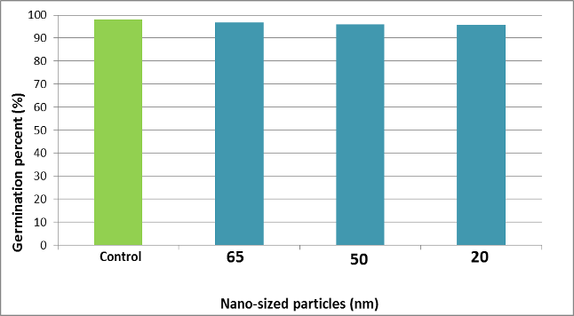

Figure 5. Relationship between nanoparticles-size of Ag metal and seed germination percent of *Vicia faba*.

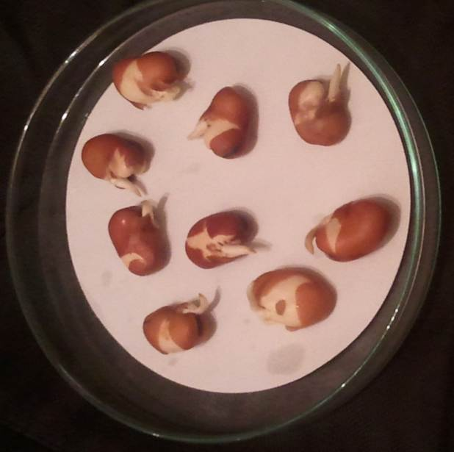

Figure 6. Germination rate of *Vicia faba* not affected after exposure to AgNPs of different sizes.

**3.2. Effect of AgNPs on root growth**

Exposure to silver nanoparticles has statistically significant decreasing root length where the average root length was 0.87 cm after treatment with 20 nm as compared to the control of the average root length 3.33 cm. Overall, as the size of nanoparticles decreased, the average root growth significantly decreased (Table 1 and Figs. 7, 8). Our findings were consistent with several studies which investigated that different types of nanomaterials statistically significantly decreased root growth as the nanoparticle size decreased[10]. Numerous studies showed that as the concentration of ENPs of silver increased, the root lengths significantly decreased[10,18,22]. Yin *et al.*[10] have been stated that most of the Ag in the plant appeared to remain associated with its roots and the translocation factor (Ag in shoot / Ag in root) was very low. It has also been reported that NPs may have to penetrate cell wall and plasma membranes of epidermal layers in roots to enter vascular tissues[23]. This could explain why the root response was strong.

**3.3. Microscopic changes**

**3.3.1. Mitotic Index(MI) and cell cycle**

The mitotic index reflects the frequency of cell division and can be correlated with rate of root growth, suggesting that the inhibition of root growth resulted from inhibition of the cell division. It is clearly evident (Tables 2, 3, 4 and Fig. 9) that treatments with nano-sized particles of Ag (50 ppm) for time intervals 6, 12, 24 hrs produced a size, duration, and concentration-dependent mitotic index. The results showed that mitotic indices values were found to be decreasing with the increase in duration treatment and the decrease in nano-sized particles. The obtained data recorded cytotoxic effects after treatment with AgNPs of 20 nm for 24 hrs as compared to the control (Table 4). It was concluded that increasing in time of treatment had an inhibitory effect on cell cycle when the treatment was exposed to lower nano-sized Ag particles (20 nm). The reduction of MI in most treatments clearly showed the mitodepressive and cytotoxic effect of AgNPs. Our results were consistent with those observed by Pulate *et al.*[8], Patlolla *et al.*[9] and Kumari *et al.*[7]. This could be due to a slower progression of cells from S (DNA synthesis) phase to M (Mitosis) phase of the cell cycle as a result of AgNPs suspension exposure. It has been suggested that the cytotoxicity level can be determined by the decreased rate of the mitotic index[25].The mitodepressive and cytotoxic effect of AgNPs might have been achieved by the inhibition of DNA synthesis at S-phase[26]. It has been reported that the presence of ionic Ag has shown to be important to the toxicity of AgNPs to human hepatoma cells[27], algae[28] and bacteria[29]. However, it is found that the phytotoxic effect of AgNPs to *Lolium multiflorum* was not due to solely the ionic Ag ions [30]. In this regard, it has been reported that the high toxicity of GA-AgNPs was not only due to the presence of ionic silver. However, it is possible that interactions between the plants and the AgNPs enhanced the release of Ag from the AgNPs colloids as reported for algae[10].

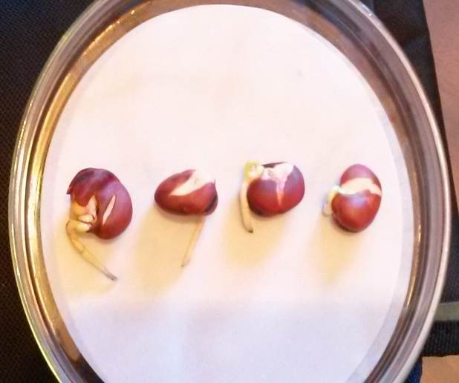

Figure 7. Effect of silver nanoparticles on root growth of *Vicia faba* From left to right, control, 65nm, 50nm and 20nm.

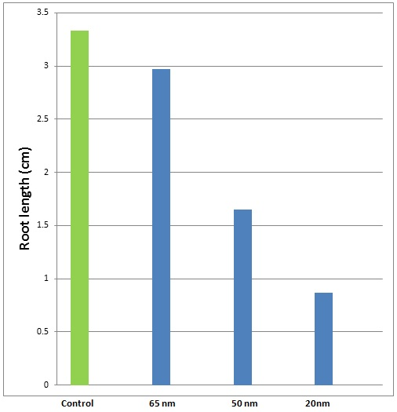

Nano-sized paticles (nm)

Figure 8. Relationship between AgNPs-size and root growth of *Vicia faba*.

**3.3.2. Types and frequency of aberrant cells**

Results of this investigation (Fig. 10) clearly revealed that the chromosomal aberrations were observed in most treatments (Tables 2, 3, 4). The higher frequency of mitotic abnormalities (80.72%) was induced after treatment with the lower nano-sized particles (20 nm) for 12 hrs (Table 4). The number of aberrant cells were significantly increased with decreasing in size of NPs and, at the same time, increasing in duration (hrs). In this study cytological changes were observed viz. disturbed chromosomes (Figs. 11, 12), chromosome fragments (Fig. 13), stickiness (Figs. 14, 15, 16), bridge (Fig.13) and laggards chromosomes (Fig. 12). Similar observations were also recorded by many workers, following treatment with NPs suspension for time intervals[7,8,9,35]. The high percent of clastogenic abnormalities (disturbed chromosomes), induced by nano-Ag primarily reflects its action on mitotic spindles, altering the orientation of chromosomes at various stages of mitotic cell cycle[31]. Impairment of mitotic spindle function is probably due to the interaction of AgNPs with tubulin SH group [32]. The induction of chromosomal fragments by nano-silver indicates the clastogenic potential of the tested NPs suspention leading to a loss of genetic material indicating mutagenicity of the inducers[31]. Sticky chromosomes were also clearly obvious with different treatments and presumably is due to intermixing of chromatin fibers resulting in sub-chromatid connections between chromosomes [33]. One of the frequent observations is the formation of bridges which may be the results of reunion of broken chromosome ends[34]. Micronuclei were

observed (Fig. 14) only after exposure root meristems of *Vicia faba* to AgNPs for long period (24 hrs). Similar observations were reported in *Vicia faba* root-tips exposed to AgNPs[9], *Allium cepa* root meristems exposed to zinc oxide nanoparticles (ZONPs)[40] and *Allium cepa* root-tip cells exposed to silver nanoparticles (AgNPs)[41]. Micronuclei may be attributed to malformation of spindle fibers[43] and were considered as an indication of a true mutagenic effect which may lead to a loss of genetic material[42].

Table 2. Effect of AgNPs (65nm) on mitotic index (MI%) and chromosomal aberration (CA%) of meristems of *Vicia faba*

|  |  |  |  |  |  |
| --- | --- | --- | --- | --- | --- |
| CA (%) | MI (%) | Total Aberrant Cells | Total Dividing Cells | Total Examined Cells | Duration (hrs) |
| 0.02 ± 0.16 | 12.29 ± 0.46 | 15 | 6 93 | 5636 | Control |
| 4.66 ± 1.77  +S | 10.87 ± 1.13  -S | 25 | 536 | 5433 | 6 |
| 11.60 ± 1.38  +HS | 7.31 ± 1.85  -S | 52 | 448 | 5679 | 12 |
| 29.19 ± 0.58  +HS | 5.43 ± 1.72  -HS | 113 | 387 | 5537 | 24 |

S= Significant at 0.05 level, HS= Highly significant at 0.01 level

Table 3. Effect of AgNPs (50nm) on mitotic index (MI%) and chromosomal aberration (CA%) of meristems of *Vicia faba*

|  |  |  |  |  |  |
| --- | --- | --- | --- | --- | --- |
| CA (%) | MI (%) | Total Aberrant Cells | Total Dividing Cells | Total Examined Cells | Duration (hrs) |
| 0.03 ± 0.46 | 12.33 ± 0.73 | 17 | 720 | 5836 | Control |
| 5.32 ± 1.13  +HS | 9.80 ± 1.16  NS | 21 | 469 | 4781 | 6 |
| 12.44 ± 0.97  +HS | 6.85 ±1.13  -HS | 27 | 343 | 5003 | 12 |
| 34.37 ± 0.81  +HS | 3.88± 1.17  -HS | 33 | 197 | 5067 | 24 |

S= Significant at 0.05 level, HS= Highly significant at 0.01 level

Table 4. Effect of AgNPs (20nm) on mitotic index (MI%) and chromosomal aberration (CA%) of meristems of *Vicia faba*

|  |  |  |  |  |  |
| --- | --- | --- | --- | --- | --- |
| CA (%) | MI (%) | Total Aberrant  Cells | Total Dividing  Cells | Total Examined  Cells | Duration (hrs) |
| 0.12 ± 1.06 | 12.42 ± 1.77 | 23 | 703 | 5660 | Control |
| 16.52 ± 0.93  +HS | 6.29 ± 0.97  -HS | 39 | 316 | 5019 | 6 |
| 80.72 ± 2.03  +HS | 2.24 ± 1.34  -HS | 67 | 117 | 5213 | 12 |
| 00 | 00 | 00 | 00 | 5013 | 24 |

S= Significant at 0.05 level, HS= Highly significant at 0.01 level, 00= No dividing cells

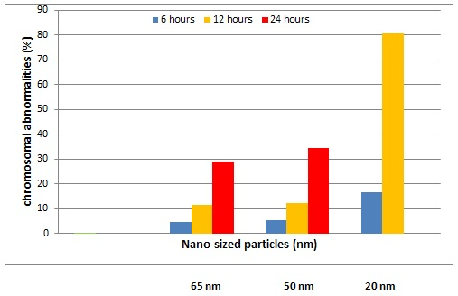

Figure 10. Relationship between nanoparticles- size and percent of chromosomal abnormalities.

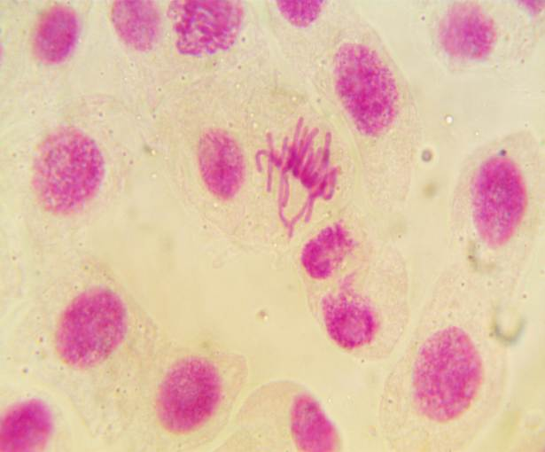

Figure 11. Disturbed chromosomes at metaphase stage with disoriented chromosomes.

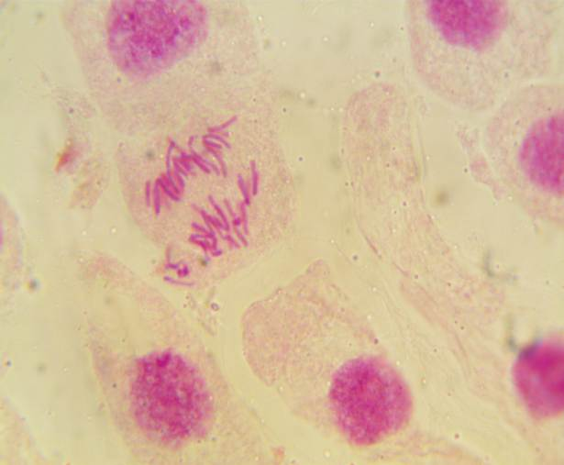

Figure 12. Disturbed multipolar anaphase with lagging chromosomes (laggards).

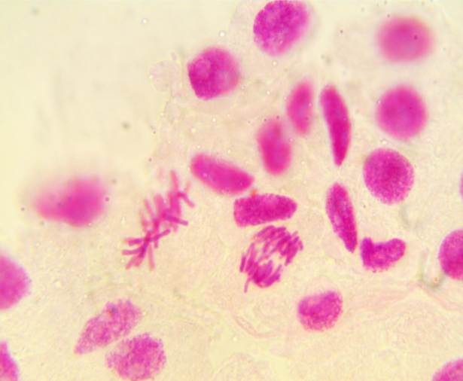

Figure 13. Fragment chromosome at metaphase stage (Left). Bridge at ana-telophase stage (Right).

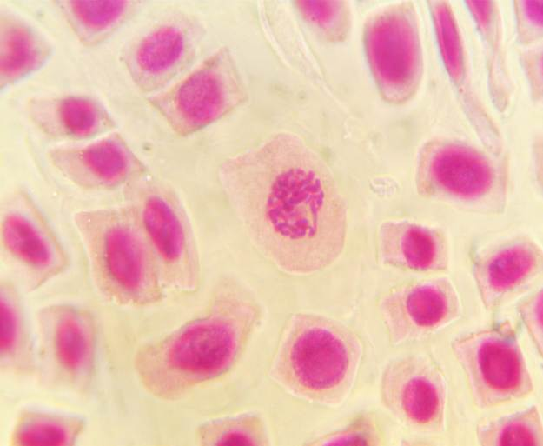

Figure 14. Sticky chromosomes at prophase stage with micronucleus.

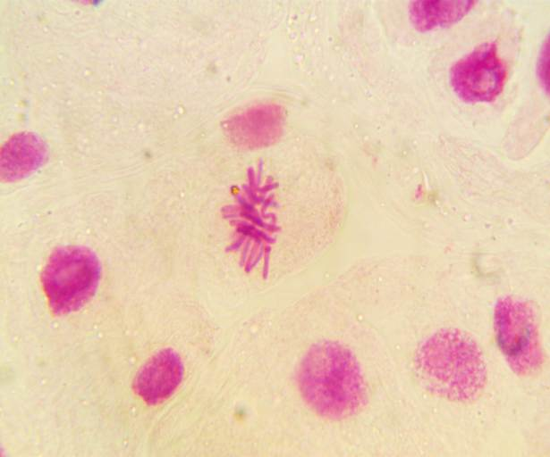

Figure 15. Sticky chromosomes at metaphase stage.

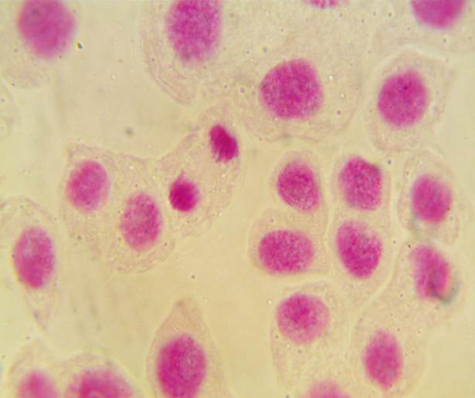

Figure 16. Sticky chromosomes at ana-telophase stage.

**4. Conclusion**

Seed germination and root elongation is a rapid and widely used acute phytotoxicity test owing to sensitivity, simplicity, low cost and suitability for unstable chemicals. Seed coats, which can have selective permeability, play a very important role in protecting the embryo from harmful external factors. Pollutants as nano-metals could penetrate root system causing obviously root growth inhibition, may not affect seed germination if they cannot pass through seed coats. This may explain that seed germination in our study was not affected by exposure to AgNPs suspension. Also, mitotic cell division was greatly altered following treatment with nanoparticles (65, 50 and 20 nm) whereMitotic Index (MI) significantly decreased while the percentage of chromosomal aberrations significantly increased. In this study, different types of aberrant cells were observed after treatments with nano-sized particles for time intervals. Thus, AgNPs can explicate their action depending not only on their size and/or shape but also on the applied concentration, plant species and mechanism of uptake.

**Corresponding Author:**

Dr. Essam Ahmed Abdel-Azeem

Botany and Microbiology Department

Faculty of science

Al-Azhar University, Cairo, Egypt

E-mail: [essam_1616@hotmail.com](mailto:essam_1616@hotmail.com)

**References**

1. Asharani PV, Low Kah MG, Hande MP, Valiyaveettil S (2009). Cytotoxicity and genotoxicity of silver nanoparticles in human cells. ACS nano. 3: 279-290.
2. Benn TM and Westerhoff P (2008). Nanoparticle silver released into water from commercially available sock fabrics. Environmental Science and Technology 42: 4133-4139.
3. Choi O and Hu ZQ (2008). Size dependent and reactive oxygen species related nanosilver toxicity to nitrifying bacteria. Enviromental Science and Technology 42: 4583-4588.
4. Meyer JN, Lord CA, Yang XY, Turner EA, Badireddy AR, Marinakos SM, Chilkoti A, Wiesner MR and Auffan M (2010). Intracellular uptake and associated toxicity of siver nanoparticles in *Caenorhabditis elegans*. Aquatic Toxicology 100: 140-150.
5. Stamploulis D, Sinha SK and White JC (2009). Assay-dependent phytotoxicty of nanoparticles to plants. Environmental Science and Technology 43: 9473-9479.
6. Gubbins EJ, Batty LC and Lead JR (2011). Phytotoxicity of silver nanoparticles to *Lemna minor* L. Environmental Pollution. 159: 1551-1559.
7. Kumari M, Mukherjee A and Chandrasekaron N (2009). Genotoxicity of silver nanoparticles in *Allium cepa*. Science of the Total Environment 407: 5243-5246.
8. Pulate PV, Ghurde MU and Deshmukh VR (2011). Cytological effects of the biological and chemical silver-nanoparticles in *Allium cepa* L. International Journal of Innovations in Bio-Sciences 1: 32-35.
9. Patllola AK, Berry A, May L and Tchounwou PB (2012). Genotoxicity of silver nanoparticles in *Vicia faba*: A pilot study on the environmental monitoring of nanoparticles. Int. J. Environ. Res. Public Health 9(5):1649-1662.
10. Yin L, Colman BP, McGill BM, Wright JP and Bernhardt ES (2012). Effects of Silver Nanoparticle Exposure on Germination and Early Growth of Eleven Wetland Plants. PLoS ONE 7(10): e47674.
11. Morones JR, Elechiguerra JL, Camacho A, Holt K, Kouri JB, Ramirez JT and Yacaman MJ (2005). The bacterial effect of silver nanoparticles. Nanotechnology 16: 2346-2353.
12. Carlson C, Hussain SM, Schrand AM, Brayditch-Stolle LK, Hess KL, Jones RL and Schlager JJ (2008). Unique cellular interaction of silver nanoparticles: Size-dependent generation of Reactive oxygen species. Journal of physical chemistry 112(43): 13608-13619.
13. Donaldson K, Stone V and Macnee W (1999). In Particulate Matter: Properties and effects upon health; Maynard, RL, Howards, CD, Eds.; BIOS Scientific Publishers: Oxford, p 115.
14. Oberdoster G (1996). Effect of ultrafine particles in the lung and potential relevance to environmental particles. In Marijnissen JMC,Gradrecht: Kluwer Academic, p.165.
15. Ma TH (1982). *Vicia* cytogenetic tests for the environmental mutagens. A report of US Environmental protection Agency Gene-Tox Program. Mutat. Res. 99: 259-271.
16. Grant WF (1982). Chromosome aberration assay in *Allium*. A report of US Environmental protection Agency Gen-Tox Program. Mutat. Res. 99: 273-291.
17. Castiglione MR and Cremonine R (2009). Nanoparticles and higher plants. Caryologia 62: 161-165.
18. Lin DH and Xing BS (2007). Pytotoxicity of nanoparticles: Inhibition of seed germination and root growth. Enyiro. Pollut. 150: 243-250.
19. Lin DH and Xing BS (2008). Root uptake and phytotoxicity of ZO nanoparticles. Environ. Sci. Technol. 42: 5580-5585.
20. Wierzbicka M and Obidzinska J (1998). The effect of lead on seed inhibition and germination in different plant species. Plant Science 137: 155-171.
21. Xiu ZM, Ma J and Alvarez PJ (2011). Differential effect of common ligands and molecular oxygen on antimicrobial activity by silver nanoparticles versus silver ions. Environmental Science and Technology 45: 9003-9008.
22. Burklew CE, Ashlock J, Winfrey WB and Zhang B (2012). Effects of aluminum oxide nanoparticles on the growth, development, and microRNA expression of tobacco (*Nicotiana tabacum*). PLoS ONE 7(5): e34783.
23. Dietz KJ and Herth S (2011). Plant nanotoxicology. Trends in Plant Science 16:582-589.
24. U.S. Environmental Protection Agency (USEPA) (2007). Nanotechnology White paper. Science Policy Council, USEPA, Washington, DC, USA .
25. Smaka-Kinel V, Stegnar P, Lovka M, and Toman JM (1996). The evaluation of waste, surface, ground water quality using the *Allium* test procedure. Mutation Res. 368: 171-179.
26. Sudhakar R, Gowda KNN and Venn G (2001). Mitotic abnormalities induced by silk dyeing industry effluents in the cells of *Allium cepa*. Cytologia 66: 235-239.
27. Kim S, Choi JE, Choi J, Chung KH, Park K, Yi J and Ryu DY (2009). Oxidative stress-dependent toxicity of silver nanoparticles in human hepatoma cells. Toxicology In Vitro 23: 1076-1084.
28. Miao AJ, Schwehr KA, Xu C, Zhang SJ, Luo Z, Quigg A and Santschi PH (2009). The algal toxicity of silver engineered nanoparticles and detoxification by exopolymeric substances. Environmental Pollution 157: 3034-3041.
29. Xiu ZM, Zhang QB, Puppala HL, Colvin VL and Alvarez PJ (2012). Negligible particle specific antibacterial activity of silver nanoparticles. Nano Lett 12: 4271-4275.
30. Yin L, Cheng Y, Espinasse B, Colman BP, Auffan M, Wiesner M, Rose J, Liu J and Bernhardt ES (2011). More than the ions:The effect of silver nanoparticle on *Lolium multiflorum*. Environ. Sci. and Technology 45: 2360-2367.
31. Raun C and Lilum J (1992). Application of micronucleus test in *Vicia faba* root tips in the rapid detection of mutagenic environmental pollutants Chinese. J. Environ.Sci. 4: 56-58.
32. Kuriyama R and Sakai H (1974). Role of tublin-SH group in polymerization to microtubules. J. Biochem. 76: 651-654.
33. Klasterska I, Natarajan AT and Ramel CA (1976). An international of the origin of subchromatid aberrations on chromosome stickiness as a category of chromatid aberrations. Hereditas 83: 153-162.
34. Premjith K and Grover IS (1985). Cytological effects of some organophosphorus pesticides II. Mitotic effects. Cytologia 50.
35. Castiglione MR, Giorgetti L, Geri C and Cremonini R (2011). The effect of nano-Tio2 on seed germination, development and mitosis of root tip cells of *Vicia nabonesis* L. and *Zea mays* L. J. Nanopart. Res. 13: 2443-2449.
36. Prakash N, Jayapradeep S and Sudha PN (2009). Proceeding of ICNM-2009(1st International Conference on Nanostructured Mterials and Nanocomposites (6-8 April 2009,Kootayam,India).
37. Giordani T, Fabrizi A, Guidi L, Natali L, Giunti G, Ravasi F, Cavallini A, Pardossi A (2012). Response of tomato plants exposed to treatment with nanoparticles. EQA-Environmental quality 8: 27-38.
38. Fiskesio G (1997). *Allium* test for screening chemicals, evaluating cytologic parameters, in: Wang W, Goruch JW, Hanhes JS, editor, Plants for environmental studies, Boca Raton, New York: CRC Lewis Publishers: p 308.
39. Bakare AA, Mosuro AA and Osibanjo O (2000). Effect of simulated leachate on chromosomes and mitosis of *Allium cepa* (L). J. Environ. Biol 21: 263.
40. Kumari M, Khan SS, Pakrashi S, Mukherjee A and Chandrasekaran N (2011). Cytogenetic and genotoxic effect of Zink Oxide nanoparticles on root cells of *Allium cepa*. J. Hazard Mater 90: 613-621.
41. Panda KK, Achary MM, Krishnaveni R, Padhi BK, Sarangi SN, Sahu SN and Panda BB (2011). *In vitro* biosynthesis and genotoxicity bioassay of silver nanoparticles using plants. Toxicol. In Vitro 25: 1097-1105.
42. Ronchi VN, Bonutti S and Turchi G (1986). Preferential localization of chemically induced breaks in heterochromatic regions of *Vicia faba* and *Allium cepa* chromosomes-I. Exogenous thymidine enhances the cytologic effects of 4-epoxyethyl-1,2-epoxy-cyclohexane.Environ. Exptl. Bot.26: 115-126.
43. Srecec S (1995). Phenotypic and genotypic analysis of spike abnormality in bread wheat (*Triticum aestivum* L. em Thell) cv. Pitoma. Cereal. Res. Camm. 32(1): 63-69.

11/25/2013