**Construction of a Whole‐Cell Biosensor for Detection of Cadmium in Water Solution**

Rastegarpanah, M.1, Saidijam, M.1&2*, Shabab, N.2, Hassanzadeh, T.1&3, Rahmani, A.R.4, Karimi, M.3 and Alikhani, M.5

1 Research Center for Molecular Medicine, Hamadan University of Medical sciences, Hamadan, Iran

2 Molecular Medicine and Genetics Department, School of Medicine, Hamadan University of Medical sciences, Hamadan, Iran

3 Biochemistry Department, School of Medicine, Hamadan University of Medical sciences, Hamadan, Iran

4 Department of Environmental Health Engineering, Faculty of Health and Research Center for Health Sciences, Hamadan University of Medical Sciences, Hamadan, Iran

5 Microbiology Department, Hamadan University of Medical Sciences, Hamadan, Iran

sjam110@yahoo.com

**Abstract:** The best choice for evaluating the bioavailable deduction among thousands of toxic and hazardous pollutants is whole-cell bacterial biosensors. Major advantage of biosensors in detection of environmental contaminants is real-time perception and on-site monitoring. In bacterial biosensors reporter gene are located alongside of promoter that is sensitive to specific pollutant. Pollutant- responsive promoter in the presence of target through biochemical pathways within the cell cause the reporter gene is expressed. The activation of reporter gene can be created a detectable and measurable response. An effort has been made to construct the whole-cell biosensors by using *cadR* gene and its related promoter/operator from *Pseudomonas* *aeruginosa* strain *PAO1*, *gfp* gene as the reporter, plasmid pET28a and genetic engineering technique that is be able to clearly show the presence of cadmium in water samples. Cadmium detection by using this biosensor was done by means of microscopy and fluorometry techniques. Our results demonstrate that there is a strong positive correlation between the number of fluorescent cells and concentration of cadmium in samples.Constructed biosensor could be used successfully as a device to determine the biologically relevant concentrations of cadmium in contaminated wastewater.

[Rastegarpanah, M., Saidijam, M, Shabab, N., Hassanzadeh, T., Rahmani, A.R., Karimi, M. and Alikhani, M. **Construction of a Whole Cell Biosensor for Detection of Cadmium in Water Solution.** *N Y Sci J* 2013;6(12):38-43]. (ISSN: 1554-0200). http://www.sciencepub.net/newyork. 6

**Keywords:** Environmental Pollutants, Biosensing Techniques, Green Fluorescent protein, *Pseudomonas aeruginosa*

**1. Introduction**

Contamination of drinking water with toxic heavy metals has become one of the most fundamental problems along with industrial progress. Due to the unique physical and chemical properties, toxicity at low levels and accumulation in the food chain, cadmium has been one of the most significant environmental pollutants [1-3]. Natural sources of cadmium emissions mainly consist of sedimentary rocks, active volcanoes, excavating activities, lakes and forest fire. Man-made sources that release from industries including consumer products of cadmium such as nickel–cadmium batteries, plastics, ceramics, glass, paints, and cadmium stabilizers used to process Polyvinyl Chloride (PVC) and ferrous or non ferrous cadmium coatings products. Metallurgical industries wastes like iron and steel, cement, gypsum, zinc, lead, copper, their alloys and remains of fossil fuels, use of sewage sludge and phosphate fertilizers in agricultural fields and burning of fossil fuels are causes of soil cadmium pollution [4]. The cadmium cation by means of binding to essential respiratory proteins [5] and oxidative damage is toxic to most microorganisms [6]. Cadmium damaging depends on many factors such as cadmium forms, the amount of cadmium intake and the ways in which cadmium entry into the body. The most common effects of cadmium exposure in human health are abdominal pain, fragile bones, immune system deficiency, mental disorders, possible damage to DNA and cancers of the lungs, prostate, pancreas and Kidneys [7]. Maximum permissible of cadmium in drinking water, based on daily average consumption equivalent 2.5 liter, for human weight of 70kg, is 0.005 mg/lit [8]. According to what was mentioned above, it is clear that detect the presence of cadmium in municipal, agricultural or industrial water supplies and prevent the excessive exposure of various life forms to these metal has a great importance.

Conventional techniques to analyze metals include: ion exchange, chemical precipitation, chelation, membrane separation [9, 10] and inductively coupled plasma mass spectrometry, cold vapour atomic adsorption spectrometry, UV visible spectrometry and X-ray absorption spectroscopy [11]. This methods are more expensive, time-consuming and dependent of specific skills. In addition, lack of ability to give knowledge on the bioavailability of the metal ions and the toxicity join with them makes these methods less interesting for monitoring environmental pollutants. So easy and low cost, as well as detection speed of cadmium in sample (especially in water) are highly desirable and important.

For this purpose, whole-cell biosensors are used that consists of live cells which have been genetically manipulated [12]. Unicellular organisms, especially bacteria, are used as whole-cell biosensors. Large and diverse population, rapid growth, low cost, easy maintenance and its unique ability to genetic manipulation has made these organisms the ideal choices for use in biological assays. Use of bacterial whole-cell biosensors besides the two features of high selectivity and sensitivity have another advantages such as getting quantitative and/or qualitative data and bioavailability of target analyte, as it not only gives more precise information respecting the risk that the contaminated site poses to human health, but also controls the productiveness of potential bioremediation procedures [13].

Biosensors are analyzer device that consists of two key parts: **[1]** analyte–sensitive biological section which could include of intracellular elements such as nucleic acids (especially DNA) or proteins (enzymes, non-enzymatic purified protein or antibodies). **[2]** Converter section which convert signal generated from the interaction between the analyte and biological part into detectable and measurable signal. In bacterial biosensors reporter gene are located alongside of promoter that is sensitive to target pollutant (cadmium). Sensitive region in the presence of cadmium through biochemical pathways within the cell cause the reporter gene is expressed. The activation of reporter gene can be created a perceivable response [14].

Construction of whole-cell biosensors to evaluate the environmental pollution was conducted in 2004 by Gu, M.B; Mitchell RJ [15]. Bacterial biosensors for detection of cadmium based on *lux* and *lac Z* reporter genes have been reported by Corbisier et al.1993 [16]; Tauriainen et al. 1998 [17] and Shetty et al. 2003 [18]. Lin TJ, Chung Mf in 2008 used the optical fibers in the manufacture of cadmium diagnostic biosensor [19]. In 2009 Cindy et al. with using a gene conversion circuit and Joe et al. in 2011 based on pigment designed whole-cell biosensors for cadmium detection [20, 21].

In this project we are producing whole-cell biosensors by using *cadR* gene and its related promoter/operator from *Pseudomonas* *aeruginosa* strain *PAO1,* *gfp* gene as the reporter, plasmid pET28a and genetic engineering technique that is be able to clearly show the presence of cadmium in water samples. MerR family response regulator with unusual signal structure (promoters with long spacer regions (19 bp) and inverted repeat sequences) is one of the transcriptional factors which regulate bacterial metal resistance systems [22]. *cadR* gene from this family confers cadmium inducibility on *cadA* promoter [23].Expression of the *cad* promoter is substrate-dependent and host-specific. The promoter for *cadA* (PcadA) is responsive to Cd(II), Zn(II) and Pb(II), whilst the promoter for *cadR* (PcadR) is responsive only to Cd(II) [24]. A crucial part of the activation mechanism, as in the mer, will involve the torsional deformity of the operator/promoter region to produce an advanced substrate for RNA polymerase action [22].

Green fluorescent protein (GFP) Originated from the jellyfish *Aequorea victoria* consists of 238 [amino acid](http://en.wikipedia.org/wiki/Amino_acid) residues (26.9[kDa](http://en.wikipedia.org/wiki/Atomic_mass_unit)). When this proteins are placed in the range of blue to [ultraviolet](http://en.wikipedia.org/wiki/Ultraviolet) lights emits green fluorescence color [25].

**Materials and methods**

***Bacterial strains and plasmids:***

Original sequences were isolated by PCR amplification/cloning from *Pseudomonas* *aeruginosa* *PAO1*. Bacterial strains and plasmids are listed in Table 1. All strains were cultured in Luria broth and media were supplemented with antibiotics at standard concentrations.

***Plasmid construction:***

Plasmid DNA propagation, restriction enzyme treatment, ligation, and transformation were performed by “Molecular cloning, A laboratory manual” [26]. The O/P region and the entire CadR coding region were amplified from *P. aeruginosa PAO1* genomic DNA by using PCR primers CadR F (5’CGTCGCGGATCCTCAGCCATGCCGGCGGTGCA-3’) and CadR R (5‘-TGACCGGAATTCGGAAACAATTCCCG.

TTTGA3’) which contain BamHI and EcoRI sites, respectively. The resulting 608 bp fragment was digested with BamHI and EcoRI enzymes and ligated with T4 DNA ligase (Fermentas) into pET 28a (previously digested with the same enzymes). The recombinant plasmid (pETcadR) was transformed into the *E.coli* *DH5α* (replicating host) and *E.coli* *BL21(DE3)* (expressing host). PIVEX-GFP was used as the PCR template to amplify the *gfp* gene. The oligonucleotide primers used for PCR were GFPF(5‘GTCGCGAATTCATGAGTAAAGGAGAAGAAC-3') and GFPR(5‘-ACGTAGCGGCCGCTTATTTGTATAGTTCATCCATGCCATG -3') which consist of EcoRI and NotI restriction sites, respectively.

The amplified product was digested with these enzymes and then reintroduced next to *cadR* in EcoRI and NotI digested *E.coli* pETcadR. After ligation, recombinants were transformed into *E. coli BL21*. The colonies were selected on LB agar plates supplemented with 100 μg/ml of kanamycin.

Table 1 **Bacterial strains and plasmids in this study**

|  |  |  |
| --- | --- | --- |
| **Strain / plasmid** | **Relevant phenotype/ genotype** | **Source** |
| ***plasmids*** |  |  |
| **pET28a** | *Expression vector, kanR gene* | Pastaur institute |
| **pIVEX-GFP** | *Source of gfp gene, ampR gene* | Pastaur institute |
| **pETCadR** | *pET28a:Pcad-cadR* | This study |
| **pETCadRGFP** | *pET28a:Pcad-cadR-gfp* | This study |
| ***Strains*** |  |  |
| **P. aeruginosa PAO1** | *Heavy metal resistance* | Shahed university |
| **E. coli DH5α** | supE44lacU169[Φ80lacZM15] hsdR17recA1endA1gyrA96thi- 1relA | Razi institute |
| **E.coli BL21** | F- *ompT hsdSB[rB- mB-] gal dcm [DE3]* | Cinnagen |

***Culture and Cadmium assay conditions:***

An overnight culture of *E. coli* strain *BL21(DE3)* harboring pETCadRGFP was grown in LB broth supplemented with 100 μg/ml of kanamycin at 37°C was reactivated by diluting the culture in a ratio of 1:100 with fresh LB supplemented with 100 μg/ml of kanamycin and incubated at 37°C in an orbital shaker at 220 rpm until the optical density at 600 nm reached 0.6. Standard solutions of cadmium chloride were prepared.

Assay mixtures contained 900 μL of this bacterial suspension and with 100 μL of standard solutions of cadmium chloride were incubated in a shaker at 37 °C for a period of 3 h. Culture samples were centrifuged at 10,000 rpm for 5min, and the supernatant was removed. The cell pellet was washed 2 times with 100 mmol L-1 phosphate buffer and suspended in an appropriate amount of phosphate buffer saline (PBS) (pH 7.5) [18].

***Microscopy:***

One microliter of cell suspension was transferred to a microscope slide, and the fluorescence of individual cells was determined by epifluorescence microscopy. *E.coli BL21(DE3)* containing plasmid pET28a was used as negative control. Also *E.coli* strain *BL21(DE3)* which was harboring pIVEX-GFP was used as the positive control by using IPTG as the inducer for promoter T7 and expression of *gfp*.

***Fluorometry****:*

100 μL of assay mixtures were diluted to a volume of 2 mL and then put in the fluorometer for fluorescence measurement. The excitation and emission wavelength of the spectrofluorometer were set at 470 nm and 505 nm, respectively [18].

**Results and discussion**

*cadR* gene was isolated from chromosome of *P. aeruginosa* *PAO1* by performing colony PCR and confirmed in agarose gel electrophoresis (Fig. 1a). In the next part PCR product was digested with BamHI / EcoRI and then 608 base pairs(bp) released fragment was reintroduced into BamHI/EcoRI digested pET28a expression vector. Following plasmid purification the plasmid was subjected to restriction endonuclease analysis with BamHI and EcoRI enzymes. As it is shown in figure (Fig. 1b) there were two fragment which were about 596 bp and 5369 bp(5.4 kbp).

In the present study, GFP was amplified from pIVEX-GFP plasmid by using PCR and identified product size was 740 base pairs. Recombinant plasmids were constructed from EcoRI/NotI digested pETcadR plasmid and EcoRI/NotI digested GFP gene (amplified DNA). PETcadRGFP plasmid was subjected to PCR with CadR and GFP forward and reverse primers (Fig. 1c).

Quantity of cadmium ions present in a sample can be determined by monitoring the alteration in the fluorescence intensity of the GFP produced by the bacteria. Optimal wavelengths for carrying out the fluorescence measurements were 470 nm and 505 nm as the wave-lengths for maximal excitation and emission, respectively, for all fluorescence measurements performed with the bacterial sensing system.

By adding different doses of cadmium chloride to bacteria, we are be able to draw concentration-dependent diagram. Number of fluorescent bacteria and the intensity of produced fluorescent were increased due to rise of cadmium chloride concentrations in the sample. 10-8 mol L-1 is minimum detectable concentration of the cadmium ions. At concentrations lower than 10-8 mol L–1 GFP gene is not expressed and fluorescent light is not visible. The main justification for this event is binding of CadR to the cad O/P sequence causes repression of *gfp* gene transcription and translation. Cause of severe drop in the intensity of produced fluorescent at concentrations 10-5 mol L–1 is saturation of CadR by cadmium ions and the cytotoxicity of cadmium to the bacterial cells (Fig. 2).

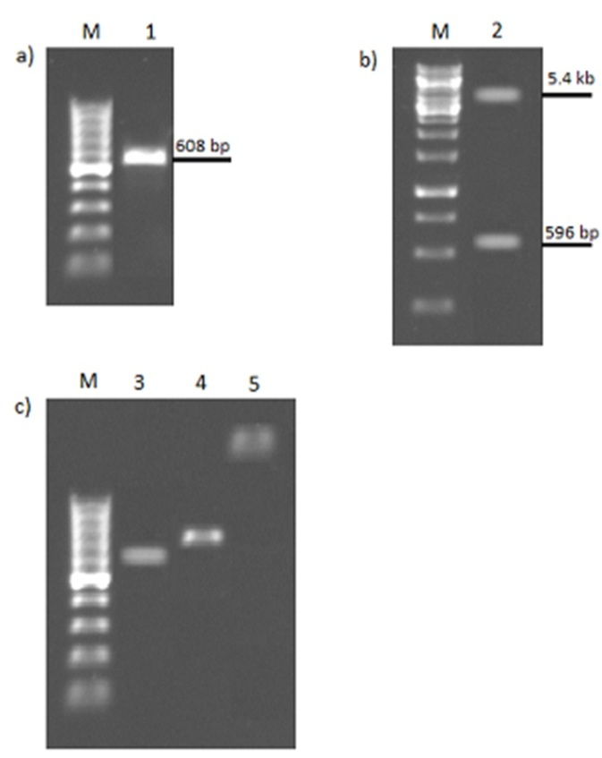

Fig. 1 **(a)** Amplification of cadR . Lane M = 100 bp ladder and Lanes1=PCR products.**(b)** Double digestion analysis of pETcadR plasmid by using BamHI and EcoRI enzymes. Lane M= 1kb DNA ladder and Lane 2=contained two fragments. **(c)** Agarose gel electrophoresis for PCR products. Lane M=100 bp ladder, Lane 3=PCR product which amplified by using CadR forward and CadR reverse primers. Lane 4=amplified product of PCR that was done by using GFP forward and GFP reverse primers. Lane 5=PCR product with using of CadR forward and GFP reverse primers.

In order to verify biosensor selectivity by cadmium, bacterial cells with standard solution of zinc, manganese and copper ions were incubated for 3 hours. The result from measuring emitted fluorescence of these metal ions compared with control samples did not show significant changes (Fig. 3).

Bacterial cells were visualized by using an epifluorescent microscope after 3 hours exposure to various concentrations of cadmium chloride. The results of microscopy can be seen in Figure 4.

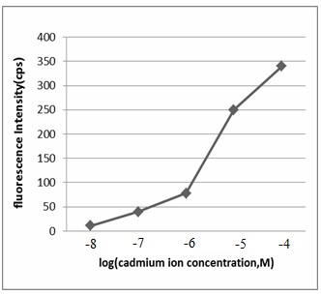

Fig. 2 Dose–response curve obtained for cadmium ions after E.coli BL21(DE3) cells harboring plasmid pETcadRGFP were incubated with standard solutions of cadmium chloride for 3 h at 37 °C. Fluorescence intensity was measured at 505 nm after excitation at 470 nm. The fluorescence signal has been corrected with respect to the blank.

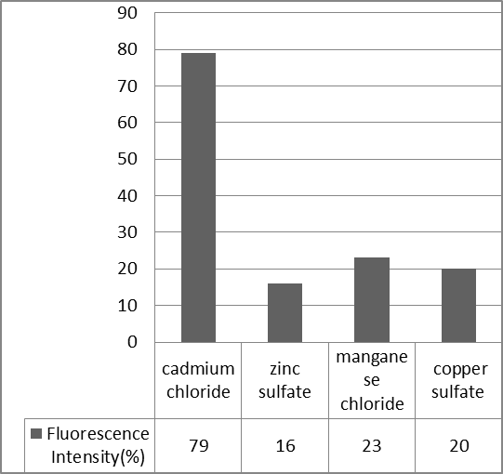

Fig. 3 Selectivity of the bacterial sensing system employing E.coli BL21(DE3) cells harboring the plasmid pETcadRGFP.

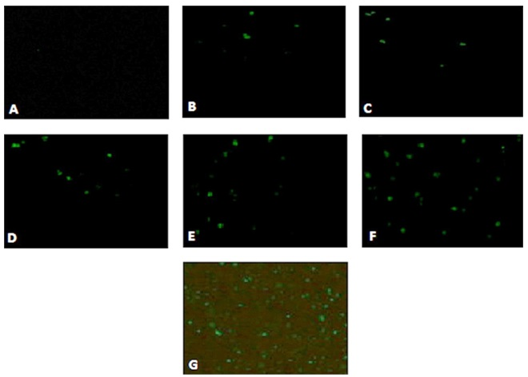

**Fig. 4** Fluorescence of biosensor exposed to various concentrations of cadmium chloride.

**A**=Negative control, **B**=10-8M, **C**=10-7M, **D**=10-6M, **E** =10 -5M, **F** =10-4 M, **G**=Positive control.

**Conclusion:**

Nowadays detection of environmental contaminant toxicity, bioavailability and bioremediation is one of the most important applications of biosensor [12]. The major advantage of biosensors in detection of environmental contaminants are real-time detection and on-site monitoring. The present results demonstrate that there is a strong positive correlation between the number of fluorescent cells and concentration of cadmium in samples and as a result the constructed biosensor could successfully be used as a device to determine the bioavailability of cadmium in contaminated wastewater. The future aspect of this study is to increase the accuracy of the obtained biosensor for advanced quantitative evaluation, development of its capabilities for using in clinical diagnosis and industrial fields, production of portable kits for testing water samples on site and even more, besides detection, it will be able to remove cadmium contamination from environment.

**Acknowledgement**

This project has been done as a MSc thesis and supported by deputy of research, Hamadan University of Medical Sciences.

**References**

1. Chaney, L. Rufus, et al. A New Paradigm for Soil Cadmium Risk to Humans. Paper presented at the OECD Cadmium Workshop in Stockholm, Sweden, October 15–22. Organization for Economic Co-operation and Development, Paris. 1995.
2. Ginter E. Cadmium as a toxic environmental. The level of lead and cadmium in the urban areas contaminant. Proc Ecology and Life II. 1993;3:14-5.
3. Yamagata N. Cadmium Pollution in Perspective. Koshu Eiseiin Kenkyi Hokuku (Institute of Public Health, Tokyo). 1970;19(1):1–27.
4. Tang XY, Zhu YG, Cui YS, Duan J, Tang L. The effect of ageing on the bioaccessibility and fractionation of cadmium in some typical soils of China. Environment International. 2006;32(5):682-9.
5. Vallee BL, Ulmer DD. Biochemical effects of mercury, cadmium, and lead. Annu Rev Biochem. 1972;41:91-128.
6. Stohs SJ, Bagchi D. Oxidative mechanisms in the toxicity of metal ions. Free Radical Biol Med. 1995;18: 321-36.
7. Waalkes MP, Coogan TP, Barter RA. Toxicological principles of metal carcinogenesis with special emphasis on cadmium. Crit Rev Toxicol. 1992;22:175-201.
8. WHO (World Health Organization). International Standards for Drinking Water, volume 3, 3d ed.1971.
9. Malakootian M, Nouri J, Hossaini H. Removal of heavy metals from paint industries wastewater using Leca as an available adsorbent. Int J Environ Sci Tech. 2009;6(2):183-90.
10. Samarghandi MR, Nouri J, Mesdaghinia AR, Mahvi AH, Nasseri S, Vaezi F. Efficiency removal of phenol, lead and cadmium by means of UV/TiO2/H2O2 processes. Int J Environ Sci Tech. 2007;4(1):19-25.
11. Townsend AT, Miller KA, McLean S, Aldous S. The determination of copper, zinc, cadmium and lead in urine by High Resolution Inductively Coupled Plasma Mass Spectrometry. Journal of Analytical Atomic Spectrometry. 1998;13:1213-9.
12. Tecon R, van der Meer JR. Bacterial biosensors for measuring availability of environmental pollutants. Sensors. 2008;8(7):4062-80.
13. Hansen LH, Sørensen SJ. The Use of Whole-Cell Biosensors to Detect and Quantify Compounds or Conditions Affecting Biological Systems. Microb Ecol. 2001;42(4):483-94.
14. Daunert S, Barrett G, Feliciano JS, Shetty RS, Shrestha S, Smith-Spencer W. Genetically engineered whole-cell sensing systems: coupling biological recognition with reporter genes. Chem Rev. 2000;100(7):2705-38.
15. Gu MB, Mitchell RJ, Kim BC. Whole-cell based biosensors for environmental biomonitoring and application. Adv Biochem Eng Biotechnol. 2004;87:269-305.
16. Corbisier P, Ji G, Nuyts G, Mergeay M, Silver S. LuxAB gene fusions with the arsenic and cadmium resistance operons of Staphylococcus aureus plasmid pI258. FEMS Microbiol Lett. 1993;110(2):231–8.
17. Tauriainen S, Karp M, Chang W, Virta M. Luminescent bacterial sensor for cadmium and lead. Biosens Bioelectron. 1998;13(9):931-8.
18. Shetty RS, Deo SK, Shah P, Sun Y, Rosen BP, Daunert S. Luminescence-based whole-cell-sensing systems for cadmium and lead using genetically engineered bacteria. Anal Bioanal Chem. 2003;376(1):11-7.
19. Lin TJ, Chung MF. Detection of cadmium by a fiber-optic biosensor based on localized surface plasmon resonance. Source: Department of Chemical Engineering, National Chung-Cheng University, 168 University Road, Min-Hsiung, Chia-Yi 621, Taiwan. 2008.
20. Joe MH, Lee KH, Lim SY, Im SH, Song HP, Lee IS, et al. Pigment-based whole-cell biosensor system for cadmium detection using genetically engineered Deinococcus radiodurans. Bioprocess and biosystems engineering. 2012;35(1-2):265-72.
21. Wu C, Le D, Mulchandani A, Chen W. Optimization of a whole-cell cadmium sensor with a toggle gene circuit. Biotechnology Progress. 2009;25(3):898-903.
22. Brocklehurst KR, Megit SJ, Morby AP. Characterisation of CadR from Pseudomonas aeruginosa: a Cd(II)-responsive MerR homologue. Biochemical and Biophysical Research Communications. 2003;308(2):234-9.
23. Nigel L. Brown, Jivko V. Stoyanov, Stephen P. Kidd, Jon L. Hobman.. The MerR family of transcriptional regulators. FEMS Microbiology Reviews. 2003;24(2-3):145-63.
24. Lee SW, Glickmann E, Cooksey DA. Chromosomal locus for cadmium resistance in Pseudomonas putida consisting of a cadmium-transporting ATPase and a MerR family response regulator. Appl Environ Microbiol 2001;67:1437–44.
25. Cubitt AB, Heim R, Adams SR, Boyd AE, Gross LA, Tsien RY. Understanding, improving and using green fluorescent proteins. Trends Biochem Sci. 1995;209(11):448-55.
26. Sambrook J, Fritsch EF, Maniatis T. Molecular Cloning: A laboratory manual. 2nd Ed. New York: Cold Spring Harbor Laboratory Press ; 1989.

12/2/2013