**Guaranteed Purchasing power in Subsidy omitting in Iran**

Mehdi Barimani1, Mohammad Reza Abedi2

1.Mazandaran Regional Electric Company, Iran

2. Iran Power Generation Transmission and Distribution Management Company, Tavanir

[m.barimani@mazrec.co.ir](mailto:m.barimani@mazrec.co.ir)

**Abstract:** Reforms in electricity industry and directed subsidy are one of the important acts for achieving sustainable energy in Iran. Actually According to the important event in omitting the subsidy in Iran since 2011, create attraction in investment and encouraging private investor are main factors to achieve the sustainable energy in Iran. Power guaranteed purchasing is the main condition for continued to investing in this part. In this article by measuring and Comparing Marginal Cost of electricity production in result of directed subsidy in two moods; with social cost and without social cost in Iran, recommended tariffs of guaranteed electricity for creating investment private sector to achieve the sustainable energy and Sustainable Development in Iran. All of the measuring in this research is done through COMFAR software.

[Mehdi Barimani, Mohammad Reza Abedi. Guaranteed Purchasing power in Subsidy omitting in Iran. *N Y Sci J* 2013;6(12):17-25]. (ISSN: 1554-0200). <http://www.sciencepub.net/newyork>. 3

**Keywords:** Guaranteed Purchasing, Tariff, Power Plant

**1. Introduction**

Clause "A" of the Article-44 the Iranian Constitutional Law [1] emphasizes on the development of Governmental sector and lack of the development of governmental establishments. According to this clause, the Government does not have the right to perform new economic activity exterior to the items on the top of the Article-44 and is required to grant any activity (Including continuation of previous activities and utilizing it) which is not included in the titles on the top of the Article- 44 to the private sector. It generally points to the discussion of private investor. Hence, the Government should provide the necessary conditions to achieve the sustainable energy in Iran through participation of private sector by removing obstacles and providing conditions for investment, subjecting policies and setting proper requirements (market-oriented), realization of Electricity tariffs and contracting long-term agreements of guaranteed purchasing electricity. In this article the researcher recommends the Tariff policy, in this way the researcher measured and recommended the Tariff for every one of power plant separately.

According to the important event in omitting the subsidy in Iran since 2011, all of the measurements and comparisons in this position are done in two moods; with social cost and without social cost in electricity production. Finally, for developing the cooperation in private sector and supporting the sustainable energy researcher recommends the Tariff for each of these technologies.

**2. Materials and Methods**

For analyzing and as simulating the data in this study the Benefit-Cost analyze is used. It is a usual method in evaluating the plants of economy, for measuring the Marginal Cost of producing unit or cost of electricity production unit which is the specifying factor for tariffs recommended for guaranteed electricity buying and finally the equality of B/C for comparing.

The Equivalent Uniform Annual Cost (EUAC) and in this case Levelized Cost of Energy (LCOE) is used.

**B/C = EUAB / EUAC** (1)

If it is B/C ≥ 1, it is justifiable for private investor and

If B/C < 1 it is not justifiable for private investor [2].

In this method all the Marginal Cost annually are measured with discounting rate (*i=*10) [3] to the reference year and then it is distributed during the project life time.

The interest rate of Loan is the most important factor in making decision of financial cases, all the measurements and comparisons and as simulations in different interest rates of loan (7% interest from Foreign Exchange Saving of Iran, 12% and 17% interest from Governmental Banks in Iran and also 25% interest loan from private Banks) [4]. Has been done, also, all the indexes in this research are measured with the aim of studying the suitable plants for investors in private sector with IRRE = 20% [5]. All the measurements in this research are done through ***COMFAR software*** (Computer Model for Feasibility Analysis and Reporting) which is a flexible program for economical evaluation of the industrial projects based on national and international standards [6].

In this Article, the Benefit-Cost analyze is used to measure and compare Marginal Cost of electricity production through every power plants and recommended tariffs of guaranteed electricity and the respect of B/C ratio. For measuring and comparing the annual Cost_Benefit related to every technology we use NPV, IRRE, DPB, NPB, IRR criterions (refer to the Appendix.3).

The properties and technical information of technologies in selecting the kind of every technology by paying attention to experts and professionals in electricity industry and assistance professor selected: Steam Power Plant (400), Large Gas (300MW), Small Gas Power Plant (50MW) and Combined cycle (400). The technical properties and information of the fossilized technology are measured according to the Iran Power Generation Transmission and Distribution Management Company -TAVANIR in Iran in 2006 with the discount rate of 15% Rials and also 2.5% stock by the researcher was adjusted to the year 2011(refer to the Appendix.1).

In measurements, researcher assume that the fuel for fossilized station is Natural Gas and the price of Natural Gas in this position by programming subsidy is 75% price average for importing price of gas which is 18.93 €¢/m3 is measured and determined [7].

**3. The measurements related to technologies**

The price of fuel is the most important factor in Marginal Cost of fossilized power plant. It is considered that the fossilized fuel consumption in fossilized Power Plants is just Natural Gas and the price of it is specified 18.93 €¢/m3.

The measuring of monotones Marginal Cost of electricity production, the Tariffs for guaranteed electricity shopping and the proportions in Cost_Benefit ratio are as the following:



|  |  |  |  |  |
| --- | --- | --- | --- | --- |
|  | ***Small gas*** | ***Large gas*** | ***Steam*** | ***Combined cycle*** |
| ***7*** | 5.39 | 7.36 | 7.81 | 6.86 |
| ***12*** | 5.60 | 7.55 | 8.52 | 7.35 |
| ***17*** | 5.79 | 7.72 | 9.21 | 7.80 |
| ***25*** | 6.14 | 8.05 | 10.61 | 8.69 |

Figure 1. LCOE vs. Interest Rates without Social Cost- Fossilized Technologies

The Figure 1 compares the Marginal Costs of electricity production through four technologies of fossilized electricity. The Social Costs caused by pollutions have not been added.

It is observed that, with interest rate 7% the Marginal Cost of electricity production Small Gas Power Plant is lower than all the other. Then the Combined cycle Power Plant, Large Gas and Steam Power Plant are existed. Of course, the Cost difference of the two cases is lower than others. By increasing interest rate, the increasing trend of this Cost starts, but due to the steep trend related to Combined cycle Power Plant in the interest rate 16% the Marginal Cost of electricity through Combined cycle and Large Gas Power Plant is the same and after that the Combined cycle Power Plant is at second position in Marginal Cost.

As the Figure shows, due to low Cost of electricity produced by Small Gas Power Plant and low increasing steep, this Power Plant can be a suitable case for electricity production.



|  |  |  |  |  |
| --- | --- | --- | --- | --- |
|  | ***Small gas*** | ***Large gas*** | ***Steam*** | ***Combined cycle*** |
| ***7*** | 6.02 | 8.00 | 9.06 | 7.29 |
| ***12*** | 6.23 | 8.18 | 9.77 | 7.77 |
| ***17*** | 6.42 | 8.36 | 10.45 | 8.21 |
| ***25*** | 6.77 | 8.68 | 11.86 | 9.11 |

Figure 2. LCOE vs. Interest Rates with Social Cost

Figure 2 shows the comparing of the Marginal Costs of electricity production through four power plants, the Social Cost caused by pollutions has been added.

The Social Cost is based on energy balance in 2011, first for Steam Power Plant 1.24 €¢/kWh and Gas Power Plant 0.63 €¢/kWh and finally Combined cycle Power Plant 0.42 €¢/kWh are measured by the researcher (refer to the Appendix.2).

It is observed that, with interest rate 7% the Marginal Cost of electricity production Small Gas Power Plant is lower than all the other. Then the Combined cycle Power Plant, Large Gas and Steam Power Plant are existed. Of course, the Cost difference of the two cases is lower than others.

By increasing interest rate, the increasing trend of this Cost starts, but due to the steep trend related to Combined Power Plant, in the interest rate 19%, the Marginal Cost of electricity production through Combined cycle and Large Gas Power Plant is the same and after that the Combined cycle Power Plant is at the second position on Marginal Cost.

As the Figure shows, due to low Cost of electronic produced through small Gas Power Plant and low increasing steep, this Power Plant can be a suitable case for electricity production.



|  |  |  |  |  |
| --- | --- | --- | --- | --- |
|  | ***Small gas*** | ***Large gas*** | ***Steam*** | ***Combined cycle*** |
| ***7*** | 5.97 | 9.94 | 8.27 | 7.34 |
| ***12*** | 6.13 | 10.18 | 8.85 | 7.58 |
| ***17*** | 6.33 | 10.40 | 9.64 | 8.06 |
| ***25*** | 6.73 | 10.82 | 11.24 | 9.07 |

Figure 3. Tariffs vs. Interest Rates without Social Cost

Figure 3 shows compares the Tariffs for guaranteed electricity shopping through four power plants by fossilized technology. Since the Social Costs are parts of Externality Cost, they are not added to Tariff.

It is observed that, by interest rate 7% the Tariff for guaranteed electricity shopping from Large Gas Power Plant is more than others. After that the Steam Power Plant, Combined cycle and Small Gas Power Plant are existed. By increasing the interest rate the trend of increasing in this Tariff starts but due to more steep the trend related to Steam Power Plant, in the interest rate of 22% Tariff for guaranteed electricity shopping from Steam and Large Gas Power Plants are similar and then after that, the Steam Power Plant is at the first rate of high Tariff for electricity.

As the Figure shows, due to low Tariff for guaranteed electricity shopping through Gas Power Plant and also the low steep increase on the one hand and low Marginal Cost by Small Gas Power Plant other hand and also low speed increase, this Power Plant can be a suitable choice for electricity production and supporting government.



|  |  |  |  |  |
| --- | --- | --- | --- | --- |
|  | ***Small gas*** | ***Large gas*** | ***Steam*** | ***Combined cycle*** |
| ***7*** | 1.10 | 1.07 | 1.16 | 1.18 |
| ***12*** | 1.09 | 1.07 | 1.14 | 1.14 |
| ***17*** | 1.09 | 1.07 | 1.15 | 1.14 |
| ***25*** | 1.09 | 1.07 | 1.17 | 1.15 |

Figure 5. B/C Ratios vs. Interest Rates without Social Cost

Figure.5 shows the proportion Cost_Benefit ratio for electricity production through four power plants in respect to accepted interest rate, which this proportion is one of the profitable in dense, the more this proportion is, the more profitable it will be. The Social Cost caused by pollutions in this proportion has not been added.

It is observed that, the Combined cycle choice which has average Marginal Cost and Tariff in respect to three other choices has high Cost_Benefit ratio due to production more electricity, that keep this position up to 10% interest rate and after that the Steam Power Plant accepts the first position. After that there are the Small Gas and Large Gas Power Plant. For interest rate more than 7% this proportion decline, but in higher interest rate of 13%, this decline is very slow. It means that, the attraction of all choices increases for interest rate less that 13%, but in interest rate higher that 13% there is not big difference that how much is the interest rate.

Of course, increasing this ratio in Steam and Combined cycle Power Plants in interest rate more than 13% should be avoided and should be consider as limitation of the problem. The important point is that, the Large Gas Power Plant is the worst choice for electricity production and government support since, the Marginal Cost of electricity shopping and also low Cost_Benefit ratio and almost constant in respect to interest rate.



|  |  |  |  |  |
| --- | --- | --- | --- | --- |
|  | ***Small gas*** | ***Large gas*** | ***Steam*** | ***Combined cycle*** |
| ***7*** | 1.09 | 1.06 | 1.15 | 1.17 |
| ***12*** | 1.07 | 1.06 | 1.12 | 1.13 |
| ***17*** | 1.07 | 1.06 | 1.13 | 1.13 |
| ***25*** | 1.08 | 1.06 | 1.15 | 1.14 |

Figure.6 B/C Ratios vs. Interest Rates with Social Cost

Figure.6 shows the proportion of Cost_Benefit ratio for electricity production through four power plants in respect to accepted interest rate, which this proportion is one of the profitable indexes. The more this proportion is, the more profitable it will be. The Social Cost caused by pollution in this proportion has not been added. The effect of Social Costs in decreasing the Cost_Benefit ratio electricity production is through fossilized energy resources. It is observed that the compound cycle choice which has average monotones Cost and Tariff in respect to the three choices , due to producing more electricity has high Cost_Benefit ratio, that this position will be keep or preserved up to interest rate from 13% to 14% (but better to say in all Benefit are the first position).

After that Small Gas, Large Gas Power Plants are existed. For interest rate more than 7% this proportion decline, but in higher interest rate 13% the steep of this decline is very slow. It means that, the attraction of all choices in interest rate for lower than 13% increases.

But with interest rate more than 13% there is not big difference that how much the profit is. Of course, we should not consider the increase in this proportion about Steam and Combined cycle Power Plants in interest rate more than 13%, and that is considered for limitation of problems. The important point is that, the Large Gas Power Plant is the worst choice for electricity production and government support, due to high Marginal Cost of electricity production and the need for high Tariff in guaranteed electricity shopping and also the low proportion (Cost_Benefit ratio) and almost constant.

**4. Recommendation**

By measuring and Comparing Marginal Cost of electricity production in result of directed subsidy in two moods; with social cost and without social cost in electricity production in Iran, for creating investment private sector to achieve the sustainable energy and Sustainable Development in Iran, the researcher recommends;

1. Complete execution of the law of the omitting the Directed Subsidy
2. Applying the Environmental Criteria (Pollution Taxes) for Fossilized Fuel Power Plants
3. Presenting loan facilities just with Nominal interest rate for the investment of private sector
4. Applying the guaranteed Tariffs of electricity purchase which are recommended in **Fig.3**
5. the Large Gas Power Plant is the worst choice for electricity production and government support, due to high Marginal Cost of electricity production and the need for high Tariff in guaranteed electricity shopping and also the low proportion (Cost_Benefit ratio) and almost constant
6. due to low Cost of electronic produced through small Gas Power Plant and low increasing steep, this Power Plant can be a suitable case for electricity production.

***Appendix 1***

***The Technical Properties and Information***

***of the Fossilized Technology***

*Are measured according to the TAVANIR organization in Iran in 2006 with the Discount rate of 15% Rials and also 2.5% stock by the researcher was adjusted to the year 2011*

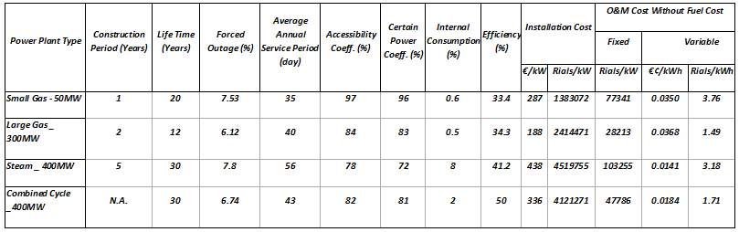

***Appendix 2***

***\* Social cost of electricity production through thermal power plant***

***According to energy balance of Iran -2011***

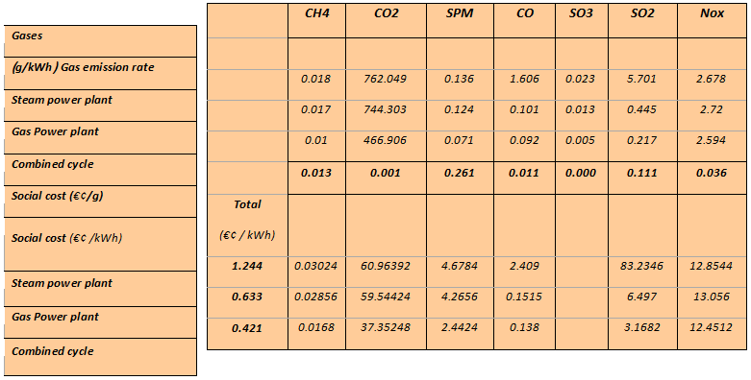

***Appendix 3***

***The Measurement Related To Fossilized Technologies***

***In the result of directed subsidy (the Natural Gas price # 0.189 € /m3)***

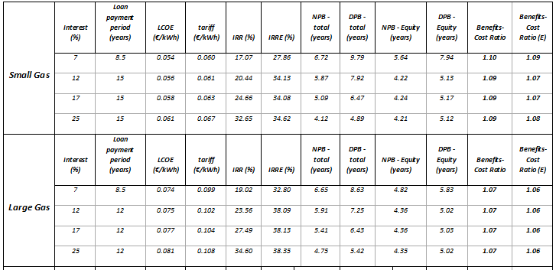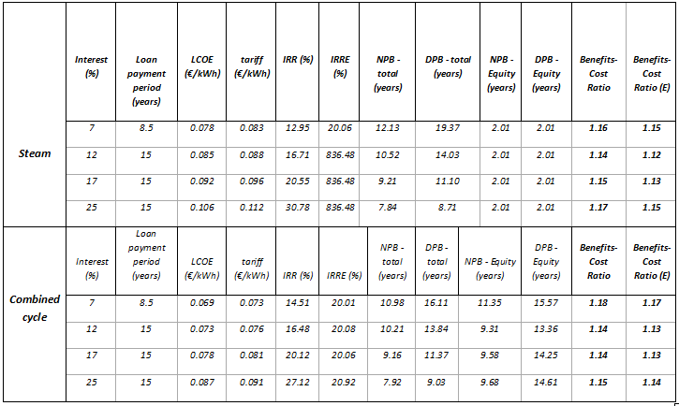

**References**

Parliament of Islamic Republic of Iran/Research Center/Law/Constitutional Law, Article-44, <http://rc.majlis.ir/fa/content/iran_constitution>

Oskounejad.M.Mehdi, Engineering Economy or Economic Evaluation of Industrial Projects, 30th Ed, AmirKabir University Publish, Tehran, 2008. P.48-50

Islamic Republic of Iran Power Sector Note, World Bank, No.38360_IR, 2007

Central Bank of the Islamic Republic of Iran, Key Economic Indicators, Publisher: Public Relations Department, Tehran, 2009/2010, <http://www.cbi.ir>

Islamic Republic of Iran Power Sector Note, World Bank, No.38360_IR, 2007

Akhoondy, Shahriar, the reference guide of COMFAR III, United Nation Industrial Development Organization (UNIDO), 2008, Tehran, p.9

1. Parliament of Islamic Republic of Iran/Research Center/Law, <http://rc.majlis.ir/fa/law>.

11/18/2013