A Botanical Enigma on India’s Hottest Chillis ‘Bhoot Jolokia’ (Capsicum Chinense Jacq)

Praveen Kumar Verma^{1*}, Krishna Kumar Rawat², Niren Das³ and Bijoy Pradhan⁴

^{1,3,4}Rain Forest Research Institute, Deovan, Sotai Ali, Post Box # 136, Jorhat – 785 001(Assam), India.
²CSIR-National Botanical Research Institute, Rana Pratap Marg, Lucknow – 226 001, Uttar Pradesh, India.
E-mail for Correspondence: pkverma_bryo@yahoo.co.in

Abstract: The paper is deals with recent botanical enigma on India’s hottest chilli ‘Bhoot Jolokia’, or ‘Bih Jolokia’ earlier identified as Capsicum chinense, now identified as Capsicum assamicum Purakyasth et al., as new species from Assam, India. But after the detail investigation as well as literature survey it has been found the new species has no novel characters other than Capsicum chinense Jacq. Hence the establishment of the species is in question.
[Verma, P. K; Rawat, K.K; Das, N. & Pradhan, B. A Botanical Enigma on India’s Hottest Chilli ‘Bhoot Jolokia’ (Capsicum Chinense Jacq). N Y Sci J 2013;6 (11):49-51]. (ISSN: 1554-0200). http://www.sciencepub.net/newyork. 7

Keywords: Capsicum chinense; C. assamicum; Bhoot Jolokia; Assam; India.

1. Introduction
Bhoot Jolakia, placed among hottest chillis with ‘Trinidad Moruga Scorpion’ (Wikipedia, April 2013), is an indigenous cultivar growing in Brahmaputra flood plain of Assam, Nagaland, Manipur and other part of Northeast India. The ‘Bhoot Jolokia’ came in highlight when Tezpur (Assam) based Defense Research Laboratory declared it is as hottest chilli of the world which replaced the world famous Red Savina Habanera (scientifically Capsicum chinense). Guinness Book of World Records, 2006 has recorded it hottest chilli with 1001304 SHU. This extreme character of chilli is due to a volatile phenolic amine ‘Capsaicin’, a molecule which is responsible for the pungency of chilli peppers and found mainly in the placenta as well as fleshy tissue of the fruit (Heiser, 1969). The capsaicin amount varies from 3-5% in comparison to other chillis of the subcontinent. It has been associated among ethno-agricultural activities of the rural people within region. The people of the north eastern India used the fruits of Bhoot Jolokia in different food formulations like flavouring curries due to its high-quality fragrance and pungency and also for various medicinal treatments like headache, night blindness (Deorani and Sharma, 2007), rheumatism, arthritis, gastritis, ankylosing spondylitis, digestive diseases (Sarwa et al., 2012) and to reduce chronic congestion (Bhagowati and Changkija (2009). The peoples inhabiting near forest area use the chilli powder or its smoke to keep elephants away from their agriculture fields. The archaeological data proved that the human civilization has been cultivating Capsicum since past 7000 years (Basu and De, 2003) to be used in food recipes for hotness and colouration (Purkayastha et al., 2012). FAO (2000) estimated 1.4 Million Hectares land is currently being under Capsicum cultivation producing about 18 Million metric tons per annum.
According to Chewicz and Thorpe (1996) more than 20 taxa of Capsicum are found across the world out of which India hosts five viz. Capsicum annuum Linn., Capsicum frutescens Linn., Capsicum chinense Jacq., Capsicum baccatum Linn., and Capsicum pubescens Linn. (Antonious and Jarret, 2006). Walsh and Hoot (2001) proposed two complexes of Capsicum species viz. C. annuum complex (with C. annuum, C. frutescens, and C. chinense) and C. eximium complex (with C. eximium and C. cardenasii). The chilli growing even in same geographical and climatic zone shows significantly difference in pungency. The heat of the chilli may reduce up to 50% in arid environment (Tiwari, 2005). On the other hand, ripe fruits may have a maximum number of 45 seed per fruit against a normal count of 25 to 40. Similarly, the full grown healthy plants may produce more than 70 fruits in a single season against a normal range of 30-45.
The traditional ‘Bhoot Jolokia’ or ‘Naga king’ chilli has several vernacular names like ‘Naga Jolokia’, ‘Bih Jolokia’, ‘Dorset Naga’, ‘Raja Mirchi’, ‘Borbih Jolokia’, ‘Nagahari’, ‘Ghost chilli’, ‘Naga Viper chilli’, ‘Poison chilli’ etc. Earlier it was identified as Capsicum frutescens Linn., however, a number of workers believed that C. frutescens do not produce as much hotness as Bhoot Jolokia and Bosland and Baral (2007) ended the dilemma on authenticity of Bhoot Jolokia and established through RAPD analysis it as Capsicum chinense with inclusion of genes of Capsicum frutescens through natural hybridization by cross pollination between species or any other method. Moreover, several taxonomists have suggested that C. frutescens and C. chinense should be merged as one species (Pickersgill 1971; McLeod et al. 1979) as both the species are interbreeding in nature very smoothly (Smith and Heiser, 1957; Lippert et al., 1966). Recently Purakyasth et al (2012) reported Capsicum assamicum as a separate new species, which was earlier known as ‘Bhih Jolokia’ (synonym vernacular name of Bhoot Jolokia), hence creating again the taxonomic enigma as the treatment of new species doesn’t answers many taxonomic questions. The authors used only single accession from only one locality and compared with specimens of C. chinense and C. frutescens available in KAL (Central Botanical Herbarium, Kolkatta). No Holotype or Isotype was concerned which puts a big question mark on its authenticity, as even molecular characterization failed to support it. It may be a natural cultivar as several ecotype growing in farmers field have been found with a large variation in morphological characters, viz. growth habit (branching pattern, branching), floral features like calyx, corolla, androecia and gynaecium especially in plants from of Jorhat, Sibsagar, Golaghat, Sonitpur, Karbi-Anglong, and Tuli. The extreme variations among different cultivars of Bhoot Jolokia include several colours, sizes and textures of fruits. Particularly the colour ranges from light green, yellowish green to dark green in young fruits and gradually changes into light red, bright red, bright orange and even chocolate while the texture varies from wrinkled to semi smooth as well as gloomy with fleshy tissue. Bhagowati and Changkija (2009) also reported existence of several such genotypic and phenotypic variant landraces of Bhoot Jolokia in Nagaland. Due to growing in different climatic conditions the different races become more or less pungent.
On the basis of exhaustive survey of published literatures on different aspect taxonomy, chemotaxonomy and molecular characterization of C. chinense, C. frutescens and C. assamicus (Bosland and Baral, 2007; Sarwa et al., 2012; Mathur et al., 2000; Purkayastha et al., 2012) as well as local survey in Assam valley on different cultivars of the Bhoot – Jolokia. It is seems the C. assamicum may be the result of natural hybridization of cultivated/ escaped populations of C. frutescens and C. chinense. The latter two species are closely related and likely to produce hybrids with some degree of fertility. Similarly, the molecular characterization presented by Purakyasth et al (2012) provides no explanation of the source of several samples, particularly those of C. assamicum, for which only a single population is indicated but several accessions appear in Fig. 5 of the paper. It is better to reduce C. assamicum as a synonym under Capsicum chinense as there are several intermediate natural cultivars which shares characters of both.

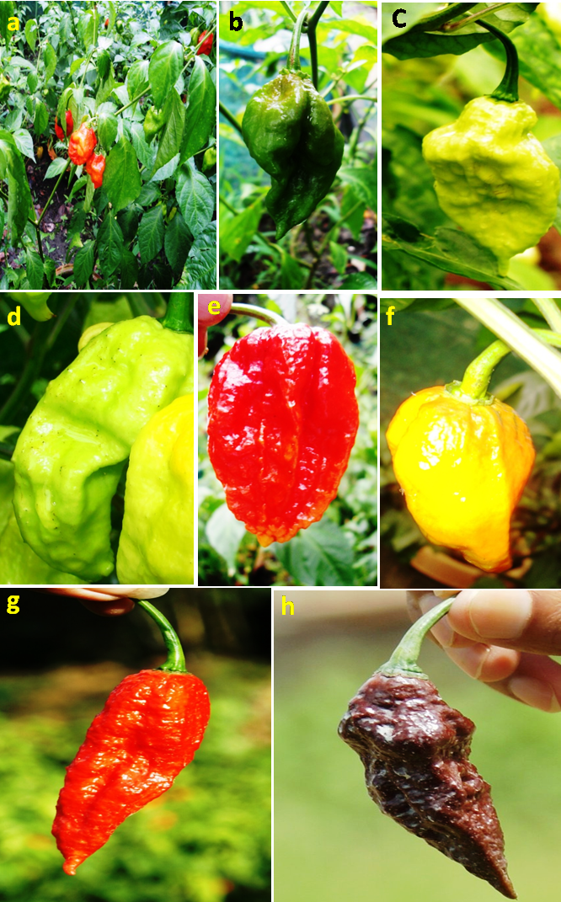
Figs.: Phenological variation within Bhoot Jolokia’ at Jorhat (Assam) a. Habit, b. Dark green in colour, c. Light green in colour surface rough, without spines, d. Light green in colour surface rough, with spines, e. Fruit red in colour in ovate size, f. Fruit yellow in colour, g. Fruit red in colour, cylindrical, ovate in size, h. Fruit chocolate in colour

Acknowledgements:
We are thankful to Director, Rain Forest Research Institute, Jorhat, Assam, for his encouragements and to Indian Council of Forestry Research and education, Dehradun for financial support under ICFRE-Demo Village Programme.

Corresponding Author:
Dr. Praveen Kumar Verma
Rain Forest Research Institute, Deovan, Sotai Ali, Post Box # 136, Jorhat – 785 001 (Assam), India.
E-mail: pkverma_bryo@yahoo.co.in

References
- Antonious GF and Jarrett RL 2006. Screening Capsicum accessions for capsaicinoids content. J. Env. Sci. Health. 41: 717-729.
- Ballard RE, McClure JW, Eshbaugh WH and Wilson KG 1970. A chemosystematic study of selected taxa of Capsicum. Am. J. Bot. 57: 225–233.
- Bhagowati RR and Changkija S 2009. Genetic variability and traditional practices in Naga King Chili landraces of Nagaland. Asian Agri-History. 13: 171–180.
- Bosland PW and Baral, JB 2007. ‘Bhut Jolokia’-the world’s hottest known chilli pepper is a putative naturally occurring interspecific hybrid. Hort. Science 42: 222–224.
- Bosland PW 1994. Chiles: history, cultivation and uses. In: Charalambous G (Ed.) Spices, Herbs, and Edible Fungi. Elesevier Publishers, New York USA pp. 347 -366.
- Chewicz RH and Thorpe PA 1996. The antimicrobial properties of Chile peppers (Capsicum species) and their uses in Mayan medicine. J. Ethnopharmacol. 52: 61–70.
- Cochran HL 1940. Characters for the classification and identification of varieties of Capsicum. Bull. Torrey Bot. Club 67: 710–717.
- Collins M and Bosland P 1994. Rare and novel capsaicinoid profiles in Capsicum. Capsicum and Eggplant Newsletter 13: 48–51.
- Deorani SC and Sharma GD 2000. Medicinal plants of Nagaland. Bishen Mahandra Pal Sigh. Dehradun.
- FAO 2000. Chillies and Peppers. In FAO Bulletin of Statistics (ed. FAO), Rome.
- Karjewska, E.K. & Powers, J.J. (1988). Sensory properties of isolated natural capsaicinoids. J. Food Sci. 53: 902–905.
- Sarwa KK, Kira, J, Sahu J, Rudrapal M and Debnath M 2012. A short review on Capsicum chinense Jacq. Journal of Herbal Medicine and Toxicology. 6: 7 – 10.
- Lippert LF, Smith PG and Bergh BO 1966. Cytogenetics of the vegetable crops: garden pepper, Capsicum sp. Bot. Rev. 32: 25–55.
- Mathur R, Dangi RS, Das SC and Malhotra RC 2000. The hottest chilli variety in India. Curr. Sci. 79: 287–288.
- McLeod MJ, Guttman SI and Eshbaugh WH 1982. Early evolution of chilli peppers (Capsicum). Econ. Bot. 36: 361–368.
- McLeod MJ, Eshbaugh WH and Guttman, SI 1979. A preliminary biochemical systematic study of the genus Capsicum—Solanaceae. In: Hawkes JG, Lester RN and Skelding AD (Eds.) The biology and taxonomy of the Solanaceae. Academic Press, London, pp 701–713.
- Mosquera MIM and Mendez, DHJ 1994. Formation and transformation of pigments during the fruit ripening of Capsicum annuum cv. Bola and Agridulce. Agri. Food Chem. 42: 38–44.
- Pickersgill B 1971. Relationships between weedy and cultivated forms in some species of chili peppers (genus Capsicum). Evolution 25: 683–691.
- Purkayastha J, Alam S, Gogoi HK, Singh L and Veer V 2012. Molecular characterization of 'Bhut Jolokia' the hottest chilli. J. Biosci. 37: 757–768.
- Purkayastha J, Alam SI, Gogoi HK and Singh L 2012. Capsicum assamicum sp. nov. (Solanaceae), from Assam, northeastern India. Ozean J. Appl. Sci. 5: 55–66.
- Shopova M 1966. Studies in the genus Capsicum. I. Species differentiation. Chromosoma 19: 340–348.
- Smith PG and Heiser Jr. CB 1951. Taxonomic and genetic studies on the cultivated peppers, Capsicum annuum L. and C. frutescens L. Am. J. Bot. 38: 362–368.
- Smith PG and Heiser Jr. CB 1957. Taxonomy of Capsicum sinense Jacq. and the geographic distribution of the cultivated Capsicum species. Bull. Torrey Bot. Club 84: 413–420.
- Suzuki T and Iwai K 1984. Constituents of red pepper species: Chemistry, biochemistry, pharmacology, and food science of the pungent principle of Capsicum species. In: Bross A. (Ed.) The Alkaloids: Chemistry and Pharmocology, Acdemic Press: Orlando, FL, pp. 23.
- Tiwari A, Kaushik MP, Pandey KS and Dangi RS 2005. Adaptability and production of hottest chilli variety under Gwalior agroclimatic conditions. Curr. Sci. 88: 1545–1546.
- Walsh BM and Hoot SB 2001. Phylogenetic relationships of Capsicum (Solanaceae) using DNA sequences from two Noncoding regions: The chloroplast Atpb-Rbcl spacer region and Nuclear waxy Introns. Int. J. Plant Sci. 162: 1409–1418. Wikipedia 2013.
- http://en.wikipedia.org/ wiki/Bhut_Jolokia_chili_pepper/Searched April4, 2013.

10/11/2013

