Temporal and Spatial Change Detection of Variations in the Groundwater Composition by Multivariate Statistical Techniques

Nahed El Arabi ¹, Yehia Idris ², Akram Fekry ³

1 Director of the Research Institute for Groundwater (RIGW), National Water Research Center (NWRC), Egypt
² RIGW, NWRC, Egypt
³ Head of Nile Basin Research Department, RIGW, NWRC, Egypt.
Email: Yehia_Idris@Yahoo.com.

Abstract: A set of quantitative analytical data from the Nile Delta aquifer, lies between longitudes 30° 00’ 07” to 32° 02’ 47” East and latitudes 30° 08’42” to 31° 30’ 08” North in the Nile Delta region north Egypt, has been processed by multivariate statistical techniques in order to investigate the factor controlling the groundwater composition within a period of four years (2007-2010). The original matrix consisted of 13 hydro-chemical parameters, determined in 61 groundwater sampling sites of the aquifer. The data of each round was analyzed separately. The exploration of the correlation matrices allowed uncovering perfect and strong associations between some variables as well as moderate and a lack of association between the others. Factor analysis showed the existence of up to five significant factors which account for 80-91 % of the total variance of hydrochemistry data. The first two can be initially assigned to natural mineralization and saline man made salinity whereas the others are built from variables indicative of pollution as a result of agriculture and industrial activities. The results showed that the first factor component explained that salinity increased naturally and an accumulation of human activities by the end of the survey period. Loading factor of some trace elements was also increasing from the first round to the last one as a result of industrial activities as accounted by the results of other four factors. Factor analysis represented that lithology, and landuse played a significant role on groundwater quality in the study area. The ARCGIS was utilized to detect the spatial variations. This work will provide policy makers and land managers with knowledge of the precise groundwater quality problems affecting the aquifer and can also serve as a guide for assessment of the hydrogeochemical processes controlling groundwater in the study area. The study recommended the environmental treatment for the industrial wastes as well as regularly environmental check for the industrial activities.
[Nahed El Arabi, Yehia Idris and Akram Fekry. Temporal and Spatial Change Detection of Variations in the Groundwater Composition by Multivariate Statistical Techniques. N Y Sci J 2013;6(11):38-48]. (ISSN: 1554-0200). http://www.sciencepub.net/newyork. 6

Keywords: Groundwater; Multivariate Analysis; Factor Analysis; Hydrochemistry; Change Detection; GIS

1. Introduction
Groundwater is the major source of drinking water in both urban and rural areas. Also, it is frequently used as an alternative source for agricultural and industrial sectors. There are several factors capable of impinging on groundwater quality not only the natural factors such as the lithology of the aquifer, the quality of recharge water and the type of interaction between water and aquifer, but also the human activities. Either one or two factors could contaminate the aquifers to such an extent that the use of groundwater becomes restricted. Thus, there is a need to regularly evaluate groundwater quality for improving water management (Mahmood et al., 2011).
The particular problem in case of water quality monitoring is the complexity associated with analysis a large number of measured variables. The data sets contain rich information about the behavior of the water body. In recent years many studies have been done using multivariable statistical methods in the interpretation of water quality parameters which offer a better understanding of water quality and interpreting the complicated data sets. A case study for the application of principal components analysis method for identifying relevant types of groundwater and the processes that bring about a change in their quality was presented by (Sanchez-Martos et al., 2001). This methodology has been applied to the investigation of the detrital aquifer of the Bajo Andarax (Almeria, Spain). Subyani, and Al Ahmadi (2010) characterized the hydrochemical facies of groundwater system (major and minor components) presented in the shallow alluvial aquifer situated in the western portion of Saudi Arabia, by using cluster and factor analysis. The impact of agriculture on surface and groundwater quality was determined by (Ishaku et al., 2011). They also identified the hydrogeochemical processes responsible in the modification of groundwater quality using factor analysis in Mararaba-mubi area Northeastern Nigeria. The multivariate statistical analysis technique as a very useful tool for interpreting the groundwater quality parameters was reported by (Lalitha et al., 2012). The evaluation of the similarities and dissimilarities with specific process that control the quality of groundwater throughout the Principal Component Analysis (PCA) was also discussed. Cobbina et al. (2012) applied the multivariate statistics (cluster analysis and principal components) to reveal information about the natural and anthropogenic origin of contaminants in ground water, the possible non-point sources of contamination and the contributions of possible sources to concentrations of the determined parameters in the Tolon-Kumbungu District, Ghana.
A difficulty in determining temporal degradation of groundwater quality is the lack of long-term chemical data and thus an understanding of how groundwater quality has changed or is changing. Because of this, the literature on temporal variations in groundwater quality is limited. Many researchers treated groundwater quality parameters individually by describing the seasonal variability and their causes, while it is difficult to interpret all the parameters patterns in combinations. Some of these studies consider only two points in time or one particular parameter. An approach illustrating that the temporal changes in groundwater quality can be identified from a trend analysis of time-series data measured at a specific depth and a comparison of solute concentrations at different depths at a specific time was presented by (Broers et al., 2001). The approach combined the two data sources for area-types with homogeneous land use, geohydrological situation, and soil characteristics.
The main objectives of this study are to detect the temporal and spatial variations of groundwater composition within a period of four years (2007-2010). Extraction of latent information about the quality of groundwater and detection of the parameters that are most important in assessing variations in groundwater quality in the study area is considered as the specific objectives of present study. The use of factor analysis is proposed, for identifying the groundwater chemical parameters and the processes that bring about a change in their quality where the ARCGIS was utilized to trace the change of the spatial variations.
2. Study Area and Data
2.1. Study Area Description
The study area lies between longitudes 30° 00’ 07” to 32° 02’ 47” East and latitudes 30° 08’42” to 31° 30’ 08” North in the Nile Delta region north Egypt as shown in Figure 1. The climate is less arid compared to the rest of Egypt and the rainfall is in excess of 150 mm/y along parts of coastal zone, decrease rapidly southwards to less than 25 mm/y in the vicinity of Cairo city. The annual minimum and maximum temperatures vary from about 13ºC to about 28ºC. On the basis of landuse it includes the traditionally cultivated land areas, the newly reclaimed areas as well as the scattered urbanized areas. Industrial activities are mainly in urbanized areas. The ground elevation varies from near sea level in the north to 5.5 m above mean sea level (AMSL) in the southern portion. The average groundwater level ranges from 1.3 m to 3.65 m AMSL. Extensive man made drainage systems are found which are particularly noticeable in the traditionally cultivated land areas and have been extended to some of the newly reclaimed areas, which allow for conveyance of the agriculture drainage water directly to the Mediterranean Sea or to its peripheral lakes (RIGW 1992).
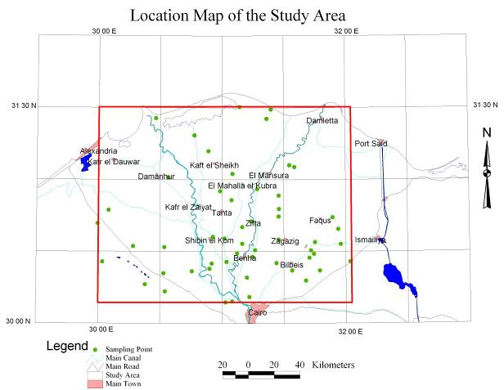
Figure 1. Location Map of the Study Area

2.2 Geomorphology, Geology, Stratigraphy and Hydrogeology of the Study Area
In the study area two geomorphic units out of seven units represented in the Nile delta Region. The first unit is the Mediterranean Foreshore Plain which occupies the area determined by the coastal lakes and their inland extension into the brackish water lagoons. Landforms include the wetland areas of the main lakes, the sabkhas or evaporites consisting of gypsum, halite and clays mixed with quartz sand and silt. The second unit is the Young Fluviatile Plain which occupies much of the central portion of the Nile delta region. It is underlain by a fertile silty clay layer. This plain slopes very gently northward at rate of about 1m per 10 km. In its eastern portion the surface is dotted with number of hills, known as turtle backs, which rise a few meters above the surrounding plain and built up of coarse sand belonging to an older phase of the Neonile system (RIGW, 1992).
The surface exposures in the study area belong almost totally to the Quaternary and to the late Tertiary and are essentially developed into clastic facies. The Nile delta itself is a morpho-tectonic depression, which is bounded on the western side by the North Western Desert and on the eastern side by the Cairo_Suez district. In the Nile Delta, the Quaternary sediments attain a thickness in excess of 1000 m. They lie unconformably over the Pliocene or older sediments. In the adjacent desert areas, the Quaternary section is thin and incomplete (RIGW, 1992).
The strata of hydrological importance belong essentially to the Quaternary and to the Tertiary. The deltaic deposits (200-500 m thick) which belong to the Pleistocene constitute the bulk of the main aquifer. These are dominated by unconsolidated coarse sands and gravels (with occasionally clay lenses). The top portion of such deposits changes in the seaward direction into impervious clays and silt. The basal portion of the deltaic deposits rests unconformably on a thick clay section (up to 4,000 m) which belongs to the Neogene. This clay section acts as an aquiclude.
There is a regional northward dip which accounts for the marked thickening of the gravelly sand layers (from 200 to 500 m), and consequently for the increase of the reservoir capacity. Only at the approach to the edge of the Mediterranean Geosyncline, where there is a conspicuous change of facies (particularly noticeable in the upper portions) the aquifer loses some of its hydrological characteristics, especially in regard to the free nature of the ground water occurrences and to the salt water invasion from the sea. In the Nile Delta, the groundwater exists almost entirely under leaky conditions. In that area, there is a gently northward slope in the ground water level. The gradient of this slope (hydraulic gradient) is of order of 0.75 m / k m. The Nile complex constitutes the main recharging area of the delta aquifer; the discharge is in connection with the main water-table of the salt water body. Wadi El Natrum (- 20 m) and most probably also the Qattara Depression (-130 m) act also as natural discharging areas of that aquifer. Bordering that large aquifer, there is a number of secondary aquifers found in the other Quaternary sediments as well as in the Tertiary sediments. Although all such aquifers are hydraulically connected, they exhibit varying flow systems as a result of their heterogeneity. Generally speaking the specific capacity of wells in the delta region varies between 60 and 170 m3 / hr (Shaban et al., 2012).
2.3 Hydrochemical Data and Laboratory Analyses
The hydrogeochemical data was obtained from the groundwater monitoring network in the Nile Delta Aquifer belongs to the Research Institute for Groundwater. The samples were collected annually in years 2007, 2008, 2009 and 2010 from 61 observation wells at depth range from 40 to 50 m below the ground surface selected to represent the groundwater aquifer in the study area. The collected samples were analyzed in the central laboratory of the National Water Research Center (NWRC) for different physicochemical parameters, major cations major anions and trace metals such as pH, electrical conductivity (EC), Total Alkalinity, Total dissolved solids (TDS), ammonia, nitrate, sulfate, fluoride, chloride, sodium, calcium, magnesium, iron and zinc according to the standard methods.
3. Brief on Factor Analysis
Multivariate statistical techniques can help to simplify and organize large datasets to summarize information in a smaller set of factors or components having meaningful information for prediction purposes. Principal Component Analysis (PCA) and Factor Analysis (FA) are both variable reduction techniques and sometimes mistaken as the same statistical method.
The PCA is used when variables are highly correlated and reduces the number of observed variables to a smaller number of principal components which account for most of the variance of the observed variables where, the FA as a variable reduction technique identifies the number of latent constructs (factors) and the underlying factor structure of a set of variables. It also, estimates factors which influence responses on observed variables. Traditionally it has been used to explore the possible underlying factor structure of a set of measured variables without imposing any preconceived structure on the outcome. In other words, PCA includes correlated variables with the purpose of reducing the numbers of variables and explaining the same amount of variance with fewer variables (principal components) while FA estimates factors, underlying constructs that cannot be measured directly. (Child, 1990)
The purpose of FA procedures is to determine the minimum number of new variables necessary to reproduce various attributes of the data by reducing the original data matrix from one having (n) variables necessary to describe the (N) samples to a matrix with (m) factors (m < n) for each of the (N) samples. It is also aimed at transforming the variables so that the axes become orthogonal, which then allows the definition of new independent variables. By so doing, the first factor is chosen to explain as much as possible of the total variance of the observations, the second factor to explain as much as possible of the residual variance, and so forth.
In other words, the first factor is determined such that the sum of squares of the projections of the points on the factor is highest (factor loadings). Next, to define the second factor, the points are projected on a plane orthogonal to the first factor and so on for the other factors, each explaining less and less of the total variance. On the other hand, the sum of squares of the factor loadings for each variable is the communality and reflects the proportion of the total variability of each variable accounted for by the factoring. The FA procedures follow three main steps, namely: extraction initial factors, rotation of factors and calculation of each factor scores (Subyani et al., 2010 & Amadi et al., 2012).
4. Data Processing
Thirteen hydrochemical variables Calcium (Ca), Potassium (K), Magnesium (Mg), Sodium (Na), Chloride (Cl), Nitrate (NO), Sulfate (SO), Aluminum (Al), Cobalt (Co), Copper (Cu), Iron (Fe), Manganese (Mn) and Zinc (Zn) were selected as variables inputs for Factor Analysis (FA). The data of each survey was treated separately. Prior to the analysis, since groundwater quality parameters had different magnitudes and scales of measurements so the data were standardized to produce a normally distribution of all variables. In the standardization, the raw data were converted to unit less form of zero mean and a variance of one, by subtracting from each variable the mean of data set and dividing by standard deviation.
The computer package Statistical Packages like for Social Sciences (SPSS) was used to carry out the statistical analyses. In the present work, factor extraction was done by principal components; whereas, Varimax rotation with Kaiser Normalization was used for orthogonal rotation and results in factors that are uncorrelated. The factor scores that are computed for each observation which expresses the importance of each factor at that observation site outlined the importance of factor scores and their relations to potential of the processes described by each factor.
5. Results and Discussion
5.1 Correlation between Variables
First step in factor analysis is the determination of the parameter correlation matrix. It is used to account for the degree of mutually shared variability between individual pairs of groundwater quality variables. The correlation matrices with which we can observe the relationship between parameters was obtained and tabulated in Tables 1-4 for years 2007, 2008, 2009 and 2010 respectively. Perfect correlation coefficient is ranging 0.99 to 1.00. Strong correlation coefficient is ranging 0.80 to 0.98. Parameters showing correlation coefficients of r>0.5-0.8 are considered to be moderate correlation. Weak correlation coefficient is considered when r<0.5. The negative values show inverse relationships between chemical parameters. The strong to perfect correlation between the chemical parameters is an indication of common source.

Table 1. Correlation Coefficients for Chemical Parameters Year 2007.
 | Ca | K | Mg | Na | Cl | NO₃ | SO₄ | Al | Co | Cu | Fe | Mn | Zn
Ca | 1.00
K | 0.89 | 1.00
Mg | 0.97 | 0.90 | 1.00
Na | 0.58 | 0.42 | 0.67 | 1.00
Cl | 0.58 | 0.43 | 0.67 | 1.00 | 1.00
NO₃ | 0.03 | -0.11 | -0.09 | -0.17 | -0.17 | 1.00
SO₄ | 0.96 | 0.82 | 0.92 | 0.55 | 0.55 | 0.06 | 1.00
Al | 0.04 | 0.07 | 0.06 | -0.04 | -0.03 | -0.11 | 0.01 | 1.00
Co | -0.20 | -0.28 | -0.27 | -0.40 | -0.40 | 0.23 | -0.20 | -0.18 | 1.00
Cu | 0.38 | 0.41 | 0.47 | 0.73 | 0.72 | -0.14 | 0.37 | 0.06 | -0.59 | 1.00
Fe | 0.58 | 0.51 | 0.67 | 0.81 | 0.81 | -0.16 | 0.51 | 0.03 | -0.42 | 0.75 | 1.00
Mn | -0.11 | -0.08 | -0.10 | -0.10 | -0.10 | -0.09 | -0.13 | 0.02 | 0.12 | -0.05 | 0.12 | 1.00
Zn | 0.12 | 0.16 | 0.15 | -0.05 | -0.05 | 0.38 | 0.12 | -0.08 | 0.16 | 0.01 | 0.10 | -0.01 | 1.00

Table 2. Correlation Coefficients for Chemical Parameters Year 2008.
 | Ca | K | Mg | Na | Cl | NO₃ | SO₄ | Al | Co | Cu | Fe | Mn | Zn
Ca | 1.00
K | 0.95 | 1.00
Mg | 0.96 | 0.95 | 1.00
Na | 0.91 | 0.85 | 0.92 | 1.00
Cl | 0.91 | 0.85 | 0.92 | 1.00 | 1.00
NO₃ | -0.20 | -0.29 | -0.23 | -0.13 | -0.13 | 1.00
SO₄ | 1.00 | 0.96 | 0.96 | 0.89 | 0.88 | -0.22 | 1.00
Al | 0.25 | 0.15 | 0.20 | 0.20 | 0.20 | -0.02 | 0.23 | 1.00
Co | -0.08 | -0.12 | -0.20 | -0.17 | -0.18 | -0.05 | -0.06 | 0.01 | 1.00
Cu | 0.63 | 0.48 | 0.55 | 0.60 | 0.61 | 0.27 | 0.60 | 0.26 | 0.12 | 1.00
Fe | 0.67 | 0.64 | 0.55 | 0.34 | 0.34 | -0.32 | 0.69 | 0.17 | 0.15 | 0.36 | 1.00
Mn | 0.01 | -0.06 | -0.07 | -0.06 | -0.06 | -0.22 | -0.04 | 0.10 | -0.06 | 0.07 | 0.27 | 1.00
Zn | 0.57 | 0.58 | 0.48 | 0.24 | 0.24 | -0.29 | 0.60 | 0.33 | 0.22 | 0.32 | 0.84 | 0.14 | 1.00

Table 3. Correlation Coefficients for Chemical Parameters Year 2009.
 | Ca | K | Mg | Na | Cl | NO₃ | SO₄ | Al | Co | Cu | Fe | Mn | Zn
Ca | 1.00
K | 0.49 | 1.00
Mg | 0.93 | 0.55 | 1.00
Na | 0.90 | 0.68 | 0.91 | 1.00
Cl | 0.91 | 0.67 | 0.91 | 1.00 | 1.00
NO₃ | -0.01 | -0.08 | -0.04 | -0.13 | -0.13 | 1.00
SO₄ | 0.92 | 0.34 | 0.90 | 0.79 | 0.78 | 0.01 | 1.00
Al | 0.13 | -0.05 | 0.03 | 0.04 | 0.04 | -0.04 | 0.12 | 1.00
Co | 0.05 | 0.16 | 0.11 | 0.12 | 0.11 | -0.04 | 0.10 | 0.25 | 1.00
Cu | 0.56 | 0.53 | 0.56 | 0.62 | 0.62 | 0.03 | 0.49 | 0.16 | 0.24 | 1.00
Fe | 0.93 | 0.34 | 0.86 | 0.88 | 0.89 | -0.13 | 0.85 | 0.09 | 0.09 | 0.52 | 1.00
Mn | 0.15 | -0.05 | 0.26 | 0.02 | 0.01 | 0.05 | 0.24 | 0.06 | 0.10 | 0.21 | 0.08 | 1.00
Zn | 0.19 | 0.15 | 0.18 | 0.13 | 0.13 | 0.06 | 0.13 | -0.15 | -0.05 | 0.06 | 0.07 | 0.03 | 1.00

Table 4. Correlation Coefficients for Chemical Parameters Year 2010.
 | Ca | K | Mg | Na | Cl | NO₃ | SO₄ | Al | Co | Cu | Fe | Mn | Zn
Ca | 1.00
K | 0.95 | 1.00
Mg | 0.96 | 0.86 | 1.00
Na | 0.99 | 0.96 | 0.94 | 1.00
Cl | 0.99 | 0.95 | 0.95 | 1.00 | 1.00
NO₃ | 0.05 | 0.05 | 0.03 | 0.06 | 0.06 | 1.00
SO₄ | 0.03 | -0.03 | 0.06 | -0.04 | -0.05 | 0.26 | 1.00
Al | -0.04 | -0.07 | -0.07 | -0.05 | -0.05 | -0.09 | 0.09 | 1.00
Co | 0.01 | 0.01 | 0.01 | -0.01 | -0.01 | -0.17 | 0.09 | -0.02 | 1.00
Cu | 0.10 | 0.09 | 0.10 | 0.12 | 0.13 | -0.06 | -0.24 | -0.08 | 0.03 | 1.00
Fe | 0.05 | 0.02 | 0.10 | 0.05 | 0.06 | -0.01 | -0.05 | -0.04 | -0.06 | 0.31 | 1.00
Mn | 0.13 | 0.13 | 0.17 | 0.14 | 0.15 | 0.08 | -0.29 | -0.08 | -0.08 | 0.01 | -0.01 | 1.00
Zn | 0.74 | 0.67 | 0.75 | 0.68 | 0.71 | 0.09 | -0.04 | -0.05 | 0.06 | 0.16 | 0.12 | 0.04 | 1.00

From correlation tables, it can be concluded that Na and Cl showed perfect correlation all over the four rounds while Ca and SO₄ had perfect correlation only in year 2008. The last survey showed perfect correlation between Ca, Na and Cl. The relations between Ca, K and Mg were ranged from moderate to strong during the four years of survey. Negative and weak relationships during the four years were found between Ca, k, Mg, and Na with both of NO3, Al, Co and Mn. As well as the same relations were presented by SO4 against Al, Co and Mn. In addition to Al versus Co, Cu, Fe, Mn and Zn had the same behavior. Also, Co next to Cu, Fe, Mn and Zn revealed the same relation as well as the following pairs Cu and Mn, Fe and Mn, Mn and Zn, and Cu against Mn and Zn.
5.2 Factor Analysis
Factor analysis was applied to the selected variables for each round separately in order to compare the compositional patterns between the analyzed water samples and to identify the factors that influence each one. FA was performed using SPSS yielded 13 factors. Factor analysis shows that the first five factors which extracted by principal components method have eigen values greater or equal one and explained 80-91% of total variance considered to be the most important. The eigen values determine the number of factor components that are necessary. This number depends on the amount of variation in the data. The higher the eigen value of a factor component, the greater the contribution of that particular component to the variability of the groundwater chemistry
The interpretation of the factor analysis can be simplified without changing the variance by using the certain rotational procedures. In the present study, the Varimax rotation method with Kaiser Normalization which is the most popular rotation technique was applied to obtain a simple structure with scores. The scores are obtained called factor scores, which show the intensity of chemical process described by each factor.

5.2.1 Result of Year 2007
The FA results of year 2007 consist of five factors that cumulatively account for 85% of the total variance. The rotated factor loading, eignvalues, percentages of variance associated with each factor are summarized in Table 5.

Table 5. Factor Loading Matrix after Varimax Rotation Year 2007
Variable | F1 | F 2 | F 3 | F 4 | F 5
Ca | 0.954 | 0.257 | 0.058 | -0.008 | -0.039
K | 0.904 | 0.198 | 0.003 | 0.130 | -0.004
Mg | 0.915 | 0.377 | 0.018 | 0.022 | -0.008
Na | 0.375 | 0.854 | -0.098 | -0.152 | -0.041
Cl | 0.383 | 0.851 | -0.099 | -0.152 | -0.040
NO₃ | -0.035 | -0.143 | 0.805 | -0.103 | -0.162
SO₄ | 0.921 | 0.234 | 0.074 | -0.031 | -0.081
Al | 0.056 | -0.027 | -0.055 | 0.915 | 0.047
Co | -0.032 | -0.620 | 0.189 | -0.434 | 0.219
Cu | 0.168 | 0.880 | 0.006 | 0.136 | -0.031
Fe | 0.393 | 0.819 | 0.024 | 0.000 | 0.225
Mn | -0.082 | -0.021 | -0.036 | 0.019 | 0.964
Zn | 0.125 | 0.007 | 0.843 | 0.006 | 0.118
Eigen value | 3.911 | 3.606 | 1.427 | 1.119 | 1.082
Variance (%) | 30.087 | 27.741 | 10.980 | 8.610 | 8.325
Cummulative Variance (%) | 30.087 | 57.828 | 68.808 | 77.419 | 85.744

The absolute value of the loadings (their actual sign depends on the calculation algorithm used) is an indicator of the participation of the chemical variables in the factor component. The higher loading significant contribution (> 0.60 considered significant) is highlighted in bold face. The first factor loading with 30.087 % variance showed higher loading for Ca, K, Mg and SO₄. Factor 2, with higher loading of Na, Cl, Co, Cu and Fe explained 27.741% of variance. Factor 3, explained 10.980 % of variance where NO₃ and Zn gave most contribution. Factor 4 was responsible for 8.610 % of the total variance and best represented by Al. Factor 5 represented by Mn and explained the 8.325 % of the total variance.
5.2.2 Result of Year 2008
It is observed that Table 6 presented the five factors explained 91.148 % of the variance in the dataset. Ca, K, Mg, Na, SO₄, Cl and Cu are loaded in the first factor which accounted for 49.450 % of the total variance. Factor 2 had a total variance of 13.209 % was mainly related with higher loading of Co, Fe and Zn. Factor 3 accounted for 10.570 % of the total variance and includes higher loading for NO₃ and Cu. Factor 4 with a total of variance of 9.239 % showed higher loading for Mn. Factor 5 showed 8.680 % of the total variance with higher loading of Al.

Table 6. Factor Loading Matrix after Varimax Rotation Year 2008
Variable | F1 | F 2 | F 3 | F 4 | F 5
Ca | 0.966 | 0.183 | -0.037 | 0.071 | 0.117
K | 0.940 | 0.159 | -0.197 | -0.006 | 0.043
Mg | 0.977 | 0.031 | -0.101 | -0.005 | 0.084
Na | 0.960 | -0.120 | 0.076 | -0.029 | 0.060
Cl | 0.960 | -0.122 | 0.077 | -0.027 | 0.060
NO₃ | -0.156 | -0.099 | 0.866 | -0.137 | 0.011
SO₄ | 0.960 | 0.220 | -0.081 | 0.031 | 0.105
Al | 0.125 | 0.047 | 0.050 | 0.044 | 0.978
Co | -0.205 | 0.804 | 0.144 | -0.171 | -0.078
Cu | 0.618 | 0.257 | 0.612 | 0.189 | 0.134
Fe | 0.515 | 0.617 | -0.271 | 0.368 | 0.095
Mn | -0.075 | -0.013 | -0.069 | 0.966 | 0.043
Zn | 0.402 | 0.689 | -0.281 | 0.200 | 0.310
Eigenvalue | 6.429 | 1.717 | 1.374 | 1.201 | 1.128
Variance (%) | 49.450 | 13.209 | 10.570 | 9.239 | 8.680
Cummulative Variance (%) | 49.450 | 62.659 | 73.229 | 82.468 | 91.148

5.2.3 Result of Year 2009
The loading values in factor component, eigenvalues and percentage of variance evaluated using varimax rotation method of dataset surveyed in year 2009 are represented in Table7.
5.2.4 Result of Year 2010
The rotated factor loading, eignvalues, percentages of variance associated with each factor are summarized in Table 8.

Table 7. Factor Loading Matrix after Varimax Rotation Year 2009
Variable | F1 | F 2 | F 3 | F 4 | F 5
Ca | 0.976 | 0.040 | 0.017 | 0.077 | 0.045
K | 0.516 | 0.510 | 0.348 | -0.344 | -0.058
Mg | 0.946 | 0.105 | 0.114 | 0.152 | -0.006
Na | 0.949 | 0.190 | 0.097 | -0.143 | -0.086
Cl | 0.950 | 0.175 | 0.094 | -0.145 | -0.088
NO₃ | -0.052 | -0.026 | 0.042 | 0.021 | 0.988
SO₄ | 0.909 | -0.008 | -0.051 | 0.231 | 0.062
Al | 0.076 | 0.343 | -0.685 | 0.138 | 0.049
Co | -0.006 | 0.814 | -0.181 | 0.126 | -0.057
Cu | 0.588 | 0.520 | 0.036 | 0.053 | 0.125
Fe | 0.943 | -0.022 | -0.094 | 0.036 | -0.088
Mn | 0.108 | 0.110 | 0.057 | 0.919 | 0.018
Zn | 0.096 | 0.082 | 0.752 | 0.153 | 0.082
Eigenvalue | 6.009 | 1.411 | 1.238 | 1.149 | 1.037
Variance (%) | 46.222 | 10.850 | 9.526 | 8.837 | 7.973
Cummulative Variance (%) | 46.222 | 57.072 | 66.598 | 75.436 | 83.409

Factor 1 had a high loading of Ca, Mg, Na, SO₄, Cl and Fe and explained 46.222 % of the total variance. The second factor loaded with 10.850 % of the total variance showed higher loading for Co. The Third factor explained 9.526 % of the variance and showed higher loadings on Zn and Al. The fourth factor was responsible for 8.837 % of the total variance and best represented by Mn. The Fifth factor represented by NO₃ and explained the 7.973 % of the total variance.

Table 8. Factor Loading Matrix after Varimax Rotation Year 2010
Variable | F1 | F 2 | F 3 | F 4 | F 5
Ca | 0.995 | -0.009 | 0.004 | 0.008 | 0.000
K | 0.953 | -0.057 | -0.018 | 0.009 | 0.020
Mg | 0.961 | -0.004 | 0.040 | 0.024 | 0.029
Na | 0.983 | -0.069 | 0.022 | 0.024 | 0.001
Cl | 0.986 | -0.072 | 0.032 | 0.025 | 0.004
NO₃ | 0.059 | 0.294 | -0.068 | 0.722 | 0.350
SO₄ | 0.025 | 0.828 | -0.221 | 0.183 | 0.022
Al | -0.026 | 0.127 | -0.076 | 0.011 | -0.895
Co | 0.031 | 0.264 | -0.088 | -0.754 | 0.283
Cu | 0.093 | -0.149 | 0.771 | -0.132 | 0.092
Fe | 0.041 | 0.081 | 0.804 | 0.143 | -0.021
Mn | 0.127 | -0.694 | -0.174 | 0.246 | 0.185
Zn | 0.784 | 0.048 | 0.166 | -0.025 | 0.057
Eigenvalue | 5.409 | 1.383 | 1.368 | 1.225 | 1.051
Variance (%) | 41.605 | 10.642 | 10.522 | 9.421 | 8.084
Cummulative Variance (%) | 41.605 | 52.247 | 62.768 | 72.189 | 80.273

Ca, K, Mg, Na, Cl and Zn are loaded in the first factor which accounted for 41.605 % of the total variance. Factor 2 had a total variance of 10.642 % was mainly related with higher loading of SO₄ and Mn. Factor 3 accounted for 10.522 % of the total variance and included higher loading for Cu and Fe. Factor 4 with a total of variance of 9.421 % showed higher loading for NO₃ and Co. Factor 5 showed 8.084 % of the total variance with higher loading of Al.

5.3 Change Detection
Variation in concentrations of different chemical elements in natural groundwater depends on the ability of the elements on the distribution and interaction. Some elements present in natural groundwater with high concentrations, these elements compose the vast majority of groundwater salinity so called major elements (Ca, Mg, Na, K, Cl, SO_{4,} HCO₃). Some others present at very low concentrations so called trace elements (Fe, Mn, Co, B, NO_{3,} NO₂…..ect). Presence any of the major elements or trace one in groundwater is linked with hydrogeological conditions and chemical processes prevailing. Some natural interactions associated with the groundwater movement change the chemical composition of the groundwater which leads to increasing concentrations of certain elements at the expense of other elements.
To check the temporal changes of the variation of the groundwater chemistry during the period 2007-2010, by reviewing the results of the above factor analysis, selecting the chemical parameters of each factor that had higher loading and the percentage of the total variance accounted by this factor can be summarized in Table 9.

Table 9. Temporal Change Detection of Groundwater Composition (2007 – 2010)
Year | F1 / (V %) | F2 / (V%) | F3 / (V%) | F4 / (V%) | F5 / (V%)
2007 | Ca, K, Mg, SO₄ / (30.087) | Na, Cl, Co, Cu, Fe / (27.741) | NO₃, Zn / (10.980) | Al / (8.610) | Mn / (8.325)
2008 | Ca, K, Mg, SO_{4,} Na, Cl, Cu / (49.450) | Co, Fe, Zn / (13.209) | NO3, Cu / (10.570) | Mn / (9.239) | Al / (8.680)
2009 | Ca, Mg, SO₄, Na, Cl, Fe / (46.222) | Co / (10.850) | Zn, Al / (9.526) | Mn / (8.837) | NO₃ / (7.973)
2010 | Ca, K, Mg, Na, Cl, Zn / (41.605) | SO₄, Mn / (10.642) | Cu, Fe / (10.522) | NO₃, Co / (9.421) | Al / (8.084)
F1/(V%): The first factor with higher loading factor parameter and the percentage of variance accounted with it.

Considering the results of year 2007 as a base, it can be notice that groundwater contained classical hydrochemical variables represented by the first factor originating, at a first glance, from mineralization of the geological components of soils, the second factor component responsible for salinity due to cation-exchange processes at soil water interface and industrial wastes Iron loading may be due to dissolution of lithogenic materials. The other factor components are contributed by nitrate and trace elements, i.e. by species whose presence at high concentration levels can be attributed to human action: nitrate may originate from fertilizers (both agricultural and industrial), and trace metals from leachates of industrial wastes and/or manure piles.
From the results it can be concluded that the first component is the main contributor in the groundwater composition according to its accounted percentage of the total variance in the four years. It contains the main sources of salinity which can be referred to the increase of dissolution of lithogenic materials and the industrial activities. The other components revealed the increase may be the change in the industrial activities relative to the agriculture ones. There is increase in the loading factor of Zn and Mn all over the total period. Co and Cu had almost high and stable contribution. NO₃ participation decreased along the four years. Al also, showed low change during the whole period.
These results can be described as lithologically and non–lithologically controlled factors and also showed the clear impact of land use on groundwater
Visually communicating hydrochemical maps for the first factor component were constructed using ARCGIS 9.3 software to delineate spatial variation of salinity process during the four rounds as shown in Figure 2. The temporal and spatial variation of Mn can be detected individually form year 2007 to year 2009 while the loading of Mn and SO₄ can be delineated in year 2010 as illustrated in Figure 3.

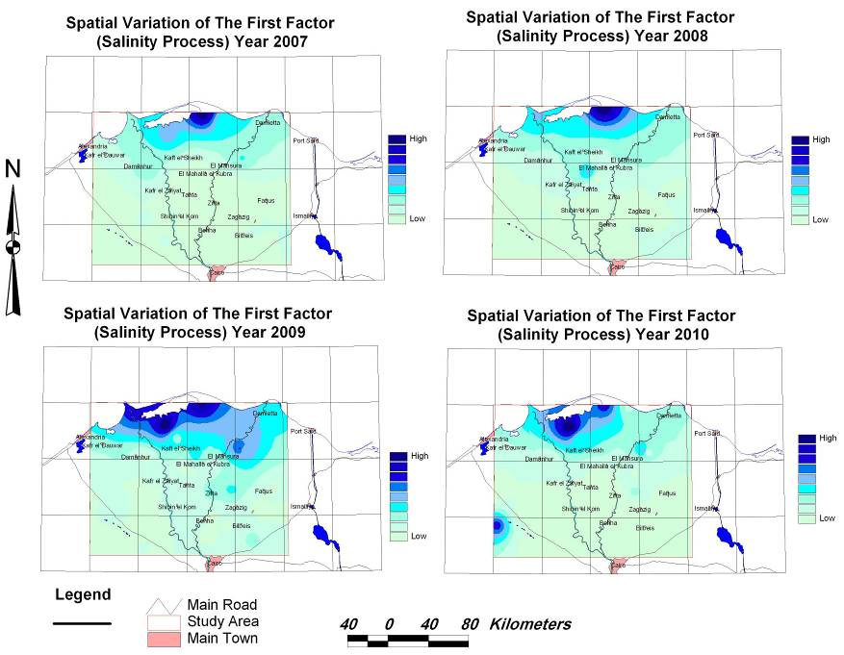
Figure 2. Spatial Variation of Salinity Process 2007-2010

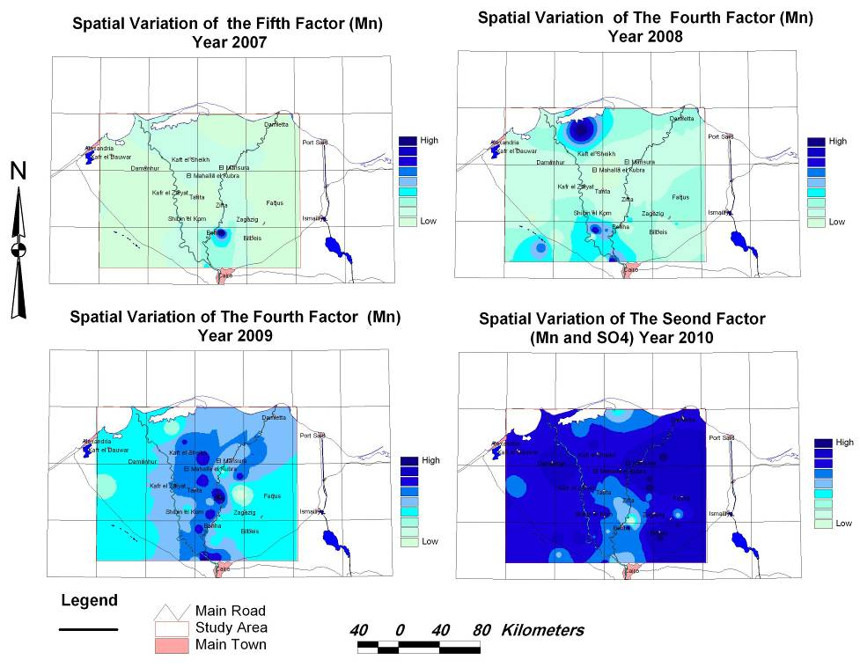
Figure 3. Spatial Variation of Mn Loading 2007-2010

The temporal and spatial variation of Al can also be detected individually for year 2007, 2008 and year 2010, while the loading of Al and Zn can be delineated in year 2009 as illustrated in Figure 4.

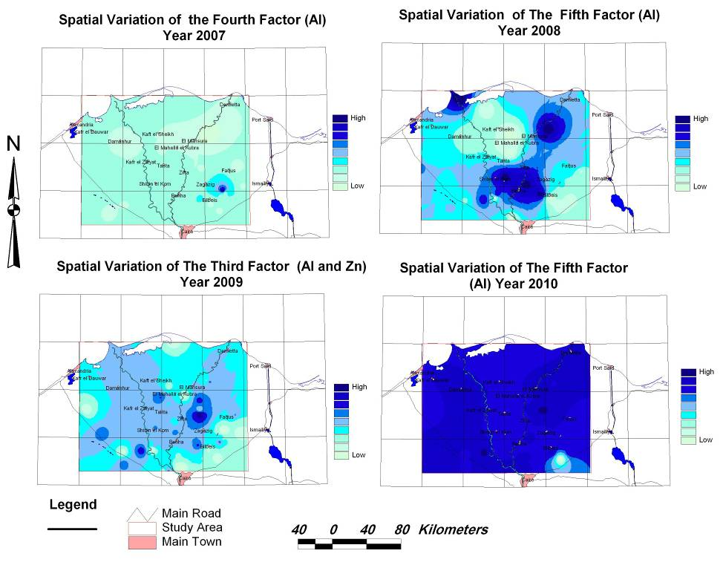
Figure 4. Spatial Variation of Al Loading 2007-2010

6. Conclusion and Recommendations
- Four surveys of 13 chemical variables were analyzed in order to evaluate the temporal modifications of the groundwater composition. The multivariate statistical methods such as FA can provide much more information for the groundwater system than classical methods. The first five factor components were chosen, which contribute 80-91% of the total variance of hydrochemistry data.
- Correlation between the chemical parameters indicated strong to perfect correlation, moderate and weak correlation which is an indication of common source and one of the major advantages of FA in the hydrochemical analysis is its ability to interpret each factor based on specific or multiple hydrochemical processes.
- The factor analysis suggests processes responsible for occurrence of ions and metals in the study area are such as agricultural land, natural processes as geological effects and industrial wastes.
- The results obtained by a scientific evaluation groundwater quality data can be addition by using FA which leads to the interpretation that the water–rock interaction process is the major mechanism responsible for the groundwater salinity and the industrial activities.
- A minimum number of sample locations are required for any statistical analysis, and this will depend on several factors particular to that case. With fewer sample locations, become difficult to interpret and parameters become uncertain.
- Controlled fertilizer application and manures on agricultural farm lands, and controlled waste disposal practice can minimize groundwater quality degradation in the area.
- It is very imperative that adequate hydrochemical knowledge be improved, in the study area, owing to the hydrogeological heterogeneity in order to evaluate the hydro chemical characteristics, determine the ionic interactions as well as the hydro geochemical facieses distribution in the area. Achieving these aims will establish a basis for enhancing the monitoring program and therefore improved management of the groundwater resources of the area.
- Mapping the results of the multivariate statistical techniques constitute a useful tool for the study of spatial variability in these hydrogeochemical processes, since they enable the distribution of the variable throughout the aquifer to be analyzed via its estimation and subsequent mapping shows the areas where these processes are evident to a greater or lesser degree and allows their relationship with geological data.
- Since domestic, industrial wastes and agricultural activities have factor effects in the hydrochemistry, it is an important issue to: Complete and improve the sanitation services and implement monitoring programs to ensure the proper use in of fertilizers and pesticides.
- Since the parameters Co, Zn and Cu have significant loading factor and their spatial variability imply larger impacts on the groundwater quality, so it must be carefully and accurately mapped.
- The environmental treatment for the industrial wastes as well as regularly environmental check for the industrial activities is highly recommended.
- Since the areas near to the shoreline are the most contaminant areas so these areas should benefit as the first priority from any monitoring programs, desalination or development projects.
- Increasing awareness among people that it is to maintain the groundwater to its highest quality and purity, the present study may prove to be useful in achieving this goal.

References
- Amadi A. N., Olasehinde P. I., Yisa J., Okosun E. A., Nwankwoala H. O. and Alkali Y. B. (2012): "Geostatistical Assessment of Groundwater Quality from Coastal Aquifers of Eastern Niger Delta, Nigeria", Geosciences, 2(3): pp 51-59.
- Borers H. P., Grift B. V. D. and Vliet M. V. (2001): "Regional Monitoring of Temporal Changes in Groundwater Quality", Impact of Human Activity on Groundwater Dynamics (Proceedings of a symposium held during the Sixth IAHS Scientific Assembly at Maastricht, The Netherlands.
- Child, D. (1990): "The essentials of Factor Analysis", Second Edition. London: Cassel Educational Limited.
- Cobbina S. J., Armah F. A. and Obiri S. (2012): "Multivariate Statistical and Spatial Assessment of Groundwater Quality in the Tolon-Kumbungu District, Ghana", Research Journal of Environmental and Earth Sciences 4(1): pp 88-98.
- Ishaku J. M., Kaigama U. and Onyeka, N. R. (2011): "Assessment of Groundwater Quality Using Factor Analysis in Mararaba-mubi Area, Northeastern Nigeria", Journal of Earth Sciences and Geotechnical Engineering, Vol. 1, No. 1: pp 9-33.
- Lalitha A., Lakshumanan C., Suvedha M., Suganya M. and Udayaganesan P. (2012): "The Evaluation of Groundwater Pollution in Alluvial and Crystalline Aquifer by Principal Component Analysis", International Journal of Geomatics and Geosciences Vol. 3, No 1: pp 285-298.
- Mahmood A., Muqbool W., Mumtaz M. W. and Ahmad F. (2011): "Application of Multivariate Statistical Techniques for the Characterization of GroundWater Quality of Lahore, Gujranwala and Sialkot (Pakistan)", Pakistan Journal of Analytical and Environmental Chemistry Vol. 12 No. 1&2: pp 102-112.
- RIGW (1992): "Explanatory Note to the Hydrogeological Map of Egypt, Nile Delta, (Scale 1:500000)", Research Institute for Groundwater, National Water Research Center, Ministry of Water Resources and Irrigation, Egypt.
- Sanchez-Martoz F., Jimenez-espinosa R. and Pulido-Bosch A. (2001):" Mapping Groundwater Quality Variables Using PCA and Geostatistics: A Case Study of Bajo Andarax, Southeastern Spain", Hydrological Sciences-Journal-des Sciences Hydrologiques, 46 (2): pp 227-242.
- Shaban M., Idris Y. and Rashed M. (2012): “Delimitation of Groundwater Facieses Using Hydro-Chemical Parameters Ratios and Fuzzy Logic Technique-Case Study North Delta – Egypt”, VII International Conference on Environmental Hydrology & Its Engineering Aspects, Cairo, Egypt
- Subyani A. M. and Al Ahmadi M.E. (2010): “Multivariate Statistical Analysis of Groundwater Quality in Wadi Ranyah, Saudi Arabia”, Journal of King Abdulaziz University: Earth Sciences, Vol. 21, No. 2: pp 29-46.

11/5/2013

