A Socioeconomic Determination of the Impact of Volcanoes National Park on the Livelihoods of the Local Neighbouring Communities in Northern Rwanda.

Isaac Emukule Ekise ¹, Alphonse Nahayo¹ and Jean Berchimas Habumugisha ² and Peter Mbabazi ²

¹ Department of Forestry and Nature Conservation, University of Rwanda, College of Agriculture, Animal Sciences and Veterinary Medicine, P.O. Box 210, Musanze, Rwanda.
² Department of Agribusiness and Rural Development, University of Rwanda, College of Agriculture, Animal Sciences and Veterinary Medicine, P.O. Box 210, Musanze, Rwanda.
iekise@yahoo.com.

Abstract: Literature on human-wildlife nexus illustrates that human-wildlife conflict is a growing global problem, which is not restricted to particular geographical regions or climatic conditions, but is common to all areas where wildlife and human population coexist and share limited resources. The purpose of this study was to assess the impact of Volcanoes National Park on local communities’ livelihoods. The household data was obtained by interviewing 100 heads of households selected by employing stratified random sampling method from four adjacent cells of Nyonirima, Nyabigoma, Kaguhu and Bisoke located around VNP in Kinigi Sector, Musanze District, and Northern Rwanda. The Statistical Package for Social Sciences (SPSS) and Microsoft Excel were used to analyze data to generate both descriptive and inferential statistics especially by using the Friedman Test. This study reveals that local communities proximal to VNP were constrained by poor roads infrastructure, long travel distances to basic social services such as nursery, primary, secondary schools and health centers, lack of clean water and wildlife damage from the wild animals straying out the park. Over the years VNP has put in place more adequate conflict mitigation measures to minimize crop raiding incidents, elaborating a new policy related to the compensation of losses, and linking community benefits to conservation processes. Also there exists strong collaboration between park managers and local communities arising from a growing understanding that park biological resources would not be sustainably conserved without the full participation of the local communities in the management of VNP and in the sharing of tourism revenue. The results of this study show that dependence on park income had a positive income distribution effect among households. There is also satisfaction among local communities since socioeconomic problems cited here have been alleviated to a large extent through revenue sharing. However, local people expressed concern over damage of crops done by park animals and inability of park management to either curb the problem or offer compensation for the damages. This study concludes that VNP has enormous potential to benefit more local people by fully implementing a participatory management approach in the conservation of this valuable natural resource.
[Ekise I.E, Nahayo A, Habumugisha J.B and Mbabazi P. A Socioeconomic Determination of the Impacts of Volcanoes National Park on the Livelihoods of the Local Neighbouring Communities in Northern Rwanda.
N Y Sci J 2013;6(11):14-26]. (ISSN: 1554-0200). http://www.sciencepub.net/newyork. 3

Keywords: Human-wildlife nexus, impacts of Volcanoes National Park, local communities, livelihoods, income distribution effect, and revenue sharing.

1. Introduction
The creation of the VNP was initiated by Carl Akeley from the American Museum of Natural History. Its main goal was to protect the last mountain gorillas (Gorilla beringeiberingei). It was created in 1925 as the first national park in Africa, under the name of “Park National Albert”. During independence in 1960, the park was divided between three countries. The VNP lies in Rwanda, the Virunga National Park lies in Congo (Plumptre et al., 2004) and Mgahinga National Park in Uganda. Indeed, as soon as the scientific community discovered these great apes, people started illegal trafficking to the western zoos.
Situated in the centre of Albertine Rift, VNP is part of a trans-boundary network of Protected Areas that is unique in the world (ORTPN, 2004). The area is characterized by a high degree of avian and mammalian endemism, due to its proximity to a Pleistocene refugium, created during the last ice age (Hamilton, 1984 as cited by Plumptreet al., 2005). The combination of great species richness and diversity, a high proportion of endemic species and significant numbers of rare and threatened wildlife, has led the World Conservation Union (IUCN) and other conservation organizations to rank the mountain forests of the Albertine rift among the highest priority areas for conservation in Africa (Hamilton, 1996 cited by Lanjouw et al., 2001).
The Virunga Massif of which VNP is part, supports a total of 878 known species of plants, 81 of them trees, and including 124 endemic plants of the Rift Valley, five of which are listed on the IUCN Red List (Plumptre et al., 2003). As for VNP, a recent study drew up a list of 301 species of herbaceous plants, 40 species of liana and 36 species of woody plants (Plumptre et al., 2005). The whole of the Virunga Massif forest has a total of 86 known species of mammals, 34 of them being big mammals, 18 species endemic to the western Rift Valley and six species are endangered and 18 have been listed on IUCN Red List (Plumptre et al., 2003). Mountain gorillas (Gorilla beringeiberingei) are only found in the Virunga Massif and Bwindi Impenetrable National Park of Uganda. Mountain Gorillas are endemic sub-species considered to be in "critical danger" by IUCN. The world population of mountain gorillas in 2004 was estimated at around 700 animals, 380 of which were in Virunga Massif (ORTPN, 2004).
Endowed with mountain gorillas, VNP has attracted attention from the scientific community. PNV was created and designated as a Biosphere Reserve because it provides the last remaining habitat for the mountain gorillas (Lanjouw et al., 2001). Its afromontane vegetation is characterized by a high rate of evapotranspiration that increases the level of precipitation in the region. As a result, the forested slopes of VNP provide a very important water-catchment area. For example, 0.6 % of the land surface representing VNP provides 10% of the water-catchment function for Rwanda (Weber, 1987 cited by Lanjouw et al., 2001)
The forest also curbs soil erosion and flooding in the region, and maintains dry season stream flow and local climate. Soil erosion is already at a critical level in north-western Rwanda. The rich volcanic soil and high rainfall make the region ideal for agriculture: the primary livelihood strategy of the local populations (Lanjouw et al., 2001).
Numerous studies worldwide illustrate that human-wildlife conflict is a growing global problem, which is not restricted to particular geographical regions or climatic conditions, but is common to all areas where wildlife and human population coexist and share limited resources. Dense human populations in close vicinity to nature reserves seem to pose the greatest challenges in many countries. Conflicts become more intense where livestock holdings and agriculture are an important part of rural livelihoods. Competition between rural communities and wild animals over natural resources is more intense in developing countries, where local human populations tend to suffer higher costs. Considering the current human population growth rate, increasing demand for resources and the growing demand for access to land, it is clear that human wildlife conflicts will not be eradicated in the near future. For this reason a better understanding of conflict management options is crucial (Distefano, 2005).
National parks can provide various goods and services to local communities around it and therefore contribute to improvement of livelihoods. This is true for all protected areas (Blom 2001; Kibirige 2003; Scherl et al. 2004). Parks do not only provide food, medicine, fodder, building poles etc to local communities but also parks offer job opportunities, educative programs, and other community services (Blom, 2000; Kibirige2003). A gorilla park like VNP can have enormous money streams due to the appeal gorillas have on tourists (Adams et al, 2003). While there is a general change in conservation doctrine to involve communities more as a means of soliciting their cooperation and support (Wells and McShane, 2004), local communities are allocated large responsibilities under the resource-use programs (Namara 2006) yet reciprocal benefits remain minimal (Wilkie et al, 2006). As a source of fuelwood, medicinal herbs, forest foods, fish, building poles and other subsistence products (Archabald and Naughton-Treves, 2002), VNP had always been important in the livelihoods of the local communities, till its elevation to park status which henceforth disenfranchised local people by making access illegal.
The increase in the extent of protected area coverage highlights the attention that biodiversity conservation has received in the past few decades. But conserving biodiversity by setting aside large tracts of land for strict protection necessitates that other land use options are sidelined (Johannesen 2007), which affects land based livelihoods. Over the years, global conservation strategies have shifted in nature (Tumusiime 2006), mainly to respond to pressures that natural resources face in an ever dynamic world. Earlier, challenges such as declining biodiversity populations and habitat transformation (Adams, William M. et al. 2004), attracted attention and support to the creation of protected areas that separated humans from nature (Adams, W. M. 2004). It appears however to have been only a quick fix to the problem.
While protected areas have proved to be largely effective in stemming species extinction (Hutton et al. 2005), evidence suggests that they may negatively be affecting human survival ( Sherbinin, 2008). Rural people in developing countries depend heavily on natural resources and derive a significant portion of their income and livelihoods from them Cavendish (2000); Escobal and Aldana (2003); Ghate (2002); Mamo et al. (2007); Pal et al. (2004). This has increased global attention towards biodiversity management in the last decades (Ferraro, 2001). Some people believe the “fortress approach” to managing natural resources is no longer tenable, due to its disadvantages especially in relation to human cost (Brockington and Schmidt-Soltau, 2004) and also the difficulty in enforcing established protected areas in face of growing local opposition (Hutton et al, 2005); Wells and McShane, 2004).
A new “community conservation” paradigm (Hulme and Murphree, 2001) later emerged that emphasized conserving biodiversity hand in hand with satisfaction of human needs (Adams et al, 2003); Adams et al (2010) and Hutton et al.(2005). The costs and benefits of conservation accrue unequally at local, national and international levels (Balmford and Whitten, 2003) and (Wells, 1992). Unfortunately, the marginalized and impoverished local people foot the bigger part of the conservation bill (Ferraro, 2001; IUCN, 2005; Roe and Elliott, 2004; Wells, 1992) and receive the least of the benefits (Adams et al, 2003).
Yet local people are indispensable for the long term integrity of protected areas (Wells and McShane, 2004). It is now commonplace that management of protected areas need to be consistent with overall socioeconomic goals of society (Adams and William, 2004). The negative effects of protected areas on people’s livelihoods undermine local support (William et al, 2004; Kiss, 1990). Most notable of these negative effects arise from crop raiding and foregone access to resources (Adams et al, 2007; Archabald and Naughton-Treves, 2002; Cernea and Michael, 2006).
Incompatibility of the development aspirations of local populations and the preservationist objectives of park authorities is usually a breeding ground for animosity and serves to increase the challenge of conservation. According to Wilson et al. (2004), “to survive, protected areas in the poorer nations must be seen as a land-use option that contributes as positively to sustainable development as other types of land use”. To counteract the negative effects of protected areas, a number of approaches have been formulated to reduce tensions between local communities and protected areas management.
Allowing for access to the park has to be incorporated into park management plans to cater for the interests of local communities. Legal extraction of park resources, revenue sharing (for instance of tourist gate fees) and community representation on park management advisory committees has been observed for instance in Rwanda (Adams et al, 2003) to enable benefits of managing protected areas to be realized by both government agencies and local communities (Mugisha, 2002).
While reduction of poverty is a secondary goal of protected areas with respect to conservation of biological diversity and provision of ecosystem services (Scherl et al. 2004), examination of the linkages between protected areas and issues of poverty is not only a practical issue but an ethical necessity. This has further emphasized the need for an increased role for local people in management of national parks (Inamdar et al. 1999; Namara, 2006). Community-based natural resource management is intended to cater for both the needs of the national government or its conservation agency and the local people. The benefits to the government include lower administrative costs by reduction in work force used in conservation. The effect of adopting community-based natural resource management on local peoples’ needs is therefore investigated by assessing their level of involvement and their perceived effects of the park on their livelihoods compared to the pre-community-based management era.

2. Material and Methods

2.1. Description of the study area
VNP is located in North-Western Rwanda on a chain of dormant volcanoes: Muhabura, Gahinga, Sabyinyo, Bisoke, and Karisimbi, and is part of the Albertine Rigft (Plumptre et al. 2004). VNP borders DRC and Uganda, and is contiguous with two other national parks in these neighbouring countries: Virunga National Park in DRC and Mgahinga Gorilla National Park (MGNP) in Uganda. Together, these three parks comprise the Ecosystem of Virunga Massif (ORTPN, 2004). The current surface area of VNP is about 160 km². The altitude varies from 2400 m to 4500 m, and the highest point is the top of Karisimbi at 4,507 m (ORTPN, 2004). VNP is surrounded by Burera and Musanze districts in the Northern Province, and by Nyabihu and Rubavu districts in the Western province. The Districts bordering VNP are densely populated compared to other districts of the same province. The local population continues to have a considerable impact on the natural resources of the forest because household income is very low and people cannot afford other sources of energy, other than wood. As the population increases, land and other important resources become scarce, and lead to high poverty and increased dependence on park resources.

Map of VNP past encroachment 1958-1979

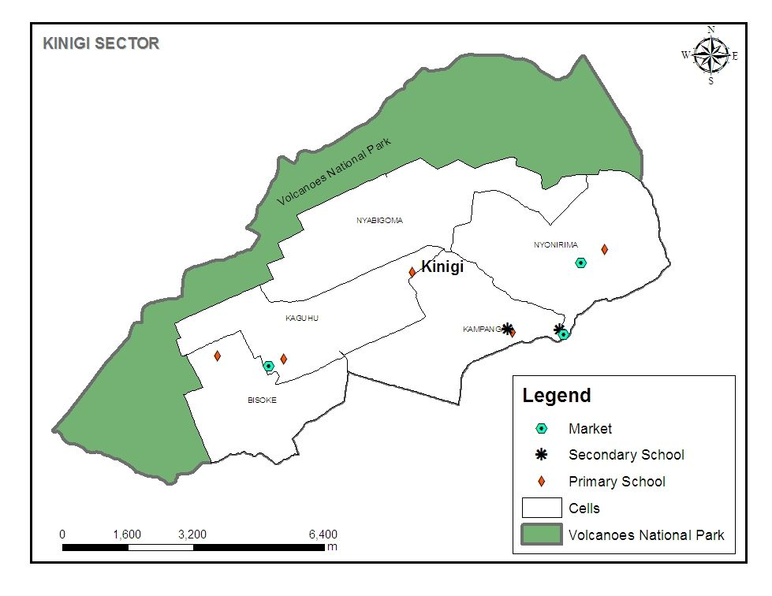
Figure 1: Map of the study Area (Source: RDB/VNP, 2011)

2.2. Research approach
This study is aimed at the analysis of the impact of VNP on the livelihoods of the communities neighbouring the park. These communities live in Kinigi Sector of Musanze district. The administrative cells considered for this study is those adjacent to the park namely Nyonirima, Nyabigoma, Kaguhu and Bisoke all situated in Kinigi Sector. The population of each cell is shown in Table 1. The approach involves calculating the representative sample at both sector and cell levels. First we calculate the sample size at sector level (n) and then the sample size at cell level (n_{i}). Substituting this total in formula in equation 1, gives the sample size of 100 households. Using the formula in equation 2 and substituting n, we obtain the sample size in each cell. After determining the sample size in the cell, the households to be interviewed are then randomly selected from the population in the cell. The cell sample size, that is, the number of households in each cell to be interviewed is depicted in Table 1.

Table 1: Determination of Sample size at cell level
Name of cell | Population of cell | Representative sample to be interviewed
Nyabigoma | 1446 | 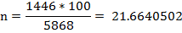
Nyonirima | 1576 | 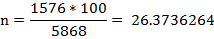
Kaguhu | 1580 | 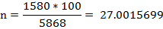
Bisoke | 1467 | 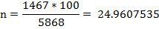
Total | 5868
Source: Survey data

--------------Equation 1.
Where: n= sample size, N= size of population in the selected cell, Z= coefficient normal distribution, q= probability of failure, d= margin error, and p= probability of success.
We used a margin of error of 10 %, a confidence level of 95 %, the probability of success p=0.5, the probability of failure q=0.5, and Z_{0.25}=1.96

n_{i} = N_{i} x n --------------------------Equation 2.
N
Where n_{i}= the sample size proportion to be determined; N_{i}= the population in the stratum (cell)
n= the sample size; N= the total population.

3. Results

The results of this study are presented in sub-topics in order to amplify the benefits the local communities neighbouring the park are obtaining from their interactions with the park.

The profile of household heads interviewed
The results revealed that 72 % of household heads interviewed are male with the age ranging between 20 to 45 years whereas the percentages of the total females interviewed is 28%. This shows that most household heads working in the different activities located in the Kinigi Sector are male who are also dynamic so that they are able to protect the VNP and its biodiversity. According to (MINECOFIN, 2003) the age distribution of households showed that the population that is active is aged from 20 to 65.This shows that the females are not participating massively in conservation activities comparative to the males. For example the study found the total employment at VNP stands at 142 (130 males and 12 females). The marital status distribution of the respondents shows that 60.0 % are married, 16.0 % are still single and 24.0 % are widowed. Regarding education level, 30% have not attended school, 42% attended up to primary level, 14% have attained secondary level and 14% have attained university level of education.

The Impact of VNP on Distance to primary school

This finding is depicted in Figure 2. From this figure 60% of households’ children walk 0 to 0.5 km; 20% walk 0.5 to 1 km; 10% walk 1 to 1.5 km; 6% walk 1.5 to 2 km; and 4% walk 2 to 3 km to school. From these figures it is clear evidence that VNP has improved significantly the education of children in the sector by building many primary schools and reducing the walking distance from home to school.

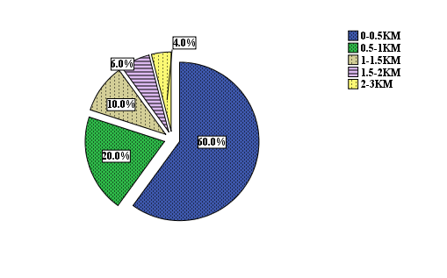
Figure 2: Distance (km) from home to the primary school

Figure 3 depicts the distances travelled by secondary school children to school. In this table, 60% of the children walk 0 to 0.5 km; 25% walk 0.5 to 1 km; 20% walk 1 to 1.5 km; 10% walk 1.5 to 2 km and 5% walk 2 to 3 km to school. It is also clear that VNP has significantly made impact by building a secondary school near to the community and thereby reducing the walking distance to school.

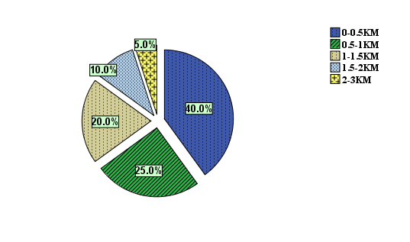
Figure 3: Distance (km) from home to the secondary school

Occupation of households in the study area
Farming emerged as the predominant activity sustaining economy in Kinigi Sector. As shown in preceding figure, the main occupation of the respondents interviewed is farming (64.0 %). The proportion of household heads involved in business is 15.0% and those employed at the park is 11%. These figures show that the park has a significant impact on households. The largest number of households in Rwanda is involved in agricultural activities at the rate of 90% and this shows that they are interested in soil conservation practices or protection of the environments (MINECOFIN, 2003). Figure 4 depicts the occupation of households.

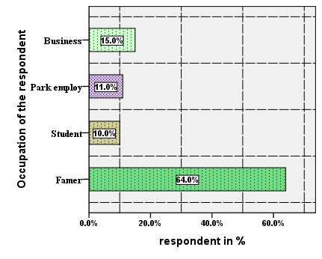
Figure 4: Occupations of households in the study area

Impact of VNP on access to health by households
Access to health care is one amongst the main indicators of the standard of living of a population. Among the causes of health problems is insufficiency of health centres, as well as poverty, which is a destabilizing factor in many households. Looking at health infrastructure (health centers, dispensaries and hospitals), we find that they were damaged and looted during the crisis of 1997-1998. Some of them have already been rehabilitated, and others have been opened. RDB/T&C have contributed in promoting health infrastructure by increasing number of Health Centers but this needs further improvement since a majority of households (78%) walk more than 3 km to access health care in clinic (Figure 5). 90 percent of the households walk more than 3 km to access health care in the dispensary (Figure 6).

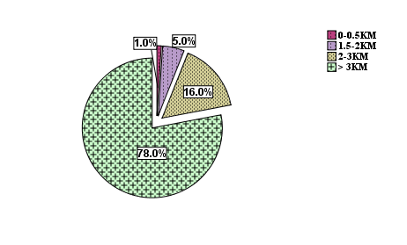
Figure 5: Distance (km) from home to the local clinic

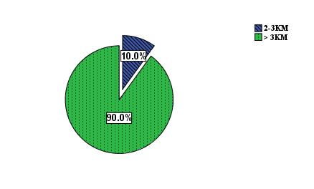
Figure 6: Distance (km) from home to the dispensary

Water supply
Access to drinkable water is another important indicator of the standard of living among households. Although the Volcanoes zone is considered to be the rainy area in the country, with an average precipitation of 1,500 mm a year, there is no water flowing which can facilitate easy tapping because of geological nature of the region mainly composed of permeable rock.
The problem of insufficiency of drinkable water is particularly sensitive in all sectors directly situated near PNV, where only some sources of spring water are located in some Sectors. As a matter of fact, lack of water remains a pertinent problem despite the effort deployed by the authorities of the region in rehabilitating some sources of water. A big proportion of the population, especially those who live near VNP have a lot of difficulties in getting water. RDB/T&C has contributed to put in place many water tanks for collecting rainwater in schools, churches, health centers, and cooperatives offices. People benefiting from collected water are students and limited number of households living near a given infrastructure. Promotion of small tanks to collect water from individual households could be the best solution. Big tanks for collecting water from these basic infrastructures are expensive to build and do not resolve the water accessibility.

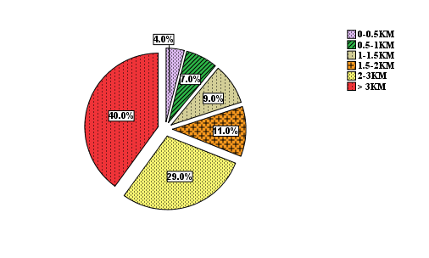
Figure 7: Distance (km) from home to the source of potable water

Figure 7 above shows that 29% are walking 2-3kms to the source of clean water, 11% walk 1.5-2 km, 9% walk 1-1.5 km, 7% walk 0.5 to 1 km and 4% walk 0 to 0.5 km to fetch water. From this figures more has to be done to improve water accessibility situation.
Habitat /Settlement and equipment
The population in the region lives in dispersed rural agricultural settlements, and in agricultural group settlements known as “Imidugudu”. The first type, with one house or more surrounded by an enclosure called “urugo”, or houses found along the road in agglomerations called “insisiro”, are diminishing. There is a new national settlement policy, which recommends the resettlement of the population in villages” imidugudu” so that land for cultivation can be available. Besides settlement, the types of row materiel used in construction of houses are another indicator of standard living of a population. Concerning “elevation” houses are built in woods or pounced stones. Concerning “roofing” most of houses are covered with iron sheets. RDB/VNP has contributed in promoting settlement by building houses for indigenous “Batwa” tribe of Rwanda. All those houses were built from incomes generated by RDB/T&C via different festivities like Naming Gorilla’s babies. In addition, modern houses were also built in collaboration with RDB/VNP for SACOLA Association in Nyange and Kinigi (Musanze District), and Kabatwa (Nyabihu District).
Energy
Another important indicator of the standard of living of a population is how people have access to energy for cooking and lighting. Firewood remains to be the main source of energy for the population living in the study area. Firewood is used to cook food and warm water. The findings show that 95% use firewood as the main source of energy; some households use charcoal (3 %). Some rare cases of biogas have been reported. Also some cases of households demanding firewood from VNP have been reported. But such cases are diminishing very significantly, because some Associations such as “AMIZERO” of former poachers are very active in fighting against incursions and encroachments in the Park. As for sources of energy for lighting, majority of families near the park use kerosene (84%); 12% have access to electricity. Apart from Kinigi Sector which has been currently provided with an electricity line and electricity, other sectors are not yet connected. Additionally, extension of electric lines to supply the main trading centres and secondary schools with power would be a great advantage. At present the region is benefiting from some initiatives in supplying electricity. Figure 8 shows that 88% of households have no access to electricity which means that local level processing of products (cottage industries) cannot adequately operate without electricity. Creating more electricity connection lines is a worth idea to be pursued by helpers. This finding is depicted in Figure 8.

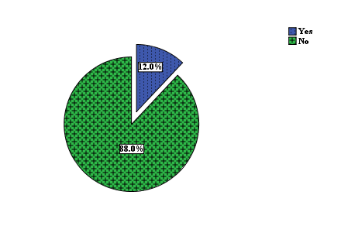
Figure 8: Accessibility to electricity by households living in Kinigi Sector

Markets and Commercial Centers
Access to markets is another key indicator of living standards of households. There are at 2 commercial centres in Kinigi Sector and 1handcraft shop. No big markets. It is important to note that the craftsmen generally work in an organized manner und receive support from RDB/VNP in the form of professional training and financial assistance helps them to improve their businesses. The distance from home to the market is another important indicator of living standards of hoseholds. Longer distances are associated with high costs of trade e.g. high transportation costs. Figure 9 below depicts the situation of distance travelled by households to the market. From this figure, a majority of households (80%) travel more than 3 km to the local market.
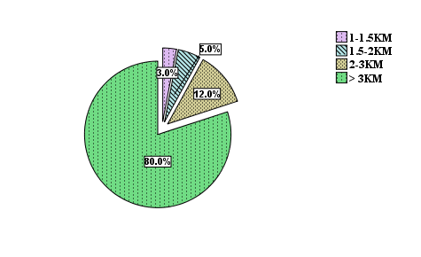
Figure 9: Distance in kilometers from home to the market location

Access to banking services
There is a good variety of banking services available at VNP. As at the time of the study three banks were operating in Kinigi sector; Bank Populaire, Bank of Kigali and Unguka Bank. A new financial system initiated by Government called “Umurenge SACCO” appears to be more efficient in terms of solving the challenges of obtaining financial assistance from banks or micro-financing institutions. Table 2 summarizes the households’ situation on banking.

Table 2: Household Membership to banks in Kinigi sector
Percentage of respondents (%) | Banks
25 | SACCO
35 | POPULAIRE
13 | BK
17 | No any member
10 | UNGUKA
Source: Survey data

Membership to Cooperatives
Many cooperatives in the area are officially registered. The findings from the study are that cooperatives are organized in the region and specifically those dealing with recommended crops such as Irish potatoes, Maize, Wheat, Beans, and Pyrethrum. Many of the cooperatives are still quite weak and capacity building would form a great part of assistance to them e.g. training them.

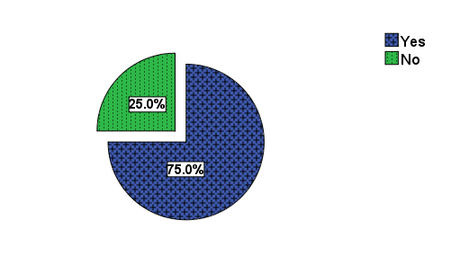
Figure 10: Cooperative or association operating in Kinigi Sector

The majority of the respondents interviewed (75.0%) in Kinigi are working in cooperatives sponsored by RDB/VNP and 25% of households formed cooperatives which are no yet financed by RDB. It is quite encouraging that RDB/VNP is involved in sponsoring cooperatives.

Tourism, environment and hotels
Kinigi sector possesses tourism potentialities beyond belief. Apart from the VNP which extends beyond the boundaries of Rwanda and endowed with mountain gorillas, the region also has other numerous attractions, in other neighbouring sectors (lakes Burera and Ruhondo; Musanze cave; etc). Sufficient infrastructure for reception has been developed. Modern Housing and Hostel development for Tourism and Ecotourism promotion are also built in collaboration with RDB/VNP for SACOLA Association.
Now in Kinigi sector there four high standard hotels: Sabyinyo Silver back lodge, Mountain Gorillas view lodge; Gorillas Nest lodge and Kinigi guest house. Tourism has had a long history since 1974. Although tourism was set back by the 1994 War and Genocide, and the insecurity that followed in 1998, the upward trend in tourism has continued. Endowed with Mountain gorillas (Gorilla beringei beringei) as the main tourist attraction, other species and activities include; Golden monkey (Cercopithecus kandti), Dian Fossey’s tomb, nature walks and bird watching etc. Despite the effects of 1994 War and Genocide and insecurity in 1998 that effected gorilla tracking in VNP, mountain gorilla tourism in VNP had since raised. These have attracted tourists as Figure 11 depicts. From increased numbers of tourists, households revenue sharing is made possible.

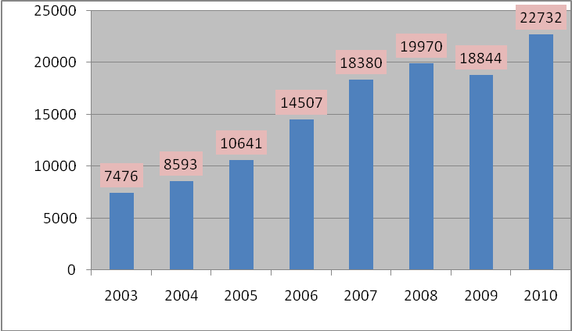
Figure 11: Evolution of Tourists in VNP (Source: RDB statistics, 2011)

Economic Contribution of VNP to the households in the study area

The contribution of VNP is depicted in Table 3. From this table it is clear that VNP is a major contributor to the economic well-being of the households through generation of household income, construction of houses and assisting households to save incomes in the banks.

Table 3: Results of the Friedman Test on the economic contribution of VNP
 | Mean Rank | Test Statisticsª
Income generated increased | 1.63 | N | 100
Construction of new houses | 2.26 | Chi-Square | 35.654
Saving money in bank | 2.11 | df | 2
 |  | Asymp. Sig. | .000

The Volcanoes National Park has a great potential of increasing the income for neighbouring people of VNP. Most respondents said that their income was increasing as depicted in the table above with mean rank of 1.63, followed by saving money in bank with a mean rank of 2.11 and the construction of new houses for different households located in the study area with mean rank of 2.26. Based on the test of Friedman, the increase of income generated from the VNP activities that helped them to get employment is significantly differed at p=0.001

Types of illegal products collected by VNP from households in the study site
In Table 4 it is evident that there is still a problem of households carrying out illegal activities at the park. Fetching water was collected at the highest level with the mean rank of 1.92, followed by the fire wood (2.52), bush meat (3.55), and bamboo products with the mean rank of 4.15.The least mean rank of 5.42 was for gorilla products. Table 4 contains a summary on illegal products.

Table 4: Statistical test of the different type of the products collected to VNP
 | Mean Rank | Test Statisticsª
Bush meat | 3.55 | N | 100
Fire wood | 2.52 | Chi-Square | 362.273
Water | 1.92 | df | 6
Honey | 5.03 | Asymp. Sig. | .000
Bamboo | 4.15
Gorillas | 5.42
Others | 5.42
Source: Survey data

Problems faced by the households who collected the different products in the VNP

Table 5: Statistical test of the different problems faced by the households who collected the products from VNP
 | Mean Rank | Test Statisticsª
To be caught by the rangers | 2.14 | N | 100
Injuries or fractures | 2.90 | Chi-Square | 112.519
Death from the wild animals | 3.16 | df | 3
Punishment from the park | 1.80 | Asymp. Sig. | .000
Source: Survey data

Most respondents revealed the main challenges encountered the population of Kinigi Sector as the punishment to the people made the illegal activities inside with the mean rank of 1.80 whereas the wild animals which attacked the population living around the forest with mean rank of 2.14 due to the wild animals, followed by injuries or fracture with mean rank of 2.90 while the last challenge was the death from the wild animals with mean rank of 3.16.

Benefits from tourism income to the households living in Kinigi Sector
The majority of the respondents interviewed told that the most benefit of getting the big number of tourist in the village was the infrastructure development in the study area with the mean rank equal to 2.03, followed by the handcraft business with the mean rank of 3.41, watching the white people with the mean rank of 3.74 and facilitate the farming products market with the mean rank of 3.95 and to get the jobs with the mean rank of 3.86 respectively while the others activities such as trading, artisans activities, etc helped them to get the benefit or income with the mean rank of 4.01.

Table 6: Statistical test of the different benefits from tourism income to the population of Kinigi Sector
Benefits of VNP’s visitors | Mean Rank | Test Statisticsª
Hand craft business | 3.41 | N | 100
Getting job facility | 3.86 | Chi-Square | 123.958
Infrastructure development | 2.03 | df | 5
To see White people | 3.74 | Asymp. Sig. | .000
Farming product market facility | 3.95
Other | 4.01

Challenges of households living near VNP
Most respondents spoke of main challenges encountered by the households of Kinigi Sector was the crop raiding because of many wild animals used coming out the park with the mean rank of 1.51, followed by the inaccessibility of park resource and the others challenges like the diseases caused by the wild animals with the mean rank of 2.67 respectively while the injuries or the fractures and the death of the population caused by the wild animals coming out the park with mean rank of 2.93.

Table 7: Statistical test of the challenges encountered from VNP
Challenges encountered | Mean Rank | Test Statisticsª
Crop raiding | 1.51 | N | 100
Death or factures and / the death of population | 2.93 | Chi-Square | 131.961
Inaccessible park resource | 2.67 | df | 3
Other | 2.89 | Asymp. Sig. | .000

Solutions implemented by VNP to improve the well-being of the households

This result is depicted in Table 8.

Table 8: Statistical test of the different projects initiated by VNP
Project initiated by VNP | Mean Rank | Test Statisticsª
Fencing the national park | 2.68 | N | 100
Water tank construction | 1.38 | Chi-Square | 171.562
School room construction | 2.96 | df | 3
Eradication of NYAKATSI | 2.96 | Asymp. Sig. | .000

Monthly income generated from the different resource the local people are benefiting

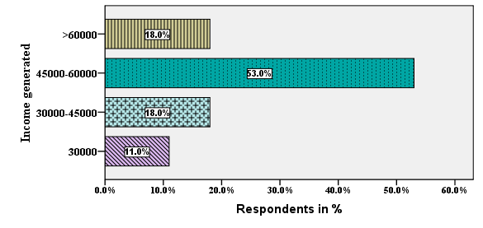
Figure 12: Monthly income obtained by the population living around the VNP in Kinigi Sector

Most of respondents interviewed (53.0 %) said that the estimated lower gross income obtained by the population living around the VNP in Kinigi Sector was approximately between 45000 rwf to 60000rwf equal 18% ;the people got 30000rwf are 11% and above 60000 rwf at the same proportion equal to 18.0% per month (mean = 525000 rwf per month. This results show the people living around the park are enjoying the better life with the high income generated.

Table 9: Statistical test of the mean monthly income gained by the population of Kinigi Sector
One-Sample Statistics |  |  |  |  | One-Sample Test
 | N | Mean | Std. Deviation | Std. Error Mean | Test Value = 0
 |  |  |  |  | t | df | Sig. (2-tailed) | Mean Difference | 95% Confidence Interval of the Difference
 |  |  |  |  |  |  |  |  | Lower | Upper
Monthly generated income | 100 | 48675.00 | 9623.303 | 962.330 | 50.580 | 99 | .000 | 48675.000 | 46765.53 | 50584.47

The results presented in the table above shows the mean monthly income gained from the different service were equal to 48675.000 rwf. Based on the One-Sample T- Test, the mean monthly generated income is significantly differed at p=.000 (p value =.000 is less than 5%).

4. Discussions
This study has determined that the existence of VNP has brought about significant spillover effects to the households living near it. More could be achieved through linking benefits to conservation. Without attention to these details, even if revenue from tourism is shared around VNP, the degree of linkage will not be sufficient among communities so that they may appreciate how tourism around VNP has the potential to serve as a pertinent conservation incentive. Finally, there is need to understand what makes community members satisfied, motivated and design projects accordingly. Benefits from wildlife are substantial, no matter how they are measured, but the incentive and benefits need to be earned, rather than that given out as communities/beneficiaries rights. Once there has been some debate and resolution about the benefits, how they will be distributed and for how long they will be received, then communities will know what to expect and what conditions are attached, (Plumptre, 2004). Genuine community conservation, with the objective of ensuring effective participation of communities in conservation, is the one which satisfies local community’s needs; fostering community effective participation; minimizing costs while maximizing benefits; empowering communities in deciding how to share benefits; and linking them to conservation (Laslaz, 2008).

Acknowledgements
We acknowledge the support we received from staff working at Volcanoes National Park especially Mr. Gasper, the Warden of the park. We also thank ISAE Institute for their valuable support and to all other persons who contributed in one way or the other to the success of this study.

Corresponding Author
Mr. Isaac Emukule Ekise
Department of Forestry and Nature Conservation, University of Rwanda, College of Agriculture, Animal Sciences and Veterinary Medicine, P.O. Box 210, Musanze, Rwanda.
E-mail: iekise@yahoo.com

References
- Adams, M. W. & Hulme, D. (2001). Conservation and Communities: Changing Narratives, Policies and Practices in African Conservation. In Hulme, D. & Murphree, M. W. (eds) African wildlife & livelihoods: the promise and performance of community conservation, pp. 9-23. Oxford, James Currey, London.
- Adams, M. W. & Hutton, J. (2007). People, Parks and Poverty: Political Ecology and Biodiversity Conservation. Conservation and Society, 5 (2): 147–183. Adams, W. M. (2004). Against extinction: the story of conservation. London, Earthscan. xvi, 311 s. p.
- Adams, W. M., Aveling, R., Brockington, D., Dickson, B., Elliott, J., Hutton, J., Roe, D., Vira, B. & Wolmer, W. (2004). Biodiversity Conservation and the Eradication of Poverty. Science, 306 (5699): 1146-1149.
- Archabald, K. & Naughton-Treves, L. (2002). Tourism revenue-sharing around national parks in Western Uganda: early efforts to identify and reward local communities. Environmental Conservation, 28 (02): 135-149.
- Balmford, A. & Whitten, T. (2003). Who should pay for tropical conservation, and how could the costs be met? Oryx, 37 (02): 238-250.
- Barrett, C. B., Reardon, T. & Webb, P. (2001). Nonfarm income diversification and household livelihood strategies in rural Africa: concepts, dynamics, and policy implications. Food Policy, 26 (4): 315-331.
- Blom, A. (2000). The Monetary Impact of Tourism on Protected Area Management and the Local Economy in Dzanga-Sangha (Central African Republic). Journal of Sustainable Tourism, 8 (3): 175–189.
- Blom, A. (2001). Ecological and economic impacts of gorilla-based tourism in Dzanga-Sangha, Central African Republic. Wageningen, Wageningen University, Department of Environmental Sciences. vi +164pp p.
- Brockington, D. & Schmidt-Soltau, K. (2004). The social and environmental impacts of wilderness and development. Oryx, 38 (02): 140-142.
- Cavendish, W. (2000). Empirical Regularities in the Poverty-Environment Relationship of Rural Households: Evidence from Zimbabwe. World Development, 28 (11): 1979-2003.
- Cavendish, W. (2002). Quantitative methods for estimating the economic value of resource use to rural households. In Campbell, B. M. & Luckert, M. L. (eds) Uncovering the Hidden Harvest Valuation Methods for Woodland and Forest Resources pp. 17-63 Ch.2. London, Earthscan.
- Cernea, M. M. & Schmidt-Soltau, K. (2006). Poverty Risks and National Parks: Policy Issues in Conservation and Resettlement. World Development, 34 (10): 1808-1830.
- Chhetri, P., Mugisha, A. & White, S. (2003). Community resource use in Kibale and Mt Elgon National Parks, Uganda. Parks, 13 (1).
- Ellis, F. (1998). Household strategies and rural livelihood diversification. Journal of Development Studies, 35 (1): 1 - 38.
- Ellis, F. & Freeman, H. A. (2004). Rural Livelihoods and Poverty Reduction Strategies in Four African Countries. Journal of Development Studies, 40: 1-30.
- Escobal, J. & Aldana, U. (2003). Are Nontimber Forest Products the Antidote to Rainforest Degradation? Brazil Nut Extraction in Madre De Dios, Peru. World Development, 31 (11): 1873- 1887.
- Ferraro, P. J. (2001). The Local Costs of Establishing Protected Areas in Low-Income Nations: Ranomafana National Park, Madagascar.
- Fisher, M. (2004). Household welfare and forest dependence in southern Malawi. Environment and Development Economics, 9: 135-154.
- Ghate, R. (2002, June 17-21, 2002). Global Gains at Local Costs: Imposing Protected Areas: A Case Study From India." Presented at "The Commons in an Age of Globalisation. The Ninth Conference of the International Association for the Study of Common Property, Victoria Falls, Zimbabwe.
- Hamilton, A., Cunningham, A., Byarugaba, D. & Kayanja, F. (2000). Conservation in a Region of Political Instability: Bwindi Impenetrable Forest, Uganda, 14, 6. pp. 1722-1725.
- Hart, G. (1994). The Dynamics of Diversification in an Asian Rice Region. In Koppel, B.,
- Holland, J., Burian, M. & Dixey, L. (2003). Tourism in Poor Rural Areas: Diversifying the product and expanding the benefits in rural Uganda and Czech Republic. Working Paper No. 12. Lesson-Sharing on Pro-poor Tourism.
- Hulme, D. & Murphree, M. W. (2001). African wildlife & livelihoods: the promise and performance of community conservation. Oxford, James Currey. XVI, 336 s. p.
- Hutton, J., Adams, M. W. & Murombedzi, C. J. (2005). Back to the barriers? Changing narratives in biodiversity conservation. Forum for Development Studies, 32 (2): 341-47.
- Inamdar, A., Jode, H. d., Lindsay, K. & Cobb, S. (1999). Conservation:Capitalizing on Nature: Protected Area Management. Science, 283 (5409): 1856-1857.
- Infield, M. & Adams, M. W. (1999). Institutional Sustainability and Community conservation: A Case study from Uganda. Journal of International Development, 11: 305-315.
- IUCN. (2005, 8–17 September 2003). Benefits Beyond Boundaries. Switzerland and Cambridge, UK. The Vth IUCN World Parks Congress, Durban, South Africa. IUCN, Gland, Switzerland and Cambridge, UK. ix + 360 pp p.
- Joan, M., (2007) Diversifying Rwanda’s tourism industry: A role for domestic tourism. IIPT Africa, Tourism Conference.
- Johannesen, A. B. & Skonhoft, A. (2005). Tourism, poaching and wildlife conservation: what can integrated conservation and development projects accomplish? Resource and Energy Economics, 27 (3): 208-226.
- Kamugisha, R. J., Ogutu, Z. A. & Ståhl, M. (1997). Parks and people: Conservation and livelihoods at the crossroads- Four case histories Nairobi, Regional Soil Conservation Unit. Pp 7-30 p.
- Kiss, A. (1990). Living with wildlife: wildlife resource management with local participation in Africa. Washington, D.C., World Bank. XI, 217 s. p.
- Kibirige, R. (2003). The socio-economic impacts of tourism on poor rural communities: the Mpembeni community, Hluhluwe-Umfolozi Park, Kwazulu-Natal, South Africa. In Africa Insight [Online], 33(1). pp23-28. Available at: http://www.ajol.info/viewarticle.php?id=12215 (accessed: 15/02/2008).
- Lanjouw, P. & Ravallion, M. (1995). Poverty and Household Size. The Economic Journal, 105 (433): 1415-1434.
- Laslaz, (2005), ‘Les zones centrales des parcs nationaux francais: des conflits au concensus social, contribution critique’, pp 186- 313
- MacChapin. (2004). A Challenge to Conservationists. World Watch, 17 (6).
- Mugisha, A. (2002). Evaluation of Community-based Conservation Approaches: Management of Protected Areas in Uganda. Florida, University of Florida.
- Murphy, L., Bilsborrow, R., Pich, oacute & n, F. (1997). Poverty and prosperity among migrant settlers in the Amazon rainforest frontier of Ecuador. Journal of Development Studies, 34 (2): 35 - 65. Musanze District Development Plan, 2007.
- Mutebi, J. (2003). Co-managed Protected Areas: from conflict to collaboration. Experience in Bwindi Impenetrable National Park, Uganda.
- Mwima, P. M. & McNeilage, A. (2003). Natural regeneration and ecological recovery in Volcanoes National Park. African Journal of Ecology, 41 (1): 93-98.
- Namara, A. & Nsabagasani, X. (2003). Decentralization and Wildlife Management: Devolving Rights or Shedding Responsibility? Volcanoes National Park, Rwanda. In Jesse, R. C. (ed.) Environmental Governance in Africa Working Paper Series, Evironmental Gorvenance in Africa. Washington DC 20002, World Resources Institute.
- Narain, U., Gupta, S. & Van'T Veld, K. (2005). Poverty and the Environment: Exploring the Relationship between Household Incomes, Private Assets, and Natural Assets.
- Reddy, S. R. C. & Chakravarty, S. P. (1999). Forest Dependence and Income Distribution in a Subsistence Economy: Evidence from India. World Development, 27 (7): 1141-1149.
- ORTPN, (2004) Rwanda Office of Tourism and National Parks Strategic Plan 2004-2008, ORTPN, IGCP, Kigali-Rwanda
- ORTPN, (2005) Tourism revenue sharing in Rwanda, Provisional Policy and Guidelines, Kigali-Rwanda
- Plumptre, A. (2003).The Socio-economic Status of People Living near Protected Areas in the Central Albertine Rift, pp 198
- Plumptre, A., Masozera, M. & Vedder, A. 2001. Impact of civil war on the conservation of protected areas in Rwanda. Washington, DC: Biodiversity Support Program.
- Roe, D., Mayers, J., Grieg-Gran, M., Kothari, A., Fabricius, C. & Hughes, R. (2000). Exploring the myths and realities of community-based wildlife management. Evaluating Eden. London, IIED.
- Scherl, M. L., Wilson, A., Wild, R., Blockhus, J., Franks, P., McNeely, A. J. & McShane, T. (2004). Can Protected Areas contribute to Poverty Reduction? Opportunities and Limitations. IUCN, Gland, Switzerland and Cambridge. UK. viii + 60pp.
- Scoones, I. (1998). Sustainable rural livelihoods: a framework for analysis. Brighton, Institute of Development Studies. 22 s. p.
- Vedeld, P., Angelsen, A., Bojo, J., Sjaastad, E. & Kobugabe Berg, G. (2007). Forest environmental incomes and the rural poor. Forest Policy and Economics, 9 (7): 869-879.
- Wilkie, D. S., Morelli, G. A., Demmer, J., Starkey, M., Telfer, P. & Steil, M. (2006). Parks and People: Assessing the Human Welfare Effects of Establishing Protected Areas for Biodiversity Conservation, 20, 1. pp. 247-249.

11/2/2013

