**Impact of Some Environmental Condition on Water Quality and Some Heavy metals in Water From Bardawil Lake**

Rabie S. F. El-Halag1; Ibrahim M. Shaker2; Sahar F. Mehanna3; Mohammed F. Othman4 and Alam El-Deen Farouk2

1Faculty of Science, Al Azahr University, Egypt. 2Central Laboratory for Aquaculture Research, Abbassa – Sharkia, Egypt. 3National Institute of Oceanography and fisheries, Egypt. 4Faculty of Agriculture, Ain Shams University, Egypt.

[dr_ibrahim_sh@yahoo.com](mailto:dr_ibrahim_sh@yahoo.com)

**Abstract:** Bardawil Lake has a great economic and global reputation because of its production from high-quality fish which is exported to Europe. So it is important to follow-up water and soil properties and quality of the fish, so as not to suffer this lake like the rest of other Egyptian lakes from the deterioration of water quality and fish product quality. The lake has been divided into 12 terminal sites for periodic sampling (monthly) of water. Field analyses was done during the samples collection and then transported to the laboratory in plastic containers inside Ice Box for analyses. The most important results obtained are as follows: Differences in temperature between the studied sites were changed due to the time of sampling, only the differences between months were statistically significant. The differences among the sites in the pH values of the sampled water at the same month low either among months were significantly different. There are no significant differences (P>0.05) among seasons in the same locations. The obtained results showed an oncrease in dissolved oxygen due to the water exchange between the Mediterranean Sea and the lake which increase the oxygen concentration. Tulul (site 6) showed a significant decrease (P<0.05) in oxygen concentration due to the absence of water exchange between the site and the sea as well as the decomposition of organic compounds that consume oxygen. The highest values of dissolved oxygen concentration was recorded in winter season at all studied sites. The movement of water exchange between the Mediterranean Sea and the lake has an important role in improving the water quality in the lake water, especially pH, dissolved oxygen, salinity, the content of nutrients and chlorophyll ″a″. As for heavy elements in the water are regarded as Lake Bardawil best lakes in the world for free from contaminants in general, and especially of heavy elements. It was observed that the iron is the more focused elements, followed by zinc, manganese and copper, but it was less than lead and cadmium concentration. Concentrations of all the studied heavy elements were generally much less than the allowable limits globally. The most important problem facing the lake now is the need to create sufficient radial channels to connect the Mediterranean Sea to the last point in the lake and the need for follow-up clearing operations Boughaz of continuous sedimentation. The study showed that the waters of Bardawil Lake is poor nutritionally, but water is clean and free of contaminants, so we suggest the need to work on the development of natural food out and add safe fertilizer food to improve water quality and increase fish production and crustaceans and the organization of traffic exchanges waterway between the Mediterranean Sea and the lake to cover all bodies of water in the lake.

[Rabie S. F. El-Halag; Ibrahim M. Shaker; Sahar F. Mehanna; Mohammed F. Othman and Alam El-Deen Farouk. **Impacts of Some Environmental Condition on Water Quality and Some Heavy Metals in Water from Bardawil Lake**. *N Y Sci J* 2013:6(11):5-13]. (ISSN: 1554-0200). <http://www.sciencepub.net/newyork>.2

**Keywords**: water quality, heavy metals, lake, environmental, Lake Bardawil, monthly, seasonaly.

**1. Introduction**

Water is one of the most essential constituents of the human environment. The resource generates development in socio-economical issues crucial to the society in general and more specifically for industries, agricultural activities and for the public use. Water quality refers to the physical, chemical and biological characteristics of water in relation to the existence of life and especially human activity. The quality of water is predetermined by the intended uses and each of these uses affects, more or less, its quality.

Water quality of shallow lakes around farmlands influence by extrinsic factors, mostly by the fertilizer loss via runoff (**Hooda *et al.*, 2000**), and intrinsic factors, such as sediment aggradations or float (**Reddy *et al.*, 1996**), hydrophytes uptake or decompose (**Rectenwald and Drenner, 2000**).

Changes in lake water temperature and temperature stratification dynamics can have a profound effect on lake biological and chemical processes.

Temperature and oxygen are two of the principal water quality factors of Lake Hydro-ecosystems. Dissolved oxygen (DO), nutrient cycling, biological productivity and fisheries are some water’s quality parameters severely controlled by temperature changes (**Stefan *et al*., 1993**).

Oxygen distribution and variation is described either along with the temperature distribution or as a sub-model of an ecological model (**Fang and Stefan, 1995**).

Ammonia toxicity is predominately controlled by pH, with elevated pH leading to the formation of the un-ionized, toxic form of ammonia, NH3.

The interaction between lake water and bottom sediments takes place most actively in the shallow lakes or littoral zone. A large portion of suspended matter, carried into a lake by inflowing water, precipitates on the bottom of the littoral zone and various kinds of soluble substances are released from bottom sediments into the water. In addition, wind and wave action cause the agitation and re-suspension of fine particulate matters, either organic or inorganic, in the surface layer of bottom sediments, thereby enhancing the interaction. The quality of near-shore water thus depends on such physical properties of sediments as particle size and on their chemical content (e.g. the concentrations of nitrogen and phosphorus compounds and metal elements). These processes are obviously affected by shore geology and lake water level fluctuation, among others (**Ali, 2006**).

Heavy metals are considered a major anthropogenic contaminant in coastal and marine environments worldwide (**Ruilian *et al.*, 2008**). They pose a serious threat to human health, living organisms and natural ecosystems because of their toxicity, persistence and bioaccumulation characteristics (**Deforest *et al.*, 2007**). Many heavy metal ions are known to be toxic or carcinogenic to humans (**Fu and Wang, 2011**). Heavy metals can contribute to degradation of marine ecosystems by reducing species diversity and abundance and through accumulation of metals in living organisms and food chains (**Hosono *et al.*, 2011**). Anthropogenically, heavy metals can be introduced to coastal and marine environments through a variety of sources, including industries, wastewaters and domestic effluents (**Fu and Wang, 2011**).

Metal contamination in aquatic environments has received huge concern due to its toxicity, abundance and persistence in the environment, and subsequent accumulation in aquatic habitats. Heavy metal residues in contaminated habitats may accumulate in microorganisms, aquatic flora and fauna, which, in turn, may enter into the human food chain and result in health problems (**Cook *et al*., 1990** and **Deniseger *et al*., 1990**). The measurements of pollutants in the water only are not conclusive due to water discharge fluctuations and low resident time. The same holds true for the suspended material (**Förstner and Wittman, 1983**).

Hence, the main aspects of the present work are to evaluate of water quality parameters fluctuations during different months and evaluate the heavy metals concentrations in water and their suitability for fish production and human consumption.

**2. Materials and Methods**

**Area of study:**

Bardawil Lake (Fig. 1) is situated in the north of Sinai Peninsula between W 32°40` and E 33°30` and between N 31°19` and S 31°03`, about 90 Km long with a maximum width of 22 Km, the wet area about 650 Km2. The lake is a natural depression separated from Mediterranean Sea by long arrow – shaped sand bar, 300-800 m wide. The main connection between the Mediterranean Sea and the lake through two man-made inlets: the western inlet (Boughaz I) and the Eastern inlet (Boughaz II). There is also a third small natural Boughaz called El-Zaranik at the lake eastern corner. Bardawil Lake has a great economic importance and global reputation of what is produced of high-quality fish, most of its production is exported to Europe. So it is important need to follow-up water and soil properties and quality of the produced fish, so as not to suffer this lake like the other Egyptian lakes of the deterioration of water quality and fisheries product quality.

**Sampling locations and analytical methods:**

The lake has been divided into 12 terminal sites for periodic sampling (monthly) of water, **Campbell (1982)** and **Ruffo (1982)**.

The present study was extended from November 2009 to October 2010. Water samples were taken monthly at different places of each sampling station (with about 1 Km around). Field analysis was done during the samples collection and the rest of samples are transported in plastic containers inside Ice Box for further laboratory analyses.

**Water prosperities analysis:**

Temperature (Temp.) and dissolved oxygen (DO) were measured at the site of sampling using an oxygen-meter (AQUALYTIC, OX 24). pH was measured by using glass electrode pH-meter (Thermo Orion, model 420A). Salinity was measured by using a salinity-conductivity meter (model YSI Environmental, EC 300). Total alkalinity was measured by titration method according to **APHA (2000)**. Nitrite-nitrogen and Nitrate-nitrogen were measured by phenol di-sulphonic acid method according to **Boyd (1984)** using the spectrophotometer (model Thermo, Electro Corporation, Nicollet evolution 100). Ortho-phosphorus was measured according to **APHA (2000).** Chlorophyll ″a″ concentration was determined by spectrophotometer (model Thermo, Electro Corporation, Nicollet evolution 100) according to **APHA (2000)** by using the following equation (**Vollenweider, 1969**):

Chlorophyll ″a″ = 11.9 (R665- R750) Ac/1.25 × 1000/V.

Where: R665= reading of spectrophotometer at a wave length of 665 nm.

R750= reading of spectrophotometer at a wave length of 750 nm.

AC= acetone volume.

V= water sample volume.

|  |
| --- |
|  |

**Figure (1): Map of the northern side of Sinai showing the location of Bardawil Lagoon and the selected stations.**

**Heavy metals in water analysis:**

Heavy metals concentrations in water were determined by atomic absorption spectrophotometer (model Thermo, Electro Corporation, S SERIES with Graphite Furnace, made in England). The samples were prepared and analyzed in sequential for iron (Fe); copper (Cu); zinc (Zn); manganese (Mn) and cadmium (Cd) according to (**APHA 2000**).

**Statistical analysis**

Statistical analysis was performed using the analysis of variance (ANOVA). Duncan's Multiple Range test was used to determine differences among water resources treatments mean at significance level of 0.05. Standard errors were also estimated. All statistics were run on the computer using the SAS program (**SAS, 2000**).

**3. Results and Discussion**

The quality of water is the main factor for any production of fish in any lake alongside or fish farm, it the determining factor for fish product quality, where fish live in the water to take its food needs and breathing and then received the waste, which is considered one of the factors to increase the fertility of water. Fish is considered one of the most vital indicators for water quality, so the water quality management of specific factors is playing an important role in production and fish product quality.

Monthly monitored water quality are summarized in Fig. 2. All parameters were within the acceptable range for different fish species in lake (**Shaker, 2008**). From the presented data in Fig. 2A, temperature (oC) in water of Bardawil Lake showed monthly fluctuations at different stations during the study period. The water temperature ranged from 15 in January to 31.8 in August. Also, the water temperatures in different locations were not significantly (P<0.05) differ among locations in the same months but were significantly (P<0.05) in the same locations among different months. The obtained data revealed that the water temperature was differed time to time. The water temperature depends on air temperature during different seasons.

Table (1) indicated that the annual average of water temperature were 22.5; 21.8; 22.1; 22.5; 22.6; 22.6; 22.6; 21.4; 22.5; 22.6; 22.7 and 22.5 oC for Kurn Hamd; Boughaz (II); El –Kalsa; Matiblis (Ofra); Mazfak; Tulul; El- Roak; Boughaz (I); Rumia; El- Naser; Nigela and Rabba respectively.

The obtained results showed that the temperature changed from time to time and from one month to another and from one season to another, where it depends on the air temperature and the neighboring sites of the sea is the most sites decrease in temperature.

The pH values ranged from 7.6 to 8.8. This variation could be explained by the photosynthetic uptake of CO2 and bicarbonate that substituted hydroxyl ions. The annual average of pH were 8.1; 7.9; 8.0; 8.0; 8.2; 7.7; 8.4; 7.9; 8.4; 8.1; 8.1 and 8.1 for Kurn Hamd; Boughaz (II); El –Kalsa; Matiblis (Ofra); Mazfak; Tulul; El- Roak; Boughaz (I); Rumia; El- Naser; Nigela and Rabba respectively and these data are presented in Table (1). These results indicated that the using of organic and inorganic fertilizer increased pH values significantly than feed only **(Shaker, 2008**).

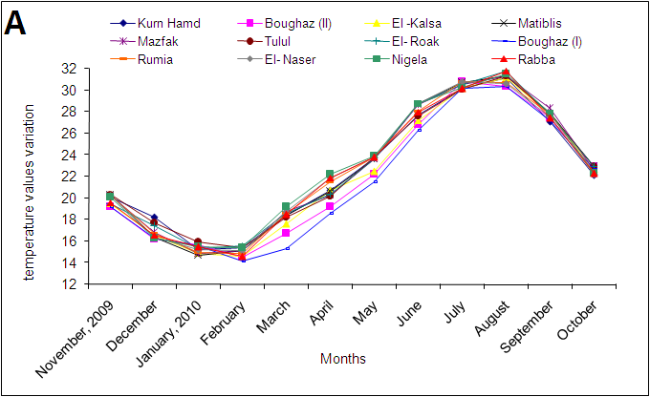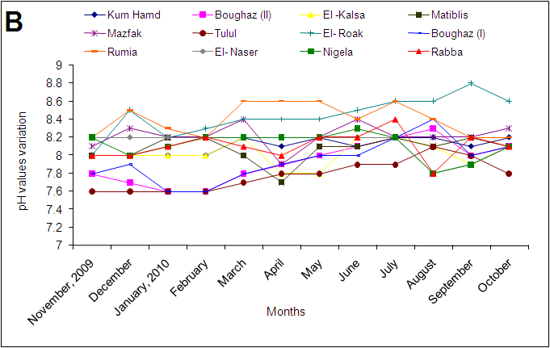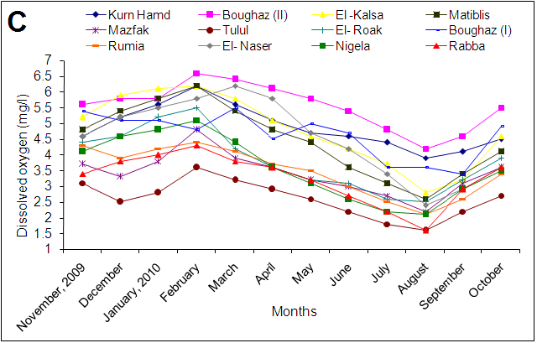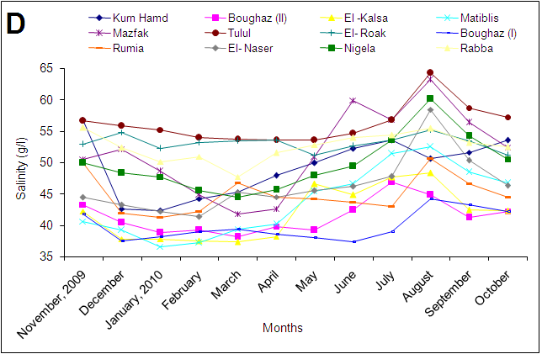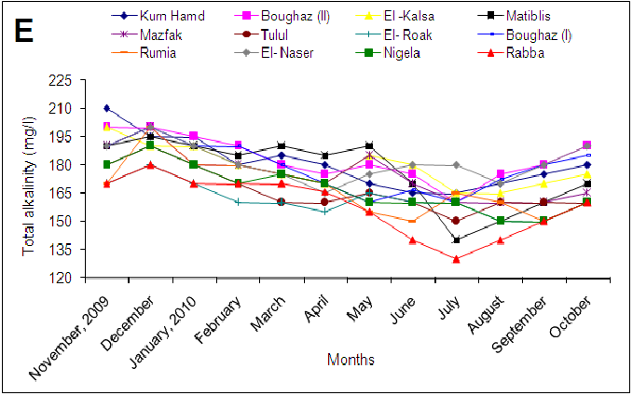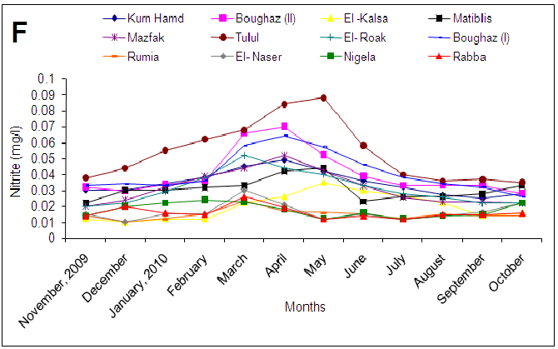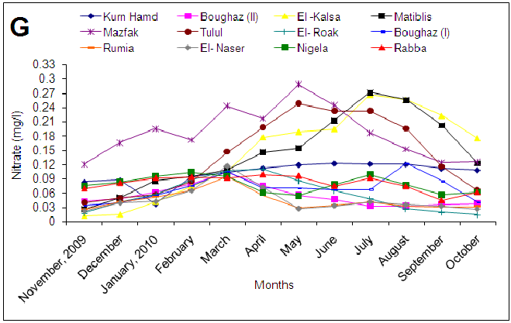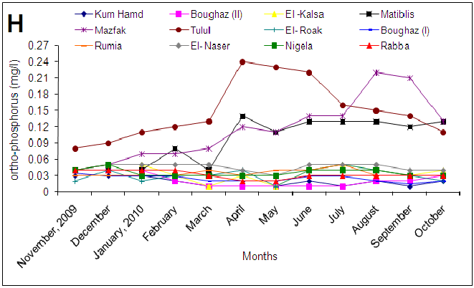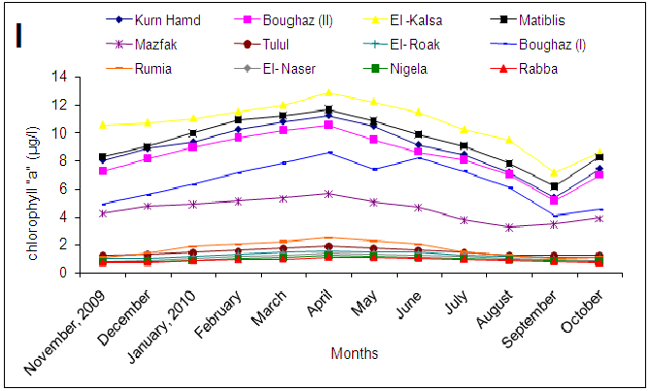

**Fig. (2): Monthly fluctuations in water quality parameters as A: temperature, B: pH, C: dissolved oxygen, D: salinity, E: total alkalinity, F: nitrite, G: nitrate, H: ortho- phosphorus; I: chlorophyll ″a″ in the Bardawil Lake during the experimental period (2009-2010).**

**Table (1): Annual data of water quality parameters of Bardawil Lake during the study period (2009-2010)**

|  |  |  |  |  |  |  |  |  |  |  |  |  |
| --- | --- | --- | --- | --- | --- | --- | --- | --- | --- | --- | --- | --- |
| Stations  Items | Kurn Hamd | Boughaz (II) | El –Kalsa | Matiblis  (Ofra) | Mazfak | Tulul | El- Roak | Boughaz (I) | Rumia | El- Naser | Nigela | Rabba |
| Temp. (oC) | 22.5  ±1.5a | 21.8  ±1.5a | 22.1  ±1.5a | 22.5  ±1.5a | 22.6  ±1.5a | 22.6  ±1.5a | 22.6  ±1.5a | 21.4  ±1.5a | 22.5  ±1.5a | 22.6  ±1.5a | 22.7  ±1.5a | 22.5  ±1.5a |
| pH | 8.1  ±1.1a | 7.9  ±1.3ab | 8.0  ±1.1a | 8.0  ±1.1a | 8.2  ±1.1a | 7.7  ±1.2b | 8.4  ±1.1a | 7.9  ±1.1a | 8.4  ±1.1a | 8.1  ±1.1a | 8.1  ±1.1a | 8.1  ±1.1a |
| DO (mg/l) | 4.8  ±0.5a | 5.5  ±0.4a | 4.7  ±0.5a | 4.4  ±0.4a | 3.4  ±0.3b | 2.5  ±0.2c | 3.8  ±0.3b | 4.3  ±0.4a | 3.4  ±0.3b | 4.5  ±0.5a | 3.5  ±0.2b | 3.2  ±0.2b |
| Sal. (g/l) | 49.2  ±4.2a | 41.3  ±3.5b | 41.9  ±3.1b | 43.6  ±2.8b | 50.9  ±4.1a | 56.1  ±4.1a | 53.0  ±4.2a | 39.8  ±2.2c | 44.5  ±2.4b | 46.2  ±3.4b | 49.7  ±3.2a | 52.5  ±3.6a |
| T. alk. (mg/l) | 180.8  ±14a | 183.3  ±12a | 178.3  ±12a | 176.2  ±14a | 174.5  ±15a | 166.2  ±15b | 161.6  ±14b | 177.5  ±15a | 167.9  ±12b | 181.2  ±20a | 167  ±14b | 158.3  ±12b |
| NO2 (mg/l) | 0.034  ±0.001b | 0.040  ±0.001b | 0.019  ±0.001c | 0.030  ±0.001b | 0.031  ±0.001b | 0.053  ±0.001a | 0.031  ±0.001b | 0.040  ±0.001b | 0.014  ±0.001c | 0.016  0.001c | 0.017  ±0.001c | 0.016  ±0.001c |
| NO3 (mg/l) | 0.106  ±0.001b | 0.053  ±0.001c | 0.144  ±0.01ab | 0.150  ±0.001a | 0.198  ±0.01a | 0.138  ±0.01ab | 0.056  ±0.01c | 0.081  ±0.01b | 0.044  ±0.01c | 0.045  ±0.001c | 0.078  ±0.001c | 0.081  ±0.01c |
| Ortho. Phos. (mg/l) | 0.018  ±0.001b | 0.021  ±0.001b | 0.035  ±0.001b | 0.101  ±0.01a | 0.115  ±0.01a | 0.148  ±0.01a | 0.031  ±0.001b | 0.025  ±0.001b | 0.034  ±0.001b | 0.045  ±0.001b | 0.035  ±0.001b | 0.031  ±0.001b |
| Chlor. "a" (mg/l) | 8.86  ±0.4a | 8.32  ±0.5a | 10.64  ±0.5a | 9.40  ±0.5a | 4.50  ±0.3b | 1.46  ±0.2c | 1.24  ±0.1c | 4.60  ±0.3b | 1.69  ±0.1c | 1.10  ±0.1c | 0.98  ±0.1c | 0.89  ±0.1c |

Letters (a to c) show horizontal differences among stations in the same parameter. Data shown with different letters are statistically different at P < 0.05 level.

The lowest values of pH were recorded in Boughaz 1, 2 and Tulul during all months. These results may be attributed to the change rate of water between lake and Mediterranean Sea and in Tulul due to the highest accumulation of organic compound. The pH were significantly (P<0.05) different among different locations during the same month, also, were significantly (P<0.05) different in the same locations during different months.

From the obtaned results, Tulul (site 6) recorded lowest pH value (P<0.05) during the syudy (Fig. 2B) and it could be due to the proximity of the site of the housing, a station docking for boats so accumulate out a lot of organic waste, which decrease the pH of water in addition to the lack of water exchange between the Mediterranean Sea and this site.

Dissolved oxygen concentration was significantly (P<0.05) higher in February than in the other months followed by March, April and May as shown in Fig. 2C. The DO was significantly increased in Boughaz (II) during February than other locations. These results may be due to the highest speed of water led to more water exchange between lake and Mediterranean Sea. The highest value of DO was 6.6 mg/l during February in Boughaz (II) and the lowest value was 1.6mg/l in Tulul during August. The DO values were significantly (P<0.05) decrease in summer season than other seasons. The annual average of DO were 4.8; 5.5; 4.7; 4.4; 3.4; 2.5; 3.8; 4.3; 3.4; 4.5; 3.5 and 3.2 mg/l for the same sites respectively, Table (1). Concentration of dissolved oxygen in the water depends on the temperature and the proliferation of air where increasing solubility of oxygen in water down the temperature in the sense that there is an inverse relationship between temperature and solubility of oxygen in the water as well as on the process of photosynthesis by phytoplankton in the water **(Shaker *et al.,* 2013)**. These results are in agreement with those obtained by **Ayub and Boyd (1994)** and **Boyd and Tucker (1998)** who reported that the dissolved of oxygen from air to water decreased with increasing temperature and **Shaker *et al.* (2009a,b)** who found the negative correlation between water temperature and dissolved oxygen values in water.

The average values of salinity were significant (P<0.05) among locations. The average values of salinity were significantly (P<0.05) increase independent in Tulul location than other locations during all months as shown in Fig. (2D). These results revealed that the average values of salinity have negative correlation with water exchange between lake and Mediterranean Sea. Also, the lowest values of salinity were recorded in locations near Mediterranean Sea. Of the map note that Tulul site is the farthest locations from the Mediterranean and the movement of water exchange between the Mediterranean Sea and the lake is not up to this site, despite the large area of this region. These results suggest the need to establish waterways into the lake to ensure access to waters of the Mediterranean to the last point in the lake.

The average values of salinity in autumn ranged from 40.7 to 56.5g/l, in winter ranged from 37.5 to 52.9g/l, in spring ranged from 37.5 to 53.8g/l and in summer ranged from 44.3 to 59.8g/l. From the previous results, the salinity of the water rised in the summer season more than the rest of the seasons, and this is may be due to the high temperature and increasing the evaporation rates in addition to the lack efficiency Boughazs in water exchanges between the Mediterranean Sea and the lake to compensate the evaporation loss and reduce salinity. This means that Boughazs need fast and continuous cleansing and reduce sedimentation processes in which they occur. And to reduce the salinity of the water in the lake we suggest establishing of radial channels within the lake included connecting the Mediterranean Sea to the last point in the lake and increase the water exchange process and follow-up to this cleansing and maintaining channels of continuous sedimentation.

The annual average of salinity were 49.2; 41.3; 41.9; 43.6; 50.9; 56.1; 53.0; 39.8; 44.5; 46.2; 49.7 and 52.5 g/l for the same sites respectively, Table (1).

From the results obtained it noted that the total alkalinity located within the allowable range in all studied locations throughout the year (Fig. 2E) despite the existence of the significant differences (P<0.05) among sites and months too, which is mostly due to water exchanges between the Mediterranean Sea and the lake.

Nitrogenous compounds nitrite and nitrate, in spite of the seriousness of these compounds, but it is one of the specific compounds to the water where fertility is considered alongside of the most important sources of ammonia nitrogen for algae and aquatic plants, and the three photos of nitrogenous compounds turn to each other and redox reactions.

Fig. 2F showed different values of nitrite concentrations in sampled water where the concentrations differs significantly (P<0.05) from one location to another within the same location from one month to another.

We noted that all values except for low Tulul site is rather high values as a result of decomposition of organic compounds and decomposition of herbs and sea grass with fishing boats accrued to this site. The annual average of nitrite were 0.034; 0.04; 0.019; 0.03; 0.031; 0.053; 0.031; 0.04; 0.014; 0.016; 0.017 and 0.016mg/l for the same sites respectively, Table (1). The same trend was observed by nitrate.

The nitrogen and phosphorus are considered from the major nutrients and important for all plants, especially phytoplankton, which is the main source to feed the fish in the lakes even in the case of fish that feed on the zooplankton because they invoke primarily on phytoplankton. And to a large extent determines the fertility of water based on the concentration of the elements nitrogen and phosphorus in the water because they are racist construction and development of natural food in the lake. So the picture that the element resides one of the most important factors determining the extent of benefit from it directly or indirectly **Shaker and Mahmoud (2007).**

The highest annual concentration of ortho-phosphate recorded in Tulul, Mazfak and Matiblis (Ofra) in the water as presented in Table (1). These results cleared that highest accumulation of organic compound in these locations as shown in Fig. 2H.

Bardawil Lake is considered poor in the water content of nutrients in general so increasingly rely on the water exchange between the Mediterranean Sea and the lake so as to increase the nutrient is evident from Fig. 2I, where the chlorophyll ''a″ concentration is very low. The annual concentration of Chlorophyll ''a″ were 8.86; 8.32; 10.64; 9.4; 4.5; 1.46; 1.24; 4.6; 1.69; 1.1; 0.98 and 0.89µg/l for Kurn Hamd; Boughaz (II); El –Kalsa; Matiblis (Ofra); Mazfak; Tulul; El- Roak; Boughaz (I); Rumia; El- Naser; Nigela and Rabba respectively.

Use of heavy metals in the water as an indicator of water quality, which can be judged on the level of contamination of the water and then can be judged on the quality of the produced fish from the lake. For example, the presence of lead, cadmium and mercury in the water even at low concentrations evidence of sewage pollution and industrial. Of the biggest problems that cause pollution facing the lake is big boats exchange at sea for oil Parts of this along with sewage in lakes.

Metal concentrations in water samples are presented in Fig. 3, which include mean concentrations with standard deviation values. Due to variations within each element, mean concentration might be significantly affected via the extremely high or low values.

Fig. 3A showed the iron concentration in water during the months of study. Iron is the most common elements in water and soil of Egypt. The concentration of iron in Tulul had significant (P<0.05) increases than other locations, and this is due to the fact that site Tulul is the largest fishing ports in the lake. Also, summer had significant (P<0.05) increases than other seasons, while, winter had significant (P<0.05) decrease than other seasons. This result is probably due to increased evaporation rates associated with high temperatures during the summer season.

|  |
| --- |
|  |
|  |

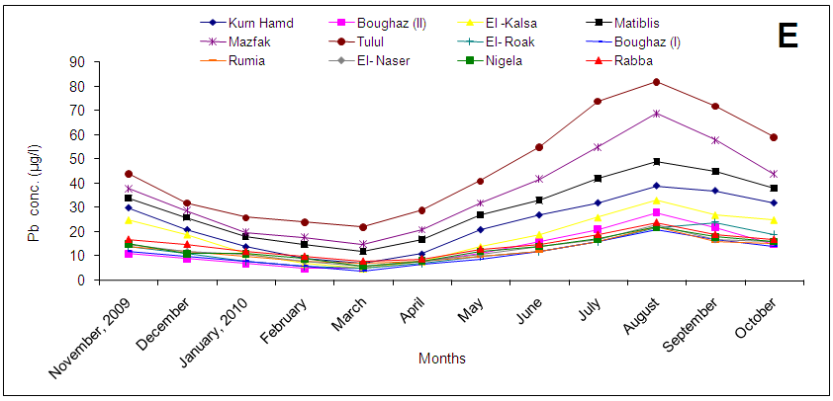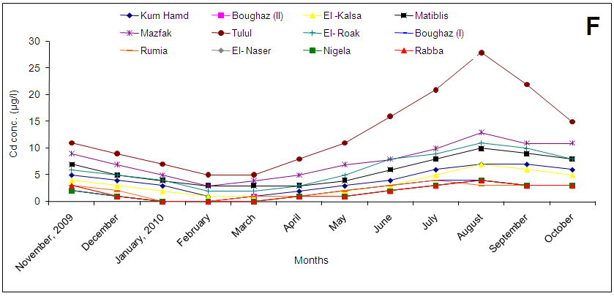

**Fig. (3): Monthly fluctuations of heavy metals concentration as A- Fe; B- Mn; C- Zn; D- Cu; E- Pb and F- Cd in water of Bardawil Lake during the experimental period (2009-2010).**

Zinc is the second in terms of element concentration in the water during the months of the year, comes after iron. It takes the same direction as iron Zinc in terms of the increase in Tulul site than other sites and the increase in the summer season than other seasons. These results are in agreement with those obtained by **Ahmet *et al.* (2006).**

Manganese is the third element in terms of the concentration in the water during the months of the year, comes after iron and zinc. It takes the same direction as iron manganese in terms of the increase in Tulul site than other sites and the increase in the summer season than other seasons as shown in Fig. 3B & C.

Copper is the fourth element in terms of the concentration in the water during the months of the year (Fig. 3D) comes after iron, zinc and manganese. It takes the same direction as iron copper in terms of the increase in Tulul site than other sites. Copper differs in that the only element which increases in winter from the rest of the seasons. These results are in agreement with those obtained by **Ruilian *et al.* (2008).** However, in the Mediterranean Sea, **Kalantzi *et al.* (2013)** concluded that Zn, Cu, Mn and Fe were at tolerable levels for the marine ecosystem and that the oligotrophic nature of the water in the study area was able to assimilate both the organic and inorganic fish farm effluents. Differences in metals concentrations between sites could be attributed to the difference between the stations under study in concentration of heavy elements to several factors, including:

1- The distance between them and the areas of water exchange between the Mediterranean Sea and the lake where the concentration reduce the closer location of the water exchange areas.

2- The distance between them and the port areas for fishing vessels.

3- The distance between them and the places of accumulation of organic wastes and plant resulting from over fishing.

4- The presence of the density of aquatic plants, which absorb heavy elements, especially as the concentrations in the allowable limits. The presence of cadmium in water is a proof to the presence of industrial water pollution drainage even at low concentrations. Lead and cadmium concentrations in water samples are presented in Fig. (3E & F).

From the previous results we can observe that less lead and cadmium concentration in the water elements. Cadmium concentration in the water was imperceptible sites Tulul, El-Roak and Mazfak is concentrations on lead and cadmium, and due to the presence of the fishing port, as well as some of the materials used in coating boats. Also, we can see that the concentration of lead and cadmium be higher in the summer season from the rest of the seasons. The study showed that the waters of Lake Bardawil is poor nutritionally, but water is clean and free of contaminants, so we suggest the need to work on the development of natural food out and add safe fertilizer food to improve water quality and increase fish production and crustaceans and the organization of traffic exchanges waterway between the Mediterranean Sea and the lake to cover all bodies of water in the lake.

**References**

1. **Ahmet D.; Y. Fevzi; T. Levent and O. Nedim (2006):** Heavy metals in water, sediment and tissues of *Leuciscus cephalus* from a stream in southwestern Turkey. Chemosphere 63:1451–1458.
2. **Ali, M.H. (2006):** Water prosperities (chapter 1&2). Lake Bardawil and Zaranik protected Area. Publication of National Biodiversity Unit. No. IS. 2006.
3. **APHA (American Public Health Association) (2000):** Standard Methods for Examination of Water and Waste Water (16th edition). Washington, D.C.
4. **Ayub, M. and C.E. Boyd (1994):** Comparison of different methods for measuring organic carbon in pond bottom soils. Journal of Aquaculture Society, 25:322-325.
5. **Boyd, C.E. (1984):** Water Quality in Warm Water Fish Pond. Alabama Agriculture Experimental Station, Auburn University, Alabama.
6. **Boyd, C.E. and C.S. Tucker (1998):** Water Quality and Pond Soil Analysis for Aquaculture., Alabama agriculture Experiment Station, Alabama, USA.700pp.
7. **Campbell, A.C. (1982)**: The Hamlyn Guide to the flora and fauna of the Mediterranean Sea. Hamlyn. London. New York, Sydney, Toronto: 321 pp.
8. **Cook, J.A.; S.M. Andrew and M.S. Johnson (1990):** Lead, zinc, cadmium and fluoride in small mammals from contaminated grass-land established on fluorspar tailings, Water Air Soil Poll., 51: 43–54.
9. **Deforest, D.; K. Brix and W. Adams (2007):** Assessing metal bioaccumulation in aquatic environments: The inverse relationship between bioaccumulation factors, trophic transfer factors and exposure concentration. Aquat. Toxicol., 84: 236–246.
10. **Deniseger, J.; J. Erickson; A. Austin; M. Roch and M.J.R. Clark (1990):** The effects of decreasing heavy metal concentrations on the biota of Buttle Lake, Water Res., 24: 403–416.
11. **Fang, X. and H.G. Stefan (1995):** Interaction between oxygen transfer mechanisms in lake models. J. Environ. Eng., ASCE 121 (6): 447-454.
12. **Förstner, U. and G.T.W. Wittman (1983):** Metal Pollution in Aquatic Environment, Springer-Verlag, New York.
13. **Fu, F. and Q. Wang (2011):** Removal of heavy metal ions from wastewaters: a review. J. Environ. Manage., 92: 407–418.
14. **Hooda, P.S.; A.C. Edwards and H.A. Anderson (2000**): A review of water quality concerns in livestock farming areas. Science of the Total Environment, 250 (1–3): 143–167.
15. **Hosono, T.; C. Su; R. Delinom; Y. Umezawa; T. Toyota; S. Kaneko and M. Taniguchi (2011):** Decline in heavy metal contamination in marine sediments in Jakarta Bay, Indonesia due to increasing environmental regulations. Estuar. Coast. Shelf Sci., 92: 297–306. Institute Incorporation, Cary, NC 27513 USA.
16. **Kalantzi, I.; T.M. Shimmield; S.A. Pergantis; N. Papageorgiou; K.D. Black and I. Karakassis (2013):** Heavy metals, trace elements and sediment geochemistry at four Mediterranean fish farms. Science of the Total Environment, 444:128–137.
17. **Rectenwald, L.L. and R.W. Drenner (2000):** Nutrient removal from wastewater effluent using an ecological water treatment system. Environmental Science Technology, 34 (3): 522–526.
18. **Reddy, K.R.; M.M. Fisher and D. Ivanoff (1996):** Resuspension and diffusive flux of nitrogen and phosphorus in a hupereutrophic lake. Journal of Environmental Quality, 25 (2): 363–371.
19. **Ruffo, S. (1982):** The amphipoda of the Mediterranean. Mem. Del. Inst. Ocean., Part (1): Gammaridae.
20. **Ruilian, Y.; Y. Xing; Z. Yuanhui; H. Gongren and T. Xianglin (2008):** Heavy metal pollution in intertidal sediments from Quanzhou Bay, China. J. Environ. Sci. 20, 664–669.
21. **Shaker, I.M. and A.A. Mahmoud (2007):** The biological load of silver carp cages in the River Nile and their effects on water quality and growth performance. Egypt. J. Aquat. Biol. & Fish., 11(2): 119-143.
22. **Shaker, I.M.** **(2008):** Effect of using different types of organicmanure (compost; chicken, Mycelium) and mineral fertilizer on water quality, plankton abundanceand on growth performance of *Oreochromis niloticus* in earthen ponds. Abbassa Int. J. Aqua. 4 (1), 203-226.
23. **Shaker, I.M.; M.H. Agouz and A.A. Mahmoud (2009a):** Environmental impacts of fish cages in Lake Manzalla and growth performance of different fish species. Egypt. J. Aquat. Biol. & Fish., 13(4): 293-308.
24. **Shaker, I.M.; A.H. Mona and A.A. Mahmoud (2009b):** Effect of periphyton substrate on water quality and growth performance of Nile tilapia in earthen ponds. Abbassa international journal for aquaculture, Special Issue for Global Fisheries & Aquaculture Research Conference, Cairo International Convention Center, 24–26 October pp 741-763.
25. **Shaker, I.M.; M.Y. Abou Zeid and A. Batran (2013):** Effect of using periphyton substrate (bamboo stems) on water quality, phytoplankton, zooplankton, periphyton and growth performance for tilapia, mullet and catfish in earthen ponds. Abbassa, Int., J. Aqua., 6 (1): 108-139.
26. **SAS (Statistical Analysis System) (2000):** SAS program ver.612, SAS.
27. **Stefan, H.G.; M. Hondzon and X. Fang (1993):** Lake water quality modeling for projected future climate scenarios. J. Environ. Quality, 22 (3): 417-431.
28. **Vollenweider, R.A. (1969):** A manual of method for measuring Primary Production in Aquatic Environmental. I BP Handb. No, 12, Blackwell Sci. Publ., Oxford, 213pp.

11/2/2013