Comparison Study between using HPS, LED and C.F Lamps in Roadway Lighting

Bahaa Medkour ¹, Mohamed Mehanna ², Mohamed Abdelmonem ³

^{1.} Faculty of Engineering, Al-Azhar University, Nasr City, Cairo-Egypt.

mohamed.pee@gmail.com

Abstract: A new Light-Emitting Diode (LED) Lighting system is proposed as an optimized solution for existing and future roadway lighting system compared with High Pressure Sodium (HPS) and Compact Fluorescent Lamps (CFL) lighting system. This study is developed based on a set of facts, which state that the LED lighting system is optimum for following reasons: (i) The LED Utilization factor are higher for lenses light concentrated distribution; (ii) The LED life time is much longer than HPS and CFL systems (four times at least); (iii) Light Output Ratio (LOR) of LED lamp is closed to 100% (no diffuser); (iv) Step power rating can be set by 1watt incremental.
HPS lamp lighting system was used for its lower capital cost than LED. Compact fluorescent lamp (CFL) lighting system was suggested for its lower capital cost than HPS and LED as well.
[Mohamed Abdelmonem. Comparison Study between using HPS, LED and CF lighting system in Roadway Lighting Forests. N Y Sci J 2013;6(10):26-30] 1554-0200). http://www.sciencepub.net/newyork. 5

Keywords: Lighting; Rood Lighting; HPS; CFL; LED

1. Introduction
Roadways lighting for both vehicles and pedestrians can create a nighttime environment in which people can see comfortably and can quickly and accurately identify objects on the roadways being traveled.
Roadway lighting can improve traffic safety, achieve efficient traffic movement, and promote the general use of the facility during darkness and under a wide variety of weather conditions.
As an addition to vehicular headlight illumination, fixed lighting can enable the motorist to see details more distinctly, locate them with react safely to roadway and traffic conditions present on or near the roadway facility.
Pedestrians must be able to see with sufficient detail to readily negotiate the pedestrian facility and recognize the presence of other pedestrians, vehicles, and objects in their vicinity.
When fixed-lighting principles and techniques are
Properly applied, the visibility provided on these public ways can provide economic and social benefits to the public, including:
- Reduction in nighttime accidents.
- Aid to police protection and safety of population.
- Facilitation of traffic flow.
- Promotion of transport and travelling for business and industry during nighttime hours.
- Inspiration for community spirit and growth.[2]
This study considers only fixed lighting for the different kinds of public roads of a quality considered appropriate to modern requirements for night use.
At present, the greenhouse artificial light sources mainly are fluorescent lamps, high pressure sodium, low pressure sodium, metal halide lamps act. In recent years, with the successful development of high-power LED, the new energy-saving LED light source also attracted widespread attention.
LED (Light Emitting Diode) is a solid-state semiconductor light source devices (SSL) that can convert electrical to light directly. The heart of LED is a semiconductor chip. LED is now used as the light source in roadway lighting. Compare LED with HPS and CF lamps, LED has the following features are noted:
1) High energy efficient: it can achieve over 150lm/W.
2) Long life as 50,000h or more.
3) LED light in theoretically, its spectral characteristics include the entire visible spectral range. Color Rendition Index is 80-95.
4) Environmental protection: it doesn’t contain mercury or xenon and other harmful elements, also does not produce radiation, it is recyclable. [5]
High Pressure Sodium lamp (HPS) is mercury and sodium vapor light, the standard vapor pressure is about 10kPa, the emission spectrum most are red-orange light and a little blue-green light. It with high luminous efficiency, high power, long life (about 22,000 h), it used a lot in the greenhouse. However, due to the high pressure sodium lamp is heating source, with high surface temperature, the lamp cannot shoot the crop in closed distance.
The ordinary compact fluorescent lamp provides more green, about 50%, most of the rest are red and blue, which take about 25% of the total spectrum, infrared spectral ratio is very low. Fluorescent lamp with luminous efficiency 80lm/W, long life (about 8,000h), and CRI>85, but less power (currently used both 28W and 36W). Because it contains a lot of green light, which likely to cause crop growth, commonly used in plant tissue culture.[11]
Obviously, Countries all over the world take more and more attention to the problem of energy-saving and environmental protection; some countries are already promoting the use of LED lamps. As long as the of LED lamps cost reduce, and LED technology continues to improve, it will replace the fluorescent lamp, Sodium lamp, the metal halide light inevitably.
Today's LED (light-emitting diode) bulbs cause slightly less environmental harm than compact fluorescents and HPS in much areas studied. Those areas include global warming potential, land use and pollution of water, soil and air. By 2017, LED bulbs will have half the impact of today's LED bulbs and 70 percent less impact than today's CFLs, which are not expected to change significantly. LED bulbs will become more efficient, for example, reducing energy use and cutting the heat generated and the required size of heat sinks. [9]
By Encouraging LED technology and its benefits the environment as in the following items:
- Reduce energy costs by 50 percent as least.
- Life rating of more than four times that of traditional high-pressure sodium (HPS) lamps significantly reducing costs and allowing the municipalities to better utilize maintenance resources.
- Visibility improvement dramatically for vehicles and pedestrian traffic through the use of patented nano-Optic product technology that layer light into the desired target zone for superior uniformity and control while HPS and CFL sources often require an external reflector to collect light and direct it in a usable manner.
- Using backlight control with LED streetlights preserve the uniqueness night sky and complies with Dark Sky and IES standards.
- In addition, with more than 100,000 hours of Delivered lumens, no re-lamping, replacement or labor costs.
- The proprietary technology within LED streetlights creates safer conditions for motorists and pedestrians by producing a whiter light with better uniformity.
- LEDs are ideal for frequent on-off cycling,
not like CFL that fail faster when cycled often, or HPS that require a long time before restarting. [3,9]

The following case study example is a 250W high-pressure Sodium unit (HPS), 170W neutral white LED luminaries and 80W compact fluorescent lamp (CFL). The comparing study for the same road to achieve the required standard as per IES. So the constant is the illuminations requirement values for the same roadway regardless of the number of fixtures, its arrangement type, mounting height, poles spacing or other parameters as mentioned in the following study, only achieving the illumination requirements for the same road by three types of lighting systems.
2. Material and Methods
The following data for the road way used for this comparison study(Road class can be evaluated by more standard like BS, DIN or IES which chosen for this comparison).[4,5]

Table-1. Case study roadway data
Road Way Data
Road class  (IES RP-8-00) | Major med. ped. confl
Width (m) | 10.5
No. of lanes | 3
Lanes Width (m) | 3.5
Road surface | R3
Q0 | 0.07
Av. no. of op. hours per day | 12

Figure 1. Case study Roadway

4. Discussions
In this study assumed life cycle is ten years and light loss factor (LLS) is 0.68 and some advanced factors like pricing changing from country to other and from manufacturer to other and some other factors will not be more effective in the calculation results but it will be almost the same respective percent to each other.[13,14,15]
The final results and payback period in this study will improve with time due to following parameters:
- Reduction of capital cost for LED with time.
- Improvement of LED efficacy which is now (150LM/W) compared with 90LM/W used in this study.
Improvement of LED manufacturing quality and life time of fixtures.
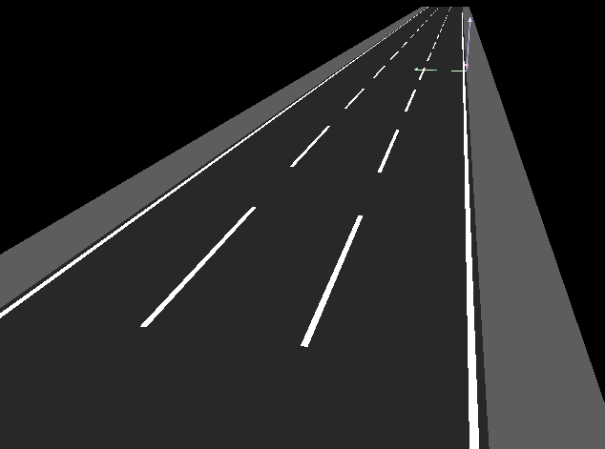
Figure 2. Roadway 3D view

Table -2. Case study Lighting design criteria
Lighting Design Criteria | HPS (SON) | LED | CF
Supplier | Philips Widelite | Philips Widelite | philips
Arrangement | Single row | Single row | Single row
Pole Spacing (m) | 42.0 | 42.0 | 10.0
Mounting Height (m) | 10.0 | 10.0 | 6.5
Tilting angle | 0.0 | 0.0 | 0.0
Over hang (m) | 0.0 | 0.0 | 2.6
Luminaire Wattage | 310 (250) | 172 | 88
Lamp Flux (Lumen) | 27,000 | 15,396 | 6,000
Luminaire Flux (Lumen) | 21,000 | 15,396 | 3,900
LOR | 78% | 100% | 65%
Lamp. Effecacy (Lm/watt) | 67.7 | 89.3 | 44.3
Photometric Category* | II-M-F.C | II-M-F.C | N/A
Maintenance factor | 0.68 | 0.68 | 0.68

3. Results

Table -3. Case study calculation results.
Results and Comparison | HPS | LED | C.F | Standard IES-08-00
Eav(lux) | 13.0 | 13.0 | 13.3 | ≥ 13
Eav / Emin (Uo) | 1.9 | 1.5 | 2.3 | ≥ 3
Lv max/Lav | 0.3 | 0.3 | 0.2 | ≥ 0.3

Table 4. Analysis of results
Results conclusions | HPS(SON) | LED | C.F
Poles nos. per km | 23.8 | 23.8 | 100.0
Power consumption per km (Kwatt/km) | 7.4 | 4.1 | 8.8
Power consumption per m2 (Kw/km/lux) | 0.6 | 0.3 | 0.7
Elec. Tariff Price (L.E) | 0.4 | 0.4 | 0.4
Road energy consumption (kwh/km/year) | 32,329 | 17,979 | 38,544
Consumption Running cost (LE/km/year)⁽¹⁾ | 13,319 | 7,407 | 15,880
Replacing price (LE) | 400.00 | 1,500.00 | 200.00
Life time (hour) | 22,000 | 100,000 | 8,000
Replacing cost (LE/km/year) ⁽²⁾ | 1,896 | 1,564 | 10,950
Total Running Cost (LE/km/year)⁽¹⁾⁺⁽²⁾ | 15,215 | 8,972 | 26,830
Fixture & pole supply/Install price (LE) | 2,500 | 3,500 | 2,000
Capital cost (LE/km) | 59,524 | 83,333 | 200,000
LED simple Payback period (0% annual rate) (years) | 3.8 | - | -
LED Payback period (8% annual rate) (years) | 4.7 | - | -
Total Cost for 10 Years System | 348,927 | 309,878 | 820,461

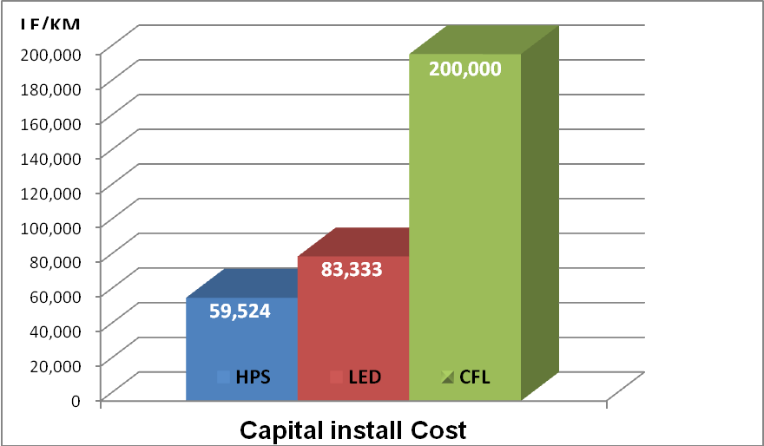Figure 3.Capital cost comparison (LE/Km) | 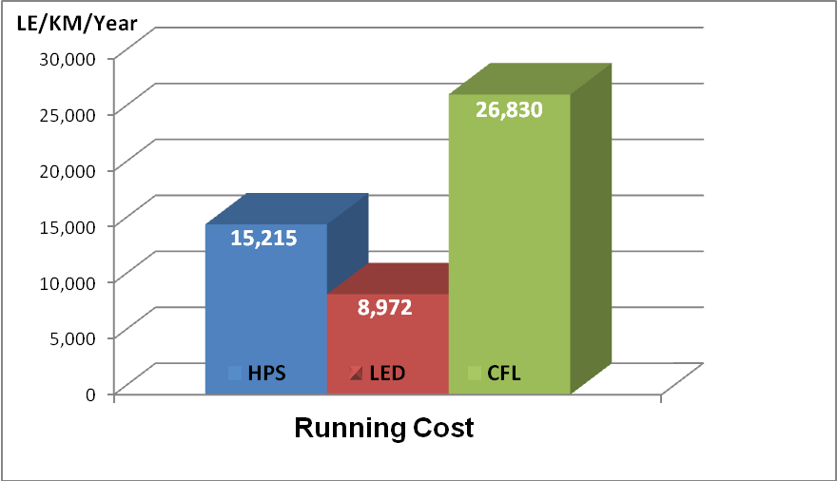Figure 4. Running cost comparison (LE/Km/year)

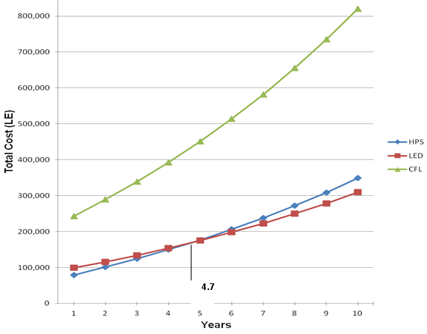
Figure 5. Payback period chart.

Table 5. Comparison table for LED,HPS and CFL lighting systems.
Items | LED | HPS | CFL
Energy Consumption | Quite Low | High | Very High
Average Working Life (hrs) | ＞70,000 | 20,000 | < 8,000
Efficacy(lm/W) | ＞130 | ＞120 | 70-80
Environmental Friendly | YES | Lead & Mercury | Lead & Mercury
Startup Speed | Rapid | Quite Slow( Over 10minutes)
Optical Efficiency/ Photometric | Very High/ Excellent | Low/ Bad | Very Low/ Very Bad
Color Index (CRI) | ＞80 | < 22 | ＞65
UV (ultra violet) | NO UV | UV component present | UV component present

5. Conclusion
LED technology is the future of lighting, So by accepting LED technology and its benefits, the world will set new standards for all municipalities to follow:
Helping to reduce the impact we’re making on our environment as following items:
- Decrease maintenance cost by increasing maintenance time period.
- Reduce power demand.
- Decrease CO2 emission.
- Decrease light pollution.
- Best vision.
- Little infrared light and almost zero UV emissions.

Corresponding Author:

Eng. Mohamed Abdelmonem

Department of Electrical Engineering
Faculty of Engineering
Al-Azhar University
Nasr city, Cairo, Egypt

E-mail: mohamed.pee@gmail.com

Mob: (+2)01281462248

References
- IESNA Lighting handbook (10th ed.) reference & Application, 2011 http://www.iesna.org/.
- IES 2000. RP-8-00. Roadway Lighting. Illuminating Engineering Society of North America, New York, NY.
- LD+A: the magazine of illuminating engineering society of north America.
- Licht.wissen 03: roads, paths and squares, Germany, www.licht.de.
- Lighting research center, 21 union street, http://www.lrc.rpi.edu.
- Tarek M. Zarif, LC, PE Lighting courses and publications. http://www.mep-ls.com/
- Commission Internationale de l'Éclairage. 1990. Calculation and measurement of luminance and illuminance in road lighting. CIE publication 30.2-1982. Paris: Bureau Central de la CIE.
- American National Standards Institute and IES. 1983. American national standard practice for roadway lighting, ANSI/IES RP-8-1983. New York: Illuminating Engineering Society of North America.
- Cree lighting applications and case study http://www.cree.com.
- Lighting engineering applied Calculations, R. H. Simons and A. R. Bean.2001.
- Cooper Lighting Online library.
- DOE. 2010. Final Report Prepared in Support of the U.S. DOE Solid-State Lighting Technology Demonstration Gateway Program: Demonstration Assessment of Light-Emitting Diode (LED) Roadway Lighting on Residential and Commercial Streets, Host Site: Palo Alto, California. Accessed August 2, 2011
- DOE. 2009(b). Final Report Prepared in Support of the U.S. DOE Solid-State Lighting Technology Demonstration Gateway Program: Demonstration Assessment of Light-Emitting Diode (LED) Street Lighting, Host Site: Lija Loop, Portland, Oregon. Accessed August 2, 2011
- DOE. 2009(a). Final Report Prepared in Support of the U.S. DOE Solid-State Lighting Technology Demonstration GATEWAY Program: Demonstration Assessment of Light-Emitting Diode (LED) Roadway Lighting, Host Site: I-35 Bridge, Minneapolis, Minnesota. Accessed August 2, 2011.
- DOE. 2008. Final Report Prepared in Support of the U.S. DOE Solid-State Lighting Technology Demonstration Gateway Program: Demonstration Assessment of Light-Emitting Diode (LED) Street Lighting, Phase III Continuation, Host Site: City of Oakland, California. Accessed August 2, 2011.

8/25/2013

