Influence of Physicochemical Parameters On Βeta-Galactosidase Production And Growth of Trichoderma Species

Akinola Gbemisola Elizabeth¹, Adebayo-Tayo Bukola², Ogunleye Peter Abiodun³

¹Department of Microbiology, University of Ibadan, Ibadan, Oyo state, Nigeria
<gbemiakinola@yahoo.com> < bukola_tayo@yahoo.com >

Abstract: β-galactosidase or β-D-galactoside-galactohydrolase is an important enzyme industrially used for the hydrolysis of lactose from milk and whey for several applications. The influence of physicochemical parameters on β-Galactosidase production and growth of Trichoderma species was investigated. The β-Galactosidase production by Trichoderma species attained the maximum production (4.37962 U/ml) at 30ºC by T. crassum and optimum growth (0.2709ª) was recorded at 30ºC by Trichoderma asperellum. The highest production of β-galactosidase (7.8171 U/ml) was attained after 6days of incubation by T. crassum. There was a gradual increase in the growth of the isolates from 6days - 12days and Trichoderma asperellum had the highest growth (0.2504ª). β-galactosidase production (2.2369U/ml) at pH 4 by T. crassum was the best but at pH 12 the growth of the isolates decreases and Optimum growth was attained by Trichoderma asperellum (0.1907ª). Among the carbon sources tested manitol at the concentration of 2%(w/v) induced the higher level of β-galactosidase production and it ranged from 2.7666 - 6.9888 U/ml in which Trichoderma crassum had the highest production while fructose supported the growth of all the selected isolates in which Trichoderma fertile (0.2809ª) and Trichoderma harzarium (0.2804ª) had the best growth. Casein at the concentration of 0.5% (w/v) supported the optimal production of β-galactosidase, it ranged from 2.6773 - 7.4853 U/ml in which Trichoderma crassum had the highest production and ammonium sulphate supported the growth of the isolates. Tween80 at the concentration of 0.15ml stimulated optimum β-galactosidase production (3.8999 U/ml) by Trichoderma viride and at 0.15% - 0.30% concentration there was a steady increase in the growth of the isolates and Trichoderma harzarium had the best growth (0.1650ª). Trichoderma species isolated are potential producers of β-galactosidase.
[Akinola GE, Adebayo-Tayo BC, Ogunleye PA. Influence of Physicochemical Parameters On Βeta-Galactosidase Production And Growth of Trichoderma Species. N Y Sci J 2013;6(10):1-6]. (ISSN: 1554-0200). http://www.sciencepub.net/newyork. 1

Keywords: β-galactosidase, Trichoderma, Temperature, Tween80, Growth

- Introduction
β- galactosidase enzyme hydrolyzes lactose which is the main carbohydrate in milk, into glucose and galactose, which can be absorbed across the intestinal epithelium (Troelsen, 2005; Vasiljevic and Jelen, 2001; Heyman, 2006). β-galactosidase has two enzymatic activities: one is responsible for the hydrolysis of lactose and also cleaves cellobiose, cellotriose, cellotetrose and to a certain extent cellulose and the other, splits β-glycosides (Heyman, 2006). Low activity of β-galactosidase causes digestive insufficiency, called lactose intolerance in most cases (Karasova et al., 2002). The symptoms of lactose intolerance such as abdominal pain and diarrhea, nausea, flatulence, and or bloating after the ingestion of lactose or lactose containing food substances which can lead to low quality of life and decrease daily activities. Treatment is relatively simple by eliminating lactose from the diet or by using of supplemental β-galactosidase enzyme replacement (Vasiljevic and Jelen, 2001).
Trichoderma species are fungi that are present in nearly all soils and other diverse habitats. They are frequently the most prevalent cultivable fungi in soil, favoured by the presence of high levels of plant roots, which they colonize readily. Some strains are highly rhizosphere competent, i.e., able to colonize and grow on roots as they develop (Harman et al., 2000). The most strongly rhizosphere competent strains can be added to soil or seeds by any method. Once they come into contact with roots, they colonize the root surface or cortex, depending on the strain. Thus, if added as a seed treatment, the best strains will colonize root surfaces even when roots a meter or more below the soil surface and they can persist at useful numbers up to 18 months after application (Howell, 2003).
Trichoderma species are strongly antagonistic to other fungi. They kill other fungi with a b toxin and then consume them using a combination of lytic enzymes and with this bioactive component it shows that they are actually microbial predators. This antagonistic behavior has led to their use as agents of biological control of some fungi causing plant disease. However, they can be serious pests in cultivated mushroom beds. Species of Trichoderma are common in soil (especially water-logged soil), dung, and decaying plant materials (Howell, 2003).

- Materials and Methods
Culture collection and Inoculum preparation
Six strains of Trichoderma species (Trichoderma viride, Trichoderma arundinaceum, Trichoderma fertile, Trichoderma longibrachiatum, Trichoderma crassum, and Trichoderma asperellum) were obtained from a culture collection of our previous work in the Department of Microbiology, University of Ibadan, Ibadan, Oyo State, Nigeria. The stock cultures were maintained on Potato Dextrose Agar (PDA) and incubated at 28ºC for 7 days and stored at 4ºC. The seed culture was grown in a 250ml flask containing 50ml of sterile seed medium (containing: Yeast extract, 5; peptone, 1.5; MgSO₄.7H₂O 1; KH₂PO₄, 3; distilled water, 1000ml, pH 5.5) inoculated with a known volume of the stock culture and incubated for 5 days.

Effect of Temperature on growth and β- galactosidase production by the strains
All the fungi isolates were grown in a basal medium containing Lactose 10g, KH₂PO₄ 5g, (NH₄)₂SO₄ 1.2g, MgSO₄. 7H₂O 0.4g and yeast extract 1g in 1 liter of 0.2M potassium phosphate buffer, pH 5.5. 1ml of streptomycin was added to suppress the growth of the bacterial. Sterilization of the medium was done at 121⁰C for 15min. lactose was sterilized by filtration. $β$β-galactosidase was produced in 500ml Erlenmeyer flask with 150ml of culture medium. Fermentation was carried out at the temperature of 25⁰C, 30⁰C, 35⁰C, 40⁰C and 45⁰C. The fermentation medium was analyzed for growth and enzyme production.
Effect of pH on growth and β- galactosidase production by the strains
Effect of pH on growth and β- galactosidase production by the strains was investigated by using basal media containing: Lactose 10g, KH₂PO₄ 5g, (NH₄)₂SO₄ 1.2g, MgSO₄. 7H₂O 0.4g and yeast extract 1g in 1 liter. The pH of the basal medium was adjusted to pH 3, 6, 10 and 14 respectively using 1M NaOH and 1M HCl. Lactose was sterilized by filtration and 20ml each of basal medium was dispense into 100m flask, autoclaved, 1ml of streptomycin was added to suppress the growth of the bacterial and inoculated with 2ml of 5-day old young culture. The inoculated medium was incubated at 28⁰C for 5days.

Effect of incubation time on growth and β- galactosidase production by the strains
Effect of incubation time on growth and β- galactosidase production by the strains was investigated using Basal medium containing Lactose 10g, KH₂PO₄ 5g, (NH₄)₂SO₄ 1.2g, MgSO₄. 7H₂O 0.4g and yeast extract 1g in 1 liter of 0.2M potassium phosphate buffer, pH 5.5. Lactose was sterilized by filtration was prepared and 20ml each of basal medium was dispense into 100ml flask and autoclaved, 1ml of streptomycin was added to suppress the growth of the bacterial and inoculated with 2ml of 5-day old young culture. The inoculate broth was incubated at 28⁰C for 3, 6, 9 and 12 days.

Effect of Tween80 on growth and β- galactosidase production by the strains
Effect of Tween80 on growth and β- galactosidase production by the strains was investigated by supplementing the basal medium with different concentration (0.05, 0.10, 0.20 and 0.30) of Tween80 20ml each of basal medium was dispense into 100ml flask, autoclaved, 1ml of streptomycin was added to suppress the growth of the bacterial and inoculated with 2ml of 5-day old young culture. The inoculated medium was incubated at 28⁰C.

Effect of Carbon sources
Effect of carbon sources on enzyme production by the strains was investigated. Basal medium was supplemented with six carbon sources (Maltose, Manitol, Fructose, Glucose D, Sucrose, Lactose) and the pH was adjusted to 6.0. 20ml each of basal medium was dispense into 100ml flask and autoclaved, 1ml of streptomycin was added to suppress the growth of the bacterial. The medium was inoculated with 2ml of 5-day old young culture and incubated at 28⁰C for 2, 4, 7 and12days. The fermentation medium was analyzed for enzyme activities.

Effect of Nitrogen Sources on growth and β- galactosidase production by the strains
Effect of Nitrogen Sources on growth and β- galactosidase production by the strains on enzyme production and growth was investigated. The basal medium was supplemented with six nitrogen sources including inorganic (ammonium nitrate, ammonium sulphate, sodium nitrate) and complex organic (casein, urea, yeast extract) sources. 0.1% of inorganic nitrogen sources were used and the pH was adjusted to 6.0. 20ml each of basal medium was dispense into 100ml flask, autoclaved and 1ml of streptomycin was added to suppress the growth of the bacterial. 2ml of 5-day old young culture was used to inoculate and incubated at 28⁰C for 5days.
$β$β-galactosidase enzyme was assayed using a chromogenic substrate containing O-nitrophenyl-β-D-galactopyranoside (ONPG). P-nitrophenyl-D-galactopyranoside was dissolved in 0.05M phosphate buffer (pH 7.7) to make it suitable for β-galactosidase assay (Mital et al., 1973). The solution is now known as P-nitrophenyl-β-D-galactopyranoside (PNPβG). 4ml of PNPβG solution was added to 1ml of enzyme. The mixture was incubated at 37⁰C for 15mins. The reaction was terminated by addition of 1ml ice cold 1M Sodium carbonate. The absorbance of the solution was measured at 420nm using a Lambda 25UV/V is spectrophotometer. The micromole of P-nitrophenol liberated from PNPβG was determined from a standard curve prepared using p-nitrophenol at various concentrations. One unit of enzyme activity was equivalent to the release of one mole of P-nitrophenol per minute as determined from the standard curve.
Dry Cell Weight Determination
The dry weight of the isolates was determined. The mycelium from each flask was filtered and then washed. The washed mycelium was dried in British-made Gallenkamp oven at 110ºC to a constant mass and the mass was determined using an automatic electronic balance.

- Results
The effect of temperature on the production of β-galactosidase was shown in Figure 1a. It ranged from 1.0422 - 4.3796 U/ml and the highest production (4.37962 U/ml) was attained at 30ºC by T. crassum. Highest growth was recorded at 30ºC as shown in Figure 1b.
Figure 2a shows the effect of incubation time on β-galactosidase production by the selected isolates, 6days was the best for β-galactosidase production (7.8171 U/ml) by T. crassum. There was a gradual increase in the growth of the isolates from 6days - 12days as shown in Figure 2b and Trichoderma asperellum had the highest growth.
Figure 3a shows the effect of pH on enzyme production. pH 4 supported the highest β-galactosidase (2.2369U/ml) by T. crassum. β-galactosidase production ranged from 0.3476 - 2.2369 U/ml. It was observed that there was a gradual increase in the growth of the selected isolates from pH 3 to pH 9 but at pH 12 the growth of the isolates decreases as shown in Figure 3b.
Figure 4a shows the effect of different concentration of Tween80 on enzyme production. β-galactosidase production ranged from 0.2353 - 3.8999 U/ml in which Trichoderma viride had the highest production at 0.15% concentration. There was a steady increase in the growth of the selected isolates for β-galactosidase production with the concentration of Tween80 from 0.15% - 0.30% and Trichoderma harzarium had the highest growth as shown in Figure 4b.
Effect of different carbon sources on β-galactosidase production is shown in Figure 5a. It was observed that manitol induced the higher level of β-galactosidase production. It ranged from 2.7666 - 6.9888 U/ml in which Trichoderma crassum had the highest. It was observed that manitol, maltose, fructose supported the growth of all the selected isolates in which Trichoderma fertile and Trichoderma harzarium had the best growth as shown in Figure 5b.
Figure 6a shows the effect of different nitrogen sources on β-galactosidase production by the selected isolates. Casein supported the highest production of β-galactosidase, it ranged from 2.6773 - 7.4853 U/ml in which Trichoderma crassum had the highest production. Figure 6b shows the effect of different nitrogen sources on the growth of the selected isolates and it was observed that ammonium sulphate induced the growth of the isolates.

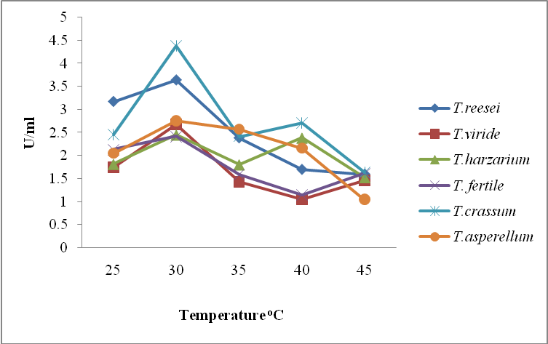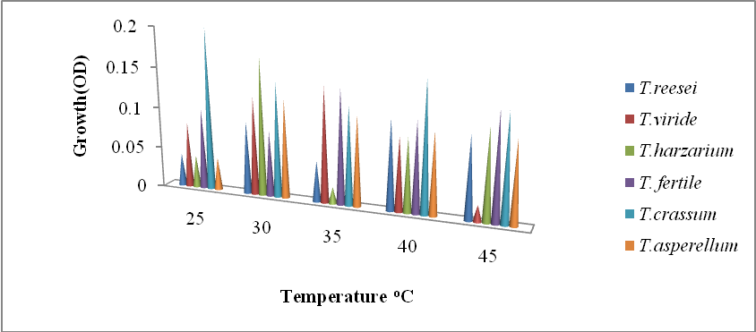
1a 1b
Figure 1a and 1b: Effect of temperature on β-galactosidase and growth of Trichoderma species

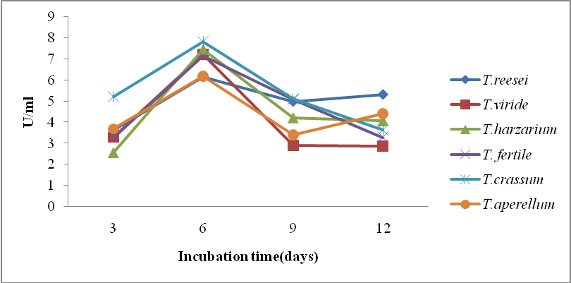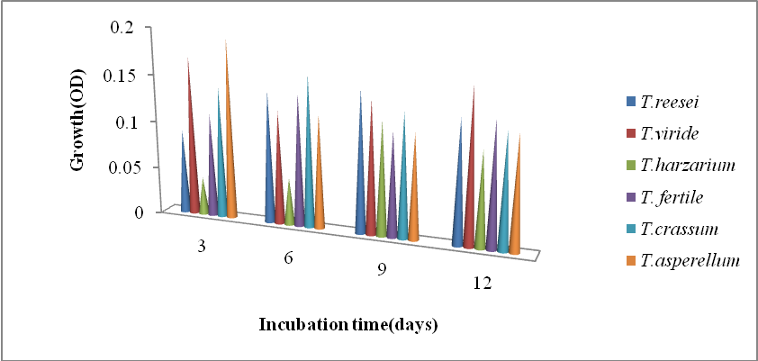
2a 2b
Figure 2a and 2b: Effect of incubation time on β-galactosidase and growth by Trichoderma species

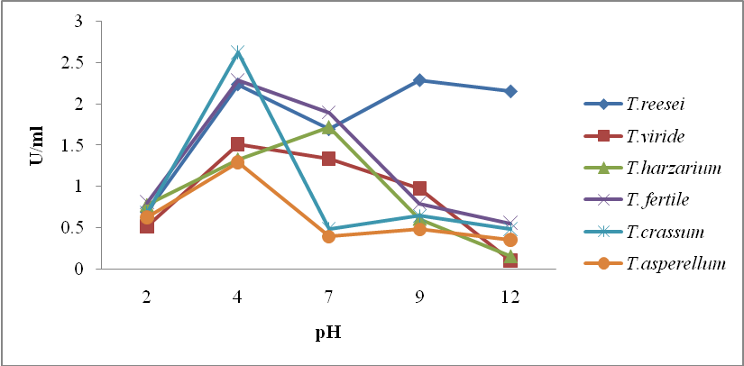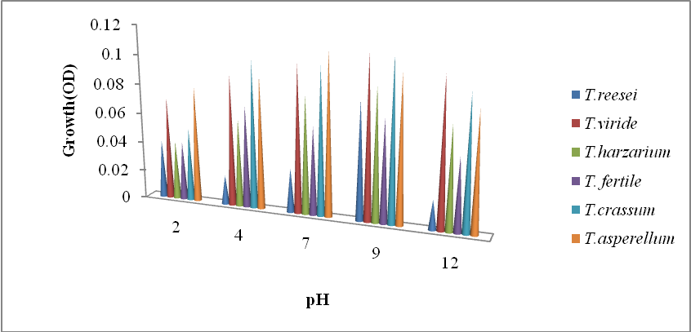
3a 3b
Figure 3a and 3b: Effect of pH on β-galactosidase and growth of Trichoderma species

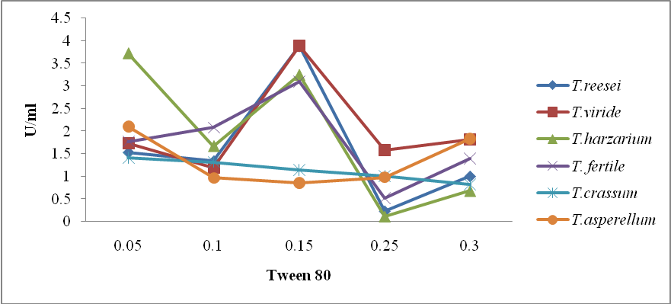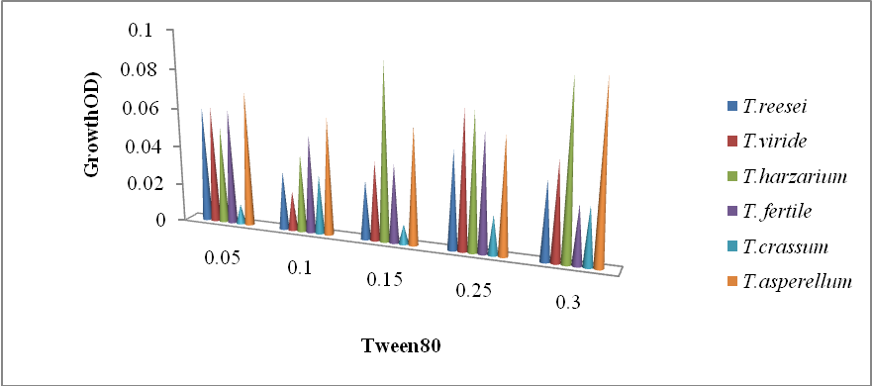
4a 4b
Figure 4a: Effect of Tween80 on β-galactosidase and growth of Trichoderma species.

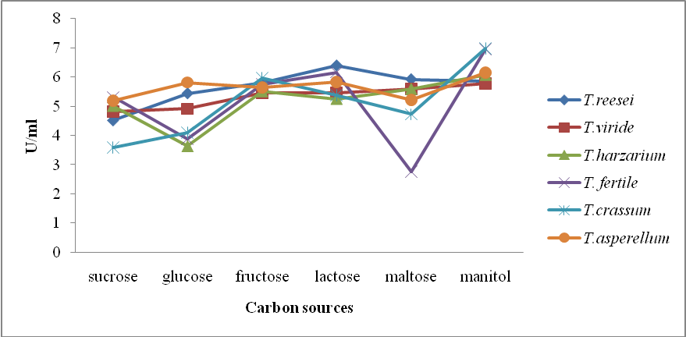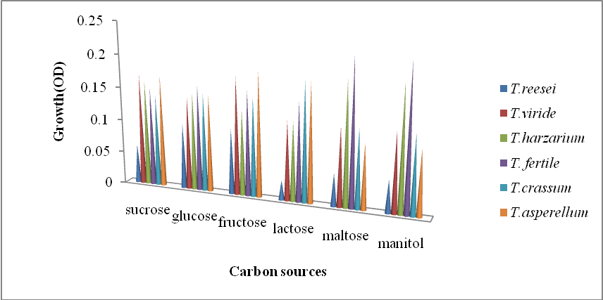
5a 5b
Figure 5a and 5b: Effect of carbon sources on β-galactosidase and growth of Trichoderma species

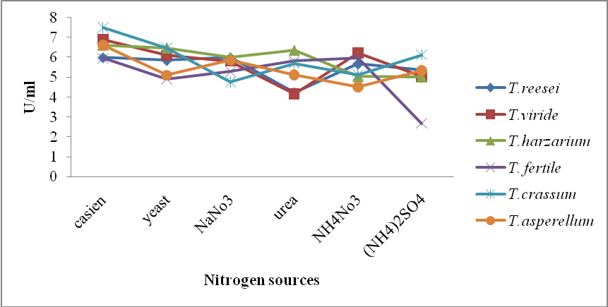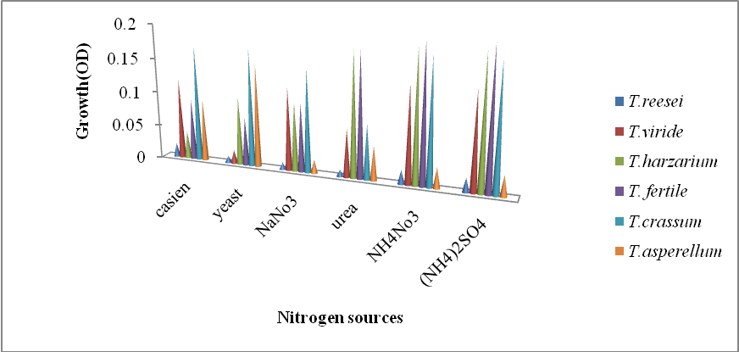
6a 6b
Figure 6a: Effect of Nitrogen sources on β-galactosidase and growth of Trichoderma species

- Discussion
The highest β-galactosidase production was recorded at 30ºC. As the temperature increased, there was a gradual increase in the production of the enzyme and growth from 25ºC - 40ºC but at 40ºC drastic reduction in production began with growth, it might be due to the fact that high temperature can change membrane composition and can cause the protein catabolism and inhibition of fungal growth.
The highest β-galactosidase production recorded at 6 days after incubation was an indication that the organisms are at their lag phase in which metabolic activities are very high but all the selected isolates grew best right from the 3rd day to 12th day. The highest yield of β-galactosidase at pH 4 in this study might be due to the organism’s requirement of acidic pH for enzyme production (Puntambekar, 1995). This report does not concur with the report of Saad (2004) who reported that maximum production is attained at pH 5.2. The growth of the selected Trichoderma isolates were optimal at pH 9 and this shows that conditions necessary for growth might not be good for enzyme production.
β-galactosidase production was increased when Tween80 was added to the fermentation medium but when the concentration was increased to 0.15%, a substantial increase in production was recorded. El-Halwary and Mostafa, (2001) which reported that supplement like Tween80 enhances enzymes activities by increasing availability of nutrients. The mechanism of enhancement by Tween80 at low concentration increases the permeability of the cell membrane allowing for more rapid secretion of the enzyme which in turn leads to greater enzyme synthesis which is in agreement with the work of Kishen et al. (1981).
The different carbon sources used supported the growth of all the isolates but it was only manitol that gave highest production of β-galactosidase and this result is not in agreement with the work of Dabhole and Joishy, (1998). Among the organic and inorganic nitrogen sources used in this study, casein gave a profound increase in β-galactosidase production.

Corresponding Author:
Akinola Gbemisola Elizabeth
Department of Microbiology
University of Ibadan
Ibadan, Nigeria
E-mail: gbemiakinola@yahoo.com

References
- Dabhole, MP, Joishy K.N. Beta-galactosidase from the Yeast Kluyveromyces lactis. Journal Scientist Industrial Research 1998; 57(4): 201-204.
- Harman GE. Myths and dogmas of biocontrol. Changes in perceptions derived from research on Trichoderma harzianum T22. Plant Diseases. 2000; 84: 377–393.
- Heyman MB. The Committee on Nutrition. Lactose intolerance in infants, children, and adolescents. Journal of Pediatrics. 2006; 118: 1297-1286.
- Howell CR. Mechanisms employed by Trichoderma species in the biological control of plant disease; the history and evolution of current concepts. Plant Diseases 2003; 87: 4-10.
- Karasova P, Spiwok V, Mala S, Kralova B, Russell NJ. Betagalactosidase activity in psychrophic microorganisms and their potential use in food industry. Journal of Food Science. 2002; 20: 43-47.
6 Mital BK., Shalleberger, RS, Steinkraus KH. β-galactosidase activity of lactobacilli. Applied Microbiology, 1973; 26: 783-788.
7 Puntambekar, US. Cellulase production by the edible mushroom Volvariella diplasia. World J. Microbiol. Biotechnol., 1995; 11:695.
8 Saad RR. Purification and some properties of β-galactosidase from Aspergillus Japonicus. Annals of Microbiology 2004; 54 (3): 299-306.
9 El-Hawary FI, Mostaka YS. Factors affecting cellulase production by Trichoderma konnigii. Acta Alimentaria 2001; 5:30-13.
10 Vasiljevic, T, Jelen, P. “Production of beta-galactosidase for lactose hydrolysis in milk and dairy products using thermophilic lactic acid bacteria.” Innovative Food Sci. & Emerg. Technol. 2001; Vol. 2, p. 75-85
11. Vasiljevic T, Jelen P. “Lactose hydrolysis in milk as affected by neutralizers used for the preparation of crude beta-galactosidase extracts from Lactobacillus bulgaricus11842” Innovative Food Science & Emerging Technologies 2002; Vol. 3, pp.175-184.
- Kishen tangnu, S, Harvey W, Blanch, Charles R, Wuke. Enhanced production of cellulase, Hemicellulase and β-glucosidase by Trichoderma reesei (RutC30). Biotechology and Bioengineering. 1981; 23: 1837-1849

8/21/2013

