Assessment of Spectral Angle Mapper and Binary Encoding in the Quantification of the Built Environment from Multi-Spectral Landsat Imagery

¹Christopher E. Ndehedehe & ²Eno E. James

¹Department of Geoinformatics & Surveying, Faculty of Environmental Studies, University of Uyo, Nigeria
²Department of Urban & Regional Planning, Faculty of Environmental Studies, University of Uyo, Nigeria
christopherndehedehe@gmail.com

Abstract: Classifying urban areas in remotely sensed imageries is challenging because of the heterogeneous nature of the urban landscape resulting in mixed pixels and classes with highly variable spectral ranges. This study is an assessment of Spectral Angle Mapper and Binary Encoding techniques in the classification and quantification of the built environment from multi-spectral Landsat Imagery. Here, we examine their performances in the extraction of built environment. Post-classification comparison is applied to this study to determine the total area classified as urban areas using digitsed vector derived from existing Orthophoto and the vectorised derived from classification results. The previously produced vector map sampled from a section of Uyo metropolis showed that, the total area of built up environment is 158.62 Hectares i.e. the building polygons only. The results in this study showed that Binary Encoding performed better than Spectral Angle Mapper in the quantification of built environment from multi spectral Landsat imagery using post classification approach. Quantified built up environment with Binary Encoding is 772.86 hectares while SAM is 950.66 hectares. The built environments extracted by the two proposed methods are the impervious surface which includes building polygons and roads. Both results are very good and reliable. The two algorithms are very efficient in the mapping of built environment but poor in vegetation mapping. The two models implemented in this study though unpopular in urban studies are very good classifiers.
[Christopher E. Ndehedehe & Eno E. James. Assessment of Spectral Angle Mapper and Binary Encoding in the Quantification of the Built Environment from Multi-Spectral Landsat Imagery. N Y Sci J 2013;6(9):107-111]. (ISSN: 1554-0200). http://www.sciencepub.net/newyork. 18

Key words: Spectral Angle Mapper, Binary Encoding, Remote Sensing, Built-up, Classification, Landsat imagery

- Introduction
Classifying urban areas in remotely sensed imageries is challenging because of the heterogeneous nature of the urban landscape resulting in mixed pixels and classes with highly variable spectral ranges (Wentz et al, 2010). Remotely sensed data provide abundant information for urban area analyses because of the extensive spatial and temporal coverage and the broad spectral range of the data. A lot of studies have used remotely sensed data in urban areas for numerous applications such as characterizing and monitoring urban sprawl at various spatial scales (Jat et al, 2008 and Wentz et al. 2006 in Wentz et al, 2010), mapping impervious surfaces (Weng and Lu 2008), calculating temperature of urban surfaces (Chen et al, 2005) and mapping of built up areas from Landsat-based satellite imagery (Ndehedehe et al, 2013). Satellite data can provide the capability for precisely mapping and monitoring urban sprawl. Impervious surface area (ISA) is relatively easily detected in multispectral Landsat imagery but requires the development of accurate and repeatable techniques that can be extended to a broad range of conditions and environments.
The classiﬁcation of optical urban remote-sensing data has become a challenging problem due to recent advances in remote sensing technology (Ndehedehe et al, 2013). For the purpose of classification and mapping of urban areas over large spatial scales remotely sensed data are generally used. This acts as a substitute for traditional classification methods, which necessitates expensive and time-intensive field surveys. The increasing spatiotemporal dimensions of remote sensing data and weaknesses of traditional classification algorithms is the reason for the divers research seeking an efficient classifier that will effectively extract information from remote sensing imageries. This study is an assessment of Spectral Angle Mapper and Binary Encoding techniques in the classification and quantification of the built environment from multi-spectral Landsat Imagery. Here, we examine their performances in the extraction of built environment. Post-classification comparison is applied to this study to determine the total area classified as urban areas using digitsed vector derived from existing Orthophoto and the vectorised derived from classification results. This approach identifies Impervious Surface Areas (ISA) e.g. buildings, roads, etc. as the basis for the signature extraction from the multispectral Landsat data
.
- Study Area
The study area is a Metropolis (Uyo Metropolis) that lies within latitudes 4⁰ 56¹ 30” N and 5⁰ 07¹ 40” N, and longitudes 7⁰ 49¹ 50” E and 8⁰ 01¹ E and situates at about 55 km inland from the coastal plain of South-Eastern Nigeria. The present area of Uyo Metropolis is about 312.6 Sq km with a population of about 3.9 million. The 1991 national population census puts Uyo population density of about 1,500 people 1 Sq km. Uyo LGA is originally a collection of villages, now almost seamlessly joined together to form the conurbation that it is today. A nucleated settlement pattern is exhibited in the area. Uyo Metropolis falls within the tropical zone with a dominant vegetation of green foliage of trees, shrubs and oil palm trees. The commonly grown crops by the people include cassava, yam, cocoyam, plantain, maize and vegetables, while livestock such as goats, sheep, pig, rabbit and poultry are also reared. The land holds promise of exciting people, splendid opportunities for leisure investment and wealth creation.

3.0 Materials and Method
The main focus of this study is the quantification of exact pixels representing built environment from multispectral Landsat- based imagery. An impervious surface map of the study area with very high accuracy was previously produced for this purpose. Sub-pixel estimation of Impervious Surface Areas (ISA) is done by first using the high resolution data (Orthophoto) to calculate the proportional impervious cover for the specified region of interest. Regions of Interest (ROIs) were also used to extract statistics and average spectra from groups of pixels. We created the ROIs of pixels and then we examined and extracted statistics of the selected ROIs. Post-classification comparison will be adopted to examine the performance of the two algorithms in the quantification of urban areas in Uyo metropolis. The class statistics of the two models will also be computed and compared. Figures 1 and 2 shows the extracted Orthophoto of the study area and digitised vector from Orthophoto respectively.

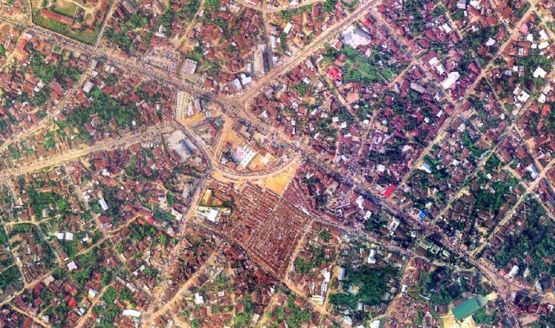
Figure 1. Extracted Orthophoto of the Study Area

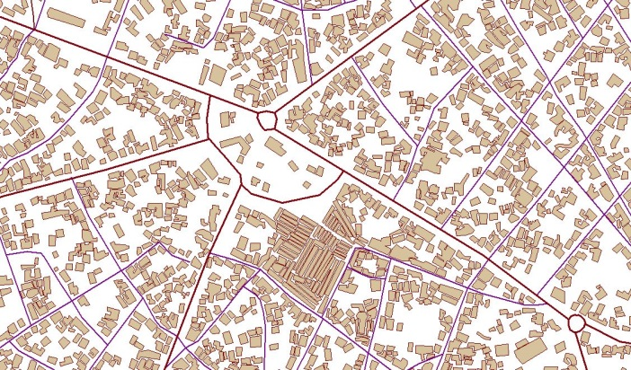
Figure 2. Extracted Digitised Vector from Orthophoto

4.0 Applications
The goal of classification is to extract as much information as possible from the image data with high reliability. It is a significant challenge to achieve these goals when high spectral resolution data is involved, particularly within practical processing time, and these are some of the issues upon which this study is based. One challenging task in satellite image processing is to find an effective technique to best discriminate ground information classes whose spectral signatures are similar (Zhao and Maclean 2000). Moreover, the selection of the appropriate classification technique to be employed can have a considerable upshot on the results of whether the classification is used as an ultimate product or as one of numerous analytical procedures applied for deriving information from an image for additional analyses (see Lu and Weng, 2007; Perumal and Bhaskaran, 2010). A lot of studies on urban modelling/ mapping can yield better results with an efficient classifier of the built environment from multi spectral and multi temporal satellite imageries. Previous studies have investigated other supervised methods in urban mapping (Ndehedehe et al, 2013) but the two models implemented in this study are unpopular in urban studies.

4.1 Binary Encoding
The Binary Encoding classification technique encodes the data and endmember spectra into zeros and ones, based on whether a band falls below or above the spectrum mean, respectively. An exclusive OR function compares each encoded reference spectrum with the encoded data spectra and produces a classification image (Mazer, et al, 1988). All pixels are classified to the endmember with the greatest number of bands that match, unless you specify a minimum match threshold, in which case some pixels may be unclassified if they do not meet the criteria. Standard binary encoding reduces the information of a pixel (often represented as 8 bit per channel) into one or two bits per channel only. In DU et al, 2005, the basic idea of Binary Encoding is stated thus; for each pixel, to compare its albedo on every band with a threshold and then assign a code“0”or“1”to it:
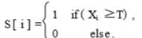
Here, S [ i ] is the code of the ith band, X_{i} is the attribute (albedo) of the original spectral vector , and T is a threshold. In general, the mean of spectral vector is selected as the threshold. Sometimes median or manual threshold can be used according to spectral curve. For this type of encoding , match by bit is used as a similarity measure , which can be programmed as: for( i = 0; i < N; i + + ) if (pnCode1[ i ] = = pnCode2[ i ]) nMatch + + ; fMatchRatio = (float) nMatch/(float) N;
where N is the amount of bands , pnCode1 [ ] and pnCode2 [ ] are encoding vectors of the two spectral vectors , nMatch is the amount of bands in which the two vectors have the same code , and fMatchRatio is the matching ratio of matched bands to total band number. This study has been implemented in some studies e.g hyperspectral remote sensing classification (DU et al, 2005) and mapping of built up areas from Landsat-based satellite imagery (Ndehedehe et al, 2013). Although this method is frequently used and offers good performance, yet the efficiency sometimes is low because it mainly operates on pixels besides it can still be improved.

4.2 Spectral Angle Mapper
Spectral Angle Mapper (SAM) is a physically-based spectral classification that uses an n-D angle to match pixels to reference spectra. The algorithm determines the spectral similarity between two spectra by calculating the angle between the spectra and treating them as vectors in a space with dimensionality equal to the number of bands (Kruse et al, 1993). This technique, when used on calibrated reflectance data, is relatively insensitive to illumination and albedo effects. SAM compares the angle between the endmember spectrum vector and each pixel vector in n-D space. Smaller angles represent closer matches to the reference spectrum. Pixels further away than the specified maximum angle threshold in radians are not classified. SAM is the widely used in RS image classification and information extraction technique. In DU et al, 2005 Spectral angle can be computed as:

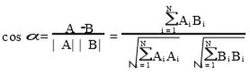

where N is the amount of bands ; A = ( A₁ , A₂ , ⋯, A_{N} ) and B = ( B₁ , B₂ , ⋯, B_{N} ) are two spectral vectors. α is a spectral angle. In general cos α is considered. Pixels belonging to the same class have small spectral angle, therefore the cosine is close to 1. On the other hand, spectral angles of different types of pixels are large so that cos α is close to 0. In addition, the Euclidean distance is used as a similarity measure of spectral vectors in many cases. A major difference between the spectral angle classifier and conventional classifiers (e.g. Isodata, minimum distance, maximum likelihood, Parallelpiped, neural nets, etc.) is that the spectral angle classifier rests on the spectral shape pattern, i.e., the "identity" of the spectral pattern, while conventional classifiers rest on the statistical distribution pattern (Sohn, and Rebello, 2002). A number of studies have been carried out using SAM technique. This include, urban land cover mapping (Petropoulos et al,2013) and ice area classification (Albert, 2011).The main advantages of the SAM algorithm are that it’s an easy and rapid method for mapping the spectral similarity of image spectra to reference spectra. It is also a very powerful classification method because it represses the influence of shading effects to accentuate the target reflectance characteristics (De Carvalho and Meneses, 2000). The main disadvantage of this method is the spectral mixture problem. The most erroneous assumption made with SAM is the supposition that endmembers chosen to classify the image represent the pure spectra of a reference material. This problem generally occurs with medium spatial resolution images, such as Landsat TM. The surface of the Earth is complex and heterogeneous in many ways, thus having mixed pixels is unavoidable. The spectral confusion in pixels can lead to underestimation and overestimation errors for a spectral class. In general, the spectral mixture problem should decrease with higher resolution images like world view 2 and Quick Bird. The spectral angle classifier can potentially be one of the most accurate classifiers and a valuable tool for land-cover mapping using remotely sensed multispectral data.

Results and Discussion
The extracted pixels from the regions of interest were examined and used for the classification of the imagery into five different classes. A total of 250,000 points representing five different land use classes were sampled for the study while the training samples used for the signature development for this study was a total of 145 randomly selected points (pixels). The post classification results of the built up pixels from the two models is indicated in Table 1. The previously produced vector map sampled from a section of Uyo metropolis showed that, the total area of built up environment is 158.62 Hectares. This area represents the building polygons only while the areas extracted by the two proposed methods are the impervious surface which includes building polygons and roads. The classification results of the two methods is shown in Figure 3.

Table 1. Extracted Built Environment from the Two Proposed Methods
Method | Quantified Built up Areas (Hectares) | Classified Built up Pixels | Percentage of Study Area (%)
Spectral Angle Mapper (SAM) | 950.66 | 11,704 | 4.682
Binary Encoding | 772.86 | 9,515 | 3.806

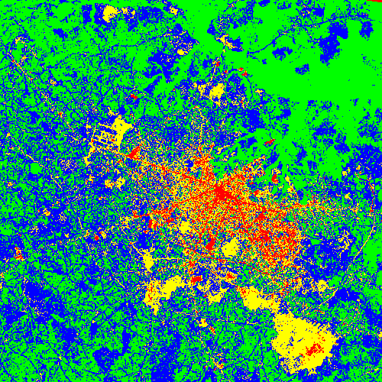

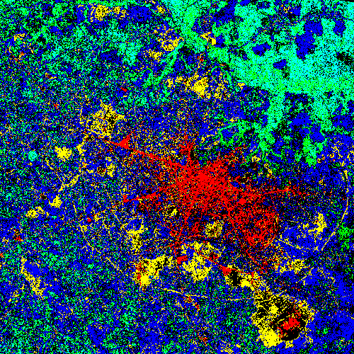
Binary Encoding Spectral Angle Mapper (SAM)
Built -up
Figure 3. Classification results of the two proposed methods

The results in this study showed that Binary Encoding performed better than Spectral Angle Mapper in the quantification of built environment from multi-spectral Landsat imagery using post classification approach. Quantified built up environment with Binary Encoding is 772.86 hectares while SAM is 950.66 hectares. Both results are very good and reliable. The two algorithms are very efficient in the mapping of built environment but poor in vegetation mapping. The two models implemented in this study though unpopular in urban studies yet very good classifiers.

Conclusion
The paper is an experiment to assess the performance of Binary Encoding and Spectral Angle Mapper in quantifying built environment from multi-spectral imagery. The two proposed methods were used in the classification and quantification of the built environment from multi-spectral Landsat Imagery. This study examined their performances in the extraction of built environment. The approach identifies Impervious Surface Areas (ISA) e.g. buildings, roads, etc as the basis for the signature extraction from the multispectral Landsat data. Post-classification comparison is applied to this study to determine the total area classified as built environment. The built environments extracted by the two proposed methods are the impervious surface which includes building polygons and roads. The two algorithms are very efficient in the mapping and quantification of built environment from Landsat imageries but poor in vegetation mapping. These models can be used extensively for urban studies.

Corresponding Author:
Christopher Ndehedehe
Department of Geoinformatics & Surveying
Faculty of Environmental Studies,
University of Uyo, Nigeria
christopherndehedehe@gmail.com

References
- Albert, Todd H. 2002: Evaluation of Remote Sensing Techniques for Ice-Area Classification Applied to the Tropical Quelccaya Ice Cap. Peru Polar Geography Volume 26, Issue 3, 2002
- Chen, X., Vierling, L. and Deering, D., 2005: A simple and effective radiometric correction method to improve landscape change detection across sensors and across time. Remote Sensing of Environment 98 pp. 63-79.
- De Carvalho, O.A. and Meneses, P.R. 2000: Spectral Correlation Mapper (SCM); An Improvement on the Spectral Angle Mapper (SAM). Summaries of the 9th JPL Airborne Earth Science Workshop, JPL Publication 00-18, 9 p.
- DU Pei-jun , FANG Tao,TANG Hong , SHI Peng-fei 2005:Encoding Methods of Spectral Vector in Hyperspectral Romote Sensing Image. J ournal of Shanghai University, Vol. 9 No. 1, pp 52-57. http://www.paper.edu.cn
- Jat, M. K., Garg, P. K., and Khare, D., 2008: Monitoring and modelling of urban sprawl using remote sensing and GIS techniques. International Journal of Applied Earth Observation and Geoinformation 10 pp. 26-43.
- Kruse, F. A., A. B. Lefkoff, J. B. Boardman, K. B. Heidebrecht, A. T. Shapiro, P. J. Barloon, and A. F. H. Goetz, 1993:The Spectral Image Processing System (SIPS) - Interactive Visualization and Analysis of Imaging spectrometer Data. Remote Sensing of the Environment, v. 44, p. 145 - 163.
- Lu, D. and Q. Weng 2007: A survey of image classification methods and techniques for improving classification performance, International Journal of Remote Sensing, Vol. 28, No. 5, pp. 823-870.
- Mazer, A. S., Martin, M., Lee, M., and Solomon, J. E., 1988: Image Processing Software for Imaging Spectrometry Analysis. Remote Sensing of the Environment, v. 24, no. 1, p. 201-210.
- Ndehedehe, Christopher E., Segun M. Oludiji & Inemesit M. Asuquo 2013: Supervised Learning Methods in the Mapping of Built Up Areas from Landsat-Based Satellite Imagery in Part of Uyo Metropolis. New York Science Journal 2013;6(9) 45-22:ISSN: 1554-0200. http://www.sciencepub.net/newyork 7
- Petropoulos, George P. , Krishna Prasad Vadrevu & Chariton Kalaitzidis 2013: Spectral angle mapper and object-based classification combined with hyperspectral remote sensing imagery for obtaining land use/cover mapping in a Mediterranean region. Geocarto International Volume 28, Issue 2, 2013
- Perumal, K and R Bhaskaran (2010): Supervised Classification Performance Of Multispectral Images. Journal Of Computing, Volume 2, Issue 2, February 2010, ISSN 2151-9617. https://sites.google.com/site/journalofcomputing
- Sohn, Youngsinn and N. Sanjay Rebello 2002: Supervised and Unsupervised Spectral Angle Classifiers. Photogrammetric Engineering & Remote Sensing,Vol. 68, No. 12, December 2002, pp. 1271-1280. Q 2002 American Society for Photogrammetry and Remote Sensing
- Weng, Q., Lu, D. and Schubring, J., 2004: Estimation of land surface temperature- vegetation abundance relationship for urban heat island studies, Journal of Environmental Management 70 pp. 145-156.
- Wentz, E.A. Song, Y. Anderson, S. Roy, S.S. Myint, S.W. Stefanov, W.L 2010: Discriminant Analysis with Spatial Weights for Urban Land Cover Classiﬁcation. Geodata centre for geospatial analysis and computation, Arizona state university,Working Paper Number 21.
- Wentz, E. A., Stefanov , W., Gries, l. And Hope, D., 2006: Land use and land cover mapping from diverse data sources for an arid urban environments. Computers Environment and Urban Systems 30.3 (2006): 320-346.
- Zhao, Guang and Ann L. Maclean 2000: A Comparison of Canonical Discriminant Analysis and Principal Component Analysis for Spectral Transformation. Photogrammetric Engineering & Remote Sensing Vol. 66, NO. 7, July 2000, pp. 841-847. 2000 American Society for Photogrammetry and Remote Sensing

7/28/2013

