Supervised Learning Methods in the Mapping of Built Up Areas from Landsat-Based Satellite Imagery in Part of Uyo Metropolis

¹Christopher E. Ndehedehe, ²Segun M. Oludiji, ³Inemesit M. Asuquo

^{1&3}Department of Geoinformatics & Surveying, Faculty of Environmental Studies, University of Uyo, Nigeria
² Federal School of Surveying Oyo, Oyo State, Nigeria. christopherndehedehe@gmail.com

Abstract: The classiﬁcation of optical urban remote-sensing data has become a challenging problem due to recent advances in remote sensing technology. For the purpose of classification and mapping of urban areas over large spatial scales remotely sensed data are generally used. This acts as a substitute for traditional classification methods, which necessitates expensive and time-intensive field surveys. This paper examines some supervised learning methods in the mapping of built up Areas from Landsat-based Satellite Imagery in part of Uyo Metropolis. Here, we compare the different classification methods and their performances in the extraction of built up areas. Post-classification comparison is applied to this study to determine the total area classified as urban areas using digitsed vector derived from existing Orthophoto and the vectorised derived from classification results. Our approach identifies Impervious Surface Areas (ISA) e.g. buildings, roads, etc. and adopt that as the basis for the signature extraction from Landsat data. From the vector map previously produced, the total area of built up areas in part of Uyo metropolis is 268.57 Hectares. This area represents the building polygons only while the areas extracted by the supervised methods include building polygons and roads. The performance of six supervised methods in urban region extraction was noted. Binary Encoding Classifier proved the best classifier for urban areas in this study with a total extracted ISA of 721.6 Hectares from Landsat-based satellite imagery. This figure comparatively is very good. Support Vector Machine actually proved to be faster in classification of built up areas and it can yield very accurate solutions with few training pixels. Parallelpiped classifier demonstrated a good classification speed of built up areas from the Landsat-based satellite imagery but with poor accuracy. Binary Encoding Classifier despite its low processing speed is an excellent model for urban studies and should be investigated further.
[Christopher E. Ndehedehe, Segun M. Oludiji, Inemesit M. Asuquo. Supervised Learning Methods in the Mapping of Built Up Areas from Landsat-Based Satellite Imagery in Part of Uyo Metropolis. N Y Sci J 2013;6(9):45-52]. (ISSN: 1554-0200). http://www.sciencepub.net/newyork. 7

Key Words: supervised methods, Landsat based imagery, classification, remote sensing, Impervious Surface Areas (ISA)

- Introduction
The ability to map and monitor the spatial extent of the built environment, and associated temporal changes, has important societal and economic relevance. For the purpose of classification and mapping of urban areas over large spatial scales remotely sensed data are generally used. This acts as a substitute for traditional classification methods, which necessitates expensive and time-intensive field surveys. Remote sensing offers imperative coverage and mapping of land-cover features and the principal application of remotely sensed data is to create a classification map of the identifiable or meaningful features or classes of land cover types in a scene (Perumal and Bhaskaran 2010; Jasinski, 1996). Aerial photograph interpretation has traditionally been used to map and monitor changes in urban areas. The spatial resolution of aerial photos can enable more precise change detection, although replicating these interpretations is difficult and can be inconsistent (Coppin et al. 2004 in Baker et al, 2007;). High temporal resolution, precise spectral band- widths, repetitive flight paths, and accurate georeferencing procedures are factors that contribute to the increasing use of satellite image data for change detection analysis (see e.g. Baker et al, 2007; Jensen, 1996; Coppin et al, 2004). Landsat-based classification procedures can provide equal or greater overall accuracies than other comparable space-borne sensors because of Landsat’s greater spectral resolution (e.g. Baker et al, 2007; Bolstad and Lillesand, 1992). Multi-temporal satellite data now provide the potential for mapping and monitoring urban land use change, but require the development of accurate and repeatable techniques that can be extended to a broad range of conditions and environments. A lot of research has been carried out to develop an accurate classifier for extraction of objects with varying success rates (Ali et al, 2010). Different methods can be used for the multispectral classification of images and these include: Algorithms based on parametric and nonparametric statistics that use ratio-and interval-scaled data and nonmetric methods that can also incorporate nominal scale data, supervised or unsupervised classification logic, Hard or soft (fuzzy) set classification logic to create hard or fuzzy thematic output products, Per-pixel or object-oriented classification logic, and Hybrid approaches (Duda et al, 2001). Most research has centred on supervised or unsupervised classification logic (see e.g. Ndehedehe et al, 2013; Yedla et al, 2010; Peddle et al, 1994 and Alsabti et al, 1997).
The increasing spatiotemporal dimensions of remote sensing data and weaknesses of traditional classification algorithms is the reason for the divers research seeking an efficient classifier that will effectively extract information from remote sensing imageries. This paper considers the effectiveness of some Supervised Learning Methods in the Mapping of Built up Areas from Landsat-based Satellite Imagery in Uyo Metropolis. Here, we compare the different classification methods and their performances in the extraction of built up areas. Post-classification comparison will be applied to this study to determine the total area classified as urban areas using digitsed vector derived from existing Orthophoto and the vectorised derived from classification results. Our approach identifies Impervious Surface Areas (ISA) e.g. buildings, roads, etc. and adopt that as the basis for the signature extraction from Landsat data.
2.0 Supervised Learning Methods
Supervised classification is a process of sorting pixels into a finite number of individual classes, or categories, of data based on their values extracted from training sites identified by an analyst. The Concept of supervised methods includes that of using samples with known identities (i.e., assigned pixels to information classes), to classify pixels with unknown identities. The quality of a supervised classification depends on the quality of the training sites (Palaniswami et al, 2006). Supervised image classification procedure includes; selecting training data, classifying the image and then accuracy assessment. Several methods of supervised image classification exist and this include; maximum likelihood, parallelepiped, binary encoding, minimum distance, support vector machine, neural network, mahalanobis distance etc. The training sites are done with digitized features. Usually two or three training sites are selected. The more the training sites, the better the classification results. The developments of the training sites are called spectral signatures. Finally the classification methods are applied based on statistical characterizations of the information created from the training sites.
3.0 Study Area
The study area is a Metropolis (Uyo Metropolis) that lies within latitudes 4⁰ 56¹ 30” N and 5⁰ 07¹ 40” N, and longitudes 7⁰ 49¹ 50” E and 8⁰ 01¹ E and situates at about 55 km inland from the coastal plain of South-Eastern Nigeria. The present area of Uyo Metropolis is about 312.6 Sq km with a population of about 3.9 million. The 1991 national population census puts Uyo population density of about 1,500 people 1 Sq km. Uyo LGA is originally a collection of villages, now almost seamlessly joined together to form the conurbation that it is today. A nucleated settlement pattern is exhibited in the area. Uyo Metropolis falls within the tropical zone with a dominant vegetation of green foliage of trees, shrubs and oil palm trees. The commonly grown crops by the people include cassava, yam, cocoyam, plantain, maize and vegetables, while livestock such as goats, sheep, pig, rabbit and poultry are also reared. The land holds promise of exciting people, splendid opportunities for leisure investment and wealth creation.
4.0 Materials and Method
In this study, our focus is the extraction and categorisation of pixels representing built up areas from multispectral Landsat- based imagery. An impervious surface map of the study area with very high accuracy was previously produced for this purpose. The resulting Orthophoto and ISA map is shown in figure 3.1a and b. Sub-pixel estimation of Impervious Surface Areas (ISA) is done by first using the high resolution data (Orthophoto) to calculate the proportional impervious cover for the region of interest. This data provide the basis for training site development applicable to the Landsat data for the urban characterization. Post-classification comparison will be adopted to examine the performance of the supervised learning methods in the mapping of urban areas in Uyo metropolis. The class statistics of the different supervised models will also be compared.
4.1 Data Source and Preparation
Acquired maps and images (Orthophoto, digitised vector, Landsat 7 ETM etc.) were sorted and classified for analysis and interpretation. Landsat 7 imagery (Path 188, Row 57) scenes of year 2001 (Projection: UTM, Zone 32 North Datum: WGS-84) and digitsed vector from an existing Orthophoto of the same year were employed in this study to produce urban vector map of 2001. In the present study, a processed geo-referenced Landsat based data was used as a base for image registration. Images were traced from Landsat 7 of year 2001. Band 2 (visible), Band 4, and Band 7 (infrared) were used to create a False Colour Composite (FCC). The choice of this FCC combination is because the combination provides a "natural-like" rendition, while also penetrating atmospheric particles and smoke. This combination brings out urban areas in varying shades of magenta. The RGB composite of band 742 was used for the supervised classification in ENVI 4.7 module. Figure 3.1a and b is an Orthophoto extraction and digitised vector of the study area.

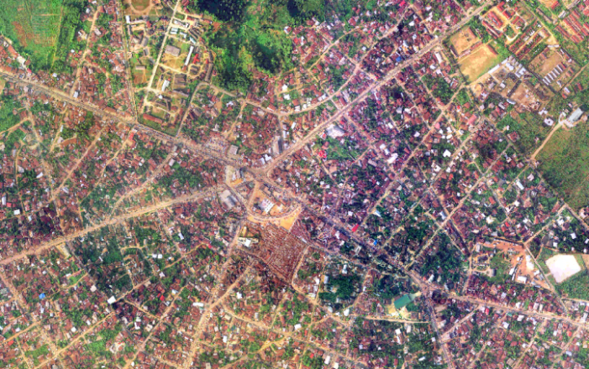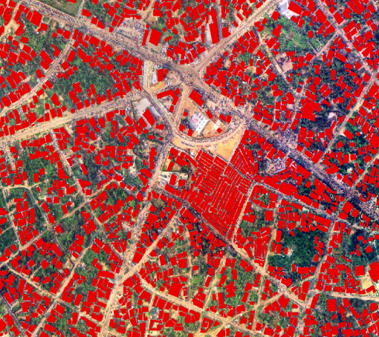
Figure 3.1a Extracted Orthophoto of the Study Area Figure 3.1b Extracted Digitised Vector from Orthophoto

5.0 Applications
The main aim of the study is to evaluate the effectiveness of some supervised learning methods in the classification and mapping of built up areas from Landsat-based satellite imagery in Uyo metropolis. The classification results of the different classifiers will be compared with a previously produced impervious surface map of the study area.
5.1 Maximum Likelihood
Maximum Likelihood (ML) is a supervised classification method derived from the Bayes theorem, which states that the a posteriori distribution P (i|ω), i.e., the probability that a pixel with feature vector ω belongs to class i, is given by:
P(i|ω)=P (i|ω)/ P(i) Eqn 1
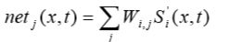
P(ω)
Eqn 4
Where P (ω|i) is the likelihood function, P (i) is the a priori information, i.e., the probability that class i occurs in the study area and P(ω) is the probability that ω is observed, which can be written as:
$P(ω)=\sum_{i=1}^{m}{P (i|ω)/ P(i) }$ Eqn 2
Where m is the number of classes. P (ω) is often treated as a normalisation constant to ensure $\sum_{i=1}^{m}{P \left(i | ω\right)}$sums to 1. Pixel x is assigned to class i by the rule: x∈i if P (i|ω) > P (j|ω) for all j≠I Eqn 3
See Ahmad and Quegan, 2012 for details. It is the most powerful classification methods when accurate training data is provided and one of the most widely used algorithm (Perumal and Bhaskaran 2010).
5.2 Artificial Neural Network (ANN) Classifier
This method has an ability to identify a relationship from given patterns and this makes it possible for ANNs to solve large-scale complex problems such as pattern recognition, nonlinear modelling, classification, association, and control (Gokmen, 2002). The advantages of neural networks over the traditional methods are the ability to handle large amounts of noisy data from dynamic and nonlinear systems, especially when the underlying physical relationships are not fully understood (Openshaw, and Openshaw, 1997). Neural nets offer the potential to classify data based upon a rapid match to overall patterns using previously calculated weighting factors, rather than point-by-point comparisons involving algorithmic logic applied to individual data values. Analytical tasks thus are greatly reduced (Foody et al, 1997).The ANN consists of three main components: the input layer, hidden layer, and the output layer. The hidden layer is the engine room of the neural network; it consists of n neurons (n = 1, 2, 3…). The output layer consists of just a single neuron (Almeida et al., 2008). Basically a signal from neuron i of the first input layer of a cell x, at time t received by a neuron j of the hidden layer can be expressed as;
Where S’_{i} (x, t) denotes the site attributes given by variable (neuron) i; W _{i,j} is the weight of the input from neuron i to neuron j; net _{j} (x,t) is the signal received for neuron j of cell x at time t (see Okwuashi et al, 2012).
Many classifiers are available for classification of multi-spectral satellite images. A major disadvantage of these classifiers is that they are not distribution free. This has prompted significant increase in use of ANN for classification of remotely sensed images (Mather, 1999). Several other reasons have been sighted in favour of Neural Network (NN) based classifiers which is listed below (see Ali et al, 2010 and Han et al, 2002).
- NN classifiers can detect and use to their advantage non-linearity in data patterns.
- Ancillary data can be included in NN classifiers.
- NN architectures are flexible which can be easily optimized for performance.
- NN can handle multiple subcategories per class.
5.3 Parallelepiped Classifier
This is a widely used decision rule based on simple Boolean “and/or” logic. Training data in n spectral bands are used in performing the classification. Brightness values from each pixel of the multispectral imagery are used to produce an n-dimensional mean vector, Mc = (µck , µc2 , µc3 , ... µcn ) with µck being the mean value of the training data obtained for class c in band k out of m possible classes, as previously defined. Sck is the standard deviation of the training data class c of band k out of m possible classes (Devi and Baboo, 2011). The parallelepiped algorithm is a computationally efficient method of classifying remote sensing data. This classifier uses the class limits stored in each class signature to determine if a given pixel falls within the class or not. The class limits specify the dimensions (in standard deviation units) of each side of a parallelepiped surrounding the mean of the class in feature space. If the pixel falls inside the parallelepiped, it is assigned to the class. However, if the pixel falls within more than one class, it is put in the overlap class. If the pixel does not fall inside any class, it is assigned to the null class. The parallelepiped classifier is typically used when speed is required. It is very simple and easy to understand schematically. The drawback is (in many cases) poor accuracy and a large number of pixels classified as ties or overlap (see e.g. Devi and Baboo, 2011 and Perumal and Bhaskaran 2010).
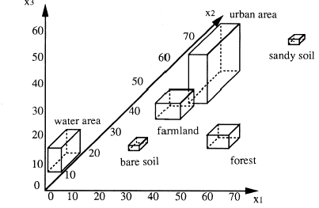
Figure 4.1 Schematic Concept of Parallelepiped Classifier in Three Dimensional Feature Space

5.4 Support Vector Machine
Support Vector Machines (SVMs) are modern learning systems that deliver state-of-the-art performance in real world pattern recognition and data mining applications such as text categorization, hand-written character recognition, image classiﬁcation and bioinformatics (Keerthi et al, 2006). A good introduction to SVM for pattern recognition may be found in Burges, C. J. C. 1998. Given a training set S ={ (x¹, y1),...,(x^{ε}, yε)}∈R^{n} ×{−1;1}, the decision ^{function} is found by solving the convex optimization problem:
Max_{a} g(a)=∑^{ε}_{i=1}αi - ½∑^{ε}_{i,j=1} α_{i}α_{j}y_{i}y_{j}k(x^{i},x^{j}) Eqn 5
Subject to 0≤α_{i} ≤C and ½∑^{ε}_{i=1} α_{i}y_{i}=0 where α are the Lagrange coeﬃcients, C a constant that is used to penalize the training errors, and k the kernel function. When the optimal solution of (Eqn5) is found, that is, αi, the classiﬁcation of a sample x is achieved by observing to which side of the hyperplane it belongs:
y =sgn(½∑^{ε}_{i,=1} α_{i}y_{i}k(x^{i},x)+b) Eqn 6
see Fauvel et al, 2009 for more details.
Support vector machine SVM is a classification system derived from statistical learning theory. It separates the classes with a decision surface that maximizes the margin between the classes. The surface is often called the optimal hyperplane, and the data points closest to the hyperplane are called support vectors. The support vectors are the critical elements of the training set. You can adapt SVM to become a nonlinear classifier through the use of nonlinear kernels. While SVM is a binary classifier in its simplest form, it can function as a multiclass classifier by combining several binary SVM classifiers (creating a binary classifier for each possible pair of classes). Different types of kernels provided in SVM classifier includes: linear, polynomial, radial basis function (RBF), and sigmoid. SVM classifier can achieve higher accuracies with less number of training pixels i.e. they yield very accurate solutions. One disadvantage of the SVM is that, its effective use depends on the values of a few user-defined parameters. Kernels like RBF and Sigmoid are very much dependent on user-defined parameters (Debojit et al, 2011). Secondly, SVMs, though accurate, are not preferred in applications requiring great classiﬁcation speed, due to the number of support vectors being large (Keerthi et al, 2006).
5.5 Minimum Distance
The minimum distance technique uses the mean vectors of each endmember and calculates the Euclidean distance from each unknown pixel to the mean vector for each class. All pixels are classified to the nearest class unless a standard deviation or distance threshold is specified, in which case some pixels may be unclassified if they do not meet the selected criteria (Richards, 1999). The following distances are used in this method:
Euclidean distance: Euclidean distance is used in cases where the variances of the population are different to each other. Euclidean distance is theoretically identical to the similarity index.
d_{k}²=(X -µ_{k})^{t}. (X -µ_{k})^{t} Eqn 7
Normalized Euclidean distance: The Normalized Euclidean distance is proportional to the similarity index. It is given as:
d_{k}²=(X -µ_{k})^{t}.δ_{k}-¹ (X -µ_{k})^{t} Eqn 8
Mahalanobis distance: In cases where there is correlation between the axis in feature space, the Mahalanobis distance with variance-covariance matrix should be used.
d_{k}²=(X -µ_{k}) ^{t}.∑_{k}-¹ (X -µ_{k})^{t} Eqn 9
^{Where:}
µk^{- mean of the kth class} X=[x₁, x₂……x_{N}]
X- vector of image data in bands µ_{k=}[ m₁, m₂……m_{n}]
δ_{k-variance matrix}
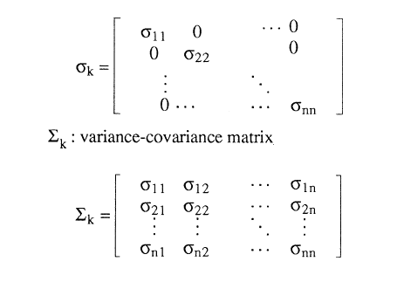
The minimum Mahalanobis distance classifier is optimum for normally distributed classes and equal covariance matrices and equal priors. The minimum Euclidean distance classifier is optimum for normally distributed classes and equal covariance matrices proportional to the identity matrix and equal priors. It is important to note that both Euclidean and Mahalanobis distance classifiers are linear. It is also important to realize that using a specific (Euclidean or Mahalanobis) minimum distance classifier implicitly corresponds to certain statistical assumptions. The question whether these assumptions hold or don’t can rarely be answered in practice.
5.6 Binary Encoding
The binary encoding classification technique encodes the data and endmember spectra into zeros and ones, based on whether a band falls below or above the spectrum mean, respectively. An exclusive OR function compares each encoded reference spectrum with the encoded data spectra and produces a classification image. All pixels are classified to the endmember with the greatest number of bands that match, unless you specify a minimum match threshold, in which case some pixels may be unclassified if they do not meet the criteria (Mazer et al, 1988). In DU et al, 2005, the basic idea of binary encoding is stated thus; for each pixel, to compare its albedo on every band with a threshold and then assign a code“0”or“1”to it:
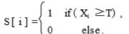
Here , S [ i ] is the code of the ith band, X_{i} is the attribute (albedo) of the original spectral vector , and T is a threshold. In general , the mean of spectral vector is selected as the threshold. Sometimes median or manual threshold can be used according to spectral curve. For this type of encoding , match by bit is used as a similarity measure , which can be programmed as: for( i = 0; i < N; i + + ) if (pnCode1[ i ] = = pnCode2[ i ]) nMatch + + ; fMatchRatio = (float) nMatch/(float) N;
where N is the amount of bands , pnCode1 [ ] and pnCode2 [ ] are encoding vectors of the two spectral vectors , nMatch is the amount of bands in which the two vectors have the same code , and fMatchRatio is the matching ratio of matched bands to total band number. Although this method is frequently used and offers good performance, yet the efficiency sometimes is low because it mainly operates on pixels
6.0 Experimental Results
The training samples used for the signature development for this study was a total of 145 randomly selected points (pixels). The same sampled pixels representing built up areas were used in all the supervised methods for the classification. Table 5.1 shows extracted built up areas from the different supervised methods while figure 5.1 is the classification results of the different supervised methods.

Table 5.1 Extracted Built Up Areas from the Supervised Methods
Supervised Learning Method | Total Area Classified as Built up (Hectares) | Classified Built up Pixels | Percentage of Study Area (%)
Minimum Distance | 1,846.0 | 25,102 | 10.041
Maximum Likelihood | 1,981.1 | 27,004 | 10.802
Parallelepiped | 2,715.5 | 41,388 | 16.555
Neural Network | 1,982.6 | 26,934 | 10.774
Support Vector Machine | 1,845.8 | 24,600 | 9.840
Binary Encoding | 721.6 | 9,472 | 3.789

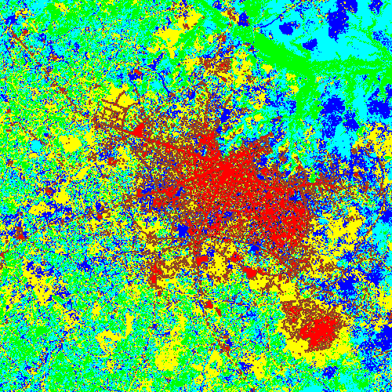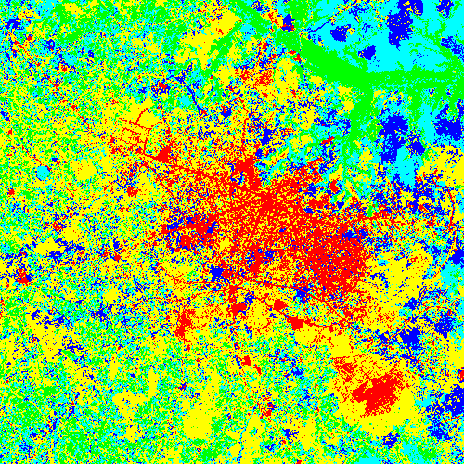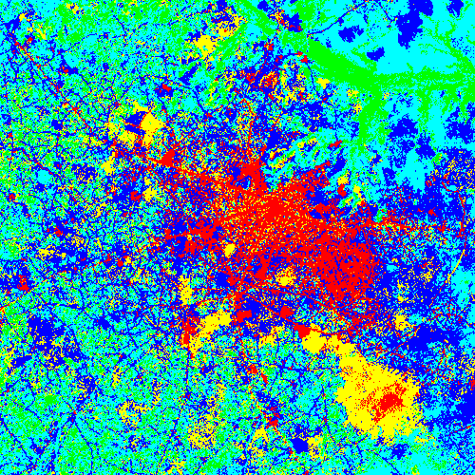
Support Vector Machine Maximum Likelihood Minimum Distance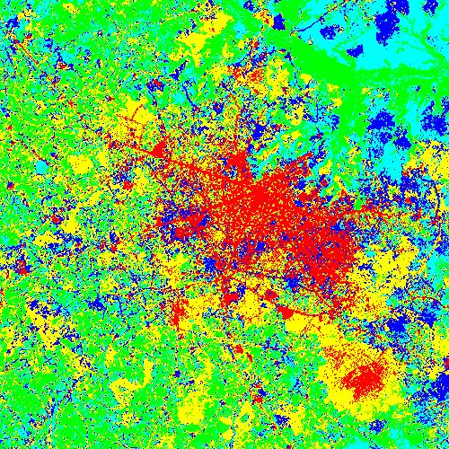 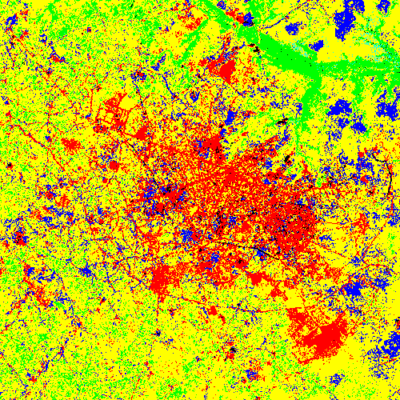 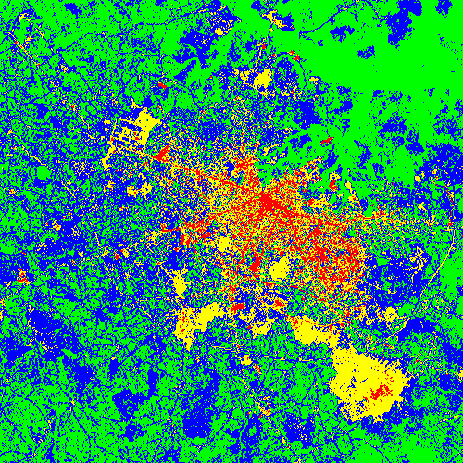
Neural Network Parallelpiped Binary Encoding
Built -up
Figure 5.1 Classification Results of the Six Supervised Methods

6.1 Discussion and Analysis
A total of 250,000 points representing five different land use classes were sampled for the study. The post classification results of the built up pixels from each model is indicated in Table 5.1. From the vector map previously produced, the total area of built up areas in Uyo metropolis is 268.57 Hectares. This area represents the building polygons only while the areas extracted by the supervised methods include building polygons and roads. The results in this study showed that Binary Encoding is the best classifier amongst the six supervised methods experimented for urban regions with a total extracted ISA of 721.6 Hectares from Landsat-based satellite imagery in part of Uyo metropolis followed by Support Vector Machine and Minimum distance classifier that extracted 1,845.8 and 1,846.0 Hectares respectively. Also in terms of processing speed, SVM was the fastest and it can perform better if the training pixels are few. Parallelpiped classifier demonstrated a good classification speed of built up areas from the Landsat-based satellite imagery but with poor accuracy. If the polygons representing roads from the classified Landsat imagery can be separated then the area of the exact built up polygons can be known. This can be achieved by direct vectorization of the classified imagery. Binary Encoding Classifier despite its low processing speed is an excellent model for urban studies and should be investigated further.
Conclusion
This paper considers the effectiveness of some Supervised Learning Methods in the Mapping of Built up Areas from Landsat-based Satellite Imagery in Uyo Metropolis. Post-classification comparison was adopted to examine the performance of the supervised learning methods in the mapping of urban areas in Uyo metropolis. The class statistics of the different supervised models were also compared. Binary Encoding is proved the best classifier for urban regions with a total extracted ISA of 721.6 Hectares from Landsat-based satellite imagery in part of Uyo metropolis followed by Support Vector Machine and Minimum distance classifier. Also in terms of processing speed, SVM was the fastest and it can perform better if the training pixels are few. Parallelpiped classifier demonstrated a good classification speed of built up areas from the Landsat-based satellite imagery but with poor accuracy. Binary Encoding Classifier despite its low processing speed is an excellent model for urban studies and should be investigated further.

Corresponding Author:
Christopher Ndehedehe
Department of Geoinformatics & Surveying
Faculty of Environmental Studies,
University of Uyo, Nigeria
christopherndehedehe@gmail.com

References
- Ahmad, Asmala and Shaun Quegan 2012: Analysis of Maximum Likelihood Classification on Multispectral Data. Applied Mathematical Sciences, Vol. 6, 2012, no. 129, 6425 - 6436
- Ali, Imdad Rizvi & B.Krishna Mohan 2010: Improving the Accuracy of Object Based Supervised Image Classification using Cloud Basis Function Neural Network for High Resolution Satellite Images. International Journal of Image Processing (IJIP), Volume (4): Issue (4), pg 342 353
- Almeida, C. M., Gleriani, J. M., Castejon, E. F., & Soares-Filho, B. S. 2008: Using neural networks and cellular automata for modelling intra-urban land-use dynamics. International Journal of Geographical Information Science, 22(9), 943-963. http://dx.doi.org/10.1080/13658810701731168
- Alsabti, K. S. Ranka, and V. Singh 1997: An Efﬁcient K-Means Clustering Algorithm. http://www.cise.uﬂ.edu/ranka/.
- Baker Corey, Rick L. Lawrence, Clifford Montagne, and Duncan Patten 2007: Change Detection of Wetland Ecosystems Using Landsat Imagery and Change Vector Analysis. WETLANDS, Vol. 27, No. 3, September 2007, pp. 610–619.
- Bolstad, P. V. and T. M. Lillesand 1992: Rule-based classification models: flexible integration of satellite imagery and thematic spatial data. Photogrammetric Engineering and Re- mote Sensing 58:965–71
- Burges, C. J. C. 1998: A tutorial on support vector machines for pattern recognition. Data Mining and Knowledge Discovery, vol. 2, no. 2, pp. 121–167.
- Coppin, P., I. Jonckheere, K. Nackaerts, B. Muys, and E. Lambin 2004: Digital change detection methods in ecosystem monitoring; a review. International Journal of Remote Sensing 25:1565–96.
- Debojit, Biswas Jain Hitesh, Arora Manoj K, Balasubramanian R 2011: Study and Implementation of a Non-Linear Support Vector Machine Classifier. International Journal of Earth Sciences and Engineering ISSN 0974-5904, Volume 04, No 06 SPL, October 2011, pp. 985-988
- Devi M.Renuka, S. Santhosh Baboo 2011: Land use and Land Cover Classification using RGB&L Based Supervised Classification Algorithm.International Journal of Computer Science & Engineering Technology (IJCSET). ISSN: 2229-3345 Vol. 2 No. 10 October 2011
- Duda, R. O., Hart, P. E., & Stork, D. G. 2001: Pattern Classification. New York: John Wiley & Sons
- Fauvel, Mathieu, Jocelyn Chanussot, and J´on Atli Benediktsson 2009: Kernel Principal Component Analysis for the Classiﬁcation of Hyperspectral Remote Sensing Data over Urban Areas. EURASIP Journal on Advances in Signal Processing Volume 2009, Article ID 783194, 14 pages doi:10.1155/2009/783194. Hindawi Publishing Corporation.
- Foody G.M, Mcculloch M. B., and Yates W.B. 1997: Classification of remotely sensed data by an artificial neural network: issues related to training data characteristics. Photogrammetric engineering and remote sensing ISSN 0099-1112
- Gokmen Tayfur 2002: Artificial neural networks for sheet sediment transport. Mythological Sciences-Journal-des Sciences Hydrologiques, 47(6) page 879-892.
- Han, J., S. Lee, K. Chi, K. Ryu, 2002: Comparison of Neuro-Fuzzy, Neural Network, and Maximum Likelihood Classifiers for Land Cover Classification using IKONOS Multispectral Data. In Proceedings of the IEEE International Geoscience and Remote Sensing Symposium, vol 6, pp. 3471-3473, Toronto, Canada,
- Jasinski, M. F., (1996): Estimation of Subpixel Vegetation Density Of Natural Regions Using Satellite Multispectral Imagery, IEEE Trans. Geosci. Remote Sensing, Vol. 34, pp. 804–813, 1996
- Keerthi, S. Sathiya, Olivier Chapelle, Dennis DeCoste 2006: Building Support Vector Machines with Reduced Classiﬁer Complexity. Journal of Machine Learning Research 7 (2006) 1493–1515
- Mather P. 1999: Computer Processing of Remotely Sensed Images, John Wiley & Sons, Inc. New York, NY, USA.
- Mazer, A. S., Martin, M., Lee, M., and Solomon, J. E., 1988: Image Processing Software for Imaging Spectrometry Analysis.Remote Sensing of the Environment, v. 24, no. 1, p. 201-210.
- Ndehedehe, Christopher, Akwaowo Ekpa, Ogunlade Simeon & Otobong Nse 2013: Understanding the Neural Network Technique for Classification of Remote Sensing Data Sets. New York Science Journal 2013;6(8):26-33, ISSN: 1554-0200. http://www.sciencepub.net/newyork. 5
- Okwuashi Onuwa, Mfon Isong, Etim Eyo, Aniekan Eyoh, Okey Nwanekezie, Dupe Nihinlola Olayinka, Daniel Okon Udoudo & Beulah Ofem 2012: GIS Cellular Automata Using Artificial Neural Network for Land Use Change Simulation of Lagos, Nigeria. Journal of Geography and Geology; Vol. 4, No. 2; 2012 ISSN 1916-9779 E-ISSN 1916-9787 Published by Canadian Center of Science and Education
- Openshaw, S. and C. Openshaw, 1997: Artificial Intelligence in Geography. Chichester. John Wiley & Sons Ltd.
- Palaniswami, C., A. K. Upadhyay and H. P. Maheswarappa 2006: Spectral mixture analysis for subpixel classification of coconut, Current Science, Vol. 91, No. 12, pp. 1706 -1711.
- Peddle, D.R. G.M. Foody, A. Zhang, S.E. Franklin, and E.F. Ledrew 1994: Multisource image classification II: an empirical comparison of evidential reasoning, linear discriminant analysis, and maximum likelihood algorithms for alpine land cover classification. Can. J. Remote Sensing 20: 397-408.
- Perumal, K and R Bhaskaran (2010): Supervised Classification Performance Of Multispectral Images. Journal Of Computing, Volume 2, Issue 2, February 2010, ISSN 2151-9617. https://sites.google.com/site/journalofcomputing
- Richards, A. 1999: Remote Sensing Digital Image Analysis, Springer-Verlag, Berlin, p. 240.
- Yedla Madhu, Srinivasa Rao Pathakota, T M Srinivasa 2010. Enhancing K-means Clustering Algorithm with Improved Initial Center. International Journal of Computer Science and Information Technologies, (IJCSIT) Vol. 1 (2), 2010, 121-12.

7/28/2013

