Investigation into Viability of Briquettes from different Agricultural Residues as Alternatives to Wood and Kerosene Fuels

Oladeji, J.T.

Department of Mechanical Engineering, Ladoke Akintola University of Technology, Ogbomoso, Nigeria researh222a@gmail.com

Abstract: The use of wood is increasing on daily basis especially in the less technologically developed countries of the world. Heavy reliance on wood for domestic cooking would lead to deforestation or desertification. The present work identified biomass briquettes as viable alternatives or supplements to wood and petroleum based fuels for domestic and industrial cottage applications in Nigeria. Two sets of briquettes (one from cassava starch and the second from glue) were produced from each of the four selected residues. Briquettes from each set from the four residues were used to boil a measured quantity of water and temperatures were taken at various time intervals with the aid of mercury-in-glass-thermometer, which was inserted through a hole drilled on the cover of the pot. A stop clock was used to time the boiling process and readings were taken every two minutes interval until the water boils. Results of briquettes produced with glue as binding agent were compared with those mixed with starch. Firewood and kerosene were also used to boil the same quantity of water. Results of boiling test showed that it took 28 minutes for rice husk binded with starch and glue to boil the water, while the sawdust briquettes binded with glue and starch raised the temperature of water to boiling point in 26 and 28 mins respectively. It took melon shell briquettes binded with glue and starch 22 and 24 mins respectively to boil the water, while the time used by cassava peel briquettes binded with glue and starch to boil the same quantity of water were 20 and 22 mins respectively. Using firewood, the water boiled in 18 mins, while kerosene boiled the same quantity of water in 14 mins. The results had shown that biomass briquettes are good substitutes for firewood and kerosene. Of all the four biomass briquettes examined, briquettes from cassava peel and melon shells appear more efficient.
[Oladeji, J.T. Investigation into Viability of Briquettes from different Agricultural Residues as Alternatives to Wood and Kerosene Fuels. N Y Sci J 2013;6(8):78-83]. (ISSN: 1554-0200). http://www.sciencepub.net/newyork. 13

Keywords: Agricultural residues, briquette, melon shell, rice husk, saw dust, wood, yam peel

1. Introduction
The use of wood is increasing on daily basis especially in the less technologically developed countries of the world (Aremu and Agarry, 2013). Heavy reliance on wood for domestic cooking would not solve the present energy crisis; rather it would lead to deforestation or desertification resulting in further scarcity of this resource (Salunkhe, et al., 2012). The use of kerosene and gas for cooking and domestic heating is very expensive and ordinary common in Nigeria cannot afford this. In Nigeria- a country that is so much endowed with many natural resources, there is problem of energy scarcity. More than 70% of the populace has no access to national grid and those who have access are experiencing low and epileptic supply coupled with high cost (Jekayinfa and Scholz, 2009;Oladeji, 2012a; Oladeji, 2013a).
Agricultural biomass residues have the potential for the sustainable production of bio-fuels and to offset greenhouse gas emissions (Campbell et al., 2002; Sokhansanj et al., 2006; Oladeji, 2013b). Straw from crop production and agricultural residues existing in the waste streams from commercial crop processing plants have little inherent value and have traditionally constituted a disposal problem (Osadolor, 2006). In fact, these residues represent an abundant, inexpensive and readily available source of renewable lignocellulosic biomass (Liu et al., 2005). Agriculture offers much potential for renewable energy sources in form of biomass. With advances in biotechnology and bioengineering, some resources, which could have been classified as waste, now form the basis for energy production (McKendry, 2002; Oladeji, 2011).
The large quantities of agricultural residues produced in Nigeria can play a significant role in meeting her energy demand (Jekayinfa and Scholz, 2009). However, the abundant quantities of agricultural wastes and forest residues are neither managed effectively, nor utilized efficiently in all developing countries (Jekayinfa and Scholz, 2009). The common practice is to burn these residues or they are left to decompose (El-Saeidy, 2004; Jekayinfa and Omisakin, 2005; Husan et al., 2002; Oladeji, 2012b). This burning itself contributes to atmospheric pollution, but more than that; the burning or decomposition is a waste of available energy (Oladeji and Ogunsola, 2010).
There are many advantages to be derived from the use of agricultural residues for biomass energy generation. Notable among these advantages are low emissions of green-house and acid gases, which are friendly both to human and ecology (Oladeji, 2012c) .However, there are many challenges with the use of agricultural residues in their original form. Some of these drawbacks are the variable quality of the residue, the cost of collection, and problems in transportation and storage (Sokhansanj et al., 2006).
One of the promising technologies by which these agricultural residues could be converted to energy is briquetting process (Lucas and Oladeji, 2011). Briquetting is the process of compaction of residues into a product of higher density than the original raw materials. It is also known as densification (Kaliyan and Morey, 2008; Oladeji, 2013b). Among the notable advantages of briquetting process are increment in bulk density of biomass residues, lowering moisture content and making briquettes of uniform size and shape for easy handling, transport and storage. It also helps in uniform burning when used as fuel.
All crops and agro-processing residues, woody biomass, saw dust from timber mills, dried leaves from orchards, shrubs and grasses along the road sides can be used for briquetting. Crop residues like rice and wheat straw, cotton stalks and many agro-processing residues can also be briquetted. However, the main problem lies in their collection, drying, handling and transport (El-Saeidy, 2004).
The aim of this present study was to evaluate the performance of briquettes produced from rice husk, sawdust, melon shell and cassava peels. This was done with a view of establishing them as viable alternative or supplement to fuel wood and kerosene.

2. Materials and Methods
The biomass residues utilized in this study were obtained from farm waste dumps. They were sun-dried until stable moisture contents were obtained. The four residues were individually chopped into small pieces using a hammer mill and 4.70 mm particle size representing coarse series was chosen for each residue. The procedure as highlighted in accordance with ASAE424.1 (2003) was followed to determine the chosen particle size.
A simple briquetting machine was fabricated to facilitate the process of conversion of the four residues into briquettes (Plate 1/Fig.1). Its design was based on hydraulic principle and it consists of four moulds where the briquettes were formed.
Rice husk, sawdust, melon shell and cassava peel residues were separately mixed with starch and compacted with the briquetting machine. Another set of the same materials were mixed with glue and also compacted. The two set of briquettes were removed from the mould and were sun-dried under atmospheric condition. Set of briquettes with starch as a binding agent for each type of residue was used to boil a known quantity of water and with the aid of mercury-in-glass-thermometer; temperatures were taken at various regular time intervals. A stop clock was used to record the process and readings were taken every two minutes interval until the water boils. The same procedure was repeated for briquettes produced with glue as a binder and a comparison was made between the two sets. Furthermore, kerosene and firewood were also used to boil the same quantity of water. This was done with a view to comparing those briquettes from the residues with wood fuel and kerosene which serve as controls.

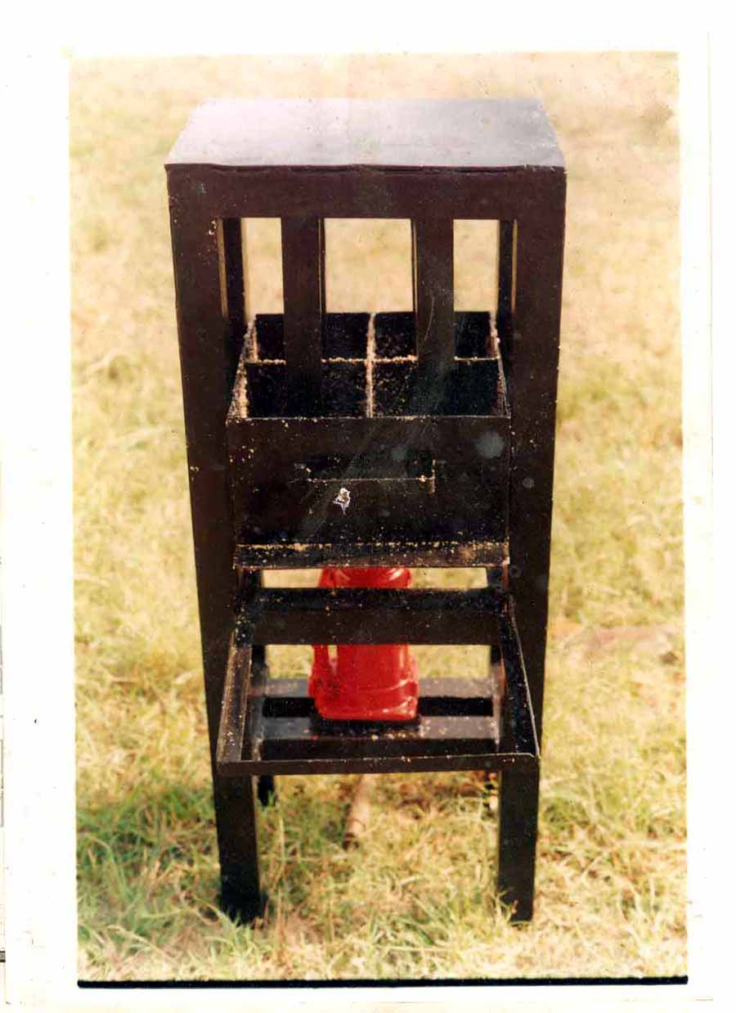
Plate 1. Pictorial View of Briquetting Machine
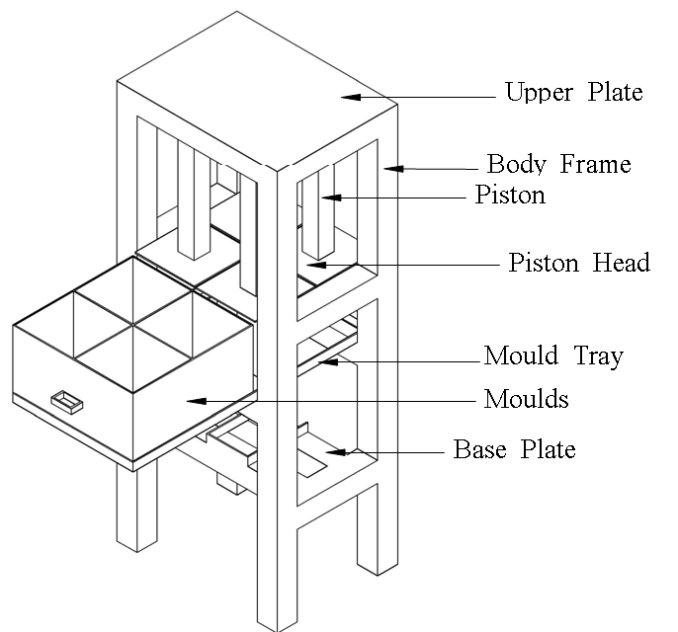
Figure 1. Isometric view of Briquetting Machine

3. Results and Discussion
Results of performance of different briquettes were presented in Table 1. The Table also shows the temperature attained when a measured quantity of water was boiled using the different briquettes mixed with starch and glue. The performance of four selected biomass residues binded with starch and those binded with glue are depicted in Figures 2 to 5. On the same figures, they were furthered compared with the performance of firewood and kerosene.
The results of boiling tests showed that it took 28 minutes for rice husk binded with starch and glue to boil the water, while the sawdust briquettes binded with glue and starch raised the temperature of water to boiling point in 26 and 28 mins respectively. It took melon shell briquettes binded with glue and starch 22 and 24 mins respectively to boil the water, while the time used by cassava peel briquettes binded with glue and starch to boil the same quantity of water were 20 and 22 mins respectively. Using firewood, the water boiled in 18 mins, while kerosene boiled the same quantity of water in 14 mins.
Briquettes with glue as a binder showed better performance than their starch counterparts. The implication of this is that the quality and energy amount of biomass briquettes depend on the type of original biomass residue and type of binders used among other variables (Adegoke and Ajueytsi, 2003; Musa, 2007).
From Table 1 and Figures 2 to 5, the briquettes produced showed good performance as cooking and heating fuels. Their performance was closed to firewood and kerosene, which makes them viable substitutes as well as good supplements to fire wood and kerosene. This confirms assertion by many researchers (El-Saeidy, 2004; Jekayinfa and Omisakin, 2005; Jekayinfa and Scholz, 2009; Wilaipon, 2008; Oladeji, 2012a) that a lot of energy abounds in biomass residues if converted to biomass fuel through various conversion routes such as briquetting, pyrolysis and anaerobic digestion among other methods. These results are also in agreement with the ones obtained by Osadolor (2006), where performance evaluation of briquettes produced from wood shaving and composite biomass were carried out.

Table 1. Results of boiling test (Temperature versus Time)
Time  (min) | Temperature (₀C)
 | Rice Husk |  | Sawdust |  | Melon shell |  | Cassava peel |  | Firewood | Kerosene
 | Starch | Glue | Starch | Glue | Starch | Glue | Starch | Glue
0.00 | 25.0 | 25.0 | 25.0 | 25.0 | 25.0 | 25.0 | 25.0 | 25.0 | 25.0 | 25.0
2.00 | 39.0 | 36.0 | 28.0 | 31.0 | 28.0 | 33.0 | 30.0 | 35.0 | 36.0 | 39.0
4.00 | 42.0 | 42.0 | 35.0 | 39.0 | 33.0 | 38.0 | 38.0 | 42.0 | 40.0 | 53.0
6.00 | 50.0 | 49.0 | 38.0 | 42.0 | 40.0 | 43.0 | 47.0 | 52.0 | 49.0 | 65.0
8.00 | 54.0 | 53.0 | 45.0 | 49.0 | 48.0 | 51.0 | 55.0 | 59.0 | 57.0 | 73.0
10.00 | 65.0 | 59.0 | 54.0 | 56.0 | 54.0 | 57.0 | 61.0 | 66.0 | 72.0 | 85.0
12.00 | 69.0 | 65.0 | 61.0 | 63.0 | 62.0 | 64.0 | 71.0 | 73.0 | 80.0 | 94.0
14.00 | 72.0 | 70.0 | 64.0 | 68.0 | 71.0 | 71.0 | 78.0 | 85.0 | 87.0 | 98.0
16.00 | 75.0 | 73.0 | 73.0 | 75.0 | 79.0 | 79.0 | 83.0 | 92.0 | 91.0
18.00 | 78.0 | 74.0 | 77.0 | 81.0 | 86.0 | 88.0 | 89.0 | 95.0 | 96.0
20.00 | 81.0 | 81.0 | 81.0 | 83.0 | 91.0 | 93.0 | 94.0 | 98.0
22.00 | 84.0 | 86.0 | 84.0 | 87.0 | 94.0 | 98.0 | 98.0
24.00 | 88.0 | 93.0 | 86.0 | 94.0 | 98.0
26.00 | 94.0 | 96.0 | 92.0 | 98.0
28.00 | 98.0 | 98.0 | 98.0

Figures 2 to 5 depict the performance of biomass binded with glue and those binded with starch. In each figure, comparison was done with firewood and kerosene and it could be seen that the biomass examined compared well with two fuels, which serve as controls.

Boiling Time (min)
Figure 2. Boiling test for Rice Husk with glue and starch compared with firewood and kerosene

Boiling Time (min)

Figure 3. Boiling test for sawdust with glue and starch compared with firewood and kerosene

Boiling Time (min)
Figure 4. Boiling test for melon shell with glue and starch compared with firewood and kerosene

Boiling Time (min)
Figure 5. Boiling test for cassava peel with glue and starch compared with firewood and kerosene

Conclusions
From the results and findings of this study, the following conclusions could be drawn:-
i. The briquettes produced from the four biomass residues in this work would make good biomass energy.
ii. The briquettes produced would make good substitutes as well as good supplements to firewood and kerosene.
iii. The briquettes produced with glue as a binder perform better than their cassava starch counterparts as the former took less time to reach the boiling stage.
iv. The quality and energy amount of biomass briquettes depend on the type of original biomass residue and type of binders used among other variables.

References
1. Aremu, MO, Agarry, SE. (2013) Enhanced Biogas Production from Poultry Droppings using Corn Cob and Waste Paper as Co-Substrates, International Journal of Engineering Science and Technology; 2013 Vol. 5 No. 2 pp 247-253
2. Salunkhe, DB, Rai, RK,. Borkar, RB. Biogas Technology, International Journal of Engineering Science and Technology; 2012 (4) No.12 pp 4934-4940
3. Jekayinfa, SO., Scholz, V. (2009) Potential Availability of Energetically Usable Crop Residues in Nigeria” Energy Sources, Part A; 2009 (31): 687-697
4. Oladeji, JT. Comparative Study of Briquetting of Few Selected Agro-Residues Commonly Found in Nigeria. Pacific Journal of Science and Technology; 2012 (13) No.2:80-86
5. Oladeji, JT. A Study of Effects of Different Particle Sizes on some Densification Characteristics of Corncob Briquettes, Epistemics in Science, Engineering and Technology; 2013a (3), No. 1, pp 267- 271
6. Campbell, CA, Zentner, RP, Gameda, S. Blomert, B, Wall, DD. Production of annual crops on the Canadian prairies: trends during 1976 – 1998. Canadian Journal of Soil Science; 2002 (82), pp. 45-57.
7. Sokhansanj, S Mani, S, Stumborg, M, Samson, R, Fenton, J. Production and Distribution of Cereal Straw on the Canadian pariries, Canadian Bio-systems Engineering; 2006 (48), pp. 339-346.
8. Oladeji, JT. Harnessing Energy from the Sun, Report and Opinion; 2013b (5) No.6:5-9. (ISSN: 1553-9873). http://www.sciencepub.net/report.
9. Osadolor, OO. (2006) Performance Evaluation of Different Briquettes produced from Wood and Agricultural Wastes, Journal of Engineering Science and Applications; 2006 (4) No.2, pp. 90-95
10. Liu, R, Yu, H, Huang, Y. Structure and morphology of cellulose in wheat straw, Cellulose; 2005 (12), pp. 25-34.
11. McKendry, P. Energy production from biomass (part 1): Overview of Biomass, Bioresource Technology; 2002 (83), pp. 37-46
12. Oladeji, JT. (2011) Investigations into the Effects of Different Binding Ratios on some Densification Characteristics of Corncob Briquettes, New York Science Journal; 2011 (4) 11:55-58 (ISSN: 1554-0200) http://www.sciencepub.net/newyork
13. El-Saeidy, EA. Technological Fundamentals of Briquetting Cotton Stalks as a Biofuel, An Unpublished Ph.D Thesis, Faculty Agriculture and Horticulture, Humboldt University, Germany, 2004
14. Jekayinfa, SO, Omisakin, OO. The energy potentials of some agricultural wastes as local fuel materials in Nigeria, Agricultural Engineering International, the CIGR E-Journal of Scientific Research and Development; 2005, Vol. III, Manuscript EE 05 003:10
15. Husan, Z, Zainac, Z, Abdullah, Z. Briquetting of palm fibre and shell from the processing of palm nuts to palm oil, Biomass and Bioenergy; 2002 (22) pp. 505 –509
16. Oladeji, JT. (2012b) Utilization of Potential of Melon Shells for Pyrolysis as Biomass Fuels. World Rural Observation; 2012b (4)2:60-64 ISSN: 1944-6543 (Print); ISSN: 1944-6551 (Online). http://www.sciencepub.net/rural.
17. Oladeji, JT, Ogunsola, AD. Pyrolysis of Sawdust into Medium-Grade Fuels and Chemical Preservatives,. Proceedings of 2nd Engineering Conference of the School of Engineering; Federal Polytechnic, Offa, 2010, July 13-15, pp. 64-67
18. Oladeji, JT. Utilization of Potential of Melon Shells for Pyrolysis as Biomass Fuels, World Rural Observation; 2012c (4) 2:60-64
19. Lucas, EB, Oladeji, JT. (2011) Predictive Models for some Densification Characteristics of Corncob Briquettes, Report and Opinion; 2011 (3)10:4-9 (ISSN: 1553-9873). http://www.sciencepub.net/report
20. Kaliyan, N, Morey, RV. (2009) Factors affecting strength and durability of densified biomass products, Biomass and Bioenergy; 2009 (33), 337-359
21. ASAE S 424.1 Method of determining and expressing particles size of chopped forage materials by screening, 2003 (606-608), St. Joseph, Michigan
22. Adegoke, CO, Ajueyitsi, NA. (2003) Optimum Preparation of Starch Binders and Paper Waste Additives in the Formation of Coal Briquettes for Domestic Cooking, Nigerian Journal of Mechanical Engineering; 2003 (1) pp. 62-68
23. Musa, NA. Development and Performance Evaluation of Biomass Briquette making Machine, Journal of Science and Technology Research; 2007 (6) No. 5 pp.72-76
24. Wilaipon, P. (2008) The Effect of Briquetting Pressure on Banana-Peel Briquette and the Banana Waste in Northern Thailand, American Journal of Applied Sciences; 2008 (6), No.1: 167-171.

6/28/2013

