**Dielectric Properties of Pb(Mn0.5W20.5)O3 Ceramics with Guard Ring Electrode**

1Thaung Thandar Soe, 2Than Than Win, 3Yin Maung Maung, 4Ko Ko Kyaw Soe

1Department of Physics, Dagon University, Myanmar, 2Department of Physics, University of Yangon, Myanmar,

3Department of Physics, Kyaingtong University, Myanmar, 4Pro-Rector, Yangon Institute of Education, Myanmar

1[thaungthandarsoe@gmail.com](mailto:thaungthandarsoe@gmail.com), 2[thannthannwinn@gmail.com](mailto:thannthannwinn@gmail.com), 3[dryinmgmg@gmail.com](mailto:dryinmgmg@gmail.com), [4dr.kokokyawsoe@gmail.com](mailto:4dr.kokokyawsoe@gmail.com)

**Abstract:** Polycrystalline lead-manganese tungstate ceramics with the formula Pb(Mn0.5 W0.5)O3, (PMW), a ferroelectric oxide was prepared by high temperature solid state reaction method. Crystal structure and microstructure of the compound were studied by the X-ray diffraction (XRD) technique and scanning electron microscopy (SEM). In order to reduce the measurement error caused by edge capacitance, laboratory-made three-terminal guard ring electrode (including a guard terminal) was constructed. Guard ring electrode was generally applied to electrode system of the material for the measurements of insulation resistance and dielectric constant. The capacitance (C), dielectric constant (εr) and loss tangent (tan δ) of PMW ceramics were scanned with respect to frequency in the rang of 1 kHz – 100 kHz by using guard-ring electrode. The PMW ceramics (300 °C) exhibited the smallest value of capacitance gap (the smallest error = 3.26 %) at 1 kHz while the maximum degree of capacitance gap was caused at PMW ceramics at 400 °C at 50 kHz.

[Soe T T, Win T T, Maung Y M, Soe K K K. **Dielectric Properties of Pb(Mn0.5W0.5)O3 Ceramics with Guard Ring Electrode.** *N Y Sci J* 2013;6(8):67-70]. (ISSN: 1554-0200). <http://www.sciencepub.net/newyork>. 11

**Keywords:** Guard ring electrode; SEM; XRD; dielectric constant; loss tangent

1. **Introduction**

Ferroelectric materials have a wide range of applications in nonvolatile memory devices, sensor and actuators due to their properties such as remnant polarization and piezoelectricity (D H Do, 2006). The major use of ferroelectric materials continues to be in piezoelectric devices. Furthermore virtually all piezoelectric applications, with the exception of the very large business in quartz filters and oscillators, involve ferroelectric materials, mostly in ceramic form (D. Berlincourt, 1976).

The applications for ferroelectric ceramics are manifold and pervasive, covering all areas of our workplaces, homes, and automobiles (G H. Haertling, 1999). Ferroelectrics of the perovskite family having the general formula ABO3 have been the subject of extensive research both because of their technological importance and because of the fundamental interesting in the physics of their phase transition (K. Sinha, S.N. Choudhary. and R.N.P Choudhary, 2004).

A few perovskite compound exhibits simultaneous electric and magnetic ordering. In order to satisfy the necessary condition for the existence of magnetic and electric ordering simultaneously, ferroelectrically active as well as magnetic ions need to be introduced into octahedral position. Therefore, in the present case, Mn+2 and W+6 ions were introduced in B site while Pb+2 ions in A site (L. Mathe, K.K. Patankar, S.D. Lotke, P.B. Joshi and S.A. Patil, 2002).

In this paper we report structural, microstructural and dielectric properties of PMW ceramics. The magnitude of the dielectric properties of a material is a measure of the ability of a material to polarize in an electric field. Most polarization mechanisms are time dependant, so their dielectric properties are often frequency dependant (D.D. Hass, H.N.G. Wadley, 2011). In 1993, K Prasad, et al got that the minimum values of εr and tan δ of (Pb1-xCax)(Mn0.05W0.05Ti0.9)O3 ceramics at 1kHz are 224.16 and 5.88×10-2 respectively by using LCR Hi-Tester(HIOKI 3530-Japan) and also with GR 1620 AP capacitance measurement assembly(USA) (K Prasad, R Sati, R.N.P Choudhary and T P Sinha, 1993).

1. **Material and Methods**

Polycrystalline, Pb(Mn0.5W0.5)O3 was prepared by high temperature solid state reaction technique using oxides (PbO, MnO2 and WO3 ). Firstly, these oxide powders were weighed in desire molar proportion using digital balance. The three oxide powders were thoroughly mixed in agate mortar for 2 h to get homogeneous mixture. Secondly, the mixture was preheated at 1000˚C for 6 h followed by grinding. After that, the mixture powder was grinded with ball milling at constant speed for 10 h to get homogeneous mixture. Then, this sample was dispersed by the air-jet milling with constant pressure of 40 lb/in2 to ensure good dispersion. The mixture PMW powders were mesh sieved to reduce the particle size and to get spherical shape uniformly particle.

XRD investigation was carried out to examine the structural properties of PMW powder. Thermal analysis of PMW powder was also carried out to investigate thermal decomposition and crystallization. Then, microstructural properties of PMW powder were characterized by Scanning Electron Microscopy (SEM). And then, a two-state of heating treatment was carried out as follows. Each powder was annealed in electric furnace at 300°C and 400°C during 1 h each. The calcined fine powder was cold pressed into cylindrical pellets of size 1.4 cm diameter and 0.3 cm thickness using a hydraulic press with a pressure of 5 tons. Saturated solution of polyvinyl alcohol (PVA) was used as a binder for pellets. These pellets were sintered at 600°C for 1 h. The binder was burnt out during the sintering of the sample. The flat surfaces of pellets were electroded with air-drying silver paste and dried at 200°C for 2 h before taking any electrical measurement.

The dielectric constant (εٰr) and loss tangent (tan δ) of the compound were obtained as a function of frequency (1 kHz to 100 kHz) using Quad Tech 1730 LCR meter and laboratory-made three-terminal guard ring electrodes which compensated for any stray capacitance. The flowchart of preparation for PMW powder and ceramic was shown in Figure 1.

Mesh sieving

Pellet

Mixed powder

1000°C, 6h

Crystalline powder

Ball milling

Small particle size powder

Uniform particle size powder

Annealing temperature

Crystalline powder

Figure 1. The flowchart of preparation for PMW powder and ceramics.

1. **Guard Ring Electrode**

Guard ring electrodes are useful devices which enable accurate dielectric measurements to be made on small sample of insulting material. A three-terminal arrangement was used to prevent erroneous results caused by fringing effects. The edge capacitance causes a measurement error, since the current flows through the dielectric material and edge capacitor as shown in Figure 2(a).

A solution to the measurement error caused by edge capacitance is to use the guard ring electrode as shown in Figure 2(b). The guard ring electrode absorbs the electric field at the edge and the capacitance that is measured between the electrodes is only composed of the current that flows through the dielectric material.

Therefore accurate dielectric measurements are possible. When the main electrode is used with a guard ring electrode, the main electrode is called the guarded electrode. The guarded electrode can reduce fringe effects because the sample size can be equal to or larger than the guard ring and can be any shape. The another purpose of the guard ring electrode is to minimize errors due to surface conduction while volume resistivity measurements are being made and those due to volume conduction during measurements of surface resistivity.

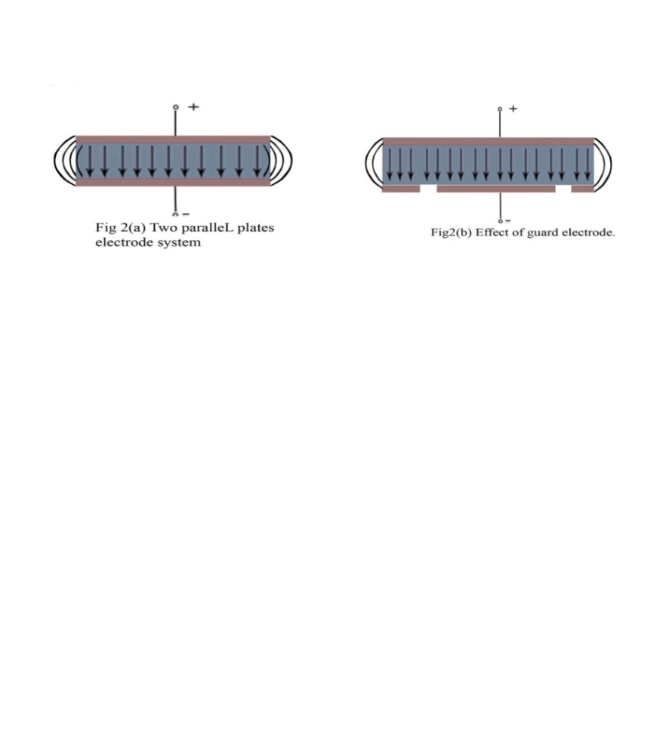

Figure 2(a). Two parallel plate electrode system.

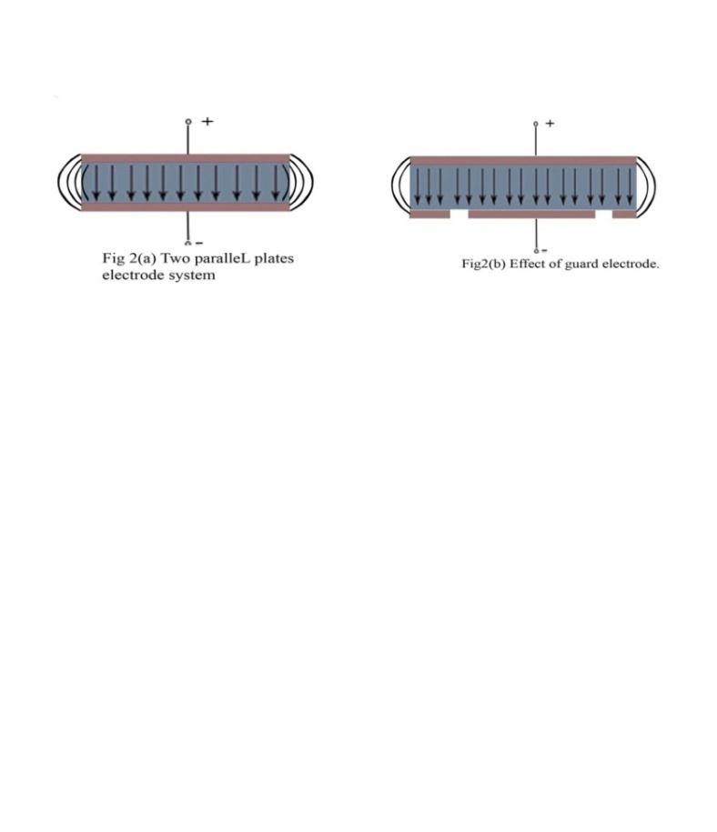

Figure 2(b). Effect of guard electrode

**4. Results**

X-ray diffraction pattern (XRD) of fine calcined powder were taken with a Phillips X-ray powder diffractometer using monochromatic Cu-Kα radiation ( λ = 1.54056 °A) in a wide range of Bragg angles, 2θ (10˚ ≤ 2θ ≤ 70˚) with a scanning rate of one degree per minute. According to the Figure 3, ten diffracted parts corresponding to (112), (004), (211), (200), (204), (220), (116), (132), (224) and (400) planes were produced. The lattice parameters of unit cell were refined using a least-squares method and were found to be: a = 7.9836 °A, b = 4.9698 °A and c = 11.9286 °A. From XRD measurement, it was obtained that the structure of PMW powder was orthorhombic structure. This fact revealed that the polycrystalline nature of fabricated powder.

Figure 4 showed DTA-TGA analysis of PMW powder. Decomposition/dehydration process was observed at the DTA endothermic peak of 266.4˚C. It was consistent with weight loss step between 250˚C and 330˚C. DTA exothermic peak at 330.2˚C, oxidation process was formed due to a little increased of TGA curve. But at 428.2˚C, the weight loss was completed and exothermic peak was may be associated with PMW crystalline process.

Figure 5 showed the SEM images of PMW ceramic. As the detail analysis of SEM image, it was found that the image was not remarkably different. Agglomerations of grain were formed on SEM image. The surface of SEM image was flat, dense and crack-free. Ice-cracks like morphology were found and the particles on the SEM surface were oriented toward right. The average grain size of compound is (0.38 ~ 075) µm.

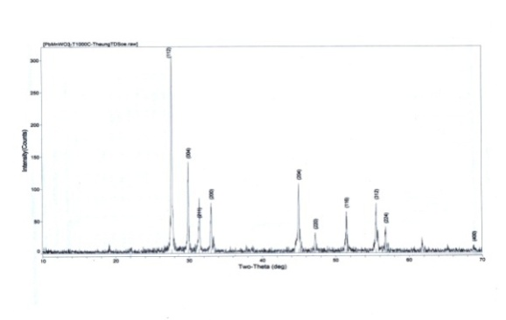

Figure 3. XRD pattern of PMW powder



Figure 4. DTA-TGA analysis of PMW Powder

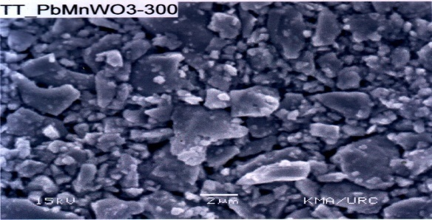Figure 5. SEM image of PbMnWO3 compound

The PMW ceramic capacitor was obtained and examined its charge storage capacity. The dielectric constant and loss tangent are important practical parameter of ferroelectric materials so we need to get the accurate value of the capacitance of the material. To get the accurate value of the capacitance we should try to reduce the measurement error.

Therefore we measured the capacitance of the material by using guard-ring electrode instead of parallel plate electrode. The change in capacitance as a function of applied frequency for PMW ceramics at different annealing temperatures was shown in Table (1~2). From the table, it was found that the capacitance value was decreased with increasing the frequency.

Table 1. The value of capacitance for PMW ceramics at 300 °C

|  |  |  |  |
| --- | --- | --- | --- |
| F  (kHz) | C(pF)  with parallel plate electrode | C(pF)  with guard-ring electrode | Error  (%) |
| 1 | 4.361 | 4.233 | 3.26 |
| 10 | 4.220 | 4.058 | 3.99 |
| 20 | 4.163 | 3.992 | 4.28 |
| 50 | 4.070 | 3.892 | 4.57 |
| 100 | 4.022 | 3.845 | 4.60 |

Table 2. The value of capacitance for PMW ceramics at 400 °C

|  |  |  |  |
| --- | --- | --- | --- |
| F  (kHz) | C(pF)  With parallel plate electrode | C(pF)  With guard ring electrode | Error  (%) |
| 1 | 5.130 | 4.751 | 7.97 |
| 10 | 4.860 | 4.538 | 7.09 |
| 20 | 4.780 | 4.437 | 7.73 |
| 50 | 4.701 | 4.278 | 9.88 |
| 100 | 4.605 | 4.192 | 9.85 |

Figure 6(a~b) showed the frequency dependence of r and tan  of PMW at 300 °C and 400°C. A decrease in dielectric constant was observed with increasing frequency because the compound exhibited different types of polarizations at lower frequencies (i.e., interfacial, dipolar, atomic, ionic, electronic, etc.). The tan  increased with increase in frequency and became maximum at 50 kHz, because the active component of the current increased more rapidly than its reactive component. At higher frequency (> 50 kHz) tan  decreased with increasing frequency, because the active component of the current was practically independent of the frequency and the reactive component increased proportionally to the frequency. This type of variation was observed in some of the ferroelectric ceramics (R Palai and S Sharma, 2000).

**5.** **Discussions**

Fabrication and microstructural of Pb(Mn0.5W0.5)O3 ceramic were successfully implemented. The sample was homogeneous single phase perovskite type with orthorhombic structure at room temperature. According to DTA-TGA analysis, the crystalline behavior was expected to start at 428.2˚C. Ice-crack like morphology was observed on SEM images and agglomerations of grain were uniformly distributed. In order to eliminate the measurement error caused by edge capacitance, a three-terminal configuration (including a guard terminal) is employed. The guard electrode encompasses the guarded (or main) electrode and absorbs the electric field at the edge of the electrodes, making accurate dielectric measurement possible. The nature of the variation of εr-f and tan δ-f spectra showed the behavior of a dielectric for ceramics as expected. From the result obtained, it was a chance to get the ferroelectricity of PMW polycrystalline at the frequency corresponding to the highest dielectric constant. It satisfied the special requirements for development of memory device of low cost and Eco-friendly.





Figure 6(a-b). Frequency dependence of dielectric constant (εr) and loss tangent (tanδ) of PMW ceramics at 300°C and 400°C

**Acknowledgments:**

This research was fully supported by Department of Physics, Yangon University, Myanmar (2012-2013).

**Corresponding Author:**

Dr Yin Maung Maung

Department of Physics,

Kyaingtong University

E-mail: [dryinmgmg@gmail.com](mailto:dryinmgmg@gmail.com)

**Authors’ Information**

**[1]** Name: Thaung Thandar Soe (Demonstrator)

Dangon University, Myanmar

Office Address: Department of Physics, Dangon University, Myanmar

Phone: +51-09448052318

[2] Name: Dr Than Than Win (Lecturer)

University of Yangon

Office Address: Department of Physics, University of Yangon, Myanmar

Phone:+51-095059602

[3] Name: Dr Yin Maung Maung (Lecturer)

Kyaingtong University, Myanmar

Office Address: Department of Physics, Kyaingtong University, Myanmar

Phone:+51-0973084418

[4] Name: Dr Ko Ko Kyaw Soe (Pro-Rector)

Yangon Institute of Education, Myanmar

**References**

1. [D.H.Do](http://D.H.Do), 2006. “Investigation of Ferroelectricity and Piezoelectricity in Ferroelectric Thin Film Capacitors Using Synchrotron X-ray Microdiffraction”, PhD Thesis, University of Wisconsin-Madison pp.7309

2. D.Berlincourt, 1976, “Current developments in piezoelectric applications of ferroelectrics” 10:111-119

3. G H. Haertling, 1999, “Ferroelectric Ceramics: History and Technology” J. Am. Ceram. Soc. 82(4):797-818

4. K.Sinha, S.N.Choudhary. and R.N.P Choudhary, 2004, “Studies of Structural, Dielectric and Electrical Behavior of Pb (Mn1/4Co1/4W1/2) O3ceramics” J. Mater. Sci. 39:315-318

 5. L. Mathe, K. K. Patankar, S. D. Lotke, P. B. Joshi and S. A. Patil, 2002, “Structural, Dielectric and Transport Properties of Pb (Mn0.5W0.5) O3”, J. Mater. Sci. 25(4):347-350

 6. D.D. Hass, H.N.G. Wadley, 2011, “A Dielectric Sensing Approach for Controlling Matrix Composition During Oxide-Oxide Ceramic Composite”, Processing. J. Nondestruct Eval 30:81-90

7. K Prasad, R Sati, R.N.P Choudhary and T P Sinha, 1993, “Synthesis and Electrical studies of modified PbTiO3 Ceramics: (Pb1-xCax) (Mn0.05W0.05Ti0.9) O3”, J. Mater. Sci. 16 (6):679-684

8. R Palai and S Sharma, 2000, “Study of Dielectric and Varistor Behaviour of Lead Manganese Tungstate Ceramics”, J. Mater. Sci. 11:685-689

6/23/2013