Understanding the Neural Network Technique for Classification of Remote Sensing Data Sets

¹Christopher Ndehedehe, ²Akwaowo Ekpa, ³Ogunlade Simeon & ⁴Otobong Nse

^{1&2} Department of Geoinformatics & Surveying, University of Uyo, Uyo, Nigeria
³ Department of Surveying and Geoinformatics, School of Environmental Technology, Federal University of Technology Akure, Nigeria
⁴ Department of Surveying and Geoinformatics, Faculty of Engineering, University of Lagos, Akoka, Nigeria
christopherndehedehe@gmail.com

Abstract: Automated land cover/land use change detection from multi-temporal satellite data is one of the most important challenges facing the remote sensing community. Satellite image classification to produce land use or land cover maps has shifted from finding the right data to finding a method able to cope with the plethora of available data. This work examines the efficiency of neural network technique for classifying Landsat 7 imagery into five different land use/ land cover classes identified in Uyo metropolis. It describes an example of the use of artificial neural networks to classify remotely sensed data. Pixels extracted from specified regions of interest were used to classify each pixel of the satellite image as belonging to one of those five classes. The Neural Network implementation was software-based and the results were validated using existing Orthophoto of the area and the computation of kappa estimates and overall accuracy. The output was good except for two Land Use Classification categories whose overall accuracy and kappa estimates were less than 70 and 0.6 respectively. Generally, in implementing Neural Network for image classification of remote sensing data using the proposed software package, the Number of Hidden Layers should be restricted to 1 (one) if a very good output must be obtained. The use of neural networks in remotely sensed image classification is promising as it offers at least comparable accuracy with respect to conventional methods and the ability to handle large amounts of noisy data from dynamic and nonlinear systems.
[Christopher Ndehedehe, Akwaowo Ekpa, Ogunlade Simeon & Otobong Nse. Understanding the Neural Network Technique for Classification of Remote Sensing Data Sets. N Y Sci J 2013;6(8):26-33]. (ISSN: 1554-0200). http://www.sciencepub.net/newyork. 5

Key words: Artificial Neural Networks, Land Use Classification, ENVI, FCC, Remote Sensing, Hidden layer

1.0 Introduction
Remotely sensed images are attractive sources for extracting land cover information, where an image classification algorithm is employed to retrieve land cover information (Debojit et al, 2011). They represent an important, cheap and no time consuming font of data (Follador, et al, 2008). Automated land cover/land use change detection from multi-temporal satellite data is one of the most important challenges facing the remote sensing community. In the past few years, satellite image classification to produce land use or land cover maps has shifted from finding the right data to finding a method able to cope with the plethora of available data (Stathakis, and Vasilakos, 2006). Artificial Neural Networks (ANN) have been successfully applied in the classification of Remotely Sensed Images, particularly in land-cover classification, forest-fire classification, geological mapping and urban area classification (see Paola et al, 1995 and Mather, 1999). ANN technology is an alternative to constructing a computer-based simulation system for land classification (see e.g. Huang and Lippmann 1987; Hepner et al. 1990; Gong and Chen 1996). The use of neural networks is promising as it offers at least comparable accuracy with respect to conventional methods and at the same time the ability to work with data not fully conforming to statistical distributions (e.g Stathakis, and Vasilakos, 2006).
One of the common applications of neural networks in remote sensing is classification (Peng and Wen 1999). The classification of multi spectral remote sensing data using a back propagation neural network has been described (Heerman et al, 1992). Hepner et al, (1990) have given a comparison to conventional supervised classification by using minimal training set in Artificial Neural Network. Peddle et al. (1994) in (Peng and Wen 1999) applied the neural network approach to classify land cover in Alpine regions from multi-source remotely sensed data. Gong and Chen (1996) have tested the feasibility of applying a back-propagation, feed-forward neural network algorithm to land-systems mapping using digital elevation and forest-cover data. Zhang et al. (1997) have reported the use of a supervised back-propagation neural network (BPNN) to identify vegetation types from TM satellite images in the northern part of the White Mountain area of Arizona. Mohanty and Majumbar, (1996) have classified remotely sensed data by using Artificial Neural Network based on software package. This work examines the efficiency of neural network technique for classifying Landsat 7 imagery into five different land use/ land cover classes identified in Uyo metropolis. It describes an example of the use of artificial neural networks to classify remotely sensed data, determining that the networks can provide a useful level of categorization. Here pixel based classification is used to classify each pixel of the satellite image as belonging to one of those five classes. The neural network implementation will be software-based and the results will be validated using cross-validation technique and the computation of kappa estimates and overall accuracy.

- Background
2.1 Artificial Neural Network
Artificial neural network (ANN) is an empirical modelling tool that has an ability to identify underlying highly complex relationship from input-output data only (Muhammad et al, 2006). Neural network operate like a black box model, requiring no detailed information about the system. Instead, they learn the relationship between the input parameters and the controlled and uncontrolled variables by studying previously recorded data (Minns, and Hall, 1996). ANN is designed to emulate the human pattern recognition function through parallel processing of multiple inputs i.e. ANN have the ability to scan data for patterns and can be used to construct non-linear models. Parametric classifiers such as maximum likelihood classifier (MLC), parallelepiped classifier and minimum distance to means classifier are highly depending upon statistical distribution (Debojit et al, 2011). Also, parametric classifiers may have difficulty in classifying data at different measurement scales and units. To overcome the limitations of parametric learning algorithms some non-parametric algorithms like nearest neighbour, decision tree and neural network algorithms are developed. The competence of the neural technique is demonstrated in (Nathaniel et al, 2007) and criteria have been suggested to help determine in advance when neural techniques may be preferable to parametric classifiers. Neural network algorithms are successful in classifying complex dataset, they are slow during training phase and setting parameters during training is also difficult (Arora et al 2000). The method has an ability to identify a relationship from given patterns and this makes it possible for ANNs to solve large-scale complex problems such as pattern recognition, nonlinear modelling, classification, association, and control (Gokmen, 2002). The advantages of neural networks over the traditional methods are the ability to handle large amounts of noisy data from dynamic and nonlinear systems, especially when the underlying physical relationships are not fully understood (Openshaw, and Openshaw, 1997). Further research on neural network application in remote sensing has been recommended (Nathaniel et al, 2007). ANN handle complex multivariate relationships, non-deterministic, or non-linear problems. In addition they offer fast speed of analysis, objective view points and the ability to generalise and extrapolate beyond initial data range. Neural nets offer the potential to classify data based upon a rapid match to overall patterns using previously calculated weighting factors, rather than point-by-point comparisons involving algorithmic logic applied to individual data values. Analytical tasks thus are greatly reduced (Foody et al, 1997).The ANN consists of three main components: the input layer, hidden layer, and the output layer (Figure 3.1). The hidden layer is the engine room of the neural network; it consists of n neurons (n = 1, 2, 3…). The output layer consists of just a single neuron (Almeida et al., 2008). Basically a signal from neuron i of the first input layer of a cell x, at time t received by a neuron j of the hidden layer can be expressed as;

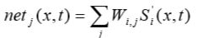
Eqn.1

Where S’_{i} (x, t) denotes the site attributes given by variable (neuron) i; W _{i,j} is the weight of the input from neuron i to neuron j; net _{j} (x,t) is the signal received for neuron j of cell x at time t (see Okwuashi et al, 2012).
Many classifiers are available for classification of multi-spectral satellite images. These include discriminate analysis, maximum likelihood classification scheme, etc (Ali et al, 2010). A major disadvantage of these classifiers is that they are not distribution free. This has prompted significant increase in use of ANN for classification of remotely sensed images (Mather, 1999). Several other reasons has been sighted in favour of Neural Network (NN) based classifiers which is listed below (see Ali et al, 2010 and Han et al, 2002).
- Each of the (region) parameters will be in a different numerical range, some in (0,1), some in (0, 255), etc. Rescaling all parameters to a single range can affect the inter-class and intra-class separation.
- NN classifiers can detect and use to their advantage non-linearity in data patterns.
- Ancillary data can be included in NN classifiers.
- NN architectures are flexible which can be easily optimized for performance.
- NN can handle multiple subcategories per class.

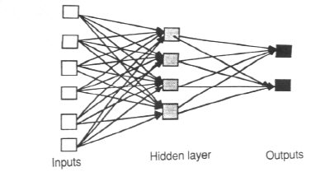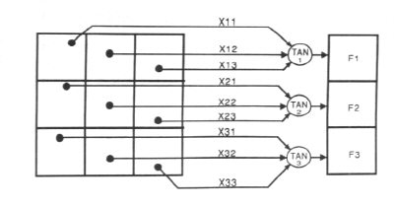
Figure 3.1 An example of a simple feed forward network

3.1 Pattern Recognition
An important application of neural networks is pattern recognition. Pattern recognition and clustering techniques are particularly useful in Remote Sensing to classify or group pixels. Pattern recognition can be implemented by using a feed-forward (Figure 3.1) neural network that has been trained accordingly. During training, the network is trained to associate outputs with input patterns. When the network is used, it identifies the input pattern and tries to output the associated output pattern. The power of neural networks comes to life when a pattern that has no output associated with it, is given as an input. In this case, the network gives the output that corresponds to a taught input pattern that is least different from the given pattern. Multi-layered perceptrons (MLP) are the most common type of feed-forward networks. Figure 3.1 shows a MLP which has three types of layers: an input layer, an output layer and a hidden layer.

3.2 Architecture of Neural Networks

Feed-forward networks: Feed-forward ANNs (figure 3.1) allow signals to travel one way only; from input to output. There is no feedback (loops) i.e. the output of any layer does not affect that same layer. Feed-forward ANNs tend to be straight forward networks that associate inputs with outputs. They are extensively used in pattern recognition. This type of organisation is also referred to as bottom-up or top-down.

Feedback networks: Feedback networks (figure 3.1) can have signals travelling in both directions by introducing loops in the network. Feedback networks are very powerful and can get extremely complicated. Feedback networks are dynamic; their 'state' is changing continuously until they reach an equilibrium point. They remain at the equilibrium point until the input changes and a new equilibrium needs to be found. Feedback architectures are also referred to as interactive or recurrent, although the latter term is often used to denote feedback connections in single-layer organisations.
- Study Area
The area known as Uyo metropolis lies within latitudes 4⁰ 56¹ 30” N and 5⁰ 07¹ 40” N, and longitudes 7⁰ 49¹ 50” E and 8⁰ 01¹ E. The present area of Uyo capital city is about 312.6 Sq km with a population of about 3.9 million. The 1991 national population census puts Uyo population density of about 1,500 people 1 Sq km. Uyo LGA is originally a collection of villages, now almost seamlessly joined together to form the conurbation that it is today. A nucleated settlement pattern is exhibited in the area. Before now Most of the area in Uyo metropolis can be classified as residential except for the commercial agglomeration in the business district. It lies almost at the centre of the state with roads linking all the local government areas in Akwa Ibom State, Nigeria.

- Materials and Method
Artificial neural networks have considerable potential for the classification of remotely sensed data. Multi-Layer Feed Forward (MLFF) and Radial Basis Function (RBF) NN classification techniques are widely used remote sensing applications. Ali et al (2010) implemented the Cloud Basis Function (CBF) NN where the image was treated as a set of objects to enhance more information extraction. In this paper a feed-forward artificial neural network using a variant of the back-propagation learning algorithm will be used for land use/ land cover mapping of the study area from remotely sensed data. Once the satellite image has been classified, the accuracy is computed by comparing it with desired output, which is produced manually. The overall accuracy is calculated from the correct number of land use pixels present in the actual output. The output class of the pixel (i, j) in the actual output is compared with its class in the desired output. If both match, then that pixel (i, j) is correctly classified. Error matrices and Cohen’s kappa will be used for accuracy assessment. Kappa can be used as a measure of agreement between model predictions and reality (Congalton, 1991) or to determine if the values contained in an error matrix represent a result significantly better than random (Jensen, 1996). Kappa is computed as:

N _{r} xii − r (xi+ × x+i )

N ₂ − (xi+ × x+i )
i=1

κ= i=1 r i=1 (Eqn. 2)

where N is the total number of sites in the matrix, r is the number of rows in the matrix, x_{ii} is the number in row i and column i, x_{+i} is the total for row i, and x_{i+} is the total for column I (Jensen, 1996). The confusion matrix, overall accuracy and kappa estimates will be used to validate and check the performance of classified data set. Our neural network implementation is software-based. The ENVI packaged was used for the implementation. ENVI provides methods for locating specific pixels and for interactive spatial/spectral pixel editing. It also offers interactive scatter plot functions, including 2D dancing pixels and the n-Dimensional Visualizer. It simplifies comprehensive interactive processing of large multiband data sets, screen-sized images, spectral plots and libraries, and image regions of interest (ROIs), while providing flexible display capabilities and geographic-based image browsing Different iterations, Root mean square (RMS) exit criteria, training threshold contribution, training rate, training momentum and hidden layers were used for the experiment.
4.1 Data source
Collected maps and images (Orthophoto, Landsat 7 etc.) were sorted and classified for analysis and interpretation. Landsat 7 imagery (Path 188, Row 57) scenes of year 2000 (Projection: UTM, Zone 32 North Datum: WGS-84) and digitsed vector from an existing Orthophoto of the same year were employed in this study to produce land use/cover categories of 2000. Reflective bands 1, 2, 3, 4, 5, and 7 of each image scene were stacked and used in an image-to-image geometric projection, using the 2000 image as master.
4.2 Data preparation

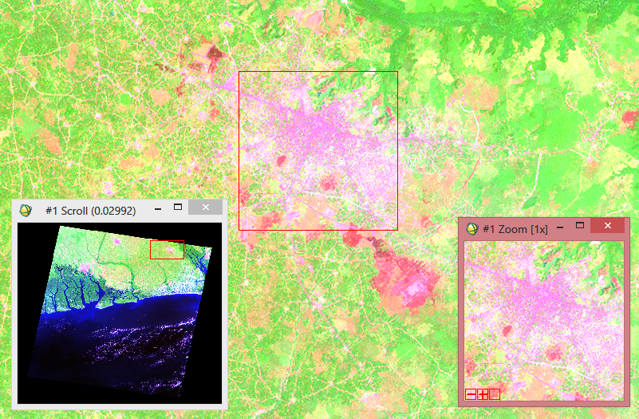
In the present study a processed geo-referenced remotely sensed data was used as a base for image registration. Images were traced from Landsat 7 of year 2000. The standard image processing techniques such as, image extraction, rectification, and restoration, were applied in this work. The image obtained were made up of three bands, viz., Band 2 (visible), Band 4, and Band 7 (infrared) and were used to create a False Colour Composite (FCC) as shown in Figure 4.1. The choice of this FCC combination is because the combination provides a "natural-like" rendition, while also penetrating atmospheric particles and smoke. This combination brings out urban areas in varying shades of magenta, Grasslands/agricultural areas appear as light green, forested areas are Olive-green to bright-green hues.
Study Area- Uyo Capital, Nigeria

Figure 4.1 RGB composite from Landsat 7 ((Path 188, Row 57) scene of 2000

Sparsely vegetated areas appear as oranges and browns, cultivated areas/burnt areas appear as red etc. Pattern recognition helps in finding meaningful patterns in data. Spectral pattern recognition can be improved through Digital image processing as mentioned earlier. The RGB composites of band 742 was used for the neural network classification in ENVI 4.7.

- Results and Discussion
A 500m x 500m Landsat-7 composite image, shown in fig. 4.1 was extracted and classified using support vector machine being a robust supervised learning algorithm. The same image has been classified using the proposed method. Pixels extracted from specified regions of interest were used to classify each pixel of the satellite image as belonging to one of those five classes. Results for the neural network classification are shown below in figure 5.1. The land use classification (LUC) was repeated 9 times with different NN parameters as shown in table 5.1 and Figure 5.2 shows the neural net root mean square plot. The overall accuracy and kappa estimates were computed using a reference data that was earlier classified with support vector machine technique and validated using existing digitised vector from the Orthophoto of the study area.

Table 5.1 Neural network parameters and Overall Accuracy and Kappa Estimates for the Classification
Parameters | LUC 1 | LUC 2 | LUC 3 | LUC 4 | LUC 5 | LUC 6 | LUC 7 | LUC 8 | LUC 9
TTC | 0.9 | 0.9 | 0.5 | 0.9 | 0.9 | 0.9 | 0.9 | 0.9 | 0.2
TR | 0.9 | 0.9 | 0.1 | 0.2 | 0.2 | 0.2 | 0.2 | 1.0 | 0.2
TM | 0.1 | 0.1 | 0.9 | 0.9 | 0.9 | 0.9 | 0.9 | 0.9 | 0.9
RMSEC | 0.05 | 0.08 | 0.9 | 0.1 | 0.1 | 0.06 | 0.1 | 0.001 | 0.01
NHL | 1 | 1 | 1 | 1 | 2 | 1 | 1 | 1 | 1
NI | 1000 | 1000 | 100 | 1000 | 5000 | 1000 | 200 | 500 | 1000
Accuracy (%) | 86.3626 | 87.5049 | 86.5190 | 86.5190 | 55.3040 | 79.9066 | 85.8801 | 65.0751 | 84.6705
Kappa | 0.8262 | 0.8397 | 0.8286 | 0.8286 | 0.4681 | 0.7403 | 0.8197 | 0.5590 | 0.8038
*Key
TTC-Training Threshold Contribution
TR- Training Rate
TM-Training Momentum
RMSEC-Root Means Square Exit Criteria
NHL- Number of Hidden Layer
NI-Number of Iteration
LUC-Land Use Classification
  - Experimental Results for Land Use Classification (LUC) of the Study area
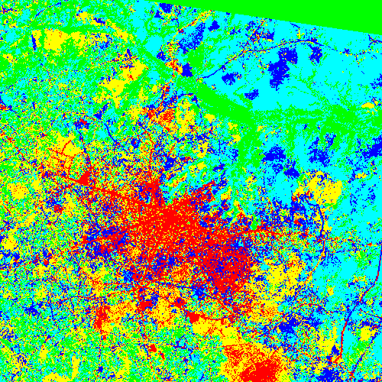
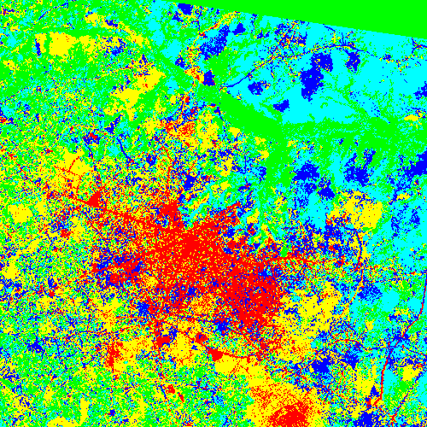
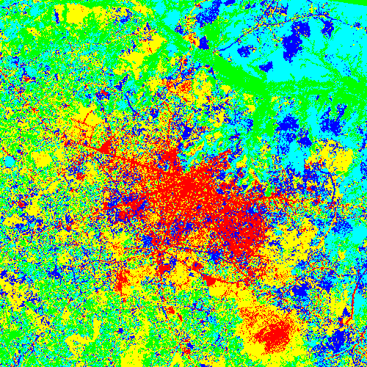

LUC 1 LUC 2 LUC 3

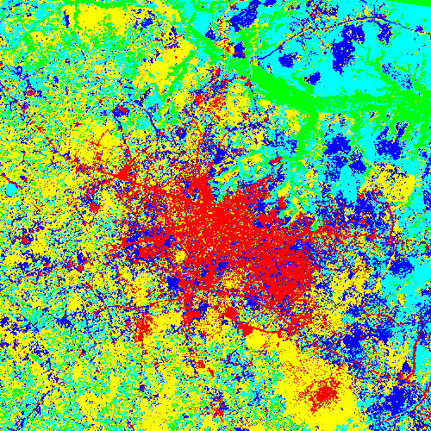
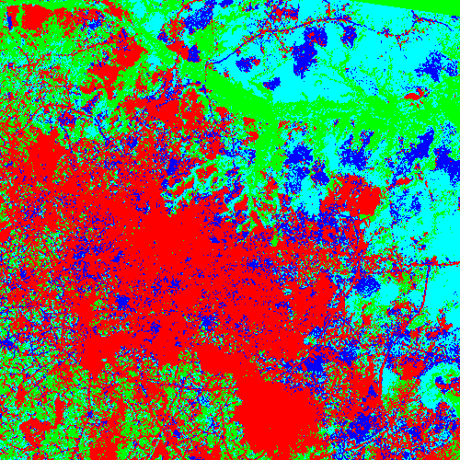

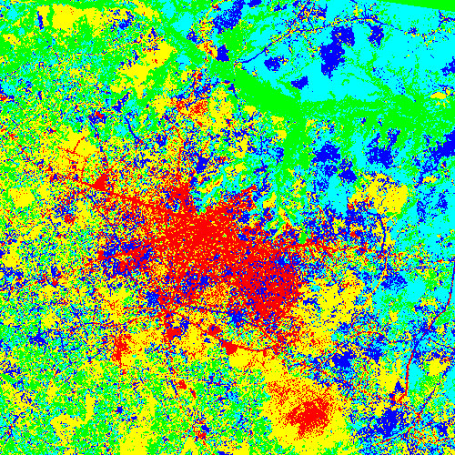
LUC 4 LUC 5 LUC 6
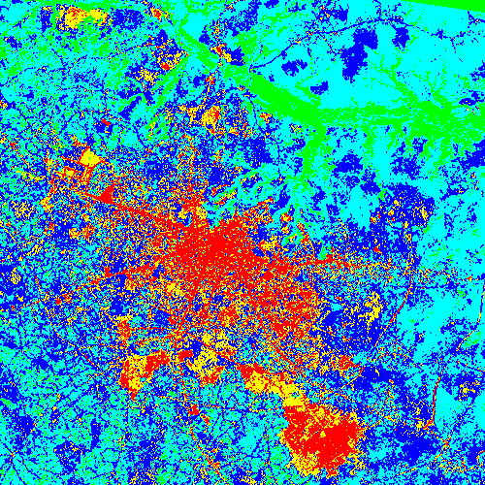
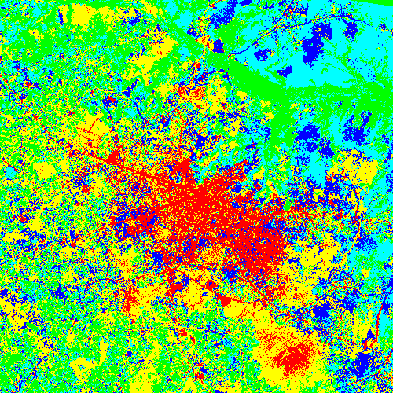
LUC 7 LUC 8 LUC 9
Built -up
Cultivated areas
Agricultural areas
Sparse vegetation
Forested areas
Figure 5.1: Land Use Classification of Uyo Metropolis using Neural Network

The relationship of the classified data set with Neural network and reference data set showed that LUC 5 had a fair agreement, LUC 8 had Moderate agreement, LUC 6 & 9 had a Substantial agreement while LUC 1, 2, 3, 4, &7 had an almost perfect agreement (see table 5.2). The higher the accuracy and kappa values the better the classification. In figure 5.2, a high training RMS was recorded for Plot 5(LUC 5) which must have been influenced by the Number of Hidden Layers specified. Generally, implementing NN for image classification of remote sensing data using the proposed software package, the Number of Hidden Layers should be restricted to one if a very good output must be obtained. Root Means Square Exit Criteria is another parameter that improves the classification performance. It should be kept below 0.1 while the Training Rate and Training Momentum can vary between 0.1 and 0.9 for better results. The NN output was good except for LUC 5&8 whose overall accuracy and kappa estimates were low.

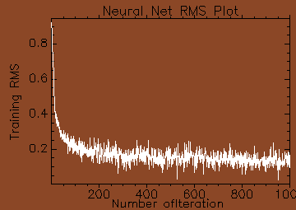
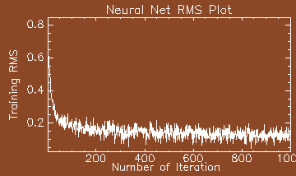
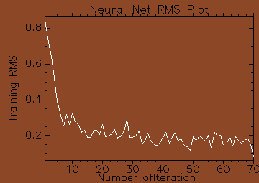
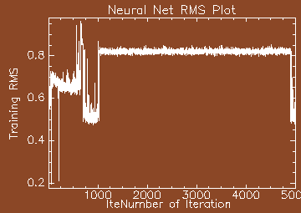
Plot 1(LUC 1) Plot 2(LUC 2) Plot 3(LUC 3) Plot 5(LUC 5)
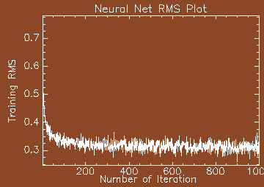
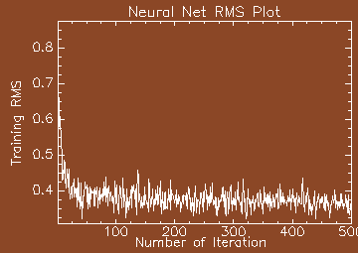
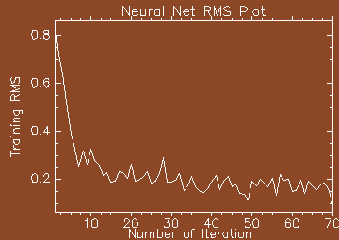
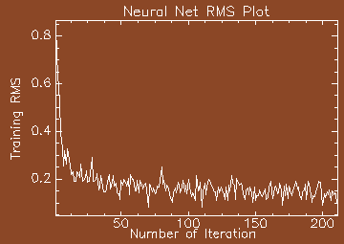
Plot 6 (LUC 6) Plot 7(LUC 7) Plot 8 (LUC 8) Plot 9 (LUC 9)

Figure 5.2: Neural Net Root Mean Square (RMS) Plot Showing Different Iterations and Training RMS

Table 5. 2 Interpretation of Kappa estimates
Kappa |  | Interpretation
< 0 |  | No agreement
0.0 - 0.20 |  | Slight agreement
0.21 – 0.40 |  | Fair agreement
0.41 – 0.60 |  | Moderate agreement
0.61 – 0.80 |  | Substantial agreement
0.81 – 1.00 |  | Almost perfect agreement

Conclusion
Remotely sensed images are attractive sources for extracting land cover information, where an image classification algorithm is employed to retrieve land cover information. Artificial Neural Network (ANN) Technique has the ability to identify a relationship from given patterns and this makes it possible for ANNs to solve large-scale complex problems such as pattern recognition, nonlinear modelling, classification, association etc. One of the common applications of neural networks in remote sensing is classification. An example of the use of artificial neural networks to classify remotely sensed data based on software has been described. The Neural Network performance for image classification of remote sensing data is good considering the accuracy and kappa results obtained in this work. Generally, in implementing Neural Network for image classification of remote sensing data using the proposed software package, the Number of Hidden Layers should be restricted to one (1) if a very good output must be obtained.

Corresponding Author:
Christopher Ndehedehe
Department of Geoinformatics & Surveying
Faculty of Environmental Studies,
University of Uyo, Nigeria
christopherndehedehe@gmail.com

References
- Ali, Imdad Rizvi & B.Krishna Mohan 2010: Improving the Accuracy of Object Based Supervised Image Classification using Cloud Basis Function Neural Network for High Resolution Satellite Images. International Journal of Image Processing (IJIP), Volume (4) : Issue (4), pg 342 353
- Almeida, C. M., Gleriani, J. M., Castejon, E. F., & Soares-Filho, B. S. 2008: Using neural networks and cellular automata for modelling intra-urban land-use dynamics. International Journal of Geographical Information Science, 22(9), 943-963. http://dx.doi.org/10.1080/13658810701731168
- Arora M.K, Tiwari K.C and Mohanty B. (2000): Effect of neural network variables on image classification. Asian pacific Remote Sensing and GIS Journal, 13, 1-11.
- Congalton, R. G. 1991: A review of assessing the accuracy of classifications of remotely sensed data. Remote Sensing of Environment 37:35-46.
- Debojit, Biswas Jain Hitesh, Arora Manoj K, Balasubramanian R 2011: Study and Implementation of a Non-Linear Support Vector Machine Classifier. International Journal of Earth Sciences and Engineering ISSN 0974-5904, Volume 04, No 06 SPL, October 2011, pp. 985-988.
- Follador, M., N. Villa, M. Paegelow, F. Renno, R. Bruno 2008: Tropical Deforestation Modelling: A Comparative Analysis Of Different Predictive Approaches. The Case Study Of Peten, Guatemala. "Modelling Environmental Dynamics, page 77-108" DOI : 10.1007/978-3-540-68498-5_3
- Foody G.M, Mcculloch M. B., and Yates W.B. 1997: Classification of remotely sensed data by an artificial neural network: issues related to training data characteristics. Photogrammetric engineering and remote sensing ISSN 0099-1112
- Gokmen Tayfur 2002: Artificial neural networks for sheet sediment transport. Mythological Sciences-Journal-des Sciences Hydrologiques, 47(6) page 879-892.
- Gong, P. and J. Chen 1996: Mapping ecological land systems and classification uncertainties from digital elevation and forest-cover data using neural network. Photogrammetric Engineering and Remote Sensing 62: 1249-1260.
- Han, J., S. Lee, K. Chi, K. Ryu, 2002: Comparison of Neuro-Fuzzy, Neural Network, and Maximum Likelihood Classifiers for Land Cover Classification using IKONOS Multispectral Data. In Proceedings of the IEEE International Geoscience and Remote Sensing Symposium, vol 6, pp. 3471-3473, Toronto, Canada,
- Heerman.P.D. and khazenie 1992: Classification of multi spectral remote sensing data using a back propagation neural network. IEEE trans. Geoscience Remote Sensing, 30(1), 81-88.
- Hepner, G.F., T. Logan, N. Ritter, and N. Bryant 1990: Artificial neural network classification using a minimal training set: Comparison to conventional supervised classification. Photogrammetric Engineering and Remote Sensing 56: 469-473.
- Huang, W. and R. Lippmann 1987: Comparisons between neural net and conventional classifies, IEEE First International Conference on Neural Networks, Vol. IV. San Diego, California, 21-24 June, pp. 485-494.
- Jensen, J. R. 1996: Introductory Digital Image Processing: A Remote Sensing Perspective (Second edition). Prentice Hall, Inc., Upper Saddle River, New Jersey, USA.
- Mather P. 1999: Computer Processing of Remotely Sensed Images, John Wiley & Sons, Inc. New York, NY, USA.
- Minns, A. W. and M.J. Hall, 1996: Artificial neural networks as rainfall- runoff models. Hydrol. Sci. J., vol. 41, pp. 399-418, 1996.
- Mohanty.k.k.and Majumbar. T.J., 1996: An Artificial Neural Network (ANN) based software package for classification of remotely sensed data. Computers and Geosciences, 81-87.
- Muhammad, Aqil. Ichiro Kita, Akira Yano, and Nishiyama Soichi 2006: Decision Support System for Flood Crisis Management using Artificial Neural Network. International Journal of Electrical and Computer Engineering 1:5
- Nathaniel G. Plant, Stefan G. J. Aarninkhof, Ian L. Turner, and Kenneth S. Kingston (2007): The Performance of Shoreline Detection Models Applied to Video Imagery. Journal of Coastal Research: Volume 23, Issue 3: pp. 658 – 670.
- Okwuashi Onuwa, Mfon Isong, Etim Eyo, Aniekan Eyoh, Okey Nwanekezie, Dupe Nihinlola Olayinka, Daniel Okon Udoudo & Beulah Ofem 2012: GIS Cellular Automata Using Artificial Neural Network for Land Use Change Simulation of Lagos, Nigeria. Journal of Geography and Geology; Vol. 4, No. 2; 2012 ISSN 1916-9779 E-ISSN 1916-9787 Published by Canadian Center of Science and Education
- Openshaw, S. and C. Openshaw, 1997: Artificial Intelligence in Geography. Chichester. John Wiley & Sons Ltd.
- Paola, J. D, and Schowenderdt, R. A. 1995: A review and analysis of back propagation neural networks for classification of remotely sensed multi-spectral imagery. International Journal of Remote Sensing, 16, 3033-3058.
- Peddle, D.R. G.M. Foody, A. Zhang, S.E. Franklin, and E.F. Ledrew 1994: Multisource image classification II: an empirical comparison of evidential reasoning, linear discriminant analysis, and maximum likelihood algorithms for alpine land cover classification. Can. J. Remote Sensing 20: 397-408.
- Peng, Changhui and Xuezhi Wen 1999: Recent Applications of Artificial Neural Networks in Forest Resource Management: An Overview. AAAI Technical Report WS-99-07. Compilation copyright © 1999, AAAI (www.aaai.org).
- Stathakis, D. A. Vasilakos 2006: Satellite image classification using granular neural networks. International Journal of Remote Sensing Vol. 27, No. 18, 3991–4003
- Zhang, X., C. Li, and Y. Yuan 1997: Application of neural networks to identifying vegetation types from satellite images. AI Application 11: 99-106.

6/25/2013

