**A Theoretical Study on the Effect of Substituent on the Properties of Pyrrole and Thiophene**

Isaiah, A. Adejoro and Collins, U. Ibeji*

Department of Chemistry, University of Ibadan, Ibadan, Nigeria

E-mail: [ibejicollins@yahoo.com](mailto:ibejicollins@yahoo.com)

Phone: +2348063653002

**Abstract:** In this study we have investigated a theoretical study on the structural, opto-electronic and conducting properties of two conjugated polymers. The purpose is to display the effect of replacing H atoms with -C**≡**N (cyano) and >C═O (carbonyl) groups on their properties. In order to propose a method to describe the electronic properties and molecular geometry of these polymers, we have used the following methods to estimate the band gaps: Semi-empirical AM1, ab-initio HF/6-31G and Density Functional Theory BLYP/6-31G* and B3LYP/6-31G*. The substitution of these groups destabilized the HOMO and LUMO levels, decreased the band gaps, and increased the conjugation length, which are essential features in the design of low band gap conducting polymers

[Isaiah, A. Adejoro and Collins, U. Ibeji. **A Theoretical Study on the Effect of Substituent on the Properties of Pyrrole and Thiophene.** *N Y Sci J* 2013;6(7):99-105]. (ISSN: 1554-0200). <http://www.sciencepub.net/newyork>. 15

**Keywords** HOMO, LUMO, Band gap, Density Functional theory, Semi-empirical, Conducting polymers

**1. Introduction**

Conducting polymer-based electrochemical sensors and biosensors play an important role in the improvement of public health and environment because rapid detection, high sensitivity small size and specificity are achieved for environmental monitoring and chemical diagnosis. Due to their straight forward preparation methods, unique properties and stability in air, conducting polymers have been applied to energy storage, electrochemical devices, memory devices, chemical sensors and electrocatalysts [1]. Polypyrrole (PPy) and Polythiophene (PT) are among the most widely studied conjugated organic polymers, experimentally and theoretically, this is due to their chemical stability, high conductivity upon doping and non-linear optical properties [2]. Molecular design of low band-gap polymers is of current interest in research into electrically conducting polymers. The search for polymers that could effectively interact with biological systems has attracted much interest due to its potential technological applications in the areas of biological sensors, molecular electronics, surgical plasters containing active ingredients and membranes, etc. [3-10]. It has been reported in literature that there is a direct electronic communication between functionalized, conducting polypyrrole and a redox protein in solution [11-17]. Polymers with low band gaps are expected to show not only good intrinsic conductivity but also good non-linear optical properties [18]. The experimental band gap values of polypyrrole and polythiophene had been investigated by Colditz, [19] and Zotti *et al*.,[20]. Several theoretical studies of these polymers have been theoretically investigated.

This work is aimed at investigating the effects of these chemical groups (-C≡N and >C═O) on the geometries and electronic properties of polypyrrole and polythiophene, using the hybrid DFT-B3LYP/ 6-31G* basis set. The two neutral chemical groups were introduced by replacing a single H on C

**2. Computational Details**

The hybrid Density Functional Theory (DFT) method at B3LYP/6-31G* levels of theory, refers to the combination of functional hybrid exchange of Becke’s three, [21] with functional correlation gradient of Lee and Yang [22]. First, in order to propose the best method able to describe the electronic properties and molecular geometry on the effect of the chemical groups on these polymers that will be in agreement with experimental data, we have used the following methods; Semi-Emperical AM1, [23] ab-initio HF/6-31G*, [24] and density Functional theory. Some properties have been investigated, these include; optimized geometries, dipole moments, heat energy and HOMO-LUMO energy gaps. All quantum chemical calculations were performed using Spartan 10 program package.

**3. Results and discussion**

The structural modification through the control of HOMO-LUMO gap is very important in the designing of low band gap polymers with intrinsic conductivity (conductivity without doping), yet without disregarding the important properties like solubility and processability. [25] The optimized results of the geometry using B3LYP/6-31G* are shown in table 2 and Figure 1. This is the stable geometry of thiophene and pyrrole (monomer and dimer).

A comparison among the results obtained from all the calculations in Table 1 indicates that B3LYP/6-316* method is most suitable for investigating the geometries and electronic properties of these polymers. This is because the band gap values are in correlation with the experimental values. The method was then used to investigate the effect of -C≡N (cyano) and >C═O (carbonyl) groups on polypyrrole (PPy) and polythiophene (PTh).

**Table 1.** Theoretical and experimental band gaps (*Eg* in eV) of thiophene and pyrrole (monomer and dimer) employing various levels of theory at 6-31G*

|  |  |  |  |  |
| --- | --- | --- | --- | --- |
| Levels of theory | Thiophene Monomer | Dimer | Pyrrole Monomer | Dimer |
| RHF | 12.69 | 10.16 | 13.620 | 1159 |
| BLYP | 4.44 | 2.8 | 5.10 | 3.62 |
| B3LYP | 6.12 | 4.23 | 7.05 | 4.90 |
| AM1 | 9.46 | 8.01 | 10.04 | 8.31 |
| Expt’l. Value | 5.2300 | 4.0500 | 5.9700 | 4.4900 |

The references for the experimental band gaps of polymers: Thiophene [26, 19,] Pyrrole [20]

Table 2: Calculated Optimized geometry (Mulliken atomic charge) of polymers

|  |  |  |  |  |  |
| --- | --- | --- | --- | --- | --- |
| Pyrrole  (monomer) (Ǻ) | aExpt. (Ǻ) | (Dimer) | Thiophene Monomer) | bExpt. (Ǻ) | (Dimer) |
| C2 0.025 | -0.027 | C2 - 0.302 | C2 -0.298 | -0.2761 | C2 -0.344 |
| C3  -0.17 | -0.008 | C3 - 0.108 | C3  -0.052 | -0.052 | C3 -0.144 |
| C4  0.17 | 0.066 | C4 - 0.123 | C4  -0.052 | 0.0517 | C4 -0.144 |
| C5 0.025 | 0.115 | C5 - 0.044 | C5 -0.298 | -0.297 | C5 -0.097 |
| N1 - 0.548 | -0.509 | N1 -0.185 | S1  0.251 | 0.247 | S1 0.260 |
| H2 0.138 |  | C6 0.302 | H4 0.129 | 0.139 | C6 -0.144 |
| H4 0.329 |  | C9 0.222 | H6 0.129 | 0.139 | C8 -0.344 |
| H6 0.138 |  | C7 -0.185 | H8 0.096 | 0.102 | C7 -0.097 |
| H8 0.121 | 0.231 | N2 -0.642 | H10 0.129 | 0.139 | N2 -0.642 |

aExpt. Value [36], bExpt. Value [37]

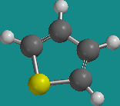 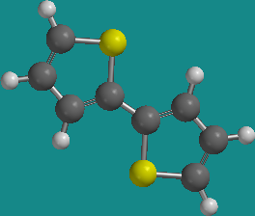 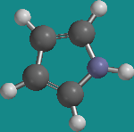 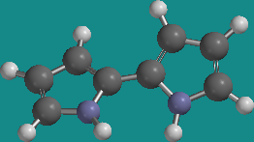

(a) (b)

Fig.1. Optimized structures of (a) thiophene and (b) pyrrole (monomer and dimer) and calculated atomic charges of dimers in angstrom at B3LYP/6-316*

***3.1. Geometries of Optimized Structures***

The optimized structures of PPy and PTh at ground state has a symmetry of C2h and C2h. respectively. The bond length C5-N1, N1-H1 and C5-S1 of PPy and PTh respectively calculated by B3LYP/6-316* are 1.374 Ǻ, 1.008Ǻ and 1.7354 Ǻ. The bond angle N1-C5-H10 and S1-C2-H2 of PPy and PTh are 125.2580 and 119.8090and the dihedral angle C5-N1-C2-C1 and H4- C2-S1-C4 for PPy and PTh respectively are 1800 shown in Table 3

When a single H atom in PPy was replaced with – C≡N group (Fig 2), the symmetry C2h of PPy and PTh was being distorted by replacing one of the H atoms with each one of the chemical group, Thus, PPy has a Cs symmetry and PTh with a C1 symmetry. The bond length of PPy C5-N1, N1-H1 increased to 1.3855 Ǻ, 1.009Ǻ; the bond angle and Dihedral remained unchanged, being 125.2580 and 1800, while for PTh, the bond length, bond angle and dihedral remained almost unchanged, being 1.707Ǻ, 110.6850 and 1800 respectively. When a single H atom in PPy was replaced with the >C═O group (Fig 2), the symmetric C2h of PPy and PTh was also being distorted. Thus PPy has a C1 symmetry and PTh with a C1 symmetry. The bond length and Bond angle remained almost unchanged: for PPy, 1.3886 Ǻ, 124.992­0, a change was however observed in the dihedral angle, -1.79.780, and while for PTh, the bond length, bond angle and dihedral remained almost unchanged, being 1.7503Ǻ, 110.9570 and 179.6800. The result agrees similarly with the earlier studies predicted by Dubis and Grabowski. [26] and Teobald *et al.,* [27]

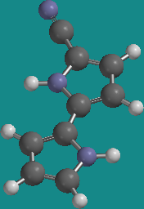 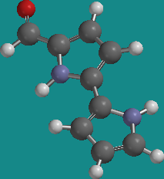

(1a) (1b)

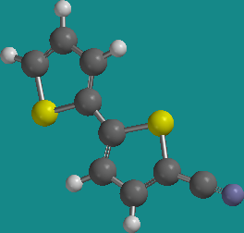 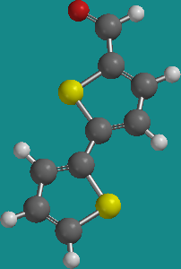

(2a) (2b)

Fig.2. Optimized structures of (1a) PPy- C**≡**N, (1b) PPy>C═O, (2a) PTh- - C**≡**N and (2b) PTh >C═O

Table 3: Optimized geometry of calculated and experimental of polymers

|  |  |  |  |  |
| --- | --- | --- | --- | --- |
| Bonds (Ǻ), bond angles and dihedral angles (deg) | Pyrrole calculated | aExpt. | Thiophene | bExpt. |
| C5-N1 | 1.374 | 1.349 | - |  |
| N1-H1 | 1.008 | 1.017 | - |  |
| C5-S1 |  |  | 1.7354 | 1.714 |
|  |  |  |  |  |
| N1-C5-H10 | 125.26 | 126.5 | - |  |
| S1-C2-H2 |  |  | 119.81 | 119..9 |
|  |  |  |  |  |
| C5-N1-C2-C1 | 180.0 | 180.0 | - |  |
| H4-C2-S1-C4 |  |  | 180.0 | 180.0 |

aExpt [26] and bExpt [27]

***3.2. Vibrational Frequencies***

The simulated IR spectra of PPy and PTh are shown in Table 4 and (Fig. 3), with the strongest IR absorption peak located at 767cm-1 and 2332cm-1 respectively. The IR spectra derived by replacing one of its H atoms with -C≡N and >C═O for PPy are 2332cm-1 and1771 cm-1, while for PTh are 1504cm-1 and1766 cm-1 respectively. From the absorption peaks, spectra of PPy>C═O and PTh>C═O appear to be quite similar. The result also agrees similarly with the earlier studies predicted by Lord and Miller [28]

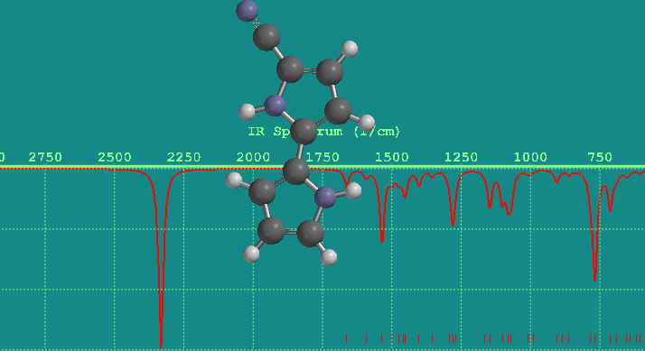

(a)

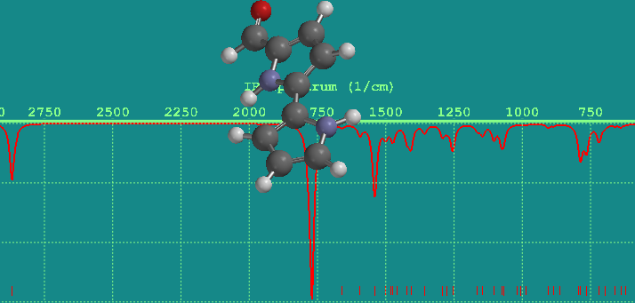

(b)

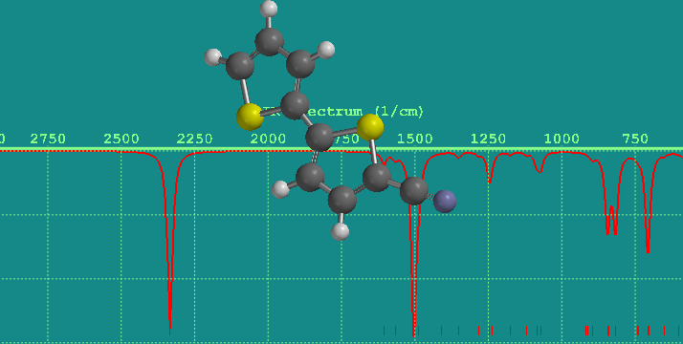

(c)

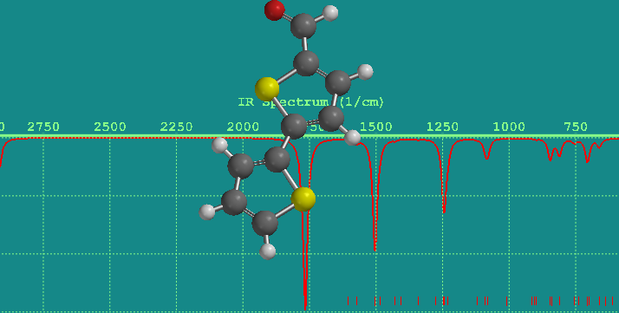

(d)

Fig.3. Showing simulated spectra for polymers

Table 4: Showing calculated and experimental wavenumbers

|  |  |  |
| --- | --- | --- |
| Polymers | Cal. [λ (cm-1)] | aExpt’ [ λ (cm-1)] |
| PPy | 767 | 736 |
| PTh | 2332 | 726 |
| PPy- C≡N | 5.63 | - |
| PTh- C≡N | 5.49 | - |
| PPy>C═O | 4.96 | - |
| PTh>C═O | 4.17 | - |

aExpt’ value [28]

***3.3. Thermochemistry***

The reaction energies (∆H) and Zero-point energies (De) of the polymers evaluated by B3LYP methods are shown in Table 5**.**

The reaction for reaction energies and Zero-point energies are as follows:

Polymer +X ↔ Polymer-(X)

∆H= H (Polymer(X)) – H (Polymer) – H(X)

De = E (Polymer) + E(X) – E (Polymer(X))

where X= - C≡N and >C═O. Thermodynamic stability is expected when ∆H is negative, and the more negative the value of ∆H, the more stable the (X) compound. With De, the situation is the opposite, which is, the more positive the values of De, the more stable the polymer(X). This can be seen from Table 2. Table 2 shows that the most negative ∆H and the most positive De are -2395.036au and 0.5eV, respectively, so it is implied that PTh- C≡N is most stable structure, meanwhile, the stable order is PTh- C≡N > PPy- C≡N > PTh >C═O > PPy>C═O. To our knowledge, there are no experimental and theoretical data regarding the properties of these substituted polymers.

***3.4. Electronic properties***

Energy gap between the Highest Occupied Molecular Orbital (HOMO) and the Lowest Unoccupied Molecular Orbital (LUMO), or simply HOMO-LUMO gap (HLG; ΔEg), also called band gaps, is a key parameter which determines the molecular admittance because it is a measure of the electron density hardness [29-30]. In order to propose a method to describe the electronic properties of the monomeric form these polymers, we have used the following methods to estimate the band gaps : Semi-empirical AM1(9.46V for thiophene, 10.04V for pyrrole) ab-initio HF/6-31G* (12.69V for thiophene, 13.620V for pyrrole), DFT BLYP/6-31G*(4.44V for thiophene, 5.10V for pyrrole) and B3LYP/6-31G* (6.12V for thiophene, 7.05V for pyrrole) methods. Comparing the values obtained before and after substitution, we found that for PPy, - C≡N substitution reduces the band gap from 4.90eV to 4.38eV, >C═O substitution reduces the band gap from 4.90eV to 4.01eV. Furthermore for PTh, C≡N substitution reduces the band gap from 4.24eV to 3.94eV, >C═O substitution reduces the band gap from 4.24eV to 3.71eV. (Fig.4) also shows a corresponding decrease in band gap values. This result agrees with the experimental value by [19, 20, 31] found in Table 1.

The orientation of the electric dipole moment vector (µ) of the oligomers with respect to the direction of the polymer chain determines electrochemical characteristics of the polymer on the electrode surface. In addition to their orientations, the size of the electric dipole moment vector of the monomers , their interactions with the solvent and support electrolyte are the key factors in their selection for electro-polymerization. Furthermore, the structure of the electrical double layer at the surface of electrodes which determines the kinetics of the diffusion controlled electrode reactions depends on the dipole moment of the solute molecules [32-33]. In Table 5, interestingly, PPy possesses a net dipole moment, and the dipole moment of PPy- C≡N is the largest, 5.63D, followed by those of PTh- C≡N, 5.49D and PPy>C═O, 4.96D. It is worth knowing that the dipole moment of PTh >C═O is the smallest, 4.17D.

Table 5. Dipole moment, Reaction energies, (∆H), Zero-point energies (De) and its Band gaps (Egap)

|  |  |  |  |  |
| --- | --- | --- | --- | --- |
| Polymers | Dipole (debye) | ∆H(au) | De (eV) | Egap (eV) |
| PPy | 0.00 | - | - | 4.90 |
| PTh | 0.00 | - | - | 4.23 |
| PPy- C≡N | 5.63 | -836.34 | 0.49 | 4.38 |
| PTh- C≡N | 5.49 | -2395.04 | 0.50 | 3.94 |
| PPy>C═O | 4.96 | 1.15 | 0.19 | 4.01 |
| PTh>C═O | 4.17 | 1.15 | 0.49 | 3.71 |

Fig.4. Plot showing the effect of substituent on Band gaps of polymers

**4. Conclusion**

Polypyrrole and polythiophene present special problem in computational modeling because of their extended molecular system. Their size and structure complexities cause the difficulty. The same observation was reported previously by [34-35]. This study shows that using hybrid DFT /6-31G* basis set, a substantial improvement in the properties can be obtained.

From the results obtained it can be implied that PTh- C≡N is the most stable structure under the values of ∆H and De. The calculated dipole moment of PPy- C≡N is the largest, (5.63D) and with the strongest IR absorption peak located at 2332 cm-1. The substitution of these groups destabilized the HOMO and LUMO levels; decreased the band gaps, and increased the conjugation length, implying that the substituted compounds are better polymers for biosensor applications. We hope that our results may provide a reference for further experimental and theoretical work as well as effects directed towards the synthesis of these derivatives.

***Acknowledgement***

The authors are grateful to God for his Grace and mercies.

**References**

[1]. M. D. Aminur Rahman, Kumar, P. DEOG-su, S.Toon-Bo, *Sensors* **2008,** 8, 118-141.

[2]. U .Salzner, J. B. Lagoswski, P.G. Pickup, A*.* Poirier, *Synth. Met*., **1998**, 96, 177-189.

[3]. H. Naarmann, *Appl. Conduct. Polym*., **1990, 7,** 81.

[4]. R. Friend, Nature **1991,** 35-377.

[5]. O. Ouerghi, A. Senillou, N. Jaffrezic-Renault, C. Martelet, H. Ben Ouada, S. Cosnier, *J. Elecroanal. Chem*., **2001**, 62**,** 501.

[6]. N. Alizadeh, M.Mahmodian, *Electroanalysis* **2000**, 12, 509.

[7]. B.P.J.D. Costello, P. Evans, N. Guernion, N.M. Ratcliffe, P.S. Sivanand, G.C. Teare, *Synth. Met*., **2000,** 114**,** 181.

[8]. S. Cosnier, *Appl.* *Biochem. Biotech.,* **2000**-89**-**p**.**127.

[9]. K.Yamada, Y. Kume, H. Tabe, *Jap*. *J. Appl. Phys*., **1998**, 37**,** 5798.

[10]. J.C. Vidal, E. Garcia, J.R. Castillo, *Sens. Actuators, B-Chem.,* **199,** 57, 219.

[11]. K.S. Ryder, L.F. Schweiger, A. Glidle, J.M. Cooper, *J. Mater. Chem.,*  **2000**, 10, 1785.

[12]. M.J. Swann, A. Glidle, N. Gadegaard, L. Cui, J.R. Barker, J.M. Cooper, *Physica B*  **2000**, 276-357.

[13]. Y. Chen, C.T. Imrie, J.M. Cooper, A. Glidle, D.G. Morris, K.S. Ryder, *Polym. Int.,* **1998**, 47**,** .43.

[14]. A. Griffith, A. Glidle, G. Beamson, J.M. Cooper, *J. Phys. Chem. B.,* **1997**, 101**,** 2092.

[15]. K.S. Ryder, D.G. Morris, J.M. Cooper, *J. Chem. Soc- Chem. Commun*., **1995**, 14, 1471.

[16]. J.M. Cooper, K.S. Morris, K.S. Ryder*, J. Chem. Soc. Chem. Commun*., **1995,** 6, 697.

[17]. J. D. Nero, D.S. Galvao, B. Laks, *Optical Materials* **2002**, 21, 461–466.

[18]. W. Havinga, T. Hoeve, H.Wynberg, *polym. Bull*., **1992**, 29, 119.

[19]. R. Colditz, G. Helbig, M.Rentsch, *S. chem.,* **1995**, 201, 309.

[20]. G. Zotti, S. Martina, G. Wegner, A.D*.* Schluter, *Adv. Mater* **1992**, 4, 798.

[21]. Becke, A.D*. J.; Chem. Phys.* **1993**, 98, 5648-5652.

[22]. C. Lee, W. Yang, R.G. Parr, *Phys. Rev. B.,* **1988**, 37**,** 785-789.

[23]. M. Dewar, W. Thiel, J*. Am. Chem. Soc.,* **1977**, 99, 4499.

[24]. J.M. Andre, L. Ladik, *G.* Biczo*, Phys. Rev*., **1976**, 155, 997.

[25]. *A.* Ajayaghosh. Supplementary material for chemical society. **2003b**. Reviews: http://www.rsc.org/suppdata/cs/b2/.

[26]. A.T. Dubis, S.J. Grabowski, *Journal of Molecular Structure* **2001**, 562, 107-117.

[27]. K. Teobald R. Wrzalika, G. Pasternaa, K. Pasternya, *Journal of Molecular Structure* **2002**, 616, 17–32.

[28]. R.C. Lord, F.A. Miller, *J. Chem. Phys*., **1942**, 10, 328.

[31]. *W.W*. Simmons, Handbook of Ultraviolet spectra, sdler Res. Lab. Philadelphia.

[29]. S. Hirata, C.G. Zhan, E. Apra, T.L. Windus, D.A. Dixon,*. J. Phys. Chem. A.,* **2003**, 107, 10154-10158.

[30]. R.G. Parr, R.G*.* Pearson, *J. Am. Chem. Soc*., **1983**, 105, 7512-7516.

[32]. W.H. Meyer, H. Kiess, B. Binggeli, E. Meier, G.Harbeke, *Synth. Met*., **1985**, 10, 255-259.

[33]. H. Nikoofard, H. Sabzyan,. *J. Fluorine Chem.,* **2007**, 128, 668-673.

[34]. U. Salzner, J.B. Lagowski, P.G. Pickup, A.Poirier, *J. Comp. Chem.,* **1997**, 18, 1943-1953.

[35]. U. Salzner, J.B. Lagowski P.G. Pickup, A. Poirier, *.synth. Meth*., **1998**, 96, 177-189.

[36]. C.I. Sainz-Diaz, M. Francisco-marquez, *Theor. Chem. Acc.,* **2010,** 125, 83-95.

[37]. M. G. Barbara Igor F. Rui, *Phys. Chem*., A **2010**, 114, 2506–2517.

6/6/2013