Purification and Characterization of Pomphorhynchus kashmirensis Somatic Antigens Collected from Naturally Infected Local Fish Schizothorax.

Sumayya Nazir¹, Md. Niamat Ali ^{1*} , M. Z. Chishti²

¹P. G. Department of Zoology, University of Kashmir, Srinagar- 190006, India
²Centre of Research for Development, University of Kashmir, Srinagar- 190006, India

*Corresponding author: Md. Niamat Ali; Tel: +91 9796754654; E-mail: mdniamat@hotmail.com

Abstract: The present investigation deals with the fish intestinal parasite Pomphorhynchus kashmirensis isolated from local fish species Schizothorax. The host fish were collected from two study sites viz the Dal Lake and the River Jhelum, Srinagar, India. The Pomphorhynchus kashmirensis were subjected to immunological studies, especially to reveal the nature of their somatic antigens. The nature of somatic antigens was studied by affinity chromatography and SDS-PAGE and their antigenic properties were also confirmed by Ouchterlony double diffusion test (ODD). A total of 363 fish specimens were collected and out of which 94 specimens were found to harbor the Pomphorhynchus kashmirensis constituting an overall prevalence of 25.89%. SDS-PAGE of partially purified somatic antigens of Pomphorhynchus kashmirensis through affinity chromatography resolved into five prominent polypeptides of molecular weight ranging from 29-66 kDa by using the known molecular weight marker. Furthermore, the antigenicity of the purified antigens was confirmed in ODD against hyper immune sera raised in rabbit and with homogenous immune sera of naturally infected fish. Only one precipitation arch was formed against hyper immune sera and many precipitation arches were formed against homogenous immune sera.
[Sumayya Nazir, Md. Niamat Ali, M. Z. Chishti. Purification and Characterization of Pomphorhynchus kashmirensis Somatic Antigens Collected from Naturally Infected Local Fish Schizothorax. N Y Sci J 2013;6(7):24-28]. (ISSN: 1554-0200). http://www.sciencepub.net/newyork. 5

Keywords: Pomphorhynchus kashmirensis, affinity chromatography, SDS-PAGE, Ouchterlony double diffusion test (ODD).

1. INTRODUCTION
The basic aim of any study related to immunological problems is to contribute directly or indirectly towards the control of infection. An efficient control of the disease depends on the correct diagnosis, correct identification of causative agent and then the integrated application of several control measures.
Pomphorhynchus kashmirensis is an endoparasite, usually found in the intestine of the fish Schizothorax. It adheres to the intestinal tract by inserting its hooked proboscis through it and thereby produces lesions and makes it prone to further secondary infections. Besides, it is also present in the body cavity, liver and spleen of its fish host. It causes tremendous damage to the intestinal walls at the site of its attachment. The lamina propia gets thickened and goblet cells in this region become more prominent and their number also gets increased (Yildiz et al., 2004).This parasite is considered to be one of the most dangerous parasite responsible for fish mortality and morbidity. Hence the need was felt to study this parasite at molecular level so that our fish fauna are spared from them.
Besides, several serological and hematological studies have been extensively used for the diagnosis of the fish diseases but little work regarding the immunological aspects of the parasites have been carried out. However, a lot of research work on such properties of the parasites have been carried out in abroad on various parasites, with meager work on fish parasites, using the different techniques- chromatography, SDS-PAGE, etc because of their convenience (Parkhouse et al., 1987; Kennedy and Qureshi, 1989; Woo and Thomas, 1991; Feng and Woo, 1996; Joshi and Singh, 1999; Knopf et al., 2000; Saifullah et al., 2000; Hamwood et al., 2002; Chibani et al., 2004; Akimasa et al., 2008; Meshgi et al.,2008; Selvarayar, A. 2012; El Hassan and Sabry, 2012).
The present endeavor mainly deals with immunological studies especially the nature of somatic antigens of the fish parasite Pomphorhynchus kashmirensis using chromatography and SDS-PAGE and confirming the antigenicity strength by Ouchterlony double diffusion test (ODD) which will thus provide the baseline data about the antigenic properties of the Pomphorhynchus kashmirensis and hence can be utilized for the preparation of vaccines against it. The introduction of such a vaccine in the fish will boost its adaptive immune response and thus in turn, will be strongly in a position to combat the infection of Pomphorhynchus kashmirensis much before its entry in it.

2. MATERIALS AND METHODS
A total of 363 fish specimens of Schizothorax were collected and out of which, 203 fishe were collected and examined from Dal Lake (Srinagar, India) and 160 fishes were collected and examined from River Jhelum (Srinagar, India) during the present study. Three species of Schizothorax were assessed i.e. S. niger, S. curvifrons and S. esocinus The host was collected with the help of local fishermen in live condition. Fishes were dissected and body cavity was thoroughly examined for any parasite. Intestines were placed in Petri dish containing normal saline (0.75%Nacl) to allow adhering parasites to be released from the lumen. Pomphorhynchus kashmirensis were carefully removed from the intestines with the help of brush and needle. A regular record of this parasite was done and then subjected to various immunological and biochemical studies in order to understand the nature of somatic antigens.
2.1. Preparation of the PBS antigens
Whole worm antigens of Pomphorhynchus kashmirensis were prepared by dissolving 2 grams of parasites in 100ml of the PBS (pH 7. 2) and homogenized at 12000 rpm for 15 minutes. The homogenate was kept in refrigerator at overnight and then centrifuged at 6000 rpm for 30 minutes. The clear supernatant was collected in small tubes as a purified PBS antigen and stored at -20 ºC (Feroz et al., 2003). Estimation of protein concentration was done by Lowry Method (Lowry et al., 1951).
2.2. Production of antisera
Healthy rabbits were used for raising hyper immune sera against crude somatic antigens of Pomphorhynchus kashmirensis. Crude PBS antigens containing one mg protein in equal amount of Freund’s complete adjuvant was thoroughly mixed with the help of syringes till white precipitate was observed. The following immunizations were given intramuscularly on day 15th, 30th, 45th and 60th after the first inoculation along with Freund’s complete adjuvant. After 15th days of last immunization, the animals were bled and sera samples were collected.

2.3. Isolation of somatic antigens from Pomphorhynchus kashmirensis through Affinity chromatography.

2.3. a. Construction of immuno affinity column:

Sera from infected fish were utilized as a source of antibodies for preparation of affinity column. Blood from 6 randomly selected infected fish was collected in non-heparinized tubes and allowed to coagulate for 30min at room temperature, following which the tubes were centrifuged at 10,000 rpm at 4 ºC for 10 min. Sera was separated from the cell pellet and stored at -20ºC until further use.

For construction of affinity column, Immunoglobulins (IgG) were precipitated from the Fish sera with ammonium sulphate as per the method of Fey et al. (1976). The precipitated Igs were extensively dialyzed against coupling buffer i.e. 0.1 M NaHCO3, 0.5 M NaCl, pH 8.5 for 36 h and coupled to swelled CNBr activated Sepharose-4.

2.3. b. Affinity purification of antigen

A total of 28 mg equilibrated (20 mM Tris saline, pH 8.0) P. kashmirensis somatic antigen (PSAg) was loaded on the pre-equilibrated affinity column and then washed with excess equilibrating buffer. The bound proteins were eluted using 0.2 M Glycine HCl (pH 2.2) and the pH of the eluted fractions was brought to neutral by adding 2 M Tris. The absorbance of fractions was measured at 260 and 280 nm on a spectrophotometer (Photometer 5010, Germany) and the protein concentration was estimated (Aiken and Learmoth, 1996). The column was regenerated using 0.1 M Tris–HCl, 0.5 M NaCl, pH 8.5, 0.1 M Sodium acetate and 0.5 M NaCl, pH 4.5 after each use. The eluted bound protein was dialyzed extensively against 20 mM Tris-saline buffer, pH 7.4, concentrated with PEG 20,000 and was designated as affinity purified P. kashmirensis somatic antigen (Aff-PSAg).
2.4. Characterization of affinity purified P. kashmirensis somatic antigen (Aff-PSAg) antigens by SDS PAGE.
8% resolving gel and 5% stacking gels were used in the present study. A constant current of 14mA/h (320 V) was maintained during the migration of proteins through staking and separating gels. The gel was removed carefully and placed in a petridish containing staining solution prepared by dissolving 0.3g of Coomassie blue(R-250) in a mixture of 45ml of methanol,10 ml of glacial acetic acid and 45 ml of water. The staining was done at room temperature for two hours. The gel was then removed from staining solution, rinsed with distilled water & placed in the destaining solution containing 10 ml of acetic acid, 10 ml of methanol and 80 ml of water. Then the gel was observed for protein bands and compared with standard protein marker (PMW –M, Genei, Bangalore, India).
2.5. Immunodiagnostic method
To measure the antigenicity of the purified antigens the commonly used serotest viz., Ouchterlony double diffusion (ODD) was used. Crude somatic and partially purified pooled fractions of Pomphorhynchus kashmirensis were subjected to double immunodiffusion against rabbit hyper immune sera. The ODD was performed according to the method of Hudson and Hay (1989).

3. RESULTS
Out of 203 specimens examined from the Dal Lake only 42 specimens were found infected with the Pomphorhynchus kashmirensis which constitutes the prevalence of 20.68%. Similarly out of 160 specimens examined from the River Jhelum only 52 specimens were infected with the Pomphorhynchus kashmirensis which constitutes 32.5% prevalence. Also, Pomphorhynchus kashmirensis showed a wide host range and was successfully establishing in various species of Schizothorax.
The percentage binding of IgG with CNBr activated Sepharose-4B was 83.74%. Out of a total of 28.0 mg of PSAg loaded thrice in 2 batches on the immunoaffinity columns, 0.8374 mg Aff-PSAg was eluted as (E1, E2, E3, E1’, E2’and E3’) with a recovery percentage of 2.97.
Electrophoretic separation of Aff-PSAg resolved into 5 prominent polypeptides of molecular weight ranging from 29 to 66 kDa (Fig. 1) which is inferred to the presence of 5 or more number of active somatic antigens of P. kashmirensis. Hence the isolation of these polypeptides was achieved in pure form. In similar study, low molecular weight polypeptides of Mr<14-33 kDa were predominantly antigenic in G. crumenifer.

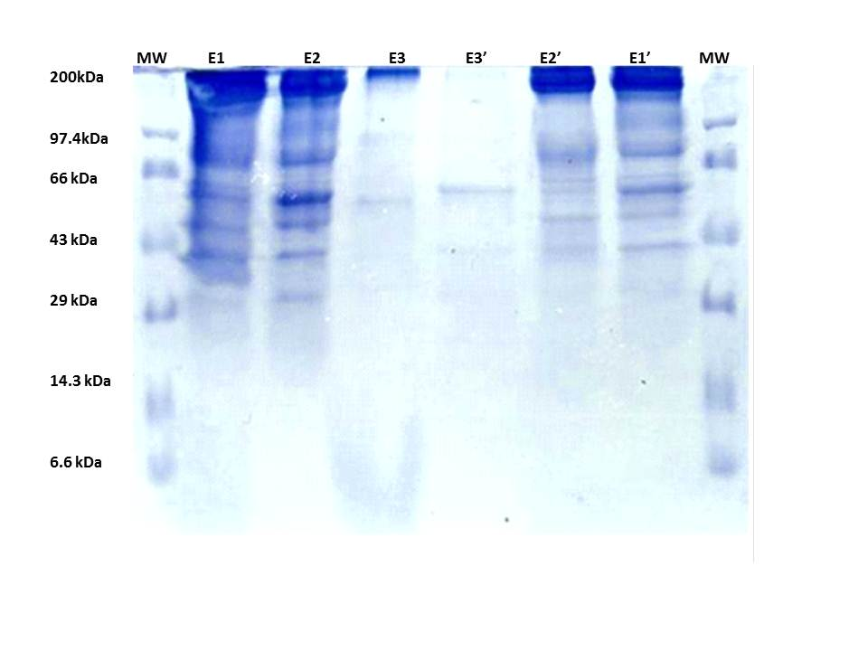
Fig. 1: SDS-PAGE profile of purified somatic antigens of Pomphorhynchus kashmirensis.Analysis of elutes from affinity column using 10% SDS-PAGE, MW= molecular weight; E1, E1’= primary elute; E2, E2’secondary elute; E3, E3’ final wash of the column.

Serodiagnosis by Ouchterlony gel diffusion test:
Crude somatic antigens and affinity purified somatic antigens (E1, E2 and E3) were subjected to Ouchterlony gel diffusion test against hyper immune sera raised in rabbit in order to find the antigenicity of the purified proteins (Fig. 2). It was performed on agar coated glass slides. The same serotest was also performed on naturally infected fish sera using the affinity purified somatic antigensof P. kashmirensis (Fig: 3) Ouchterlony gel diffusion test of somatic antigens showed one precipitation arch against heterogeneous hyper immune sera and many precipitation arches against homogenous immune sera.

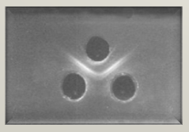
Fig. 2: Gel slide showing precipitation line stained with Amido Black Stain

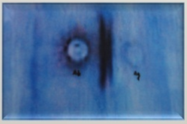
Fig.3: Coomasie blue stained gel showing many (thick) precipitation lines

Fig: 2 & 3. Ouchterlony Double Diffusion test against P. kashmirensis.

4. DISCUSSION
The results of SDS-PAGE and Ouchterlony gel diffusion test strongly reveals that somatic antigens of Pomphorhynchus kashmirensis possess proteins of low molecular weight which mainly range between 29 to 66 KDa and are highly immunogenic as revealed by Ouchterlony gel diffusion test. Such observations are in agreement with Megeed (2005). Similarly Ahmad et al., (2004) proved the antigenic molecules of each fraction were mostly in the low molecular weight range of 14 to 94 kDa. These authors have fractioned the soluble extracts of Gigantocotyle explanatum, isolated from the liver of Bubalus bubalis on Sephadex G-200 columns. Knopf et al., (2000) also proved that the humoral immune response of the experimentally infected eels indicates that the antibody response is more likely to be directed against antigens of the adult worms and secondly, the immunoblot analysis revealed the strongest reactions with antigens of adult Anguilli colacrassus which were mainly located in the body wall of the adult worms. Coscia and Oreste (2000) while working on the fish nematode Pseudoterranova decipiens antigens using different immunoassays to detect their ability to bind with the fish antibody showed that surface associated proteins have higher binding activity than other kinds of antigens. Even Akimasa et al., (2008) through agglutination techniques showed that somatic antigens of fish pathogenic ciliate Cryptocaryon irritants have good antigenic properties. However, it is not in agreement with Park house et al., (1987) who reported that somatic antigens are poor antigenic in nature. This may be due to the inefficiency of Ouchterlony gel diffusion test. The identification of these specific antigens of parasites is of immense value as it will also serve as a tool for understanding the host parasite relationships (Selvarayar A., 2012).Till date no specific diagnostic polypeptide against Pomphorhynchus kashmirensis has been identified and purified. Besides, Affinity chromatography has been shown to be a very effective tool for isolation of diagnostic candidate and vaccine molecules (Sharma et al., 2001). Pertinently, and as a fact, the results so obtained in the present study may vary because these differences may be due to difference in preparing the antigenic solutions, chemical reagents of different quality and quantity (Norouzi, 2007).Thus, the present study showed that the somatic antigens derived from the Pomphorhynchus kashmirensis can be used as good immunogens and hence can be exploited for mounting the protective immune response in fish. Vaccination would certainly be a desirable alternative control strategy to treating animals with these parasites due to consumer concerns about chemical residues in food and the presence of anthelmintic resistant parasite populations. The results of the present study suggest that low molecular weight antigens of Pomphorhynchus kashmirensis deserve further investigation.

Acknowledgements
Thanks are due to Head, P. G. Department of Zoology, University of Kashmir, Srinagar, India, for providing the laboratory facilities for the smooth conduction of the research work.

Corresponding author:
Md. Niamat Ali
P. G. Department of Zoology
University of Kashmir
Srinagar- 190 006, India
Tel: +91 9796754654;
E-mail: mdniamat@hotmail.com

References
- Ahmad, G., Saifullah MK. and Nizami WA (2004) Partial purification and characterization of Gigantocotyle explanatum somatic antigens. Journal of Helminthology 78, 95–99.
- Aiken A and Learmoth M (1996) Protein determination by UV absorption. In: Walker JM(ed). The protein protocols hand book. Humana Press, Totowa, N. J.
- Akimasa H, Naoko U and Noritaka H 2008) Identification and characterization of putative agglutination/immobilization antigens on the surface of fish pathogenic ciliate Cryptocaryon irritans. Marine Biological Technological Center, Japan.
- Chibani M., Glazewska I., and Rokicki J (2004) The use of isozymes to identify specimens of Pomphorhynchus (Acanthocephala) in flounder, Platichthys flesus from the Baltic Sea. J. Mar. Biol. Ass. UK. 84, 277-279.
- Coscia MR. and Oreste U (2000) Plasma and bile antibodies of the teleost Trematomus bernacchii specific for the nematode Pseudoterranova decipiens. Dis Aquat. Org. 41, 37-42.
- El Hassan EM., Sabry M and El-Bahr., 2012. Antigenic and immunogenic components of Haemonchus longistipes identified by western immunoblotting. American Journal of Biochemistry and Biotechnology 8 (3), 164-170.
- Feng S and Woo PTK (1996) Biological characterization of a monoclonal antibody against a surface membrane antigen on Cryptobia salmositica Katz, 1951. Journal of Fish Diseases 19, 137-143.
- Feroz S., Chishti M Z and Mahboob H. (2003) Study of humoral immune response to Helminth infection in some fishes of Kashmir. Journal of Parasitic Diseases 27(2), 94-98.
- Fey H , Phster H., Messerli J , Sturzenegger N and Grolimund F (1976) Methods of isolation, purification and quantitation of bovine immunoglobulins. A technical review. Zentralblatt fur Veterinar Medizin 23, 269.
- Hamwood TE, Cribb BW, Halliday JA, Kearn GC and Whittington ID (2002) Preliminary characterization and extraction of anterior adhesive secretion in monogeneans (platyhelminth) parasites. Folia parasitologica 49, 39-49.
- Hudson L and Hay FC (1989) A handbook of practical immunology (3rd ed.), Oxford: Blackwell Scientific Publication, London.
- Joshi P and Singh IBP (1999) Isolation and characterization of two low molecular weight protective antigens of Haemonchus contortus. Indian Journal of Animal Sciences 69, 284-288.
- Kennedy M and Qureshi F (1989) Antigenic relationships between the surface exposed, secreted and somatic materials of the nematode parasites Ascaris lumbricoides, A. suum and Toxocaracanis. Clin. exp. immunol. 75, 493-500.
- Knopf K, Naser K, Van der Heijden MHT and Taraschewski (2000) Humoral immune response of European eel Anguilla anguilla experimentally infected with Anguilli colacrassus. Dis Aquat Org. 42, 61-69.
- Lowry OH, Rosebrough NJ, Farr AL and Randall RJ (1951) Protein measurement with the Folin phenol reagent. J Biol Chem. Nov;193 (1): 265-75.
- Megeed KNA (2005) Structural characterization of Fasciola gigantic partially purified worm antigen and its potency in diagnosis of fasciolasis. Assiut Veterinary Medical Journal 51(105), 240-253.
- Meshgi B., Eslami A and Hemmetzadeh, F., (2008) Determination of somatic and excretory antigens of Fasciola.hepatica and Fasciola gigantic using SDS-PAGE. Iranian journal of Veterinary Research 9(1), Ser. No. 22.
- Norouzi F, Hashemitabar GR and Razmi GR (2007) Detection of midgut antigens of Hyalomma anatolicum anatolicum tick using SDS-PAGE and Western blot. Iranian Journal of Veterinary Research 8, No. 2, Ser. No. 19.
- Parkhouse RME, Almond NM., Cabrera Z and Harnet W (1987) Nematode antigen in protection pathology. Vet. Immunol. and Immunopathol. 17, 313-324.
- Saifullah, M. K., Ahmad G., Nizami, W. A., (2000) Analyses of excretory secretory and somatic antigens of Gastrothylax crumenifer. Journal of Helminthology 74, 271-276.
- Selvarayar A (2012) Immunoprotection in sheep against Haemonchus contortus using its thiol-purified excretory/secretory proteins. Veterinary Research Forum 3 (4), 239 – 244.
- Sharma J K, Ghosh S, Khan M H and Das G (2001) Immunoprotective efficacy of 39 kDa purified nymphal antigen of Hyalomma anatolicum anatolicum. Trop Anim Health Prod. 33, 103—113.
- Woo PTK and Thomas P T (1991) Polypeptides and antigen profiles of Cryptobia salmositica, C. bullock and C. catastomi (Kinetoplastida: Sarcomastigophora) isolated from fishes. Dis. Aquat.Org. 11, 201-205.
- Yildiz K., Kabackci N and Yarim M (2004) Pathological changes of Tench intestines infected with Pomphorhynchus laevis. Revue Med. Vet. 155(2), 71-73.

5/15/2013

