Relationship Between Intrinsic Factors And Aetiology Of Rot In Irish Potato (Solanum-Tuberosum L.) Purchased In Lagos, Nigeria.

Akinleye. O.M, Buhari. O.A, Adebisi R.T., Raheem A. R.R., Makanjuola S.O. And Oluwadun Afolabi

Department Of Medical Microbiology And Parasitology, Faculty Of Basic Medical Sciences, Olabibi Onabanjo University, P.M.B. 2002; Ago-Iwoye-Ogun State, Nigeria.

ABSTRACT: Irish potato (I.P) (Solanum tuberosum L.) tuber is a nutritious but highly perishable crop that is subject to high fungal spoilage and wastage due to non-availability of appropriate storage techniques. Therefore, the present work was carried out to isolate and characterize fungal agents of spoilage of I.P and to determine the effectiveness of traditional methods of preserving the I.P. 460 I.Ps were randomly bought from 5 markets in Lagos and stored in 50, in each ampoule under 6 storage conditions using sliced onion, dry pepper, sunlight, room temperature, refrigerator and wood ash. Moisture and ash contents of the I.P were determined using methods recommended by the Association of Analytical Chemists (AOAC). The pH of LP was determined using pH meter while titratable acidity was determined by titration method. The potato rots were cultured on potato dextrose agar and incubated at temperature between 26°C to 28°C. The fungi isolated were identified using standard cultural and microscopic methods. The total protein analysis of the I.P skin was carried out using Sodium Dodecyl Sulphate Poly-Acrylamide Gel Electrophoresis (SDS PAGE). Fusarium solani has the highest isolation rate 40%, followed by Fusarium oxysporum (26.7%), Aspergillus niger (23.3%) and Penicillium spp (10%). Sliced onion has the highest values of rot (52%) while wood ash has the lowest value of rot (10%). The results also showed that the mean pH value of rotten and un-rotten I.Ps were 5.28 and 6.58 respectively while the mean moisture values of rotten and un-rotten I.Ps were 77.54% and 72.07% respectively. The t-values of intrinsic factors of I.Ps, mean pH and moisture were 4.81 and 14.01% respectively. No significant difference was found between the mean value of pH and moisture contents of I.P (P>0.05). The proteomic analysis of the skin of rotten and un-rotten LPs showed that their relative mobilities were 0.558 and 0.465 respectively while their molecular weights were 38.5kg and 53.0kg respectively. The results of this study showed that the higher the moisture contents the lower the pH value of the I.Ps and also the more the fungal spoilage. Wood ash is recommended to be an appropriate storage technique for I.Ps.
[Akinleye. O.M, Buhari. O.A, Adebisi R.T., Raheem A. R.R., Makanjuola S.O. And Oluwadun Afolabi. Relationship Between Intrinsic Factors And Aetiology Of Rot In Irish Potato (Solanum-Tuberosum L.) Purchased In Lagos, Nigeria. N Y Sci J 2013;6(4):20-31]. (ISSN: 1554-0200). http://www.sciencepub.net/newyork. 5

Key word: Irish Potatoes, Fungi, Proteomic Analysis, pH and Moisture contents.

INTRODUCTION
Irish Potato (Solanum tuberosum L.) tuber is a nutritious but highly perishable crop that is subject to high fungal spoilage and wastage due to non-availability of appropriate storage techniques (FAO, 2008)
Despite its nutritional importance, the tubers have short storage life, generally, less than four weeks in the tropics. Their skin is easily damaged during harvest and post-harvest handling leaving the crops highly perishable in microbial spoilage (FAO; 2008).
Potato is an important source of dietary fiber and in Great Britain contributes 15% of the intake of food (Fingals et.al., 1989).
Vitamin C is the main vitamin in potatoes. Fresh tubers have vitamin content in the range of 15-24mg per 100g fresh weight (Smith, 1991).
An acceptable potato method should be able to take care of some issues that arise when potato is kept for a long time. These include the consequences of sprouting (which may not apply to seed potatoes damage due to high and very low temperatures, water and respiratory losses, mechanical injure which may precipitate further losses due to pathological factors and losses due to storage pests (Raman et al; 1987, Ali. 1992).

1.1 Research Problems
Fusarium dry rot of potatoes is a worldwide economic problem. There are many species of Fusarium reported to cause dry rot of potato Worldwide (Nielson, 1981). The disease may cause greater losses of potatoes than any other-post harvest disease. Crop losses attribute to dry rot have been estimated to an average of 6 to 25% (Powelson et al, 1993).

Potato blight is one of worst diseases problem for the Irish Potatoes grower. It can wipe out the plants almost overnight and, worst still, it can infect; causing them to rot in storage. In a sack it will travel from potato to potato ruining the lot.
Fusarium dry rot is one of the most important diseases of potato, affecting tubers in storage and seed potato pieces after planting. Fusarium dry rot of feed tuber can reduce crop establishment by killing developing potato sprouts, and crop losses can be up to 25%, while more than 60% of tuber can be infected in storage (Hanson et al, 1996).

1.2 Research Questions
What are the efficiency storage methods of Irish potatoes that will prevent early spoilage?
What fungal species are commonly responsible for Irish potato rot in Lagos?
Is there any association between the rot of Irish potato and the intrinsic and extrinsic factors?
Is there any significant difference in the protein content of the skin of rotten and un-rotten Irish-potato, that make one to be more susceptible to fungal inversion?

1.3 General Objective
The general objective of this study is to determine the relationship between intrinsic factors and aetiology of rot in Irish potatoes purchased in Lagos, Nigeria.

1.4 Specific Objectives
i. To determine the effects of storage methods on the spoilage rates of Irish potato.
ii. To isolate and identify the fungal flora of the skin of rotten Irish potato bought in Lagos markets.
iii. To find if there is any association between the rot of Irish potato and its intrinsic and extrinsic factors.
iv. To carry out proteomic analysis of the skin of un-rotten and rotten Irish potato using Sodium Dodecyl Sulfate PolyAcrylamide Gel Eletrcophoresis (SDS-PAGE).

1.5 JUSTIFICATION
The present study is of public health significance in that it evaluate the risk of intoxication posed to the consumers of fungi contaminated of the skin of freshly bought Irish potato, so as to suggest appropriate control, measures and rapid detection to the relevant regulatory authority.

1.6 LIMITATION OF THE STUDY
Due to the small nature of Irish Potato tubers required for this investigation, it was impossible to purchase the products directly from the farmers or producers. Hence, samples were purchased from retail outlets.

2.0 MATERIALS AND METHODS
2.1 Collection of Irish Potatoes Tubers For Study
Four-hundred and sixty tubers (460) of fifteen potato varieties were purchased from five different major markets in Lagos State between April, 2011 to March, 2012.
Temporary identities were given to these varieties using the methods described by Harris (1992). These market include: Bolade in Oshodi, Oyingbo in Ebutte meta, Okokomaiko in Ojo, Ojuwoye in Mushin and Oke-Aarin in Lagos Island.
2.2 Experimental Setup
For this study, storage structures such as using sliced onion, dry pepper, room temperature, sunlight, refrigerator, wood ash and Irish potatoes were kept in polythene bags.

2.2.1 Storage of Irish potato tubers with Sliced Onion
Fifty potato tubers in five-different markets were kept in polythene bag with sliced onion.
2.2.2 Storage on the floor at room temperature
On the floor of the room, fifty tubers in five different markets for each Irish potato variety were spread well enough to ensure that tubers do not lie on one another.
2.2.3 Storage in polythene bags in the sun
Fifty potato tubers in five different markets for each potato variety were kept in polythene bags and they were kept in the sun every day until up two week.
2.2.4 Storage of Irish potato tubers with dry pepper
Fifty potato tubers in five different markets were kept in polythene bags dry pepper.

2.2.5 Storage of Irish potato tubers using Refrigerator
Fifty potato tubers in five different markets were kept in polythene bag and then kept inside fridge for 2 weeks.
2.2.6 Storage in baskets after dipping in wood ash
The wood ash was collected and fifty Irish potato tubers were dipped in ash to obtain as much coverage of the tubers by ash as much as possible. After this, the tuber were put in the baskets for storage.
2.3 Determination of Rot Severity
Direct measurement of rotted tissues was carried out. The mean diameter of rotted portions was taken and recorded using a modified format of Button (1970) as follows:
1. no-rotting.
2. Mild rotting 5-10% of tubers rotted.
3. Moderate rotting 10-25% of tubers rotted.
4. Severe rotting 25-50% of tubers rotted.
5. Very severe rotting > 50% of tubers rotted.

2.4 Isolation of Organisms from Rotted Tissues
Potato dextrose agar powder was used at concentration of 6.5g/ 100m/s of distilled water. Nutrient agar was also used at a concentration of 3.5g/ 100mls of blood was added aseptically to prepare blood- agar.
Rotted tubers were collected; diseased portions (about 2mm) adjacent to healthy portion were cut with sterile scapel blade and put on PDA agar. The plates were incubated at room temperature (26-30⁰C) on laboratory bench and were observed for growth between 3-7 days and the cultural characteristics was noted.
2.4.1 Identification of the Isolates
The isolates were identified by comparison of their cultural and morphological characteristics to those in Larone (2002).
    - Microscopic Morphology (Wet Mount)
A drop of lactophenol blue was placed on a clean slide. Part of the isolate was emulsified in the lactophenol blue with the aid of a sterile wire loop. This was done for each isolates on different slides. Each isolate was identified with the aid of a binocular microscope, using x 10 and x 40 objectives.

  - Determination of Moisture Contents
A clean sample pan was weight and the weight noted down (W1). 5.0g of each rotten and un-rotten prepared sample of Irish potato tubers was spread evenly on the pan and the combine weight recorded as (W2). The dish and its contents was transferred into an air oven to dry at 130⁰C for 1 hour after which it was brought out, allowed to cool and the weight was taken. The dish and its content was returned to the oven for another 30minutes, after which it was brought out, allowed to cool and the weight was taken to obtain a constant weight measurement which was recorded as (W3).
x 100
- % moisture = W₂ – W₃
W₂ – W₁
W1: mass of the Irish dish, W₂: mass of the dish and the sample before drying, and
W3: mass of the dish and the sample after drying

2.5.1 Determination of Ash Content
Ash content of each rotten and un-rotten Irish potato tubers were determined according to AOAC (2000), using the official method 941.12. The crucibles used for the analysis were cleaned drying at 120⁰C in a drying oven and ignited at 550 for 3hrs.
Then the crucibles was removed from furnace and cooled in desiccators. The mass of each of the crucibles was measured by double analytical balance of model JYT. 20A (Ml) and about 2.5g of rotten and un-rotten were being weighed into each crucibles (M2). The crucibles were dried at 120⁰C for one-hour on a Wagtech hot plate or model ST 15. The crucibles were then placed in a furnace at about 550⁰C for l hour.

After one hour the crucibles were removed from the furnace, cooled, 5 drops of distilled water were added to each of the crucibles and placed in the furnace at 550⁰C for 30mins. After that, crucibles were removed from the furnace, allowed to cool and 5 drops of distilled water and nitric acid were added to each of the crucible. Then the crucibles once again were inserted into the furnance until they were become free from carbon and the residue appears grayish white. Then, they were removed from the furnace and placed in a desiccators. Finally the mass of each crucible was weighed as (M3).
The total ash was calculated from the equation
Ash (%W/W) =W₂ – W₃
x 100
W₂ – W₁
Where M₁: Mass of the dried ash, M₂: Mass of the dish and the sample, M₃: Mass of the dish and the sample.

2.6 SDS- PAGE Analysis
SDS Polyacrylamide Gel Electrophoresis (SDS-PAGE) involves the separation of proteins based on their size. By heating the sample under denaturing and reducing conditions, proteins become unfolded and coated with SDS detergent molecules, acquiring a high net negative charge that is proportional to the length of the polypeptide chair}-When loaded onto a gel matrix and placed in an electric field, the electrode and are separated by a molecular sieving effect. After visualization by comparison of its migration distance with that of a standard of known molecular weight.
2.6.1 Sample Preparation and Extraction
O.3g of each un-rotten and rotten Irish potato skin was grinded to powder and was weighed into different bijoe bottles. 800tl 0.lml Tris HCL pH 7.6 were added into each bottle. All were mixed vigorously for 1mm on the horizontal vortex. 5m1 of each supernant were collected into different bijoue tubes. These mark the end of samples preparation and extraction process.
2.6.2 Test Procedure
0.3g of potato skin of un-rotten and rotten was grinded to powder. 800µl 0.lml Tris HCL pH 7.6 was added. All were mixed vigorously for 1mm on the horizontal vortex. The supernant were collected and kept at 4°C for 24hrs. 2Omls of sample + 5m1 loading dye were incubated at 95°C for 5minds. 12% separating gel and 4% stack gel were used to trace the well created by the comb (loading dye without mercaptoethanol). The samples and standard were loaded in the Gel matrix. The gel was allowed to run at 1 50V for 45mins. Gel was stained in Coomassie blue for 45mins. Distained with distaining solution with several changes until band showed clearly.

2.7 Physicochemical Properties of Irish Potato Samples
2.7.1 Determination of pH in rotten and un-rotten Irish Potatoes
The pH of the Irish Potato tubers were determined manually, using JENWAY 3016 digital pH meter. Standardization (calibration) of the pH meter was done using buffer solution of pH 7 and 4. A 5.Og Irish potato of tuber rotten and un-rotten were dispersed in 25m1 of distilled water and allowed to stand for 30mins in constant stuffing and dipping the electrode of the pH meter into the dispersion with constant shaking until stable reading was obtained. At equilibrium the value was recorded with the aid of p14 meter, Triplicate determination were made in all cases the pH of each solution was determine with a calibrated pH meter at different day of storage.
2.7.2 Titratable acidity of Irish Potato tubers
The titratable acidity of Irish potato tubers of unrotten and rotten samples were determined using titration method. 5.0g of each of the unrotten and rotten tubers were macerated for 30minutes in a beaker with 15.Oml of distilled water. Before titration of the sample, the water that is used for dilution purpose was titrated as a blank. A drop of 1% alcoholic phenolphthalein indicator was added to water extract of the sample (dispersion). The dispersion was then titrated with standard base (O.1N NOAH) to phenolphthalein end point. The result of determination was reported as percentage lactic acid consuming definite volume of 0.IN NOAH. The end point of the titration was reached when the white dispersion changed from a clear white solution to a faint violet colour turbid solution. Triplicate determinations were made in all cases.
3.0 RESULTS
The effects of storage methods on 50 Irish potato and the percentage of tubers rots shows in table 4.1. Between most methods of storage and another, there is significant different in fresh Irish potato stored tubers. The lowest rot (5) was recorded in tubers stored in the Ash. While the highest rots was observed on tubers that were stored with sliced onion (26) with all the storage methods it shows that the longer the Irish potato tubers are kept the more the incidence of tubers rots.

Fungal Species isolated from Irish potato rots on potato dextrose Agar plate, shows in table 4.2 with Fatsarium solani has the highest isolation rate 40% followed by Fusariurn oxysporum (26.7%), Aspergillus niger (23.3%) and Penicillium species (10.0%). Determination of mean pH and moisture values of rotten and un-rotten Irish potatoes. The mean pH values of rotten and un-rotten were 5.277 and 6.5795 respectively, while the means moisture values of rotten and un-rotten were 77.541/and 72.068% shows in table 4.3 and 4.4 respectively. The titratable acidity of rotten and un-rotten Irish potato tubers range from 0.02- 0.16 and 0.06-0.22 shows in table 4.7 respectively. The protein estimation of the skin of rotten and un-rotten Irish potatoes were analysed using Sodium Dodecly Sulfate PolyAcrylamide Gel Electrophoresis (SDS- PAGE). In table 4.6 the total protein molecular weights of un-rotten and rotten were 3 8.5kg and 53.0kg while the relative mobilities were 0.558 and 0.465 respectively.

Table 3.1 The effects of Methods of storage on 50 Irish Potatoes and the Percentage of tubers Rots.
Days | Sliced Onion | Dry Pepper | Sunlight | Room  Temperature | Refrigerator | Ash
1ST | NO ROT | NO ROT | NO ROT | NO ROT | NO ROT | NO ROT
2ND | NO ROT | NO ROT | NO ROT | NO ROT | NO ROT | NO ROT
3RD | 2 4% | 2 4% | 1 2% | 1 2% | 1 2% | NO ROT
4TH | 6 12% | 4 8% | 2 4% | 2 4% | 1 2% | NO ROT
5TH | 8 16% | 6 12% | 2 4% | 2 4% | 2 4% | 1 2%
6TH | 8 16% | 6 12% | 4 8% | 4 8% | 2 4% | 1 2%
7TH | 10 20% | 6 12% | 6 12% | 4 8% | 3 6% | 2 4%
8TH | 14 28% | 10 20% | 6 12% | 6 12% | 3 6% | 2 4%
9TH | 14 28% | 10 20% | 8 16% | 6 12% | 3 6% | 2 4%
10TH | 16 32% | 10 20% | 8 16% | 6 12% | 5 10% | 2 4%
11TH | 20 40% | 14 28% | 8 16% | 6 12% | 5 10% | 3 6%
12TH | 20 40% | 14 28% | 10 20% | 6 12% | 5 10% | 3 6%
13TH | 22 44% | 18 36% | 12 24% | 8 16% | 6 12% | 4 8%
14TH | 26 52% | 22 44% | 14 28% | 10 20% | 6 12% | 5 10%

The various methods of storage have no significant effect on the number of rotten potatoes at 5% level of significance (P > 0.05) using ANOVA.

Table 3.2 Fungal Species isolated from Irish potato rots on potato dextrose Agar plate.
Fungal Species | N | (%) | Colonial Appearance
Fusarium solani | 12 | (40.0%) | White to cream in colour, some have a slight green, yellow or bluenish pigmentation.
Fusarium oxysporum | 8 | (26.7%) | Violet purple pigment.
Aspergillu niger | 7 | (23.3%) | Velvety dark-brown to black colour
Penicillium species | 3 | (10.0%) | White fluffy luxuriant growth.
Total | 30 | (100.0%)

Table 3:3 Determination of mean pH values of rotten and un-rotten Irish potatoes
S/N | ROTTEN POTATOES (A) | UN-ROTTEN POTATOES(B)
 | pH values | pH values
1. | 5.60 | 6.50
2. | 5.85 | 7.30
3. | 6.20 | 6.45
4. | 4.85 | 6.88
5. | 5.35 | 7.20
6. | 6.40 | 7.08
7. | 5.15 | 5.68
8. | 3.96 | 5.99
9. | 6.10 | 6.78
10. | 3.85 | 7.35
11. | 4.95 | 5.51
12. | 4.85 | 6.90
13. | 4.68 | 5.27
14. | 6.30 | 6.95
15. | 5.82 | 5.95
16. | 3.92 | 7.10
17. | 4.32 | 5.80
18. | 5.10 | 7.15
19. | 6.45 | 6.35
20. | 5.85 | 7.40
(a) Mean pH value = 5.2775 (b) Mean pH value = 6.5795
S.D = 0.8269 S.D = 0.6513
Table 3:4 Determination of mean moisture values of rotten and un-rotten Irish potatoes
S/N | ROTTEN POTATOES (A) | UN-ROTTEN POTATOES(B)
 | Moisture values | Moisture values
1. | 74.90 | 72.30
2. | 75.10 | 71.85
3. | 76.50 | 71.10
4. | 78.59 | 69.55
5. | 78.88 | 72.78
6. | 74.40 | 73.03
7. | 77.22 | 71.06
8. | 75.06 | 72.55
9. | 77.30 | 69.30
10. | 75.90 | 73.20
11. | 76.02 | 74.10
12. | 77.08 | 70.90
13. | 76.90 | 72.34
14. | 78.20 | 70.75
15. | 79.10 | 71.85
16. | 79.78 | 73.78
17. | 79.50 | 72.62
18. | 78.95 | 73.65
19. | 79.59 | 70.35
20. | 79.40 | 74.30
(a) Mean moisture value = 77.541% (b) Mean moisture value 72. 068%
S.D. 1.7304 S.D = 1.4148

Table 3.5: Determination of mean values of intrinsic factors of rotten and un-
rotten Irish Potatoes
Intrinsic  Factor | Unrotten  I.P  N= 20 | Rotten  I.P  N= 20 | t value | P value | Critical value
Mean pH | x = 6.5795 | x = 5.2715 | 4.812 | 0.05/2 | 2.093
S.D pH | SD = 0.6513 | SD = 0.8269
Moisture content | x = 72.068% | x = 77.541% | 14.01% | 0.05/2 | 2.093
 | SD = 1.4148 | SD = 1.7304

Table 3.6 Estimation of protein of the skin of rotten and un-rotten Irish potatoes using Sodium Dodecyl Sulfate Poly Acrylamide Gel Electrophoresis (SDS-PAGE).
Standard molecular  weight (KDa) | Protein Present | Log of molecular Weight (KDa) | Relative mobility  (KDa)
66.0 | Albumin, bovine-serum | 1.82 | 0.395
55.0 | Glutamine, Dehydrogenae, bovine-liver | 1.74 | 0.420
45.0 | Ovalbumin and Chicken –egg | 1.65 | 0.520
36.0 | Glyceraldehyde-3-Phosphate, Dehydrogenase, Rabbit muscle | 1.56 | 0.580
29.0 | Carbonic-Anhydrase, Boviwe-pancreas | 1.48 | 0.620
14.2 | -Lactalbumin, Bovine- milk | 1.15 | 0.780
53.0 | Un-Rotten  Irish Potatoes | 1.72 | 0.465
38.5 | Rotten  Irish Potatoes | 1.58 | 0.558

Table 3.7 Duration of Storage and Titratable acidity of Rotten and Un-rotten Irish Potato Tubers
Titratable Duration of storage (Day) Acidity
0 3 6 9 12 15
Rotten 0.02 0.05 0.08 0.10 0.12 0.16
Un-rotten 0.06 0.10 0.13 0.15 0.18 0.22

Number of rotten Potatoes
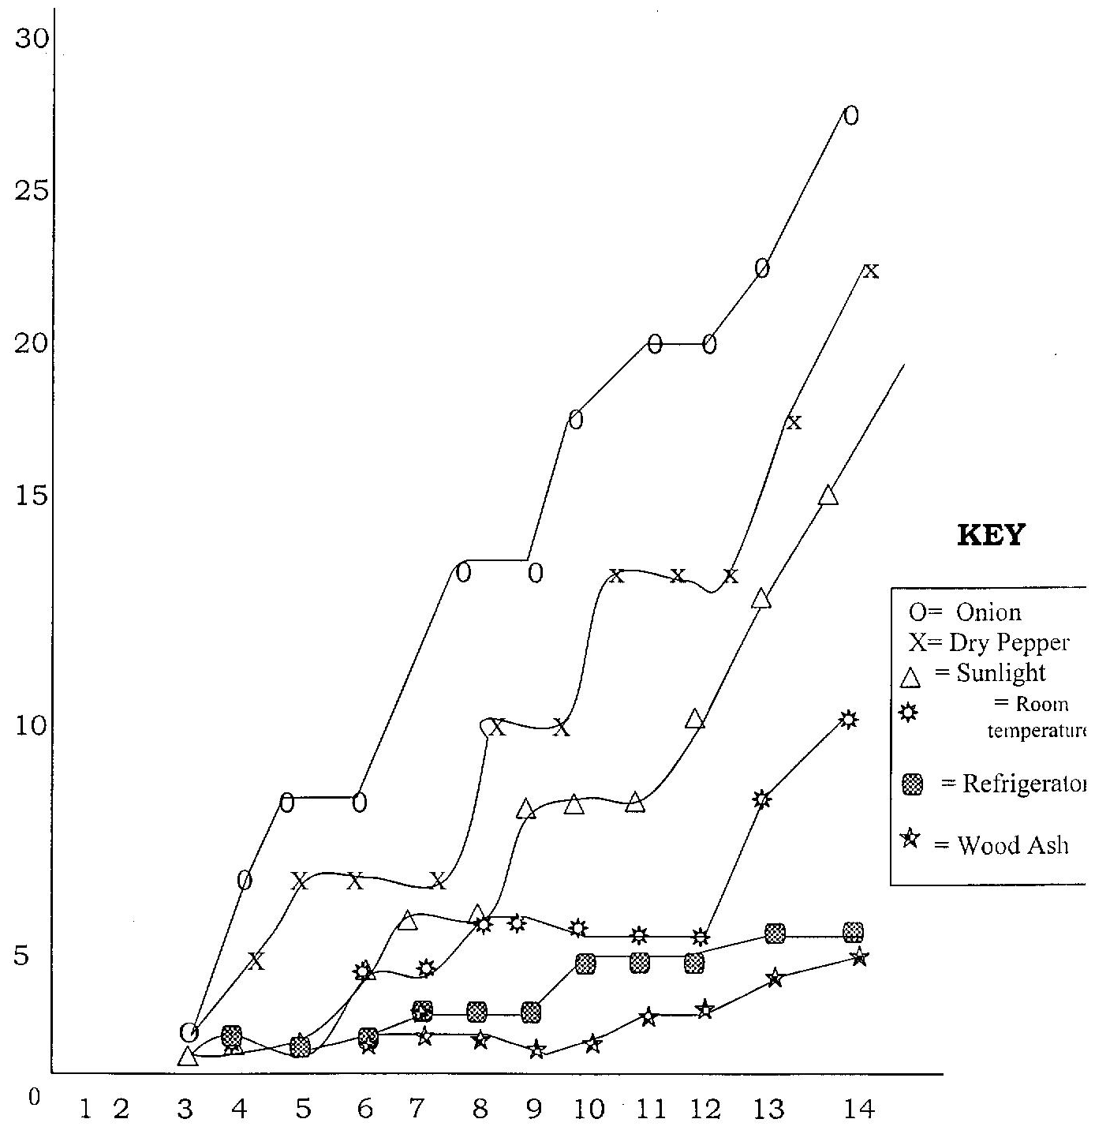
Storage in Days
FIGURE 3.1: Shows the Effects of Methods Storage on 50 Irish Potatoes and the Percentage of Tubers Rots

Relative mobility
FIGURE 3.2: Shows the Standard Curve for Estimation of Molecular Weight of Protein in Rotten and Un-Rotten Irish Potato Tubers.
Molecular weight (KDa)
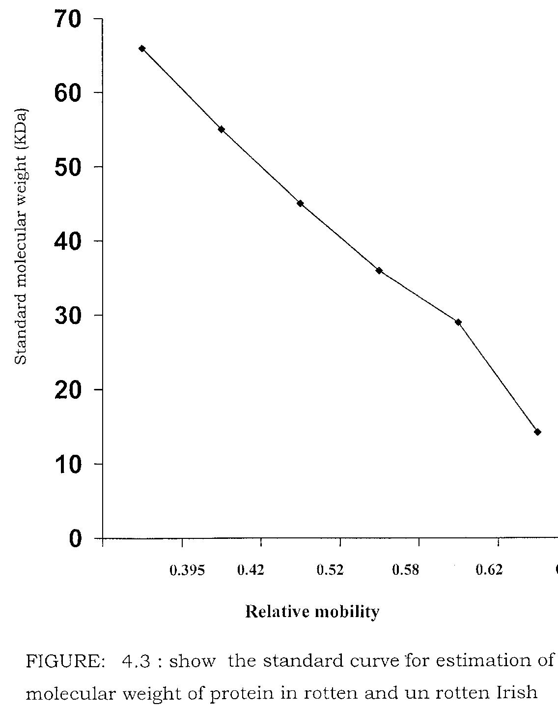

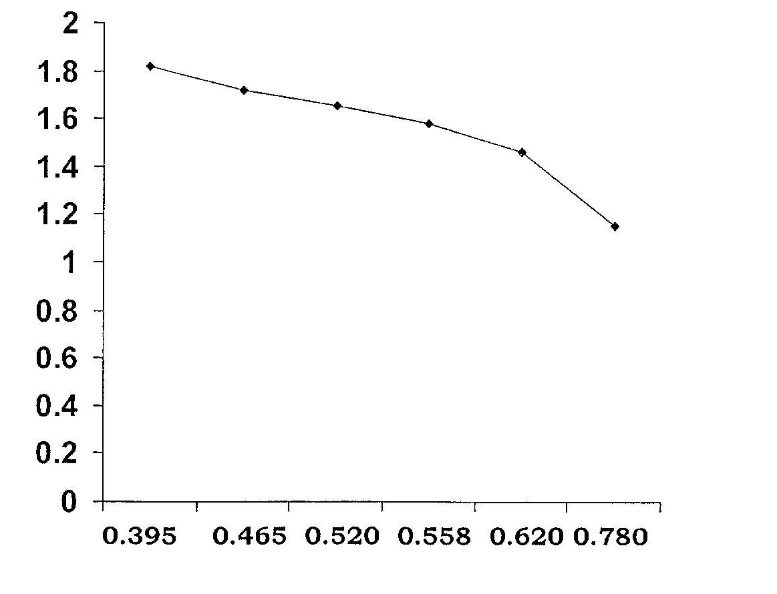

0.25

0.20

0.15

0.10

0.05

0

Log of molecular weight

Relative Mobility
FIGURE 3.3: Shows a Graph of Log Molecular Weight against Relative Mobility of Un-Rotten and Rotten Irish Potatoes.

KEY
R = ROTTEN
U = UNROTTEN

0.395 0.42 0.52 0.58 0.62 0.78

Duration of Storage (Days)
FIGURE 3.4: Shows changes in pH during storage using titratable acidity
pH
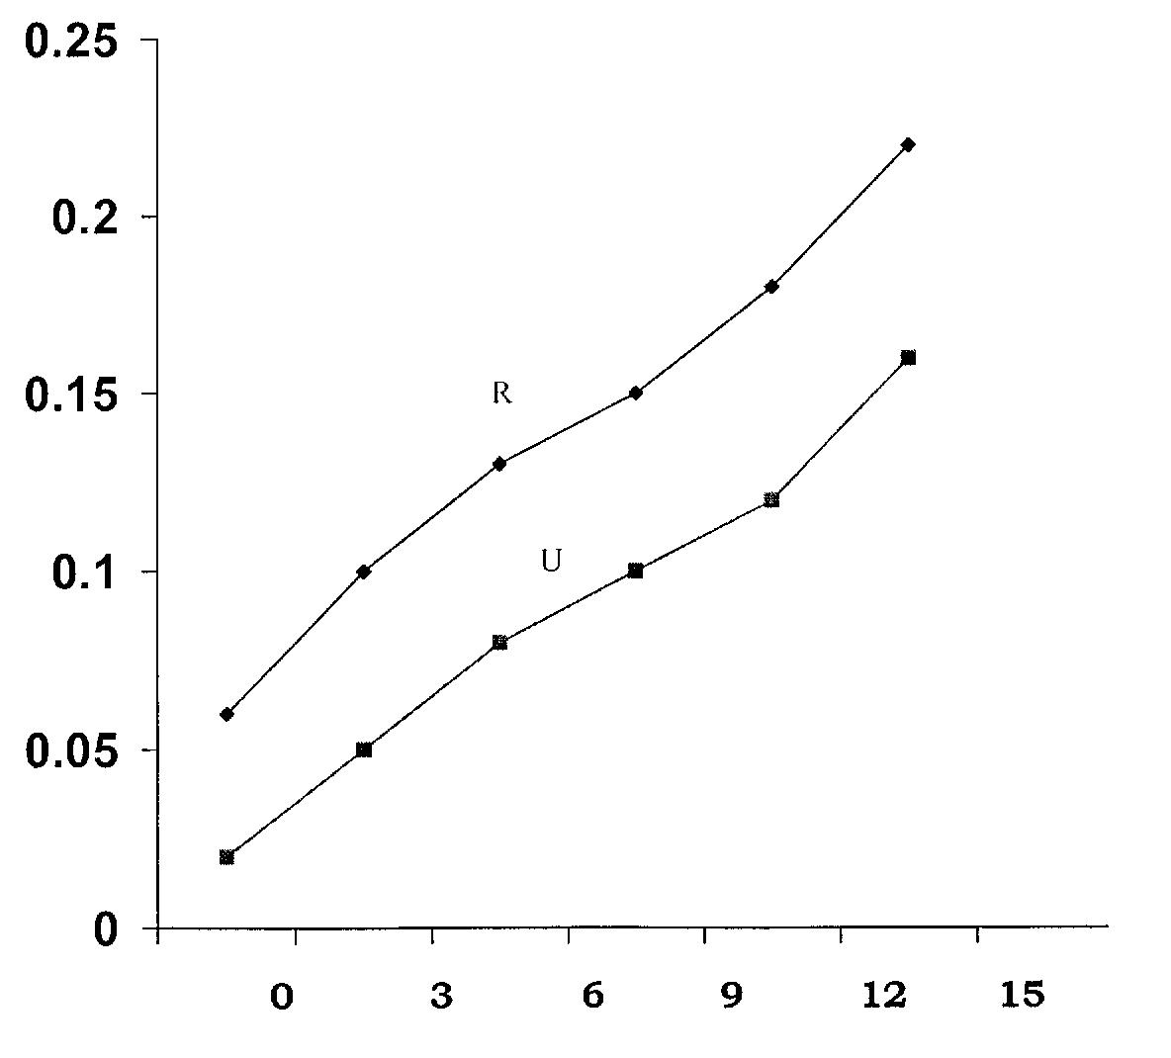
4.0 DISCUSSION, CONCLUSION AND RECOMMENDATION

KEY
R = ROTTEN
U = UNROTTEN

Duration of Storage (Days)
FIGURE 3.5: Shows changes in pH during storage using pH meter

4.1. DISCUSSION: Consideration for effective storage have always been prime concern to consumers, marketers and farmers in the production of Irish Potato especially in the tropics where control environmental condition of Irish potatoes become important in view of the fact that such tubers are prone to fungal attack, sprouting and weight loss. Successful attempt have been made in storing some Irish potatoes for relatively long time in good condition in Nigeria. These include studies on sweet potatoes (Nnodu, 1992), then Irish potatoes (Nwokocha, 1989). In this study, 460 Irish potatoes were bought from five major markets in Lagos and stored in 50, in each, ampoule under 6 storage conditions. Sliced onion has the highest value of rot 26 (52%), followed by dry pepper 22 (44%), sunlight 14 (28%), at room
pH
temperature 10 (20%), Refrigerator has value of rot 6 (12%) and ash has the lowest value of rot 5 (10%). The rate and 10% in this work of rot in Ash was lower when compared with the rate and percentage of rot 13.5% in a similar work reported by Kone (1991) in Mali. The lower rate of rot in this study could be attributed to the fact that the Irish potatoes were stored for 2 weeks in this study while in the previous study were stored for 6 months. There is no statistical significance effect on the number of rotten potatoes at 5% level of significance (P > 0.05) between difference storage methods.
Four fungi species were identified in this study: Fusarium solani (40%), followed by Fusarium oxysporum (26.7%), Aspergillus niger (23.3%) and Penicillium species (10%). Four genera also isolated by O. Faboya (2007) in Nigeria on production of oxalic acid by some fungi infected tubers of Irish potato.
Tuber rots are by far the most threatening problems in the storage of Irish potatoes. Potatoes are mainly harvested during raining season. In most potatoes farm the field is frequency waterlogged like in Jos Plateau State, Nigeria. Tubers from waterlogged fields are pre-dispose fungal and bacterial infection and such tubers have high rate of rot in storage (Okonkwo, 1992).

Mycotoxins are toxic of secondary metabolites of low molecular weight compounds that do not produce immediate symptoms and they are harmful to humans (Conner, 1993; Corrier, 1997; FDA, 2004). Aspergillus niger produces ochratoxin which is carcinogenic. Penicillium species may produce mycotoxin (Conner, 1993; FDA, 2004). Fusarium species that cause dry rots are also important to the consumer because some, Fusarium that cause dry rots also produce mycotoxins, one of such toxins is trichothecene which is an inhibitor of eukaryotic protein synthesis and can pose serious health problem to man and animals (Beremaid et al, 1991).
The results also showed that the mean pH values of rotten and un-rotten Irish potatoes in this work were 5.28 and 6.58 respectively while the moisture value of rotten and un-rotten Irish potatoes were 77.54% and 72.07% respectively. All the results obtained in this work were conductive for growth of fungi especially Asperigillus and Fusarium species. This was also observed with the work done by Wheeler et al (1999), on the influence of pH on the growth of some fungi species of Aspergillus, penicillium and Fusarisum in which it was establishment that growth can take place over the pH range of just above 2.0 to 7.2. Wheeler et al (1999)) also reported that the pH of tubers and their preservation methods play some major roles in the killing or survival of fungal in tubers.

The proteomic analysis of the skin of rotten and un-rotten Irish Potatoes showed that their relative nobilities were 0.558 and 0.465 respectively while their molecular weights were 38.5 KDA and 53.0 KDA respectively Gel-Electrophoresis (SDS-PAGE). In Japan, (Katou et al; 2003) also reported the molecular weights of tubers to be ranged from 45.0KDA to 51.0 KDA.

4.2 CONCLUSION
From this study the following conclusions were made:
i. Irish potatoes without preservation or proper storage method are likely prone to fungal spoilage, as a result wood ash is recommended to be an appropriate storage technique for Irish potato tubers.
ii. Of all the fungal agents of spoilage that were isolated, some release mycotoxins which are toxic and can pose serious health problem to man and animals
iii. Storage at low temperature favour complete rotting of potatoes and at lower temperature rotting stops. The higher the moisture contents the lower the pH value of the potatoes and also the more the fungal spoilage.

4.3 RECOMMENDATIONS
In order to prevent the fungal, that causing rot in Irish potatoes, the following recommendations are hereby suggested.
- Early harvesting and proper storage condition.
- Improvements in handling and good manufacturing practices (GMP).
- Segregation of rotten Irish potato tubers from un-rotten ones.
- Public enlightenment of fungi, mycotoxins and the health risks at the grass root levels.

REFERENCES
- A.O.A.C (2000). Official Methods of Analysis of the Association of Analytical Chemists 17th Washington, D.C.U.S.A.
- Ali, M.A (1992). Effect of Cultural Practices on reduction infestation of Potato tuber Moth (Pathorimean operacula) and greening of tuber G. Sudan, Annuals of Applied Biology D.C 219.
- Beremaid, M.M Desjardin, A.E Holton, T.M and Vanrmidale –Worth, F.I (1991) Survey of Fusarium Sanbicus (Gibberella Pukaris) for Making type. Trichothecane Production and other Selected trails plans disease 51:29-45.
- Button W.G; (1970). The Potato 3rd ed. Longman group, Ltd, (286-360).
- Conner, D.E (1993): Naturally-occuring compounds. In Antimicrobials in Foods, 2nd ed. (Eds. Branner, A.L. and Davidson, P.M) New York, Marce Dekker 12: 64-66.
- Conner, D.E (1997): Mycotoxicoses Mechanisms of Immuno suppression. Vet. Immunopathol 30: 73-87.
- F.A.O. (2008). Nation –International Year of Potato, 2008 www Potato 2008. Org.
- F.D.A (2004); The juice HACCP Hazards and Controls Guidance. FDA/CFSAN Web sit http://www.Lfsan fda gw/dms/juicegu10. html Accessed 20th May 2005.
- Faboya, O. Ikotun, T and Fatoki, O.S (2007). Production of Oxalic acid by some fungi infected tubers. Journal of Basic Microbiology Environment Health Techniques. 56:94.
- Finglas, P.M and Faults, R.M (1989). National Composition of UK retail potatoes, both raw and cooked. Journal of science food and agriculture 35:1345-1356.
- Hanson, L.E, Schwager, S.J and Loria, R (1996) Sensitivity to thiabendazole in Fusarium Species associated with dry of potato phytopathology, 86: 378- 384.
- Haris, P.M (1992). the potato crop, The Scientific Basic for improvement Chapman and Hall London 909.
- Katou, S. Yamato, A. Yoshioka, H. Kawakita, K. Doke, N. (2003)Functional analysis of potato mitrogen activated protein-kinase St. Meki J. Gen Plant Pathol 69: 161-168.
- Kone E. (1991) Traditional Methods for Prolonged Storage of Sweet Potato in Mali www.in.ico.cisti.ner, 1991.
- Larone, D.H Ed (2002) Medically Important Fungi; A guide to identification 4th ed. America society of microbiology Press, Washington D.C; 88-90.
- Nielson, L.W. (1981) Fusarium dry rots: In compendium of potato Diseases, 58-60.
- Nnodu, E.C. (1992). Storage of Fresh Sweet Potatoes tubers (Ipomea batatas) using moist saw dust, Nigeria. Journal of Plant protection 14:29-32.
- Nwokocha, H.N (1989) Construction and Evaluation of Ware Potatoes store Annual Report. National root a crop Research Institute, Umuahia, Nigeria.
- Okonkwo, J.C (1992) Potato Production in Nigeria, Training Workshop Paper National Root Crop Research Institute Vom, Jos. Nigeria 63.
- Powelson, M.L Johnson, K.B and Rowe R.C (1993) Management of Diseases caused by soil borne pathogens. In: Potato Health Management Rowe, R.C (ed.) The American phyto-pathol. Soc., St. Paul. Mn, USA, 149-158.
- Raman K.V Booth R.H and Palacois (1987) Control of Potato tuber moth (phthorimaes operculella) in rustic potato stores. Tropical science 27:175-194.
- Smith. D.A (1991). Factors affecting consumers choice among types of potatoes: A multinomial logic analysis. American Potato Journal 68:87.
- Wheeler; K.A. B.F. Huraman, and J.I Pitt (1999). Influence of pH on the growth of some toxigenic of Aspergillus, Penicillium and Fusarium. Int. J. Food Microbiol 12: 141-150.

10/13/2012

