Theory of the quantized attraction

Badr Amr Yahia

Veterinary Physician, Bachelor of Veterinary Medical Sciences, Cairo University, Cairo, Egypt
amor_vet33@yahoo.com

Abstract: The visual cosmos includes some devious phenomena which indicate presence of some dark matters that affect it directly and indirectly. Also, the stability and the sustainability of the universe for millions of years refer to a single law that controls all bodies, hence unifying all forces of attraction. Thus, deep thinking about these dark matters becomes necessary nowadays. In addition, the more the knowledge about the dark matters, the more the possibility to discover new mechanisms of some current terms, like electromagnetism and superconductivity. This paper describes the theory of the quantized attraction as a supposed model for what is called the theory of everything.
[Badr Amr Yahia. Theory of the quantized attraction] N Y Sci J 2013;6(3):35-43]. (ISSN: 1554-0200). http://www.sciencepub.net/newyork. 6

Keywords: superconductor; gravitation; electrons; photons.

Introduction:
There are many signs of universal symmetry. This necessitates presence of a certain law that controls all bodies in the universe and unifies all forces of attraction. We can prove, by this theory, that nature is programmed to save its energy, spending serious immolations for this concept. Energy is life-long while matter is not. It is also the most probable secret of creation, since it is the factor of both; construction and destruction.
Main postulates of the theory:
- All of the attractive forces submit to a single basic law of attraction.
- Charges depend on the energy content and they always submit to the concept of relativity.
- All similar neighboring matters are attracted as long as there is no cause of repulsion.
- Both of matter and wave have the same mechanisms of energy transferring.
- If an energy deficient matter exists in the field of a high energy attraction system, it unifies with similar matters in order to sustain. If it fails to unify, it will be annihilated at once.
Rules of energy transferring:
Energy transfers according to its difference in different matters and their charges. There are three cases classified as follows:
A- Allowed transfer:
Passive transfer (P.T.): Energy moves from the higher energy side to the lower one as long as there is no wide energy gap between them. [E.g. thermal equilibrium between two neighboring matters with no wide temperature difference]
P.T

+
+
P.T

+
Diagram 1- showing the cases of the allowed transfer

- Forbidden transfer :
- Safe forbidden transfer (S.F.T.): Energy does not move when there is an energy deficient matter existing in the field of attraction of a negatively charged matter. A barrier is formed to prevent their contact. [E.g. disconnection between a diamagnetic element and a magnet].
- Violent forbidden transfer (V.F.T.): It occurs when an energy deficient matter becomes in direct contact with a negatively charged matter. The first is susceptible to dislodging, distorting or even destroying. [e.g. Dislodging : in case of the superfluid Helium at which it moves against gravitation, Destroying: in cases of destructive electrical arc, destructive wave interference, and destructive laser beam]
V.F.T

-
IN DANGER
S.F.T

-
Diagram 2- showing the cases of the forbidden transfer

What is the source of any attractive force?
Any attractive force refers to presence of a potential difference between a higher energy matter and a lower energy one. In other words, attraction is just a complementary relation between two matters; one of them is an entrusted matter (i.e. the higher energy matter) that losses some extra energy before reaching its suitable abode (i.e. the negative potential matter), in order to eliminate such difference and to achieve stability. This simple mechanism enables the eddy wind or the eddy current in a sea to attract any neighboring massive body. The attracted matter should have enough potential energy (PE) that is higher than the value of the attraction potential (AP) as a condition for attraction. The process accomplishes when the attracted matter becomes motionless (in case of fixed attracting matters), whereupon the potential difference is depleted.
Consequently, the force of penetration (Fp) of an energetic matter refers to the change in its motion (∆KE) which refers to the net difference between the kinetic energy (KE) and the reverse kinetic energy (RKE) that works against gravitation, while KE is determined by the potential difference (Pd) between both of the matters. Furthermore, the potential difference (Pd) is determined by the difference between the potential energy (PE) [at a certain point that lies at a certain distance from the attracting matter affecting a certain area (A) of its field] and the attraction potential (AP) of the attracting matter that is constant per the unit of area of each attracting matter. The relation can be expressed in the Fp equation (or the basic equation of attraction) as follows:
Fp=∆KE= KE-RKE= Pd-RKE= (PE/A)-AP- RKE

So, the attracted matter stops in motion in two cases:
  - When (in absence of an interfering matter).
  - When (in presence of an interfering matter).
If PE/A is higher than AP, Fp gets a positive value and the meant matter is affected by the attracting matter (conditioning that RKE is not higher than KE). If PE/A still be higher than AP after reaching the attracting matter, what means that the attracted matter has excess KE, it works hard for getting rid of the excess Fp and KE by induction of an equivalent RKE; because ∆KE should finally equal zero. This case resembles the action of a tennis ball when powerfully struck toward Earth which provides KE with a positive charge that is reflected in the form of repeated motion of the ball against Earth till losing the excess energy.
In contrast, the value of KE may be negative when PE/A is minimized to become lower than AP; what is meaning that the mass of such attracted matter is not qualified to exist at this point without getting extra KE. In order to do that, it has to attract suitable active particles and bring them to the surrounding area in order to achieve stability. Here we can say that the original attracted matter has a negative potential; so that it can get its own attractive power. For example, the negative potential of a magnet enables it to attract the active valence particles of a paramagnetic element toward it.
What is gravitation?
It is a change of residence of the attracted matter that has enough potential energy (PE) through a certain field of attraction due to presence of an attraction potential (AP) of a negative potential matter. The attracted matter (that can be called “graviton”) is massive comparing with the other attractive force (to be mentioned later) and the former usually moves with an acceleration value (g) that is specific to each gravitational matter.
Gravitation submits to the above mentioned equation
Fp=∆KE= KE-RKE= Pd-RKE= (PE/A)-AP- RKE

Since refers to the force of penetration (Fp) of the attracted matter affecting vertically through the field of attraction of a specific attracting matter, and where PE=mgd, the value of in a graviton can be calculated as:
Fp=∆KE= KE-RKE= (mgd/A)-AP- RKE

Where m refers to the mass of the attracted matter, g refers to the gravitational acceleration, and d refers to the distance between the two matters. Accordingly, equals zero once the value of equals RKE. We can declare that AP of any gravitational matter takes the unit of Kg. s⁻² and it can be calculated by determining the value of mgd/A of the matter that has the highest density from all matters which are not attracted to the meant attracting matter (conditioning that there is no interfering matters). If we are able to do this, the value of both; Pd, KE, and RKE at this case will equal zero.
What is the electromagnetism?
Electromagnetism is that form of attraction which affects the high energy matters. It is a combination of some attractive forces which share the same fact that they can affect an electronic mass, although they affect other particles individually. However, each force should be studied singularly; because of the difference of the energy value of the common particle in each, owing to the difference in the negativity of each attracting system.
First, we should modify our knowledge about the concept of “black body radiation” before unifying the most common attractive forces.
Light absorbance & black body radiation:
* At the macroscopic level:
The package of the visual light is formed of seven colored spectra; each of which has a certain energy value that refers to a certain frequency. This package is kept coherent as long as being interfered by an energy deficient matter, like the white objects. Contrary to that, the black object is that one which is capable of interfering with the whole package of the visual light so that it can absorb all frequencies of it collectively. So, it absorbs all and emits nothing.
The colored objects lie at the midlines; since all of them have certain degrees of energy, so they partially interfere with the falling light package, resulting in absorption of few or many, but not all, of its spectra according to the energy content.
* At the microscopic level:
The degree of light absorbance in atoms depends on the activity of their valence particles. When the particles are fixed, as in diamond and glass, light absorbance is prohibited, submitting to S.F.T. of energy. Consequently, such interfering matters are transparent. But when the particles have suitable energy, some of the light’s energy is absorbed by them, leading to decreased speed. For the same reason, the speed of light reaches its maximum in plasma, because all plasma atoms are ionized and the energy values of their valence particles are minimized, so wide energy gaps are found between the photons and the valence particles. This results in keeping the light’s energy and speed constant.
Considering the Planck’s distribution and our theory, at very high frequencies, the energy gap is maximized between the radiating system and the surrounding matter while the former seems to be closed; so that it can emit nothing. So, radiation emission diminishes when the number of emitted rays decreases, and the value of decreases, while at very low frequencies, there is no power for radiation, so it can neither absorb nor emit the higher energy waves like light photons.

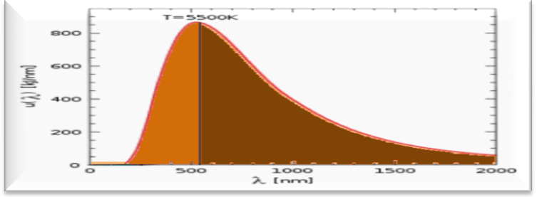
Negative body

Positive body
Neutral body
Black body

Diagram 3- Shows the relation of charges to Planck’s distribution

In his great theory, M. Planck said: "The concept of the black body is an idealization, as perfect black bodies do not exist in nature¹” This saying has been widely accepted because a perfect black body should absorb all radiation waves falling on it, at all wavelengths, with zero emission, hence it would be unvisual if found. Accordingly, the Ultra speed dark matter (to be discussed later) may be the missing link; as it absorbs all lights, but emits nothing.
Can the Fp equation be applied on the high energy matters?
Yes, exactly. But this cannot happen without supposing the presence of a high energy attracting matter. However it is unseen, I can admit that such matter is actually present; since its effects are brilliant. The higher potential side is the light (or the irradiative) source, while the lower potential side is an unseen (or dark) matter that is circuiting the whole visual cosmos. It can be called “the ultra speed dark matter” or shortly as “USDM”. It moves in extremely rapid circles that deviate in a period of time lower than 10⁻⁸ of a second per each degree to cover all degrees forming a globe, regularly and persistently, however the circumference of the circles may extend by time periodically. This unconventional motion with its superior speed seems to cover an imaginable globe in a fraction of a second. This can be realized when thinking about the behavior of the spontaneous emission of radiation during the process of Laser production. The extremely short lifetime - that is required for deviation of the direction of the emitted photons - can be logically considered as a reference to the highly speed motion of the USDM. Another reference can be seen daily when monitoring the process of metal welding and the multi-directions of the released lights that refer to the different time of releasing for each.


Diagram 4: Showing the process of metal welding

But firstly we should determine the value of both KE and PE of the matters attracted by the USDM.
Determination of the values of KE and PE in the USDM:
The energy of any matter equals the sum of both of kinetic and potential energies, so
1
[E=KE +PE]-------
In the gravitational matters there are values of gravitational acceleration (g), so increasing of any of the two energies, either KE or PE, means decreasing in the other.
In contrast, USDM has no gravitational acceleration value, so, the attracted waves have constant speed values, so we can suppose that increasing in any of the two energies does not inversely affect the other one. Hence we can suppose that each of them equals half of the net energy of the wave. So:
2
[KE=PE=¹/₂E]-----
As E of photons equals h , and after compensation in equation 2 we can conclude:
3
[KE=PE=¹/₂ h]----
Where h refers to the Planck’s constant and refers to the frequency of the accompanying wave.
Now we can easily calculate the value of Fp on the USDM system by the last equation (i.e. equation 3).
Calculation of Fp of the waves attracted by the USDM:
As the force of penetration (Fp) refers to , and while the occupied area affected by any wave can be supposed to equal the peak amplitude square (A²) of the wave, the value of in the USDM system can be expressed as [(PE/A²)-AP], so Fp equation can be modulated as:
Fp=∆KE= [ h]-RKE= Pd-RKE= ( h/A²)-AP-RKE

In case of vacuum conditions, RKE equals zero, so the attracted photon does not stop before reaching its attracting matter, as long as it has already been attracted and it is neither interfered nor attracted by any other external matter. That is to say, it is a matter of possibility; to move or not to move. But once a photon is attracted and not interfered, it neither stops nor deviates, however the USDM is not fixed; because the periodic time of the latter is extremely short.
Here we can limit the difference between both of the systems; the USDM system and the gravitational systems, in the speed of the attracted matter whether it has a mass or not, the form of their motion, and the energy richness of each attracting matter. The following comparison, in table1, clarifies such difference.

Table 1:
Items of difference | USDM system | Gravitational systems
Features of the attracted matter | Wavy particle | Massive body
Form of motion | Wavy | Vertical and straight
Speed of attraction | Constant | Variable with presence of specific g for each system
Speed of the attracting matter | Extremely rapid motion | Slow motion
Mode of attraction | Decentralization | Centralization
Demonstrating drawings (Notice the direction of the arrows) | 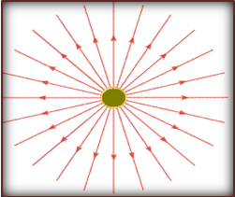 | 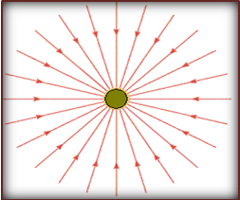

The following forces lie at the midlines between the above mentioned forces. So let’s study them individually.
- The electrical force:
It is a potential difference arising between a high energy side, represented by the positive terminal of a circuit, and a lower energy side, represented by the negative terminal of a circuit. While the former is the source of the attracted matters (i.e. the electrons), the latter is the attracting side that has negative potential compared to the former. As a result, the released electrons have relatively low PE at the positive side, but high PE at the negative side, so they travel away toward the latter in order to achieve stability. Once they reach it, the negativity is neutralized and the potential difference is depleted.
- The magnetic force:
It is a case of negativity occurs due to presence of lower PE/A² comparing with AP of the USDM, so the magnetic matter gets its own attractive force in order to absorb some kinetic energy that neutralizes its negativity. The magnet attracts the active valence particles of the nearest paramagnetic element in order to achieve stability. The diamagnetic matter has neutralized valence particles, so the net property of them is neutrality, since KE equals RKE, so ∆KE equals zero. The active valence particles can also be gotten from the current. This process makes the associative relation between the magnetism and electricity in what is called “electromagnetism”.
- The centrifugal force:
It is a force opposite in its action to the magnetism; since it results in higher AP than PE/A² of the centrifuged matters. This results in occurrence of a case of positivity (in the center of the centrifuge) against the negativity of the USDM. The process leads to repulsion of the massive matters toward the outside, so the higher the molecular mass, the lower the KE, and consequently the higher the RKE of the massive matters. We can re-describe the former process as an actual test for the centrifuged constituents to express their PE. Fortunately, this effect is desired in many scientific fields, including physics, diagnostic medicine, etc.
Application of Fp equation on flotation:
In case of the free falling of water, there is Pd between the falling water molecules and Earth, so its molecules are attracted until PE/A decreases to neutralize AP of Earth. The water system becomes stabilized when ∆KE equal zero. Any further pressure induces development of KRE, expressed in an upward motion of the pressed water molecules, so, the created KE of the added matter will not be effective as long as it does not exceed KRE of water. Accordingly, presence of an atmospheric pressure creates work that is expressed in PE/A of the air column and it induces an equivalent and opposite reflex from the stabilized water. Such stabilization arises because ∆KE at this level equals zero, while KE equals RKE as well. The same result is obtained in case of hanging of a piece of cork on the water surface, since ∆KE= [(KE of cork + KE of the air column) – RKE of the water surface] = Zero.
On contrary, a piece of metal has a high ∆KE than that of a cork having the same mass, due to the density variation that lowers the value of A (where KE=Pd= [(PE/A)-AP]). Therefore, KE of a metal piece is higher than RKE of the water surface molecules. So the metal piece sinks while the corresponding cork piece floats. In case of the ships, the affected area (A) is so high, so the value of ∆KE is low and does not exceed the value of RKE of the water surface. So the ships float like corks.
Novel concepts:-
- Wave – particle duality in sound:
It is known that there is wave – particle duality in the photons. However, sound is known to be an exception from this concept because it cannot be carried through the vacuum. I think that this is an incorrect view; since sound waves have their carrying particles as well, which are represented by the (intra-atomic) valence electrons, but such particles, with their weight and the low carried energy, are not qualified to be attracted by the USDM. Furthermore, due to the low energy of sound particles, their speed are maximized in the cold dense solids; because cooling of atoms decreases the activity of their valence particles, while their speed is also maximized in the hot gases; due to incidence of F.T. in the two cases that keeps the wavy particles from scattering. Accordingly, sound particles are not carried through vacuum because the value of PE/A² in sound particles does not exceed AP of the USDM, so ∆KE =KE=Pdzero, since RKE equals zero in the vacuum. This uncovers the value of AP of the USDM. But the value of PE in sound does not equal ¹/₂ h but ½ mv²; because the electronic mass is somewhat considerable, apart from the photon.
Therefore I expect that the false belief can be gone away if we succeed in concentrating numerous similar sound waves to occupy the least possible amplitude square; so that the value of PE/A² can be maximized to exceed the value of the AP of the USDM. At that time the sound would become qualified to invade the vacuum conditions.
2- Extra dimensions of matter:
Beside the known space – time (3+1) dimensions of matter, our theory supplies us with the kinetic dimensions which depend on the value of ∆KE. These dimensions are positive, negative, and neutral charge. So the matter's dimensions extends to cover the triplex of space-time-charge (3+1+3).

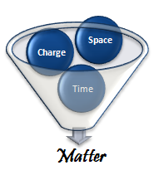
The kinetic dimensions are always interrelated. As a result, each matter can take all or some of these dimensions. That is to say it is a matter of relativity. [For example; matter(X) can be negative in relation to matter(Y), but positive in relation to matter(Z), etc]. It can take only one of them when being energetically radical or having an absolute charge which are extremely rare .
These dimensions have critical impacts on the matter’s behaviour,including force and direction of motion, distance from the other matters, the degree of visibility, the atomic reactivity, and even the matter's sustainability. It is not false to say that the kinetic dimensions have impacts on the space dimensions themselves; since any change of the formers, directly deteriorates the latters. (For example: deterioration of the energy content of a cube of ice, by heating, does directly detriorate the space dimensions of it). The following diagram (diagram 5) shows the supposed dimensions.

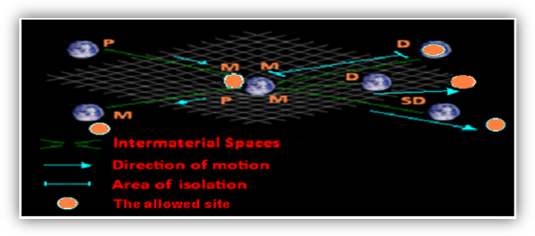
Diagram 5 showing the charge dimensions exemplified in magnetism
(Note that: P= Paramagnetic, M= Magnetic, D= Diamagnetic, SD= Super-diamagnetic)

While ∆KE in paramagnetism has a positive value, it has negative value in super paramagnetism (i.e. when similar poles meet) , and it equals zero in case of diamagnetism as long as the suitable distence is not cut, if so, ∆KE would have negative value.
3- The phenomenon of the white body:
The white body is that matter which does not absob nor emit a certain form of energy. But, unlike the black body, the white body is formed of energy difficient matters, relatively, which unify with each other to form a single united matter in order to sustain in the USDM system. This process submits to the principle shown upward that “All similar neighboring matters are attracted as long as there is no cause of repulsion”. The following table shows examples of different white bodies and the resultant effects of solidification.

Table 3-
White body | Solidified units | Effect
Solid matter | Solid atoms | Providing auto-attraction and keeping of its shape whatever its position and inclination in relation to Earth or any other gravitational matter.
Bose-Einestein Condensates (BECs) | Supercold valence electrons | Providing unique characters to the supercold gaseous atoms including superfluidity and domination of the wave characters.
Visual light | The seven spectra of light’s photons | Occurrence of the unified feature of the light’s beam that requires special conditions in order to scatter.
Laser | Monochromatic light photons | Providing unique characters to Laser beam including collimation, coherence, and intensity for very long distances.
Noble elements | Electrons of the filled shells | Over-stability of them leading to increased melting and boiling point.

- The phenomenon of “white body duality; transparency and opacity” :
As we have mentioned upward, the white body can neither absorb nor emit a certain form of energy. Therefore, when it meets a high energy matter, there will be cases of F.T., so, the form of energy will be transferred honestly or prohibited absolutely. The factors which determine such opposite fates are related to the free spaces between the white bodies and whether they allow existence of areas of isolation or not, in addition to the amplitude of the transferred wave. The term of transparency here means perfect conduction of the transferred energy. It does not restrictly refer to light, but to all forms of energy. This phenomenon is fully advantageous; as it guides us to a perfect conductor, or a perfect isolator, for each form of energy.
For example, the valence particles of carbon atoms in both of; graphete and diamond, are energy deficient. However, the former is light-opaque; because the area of isolation is difficult to be existed, while the latter has enough spaces, so it is light-transparent. The phenomenon also lies behind the necessity of incidence of wide diameter for occurrence of superconductivity.

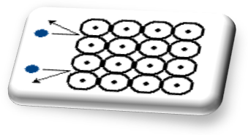
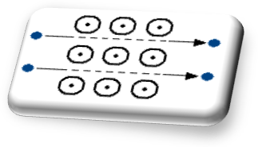
Diagram 6: showing the duality of the white body; transparency (on the right) and opacity (on the left)

- The electron cycle:
Electron is actually an amazing particle; it has minute mass and volume, so it can be attracted by most of the attracting matters, according to the different quantized energies which can be loaded on its mass. It seems to be desired or disputed by many systems. The electronic flexibility enables electrons to enter in different stages and phases. The phases collectively represent what can be expressed as the electron cycle. That’s to say there is an electron cycle including solid (or Necroton), liquid (or hydro-electron), and gaseous electron (or electron), in addition to the independent phase that can be called ‘’the massive photon’’. However, most of our cognizance about electron is greatly associated with the latter two phases. The following diagram (diagram 7) shows the electron cycle.

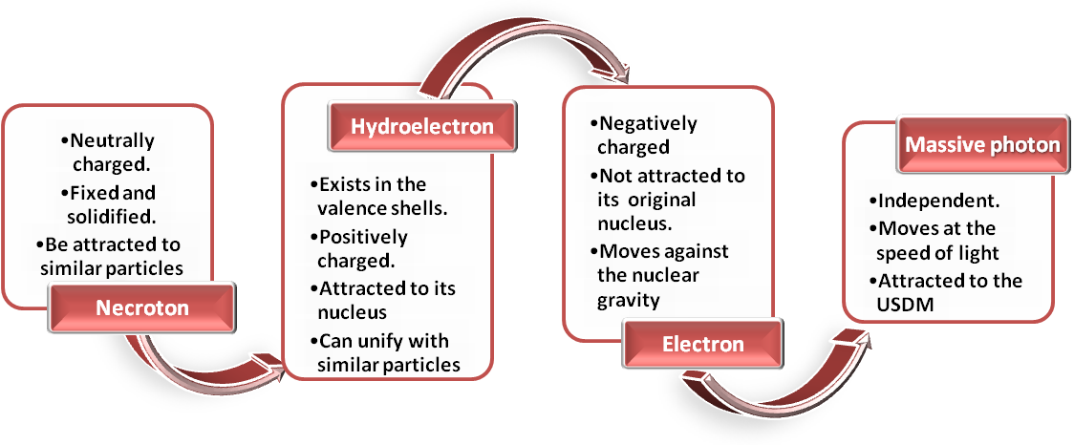
Diagram 7: Showing the electron cycle

Modified understanding about the relation between electromagnetism and superconductivity:
It can be summarized in the following points:
Magnetism:
- In the magnets, there are cases of negative potentiality; owing to the domination of the USDM that is viable even in the field of attraction of any other attracting system. This negativity refers to the lower PE of the magnetic matter itself, so its ∆KE has a negative value.
- The negativity represents a case of instability that results in the attraction of external active particles in order to increase the net PE occupying a certain surrounding area and to minimize the instability. The source of such particles is the current electrons, or the active valence particles of the paramagnetic materials. The result of attraction is the increased PE/A sequenced by increased KE and ∆KE (But in the diamagnetic materials, KE is neutralized by RKE of the pair partners, as we have mentioned upward).
- However, each magnetic body tends to overcome the instability, even in absence of such active particles, by differentiation into a positive and a negative pole; as a trial to restrict the area of negativity. While the positive pole is more stable, the negative one is less stable and it still acquires extra energy from external active particles in order to neutralize its negativity. If it meets another magnetic body, it attracts the opposite pole of it. If It meets a similar pole (i.e. a negative pole), the case of instability increases, so a force of repulsion dominates.
- It is more interestingly to note that the current electrons themselves are considered dipolar magnets, and they behave just as a magnetic rod. This observation can be felt when induction of two currents in two parallel wires. In case of opposite currents, the similar poles meet, so repulsion dominates between the two wires, while in case of the unidirectional currents, the similar poles cannot meet, hence attraction dominates.
Electricity:
- On conduction of a paramagnetic material to an electrical source, the valence particles (or the hydro-electron) are attracted to the negative poles of the current electrons, so the current is interfered by such attraction. The net result is exhaustion of the current electrons expressed in suppressed motility and increased resistivity with consequent increased temperature of the conductor.
- In cases of diamagnetic conductors, the neutrality of ∆KE of the valence pairs prevents occurrence of attraction, so repulsion occurs. Consequently, the current electrons get their possible ways through the intra-atomic spaces as long as the valence shells have minimal numbers of the hydro-electrons that provide enough spaces which allow disconnection with the valence particles. For the same reason, the wider the conductor, the lower the resistivity. This action supports the current because it saves its intensity. But, by time, the atoms loss their neutrality due to increased flow of electrons that induces ionizing of the atoms, this results in increased heat and resistivity gradually.
Superconductivity:
- In the superconductors, super cooling of atoms not only absorbs all of the energy of the valence particles converting them into necrotons, but also allows auto attraction and pairing of them, just after conduction to a current source, to face the threatening danger of the high energy shocking of electricity, so they are enforced to unify in order to sustain. Furthermore, the current electrons are kept neither disrupted nor interfered, so that they can solidify to form a coherent union that is auto attracted and they get their best situation. The latter union acts as a beam that looks like the laser beam which keeps its energy without any loss, but it requires a wide diameter to exist through it, so superconductors are not be achieved in (thin) wires. It also requires wide diameter of the attached conductor to be transferred into it, so it cannot travel away from the superconductor and the current persists forever. It also should be made of paramagnetic materials in order not to repel with the magnetic electrons of the current.
- This process allows a persistent polarization of the superconductor as long as it is kept below the critical temperature. Polarization is represented in the current electrons as the negative side, and the solidified necrotons as the positive side. This process transforms the superconductor into an electrical generator rather than a conductor.
- Furthermore, the beam of the current electrons seems to be closed, thus, their magnetism is not felt outside the beam, so diamagnetism dominates in superconductors. This case also looks like the laser beam which does not lighten anything outside it.
- Furthermore, I expect that we can get a high temperature superconductor from any metal having double valence particles in the valence shell by application of first ionization of it, followed by sudden cooling. This should achieve polarization of the metal and hence superconduction.
Future of the theory

By this theory, we can solve many scientific problems and explore many devious phenomena. The following points summarize some sequences of the theory and what we should looks for according to it.
  - A high temperature superconductor.
  - A superconductor of energy forms other than electricity.
  - A radiation absorbent to get rid of the radiation hazards.
  - Anti-gravity vehicles that would minimize the needed fuel for aviation.

Badr Amr yahia,
A Veterinary Physician, Bachelor Of Veterinary Medical Sciences, Cairo University, 2007 – He works in Researching. He tries to connect between sciences believing that all of them serve each other.


Reference
1. M. Planck (1914). The theory of heat radiation, second edition, translated by M. Masius, Blakiston's Son & Co, Philadelphia, pages 22, 26, 42, 43

1/28/2013

