Effects of Different Landuses on Soil Physical and Chemical Properties in Wondo Genet Area, Ethiopia

Fikadu Getachew^{1*}, Abdu Abdulkadir², Mulugeta Lemenih² & Aramde Fetene³

¹Oromia Bureau of Agriculture, Natural Resource Development, Protection and Utilisation Department, P.O. Box, 1397 Addis Ababa, Ethiopia * E-mail: gonfa2002@gmail.com
²Wondo Genet College of Forestry and Natural Resource, P. O. Box 128, Shashamane, Ethiopia;
³ Department of Natural Resource Management, Debre Markos University P.O.Box 269 Debre Markos, Ethiopia

Abstract: Landuses/land cover changes from natural forests to farmland, open grazing and fast growing plantation forests, and subsequent changes in soil physical and chemical properties are widespread in Ethiopia. The aim of this study was to identify and characterize the influence of different landuse changes on soil chemical and physical properties, and its implications on sustainable soil resources management. The types of landuses considered under this study were: farmland, grazing land, Eucalyptus saligna plantation and the adjacent natural forests. The natural forests provided the benchmark (control) against which the effects of the other landuses on soil properties were investigated. The result showed that some soil physical properties, particularly soil moisture and infiltration significantly differed between landuses under consideration. Soil moisture content under the plantation was lower than those of the farm and grazing landuses, but similar to the soil of the natural forest. Soil infiltration capacity was lower in the grazing land compared to the natural forest. However, significant differences were not observed on the soil chemical parameters considered (i.e. pH, soil organic carbon, total N, available P) among the different landuses. This result is not in agreement with the widely accepted notion that conversion of tropical natural forest to human-managed landuses causes extreme changes in soil chemical properties. The observed little or no effect of landuse changes on soil chemical properties might be due to a high resilience to landuse change attributed to Andosols. It was concluded that soil physical properties are more susceptible to landuse change than chemical properties in Andosols. This implies that managements of Andosols need to focus on strategies that improve the soil physical properties rather than soil chemical properties.
[Getachew F, Abdulkadir A, Lemenih M, Fetene A. Effects of Different Landuses on Soil Physical and Chemical Properties in Wondo Genet Area, Ethiopia. N Y Sci J 2012;5(11):110-118]. (ISSN: 1554-0200). http://www.sciencepub.net/newyork. 16

Keywords: Andosol, Eucalyptus saligna, Landuse, physical and chemical properties, landuse, Wondo Genet

Introduction
Landuse/land cover changes that involve conversion of natural forests to farmlands and open grazing are widely practiced in the highlands of Ethiopia. The effects of such landuse/land cover changes on soil resources of the country, particularly through soil erosion, have been reported in many scientific literatures (Hurni, 1993; EFAP, 1994; Hawando, 1997). The massive soil loss in the country is caused by its’ susceptibility to erosion due to the mountainous landscape coupled with mismanagement, intense rainfall and cultural practices of the farming community that leave the soil bare after harvest (Powell et al., 1995;Tadesse, 2002).
The concept of soil losses due to erosion is closely linked with processes of soil chemical (loss of nutrients through vegetation removal, erosion, leaching), physical and biological degradations (decline i soil humus content) (Young, 1997; Eyasu, 2002). Soil degradation in this article refers to the reduction in soil fertility due to various human managements. It is this variability of human activities (biomass burning, application of fertilizer, transfer of species, plowing the land etc.,) that are important immediate sources of the soil physical and chemical properties change in Ethiopia (Kebede, 1998; Taddese, 2002). The rate and extent of soil degradation through human influence is situation specific. For instance, soils of a given locality, which may have experienced similar pedogenic processes, can be differentially affected depending on the intensity of landuse activities exercised. Thus, susceptibility of soils to degradation must be separately assessed for each biophysical and socio-economic setting (Mesfin, 1998).
In Ethiopia, very few studies (Ashagarie et al., 2005; Mulugeta, 2004; Wakene & Elufe, 2004) have considered the effects of different landuse/cover changes, and their associated soil management practices, on soil physical and chemical properties. Ethiopia being a large country with large biophysical and socio-economic diversity, these previous studies were less adequate to describe the extent of soil degradation associated to landuse/land cover changes in the country. Thus, this study was carried out with the objectives to assess the effects of different landuses on soil physical and chemical properties and to compare the outcomes against the soil properties under natural forests in Wondo Genet area. The emphasis was to investigate how different landuse practices are affecting the soil properties under different management operating within the same soil forming factors.

2. Materials and methods

2.1. The study Site
The study site is located at about 263 km south of Addis Ababa, and 13 km to the south west of Shashemene town on the eastern escarpment of the great Ethiopian Rift Valley in the SNNP Regional state (Fig. 1). Wondo Genet is situated between 38⁰37’E to 38⁰42’E longitude and 7⁰ 02’ N to 7 ⁰ 07’ N latitude. The area is surrounded by a green chain of mountains that adds to the natural beauty of the area. It covers areas with wide altitudinal ranges, the highest peak being 2580 m.a.s.l. at mount Abaro and the lowest 1600 m a.s.l. The rainfall of the area is bimodal, with the main rain season between July and September, and a short rainy season from February to April. The mean annual rainfall is 1244 mm and the mean annual temperature ranges between 17 ^{º}C and 19 ^{º}C (Erikson & Stern, 1987).
According to makin et al., (1975) the main parent materials are volcanic deposits of ignimbrite, ash, lava and tuff. The geological bedrock of the area consists of mainly acidic rocks, sometimes inter bedded with lavas of basaltic composition, probably of tertarian origin (Eriksson & Stern, 1987). The soil of the study area is identified to be Mollic Andosol. Andosol is characterized by having soil bulk density of less than 0.9 kg dm⁻³, more clay and an Al_{ox}, high phosphate retention of 70 percent or more; and volcanic glass content in the fine earth fraction of less than 10 percent; and thickness of at least 30 cm (FAO, 1998; Brady & Weil, 2002). The soil pH of the study area varies between 5.6 and 6.5.
wondo Genet is a home to a remnant montane forest, which is located on protected and inaccessible mountain chains of abaro. At the foot of the mountain, there are different types of exotic plantation forests managed by Wondo Genet College of Forestry and Natural Resource. Patches of high forests with common species of podo carpus falcatus, pruns africana, Albizia gumifere, aningera adolfuferederci and croton macrostachyus are observed in immediate bottom of the mountain. Forest plantation within the college compound covers about 117 ha, where about 24% is made up of different Eucalyptus species (Hjelm, 2001).
The common types of landuse practices in Wondo Genet area are arable land, grazing land, natural forest, forest plantations and human structures, e.g. roads and villages. The farming system is mixed in which cattle raring are integrated in to cropping system. Grazing land is normally very scarce in the area and roadside, farm side narrow areas are used for grazing purpose. Often the natural forests and the plantations are used as grazing land. The main cereal crop grown in the area is maize followed by teff (Eragrostis teff). Ensete (Ensette ventricossum) is also stable food for the area, while chat (Chata edulis), sugarcane and various fruits (e.g. Persea americana, Musa paradisiaca) are major cash crops in the area.
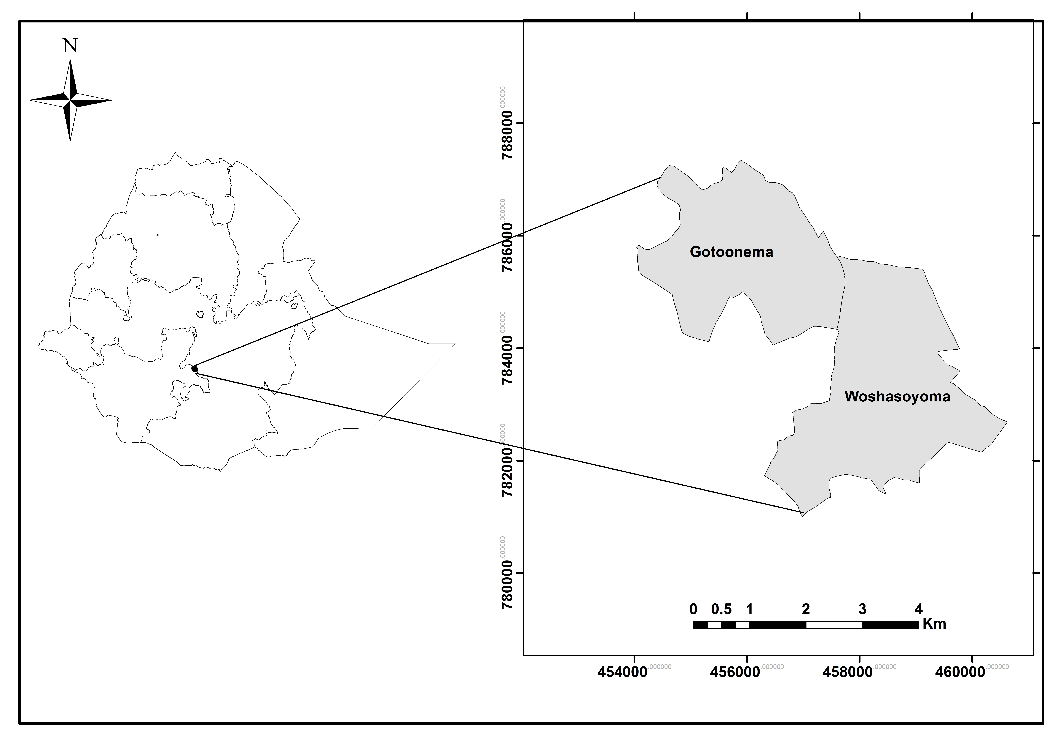

Figure 1.Map of Study area

2.2. sampling and analysis of Soil physical Properties
In this study, three blocks with four landuse types were considered. The landuse/cover types considered were farm land, Eucalyptus plantation, grazing lands and the nearby natural forest. The natural forest provided the benchmark (control) in reference to which the effect of other landuses on soil properties was studied. In each of the three blocks, five replicated soils from three depths were taken from an X design of 15m*15m square area. The five replicates were then bulked for chemical analysis and the average was taken for soil physical properties determination for each of the three depth intervals.
Representative, intact soil samples was collected with a manual core sampler of 10cm ht* 7.2cm diameter, from each landuse practice for soil moisture and bulk density determination in X design in five replications. The samples were collected from four corners of a square of 15x15m plot, with one from the center. It was separated into
0-15 cm, 15-30cm and 30–60cm depths after digging one pit on each sampling point. These samples were oven-dried at 105 ^{º}C for bulk density determination. Soil-water content was determined by standard procedures described for the gravimeter, with oven drying to a constant weight at 105 ^{º}C (Anderson & Ingram, 1993) for 30hrs. Finally, the averages of the five replications on each of the three blocks were enumerated separately for the three depth intervals to determine soil moisture and bulk density. Infiltration rate was determined in three replicates at locations close to where the soil bulk density and moisture content samples were taken. Soil infiltration rate measurement was performed using double-ring graduated turf-tec international infiltrometer (1989). The data was then collected at every 5-minte interval until steady state was reached, by maintaining the water at optimum level. The data recorded for beyond 30minute to 80minute was subjected to statistical analysis in one way ANOVA. This was for the reason that after 30minutes, infiltration somehow approached to a constant rate and assumed that constant rate would better explain the respective landuses infiltration characteristics.

2.3. Determination and Analysis of soil chemical properties
To determine the effect of different landuses on soil chemical properties, a total of 36 composite soil samples were taken (4 landuses*3 soil depths*3 replicates). Five pits were dug, in an X design of 15m*15m area, on each plot of landuse types in the three blocks and soil samples were taken from different depths by inserting a soil corer into the wall of the pits. Soil samples were taken from the pits by scuffing the wall of the soil profile for respective depth; the lowest first and the top soil at last to avoid contamination between the two layers. For all sample units, about 1kg of soil was taken. Then, the soil samples from each pit (the five) were bulked together to obtain composite soil samples for each replicates (three blocks) in three depth intervals and the four landuse types. Soil clods in each composite sample were thoroughly broken to make a uniform mix, and then divided into four equal parts from which two diagonal parts was retained and the other two parts removed. This process had continued several times until successive quartering reduced the weight of a composite sample to about 0.5 kg.
About 0.5 kg collected soil samples were air-dried, homogenized and made to pass through 0.5mm sieve for chemical (pH, OC, available P and total N) analysis. Soil sample tests for organic carbon, total nitrogen and total available phosphorus were done in a soil-testing laboratory of Water Works, Design and Supervision Enterprise in Addis Ababa. PH analysis was done in soil water ratio of 1:2.5 in Wondo Genet Forestry College Soil Laboratory. Available phosphorus was determined by Olsen’s method of bicarbonate extraction, total nitrogen by Kjeldahl procedure, and organic carbon by Walkley-Black dichromate method (Jones, 2001).

2.4. Data analysis
The results on the physical and chemical properties of the various landuse practices were subjected to one way analysis. When the analysis of variance (ANOVA) showed significant differences (at ≤ 0.05) among the various landuses for each parameter, a mean separation for each parameter was made using Turkey’s pairewise comparisons (GenStat Eighth Edition software, 2005). The soil properties analysed and compared were bulk density, moisture content, pH, OC, total N and available P in the soils of each landuse category and in 0-15, 15-30 and 30-60cm depth layer.

3. Results

3.1. Soil Physical Properties
Soil moisture content (%) differed significantly (P < 0.05) between the soils of the different landuses/land cover for the surface 0-15 cm and deeper layer of 30-60 cm. In all the layers, the soil under Eucalyptus saligna plantation has low moisture contents compared to the other landuses/land covers including the natural forest (Table 1).

Table 1 Mean (±SEM) of soil MC (%) and BD (g cm⁻³) in the soil layer of 0-15, 15-30, 30-60 cm across different landuses.
Soil Property | Depth (CM) | Landuse types |  |  |  | ANOVA
Soil Property | Depth (CM) | Natural forest | Grazing land | Farmland | Eucalyptus saligna | ANOVA
MC (%) | 0-15 | 28.62±4.09 | 19.48±2.25 | 23.01±2.95 | 14.54±2.75 | *
MC (%) | 15-30 | 26.40±3.15 | 19.96±2.27 | 29.28±2.63 | 15.87±2.54 | ns
MC (%) | 30-60 | 27.06±2.74 | 21.83±0.82 | 30.61±2.47 | 14.25±3.71 | *
BD (g cm³) | 0-15 | 0.93±0.04 | 1.05±0.05 | 0.99±0.02 | 0.94±0.07 | ns
BD (g cm³) | 15-30 | 0.94±0.02 | 1.07±0.11 | 0.99±0.02 | 0.91±0.06 | ns
BD (g cm³) | 30-60 | 0.99±0.07 | 1.05±0.12 | 1.01±0.10 | 0.93±0.08 | ns
*Significantly different at p < 0.05; ns denotes not significantly different.

Bulk density (g cm⁻³) showed no significant difference between the different landuses for the surface 0-15 cm soil layer (Table 1). In terms of absolute value, however, grazing land had the highest bulk density of 1.05 g cm⁻³, while the natural forest had the lowest bulk density of 0.93 g cm⁻³ in the top 0-15 cm soil layer. The soil under Eucalyptus saligna (0.94 g cm⁻³) had lower bulk density than the soil of the farmland (0.99 g cm⁻³), but higher than the soil of the natural forest in the surface 0-15 cm (Table 1). Furthermore, in the sub-surface layers of 15-30 and 30-60 cm depths, the bulk densities of the soil under Eucalyptus saligna are lower than the bulk densities of the corresponding depths of the soils under the other landuses/land cover investigated including the natural forest (Table 1).
Infiltration capacity has shown highly significant (P < 0.001) variation in the four landuses. Grazing land had significantly lower infiltration capacity as compared to natural forest. Eucalyptus saligna plantations have more or less similar infiltration capacity with natural forest. Graphical time series comparison (Fig. 2) also indicated that Eucalyptus saligna plantation and natural forests have more or less similar infiltration capacity followed by farmland. The mean infiltration capacities are 5.29(0.28), 5.22(0.33), 4.70(0.04), 3.14(0.25) mm/minute, for Eucalyptus saligna plantation, natural forest, farmland, and grazing land, respectively.

Figure 2. Soil infiltration capacity as influenced by various landuses on ANDOSOL in Wondo Genet area, Ethiopia.

3.2. Relationships between selected soil physical and chemical properties
An inverse relationship between soil bulk density and infiltration capacity was observed (Fig. 3a). Those landuses/land covers that had high soil bulk density showed low infiltration capacity. Thus, the result is normal to expect that soil with high bulk density should show low infiltration capacities and vise versa. There is also a positive correlation between soil moisture content and infiltration capacity of the soils compared (Fig. 3b).

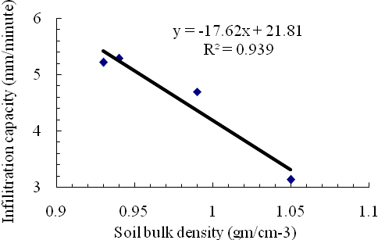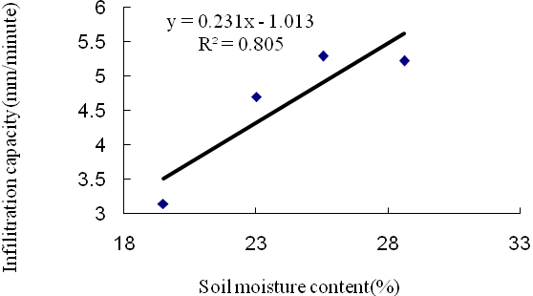
a) b)
Figure 3. Relation between soil infiltration capacity (mm/minute) and soil bulk density (gcm⁻³) (a) and soil moisture content (%) (b) at Wondo Genet, Ethiopia

Similarly, there were inverse relationships between soil bulk density (gmcm⁻³) and soil organic carbon (%) (Fig. 4a) and soil bulk density (gmcm⁻³) and soil moisture content (%) (Fig. 4b).

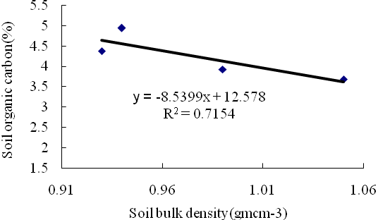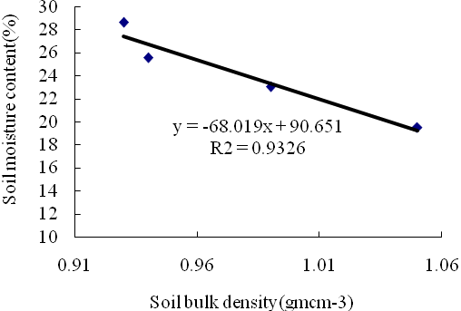

a) b)
Figure 4. Correlation between soil bulk density (gmcm⁻³) and soil organic carbon (%)(a), soil bulk density(gmcm⁻³) and soil moisture content(%) (b) at Wondo Genet, Ethiopia.

However, direct correlation was observed between soil organic carbon and soil moisture content (%) and soil organic carbon and soil infiltration capacity (mm/minute) (Fig.5a & b).
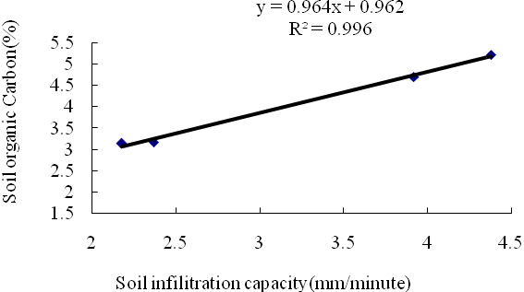
a) b)
Figure 5. Relation between soil organic carbon (%) and soil infiltration capacity (mm/minute) and (a) and soil water content (%) (b) at Wondo Genet area, Ethiopia.

3.3. Soil chemical properties
Soil chemical properties of the soils under the different landuses are general found to be in a very good state (Table 2). For instance, soil pH for all the landuses is nearly neutral, although the soil under Eucalyptus saligna showed a relatively low pH as compared to the other landuses/land cover. On the other hand, the soil under Eucalyptus saligna had the highest OC content (4.94%), while the farmland had the lowest OC content (3.92%). The C/N ratio of all the soils is also very acceptable, and indicates that the soils of the area are relatively fertile. In general, despite some differences in the values of most of the soil chemical properties across the landuses/land covers (Table 2) most of the differences are statistically not significant (Table 2).

Table 2. Mean (±SEM) of soil available Phosphorus (ppm), total nitrogen and organic carbon (%), C/N ratio and PH under different landuses in the 0-15, 15-30 & 30-60cm soil layer
Parameters | Soil depth(cm) | Landuse types
Parameters | Soil depth(cm) | NF | FM | GR | Eu
P (ppm) | 0-15cm | 6.80±2.40 | 14.61±4.71 | 7.86±0.78 | 9.68±0.00
P (ppm) | 15-30cm | 17.53±8.76 | 11.53±1.76 | 12.53±5.93 | 15.25±5.45
P (ppm) | 30-60cm | 18.9±10.3 | 11.93±1.44 | 14.60±12.2 | 7.90±0.60
OC (%) | 0-15cm | 4.38±1.14 | 3.92±0.80 | 4.68±0.71 | 4.94±0.40
OC (%) | 15-30cm | 3.16±0.74 | 2.64±0.14 | 2.92±0.26 | 3.30±0.37
OC (%) | 30-60cm | 2.25±0.82 | 2.05±0.43 | 1.78±0.23 | 2.30±0.30
N (%) | 0-15cm | 0.68±0.07 | 0.60±0.11 | 0.53±0.06 | 0.58±0.05
N (%) | 15-30cm | 0.39±0.07 | 0.36±0.02 | 0.33±0.05 | 0.39±0.05
N (%) | 30-60cm | 0.24±0.07 | 0.23±0.03 | 0.21±0.03 | 0.25±0.02
C/N | 0-15cm | 8.18±0.65 | 7.65±0.29 | 10.12±1.70 | 9.31±1.21
C/N | 15-30cm | 8.00±070 | 7.33±0.15 | 9.08±0.51 | 8.51±0.97
C/N | 30-60cm | 8.78±0.81 | 8.94±1.69 | 8.40±0.35 | 9.27±1.13
pH | 0-15cm | 6.13±0.21 | 6.34±0.09 | 6.14±0.22 | 5.63±0.34
pH | 15-30cm | 6.133±0.32 | 6.43±0.02 | 6.26±0.13 | 5.96±0.27
pH | 30-60cm | 6.52±0.22 | 6.52±0.07 | 6.38±0.17 | 6.10±0.29

4. Discussions
4.1 soil physical properties
The physical properties (infiltration capacity, soil moisture content) considered are found to have responded differently to various human induced differential managements following conversion from natural forests. This is in line with the report by Diamond & Shanley (2003) in Ireland in which infiltration capacity has found to be highly variable under different landuses. The inverse relationship between soil bulk density and infiltration capacity of these landuses/land covers indicated by this study also agrees with other study on Columbian Andosol (Hoyo & Comerford, 2005). The fact that land management for some of the landuses such as farm land caused compaction which results in increased bulk density in a way ultimately affects infiltration rate. This in turn aggravates erosion hazard, which finally leads to high soil erosion and land degradation, the main environmental degradative agent in Ethiopia (Hurni, 1993; Hawando, 1997). In terms of infiltration capacity, both Eucalyptus saligna plantation and the natural forest showed more or less comparable and high values. This can be explained by the higher and more or less equivalent amount of soil organic matter contents in the soils of the two landuses/land covers, and also by the similarity in their soils’ bulk density.
Infiltration capacity of a given locality is generally affected by many factors. For instance, surface conditions i.e. residue cover and surface roughness (Lampurlanes & Cantero-Martinez, 2006), compaction especially grazing land, water content of the soil, aggregation, structure and organic matter (Diamond & Shanley, 2003; Brady & Weil, 2002). On the other hand, a positive relationship between infiltration capacity and soil moisture contents, infiltration capacity and soil organic carbon were observed. Similarly, positive relationship was observed between soil organic content and soil water contents and inverse relationship between soil bulk density and soil moisture contents, between soil organic carbon content and soil bulk density, which are all quite logical to expect. This can be ascribed to the positive effects of soil organic carbon on soil physical properties (Haynes, 1999; Dexter, 2004; Hoyo & Comerford, 2005). And hence, an equivalent increase in soil moisture contents and infiltration capacities and reduction of the soil bulk densities with increasing organic carbon contents (Dexter, 1997; Dexter, 2004) despite the management effects practicing up on it is quite expected.
The significant variations in soil moisture content between the landuses, especially the fact that Eucalyptus saligna plantation had lower soil moisture content compared to the other can be explained by the nature of the species. Eucalyptuses in general are commonly known for their high moisture uptake. On top of this, mono-crop of Eucalyptus species has a general tendency of high demand for soil moisture as well as nutrients.
Regardless of little variation in mean values, soil bulk density between the land cover/landuse types in all the three soil layers investigated have not statistical differed. This can be explained by the more or less equal exposure of the landuses/land covers in the study area to free grazing. Normally, shortage of grazing land is very acute and the farmers use to graze their animals on roadsides, farmlands after harvest, in side natural and plantation forests so often. This means that all of the landuses are equally exposed to the effect of grazing besides the actual land management exercised on them. However, the fact that grazing and farmlands had higher bulk densities than the natural and plantation forest indicates that these two landuses are more affected by practices that cause increased soil bulk density. For instance, the cause of the higher bulk density on the farmland is due to frequent tillage that may cause some degree of soil compaction. While for the grazing land, there is much more frequent impact from animals trampling on the grazing land than the others especially during wet season. This is however inline with the reports by Zerfu (2002) in the Amahara Regional States of Ethiopia, and Hoyos & Comerford (2005) on Colombian Andosol. Zerfu (2002) had reported that landuse change from farmland to Eucalyptus plantation or vice-versa did not caused pronounced change on soil bulk density. Moreover, positive impacts of minimal tillage as compared to mechanized farming to the soil well being is highly acknowledged by different authors (Connolly et al., 1998; Ouedraogo, 2004; Smith, 2004). The study in the same locality by Tesfay (2005) also designated that scattered on farm trees and farm boarder tree keeping practices in the area have played improvement effect on soil characteristics including bulk density.

4.2. Soil chemical property responses
Despite some changes in the mean values of soil chemical properties following the conversion of natural forest to different human influenced landuses, the overall difference were found to be not as rapid as first anticipated. Contrary to normal expectations following such landuse changes, some of soil chemical properties such as organic carbon content and available phosphorus, for instance, showed higher mean values in the soils under Eucalyptus saligna and farmland, respectively compared to the soil under the natural forest. These observations somehow disagree with the short period, often up to 5 years, where significant degradation responses can be measured for tropical soils when exposed to a similar kind of landuse changes. For instance, Lal (1996) reported declines of most soil chemical properties within 8 years of deforestation and conversion to crop fields despite the use of recommended rates of fertilizer on an Alfisol in West Africa under various cropping systems. Similarly, Teissen et al. (1994) indicated that a nutrient poor Amazonian forest soil could support agriculture only for 3 years after deforestation. Nonetheless, the results also conform well with some studies that are carried out under similar soil type and socio-economic settings (e.g. Mulugeta, 2004), and (Verde et al., 2005) on Andosol in spain.
The main reason for low responses of the soil chemical properties (OC, total nitrogen, available phosphorus and PH) to different management activities can be ascribed to the nature of the parent material of the soil. The basic parent material is of alkali trachytes and basalts; overlain by volcanic ash deposits from the late tertiary period volcanic eruption (Anonymous., 1973; Eylachew, 2004). The area bordering the rift valley is normally characterized by moderately weathered dark-redish brown soil with clay loam texture all associates of the rift valley soils (Mulugeta, 2004). Thus, slow responses to chemical property changes of Andosol as the land subject to different management activities are reported (Aran et al, 2001; Rodríguez et al., 2004). The existence of soil minerals pumice and allophanic from volcanic eruptions are reported to be much more resistant to degradation due different management systems (Cotching et al., 1979). This is to the dominance of stable organo-mineral complexes formed between Al and humified organic components and are verified to be more responsible for great stability of Andosols, and also to the sorption of organic lignids on to short-range ordered compounds (Saggar et al., 1996; Aran et al., 2001 & Verde et al., 2005).
The tradition of keeping scattered trees on and around farm and grazing land and addition of organic, inorganic fertilizers to farmland, which is expected to ameliorate chemical properties are the other possible reason for lack of variation. The positive effects of the management practices in the study locality were also acknowledged in which the practice is better to the extent of maintaining the soil quality (Tesfay, 2005). On top of this, ease weatherability of Andosol in humid regions due to manipulation by oxen plough and other related activities (Sanchez, 1976; Mulugeta et al., 2004) are confirmed to contribute for the resilience of the soil (Aran et al., 2001). The unique character of Andosol (high affinity for phosphorus, striking accumulation of organic matter) (Aran et al., 2001; Rodriguez et al, 2004) would be the important aspect for the resilience or low responses to such different activities. Free access grazing across different landuses and the subsequent effects, redistribution and nutrient translocation could also be contributing to the lack of apparent differences between different management activities on soil chemical properties.

5. Conclusion
landuse/cover changes from natural forest to different landuses types and the resultant deterioration expected for soil chemical properties are found to be resistant to change on soil with andic nature. The soil physical properties are rather affected by differing managements. Especially, Eucalyptus saligna plantation is found to have high infiltration capacity and lower moisture content as compared to others. While grazing land is found to have lower infiltration capacity as compared to natural forest. Eucalyptus saligna plantation has more or less similar infiltration capacity with natural forest. High mean bulk density of grazing land and farm land could be due to the pulverizing effects of tillage on farm and high cattle trampling on grazing land especially during wet season. This implies that soil physical properties are more susceptible to effects for the reason of varying managements on the soil with andic characteristics. From this study we concluded that, for sustainable management of landuse/cover with Andosol, it is rather valuable to design the strategies that focus on soil physical properties rather than soil chemical properties.
Acknowledgments
The research was supported by Swedish International Development Agency (Sida) through Wondo Genet College of forestry and African Network for Agro-forestry Education (ANAFE). We would like to thank and acknowledge these institutions.

Corresponding Author:
Fikadu Getachew Addis Ababa, P. O. Box, 1397
Oromia Bureau of Agriculture Natural Resource
Development, Protection and Utilisation Department
E-mail: gonfa2002@gmail.com

References
- Anon. 1973. Geological Map of Ethiopia and Somalia. Consiglio Nazionale Delle Recerche, Italy.Scale1:2,000,000.
- Anderson J.M. & Ingram J.S.I. (E.ds) 1993. Tropical soil biology and Fertility, A hand book of Methods CABI publisher 2nd ed. 221p.
- Aran D., Gury M., Jeanroy E. 2001. Organo-metallic complexes in an Andosol: a comparative study with a Cambisol and Podzol. Geoderma 99, 65–79.
- Brady N.C. & Weil R.R. 2002. The Nature and Properties of Soils, 13th Edition. Prentice Hall, NJ.960p.
- Cotching W.E., Allbrook R.F. and Gibbs H.S. 1979. Influence of maize cropping on the soil structure of two soils in the Waikato district, New Zealand. New Zealand Journal of Agricultural Research 22: 431-438.
- Diamond J. & Shanley T. 2003. Infiltration Rate Assessment of Some Major Soils. Irish Geography, Volume 36(1), 32-46.
- EFAP.1994. Ethiopia Forestry Action Program. V-II. The challenge for development. Ministry of natural resources and environmental protection, Addis Ababa, Ethiopia
- Erikson H. & Stern M. 1987. A soil study at Wondo Genet, forestry resource institute, Ethiopia, Swedish university of agricultural science. International rural Development center-Uppsala, ISSN 0280-4301
- Eyasu E. 2002. Farmers’ Perceptions of Soil Fertility Change and Management. Doctorial thesis SOS SAHEL & institute for sustainable development. Addis Ababa, Ethiopia. 252pp
- Food and Agricultural Organization of the United Nation (FAO). 1998. World reference base for soil resources. World Soil Resources Reports 84. Food &Agricultural organization of the United Nation, Rome, Italy.
- Hawando T. 1997. desertification in Ethiopia high lands. RALA report No 200. Norwegian Church AID, Addis Ababa, Ethiopia.
- Hjelm B. 2001. Management plan for the forest plantation of Wondo Genet College of forestry 2001-2005, Wondo Genet College of forestry, Ethiopia.
- Hurni H. 1993. Land degradation, famines and resource scenarios in Ethiopia. In: Pimentel, D. (ed) world soil erosion and conservation. Cambridge university press. Cambridge. Pp.27-62.
- Jones J. Benton (Ed) 2001. Laboratory Guide for conducting soil tests and plant analysis. CRC Press LLC, Florida, USA. 363pp.
- Kebede Seifu. 1998. Estimating Land Cover/Landuse Changes in Munessa Forest area using Remote Sensing Techniques. MSc.Thesis Report No. 1998:32, Swedish University of Agricultural Sciences, Skinnskatteberg.
- Lal R. 1996.Deforestation and Landuse Effects on Soil Degradation and Rehabilitation in Western Nigeria. III. Runoff, soil erosion and nutrient loss. Land degradation & development, 7, 87-98.
- Lampurlane´s J. & Cantero-Martinez C. 2006. Hydraulic Conductivity, Residue Cover and Soil Surface Roughness under Different Tillage Systems in Semiarid Conditions. Soil & Tillage Research 85, 13-26.
- Makin M.J., Kingham J.J., Waddam A.E., Birchall C.J. and Tefera T. 1975. Development prospects in the southern Rift valley. Land resources Division, Ministry of overseas development, England.
- Mesfin Abebe 1998. Nature and management of Ethiopian soils. Alemaya University of Agriculture, Ethiopia. 272pp.
- Mulugeta Lemneh. 2004. Effects of Landuse Changes on Soil Quality and Native Flora Degradation and Restoration in The High Lands of Ethiopia. Implication for food Security. Doctorial Thesis. Uppsala, Swedish university of agricultural science.
- Mulugeta L., Karltun E. & Olsson M. 2004. Assessing Soil Chemical and Physical Property Responces to Deforestation and Subsequent Cultivation in Smallholders Farming System in Ethiopia. Part of PhD dissertation.
- Powell J.M., Fernandez-Rivera S., WilliaFms T.O. & Renard C. (eds). 1995. Livestock and Sustainable Nutrient Cycling in Mixed Farming Systems of sub- Saharan Africa. Volume II: Technical Papers. Proceedings of an International Conference held in Addis Ababa, Ethiopia, 22–26 November 1993. ILCA (International Livestock Centre for Africa), Addis Ababa, Ethiopia. 568pp.
- Rodriguez A.R., Guerra A., Arbelo C., Mora J.L., Gorrin S.P., Armas C. 2004. Forms of eroded soil organic carbon in andosols of the Canary Islands (Spain). Geoderma 121, 205-219
- Sanchez P.A. 1976. Properties and Management of Soils in the Tropics. John Wiley & Sons, New York.
- Tadesse kippe. 2002. Five thousand years of sustainability? A Case Study on Gedeo Landuse (southern Ethiopia). Doctorial thesis, Treemail publishers, Heelsum, The Netherlands. 295pp.
- Tesfay Teklaye. 2005. Organic inputs from Agro forestry trees on farms for improving soil quality and crop productivity in Ethiopia. Doctoral thesis, Swedish university of Agricultural Sciences, Umea.
- Verde J.R., Arbestain C.M. & As F.M. 2005. Expression of Andic properties in soils from Galicia (NWSpain) under forest and agricultural use. European Journal of Soil Science 56, 53-63.
- Wakene Negassa and Heluf Gebrekidan. 2004. Impact of Different Landuse Systems on Soil Quality of Western Ethiopian Alfisols. A Paper presented on International Research on Food Security, Natural Resource Management and Rural Poverty Reduction through Research for Development and Transformation in Tropentag 2004, October 57, 2004, Berlin, Germany
- Young A. 1997. Agroforestry for soil management, 2nd ed. CAB CAB International, Wallingford. 320pp.
- Zerfu Hailu. 2002. Ecological Impact Evaluation of Eucalyptus saligna Plantations in Comparison with Agricultural and Grazing LanduseTypes in the Highlands of Ethiopia. PhD.thesis. The Institute of Forest Ecology Vienna University of Agricultural sciences pp 302.

10/9/2012

