Field studies on the removal of lead, cadmium and copper by the use of probiotic lactic acid bacteria from the water for culturing marine tilapia T. spilurus

Amnah A.H. Rayes

Faculty of Applied Sciences. Umm Al- Qura University Makkah Saudi Arabia
Amnaa_rayes_50@yahoo.com

Abstract: The aim of this study was to examine the effect of probiotic lactic acid bacteria in removal lead, cadmium and copper from cultured water in fish farming system for marine tilapia T. spilurus, in addition studying the effect of heavy metals lead and cadmium and copper on genotoxcity of tilapia fish as bioindicator for heavy metal toxicity.A total number of 36 water samples from three localities of cultured fish farm; inlet of water, hatcheries (cement ponds) and rearing ponds (earthen ponds), The probiotic lactic acid bacteria (LAB) strains used in this study; Lactobacillus rhamnosus GG, Lactobacillus fermentum ME3, Lactobacillus bulgaricus (Commercial strain) and Lactobacillus acidophilus X 37 were used to remove lead, cadmium and copper from water of fish culture each sp. examined alone; the highest total concentration of removal was by L.acidophilus X37 (97.6) followed by L. rhamnosus GG (74.8), then L. fermentum ME3 (71.16) while the lowest concentration of removal was by L. bulgaricus (61.00). it was found that the optimal pH for L. fermentum ME3 was 6.0 for L. rhamnosus GG was 6, for L. bulgaricus was 5.0 and for L. acidophilus X37 was 6.0 While the impact of water temperature was clear that the percentage of removal of heavy metals depend on temperature where, all strains showing highest activity at temperature between 25 ºC and 37ºC then the activity was declined at 43 ºC. There was significant increase in micronucleus (MN) frequencies in erythrocytes of tilapia sp. exposed to heavy metals in the fish farm in comparison to control.
[Amnah A.H. Rayes. Field studies on the removal of lead, cadmium and copper by the use of probiotic lactic acid bacteria from the water for culturing marine tilapia T. spilurus. N Y Sci J 2012;5(11):74-82]. (ISSN: 1554-0200). http://www.sciencepub.net/newyork. 13

Key words: probiotic; lactic acid bacteria; marine tilapia (T. spirulus); Heavy metals; pH; temperature.; micronucleus

Introduction:
The rapid development of industry has resulted significant quantities of heavy metals released increasing pollution, which is a significant environmental hazard for invertebrates, fish, and humans (Uluturhan and Kucuksezgin, 2007). Metals are discharged into rivers, agriculture drainage which can be strongly accumulated and biomagnified along water, sediment, and aquatic food chain, resulting in sub lethal effects or death in local fish populations (Awad, 2012). Suspended sediments adsorb pollutants from the water, thus lowering their concentration in the water column. Heavy metals are inert in the sediment environment and are often considered to be conservative pollutants (Olivares-Rieumont et al., 2005) although they may be released into the water column in response to certain disturbances (Agarwal et al., 2005). Removal of heavy metals from water can be achieved with precipitation, flocculation, ion exchange, and membrane filtration. These methods are sometimes expensive, not effective at low metal concentrations, and produce sludge to be disposed. Thus, safe novel treatments should be searched for future decontamination targets (Halttunen et al., 2007). A vast array of biological materials, especially bacteria, algae, yeasts and fungi have received increasing attention for heavy metal removal and recovery due to their good performance, low cost and large available quantities (Wang and Chen, 2008) .
Use of inactivated microbial biomass as an adsorbent, biosorption, has been suggested as an effective and economical alternative for the removal of toxic metals from water, and the removal of a number of different minerals by varying micro-organisms have has been studied (Davis et al., 2003; Mehta and Gaur, 2005). It was established the capability of specific lactic acid bacteria to remove cadmium and lead from water (Halttunen et al., 2003, 2007,2008).
Heavy metals present in waters not only endanger survival and physiology of the aquatic organisms (Handy, 1994) but also induce genetic alterations (Fabacher et al., 1991) which may lead to mutations (Maccubin et al., 1991) and/or carcinogenesis (Folmar et al., 1993). The effects of the mutations can either be silent throughout many generations or have a significant impact on the gene pool of a population. For this reason, there is increasing interest in the use of bioindicators to study the effects of aquatic pollutants at the genomic level (Russo et al., 2004).
Among the techniques to detect genetic and genotoxic effects, the micronucleus (MN) test is often used since it allows for convenient and easy application, in particular in genotoxicologic studies with fish as the bioindicators. Thus the aim of this study was to examine the effect of probiotic lactic acid bacteria in removal lead, cadmium and copper from cultured water in fish farming system for marine tilapia T. spilurus, in addition, studying the effect of heavy metals lead, cadmium and copper on genotoxcity of marine tilapia fish as bioindicator for heavy metal toxicity.
Materials and methods:
Water samples:
Private marine tilapia T. spilurus farm, its water contains concentrations of heavy metals; lead, cadmium and copper released from adjacent metal factories.
A total number of 36 water samples from three localities of cultured fish farm; inlet of water, hatcheries (cement ponds) and rearing ponds (earthen ponds), samples were taken in glass flasks, 500 ml volume were equipped with a cork stopper and open hand prides under the water surface then equipped again and fixed with 200 µl of pure concentrated nitric acid. Water samples were collected as five replicates from various depths along the three localities at the farm and the mean of their analysis were taken with standard deviation.
Bacterial strains:
The probiotic lactic acid bacteria (LAB) strains used in this study were Lactobacillus rhamnosus GG, Lactobacillus fermentum ME3, Lactobacillus bulgaricus (Commercial strain) and Lactobacillus acidophilus X 37 were kindly kindly supplied from King Abd-El Aziz Medical City (National Guard Hospital) in Jeddah.Bacterial strains were examined each alone with specific pH and temperature. The study intended to use species of bacteria used as probiotic and immune stimulant for cultured fish.
Growth media and culture conditions:
Probiotic bacterial strains were cultured in MRS-broth for 48 h at 37°C. Biomass was then centrifuged (8000×g, 15 min) and washed twice with ultra-pure water. Washed biomass was lyophilized and stored at -20 °C. till used in the experiment.
Binding assay:
Suspensions of lyophilized bacteria (2 g/l) were spiked with the water samples and diluted to a final bacterial concentration of 1 g/l and a final metal concentrations of (1.38±0.069) mg/l, (2.13±0.007) mg/l and (4.68±0.057) mg/l for Pb2+, Cd2+ and Cu+ respectively. The pH of the metal solution was adjusted to 6 for L. fermentum ME3, for L. rhamnosus GG, and for L. acidophilus X37 but for L. bulgaricus was 5 after experiments using dilute NaOH and HNO3 and kept constant. Three 1.5 ml samples were taken from the suspension and these were incubated for 5h. at 37 °C. After incubation, the pH of the suspension was measured and bacteria were separated by centrifugation (7000 ×g 5 min).
Supernatant was preserved with 1ml/ 200 µl of pure conc. nitric acid and stored at room temperature. The effect of pH (1,2,3,4,5 and 6), and temperature (5,10,15, 25 and 37 °C) were tested, bacterial concentration used was 2.0 g for each litter. Conditions were selected, based on studies and experiments. All experiments were repeated at least twice (Halttunen et al., 2007).
Analysis of cadmium, lead and copper:
Lead, cadmium and copper concentrations were determined with atomic absorption spectrometry either by flame or graphite furnace method depending on the metal concentration before and after insertion of lactic acid bacterial species. In each analysis, samples spiked with lead, cadmium and copper were used as quality control samples.
Data analysis:
Metal removal from cultured water was calculated firstly; by determining heavy metal concentration for each metal before and after using probiotic lactic acid bacteria for each species of bacteria alone.
Then by the equation described by Achanai Buasri et al.(2012). The amount of removed pb2+, Cd+2 and Cu2+ ions (mg metal ions/g biomass) were calculated from the decrease in the concentration of metal ions in the medium by considering the removed volume and used amount of the lactic acid bacteria:
q_{e} = (C_{i} – C_{e}) V/ m
where qe is the amount of metal ions removed into unit mass of the biosorbent (mg/g) at equilibrium, Ci and Ce are the initial and final (equilibrium) concentrations of the metal ions in the solution (ppm), V is the volume of metal solution (L) and m is the amount of lyophilized lactic acid bacteria used (g).
Preparation of lactic acid bacteria for scanning electron microscopy:
Bacteria were grown in aerated liquid media to the exponential phase and harvested by centrifuging at 1000 g for 30 min. The bacterial pellet was fixed with 1 % (v/v) glutaraldehyde for 30 min then with 1 % (w/v) osmium tetroxide for 12 to 20 h, both treatments being done in a refrigerator. Fixatives were prepared in 0.15 M-sodium cacodylate buffer, pH 7.0. The fixed pellet was dehydrated in a graded ethanol series from 50 % to 100 %, followed by amyl acetate, then dried by the ‘critical point’ method. The dried pellet was broken into small fragments with the tip of forceps and pressed on to an aluminium block. The preparation was then coated with gold/palladium (60: 40). The thickness of the metal coating was controlled so that it did not exceed 10 nm, using a deposit thickness monitor (DTM-2; Sloan Instrument Corp., Santa Barbara, California, U.S.A.). Bacteria was examined using a scanning electron microscope (JEOL SEM T330; JOEL, Japan) operating at 25 kV. Amako and Umeda (1977).
Micronuclei assay:
Five fish from the rearing ponds were used for micronuclei assay. Peripheral blood samples were obtained from the caudal vein of the tilapia fish and smeared onto precleaned slides. After fixation in pure ethanol for 20 min, the slides were allowed to air-dry and then the smears were stained with Gaiemsa. From each fish three slides were prepared, and from each slide 1500 polychromatic erythrocytes were scored under 100 x magnifications. Frequencies of micronuclei was compared with the frequencies of micronuclei in erythrocytes of tilapia fish from another farm (control). Small, non-refractive, circular, or ovoid chromatin bodies, displaying the same staining as the main nucleus, were scored as micronuclei (Al-Sabti and Metcalfe, 1995).
Results:
Results of removal of heavy metals at rearing ponds by probiotic lactic acid bacteria:
With determing the concentration of removal of mixed heavy metals (pb⁺², Cd⁺² and Cu⁺²) from cultured water at the fish farm using investigated strains of probitic lactic acid bacteria each alone, it was clear from the Fig 1 and table 1 that the highest total concentration of removal was by L.acidophilus X37 (97.6) followed by L. rhamnosus GG (74.8), then L. fermentum ME3 (71.16) while the lowest concentration of removal was by L. bulgaricus (61.00).

Figure 1. percentage of removal of heavy Metals by latic acid bacteria each alone

Table 1. Percentage of removal of heavy metal ions (µg/l) onto the surface of probiotic lactic acid bacteria

Lactic acid bacteria | Heavy metal conc (µg/l) |  |  | Heavy metal conc removed (µg/l) |  |  |  |  |  | Total  %
 | Pb | Cd | Cu | Pb  removed | % of  removal | Cd  removed | %of  removal | Cu  removed | % of  removal
L. fermentum  ME3  L. rhamnosus  GG  L. bulgaricus  *(Co. st.)  L.acidophilus  X37 | 1.38  ±  0.069  1.77  ±  0.089  1.34  ±  0.117  1.12  ±  0.050 | 2.13  ±  0.007  2.73  ±  0.107  2.22  ±  0.014  2.17  ±  0.024 | 4.68  ±  0.057  3.97  ±  0.980  3.75  ±  0.870  4.34  ±  0.970 | 0.92  ±  0.184  0.89  ±  0.222  0.45  ±  0,080  1.04  ±  0.208 | 66.6  50.2  33.5  92.8 | 1.56  ±  0.312  2.20  ±  0.440  1.10  ±  0.220  2.17  ±  0.542 | 73.2  80.5  49.5  100 | 3.45  ±  0.690  3.73  ±  0.927  3.75  ±  0.770  4.34  ±  0.868 | 73.7  93.9  100  100 | 71.16  74.8  61.0  97.6
Heavy metal conc. (mean of three replicates) ± standard deviation
* Commercial strain

Factors affecting concentration of heavy metal removed from water
Experiments was done to examine the various factors affecting the concentration of removing heavy metals from cultured water determining the optimal factors; cadmium, lead and copper removal assessment indicated a strongly pH-dependent process with the highest removal at a pH close to neutral (Fig.2). it was found that the optimal pH for L. fermentum ME3 was 6, for L. rhamnosus GG was 6, for L. bulgaricus was 5 and for L. acidophilus X37 was 6 While the impact of water temperature was clear that the percentage of removal of heavy metals depend on temperature where, all strains showing highest activity at temperature between 25 ºC and 37ºC then the activity was declined at 43 ºC (Fig.3). There is leaner relation between the concentration of lactic acid bacteria and percentage of heavy metal removal.

Figure 2. pH of water and percentage of removal of heavy metal from water

Figure 3. Temperature of water and percentage of removal of heavy metal from water

Results of scan electron microscope:
Scan electron microscope was performed for L. acidophilus X37 before and after spiked with polluted water with lead, cadmium and copper for confirmation, Scan electron micrograph figure 4 (A&B).

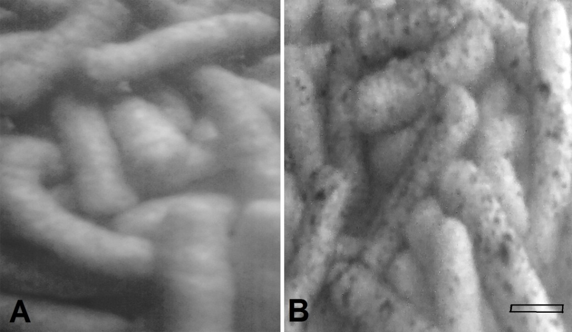
Figure 4. (A) Scanning electron micrograph for pellets of L. acidophilus X37 (LAB) before spiked with contaminated water with heavy metals, (B) L. acidophilus X37 adsorb mixed heavy metals (arrows) from water of fish culture. (scale bar represent 100 nm.)

Results of micronucleus assay:
There was significant increase in MN frequencies in erythrocytes of tilapia sp. exposed to heavy metals in the fish farm in comparison to control (tilapia fish from another farm) fig (4).

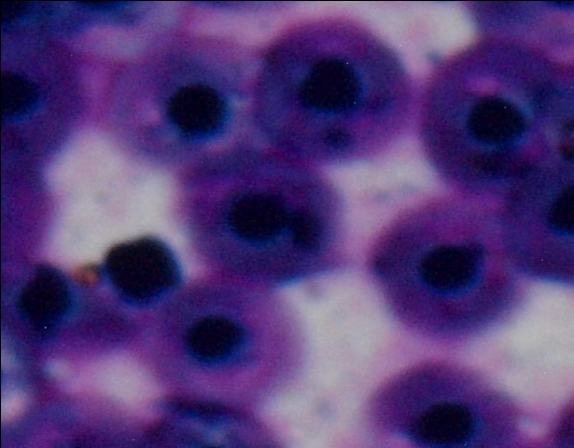

Figure 5. Showing RBCs of Tilapia spirulus stained with Giamesa exposed to pollution with mixed
heavy metals showing micronucleus (arrows)

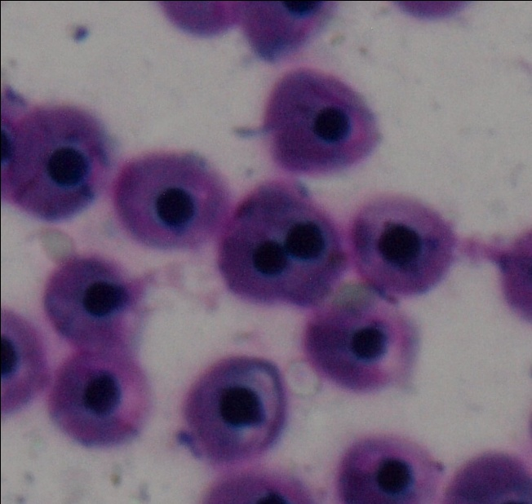
Figure 6. Showing RBCs of Tilapia spirulus stained with Giamesa exposed to pollution with mixed heavy metals showing double-nucleated RBC (arrow)

Discussion:
The goal of this study was to assess and performed in the field in tilapia (T. spilurus) fish farm naturally contaminated with mixed heavy metals lead, cadmium and copper so as to workout lactic acid bacteria which is also used as probiotic immunstimulant and growth promoter for fish in fish farm and different study from its predecessor that most of previous studies were done in the laboratory or been tested in the laboratory and not in the field.
Heavy metal contamination may have devastating effects on the ecological balance of the recipient environment and a diversity of aquatic organisms (Ayandiran et al., 2009). They can decline water and sediments quality and may adversely affect fish health and other biological attributes like taxonomic richness, tropic structure, and health of individual organisms (Batzias and Siontoro, 2008). They can also form a major hazard because of their toxicity, persistence, and bioaccumulation in the food chains (Djedjibegovic et al., 2012). Removal of heavy metals from water can be achieved with precipitation, flocculation, ion exchange, and membrane filtration. These methods are sometimes expensive, not effective at low metal concentrations, and produce sludge to be disposed. Thus, safe novel treatments should be searched for future decontamination targets (Halttunen et al,2007). Probiotic bacteria have the capacity to bind many toxic compounds like aflatoxins (Peltonen et al., 2001; Haskard et al., 2001), food-borne mutagens (Turbic et al., 2002) and microcystin-LR (Meriluoto et al., 2005) from aqueous solution. There is also some evidence that probiotic bacteria could bind aflatoxin B1 (El-Nezami et al., 2000, 2006) and the food-borne mutagen Trp-P-2 (Orrhage et al., 2002) within the gastro-intestinal tract, thereby reducing their uptake Halttunen et al.,(2007). The potential of different microbes in removal of heavy metals and other toxic compounds from water has been recently recognized. It was reported that lactic acid bacteria (LAB) effectively remove cationic heavy metals, cadmium and lead (Ibrahim et al., 2006; Halttunen et al., 2007), from water.
Present study revealed that 4 species of probiotic lactic acid bacteria; Lactobacillus rhamnosus GG (ATCC 53103), Lactobacillus fermentum ME3, Lactobacillus bulgaricus (Commercial strain) and Lactobacillus acidophilus X 37 have remove heavy metals; lead, Cadmium and copper from water at fish culture with different degrees and forces with different species used. Cadmium and lead removal was observed to occur rapidly to bacterial surface, probably by an ion exchange mechanism as LAB have negative surface charge, they are optimal for cation binding the results nearly agree with the results obtained by Halttunen et al. (2007). Present study indicate that probiotic lactic acid bacteria have potential to remove mixed concentrations of heavy metals lead, cadmium and copper from water with different degrees also (Sheng et al., 2007) observed that from binary metal solutions containing lead and cadmium, zinc, nickel, cobalt, potassium, sodium, calcium or magnesium. Many reasons have been suggested for selectivity of some metals over others. Many literatures indicates that the removal occurs at the bacterial surface probably by an ion exchange mechanism,these studies confirm the results of present study. Lactic acid bacteria have also been reported to remove also mycotoxins (Pierides et al., 2000) and cyanotoxins (Meriluoto et al., 2005; Nybom et al., 2007) from food and water.
Removal of heavy metal ions onto the surface of a probiotic lactic acid bacteria is affected by several factors, such as initial solution concentration, initial biomass concentration, temperature and pH of solutions, present study indicate that cadmium, lead and copper removal assessment indicated a strongly pH-dependent process with the highest removal at a pH close to neutral. it was found that the optimal pH for L. fermentum ME3 was 6, for L. rhamnosus GG was 6, for L. bulgaricus was 5 and for L. acidophilus X37 was 6. while the impact of water temperature was clear that the percentage of removal of heavy metals depend on temperature where, all strains showing highest activity at temperature between 25ºC and 37ºC then the activity was declined at 43ºC.
Many factors affect the growth and activity of bacteria: temperature, pH, oxygen, salt concentration and nutrients are some of the more common factors that may change in the normal environment of bacteria. While most bacteria grow best when these parameters are optimum for that strain. The pH of the environment affects bacterial growth. Most bacteria grow best in the pH range from about 6-8; however, there are many acid-tolerant bacteria as well as alkaline-tolerant strains. In general, bacteria survive alkaline pH better than acid pH, but a few strains actually grow better in an acidic environment. Some can even use sulfuric acid as an energy source. The pH of the cell contents of bacteria that grow in acidic or alkaline environments is neutral. These strains have transport mechanisms to keep a normal physiological H+ ion concentration inside the cell so the activity of used probiotic lactic acid bacteria mainly pH- dependent (Sathe et al., 2007).
The temperature in many natural environments changes drastically over the seasons. While most of the well-characterized bacteria live best at temperatures from 25°-40°C, many bacteria thrive at high temperatures and others grow best (although slowly) at 0°-15° C. Every organism has an optimum temperature for growth and activity. It was clear that the used probiotic lactic acid bacteria increasingly activated at 25 ºC – 37 ºC (Reddy and Ranganathan 1985;Batish et al., 1997; Zaitseva et al., 2004).
Regarding the results of scan electron microscope, Although the images of electron microscope for lactic acid bacteria were not good for technical reasons confirmed that the lactic acid bacteria is the main reason for the removal of heavy metals from water of aquaculture. SEM was performed for L. acidophilus X37 before and after spiked with polluted water with lead, cadmium and copper for confirmation, that the removal of heavy metals was due to probiotic lactic acid bacteria (LAB). The results nearly agree with the results obtained by Halttunen et al.(2008) who mentioned that the transmission electron microscope when performed for lyophilized B. longum 46 and L. fermentum ME3 before and after lead binding showed as large deposits of lead on the surface of both strains after binding.
Regarding genotoxic studies micronucleus assay from the present study, MN assay is a significant and potent tool for the assessment of genotoxcity as it is simple, reliable, sensitive, and is dependent of karyotypic characteristics of the test animal. Fish are excellent specimens for the study of the mutagenic or carcinogenic potential of contaminants present in water sample since they can metabolize, concentrate and store waterborne pollutants Yadav and Trivedi (2009). They can serve as useful genetic models for the evaluation of pollution in aquatic ecosystems (Park et al.,1993). The erythrocyte micronucleus test has been used with different fish species to monitor aquatic pollutants displaying mutagenic features (Pantalea et al.,2006). Rodriguez et al.,(2003) have also reported the sensitivity of micronucleus test in fish species for application in field surveys. In present study that there were significant difference in frequency in erythrocytes of tilapia exposed to heavy metals; lead, cadmium and copper in comparison with control the results nearly agree with the results obtained by Galan et al.,(2001) who reported that there is significant increase in frequency of micronucleus was found in eels injected with cadmium or mercury. Manna and Sadhukon (1986) also reported that cadmium also induces micronuclei formation in tilapia fish. From the investigation it was concluded that probiotic lactic acid bacteria have been identified as safe potent tool for the decontamination of water of fish cultures from heavy metals; lead, cadmium and copper with different degrees according to species of lactic acid bacteria and kind of heavy metal removed.

References:
- Achanai Buasri, Nattawut Chaiyut, Kessarin Tapang, Supparoek Jaroensin and Sutheera Panphrom (2012): Biosorption of Heavy Metals from Aqueous Solutions Using Water Hyacinth as a Low Cost Biosorbent Civil and Environmental Research Vol 2, No.2, 17- 24.
- Agarwal, A., Singh, R.D., Mishra, S.K., Bhunya, P.K., (2005): ANN – based sediment yield river basin models for vamsadhara (India) water SA 31(1), 95 – 100.
- Al-Sabti, K., Metcalfe, C.D., (1995): Fish micronuclei for assessing genotoxicity in water. Mutat. Res. 343, 121–135.
- AMAKO, K. AND A. UMEDA (1977): Bacterial Surfaces as Revealed by the High Resolution Scanning Electron Microscope Journal of General Microbiology 98, 297-299.
- Awad E. Elsayed A. (2012): Comparative study on the effect of some heavy metals on fish health under different fish culture system ph.D, thesis faculty of veterinary medicine Cairo University.
- Ayandiran, T.A., Fawole, O.O., Adewoye, S.O., and Ogundiran, M.A. (2009): Bioconcentration of metals in the body muscle and gut of Clarias gariepinus oxposed to sublethal concentrations of soop and detergent effluent. Journal of cell and animal biology, 3 (8), 113 – 118.
- Batish, V. K., Roy, U., Lal, R., & Grover, S. (1997): Antifungal attributes of lactic acid bacteria – A review. Critical Reviews in Biotechnology, 17, 2009–2225.
- Batzias, A.F., and Siontorou, C.G. (2008): Anew Scheme for biomonitoring heavy metal concentrations in semi – natural wetlands. Journal of Hazardaus Materials, 158 (2 – 3), 340 – 358.
- Davis, T.A., Volesky, B., Mucci, A., (2003): A review of the biochemistry of heavy metal biosorption by brown algae. Water Research 37, 4311–4330.
- Djedjibegovic Jasmina, Thorjørn Larssen, Armin Skrbo, Aleksandra Marjanovic´, Miroslav Sober (2012): Contents of cadmium, copper, mercury and lead in fish from the Neretva river (Bosnia and Herzegovina) determined by inductively coupled plasma mass spectrometry (ICP-MS) Food Chemistry 131, 469–476.
- El-Nezami, H., Mykkanen, H., Kankaanpaa, P., Salminen, S., Ahokas, J., (2000): Ability of Lactobacillus and Propionibacterium strains to remove aflatoxin B1 from the chicken duodenum. Journal of Food Protection 63, 549–552.
- El-Nezami, H., Polychronaki, H.H., Ma, J., Zhu, H., Ling, W., Salminen, E.K., Juvonen, R.O., Salminen, S.J., Poussa, T., Mykkanen, H.M., (2006): Probiotic supplementation reduces a biomarker for increased risk of liver cancer in young men from Southern China. American Journal of Clinical Nutrition 83, 1199–1203.
- Fabacher, D.L., Besser, J.M., Schmitt, C.J., Harahbargar, J.C., Peterman, P.H., Lebo, J.A., (1991): Contaminated sediments from tributaries of the Great Lakes: chemical characterization and carcinogenic effects in Medaka (Oryzias latipes). Arch. Environ. Contam. Toxicol. 20, 1734.
- Folmar, L.C., Gardner, G.R., Hickey, J., Bonomelli, S., Moody, T., (1993): Serum chemistry and histopathological evaluations of brown bullheads (Ameiurus nebulosus) from Buffalo and Niagara Rivers, New York. Arch. Environ. Contam. Toxicol. 25, 298 – 303.
- Galan, S.S., A.R. Linde, F. Ayllon, and E. Garcia – Vazquez (2001): Induction of Micronuclei in Eel (Anguillo angeiella L.) by heavy metals. Ecotoxicology and Enviranmental Sofety 49, 139 – 143.
- Halttunen T., Mattias Finell, Seppo Salminen (2007): Arsenic removal by native and chemically modified lactic acid bacteria International Journal of Food Microbiology 120, 173–178.
- Halttunen T., S. Salminen, R. Tahvonen (2007): Rapid removal of lead and cadmium from water by specific lactic acid bacteria International Journal of Food Microbiology 114, 30–35.
- Halttunen Teemu; Salminen Seppo; Meriluoto Jussi; Tahvonen Raija; Lertola Kalle (2008): Reversible surface binding of cadmium and lead by lactic acid and bifidobacteria, International Journal of Food Microbiology 125, 170-175.
- Halttunen, T., Kankaanpaa, P., Tahvonen, R., Salminen, S., Ouwehand, A.C., (2003): Cadmium removal by lactic acid bacteria. Bioscience and Microflora 22,93–97.
- Handy, R.D., (1994): Intermittent exposure to aquatic pollutants: assessment, toxicity and sublethal responses in fish and invertebrates. Comp. Biochem. Physiol. C 107, 171–184.
- Haskard, C., El-Nezami, H., Kankaanpaa, P., Salminen, S., Ahokas, J., (2001): Surface binding of aflatoxin B1 by lactic acid bacteria. Applied and Environmental Microbiology 67, 3086–3091.
- Ibrahim, F., Halttunen, T., Tahvonen, R., Salminen, S., (2006): Probiotic bacteria as potential detoxification tools: assessing their heavy metal binding isotherms. Canadian Journal of Microbiology 52, 877–885.
- Maccubin, A.E., Ersing, N., Frank, M.E., (1991): Mutagenicity of sediment from the Detroit River. J. Great Lakes Res. 17, 314–321.
- Manna, G.K., Sadhukhan, A., (1986): Use of cells of gill and kidney of tilapia fish in micronucleus test (MNT). Curr. Sci. 55, 498–501.
- Mehta, S.K., Gaur, J.P., (2005): Use of algae for removing heavy metal ions from wastewater: progress and prospects. Critical Reviews in Biotechnology 25,113–152.
- Meriluoto, J., Gueimonde, M., Haskard, C.A., Spoof, L., Sjovall, O., Salminen, S., (2005): Removal of the cyanobacterial toxin microcystin-LR by human probiotics. Toxicon 46,111–114.
- Nybom, S.M.K., Salminen, S.L., Meriluoto, J.A.O., (2007): Removal of microcystin-LR by
metabolically active probiotic bacteria. FEMS Microbiology Letters 270, 27–33.
- Olivares – Rieumont, S., de la Roso, D., Lima, Graham, D.W., D'Alessandro, K., Borroto, J., Mortinez, F., Sanchez, J., (2005): Assess ment of heavy metal levels in Almendares River Sediment – Havana City, Cuba. Water Research 39,3945 – 3953.
- Orrhage, K.M., Annas, A., Nord, C.E., Brittebo, E.B., Rafter, J.J., (2002): Effects of lactic acid bacteria on the uptake and distribution of the food mutagen Trp-P-2 in mice. Scandinavian Journal of Gastroenterology 37, 215–221.
- Pantaleao S. De, M., Alcantara, A.V., Alves J. do, P. Spano, M.A., (2006): The piscine micronucleus test to assess the impact of pollation on the Japaratubo river in Brazil. Environ Mol. Mutagen 47, 219 – 224.
- Park, E., Lee, J., Etoh, H., (1993): Fish cell line (ULF-23HU) derived from the fin of the central mudminnow (Umbra limi): suitable characteristics for clastogenicity assay. In Vitro Cell Dev. Biol. 25, 987–994.
- Peltonen, K., El-Nezami, H., Haskard, C., Ahokas, J., Salminen, S., (2001): Aflatoxin B1 binding by dairy strains of lactic acid bacteria and bifidobacteria. Journal of Dairy Science 84, 2152–2156.
- Pierides, M., El-Nezami, H., Peltonen, K., Salminen, S., Ahokas, J., (2000): Ability of dairy strains of lactic acid bacteria to bind aflatoxin M1 in a food model. Journal of Food Protection 63, 645–650.
- Reddy, N. S., & Ranganathan, B. (1985): Effect of time, temperature and pH on the growth and production of antimicrobial substance by Streptococcus lactis ssp diacetylactis S1-67-C. Milchwissenshaft, 40, 346–348.
- Rodriguez, V.M., Jimenez-Capdeville, M.E., Giordano, M., (2003): The effects of arsenic exposure on the nervous system. Toxicol. Lett. 145, 1–18.
- Russo,C. Lucia Rocco, Maria Alessandra Morescalchi, and Vincenzo Stingo (2004): Assessment of environmental stress by the micronucleus test and the Comet assay on the genome of teleost populations from two natural environments Ecotoxicology and Environmental Safety57, 168–174.
- Sathe, S. J., Nawani, N. N., Dhakephalkar, P. K., & Kapadnis, B. P. (2007): Antifungal lactic acid bacteria with potential to prolong shelf-life of fresh vegetables. Journal of Applied Microbiology, 103, 2622–2628.
- Sheng, P.X., Ting, Y., Chen, J.P., (2007): Biosorption of heavy metal ions (Pb, Cu, and Cd) from aqueous solutions by the marine alga Sargassum sp. in single- and multiple metal systems. Industrial and Engineering Chemistry Research 46, 2438–2444.
- Turbic, A., Ahokas, J., Haskard, C., (2002): Selective in vitro binding of dietary mutagens, individually or in combination, by lactic acid bacteria. Food Additives and Contaminants 19, 144–152.
- Ulutarhan, E., Kucuksezgin, F., (2007): Heavy metal contaminants in Red pandora (pagellus erythrinus) lissues form the Eastern Aegean Sea, Turkey water Research 41, 1185 – 1192.
- Wang, S.L., Mulligan, C.N., (2006): Effect of natural organic matter on arsenic release from soils and sediments into groundwater. Environmental Geochemistry and Health 28, 197–214.
- Yadav K. K. and S. P. Trivedi (2009): Sublethal exposure of heavy metals induces micronuclei in fish, Channa punctata Chemosphere 77, 1495–1500.
- Zaitseva S. V, L. P. Kozyreva and B. B. Namsaraev (2004): The Effect of Temperature and pH on the Growth of Aerobic Alkalithermophilic Bacteria from Hot Springs in Buryatia Microbiology Vol. 73, No. 4,372-377.

18/9/2012

