Mathematical Model for Predicting the Average Hardness of Heat Affected Zone of AISI 1013 Low Carbon Steel Weldment in Selected Quenching Media

Olumuyiwa V. Oyatokun, John O. Oji

Prototype Engineering Development Institute Ilesa, Osun State. Nigeria
(National Agency for Science and Engineering Infrastructure, Abuja, Nigeria)
muyiallforone@yahoo.com

Abstract: A model for predicting the average hardness of heat affected zone of AISI 1013 low carbon steel weldment in three selected quenching media namely saline solution (brine), pure water and air is presented in this paper. Chemical composition of the selected grade of steel was carried out and experimental model set up in the workshop. Welding operations under specified conditions and model formulation was carried out, and a generalized mathematical model derived. The models were finally validated. The results show that the generalized model $γ=2.7568\left[{αβ}/{\left(α+β\right)}\right]$ can effectively predict the average hardness of heat affected zones (HAZ) of AISI 1013 low carbon steel weldment cooled a selected solution, given the average hardness values of the two other AISI 1013 low carbon steel weldment quenched in different media. Mathematical computations of the derived generalized model, given hardness values of heat affected zones of two low carbon steel weldment quenched in separate medium gives the average hardness value of the third with highly insignificant deviations from the experimental results. Upon validation the derived generalized mathematical model gave rise to correction factors of not greater the 5% indicating the reliability and validity of the model.
[Olumuyiwa V. Oyatokun, John O. Oji. Mathematical Model for Predicting the Average Hardness of Heat Affected Zone of AISI 1013 Low Carbon Steel Weldment in Selected Quenching Media. N Y Sci J 2012;5(11):49-53]. (ISSN: 1554-0200). http://www.sciencepub.net/newyork. 9

Keywords: Generalized Model; average hardness; heat affected zone; weldment, quenching media; correction factor; deviation; low carbon steel.

1. Introduction
Steel is arguably one of the world’s most “advanced” material. It is an alloy of iron and carbon or of iron, carbon and other alloying elements (Lakhtin, 1986). It is a very versatile material with a wide range of attractive properties which can be produced at a very competitive production cost. It’s wide range of applications which include bridges, pipelines, submarines and cranes just to mention but a few, makes it second only to concrete in its annual production tonnage (Keehan, 2004). The carbon content of steel is between 0.05% and about 1.2%. The other element may be controlled by impurities or alloying elements that are introduced to alter the response to heat or to produce some special properties (Ndaliman, 2006).
In many of these applications, it is essential to form strong joints that allow transfer of load between the different steel components. Generally, welding is the preferred joining method since it forms a continuous joint, alleviates corrosion problem often associated with fasteners and offers greater beauty to the application. Welding is a fabrication process that joins materials, usually metals. This is done by melting the part of the materials to be joined and adding some additional molten joining materials, when the molten material cools, it forms a strong bond or joint (Ivans, 2012). About 85% of welding is done using steel of AISI series of C-1008 through C-1025 (Ivans , 2012).
Fusion welding involves the localized injection of intense heat and its dissipation by conduction into the parent metal. The weld microstructure at each location is therefore closely related to the thermal history (Parma, 1999). Regardless of the primary solidification, the fusion zone in low alloy steel transform to austenite at a temperature not far from its solidification point and then undergoes a solid transformation to a structure that will depend on both the hardenability of the alloy and the cooling rate (Mannan, 1996). Adjacent to the fusion zone is the Heat-Affected-Zone (HAZ), a region that is not heated sufficiently to cause melting, but nevertheless has its microstructure and properties altered by the welding thermal cycle resulting from the welding or heat intensive cutting operation. The extent and magnitude of property change depends primarily on the base material, the weld filler metal, as well as the amount and concentration of heat input by the welding process used. Thermal diffusivity of the base material also plays a very important role.
It has been reported that HAZ represent the area that is most likely to present problem when welding steels with carbon content greater than 10% (Robert and Nichols, 1998). Studies on HAZ have shown that the most important mechanical property associated with it is the hardness since it gives an indication of the degree of embrittlement there, it also find out that HAZ hardness produced by any given welding operation depends on the cooling rate experienced by the HAZ (Lancaster, 1987).
The mechanical properties of low carbon steel in the rolling mill can be improved by controlling grain-recrystallisation under appropriate quenching conditions (Korad et al., 2011).The cooling rate of an object depends on many things. The size, composition, and initial temperature of the part and final properties are the deciding factors in selecting the quenching medium. There are several quenchant but the choice depends on the degree of hardness needed. Water remains the most common quenchant since it is inexpensive, easy to use and has minimal safe handling or disposal consideration, but water absorbs large quantities of atmospheric gases, and when hot piece of metal is quenched, these gases have a tendency to form bubbles on the surface of the metal. The bubble tends to collect in holes recesses and can cause soft sports that later lead to cracking or warping. Brine is another quenching medium which offers faster quench rates than plain water; brine is the result of dissolving common rock salt in water. It wets the metal surfaces and cools it more rapidly than water. In addition to rapid and uniform cooling, the brine removes a large percentage of any scale that may be present. However, its main disadvantage is its corrosive nature (Korad et al., 2011 ).
Although much has been done on different joining processes and methods, but no emphasis has been placed on evaluation of the hardness of HAZ cooled in a particular medium as a function of the hardness of HAZ from the same material but cooled in different media. Researches carried out on HAZ, its cooling and mechanical properties have not addressed the issue of predicting or evaluating the hardness of the HAZ of a material cooled in a particular medium by simple substitution of the value of the hardness of HAZ from the same material, but cooled in different media. The present study aims at deriving a model for predicting the hardness of heat affected zone of AISI 1013 low carbon steel weldment in three selected quenching media namely saline solution (brine), pure water and air.

2. Material and Methods
The chemical composition of the AISI 1013 low carbon steel used for the experiment is presented in table.
Each un-welded mild steel work plate material was machined to specification of 120mm 35mm 16mm as shown in figure 2. The weld edge was milled to a bevel angle of 300. Hole was drilled at 25mm from the end of the grove of each test piece material. Internal threads were further made at the ends of each hole and bolts were drilled (of the same size with the hole created in the plates), the hexagonal head of the bolt were turned on the lath machine so that hose can fit in to the bolt, the purpose of the bolts was to allow the coolant to pass through the hole easily.
Each test piece was later paired and tack welded. Because of work hardening that has taken place on the test pieces, the paired test piece was later annealed at 830ºC and holding time of 2 hours for homogenization of internal structure and furnace cool for 24 hours. A tank of 25 litre capacity was placed on top of a rig which is about two metres ( 2m) high. One square inch pipe (25mm × 25mm) was connected to the bottom of the tank, a T- joint pipe was connected to the end of 1” pipe to divide the flow, and a reducer was connected to the end of T-joint to reduce the flow to the size of hole and hose was connected to the reducer to carry the flow to the pair of workpiece. The rig was made of angle bar of 45mm× 45mm× 3mm thick (figure 1).

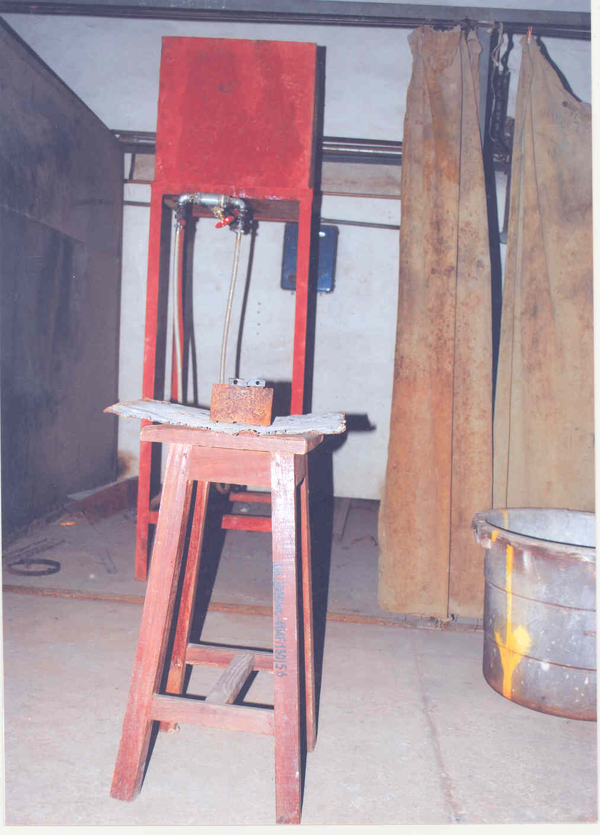
Figure 1. Experimental setup of test rig.

Table 1. Chemical composition (%) of Low carbon Steel

Element | C | Si | S | P | Mn | Ni | Cr
% composition | 0.1011 | 0.3191 | 0.080 | 0.0122 | 1.1622 | 0.2326 | 0.0316
Element | Mo | V | Cu | Zn | Fe | Al | Ca
% composition | 0.0041 | 0.003 | 0.2175 | 0.004 | 97.85 | 0.0345 | O.0316

2.1. Welding Procedure
The prepared test pieces were arc-welded in pair, with the specified welding parameters shown in table 2. The flow rate was set at 0.105 ltr/s. Coolant was allowed to pass through the channel on the plate via the hose and pipe. As soon as the coolant reaches the other end of the plate, welding commenced immediately. Three samples were prepared for each cooling media. The above procedure was first done for air, followed by water, and lastly saline solution cooling. The total number of test samples employed for the test is nine (three for each cooling medium). Table 2 below shows the welding parameters that were employed during welding operation.

120mm
35mm
25mm
16mm

Figure 2. Weldment configuration

Table 2. Welding parameters
Parameter | Value
Welding method | Arc welding
Electrode diameter | 2.5mm (gauge 10)
Welding current | 140A
Welding voltage | 80V
Welding speed | 1.44mm/sec

2.2 Hardness Test
This test was carried out at the materials testing laboratory of the Engineering Material Development Institute (EMDI) Akure, Ondo State, Nigeria. Hardness can be defined as the ability of a material to resist permanent indentation or deformation when in contact with an indenter under load. This involves pressing an indenter of known geometry and mechanical properties into the test material. The hardness of the material is quantified using one of a variety of scales that directly or indirectly indicate the contact pressure involved in deforming the test surface. For this work the Vickers microhardness test method was employed. It consists of indenting the test material with a diamond indenter, in the form of a right pyramid with a square base and an angle of 136 degrees between opposite faces subjected to a full load of 49.0g applied for dwell time of 10 seconds. The two diagonals of the indentation left in the surface of the material after removal of the load were measured using a microscope and their average calculated. The area of the sloping surface of the indentation is calculated. The Vickers hardness is the quotient obtained by dividing the grams load by the square mm area of indentation. The hardness values of each sample is measured at varying distances from the welding spot ranging from 5mm to 20mm. A total of twelve samples were tested. The obtained hardness values are as shown in Table 3.

Table 3. Average hardness values of HAZ in different quenching media
Distance from welding spot(mm) | Saline solution | Pure water | Air
5 | 280.1 | 189.3 | 164.2
10 | 263.2 | 168.8 | 167.6
15 | 230.8 | 159.3 | 182.2
20 | 175.2 | 144.0 | 204.0
Average Hardness of HAZ | $γ$ =237.27 | $α$ =165.35 | $β$ =179.50

3. Model Formulation
Table 4 shows the average hardness of HAZ of low carbon steel weldment cooled in a quenching medium expressed as a function of the average hardness of HAZ of the same material cooled in the other two media.

Table 4. HAZ average hardness ratio of low carbon steel quenched in different media.
Ratio of symbols designating HAZ average hardness | Ratio of HAZ average hardness values | Results of the Ratio of HAZ average hardness values
$$γ/α$$ | $${237.27}/{165.35}$$ | 1.4350
$$γ/β$$ | $${237.27}/{179.50}$$ | 1.3218
$$α/β$$ | $${165.35}/{179.50}$$ | 0.9211

Therefore,
$$γ =1.4350α (1)$$
$$γ =1.3218β (2)$$
$$α=0.9211β (3)$$
Adding equations (1) and (2) above we have;
$$2γ=1.4350α+1.3218β (4)$$
$$γ=0.7175α+0.6609β (5)$$
$$γ=α+β\left(1.3784\right) (6)$$
$$\frac{γ}{α+β}=1.3784 (7)$$
$$\frac{γ}{α}+\frac{γ}{β}=1.3784 (8)$$
$$\frac{γβ+γα}{αβ}=1.3784 (9)$$
$$γβ+γα=1.3784αβ (10)$$
$$γ\left(α+β\right)=1.3784αβ (11)$$
$$γ=1.3784\left[\frac{αβ}{α+β}\right] (12)$$

Mathematical computations of model equation (12) derived above, given the average hardness values of heat affected zones low carbon steel weldment quenched pure water (β) and air (α) provides us with half the average hardness value of the weldment cooled in saline solution (γ) under the same conditions. Hence, given the average hardness values of low carbon steel weldment quenched in pure water (β) and air (α), the average hardness of the weldment quenched in the saline solution can be obtained by multiplying the derived models of equation (12) by a constant factor of 2. Thus, the following general models given in equation (13), (14), and (15) are suitable for predicting the average hardness of heat affected zone of AISI 1013 low carbon steel weldment quenched in the selected quenching media.

$$γ=2.7568\left[\frac{αβ}{α+β}\right] \left(13\right)$$
$$α={\left[\frac{2.7568}{γ}-\frac{1}{β}\right]}^{-1} (14)$$
$$β={\left[\frac{2.7568}{γ}-\frac{1}{α}\right]}^{-1} (15)$$

Where

γ = Model-predicted average hardness of HAZ of low carbon steel weldment cooled in saline solution.
β = Model-predicted average hardness of HAZ of low carbon steel weldment cooled in pure water.
α = Model-predicted average hardness of HAZ of low carbon steel weldment cooled in air.

4. Model Validation
Since validation is an important aspect of modeling (Dym, 2004; Carson, 2001), the derived model was validated by evaluating the model-predicted values of HAZ average hardness of low carbon steel cooled in saline solution, pure water, and air with those derived from experiment.
Analysis and comparison between the model-predicted values γ, α, β and the respective corresponding experimental values γ_{exp}, α_{exp} and β_{exp} shows deviations of model data from the experimental data. Consequent upon these deviations there is the need for the introduction of a correction factor to bring the model-predicted values as close as possible to their corresponding experimental values.
Thus, the Deviation (D_{v}) of the model-predicted HAZ average hardness values (γ, α and β) from the corresponding experimental values γ_{exp}, α_{exp} and β_{exp} is given by

$$D_{V}=\left[\frac{H_{M}-H_{E}}{H_{E}}\right]×100 (16)$$
Also, the Correction factor ($C_{f}$) is the negative of the deviation i.e.
$$C_{f} ={-D}_{v} (17)$$
Where
($D_{v}$) = Deviation of the model-predicted average hardness values of HAZ from the corresponding experimental values
$C_{f}$ = Correction factor
$H_{M}$ = Model-predicted average hardness values of HAZ
$H_{E}$ = HAZ average hardness values from the experiment
Therefore
$$C_{f} =-\left[\frac{H_{M}-H_{E}}{H_{E}}\right]×100 \left(18\right)$$
Introduction of the value of C_{f} from equation (16) into the models give exactly the corresponding experimental values.

Table 5.Comparison of the average hardness of HAZ of low carbon steel quenched in different media as obtained from experiment and as predicted by derived model (each as a function of two other quenching medium).
Models derived | $$H_{M}$$ | $$H_{E}$$ | $$D_{V}$$ | $$C_{f}$$
$$γ=2.7568\left[\left({αβ}/{α+β}\right)\right]$$ | 237.22 | 237.27 | -0.013 | 0.013
$$α={\left[\left({2.7568}/γ-1/β\right)\right]}^{-1}$$ | 165.29 | 165.35 | -0.036 | 0.036
$$β={\left[\left({2.7568}/γ-1/α\right)\right]}^{-1}$$ | 179.53 | 179.50 | 0.017 | -0.017

The introduction of the correction factor is also indicative of the reliability and validity of derived generalized model. The above results show that the deviation in each case did not exceed 5% hence it has a high level of significance.

5. Conclusion
Hardness is the most important mechanical property associated with heat affected zones since it gives an indication of the degree of embrittlement there. Also cooling medium employed during welding varies with application. Thus, this paper has proposed generalized models for predicting the average hardness of heat affected zone of AISI 1013 low carbon steel weldment in three selected quenching media namely water, air and saline solution.
Acknowledgements:
The authors wish to express their appreciation to the management of the Prototype Engineering Development Institute PEDI) and Engineering Material Development Institute (EMDI) (both a Federal Institute under the National Agency for Science and Engineering Infrastructure, NASENI, Abuja Nigeria) for allowing the use of their facilities for this work..
Corresponding Author:
Mr Olumuyiwa V. Oyatokun,
Engineering Department,
Prototype Engineering Development Institute (PEDI),
P.M.B. 5025,
Ilesa, Osun State.
Nigeria.
E-mail: muyiallforone@yahoo.com

References
- Lakhtin YM. Engineering Physical Metallurgy and Heat Treatment. Mir Publishers Moscow, 1986: 63-286.
- Keehan E. Effect of Microstructure on Mechanical Properties of High Strength Steel Welds Metals. Thesis for the Degree of philosophy, Department of Experimental physics, Chalmers University of Technology. Sweden, 2004.
- Ndaliman MB. An assessment of mechanical properties of medium carbon steel under different quenching media. Assumption University Journal of Technology, 2006; 10 (2):100-104.
- Ivans I. Welding Basic 1. Online Available: www.welderworld.com. Retrieved January 20th, 2012.
- Ivans I. Welding Basic 2. Online Available: www.welderworld.com. Retrieved January 20th, 2012.
- Parma RS. Welding Engineering and Technology. Ist Edition. Khanna publisher, Delhi, 1999.
- Mannan SL, Laha K. Creep Behaviour of Cr Mo Steel Weldments. Trans.Indian Inst.Metal, 1996; 49:303-320.
- Robert K. Nichols PE. The Metallurgical Effect of weld seam Heat Treating. Thermatool Corporation, 1998; 116 (A): 11-98
- Lancaster, JF. Metallurgy of Welding: The Mechanical Properties of the Heat Affected Zone. Fourth Edition. Allen and University, London, 1987: 45.
- Korad T. et al. Improving Quench Hardening of Low Carbon Steel. Journal of Metals, Materials and Minerals, 2011; 21(1): 67-74.
- Dym CL. Principles of Mathematical Modeling. 2nd Edition, Academic Press, New York, 2004: 6.
- Carson E, Cobelli C. ,Modelling Methodology for Physiology and Medicine. Academic Press, San Diego, CA, 2001.

9/11/2012

