Distribution and Current Conservation Status of Some Important Threatened Medicinal Plants of Ducksum- kokernag (Kashmir Himalayas)

Bilal Ahmad Baig¹, Tariq Ahmad Bhat² and D. Ramamoorthy³

1: Corresponding author, Research scholar, Department of Ecology and Environmental Sciences, Pondicherry University, India. bilalahmadbaig@gmail.com
2: Lecturer, Department of Education, Government of Jammu and Kashmir, India. bhattariq110@gmail.com
3: Supervisor, Associate Professor, Department of Ecology and Environmental Sciences, Pondicherry University, India. d.ramamoorthy01@gmail.com

Abstract:It is imperative to understand the distribution and conservation status of medicinal plants in their natural habitats, owing to their increased demand and value. We studied the distribution pattern and current conservation status of six threatened medicinal plants in Ducksum Kokernag, Kashmir Himalayas, by random quadrate sampling (n=335) in different habitat types. The different uses of medicinal plants were obtained by informal interviews and group discussions with family elders. Recent re-emergence of herbal medicine applicability along with the ever escalating threats to biodiversity and the intensifying biopyracy controversions have necessitated for an urgent documentation of the traditional use of bioresources. This survey, in addition to the precious ethno medicinal information, recorded the important natural history details .Our results indicate that Podophyllum hexandrum Royle is most common and has the highest density followed by Picrorhiza kurroa Royle ex Benth and Arnebia benthamii (Wall ex Benth) I.M. Johnston .It is pertinent to mention that Arnebia benthamii is found in very less density and frequency in other surveyed sites of Kashmir Himalayas. While Mecanopsis aculeata Royle and Inula racemosa Hook f. are least frequent. Flat tableland (FL) situated above the tree line and moist rocky slopes (MR) were the most preferred habitats followed by flat meadow (FM). While the shady slopes (SSs), open gentle slope (OS) and moist meadow (MM) were least preferred. Our findings can help to formulate a conservation strategy for the unknown grass lands and the threatened vital medicinal plants of Ducksum. While the low and localized distribution of all studied species deserves effective conservation strategies, the scope of such measures should be explored in a way to address the reliance of local communities on these plants.
[Bilal Ahmad Baig, Tariq Ahmad Bhat and D. Ramamoorthy. Distribution and Current Conservation Status of Some Important Threatened Medicinal Plants of Ducksum- kokernag (Kashmir Himalayas). N Y Sci J 2012;5(11):41-48]. (ISSN: 1554-0200). http://www.sciencepub.net/newyork. 8

Keywords: Medicinal plants; Ducksum Kokernag; Kashmir Himalayas; bioresources; ethno-medicine; conservation strategy

Introduction:
The herbal medicine is gaining wide currency and acceptability and the documentation of valuable indigenous knowledge about medicinal plant species is assuming urgent priority, due to the recent controversies of biopyracy. The precious indigenous knowledge when supplemented and validated by the latest scientific incites can offer new holistic models of sustainable development that are economically viable, environmentally benign and socially acceptable. The Kashmir Himalayas, often referred to as terrestrial paradise on earth, is located at the north-western tip of the Himalayan biodiversity hot spot. The region supports a rich and spectacular biodiversity of great scientific curiosity and promising economic benefits owing to its topographic variations spanning from valley floor through the terraced table lands (karewas) and dense forests elevating up to the snow caped alpine peaks, since ages through trial and error. People in the Himalayan region have learned and practiced the medicinal usage of plants growing in their vicinity for treating various ailments.
The medicinal use of plants by the nomadic and migratory Gujjars and Bakerwals in Kashmir has been documented previously (Navchoo and Bhat, 1994; Khan et al., 2004). However a periodic and continuous monitoring of these species in the wild Habitat is largely lacking with the available information being either qualitative (Dhar and Kachroo, 1983) or ethno-botanical (Dar et al., 1984; Ara and Naqshi, 1992). A perusal of literature indicates that the documentation of ethno-botany of Ladakh (Bhattacharyya, 1989; Kaul et al., 1995) Doda (Kaul et al., 1994; Singh, 1995) Bhaderwah hills (Kapur, 1995) Little Tibet (Sharma, 1995) Uri sector (Lone, 2003) Muzaffarabad (Dar, 2003) and Samahni valley (Ishtiaq et al., 2006a,b, 2007) of Kashmir Himalayas has been done. However, southern region of Kashmir in spite of being great repository of medicinal plants (Dhar and Kachroo, 1983) remained unexplored in this regard. Therefore this study was undertaken in the high altitude moutains of Ducksum, Kashmir to report on the distribution, current conservation status, indigenous uses and availability of six threatened medicinal plants. i.e. Picrorhiza kurroa Royle ex Benth, Inula racemosa Hook f., Arnebia benthamii (Wall.ex Benth.) I.M. Johnston, Saussurea costus (Falc.) lipsch, Podophyllum hexandrum Royle and Mecanopsis aculeate Royle.

Material and Methods:
Kokernag
Kokernag is a notified area town of Anantnag District in Jammu and Kashmir State of India. Kokernag is the centre of Bringhi valley located at 33⁰69/ north and 75⁰22/ east. Situated at a height of 2020 m, Kokernag is 24 km. from the District Head Quarter of Anantnag and 70 km. from the summer capital Srinagar. It is a popular tourist destination due to blooming gardens which surround the spring. The diverse topography, unique climate and the varying habitats contribute to its rich biodiversity.

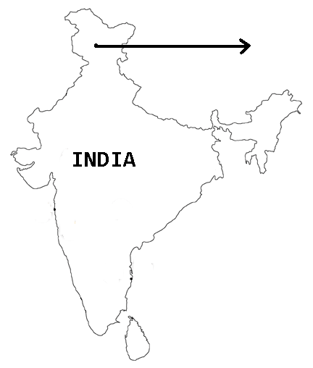
Study Site

The study was carried out in mountains and alpine grass lands of Ducksum which is located at a distance of 16 km. from the Kokernag and 40 km. from the headquarters of Anantnag District. The area extends between 33⁰61/ north and 75⁰43/ east at an altitude of 7734 ft. from the sea level. The diverse topographic features offer many habitats and microhabitat types for a variety of herbal species to grow in the high altitude forests. With the melting of snow the vegetation starts growing from early April and comes to its full bloom during June to September and starts dying out by the end of November. Then the area experiences heavy snowfall and remains under-covered by snow till March of next year

Study Site
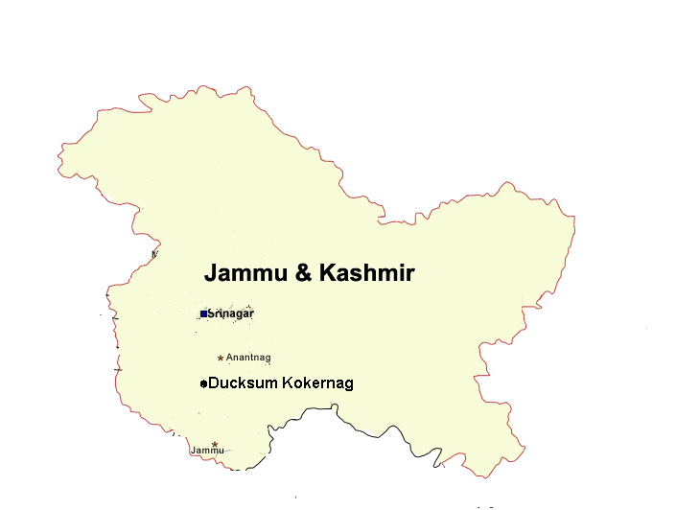

Methods
Field surveys and structured interviews were used to illicit secret knowledge from the traditional communities inhabiting inaccessible habitats of the region. Field surveys were conducted in the various localities during 2010- 2012. Usually the survey in each locality started with the interview of elderly and experienced members. Often they were accompanied to the field for the identification of plant species and authentication of plant specimens collected from the habitats. Besides the common people of the localities were consulted who have used these plant species for health-care. In addition to our focused study frequency, abundance and IVI was obtained from random quadrates (n=36) of 1m² size (Misra, 1968). Analytical features for population study and distribution pattern like percentage frequency and density (plants per m²) were calculated for each species across all sights. The mean values were taken to calculate Important Value Index (IVI) of individual species (Cottam and Curtis, 1956; Misra, 1968).
Information and data pertaining to the traditional method of medicinal uses were obtained through a structured questionnaire survey conducted among the family elders of all visiting households (n=40). As all the three ethnic community tribes frequently use these herbs, it helped us to get a comparative account of the utilization of these plant species. In addition we also conducted unstructured informal interviews with the other family members (n=13, 8 males and 5 females) and group discussions (n=20) to further increase the horizons of our understanding on the local time, traditional use, part used, current nature of use (household consumption or commercial and recent trend in species status).

Results:
Density and distribution of species
The distribution of species varied significantly among different habitats and none of the species occurred on all the habitats. P. hexandrum was found on five different habitats, A. benthamii occurred on three, while I. racemosa, and S. costus occurred on two habitats. The critically endangered M. aculeate recorded on only a single habitat type indicated its narrow distribution (Table.3). Moist rocky slope and Flat tableland were the preferred habitat types with each growing four species followed by flat meadow with two species while others grew only a single species each.
Observation on the average distribution of the species across all sights revealed P. hexandrum to be most frequent (77.77%) followed by P. kurroa (63.88.11%) and M. aculeate (11.11%) and I. racemosa (22.22%) as least frequent while A. benthamii (55.55%) and S. costus (36.11%) were intermediate with moderate distribution (Table 2). While P. hexandrum (1.83 ind.m²) and P. kurroa (1.70 ind.m²) indicated highest density, the presence of P. kurroa in a single habitat type with the highest density emphasized its narrow and squeezed distribution. The least frequent M. aculeate had also the lowest density (0.16 ind. m²). It is worth to mention here that A. benthamii is found in very less density and frequency in other surveyed sites of Kashmir Himalayas (Wani et al., 2006)
Important value Index (IVI) of each species was calculated to measure their numerical strength and assess their contribution to the total plant community. The highest IVI recorded is (0.65%) and lowest (0.16%) for P. hexandrum and M. aculeate, respectively.

Folklore use of Assessed species
The knowledge on the habitat distribution and medicinal use of these plants is maintained well within all the three ethnic tribes. The community elders and women folk have a handsome knowledge of the habitats, life history features, regeneration and uses of medicine plants. The continued belief of these communities on these high altitude easily accessible traditional medicinal plants and absence of alternative modern medicinal facilities for them have greatly affected their source of medicine at this high altitude area. Data collected through the questionnaires highlighted the indigenous uses and reflected the collection, trade and reliance (Table 4) of these ethnic people on these medicinal plants.
Almost all these plant species are used to cure common ailments like cough, cold, headache, asthma, fever, bronchitis and stomach pain by all the three ethnic tribes (Table 1). Furthermore species like A. benthamii are also used for some specific cases. A comparison of species indicates that A. benthamii and P. kurroa are the Prioritized medicinal plants for these people in terms of their ethno medicinal properties and uses. These plants have known antibacterial, anti- inflammatory and antipyretic properties, which together with their high market value make them a species of choice among all the three communities. These plants are also used frequently for their ethno veterinary applications by these tribes. Notable in this regard P. kurroa which are used by the communities to cure different diseases of their livestock. Specifically the A. benthami is used to cure cough, cardic disorders, fever and S. costus is used to cure joint pain, memorrhea and headache. While I. racemosa have known antithelmentic, antiseptic, expectorant and diuretic. Similarly M. aculeata is specifically used for cuts, wounds and bone fracture.

Discussion:
The IVI provides an excellent marker for understanding the status of distribution and availability across varying environmental and biotic conditions (Ram and Arya, 1991; Negi et al., 1992). This paper has described the distribution pattern and the current conservation status of threatened medicinal plants from a hitherto unknown Ducksum, Kashmir Himalayas. Relative values of the assessed species were tabulated and compared (Table 5) and based on this it was found P. hexandrum is widely distributed in different habitat types. The high frequency of P. hexandrum stems from its ability to grow in varied habitat types and complete the life cycle. In addition it is relatively lesser use and the part used frequently i.e. fruit also adds to its high frequency and density. However, the other species are highly localized and prone to grazing and trampling besides the part used being rhizomes and tubers. All these factors add to their low density and availability which is well reflected from our results.
Species frequency and density are efficient ways to reveal the distribution and strength of any species in a landscape (Alhamad, 2006). Comparing these features with similar studies outside Ducksum, it is evident that our values on density and distribution are slightly high (Table 5). As no scientific reporting from the area has been done and there are no historical data on the distribution of the species from the upper reaches of the Ducksum Kokernag valley which historically have been used for grazing, it appears that the sampled species are the remnants of a previously large population which over the years have narrowed in their distribution due to a multitude of factors, many of which went unnoticed. Not all assessed species are preferred by animals, but because the area is grazed mostly by goats and sheep (personal observations) which are both non-selective in foraging (Chandrasekhar et al., 2007) which adds to the damage. Trampling is the other damaging factor which seems to have affected these species enormously in open areas and squeezed their distribution. In the elsewhere IHR, earlier studies (Nautiyal et al., 1997; Pandey et al., 2000) have also reported grazing, trampling, biotic interference and low seed viability to be responsible for the diminution population of these species. Our results also high lightened the low availability i.e. population size and habitat specificity of these species in the wild (Table 3). This has important conservation applications as the species with specific habitat requirements are at great risk than the species with broad habitat range (Samant et al., 1996); besides a minimum population size is required for the long term viability of rare and endangered species (Cunningham and Saigo, 1999).
The communities of this study are rural and migrate seasonally to the higher alpine areas for live stock grazing. The people have learnt the medicinal usage of plants that grow in their proximity in their ages (Khuroo et al., 2007). This was also evident from the information we calculated through the questionnaire survey and group discussions held. The wealth of practical knowledge on the various plants, their distribution and the traditional uses further strengthens the argument. However to represent best range of the ethno medicinal use of the various high altitude species, more efforts need to put in conducting a comprehension ethno botanical survey of the whole Ducksum with due attention paid towards studying the conservation status of the important and rear medicinal herbs.
The migratory pattern of the communities differs largely among the three tribes. Bakerwals are truely migratory and nomadic, Gujjars are semi-nomadic, but the Kashmiri Chopans are semi-sedentary. This division was also reflected in the difference in the utility of the plants among the three communities with the Chopans and the young ones using the least number of the assessed species that too in minimum number of ways (Table 1).This adds to our observation that the young generation of the Chopans treat the folklore knowledge’s primitive and incompatible with the contemporary societal ideas. Consequently the older generation which harbors this wealth of the knowledge is generating and dying without passing on this invaluable legacy. This subtle change will bear a long term upshot on the maintenance and continuation of the indigenous Knowledge to subsequent generations which will greatly affect the way. These medicinal plants are used and managed by these communities.

Acknowledgment:
The authors are thankful to the Gujjars, Bakerwals and Chopans at the Ducksum and its outskirts for providing the accommodation, food and sharing their precious ethno botanical knowledge with us.

Table captions
.Tables 1: Characteristic features of selected medicinal plant species at Ducksum Kashmir Himalayas.
Table 1. Characteristic features of selected medicinal plant species at Ducksum Kashmir Himalayas. | Current use within three communities | Bakerwal | H | H | CEx | H | H | H | Note: CS, conservation status: IUCN, international union for conservation of nature and natural resources: CR, critically endangered: EN, endangered: VU, vulnerable: H, household use: CEx, commercial exploitation.
 |  | Chopan | H | Not used | CEx | CEx | Not used | Not used
 |  | Gujjar | H | H | H | CEx | H | H
 |  | CS(IUCN) | EN | CR | CR | CR | EN | CR
 |  | Folklore uses | Considered to be favourite in Dilious dyspepsia, stomachic, laxative | Antihelmenthic,antiseptic,expectprant and diuretic | Given against high fevers and particularly the flowers are reported to have soothing effect on patients with heart ailments. It is also used chest infections | Lumber pain, menorrhea, headache and also used in cough & asthama | Septic wounds, gastric problems | Water extract of whole herb including flowers used to wash wounds
 |  | Part  used | Rhizome/ roots | Roots/ foliage | Whole plant | Roots | Fruit/ Roots | Whole plant
 |  | Altitude(m) | 3500-3900 | 3100-3800 | 3100-4000 | 2800-3900 | 2300-3700 | 2900-4000
 | Local name | Bakerwal | Kaurd | Motocraz | Kahzaban | Kuth | Kakhri | Budhzadh
 |  | Chopan | Kaurd | Poshkar | Lailoot | Kuth | Wanwangun | Budhzadh
 |  | Gujjar | Kaurd | Motocraz | Kahzaban | kuth | Kakhri | Patharmaway
 |  | Scientific  name | Picrorhiza  kurroa | Inula  racemosa | Arnebia  benthamii | Saussurea costus | Podophyllum  hexandrum | Mecanopsis  aculeata

Table 2. Phytosociological parameters of the threatened medicinal plants at Ducksum Kashmir Himalayas.
 | Ducksum Kokernag
Scientific name | Density (plants/m²) | Relative density(RD) | Frequency (%) | Relative frequency(RF) | Important value Index (IVI) (%)
P. kurroa | 1.70 | 0.24 | 63.88 | 0.23 | 0.54
I. racemosa | 0.38 | 0.05 | 22.22 | 0.08 | 0.23
A. benthamii | 1.66 | 0.24 | 55.55 | 0.20 | 0.55
S. costus | 1.11 | 0.16 | 36.11 | 0.13 | 0.40
P. hexandrum | 1.83 | 0.26 | 77.77 | 0.29 | 0.65
M. aculeata | 0.16 | 0.02 | 11.11 | 0.04 | 0.16
Note: F, frequency; RF, relative frequency; IVI, Important valve Index.

Table 3: Distribution, density, frequency and IVI of selected taxa across the different habitat types at Ducksum Kashmir Himalayas
Table 3. Distribution, density, frequency and IVI of selected taxa across the different habitat types at Ducksum Kashmir Himalayas. | Habitat type | MM | IVI | _ | _ | _ | _ | 3.3 | _ | Note: SSA, shady slope ; OS, open gentle slope; MR, moist rocky slope; FL, flat tableland above tree line; FM, flat meadow ; Ds, dry shady slope: MM, moist meadow; D, density; F, frequency; IVI, Important valve Index; - (absent).
 |  |  | F | _ | _ | _ | _ | 14.4 | _
 |  |  | D | _ | _ | _ | _ | 1.30 | _
 |  | DS | IVI | _ | _ | _ | _ | 4.90 | _
 |  |  | F | _ | _ | _ | _ | 18 | _
 |  |  | D | _ | _ | _ | _ | 2.92 | _
 |  | FM | IVI | _ | _ | 1.90 | 2.8 | _ | _
 |  |  | F | _ | _ | 9.4 | 20.8 | _ | _
 |  |  | D | _ | _ | 0.38 | 1.35 | _ | _
 |  | FL | IVI | 7.9 | 2.7 | 5.7 | 1.4 | _ | _
 |  |  | F | 20 | 17.14 | 26.6 | 11.3 | _ | _
 |  |  | D | 10.9 | 0.92 | 2.97 | 0.52 | _ | _
 |  | MR | IVI | _ | 2.5 | 5.01 | _ | 4.6 | 1.01
 |  |  | F | _ | 11.4 | 13.5 | _ | 10.2 | 9
 |  |  | D | _ | 0.90 | 1.6 | _ | 1.70 | 0.12
 |  | OS | IVI | _ | _ | _ | _ | 1.30 | _
 |  |  | F | _ | _ | _ | _ | 10 | _
 |  |  | D | _ | _ | _ | _ | 0.30 | _
 |  | SS | IVI | _ | _ | _ | _ | 5.01 | _
 |  |  | F | _ | _ | _ | _ | 13.6 | _
 |  |  | D | _ | _ | _ | _ | 1.7 | __
 |  |  | Scientific  name | P. kurroa | I. racemosa | A. benthamii | S. costus | P. hexandrum | M. aculeata

Table 4: Categorization of the assessed taxa in to different groups.
 |  | Consumption
Species name | Rate in Rupees | Mostly Household | Mostly commercial | Both | Trade value (existing) | Nature of trade
P. kurroa | 400-800 | _ | Mostly commercial | Both | Low | Illegal
I.racemosa | 300-700 | + | + | _ | Low | Illegal
A.benthamii | 1200-1800 | _ | _ | _ | High | Illegal
S. costus | 2000-3000 | _ | _ | + | High | Illegal
P. hexandrum | 300-650 | + | _ | + | Lowest | Illegal
M. aculeata | 800-1000 | + | _ | _ | Low | Illegal
Note: Denotes the price which people get / kg from the middlemen and thus not reflect the market price.

Table 5. Comparative account of population status (density/m²) of selected plant species in different Kashmir Himalayan regions.
Name of species | Ducksum Kokernag | Semthantop | Gulmarg | Menwarsar Pahalgam
P. kurroa | 1.70 | 1.25 | 2.27 | 1.2
I. racemosa | 0.38 | _ | 0.11 | 0.13
A. benthamii | 1.66 | _ | _ | 0.16
S. costus | 1.11 | _ | 0.97 | 1.02
P. hexandrum | 1.83 | _ | 1.63 | 1.73
M. aculeata | 0.16 | 0.13 | 0.08 | 0.13
Note: (-) absent
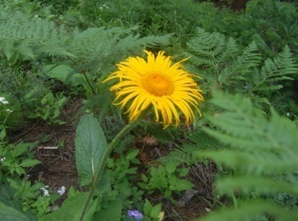
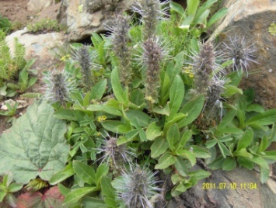
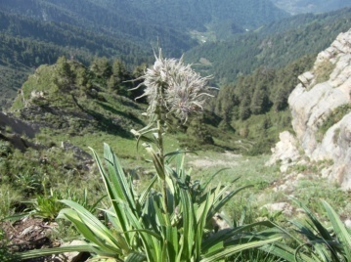

a b c
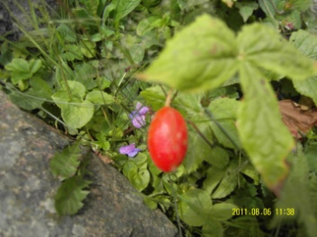
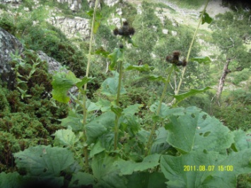
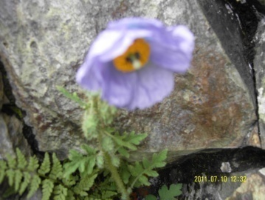

d e f
Palte-1-(a-f):(a) Picrorhiza kurroa (b) Inula racemosa (c) Arnebia benthamii (d) Saussurea costus
(e) Podophyllum hexandrum (f) Mecanopsis aculeata

Corresponding Author:
Bilal Ahmad Baig
Research Scholar
Department of Ecology and Environmental Sciences
Pondicherry University, Kalapet-605014
Puducherry, India
bilalahmadbaig@gmail.com

References:
- Alhamad MN. Ecological and species diversity of arid Mediterranean grazing land vegetation. J Arid Environ. 2006; 66:698-715.
- Ara S, Naqshi A. Ethno botanical studies in Gurais valley. J Econ Taxon Bot.1992; 17:657-678.
- Bhattacharya A. Ethnobotanical observations in the Ladakh region of northern Jammu and Kashmir State, India. Economic Botany 1989; 25:305-308.
- Chandrashekhar K, Rao KS. Maikhuri R, Saxena KG. Ecological implications of traditional livestock husbandry and associated land use practices: a case study from the Trans Himalaya, India. J Arid Environ. 2007; 69:299-314.
- Cottam G, Curtis IT. The use of distance measures in phytosociological sampling. Ecology 1956; 37:451-460.
- Cunningham WP, Saigo BW. Environmental Sciences: a global concern. Boston (MA): The Mcgraw-Hill Companies, 1999.
- Dar GM, Kachroo P, Buth HH. Ethno botany of Kashmir, Sind valley. J. Econ Taxon Bot 1984; 3:668-675.
- Dhar U, Kachroo P. Alpine flora of Kashmir Himalayas. Jodhpur (India): Scientific Publishers, Jodhpur, 1983; 280.
- Ishtiaq CM, Khan MA, Wafahi BA. An ethno medicinal inventory of plants used for family planning and sex diseases treatment in Samahni valley, (A.K) Pakistan. Pakistan Journal of Biological Science 2006; 9:2546-2555.
- Ishtiaq W, Hanif A, Khan MA, Mohammed AS, Butt A. An etnomedicinal survey and documentation of important medicinal folklore food phytonims of flora of Samahni valley, (Azad Kashmir) Pakistan. Pakistan Journal of Biological Science 2007; 10:2241-2256.
- Kapur SK. Traditionally important medicinal plants of Bhaderwah hills, Jammu province. Proceeding of the international Conference Current Programme Aromatic Plants Research, (CPAPR’ 95), Calcutta, India, 1995;103.
- Kaul MK, Sharma PK, Singh V. Crude Drugs of Zanskar (Ladakh) used in Amchi System of Traditionally Medicine. Glimpses of Indian Ethno Pharmacology (India), 1995; 163-172.
- Khan Z, Khuroo A, Dar G. Ethno medicinal survey of Uri, Kashmir Himalya. Indian J Tradit Knowl 2004;3(4): 351-357.
- Khuroo A, Akhtar H, Malik AR, Dar GH, Khan ZS. Ethno-veterinary uses of some plant species by the Gujjar tribe of the Kashmir Himalaya. Asian Journal of plant Science 2007; 6(1): 148-152.
- Lone FA. Folklore medicinal system of Uri sector Kashmir valley, India. Proceeding of the 2nd World Congress on Biotechnology Development of Herbal Medicine, Feb. 20-22 (India), 2003 ; 91-91
- Misra R. Ecology work book. New Delhi (India): Oxford & IBH Publishing Co, 1968.
- Nautiyal BP, Pandey N, Bhatt AB. Analysis of vegetation pattern in an alpine zone in North West Himalaya: a case study of Garhwal Himalaya with reference to diversity and distribution patterns. Int J Ecol Environ Sci 1997; 23:49-65.
- Navchoo IA, Bhat GM. Studies on the medicinal plants used by Gujjar, a backward tribe of Jammu and Kashmir Sahni KC, editor. Advances in plant science and research Dehradun (India): Bishen Singh & Mahendra Singh, 1994; 191-203.
- Negi GS, Rikhari HC, Singh SP. Phonological features in relation to growth forms and biomass accumulation in an alpine meadow of the Central Himalaya. Vegetatio 1992; 101:161-170.
- Pandey N, Nautiyal BP, Bhatt AB. Studies on vegetation analysis, plant form and biological spectrum of an alpine zone of north-west Himalaya. Trop Ecol, 2000; 40:163-166.
- Ram J, Arya P. Plant forms and vegetational analysis of an alpine meadow of Central Himalaya, India. Proc Indian Nat Sci Acad, 1991; 57:311-318.
- Samant SS, Dhar U, Rawal RS. Conservation of rare endangered plants: the context of Nanda Devi Biosphere Reserve In: Ramakrishnan PS, editor. Conservation and management of biological resources in Himalaya. New Delhi (India) Oxford & IBH Publishing Company, 1996; 521-545.
- Sharma GK. 1995. Medicinal flora of Ladakh (little Tibet). Flora Fauna, 1995; 1:105-106.
- Singh V. Herbal remedies in traditionally medicine of the local valley in Kashmir Himalayas, India, round progress in medicinal plants. Ethno-Medi. Pharmacology, 1995; 1: 63-71.
- Parvaiz AW, Dar AR, Mohi-ud-din GG, Khursheed AG, Irshad AN, Wafai, B.A. Treasure and tragedy of the Kashmir Himalayas. International Journal Botany 2006; 2(4): 402-408.

9/8/2012

