Assessment of the contribution of cassava crop (Manihot esculenta) to the household income in Kamonyi district, Rwanda

Alphonse Nahayo *, Irene Mutuyedata

Higher Institute of Agriculture and Animal Husbandry (ISAE), Department of Forestry and Nature Conservation, P. O. Box 210, Musanze, Rwanda; email: nahayo1@yahoo.fr

Abstract: The purpose of this study was to evaluate the contribution of cassava (Manihot esculenta) production to the increase of household income of farmers grouped in Umuhuza cooperative and individual farmers in Mukinga cell, Nyamiyaga sector, Kamonyi district, Southern province of Rwanda. Cassava is the most abundant crop in Kamonyi district but its input on the increase of household income is not estimated yet. Therefore, this study is an attempt to cover this gap. Data were collected in June and July 2011 by using a survey questionnaire through which open and closed-ended questions were asked to 128 respondents grouped in cooperative (61) and others working individually (67). Purposive, simple random selection and proportionate allocation sampling methods were used to collect data. Data analysis was done by using SPSS 17th version with Friedman test one way ANOVA and mean comparison. The results show that cassava price is 109 rwf/ kg of chips for Umuhuza and 98rwf/kg for individual farmers. The average production is 3.4556 kg for Umuhuza and 2.4524 kg for individual farmers. The average income is 181,493 rwf for Umuhuza and 140,570 rwf for individual farmers. The results also indicate that the first three services for which the income from cassava is used are food security, health insurance and children education with 2.30, 2.77 and 3.20 mean rank values respectively. The constraints in cassava production include climate variation, price variation, absence of credit bank and absence of technicians with 1.87, 2.15, 2.85, 3.13 mean rank values respectively. Cassava producers are advised to use monocropping method, to use both organic and chemical fertilizers which contribute to the increase of production. Working in cooperative is also recommended in order for farmers to gain more income.
[Nahayo A, Mutuyedata I. Assessment of the contribution of cassava crop (Manihot esculenta) to the household income in Kamonyi district, Rwanda. N Y Sci J 2012; 5(10):129-135]. (ISSN: 1554-0200). http://www.sciencepub.net/newyork. 20

Keywords: Cassava crop, household income, Umuhuza cooperative, farmers, Kamonyi district, Rwanda

1. Introduction
Cassava (Manihot esculenta) is a starchy root crop that develops underground. It holds the position as a primary food security crop in Africa due to its resistance to drought and disease, flexible planting and harvest cycle, and tolerance to low-quality soils. Cassava can remain in the ground for up to 18 months after reaching maturity (or more in the case of some varieties) and is well suited for a region that suffers both environmental and political hardships. It is originated from Southern America. Cassava is the third largest source of food carbohydrates in the tropics. Cassava is a major staple food in the developing world, providing a basic diet for around 500 million people (Ratanawaraha et al., 1999). In Rwanda, cassava constitutes the third culture after banana and sweet potato; cassava occupied 41,191ha with an average field of 9.546kg/ha. The production was 469.562 tones (MINAGRI, 1990). Cassava is cultivated for tubers which are basic food for many households and the totality of plant is used. Cassava is one of the crops promoted in Kamonyi district and many farmers take this crop as their principle crop which provides the high income but all cassava producers do not put hard effort in cassava production, the reason why this research was conducted in order to evaluate the contribution of cassava to the increase of household ‘income for farmers working in cooperative and others working individually. The specific objectives of this study are: (i) to evaluate the costs of cassava production in both cooperative and individual farmers; (ii) to estimate seasonal income from cassava production; (iii) to determine different services provided by using the income derived from cassava production. During this study, these hypotheses should be tested and verified: (i) the cost of cassava production is lower for cooperative ‘members than for individual farmers; (ii) the income from cassava production is higher in cooperative than for individual farmers; (iii) the income from cassava production help producers to build houses, to pay school fees, to buy the motorcycles and bicycles.

2. Material and Methods

Study area description
This study was conducted in Kamonyi district which is one of 8 districts of Southern province and it is situated in the centre of Rwanda. It is composed of 12 sectors, 59 cells and 317 villages. The population of Kamonyi equals to 2,654,365.The whole area of Kamonyi is 655.5 km² with the population density of 404.8 inhabitants per km². At the board of Kamonyi, there are Ruhango district in South, Muhanga district at Ouest-Eastern, Bugesera and Nyarugenge at East, Gakenke and Rurindo district at North. Kamonyi district has a hot climate. Rainfall varies between 1200 and 1400 mm and the average temperature is 20⁰C. In Kamonyi district, there are not a lot of rivers but Nyabarongo is at the board of the North-East and Akanyaru is bordered with Bugesera district. Mainly small rivers are present such as Nyabuvomo, Bishenyi, Kibuza, Bakokwe, Kayumbu, Mukunguri, and Ruvubu. The altitude of this district is between 1500 to 2000 m a.s.l and the soil is sablo-argilous and contains the average of humus.

Methods
This study was conducted in June and July 2011. The key respondents were Umuhuza Cooperative and individual cassava producers located in Mukinga cell, Nyamiyaga Sector, Kamonyi District in Southern Province of Rwanda. This cooperative is very strongly involved in cassava production and processing and it is well organized. Umuhuza Cooperative is composed of 600 members where women are 352 and men are 248. Individual cassava producers in Mukinga cell are 3,320. The survey questionnaire was conducted in Umuhuza Cooperative and individual cassava producers. The sample size was taken from Umuhuza’ members and individual cassava producers. Purposive, random and proportionate allocation sampling methods were used to collect data. The calculated sample size from Umuhuza cooperative was 61 households and the sample size from individual cassava producers was 67 farmers. Formal and informal interviews were used including the open and closed-ended questions. Data were analyzed through Excel program and Statistical Package for Social Sciences (SPSS) 17th version where mean comparison test, Friedman test and frequency methods have been used.

3. Results and discussion

3.1. Age of respondents
Table 1 : Age
 | N | Minimum | Maximum | Mean | Standard Deviation
Age of respondent | 128 | 19 | 71 | 43.05 | 12.509

According to the table1, people of different ages intervene in cassava production activity, the mean of the age of respondents is 43 years and the respondent ‘ages range from 19 to 71 years.

3.2. Education level, sex and marital status
Table 2 : Education level, sex and marital status
Education level | Sex of respondents |  |  |  |  |  | Total
Education level | Male |  |  | female |  |  | Total
Education level | single | married | widower | single | married | widower | Total
Illiterate  Primary school  Secondary school | 0  13  1 | 5  37  2 | 0  0  0 | 0  1  0 | 5  47  2 | 11  14  0 | 11  112  5
Total | 14 | 44 | 0 | 1 | 50 | 15 | 128

The table 2 shows that both sexes participate in cassava production. Among 128 respondents, 58 are male and 70 are female, hence, the sex is not an issue in these cassava producers. For education level, 11 are illiterate, 112 farmers completed primary school while only 5 farmers completed secondary school. It seems that farmers with high education level do not intervene in cassava production so it requires a high sensitization to educated people in order to make cassava culture professional. About marital status, among 128 respondents 15 are single; 94 are married and widower are19.

3.3. Farm size

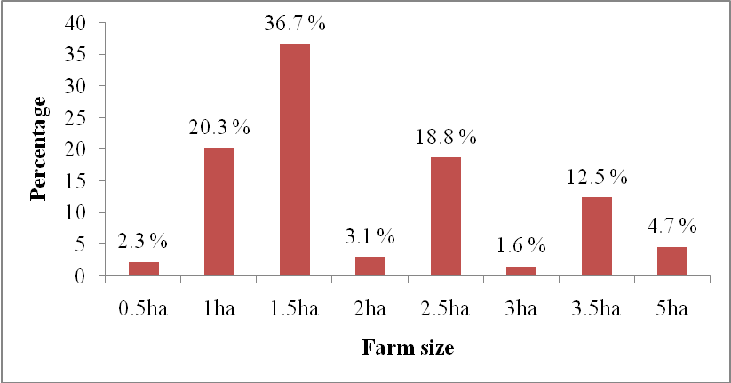
Figure 1: Farm size of respondents

The figure 1 above shows the farm size of all surveyed farmers from Umuhuza cooperative and individual farmers. The farm size used by respondents is between 0.5 and 5 ha. A big number of farmers cultivate 1.5 ha with 36.7%, respondents with 0.5 ha are 2.3 %, respondents with 1 ha are 20.3 %, those with 2 ha are 3.1 %, respondents with 2.5 ha are 18.8%, respondents with 3 ha are 1.6%, those with 3.5 ha are 12.5% and respondents who use 5 ha for cassava cultivation are 4.7% and from the survey done farmers from Umuhuza cooperative have bigger farm size comparing to individual farmers.

3.4. Inputs used for producing cassava
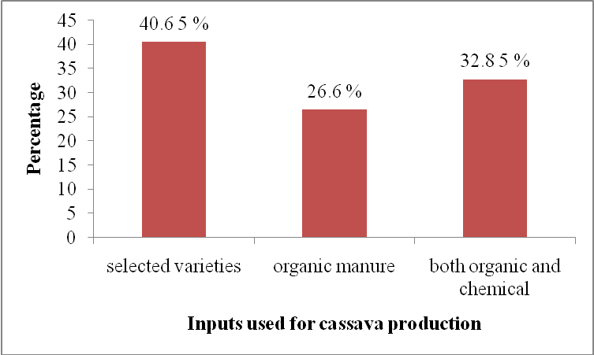
Figure 2: Inputs used for producing cassava

The figure 2 shows that the respondents use three categories of inputs for producing cassava such as selected varieties, farmyard manure and chemical fertilizers. Farmers who use varieties without fertilizers are 40.6%, respondents who fertilize with farmyard manure are 26.6% and those who combine chemical and organic fertilizers during fertilization are 32.8%. The level of using fertilizers is not sufficient in this region so sensitization on the importance of using fertilizers is required.

3.5. Cultivation methods used by respondents

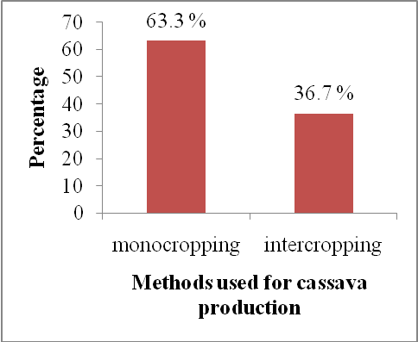
Figure 3: Cultivation methods used for producing cassava

For producing cassava, monocropping method is used at 63.3% and intercropping is used at 36.7%.

3.6. Paid workers employed during cassava cultivation
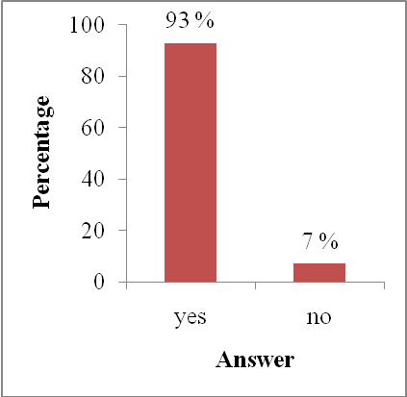
Figure 4: Paid workers

The figure 4 shows that a large number of respondents use and pay the workers in agriculture activities such as land preparation, sowing, weeding, harvesting and transport of the production.
Farmers who are helped by those workers are 93% and those who make cassava cultivation activities themselves are 7%.

3.7. Reasons for cultivating cassava
Table 3. Reasons influencing farmers to cultivate cassava
Reasons | Mean Rank | Test statistics
National agricultural policy | 3.66 | N 128  Chi-square 218.752  Degree of freedom 4  Asymp.sig 0.000
Improving welfare | 2.64
Imitating others | 3.66
Getting income | 1.45
Occupying uncultivated land | 3.58
Different reasons that influence farmers to cultivate cassava are shown in this table 3 where Friedman test is used. Getting income takes the first place with 1.45 mean rank because this crop is well promoted in the study area and farmers put a high effort in producing it. Improving life is at 2.64 mean rank where farmers, after getting income from cassava, satisfy their needs and their welfare is improved. Occupying uncultivated land is at 3.58 mean rank, meaning that the farmers choose to cultivate cassava on uncultivated land because it does not require a lot of activities. Imitating others is at 3.66 mean rank, some farmers cultivate cassava because they remark that there is enough market share and it brings high income.
The national agricultural policy is at 3.66 mean rank as cassava is a promoted crop in Kamonyi district. Some farmers cultivate it under local authority’s pressure because their land is placed on chosen sites for cassava production. Friedman test indicates that getting income and improving lifestyle are the main reasons for cultivating cassava in the region comparing to other reasons with a high significant difference where p is< 0.05.

3.8. Source of funds used for producing cassava
Table 4. Source of funds
Source of fund | Mean Rank | Test statistics
Credit bank | 3.73 | N 128  Chi-quare 330.834  Degree of freedom 4  Asymp.sig 0.000
Agriculture | 1.43
Building | 3.79
Breeding | 2.40
Trading | 3.65

The table 4 shows that for producing cassava, the farmers get funds from different sources. Credit bank is at 3.73 mean rank, agriculture is at 1.43 mean rank, building is at 3.79 mean rank, breeding is at 2.40 mean rank and trading is at 3.65 mean rank. Agriculture and breeding are the main sources of funds to use for producing cassava with a high significant difference (p=0.00) comparing to others.

3.9. Clients of cassava products
Table 5. Clients of cassava products
Clients | Mean Rank | Test statistics
Cooperative | 3.05 | N 128  Chi-square 208.4070  Degree of freedom 3  Asymp.sig 0.000
Other farmers | 2.25
Schools | 3.21
Traders | 1.49

Cassava production is bought by different clients as it is shown in table 5. Cooperative is at 3.05 mean rank, other farmers are at 2.25 mean rank, schools are at 3.21mean rank and traders are at 1.49 mean rank. Traders and other farmers are the principle clients of respondents ‘cassava production with a high significance difference (p=0.00) comparing to other clients.

3.10. Production and education level
Education level has an impact on cassava production as it is shown in the table 6.
Table 6. Production according to education level
Education level | Frequency | % | Average production | Std. Deviation | P. at 5%
Illiterate | 11 | 8.6 | 2.6726 | 0.37874 | 0.415
Primary school | 112 | 87.5 | 2.9369 | 1.00830 | 0.415
Secondary school | 5 | 3.9 | 3.3554 | 0.48661 | 0.415
Total | 128 | 100 | 2.9305 | 0.95929 | 0.415

Cassava crop is cultivated by farmers of different education level. The table 6 shows that there is no significant difference between production and education level obtained with mean comparison where p>0.05. Illiterate at 8.6% produce 2.6726 kg, farmers with primary level at 87.5% produce 2.9369 kg and farmers with secondary school at 3.9% produce 3.3554 kg. Production increases with education level because educated people adopt easily innovative technology which increases the production. A study conducted by Ofori et al., (1997) indicated that cassava production decreases due to diseases and farmers need to be educated to fight against them, to apply modern farming system methods and to be aware of environmental issues.

3.11. Production and cultivation methods
For producing any crop different methods are used and those methods may have a positive or a negative impact on the production. The following table 7 shows how monocropping and intercropping can affect the production of cassava.

Table 7. Cultivation and production methods used
Cultivation methods used in the field | Frequency | % | Average production | Std. Deviation | P.at 5%
Monocropping | 81 | 63 | 3.2386 | 1.02737 | 0.000
Intercropping | 47 | 37 | 2.3995 | 0.49984 | 0.000
Total | 128 | 100 | 2.9305 | 0.95929 | 0.000

From the results obtained by using mean comparison test, there is a high significant difference between cassava production and cultivation methods used where p<0.05. By using monocropping method at 63 % the average production is 3.2386 kg and intercropping at 47 % the average production is 2.3995. Therefore, monocropping is the best and modern method to be used in order to get more production. Similarly, Ofori (1997) proposed the adoption of new techniques in cassava cultivation and practice based on the information on soil and environment in order to solve the decreased production.

3.12. Production and inputs used

Table 8. Production and inputs used
Inputs used for cassava production | N | % | Average production | Standard Deviation | P. at 5%
Selected varieties only | 52 | 41 | 2.1949 | 0.23868 | 0.000
Farm yard manure | 34 | 26 | 2.8819 | 0.40681 | 0.000
Both organic and chemical fertilizers | 42 | 33 | 3.8807 | 1.01652 | 0.000
Total | 128 | 100 | 2.9305 | 0.95929 | 0.000

In cassava production, the farmers use different inputs which affect its production. The results obtained with mean comparison show that there is a significant difference between production and inputs used where p is <0.05; the use of selected varieties only at 41 % gives the average production of 2.1949 kg, the farmyard manure at 26 % gives 2.8819 kg and use of both farmyard manure and chemical fertilizer at 33 % gives 3.8807 kg. A study done by Ferris, (1998) revealed that Cassava crop requires the application of organic fertilizers used together with the amount of chemicals. The fertilization stimulates cassava growth and increases the cassava yield. Fertilization of 90kg N +50 P₂O₅+ 90 K₂O/Ha seems to be a good fertilization rate as it maintains both yield of crop and net income. Therefore, farmers in Kamonyi district must be sensitized on how to cultivate with both organic and chemical fertilizers in order to gain more benefits.

3. 13. Production and respondent categories
Table 9. Production and respondent categories
Cassava producers | N | % | Average production | Standard deviation | P. at 5%
Umuhuza | 61 | 48 | 3.4556 | 1.05784 | 0.000
Individual farmers | 67 | 52 | 2.4524 | 0.51631 | 0.000
Total | 128 | 100 | 2.9305 | 0.95929 | 0.000

The farmers surveyed are different, some come from Umuhuza cooperative and others are individual farmers. The results obtained by mean comparison show that there is a high significant difference between production and respondents category where p<0.005. Farmers from Umuhuza cooperative at 48% produce 3.4556 kg and individual farmers at 52 % produce 2.4524 kg. Thro (1995) suggests that cooperative should assume an increasingly important role in the development of its members, provide technical assistance and training. Therefore, working in cooperative is better than working individually.

3.14. Production, price, output, expenditure and income
Depending on the respondents, there is an average production for respondents, the price of kg of cassava chips produced, the average output, average expenditure and the average income that the farmers gained.

Table 10. Production, price, output and income
Respondents | Frequency | % | Average production 2011 (kg) | Average price 2011  (Rwf) | Average output 2011 (Rwf) | Average expenditure (Rwf) | Average income (Rwf)
Umuhuza | 61 | 48 | 3.4556 | 109 | 377574 | 196082 | 181493
Individual farmers | 67 | 52 | 2.4524 | 98 | 239161 | 98591 | 140570
Overall | 128 | 100 | 2.9305 | 103 | 305124 | 145051 | 160072
Significance between respondents | Production 2011 |  | 0.00
Significance between respondents | Price 2011 |  | 0.000
Significance between respondents | Output 2011 |  | 0.000
Significance between respondents | Expenditure 2011 |  | 0.000
Significance between respondents | Income 2011 |  | 0.004

The table 10 indicates that there is a high significant difference between Umuhuza’ members and individual farmers by Mean Comparison test regarding the price, production, output, expenditure and income in the year 2011 with respective p<0.05 where the average production is 3.4556 kg of cassava chips for Umuhuza and 2.4524 kg of cassava chips for individual farmers; The average output is 377,574 Rwf in Umuhuza and 239,161Rwf for individual farmers and average expenditure is 196,082Rwf in Umuhuza and98,591 Rwf for individual farmers. Concerning the price, there is a very high significant difference at p<0.005 with 109 Rwf/kg of cassava chips in Umuhuza and 98 Rwf/ kg for individual farmers. Prices are different comparing to the results got by Srinivas, (2007). This author explained that a non-organized marketing system often results in instability of the prices, exploitation by middlemen and a lower share for the producer in the consumer’s rupee. Wide fluctuations in the prices of starch, sago and such value added products are being observed every year in the country and the effect of which is reflected on the prices of tubers and indirectly affect the farmers. These variations are influenced by derived demand for the products, market forces, and season of production. Regarding the income between respondents, there is a very high significant difference at p< 0.005 resulting from the difference of price on cassava chips sold where the income in Umuhuza is181, 493 Rwf and 140,570 Rwf for individual farmers and this income is used for human consumption, animal feeding, industrial product (starch, ethanol, adhesive), textile industries, pharmaceutical and petroleum industries (Nweke et al., 2002).

3.15. Income according to the cultivation methods
Table 11. Income according to the cultivation methods
Cultivation methods used in the field | N | % | Average income | Std. Deviation | P. value
Monocropping | 81 | 63 | 1.73805 | 96635.95241 | 0.11
Intercropping | 47 | 37 | 1.36415 | 32027.58706 | 0.11
Total | 128 | 100 | 160072 | 81125.74799 | 0.11

According to the table 11, there is a significant difference between the average income got when monocropping and intercropping methods are used where p= 0.11. For monocropping, the average income is 173,805rwf and 136,415rwf when intercropping is used. It recommended to use monocropping method in cassava cultivation because this method is the main factor for increasing cassava production.

3.16. Income and inputs used
Table 12. Income and inputs used
Inputs used for cassava production | N | % | Average income | Std. Deviation | P. value
Selected varieties only | 52 | 41 | 134102 | 25605.65182 | 0.09
Farmyard manure | 34 | 26 | 173465 | 52874.24901 | 0.09
Both organic and chemical fertilizers | 42 | 33 | 181385 | 1.259015 | 0.09
Total | 128 | 100 | 160072 | 81125.74799 | 0.09

Income is dependent on different factors including all inputs used. The results obtained in table12 by mean comparison show that there is no significant difference between inputs used for producing cassava. The use of selected varieties without fertilization at 41% brings the income of 134,102Rwf, fertilization with farmyard manure at 26% brings the income of 173,465Rwf and fertilization with both farmyard manure and chemical fertilizers at 33% brings the income of 181,385Rwf. The results show that it is better to use both fertilizers organic and mineral in order to gain a high income.

3.17. Constraints encountered during cassava cultivation
Table 13. Contraints during cassava cultivation
Constraints | Mean Rank | Test statistics
Price variation | 2.15 | N 128  Chi-square 125.039  Degree of freedom 3  Asymp.sig 0.000
Absence of credit bank | 2.85
Climate variation | 1.87
Absence of technician agronomists | 3.13

The table13 indicates that during cassava cultivation, the famers meet different constraints which can reduce the production. The price variation is one of the constraints with 2.15 mean rank, absence of credit bank with 2.85 mean rank, climate variation with 1.87 mean rank and absence of technician agronomists with 3.13 mean rank. The statistical table indicates that climate variation and price variation are the main constraints that farmers encountered during cassava production with a high significant difference comparing to other constraints (p=0.000).

3.18. Use of income from cassava production
Table 14. Use of income gained from cassava production
Use | Mean Rank | Test statistics
Health insurance | 2.77 | N 128  Chi square 389.743  Degree of freedom 6  Asymp.sig 0.000
Children education | 3.20
Food security | 2.30
Building house | 5.34
Buying motorcycle | 5.58
Buying bicycle | 4.84
Buying cow | 3.97

Cassava crop is very important to producers because its income is used in different activities. The income from cassava production is used for food security with 2.30 mean rank where respondents buy various foods, children education with 3.20 mean rank and health insurance with 2.77 mean rank. This table 14 shows also that the income from cassava is also used for buying cows with 3.97 mean rank, buying bicycle with 4.84 mean rank, build house with 5.34 mean rank and buying motorcycle with 5.58 mean rank. The statistical table indicates that food security, children education and health insurance are the main uses of income from cassava with a high significant difference comparing to other uses (p=0.000).

4. Conclusion
This study aimed at evaluating the contribution of cassava (Manihot esculenta) production to the increase of household income of farmers grouped in Umuhuza cooperative and individual farmers in Mukinga cell, Nyamiyaga sector, Kamonyi district, Southern province of Rwanda. The cost of cassava production is different for both cooperative and individual farmers. The seasonal income is different in Umuhuza’ members and individual farmers and cassava income provides different services to farmers. Cassava contributes to the increase of household’ income where people use the money got from cassava to satisfy their daily needs such as food security, school fees, health insurance, building house, buying bicycle, motorcycles and buying cows. However, the production depends much on the methods used in the production where the monocropping is considered as the best. The findings revealed that cassava is meeting some constraints hindering its production and among them there is price variation, absence of bank credit, climate variation and absence of technician agronomists. Moreover, we found that to work in cooperatives is the best way of gaining much income rather than working individually since it provides many advantages such as easy access to agricultural credits and trainings.

Acknowledgements
We acknowledge the financial and technical supports provided by the Higher Institute of Agriculture and Animal Husbandry (ISAE)-Busogo for the completion of this study.

*Corresponding Author
NAHAYO Alphonse
Higher Institute of Agriculture and Animal Husbandry (ISAE) – Busogo; Department of Forestry and Nature Conservation; P.O.Box 210 Musanze, Rwanda; Email: nahayo1@yahoo.fr

References
1. Ferris, H., Venette, R. C., van der Meulen, H. R., and Lau, S. S. 1998. Nitrogen Mineralization by Bacterial-feeding Nematodes: Verification and Measurement. Plant and Soil (in press).
2. MINAGRI, 1989. Production agricole en 1987. Bilan d’autosuffisance alimentaire par commune et par habitant, Kigali. 201pp.
3. MINAGRI, 1990. Plans stratégiques pour la transformation de l’agriculture au Rwanda. Kigali, Rwanda.
4. Nweke, Felix I., Dunstan S. C. Spencer and John K. Lynam. 2002. The cassava transformation: Africa.s best kept secret. Lansing, Mich., USA: Michigan State University Press.
5. Ofori, F., R. Al-Hassan, J. J. Afuakwa, and R. K. Noamesi 1997. A case study of cassava development in Ghana. The Global Cassava Development Strategy Validation Forum. Rome: Food and Agriculture Organization of the United Nations and International Fund for Agricultural Development.
6. Ratanawaraha, C., N. Senanarong, and P. Suriyapan. 1999. Status of cassava in Thailand: Implications for future research and development. The Global Cassava Development Strategy Validation Forum. Rome: Food and Agriculture Organization.
7. Srinivas, T., 2007. Industrial demand for cassava starch in India. Starch/Stärke 59: 477-481.
8. Thro, A. M., 1995. Cassava biotec network, update to the ISTRC-AB: Network activities and scientific progress. In Root crops and poverty alleviation, ed. M. O. Akoroda and I. J. Ekanayake. Proceedings of the Sixth Triennial Symposium of the the International Society for Tropical Root Crops - African Branch (ISTRC-AB), held October 22-28, 1995, Lilongwe, Malawi. Ibadan, Nigeria: International Institute of Tropical Agriculture.

10/12/2012

