SUBSURFACE STRUCTURAL CHARACTERIZATION OF NATIONAL ANIMAL PRODUCTION RESEARCH INSTITUTE (NAPRI), ZARIA USING 2D ELECTRICAL IMAGING

¹J. Adamu, ²S.I. Fadele, ³P.O. Sule, ⁴K.M. Lawal

^{1,2,3,4} Department of Physics, Ahmadu Bello University, Zaria, Nigeria.
Email: 4johnny@yahoo.com; Fadeleidowu@yahoo.com

Abstract: The method adopted for this paper was the 2D Electrical Resistivity Tomography (ERT), using the ABEM LUND Imaging System. A Wenner configuration WEN32SX was carried out to map the electrical properties as an aid to characterizing the subsurface conditions. Eight profiles were occupied in the study area. For each profile, the layout geometry for the electrical imaging was such that two reels of cables were used with 5m intervals between the takeout electrodes. However, the two innermost electrodes adjoining the two reels of cables were connected together thus yielding a total of 41 electrodes and a spread length of 200m. The data obtained using ABEM Terrameter SAS 4000 were processed using RES2DIVN software. Based on the electrical images obtained in the study area, the following deductions were made. The depth to the fresh basement is generally well beyond 30.0m. The study reveals the presence of two distinct layers; the topsoil and weathered basement with resistivity ranges of 20.6-100Ωm and 25.9-406 Ωm respectively. These layers constitute the overburden with a thickness of 29.3m revealed by the pseudosections. The topsoil composed of laterite and brownish sandy clay with an average thickness of 11.0m. The weathered basement underlies the topsoil with an average thickness of 18.3.0m and this is a good aquifer in the study area. The depth of probing which is 29.3m is above the depth to the fresh basement.
[J Adamu, SI Fadele, PO Sule, KM Lawal. SUBSURFACE STRUCTURAL CHARACTERIZATION OF NATIONAL ANIMAL PRODUCTION RESEARCH INSTITUTE (NAPRI), ZARIA USING 2D ELECTRICAL IMAGING. N Y Sci J 2012;5(10):44-48].(ISSN: 1554-0200). http://www.sciencepub.net/newyork. 8
Keywords: Electrical Resistivity Tomography (ERT), ABEM LUND Imaging System and Pseudosections

1. Introduction
Geophysical investigations of the earth involves the study of physical properties, of the ground, thereby providing vital information on subsurface material conditions for numerous practical applications by taking measurements at or near the earth’s surface that are influenced by the internal distribution of physical properties. Consequently, analysis of these measurements can reveal how the physical properties of the earth’s interior vary vertically and laterally and reflecting the subsurface geology. Alternatively, another method of investigating subsurface geology is of course by drilling and pitting which provide information only at discrete locations and are expensive. Many geophysical investigations are non-intrusive and non-invasive, thus avoiding the disruption caused by intrusive investigations such as drilling and pitting. The 2D Electrical Resistivity Tomography (ERT), using the ABEM LUND Imaging System was adopted for this work. A Wenner configuration WEN32SX was carried out to map the electrical properties as an aid to characterizing the ground conditions. Resistivity surveys measure variation in the electrical resistivity of the ground by applying small electric current across arrays of ground electrodes. Resistivity imaging is particularly useful in clayey ground where methods such as the ground penetrating radar GPR are less effective and helps define translational boundaries that are difficult to detect using other geophysical methods. One of the new developments in recent years is the use of 2D electrical imaging/tomography survey to map areas with moderately complex geology (Griffiths sand Barker, 1993). Such surveys are usually carried out using a large number of electrodes, 25 or more, connected to a multi-core cable. In this survey, the Wenner array with 5m interval between 41 electrodes was employed with each spread having a length of 200m. However, the ABEM LUND Imaging System is a multi-electrode system for cost effective and high-resolution 2D and 3D resistivity surveys. The included data acquisition software supports 2D and 3D surveys with surface arrays which may also be used for borehole measurements. The results of analyzing the 2D Wenner resistivity sections based on 2D inversion of field data and borehole information are presented and interpreted.

2. The Survey Area
Shika is situated within the northern Nigerian Basement Complex, in the north, (figure 1). It lies between latitudes 11⁰8’N and 11⁰15’N and longitudes 7⁰30’E and 7⁰40’E within the Zaria sheet 102. The mean elevation of the area is about 700m above mean sea level. Figure 1 is the National Animal Production
Research Institute (NAPRI), location map showing the investigated site. The study area (NAPRI), where the profiles are laid is bounded by latitude 11⁰12’16.1”N to latitude 11⁰12’23.8”N and longitude 7⁰33’37.6”E to longitude 7⁰33’48.6”E, with an average elevation of 683m above sea level.

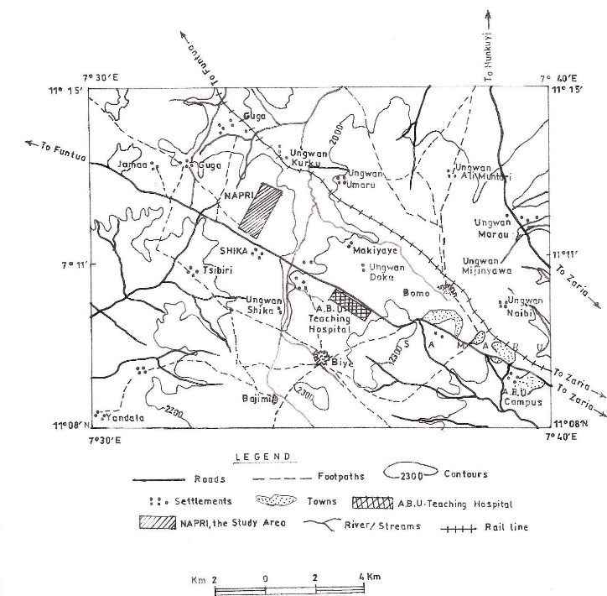

Fig 1. Location Map showing the Study Area

3. Geology of the Study Area
Nigeria lies in the Pan-African mobile belt which has been affected by Pan-African events through the ages of orogenic, epeirogenetic, tectonic and metamorphic cycles.The study area is part the Nigerian Basement Complex underlain by crystalline rocks, so the geology of the area is the same as that of the Nigerian Basement complex. The rocks of the Basement Complex occupy more than 50% of the total land surface of Nigeria, and accommodate the metasediments which are made up of gneisses. Exposures are scanty and highly weathered. The rock types are biotites, gneisses, granite gneisses and in parts with subordinate migmatites. The contact between the gneisses and metasediments are gradational (McCurry, 1970). Shika is underlain by basement rocks of Precambrian age. They are mainly granites, gneisses, and schists (Fig. 2). Oyawoye (1964) showed that there is structural relationship between this Basement Complex and the rest of the West African basement. This is partly due to the fact that the whole region was involved in a single set of orogenic episode, the Pan African orogeny, which left an imprint of structural similarity upon the rock units. Granitic intrusions form a suite of batholiths (the Zaria Batholiths), part of which outcrops as the Kufena Hill. The gneisses are found as small belts within the granite intrusions, and are also found east and west of the batholiths. The biotite gneiss extends westwards to form a gradational boundary with the schist belt. The gneiss continues eastwards to some extent and is occasionally broken up by the Older Granite (McCurry, 1970). The Older Granite intrusion is supposed to have been formed at the bottom of a fold mountain belt (Wright and McCurry, 1970).
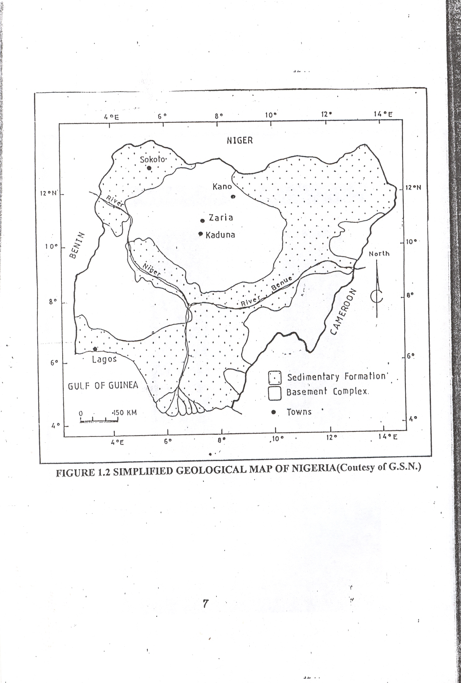

Fig 2. Simplified geological Map of Nigeria (Courtesy of Geography Society of Nigeria)

4. Methodology
The electrical resistivity imaging is a survey technique recently developed for the investigation of areas of complex geology where the use of resistivity sounding and other techniques is unsuitable (Griffiths and Barker 1993). It involves measuring a series of constant separation traverses with the electrode spacing being increased with each successive traverse. Since increasing separation leads to greater depth penetration, the measured apparent resistivities may be used to construct a vertical contoured section displaying the variation of resistivity both laterally and vertically over the section. The major limitation of the resistivity sounding method is that it does not take into account horizontal changes in the subsurface resistivity. A more accurate model of the subsurface is a two-dimensional (2-D) model where the resistivity changes simultaneously in the vertical direction, as well as in the horizontal direction along the survey line. In many situations, particularly for surveys over elongated geological bodies, the imaging technique gives a clearer picture of the cross-section of the body than what the vertical electrical sounding (VES) would do. To obtain a good 2-D picture of the subsurface, the coverage of the measurements must be 2-D as well. As an example, figure 3 shows a possible sequence of measurements for the wenner electrode array for a system with 20 electrodes. Here, measurement commences at one end of the line using electrodes 1, 2, 3 and 4. The spacing between adjacent electrodes is “a”. With wenner array, the first step is to make all the possible measurement with electrode spacing of “1a”. Electrode 1 is used as the first current electrode C₁, electrode 2 as the first potential electrode P₁, electrode 3 as the second potential electrode P₂ and electrode 4 as the second current electrode C₂. For the second measurement, electrodes 2, 3, 4 and 5 are used for C₁, P₁, P_{2,} and C₂ respectively. This is repeated down the line of electrodes until electrodes 17, 18, 19 and 20 are used for the last measurements with “1a” spacing. The spacing is then doubled without moving on, the first active electrodes with “2a” electrode spacing being 1, 3, 5 and 7. For the second measurement, electrodes 2, 4, 6 and 8 are used. This process is repeated down the line until electrodes 14, 16, 18 and 20 are used for the last measurement with spacing “2a”. The same process is repeated for measurements with “3a”, “4a”, “5a” and “6a” spacing. To get the best results, the measurements in a field survey should be carried out in a systematic manner so that, as far as possible, all the possible measurements are made. This will affect the quality of the interpretation model obtained from the inversion of the apparent resistivity measurements (Dahlin and Loke 1998). One technique used to extend horizontally the area covered by the survey, particularly for a system with a limited number of electrodes, is the roll-along method. After completing the sequence of measurements, the cable is moved past one end of the line by several unit electrode spacings. All the measurements which involve the electrodes on part of the cable which do not overlap the original end of the survey line are repeated.
http://www.sciencepub.net/newyork

Fig 3 Principle for Building up a Pseudosection (ABEM Terrameter SAS4000/ SAS1000 manual 2006)

The first stage in the production of an electrical image is the construction of a pseudosection by plotting each apparent resistivity on a vertical section at a point below the centre of the four measuring electrodes and at a depth that is equivalent to the median depth of investigation (Baker 1989, Edwards 1977) of the array employed. This depth is referred to as the pseudo – depth – section that qualitatively reflects the spatial variation of resistivity in cross-section (fig 3).

5. Results and Discussion
The raw field data were processed using RES2DINV (Loke and Barker, 1996). This is a computer program that automatically determines a two-dimensional (2-D) resistivity model for the subsurface for the data obtained from electrical survey. It is a Window based program. This method is based on the following equation:
(J^{T}J + uF)d = J^{T}g
Where F = f_{x}f_{x}^{T} + f_{z}f_{z}^{T}
f_{x} = horizontal flatness filter
f_{z} = vertical flatness filter
J = matrix of partial derivatives
u = damping factor
d = model perturbation factor
g = discrepancy vector

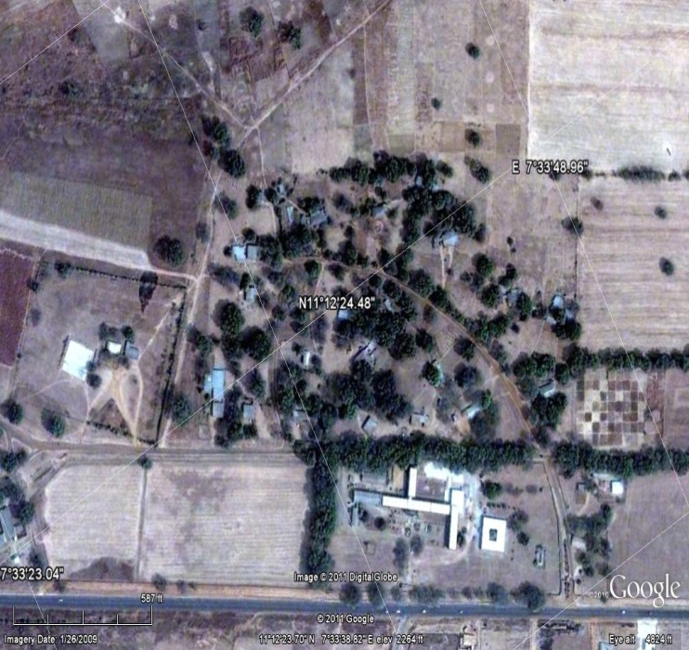
5
6
3
2
1
7
8
4
Figure 5. Google Earth Map of NAPRI Area Showing the Profiles Layout around Administrative Block

The results obtained shows measured apparent resistivity pseudosection, the calculated apparent resistivity pseudosection and the inverse model resistivity section of eight profiles, but with colour infill instead of line contours. hese data have been inverted to produce the image of figure 5. The electrical image revealed two layers, ranging from top soil which is reddish brown laterite to fracture basement. The near surface material in the entire area is intercalation of sandy soil lateritic clay with resistivity values ranging from about 26Ωm -808Ωm and thick of about 7m – 18m. The weathered basement is highly fractured with resistivity values as low as 161Ωm and as high as 406Ωm of the materials underlying the clay which is second distinct layer in the model. The materials extend to about 29.3m below the surface, towards the end of the profile. The low resistivity values of the layers is a clear evidence that they are saturated with water, since the resistivity of rock decreases as the percent water saturation increases.
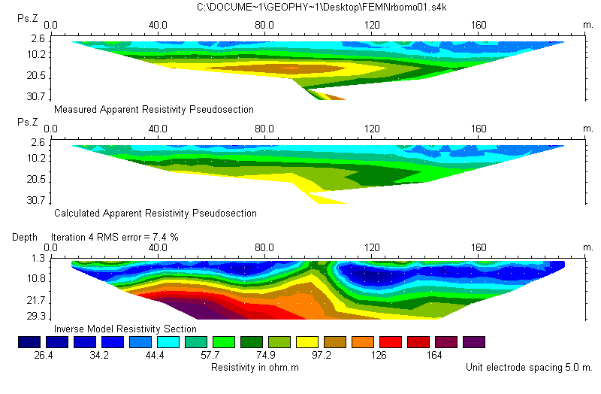
http://www.sciencepub.net/newyork

Figure 6. Electrical image along profile 1, (a) is observed data plotted as a coloured pseudosection; Ps.Z = pseudo-depth, (b) is the pseudosection computed from the model and (c) is the image or model showing true depth and true formation resistivity.
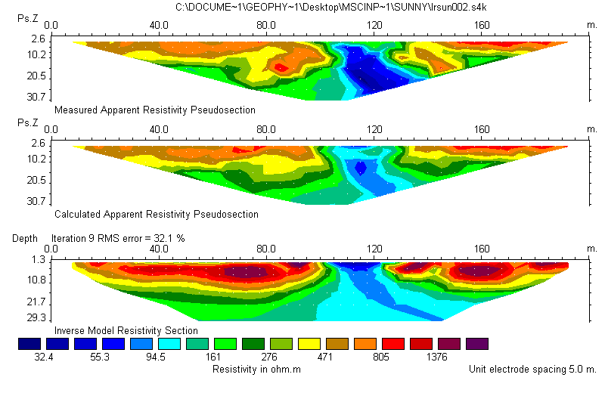

Figure 7. Electrical image along profile 3, (a) is observed data plotted as a coloured pseudosection; Ps.Z = pseudo-depth, (b) is the pseudosection computed from the model and(c) is the image or model showing true depth and true formation resistivity.
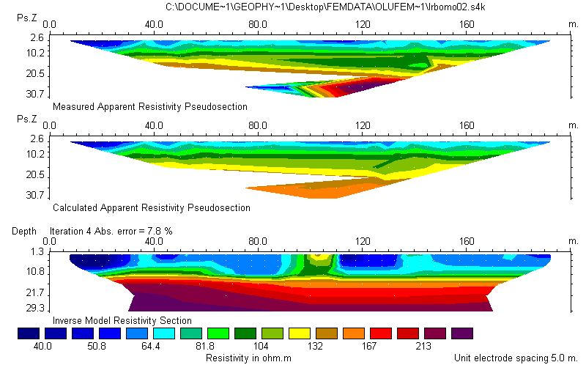
newyorksci@gmail.com

Figure 8. Electrical image along profile 2, (a) is observed data plotted as a coloured pseudosection; Ps.Z = pseudo-depth, (b) is the pseudosection computed from the model and (c) is the image or model showing true depth and true formation resistivity.
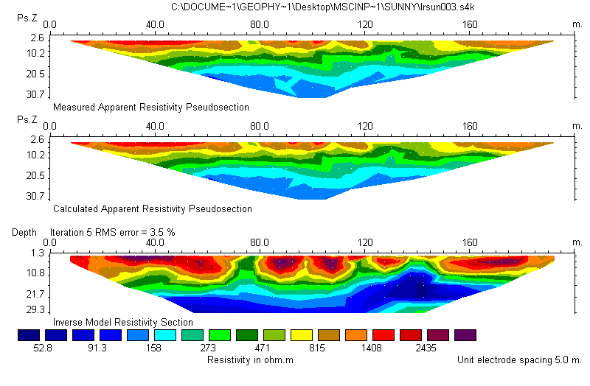

Figure 9. Electrical image along profile 4, (a) is observed data plotted as a coloured pseudosection; Ps.Z = pseudo-depth, (b) is the pseudosection computed from the model and(c) is the image or model showing true depth and true formation resistivity.

6. Conclusion
A total number of eight profiles were taken along the surface of the ground and electrical imaging was carried out along the lines. Electrical images provide a more detailed view of surface structure than can be obtained using other geophysical techniques and may therefore lead to a better understanding of the fracturing system. The inversion results of profile one reveals two distinct layers ranging from lateritic clay to fractured basement. The low resistivity value of the layers is an indication that the materials are saturated with water. The electrical image also reveals that the basement is fractured. The electrical image of profile two shows intercalation of lateritic clay and sandy clay as near-surface material with relatively thick weathered basement. The basement is fractured as clearly indicated by its low resistivity values (about 213Ωm). The resistivity inversion results for profile six also reveals that the near – surface material is not uniform. It shows that the weathered basement is highly fractured. This is evident from the low resistivity value (about 98Ωm) of the basement. The depth to the weathered basement from the surface ranges from 11.0m at the beginning of the profile to about 15.0m towards the end of the profile. The resistivity inversion result of profile seven also indicates that the near – surface is not uniform. The weathered basement is severely fractured as revealed by the low resistivity (about 68Ωm) of the basement. The resistivity inversion results of profile eight shows an anomaly with high resistivity value (about 1461Ωm) which may likely be a boulder, underlain by a weathered basement with relatively low resistivity value (about 270Ωm). Mostly, the electrical images of the profiles show two distinct layers and sandy clay, to weathered basement. The resistivity values of these layers indicate that the materials are saturated with water. None of the electrical images shows fresh basement. This indicates that the fresh basement is deeper than 29.3m from the surface which agree with the borehole lithology with the study area. The average overburden thickness of the area is 29.3m as revealed by the results (pseudosections). The results also reveal that the basement rock is highly fractured and the fracturing decreases with depth. The depth to the aquifer is believed to be the same with the depth to the weathered basement which ranges from 11.0m to 15.0m. The thickness of the aquifer cannot be ascertained because the study could not reveal the depth to the fresh basement. The pseudosections (geologic sections) revealed the various lithological compositions of various profiles delineated.
newyorksci@gmail.com

Correspondence to:
Adamu, J, Fadele. S.I, Sule, P.O and Lawal Kola
Department of Physics, Ahmadu Bello University,
Zaria, Nigeria.
(4johnny@yahoo.com; fadeleidowu@yahoo.com)

References
1. ABEM Instrument AB, Terrameter SAS4000/SAS1000 LUND Imaging System, Instruction Manual. 2006.
2. Barker, R. D. (1989). Depth of investigation of a generalized collinear 4-Electrode array. Geophysics, 54, 1031 – 1037.
3. Dahlin, T. and Loke, M. H. (1998). Resolution of 2D Wenner Resistivity Imaging as assessed by numerical modelling, Journal of Applied Geophysics, 38, 237-249.
4. Edwards, L.S. (1977). A modified Pseudosection for Resistivity and Induced Polarization. Geophysics, 42, 1020 – 1036.
5. Griffiths, D. H. and Barker, R. D. (1993). Two-dimensional resistivity imaging and modeling in areas of complex geology. Journal of Applied Geophysics, Vol. 29, Pp 211-226.
6. Loke, M. H. and Barker R. D. (1996). Rapid least-squares inversion of apparent resistivity pseudosections using a quasi-Newton method. Geophysical Prospecting, 44, 131 – 152.
7. McCurry, P. (1970). The geology of Degree Sheet 21, Zaria. Unpublished M.Sc. Thesis, Thesis, Department of Geography, Ahmadu Bello University, Zaria.
8. Oyawoye, M. O. (1964). Geology of the Nigerian Basement Complex, Journal of Nigeria Mining, Geological and Metallurgical Society, Vol. 8, pp. 87-102.
9. Wright, J. B. and McCurry, P. (1970). The geology of Nigeria Sheet 102 SW, Zaria and its regions. Edited by M. J. Mortimore. Department of Geography, Occasional paper, No. 4, Ahmadu Bello University, Zaria.

7/22/2012

