Assessment of the Effects Tacit Knowledge, cognition and self -awareness on Informal Learning Process: A Study on Private Universities in Malaysia

¹Benoush Roumi, ²Zeinab Seyed Saleki, ³shabnam alsadat seyedmehdi, ⁴Hani samimi sabet, ⁵Noushin Roumi Nejad

¹Master of business administration, Multimedia University, Cyberjaya, Malaysia
Email:behnoush.roumi@gmail.com
Tel: +60-142257831
²Master of business administration, Multimedia University, Cyberjaya, Malaysia
Email:sana_saleky@yahoo.com
Tel: +60-176107959
³Master of business administration, Multimedia University, Cyberjaya, Malaysia
Email:shabnamse@gmail.com
Tel: +60-193910158
⁴Master of business administration, Multimedia University, Cyberjaya, Malaysia
Email: hanisamimi@yahoo.com
Tel: +60-176108580
⁵Master of urban planning-Geography, Islamic Azad University, khoramabad, Iran
Email: noshin_roumi@yahoo.com
Tel: +98-9168497011

Abstract: Informal learning may have different facets such as participation in quality circles, job rotation, mentoring, but it may also be fully work integrated, taking place as people go about their daily work. Thus, in an informal learning process, the main task is on the people’s shoulders that are exposed to highly innovative technologies, which have made them professional in implementing technical tools and processes. Among the human intellectual capabilities, self-awareness and cognitional power have more contributions to informal learning process. Informal and formal learning are happening among the team members and teams are made up of employees from different cognitional and different level of self-awareness. The way to understand the importance of communication between and among the company members, is to notify that people naturally demonstrate various cognitive power and they may have diverse levels of self-awareness capabilities. With tacit knowledge, people are not often aware of the knowledge they possess or how it can be valuable to others. Effective transfer of tacit knowledge generally requires extensive personal contact and trust that are deeply rooted in cognitive and self-awareness levels of employees. Thus, it is proposed that there must be a relationship between self-awareness, cognition, and tacit knowledge with informal learning.. In this study we desire to discover those most notable aspects of these dimensions on informal learning among 150 respondents in private universities in Malaysia. Results of the data analysis show that there is significant coherency between tacit knowledge : ( social skill, experience) , cognitive skill : ( Concentration, Perception, Memory) and Self-Awareness variables with informal learning.
[Benoush Roumi, Zeinab Seyed Saleki, shabnam alsadat seyedmehdi, Hani samimi sabet, Noushin Roumi Nejad.
Assessment of the Effects Tacit Knowledge, cognition and self -awareness on Informal Learning Process: A Study on Private Universities in Malaysia. N Y Sci J 2012;5(10):25-33]. (ISSN: 1554-0200). http://www.sciencepub.net/newyork. 5

Key words: Informal learning, Tacit knowledge, Social skill, Experience, cognitive skill Concentration, Perception, Memory, Self-awareness

Over the past decade, there has been an increasing interest in applying informal learning along with other types of formal learning, while as an external method; it has contributed crucial aspects of education and knowledge. Informal learning is known as unstructured learning which occurs without planning and defined objectives within the real environment of the organization (Marsick & Volpe, 1999). Researchers like Michael Eraut (2000: 12) believed that employing concepts like ‘non-formal learning’ is more useful than ‘informal learning’ which is a ‘catch-all’ label. It is highly accepted that the ability of externalizing and sharing of knowledge and skills are the most effective factors for acquiring inputs from an employee (Haldin-Herrgard, 2000), while the importance of documentation is related to the need of transforming the hidden knowledge into an explicit one, which can be others’ tacit knowledge (Haldin-Herrgard, 2000; Karhu, 2002).Polanyi (1967) believed that tacit knowledge is an individual’s knowledge which is more than he can explain, or the knowledge of doing things without thinking. This type of personal knowledge is usually known as informal that can be felt and understood by the others (Sternberg, 1997). Moreover, Self-awareness is a wise process of feedback about one`s behavior in order to improve the effectiveness (Dubrin, 2007).
In the current study, meta-abilities are applied as a base for empowering employees to externalize their knowledge and skills, as well as share and document them. While the meta-abilities had high influence on organizational development literature (Butcher et al., 1997), lately it has become a practice for organizational learning (OL).
Furthermore, in the current study, the informal learning implies to the kind of unstructured curriculum learning which has been defined by Knowledge Advisors. Moreover, different types of informal learning can be applied socially through communities. No matter what it is called, informal learning is developed from the necessity of learning to have knowledgeable and productive employees in the dynamic environment within the organization, in order to waste the opportunities to find a structured method.
Based on the past researches, there is no single study on the impact of tacit knowledge, cognitive skill and self-awareness on different aspects of informal learning. Due to the informal learning process, the aim of the current study is to examine the impact of the tacit knowledge, cognitive skill and self-awareness on informal learning. In addition, this study seeks to address most effective methods that can be applied by the organizations in order to achieve their goals by considering the primary data. By formalizing the informal learning, organizations would not limit their learners to structural rules or definitions. Moreover, measurement is a reasonable indicator that can be used by the organizations in order to be aware of availability, quality and effectiveness of informal learning. In this research, the impact of application of the primary data on employees’ informal learning would be studied among a group of private universities in Malaysia.

2. Materials and Methods
2.1. Tacit knowledge
Based on Polanyi’s research, knowledge consists of tacit and focal parts. In fact, he has found that an individual knows more than he can explain. While it is not easy to clarify by example, it should be considered that things are done through a combination of both tacit and explicit knowledge.
Polanyi believed that the tacit knowledge is included in subsidiary awareness and it can be detected through the object of focal awareness (Nonaka & Von Krogh, 2009).Polanyi argued that the subsidiary awareness is the combination of some kind of unarticulated and indefinable knowledge, and it is determined as the manual part of the action. Although subsidiary awareness is an unexplainable issue, it has a critical role in the process of knowing (Henry, 2010; Zappavigna & Patrick, 2010).
Explicit knowledge is a systematical and formal knowledge which can be documented and reviewed by words and numbers (Saint-Onge, 1996; Wan, et al., 2011), knowledge is highly personal, and rooted in one`s mind, experience and behavior it can be shared through practical or empirical ways (Zappavigna & Patrick, 2010).
Tacit knowledge is a local knowledge which cannot be found in books, texts, databases or files, because it is not visible. (Anand,Ward, & Tatikonda, 2010; Erden, et al., 2008; Seidler-de Alwis & Hartmann, 2008).
2.1.1. Social skill
One of the crucial functions in life which leads to success is good social skills. By this skill, students understand that in different situations how to choose, how to behave and what to tell. If children and even adults have a good social skill, this skill affects their behavior, attending in different activities, performance and family and social relationships. Moreover, school environment and safety also have an impact on social skills(Greenhow & Robelia, 2009).
If students have the full repertoire, they will be able to make social choices and also they can empower their interpersonal relationships to be successful in school. (Greenhow, Robelia, & Hughes, 2009).
2.1.2 Experience
There are two types of learning, one is through studying and the other one is through experience. By experience it means the ability and knowledge that is acquired by experience not education (Holden, 2009).
Experience can help students on the things and situations that they have to be more focused on it. By having experience, making decision in divers situations become easily. Moreover in some aspects it can help to forecast the future. In other word, experience helps students to develop their instinctive ability to plan for their future (Holden, 2009; Johnson & Chandler, 2009).
2.2. Cognitive Skill
Cognition or cognitive abilities are familiar concepts. Cognition is a solution by which a person understands and acts in the world. In other words, it is set of abilities, skills or activities that are common among people. Cognitive abilities are the brain-based ability which helps to perform different duties from simple, daily to difficult and sophisticated. the most important cognitive skills which should be considered by the organizations:
- Concentration ability
- Perception ability
- Memory ability
2.2.1 Concentration
If someone has high concentration, s/he can pay more attention on something. For paying attention to something it does not need thinking, it just needs a body function because paying attention is a swift happening, it is not very useful for learning. Paying attention is just shifting from something to something else. When children want to learn, they have to be focused on something for a long time and keep their attention during that time on that thing. This focusing is concentration (Kukulska-Hulme & Pettit, 2009; Schulz & Stamov Roßnagel, 2010).
Concentration consists of two important steps. First step is the act of paying attention which cannot happen automatically. Second step is the way that has to be taught and it is a cognitive skill (Jamieson, 2009; Kukulska-Hulme & Pettit, 2009; Schulz & Stamov Roßnagel, 2010; Sendzimir et al., 2008).
2.2.2 Perception
There are many terms that can be used interchangeably; “perception” and “processing” are such terms (Caniels & Kirschner, 2010).For learning something, first of all, perception has to take place, which means that one of the sense have to be aware about what is going to be learnt. Of course when someone wants to learn something, s/he has to be seen or heard. Therefore, in other words, it can be said that perception is interpretation. In fact without experience, a person misinterprets what s/he has seen or heard. It can be concluded that perception illustrates the worries about present situations because of the past experience. As the philosopher Immanuel Kant (1724-1804) said: “we see things not as they are but as we are” (Hoekstra, Korthagen, Brekelmans, Beijaard, & Imants, 2009; Lohman, 2009; Meltzoff, Kuhl, Movellan, & Sejnowski, 2009).
People need to clarify their sense and this thing happens if they have a previous experience about that thing. Furthermore, for having a perceptual ability, people need to have perceptual practice and experience about the same subject. In conclusion, perception is a kind of cognitive skill that can be improved through experience and practice (Caniels & Kirschner, 2010).
2.2.3 Memory
There are lots of memories that can be learnt. The following table 3.3 indicates the different categories of memory and the problems that will occur without these memories (Lewis, Pea, & Rosen, 2009).

Table 2.1 Memories and Problems (Lewis, et al., 2009)

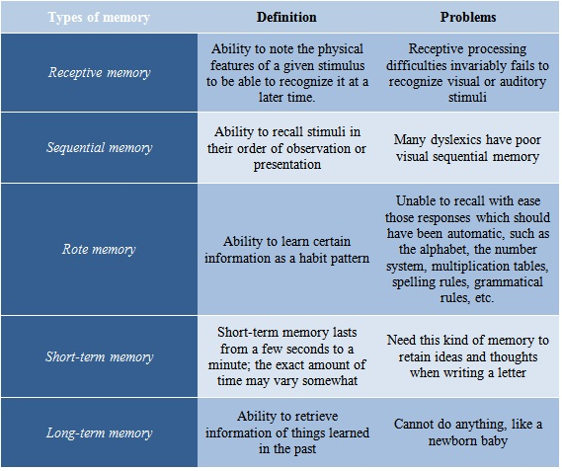

2.3. Self-awareness
Self-awareness is the ability of determining the task that should be done in the specific time through determined organizational approaches. This is the other word of “doing the right thing in the right time”. This statement helps employees to adapt with the rapid changes in organization and environment. This process includes externalization, share and classification process from other employees’ knowledge (Chisholm, et al., 2009; Dabbagh & Kitsantas, 2011; Reinhardt, 2010).
Self-awareness has been recognized as the most essential element of emotional abilities, and it is introduced as foundation of many competencies which facilitates effective interpersonal relationships. Studies show that most of the people suffer from low level of self-awareness; however, one’s high ability in understanding emotions would cause problems at the work place. People with low level of awareness about themselves have problems in intra or inter personal relationships (Boucouvalas & Lawrence, 2010; Chisholm, et al., 2009; Dabbagh & Kitsantas, 2011; Reinhardt, 2010).
2.4 Research Method
The main purpose of this research is the impact of tacit knowledge, cognitive skill and self-awareness on informal learning by which the level of learning in students makes perfect. Based on quantitative structure, developed Research Framework consists of three categories as independent variable and informal learning as dependent variables. Eight hypotheses have been defined for this study. For this study primary data will be chosen and stretchered questionnaire has been developed. Population and sampling are chosen in order to collect data. The population for this study is students of Selangor private universities in Malaysia. The sample size is 150 respondents. These 150 respondents are students from different nationalities. All these data were collected by simple random sampling. Questionnaire For this study the questionnaire includes four parts. First part focuses on general and demographic information .Numbers of 50 questionnaires have been distributed in order to examine the reliability of questionnaire. The data been analyzed through Microsoft 2007 and SPSS application frequency analysis Multiple Regression Pearson’s correlation.

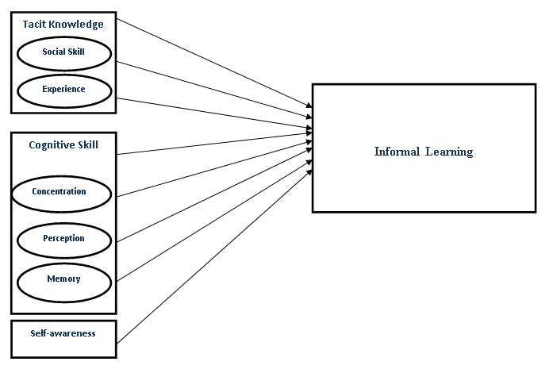

Figure 1.Proposed conceptual model by Benoush et al. (2012)

3.Results and discussion
The data analysis is being founded on collecting data from the respondents who fulfill the aims of this research. This chapter consists of four main parts:
3.1 Frequency
- Descriptive analysis
- Pearson Correlation
- Multiple Regressions
Frequency analysis for demographic variables For this study primary data will be chosen. At the firs Demographic analysis was done that the results are shown in Table1.

Table3.1. Demographics
Frequency Percent
Gender | Male | 77 | 51.3
 | Female | 73 | 48.7
Age | 20-25 | 103 | 68.7
 | 25-30 | 40 | 26.7
 | Above 30 | 7 | 4.7
program | Bachelor | 81 | 54.0
 | Master | 62 | 41.3
 | PHD | 3 | 2.0
 | DBA | 4 | 2.7
Total |  | 150 | 100

Table1 Shows that 73 of the respondents are female, which represents 48.7% of total respondents’ percentage. There are also 77 male respondents, which signify 51.3% of total respondents. In addition, it illustrates that 103 participants of the survey are between 20 to 25 years old, which represent 68.7% of total respondents. There are 40 respondents at 26.7% of total respondents, between 25 to 30 years old. While a total of 7 respondents, which represent 4.7% are above 30.Moreover, based on the respondents’ answer, total of 81 participants, which represent 54% of respondents, are in Bachelor program. There are 62 respondents, who are in Master Program which represent 41.3% of participants. A total of 3 respondents with 2% are in the PhD Program. There are 4 respondents who are in DBA Program which represent 2.7% of total respondents.
3.2 Descriptive Analysis for Variables
For this research all variables were measured according to five-point scale. Most of the mean of the variables are more than 3. This means that most of the respondents feel that informal learning will increase to a level according to the variables. The minimum of 1 indicates that the respondents strongly disagree with the effect of the independent variables on informal learning and the maximum of 5 represents that the respondents strongly agree that the independent variables bring more of that.

Table 3.2.: Descriptive Statistics for variables
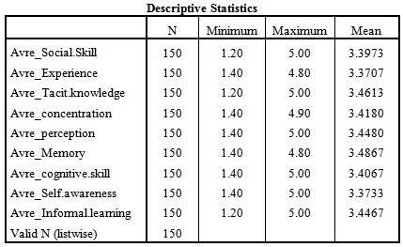

3.3. Pearson’s Correlation

3.3.1 Correlation Analysis
The following results in Table 3.3. show the bivariate correlation between independent variables and informal learning.

Table 3.3. Correlation between Independent Variables and Informal Learning
 |  | Avre_Informal.learning
Avre_Social.Skill | Pearson Correlation | .776**
 | Sig. (2-tailed) | .000
 | N | 150
Avre_Experience | Pearson Correlation | .859**
 | Sig. (2-tailed) | .000
 | N | 150
Avre_Tacit.knowledge | Pearson Correlation | .969**
 | Sig. (2-tailed) | .000
 | N | 150
Avre_Concentration | Pearson Correlation | .834**
 | Sig. (2-tailed) | .000
 | N | 150
Avre_Perception | Pearson Correlation | .785**
 | Sig. (2-tailed) | .000
 | N | 150
Avre_Memory | Pearson Correlation | .720**
 | Sig. (2-tailed) | .000
 | N | 150
Avre_Cognitive.skill | Pearson Correlation | .767**
 | Sig. (2-tailed) | .000
 | N | 150
Avre_Self.awareness | Pearson Correlation | .828**
 | Sig. (2-tailed) | .000
 | N | 150

The output of Pearson’s Correlation between independent variables and informal learning indicates that:There is a Moderate positive relationship exists between social skill and informal learning because the value of Pearson’s Correlation is 0.776 and its p-value is 0.000 which is less than 0.05. There is a High positive relationship between experience and informal learning because the value of Pearson’s Correlation is 0.859.There is a High positive relationship exists between Tacit knowledge and informal learning because the value of Pearson’s Correlation is 0.969.There is a High positive relationship that exists between Concentration and informal learning because the value of Pearson’s Correlation is 0.834.There is a Moderate positive relationship exists between Perception and informal learning because the value of Pearson’s Correlation is 0.785.
There is a Moderate positive relationship between Memory and informal learning because the value of Pearson’s Correlation is 0.720.There is a Moderate positive relationship between Cognitive skill and informal learning because the value of Pearson’s Correlation is 0.767.There is a High positive relationship between Self-awareness and informal learning because the value of Pearson’s Correlation is 0.828.

3.4. Regression analysis

3.4.1. Multiple Regression analysis on relationship between independent variables and dependent variable
The Anova table for multiple regressions is presented in table 3.4.

Table 3.4.: ANOVA for all Variables
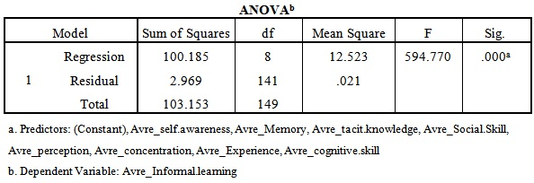

ANOVA Table 3.4.vshows that p-value is less than 0.05 (0.000 < 0.05). So, the model is valid and can be used for thesis hypothesis
.

.Table 3.5: Coefficient for all Variables
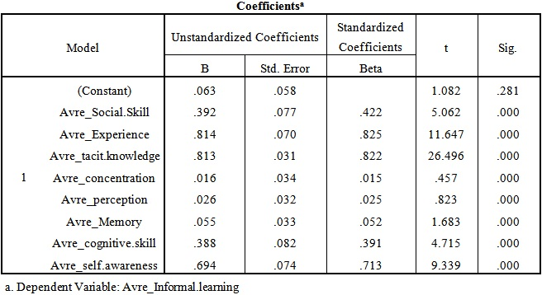

Table 3.6: ANOVA by Stepwise Method
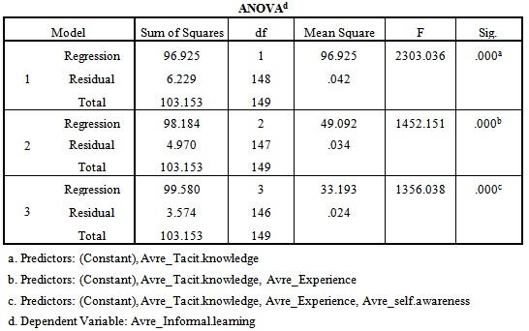

Based on Table 3.7, tacit knowledge, experience and self-awareness have the highest Positive relationship with Informal learning, and among these three variables, tacit knowledge has the highest positive relationship, experience Moderate positive relationship and self-awareness Low positive relationship.

Table 3.7: Coefficient by Stepwise Method
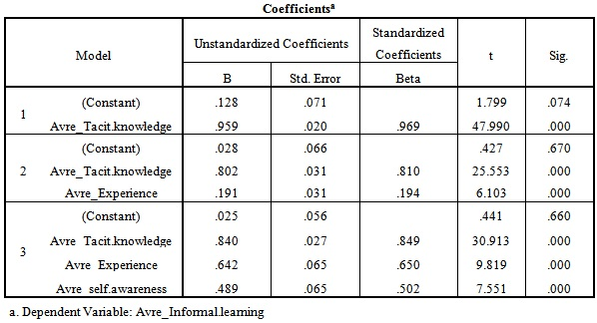

4. Conclusion
This study was conducted to trace the coherency between eight independent variables: 1) Tacit knowledge (Social skills, Experience, tacit knowledge), 2) Cognition (Concentration, Perception, Memory, Cognitive skill), 3) Self-awareness and informal learning as a dependent variable. The main purpose of this study was improving informal learning through the development of cognition, self-awareness, and tacit knowledge in private universities in Malaysia. The population of this study is the students of private universities in Malaysia. The respondents were 150 students of the above mentioned university.

4.1 Relationship between Tacit Knowledge and Informal Learning
The result of the analysis findings showed that tacit knowledge has High positive relationship with informal learning while social skill has moderate positive relationship with it, and experience has a moderate positive relationship with informal learning.

4.2 Relationship between Cognition and Informal Learning
The result showed that concentration and memory have moderate positive relationship with informal learning; on the other hand, cognitive skill has a low positive relationship with informal learning.

4.3 Relationship between Self-Awareness and Informal Learning
The result showed that self-awareness has a meaningful association with informal learning. It means that by increasing the self-awareness, the informal learning increases too.

References
[1] Anand, G., Ward, P. T., and Tatikonda, M. V. (2010). Role of explicit and tacit knowledge in Six Sigma projects: An empirical examination of differential project success. Journal of Operations Management, 28(4), 303-315.
[2] Boucouvalas, M., and LAWRENCE, R. L. (2010). Handbook of Adult and Continuing Education, 35.
[3] Butcher, D., and Harvey, P. (1998). Meta-ability development: a new concept for career management. Career Development International, 3(2), 75-78.
[4] Carr, B. N. (2012). Plan implementation dissonance: addressing the quandary of–how did they come up with that?
[5] Chisholm, C., Harris, M., Northwood, D., and Johrendt, J. (2009). The Characterisation of Work‐Based Learning by Consideration of the Theories of Experiential Learning. European Journal of Education, 44(3), 319-337.
[6] Choudrie, J., Grey, S., and Selamat, M. H. (2009). Meta‐abilities and outsourcing: an individual based conceptual framework. Knowledge and Process Management, 16(1), 30-39.
[7] Choudrie, J., and Selamat, M. H. (2006). The consideration of meta-abilities in tacit knowledge externalization and organizational learning.
[8] Dabbagh, N., and Kitsantas, A. (2011). Personal Learning Environments, social media, and self regulated learning: A natural formula for connecting formal and informal learning. The Internet and Higher Education.
[9] Dewey, J. (2009). Reflective Practice in the professions: Teaching. Handbook of Reflection and Reflective Inquiry: Mapping a Way of Knowing for Professional Reflective Inquiry, 189.
[10] Eraut, M. (2000). Non‐formal learning and tacit knowledge in professional work. British Journal of Educational Psychology, 70(1), 113-136.
[11] Erden, Z., von Krogh, G., and Nonaka, I. (2008). The quality of group tacit knowledge. The Journal of Strategic Information Systems, 17(1), 4-18.
[12] Greenhow, C., and Robelia, B. (2009). Informal learning and identity formation in online social networks. Learning, Media and Technology, 34(2), 119-140.
[13] Greenhow, C., Robelia, B., and Hughes, J. E. (2009). Learning, teaching, and scholarship in a digital age. Educational Researcher, 38(4), 246.
[14] Haldin-Herrgard, T. (2000). Difficulties in diffusion of tacit knowledge in organizations. Journal of Intellectual capital, 1(4), 357-365.
[15] Holden, R. (2009). Informal Learning: A New Model for Making Sense of Experience. Education+ Training, 51(1), 84-85.
[16] Johnson, D., and Chandler, F. (2009). Pre-service Teachers’ Fieldtrip to the Battleship: Teaching and Learning Mathematics through an Informal Learning Experience. Issues in the Undergraduate Mathematics Preparation of School Teachers: The Journal, 2, 1-9.
[17] Kyrö, P., Seikkula-Leino, J., and Mylläri, J. (2011). 3. Meta processes of entrepreneurial and enterprising learning: the dialogue between cognitive, conative and affective constructs. Entrepreneurship Research in Europe: Evolving Concepts and Processes, 56.
[18] Lam, A. (2000). Tacit knowledge, organizational learning and societal institutions: an integrated framework. Organization studies, 21(3), 487-513.
[19] Meltzoff, A. N., Kuhl, P. K., Movellan, J., and Sejnowski, T. J. (2009). Foundations for a new science of learning. science, 325(5938), 284.
[20] Nonaka, I., and Von Krogh, G. (2009). Tacit knowledge and knowledge conversion: Controversy and advancement in organizational knowledge creation theory. Organization Science, 20(3), 635-652.
[21] Pathirage, C., Amaratunga, R., and Haigh, R. (2008). Tacit knowledge generation and utilisation in the construction industry.
[22] Pramling, N., and Samuelsson, I. P. (2009). The prosaics of figurative language in preschool: some observations and suggestions for research. Early Child Development and Care, 179(3), 329-338.
[23] Reinhardt, W. (2010). A widget-based dashboard approach for awareness and reflection in online learning communities based on.
[24] Saint-Onge, H. (1996). Tacit knowledge the key to the strategic alignment of intellectual capital. Strategy & Leadership, 24(2), 10-16.
[25] Schulz, M., and Stamov Roßnagel, C. (2010). Informal workplace learning: An exploration of age differences in learning competence. Learning and Instruction, 20(5), 383-399.
[26] Seidler-de Alwis, R., and Hartmann, E. (2008). The use of tacit knowledge within innovative companies: knowledge management in innovative enterprises. Journal of Knowledge Management, 12(1), 133-147.
[27] Selamat, M. H. (2009). A Qualitative Decision Trail in the Hermeneutic Analysis: Evidence from the Case Study. International Journal of Business and Management, 3(3), P41.
[28] Selamat, M. H., and Choudrie, J. (2004). The diffusion of tacit knowledge and its implications on information systems: the role of meta-abilities. Journal of Knowledge Management, 8(2), 128-139.
[29] Selamat, M. H., and Choudrie, J. (2007). Using meta-abilities and tacit knowledge for developing learning based systems: A case study approach. Learning Organization, The, 14(4), 321-344.
[30] Straub, E. T. (2009a). Understanding technology adoption: Theory and future directions for informal learning. Review of Educational Research, 79(2), 625-649.
[31] Straub, E. T. (2009b). Understanding technology adoption: Theory and future directions for informal learning. Review of Educational Research, 79(2), 625.
[32] Wan, J., Wan, D., Luo, W., and Wan, X. (2011). Research on Explicit and Tacit Knowledge Interaction in Software Process Improvement Project. Journal of Software Engineering and Applications, 4(6), 335-344.
[33] Zappavigna, M., and Patrick, J. (2010). Eliciting tacit knowledge about requirement analysis with a Grammar-targeted Interview Method (GIM). European Journal of Information Systems, 19(1), 49-59.

7/302012

