**Subsurface Geoelectrical Investigation around Bomo Area, Kaduna State, Nigeria.**

Fadele, S.I.1 Sule, P.O.2 and Patrick, N.O3

1, 2 Department of Physics (Applied Geophysics), Ahmadu Bello University, Zaria, Nigeria.

3 Department of Geology and Mining, Nasarawa State University, Keffi.

fadeleidowu@yahoo.com

**Abstract:** Electrical resistivity investigation was carried out around Bomo area, Kaduna state, Nigeria in order to study the subsurface geologic layer with a view of determining the depth to the bedrock and thickness of the geologic layers. Vertical Electrical Sounding (VES) using Schlumberger array was carried out at fifteen (15) VES stations. ABEM terrameter (SAS 300) was used for the data acquisition. The field data obtained have been analysed using computer software (*IPI2win*) which gives an automatic interpretation of the apparent resistivity. The VES results revealed heterogeneous nature of the subsurface geological sequence. The geologic sequence beneath the study area is composed of hard pan top soil (clayey and sandy-lateritic), weathered layer, partly weathered or fractured basement and fresh basement. The resistivity value for the topsoil layer varies from 40**Ω**m to 450**Ω**m with thickness ranging from 1.25 to 7.5 m. The weathered basement has resistivity values ranging from 50**Ω**m to 593**Ω**m and thickness of between 1.37 to 20.1 m. The fractured basement has resistivity values ranging from 218**Ω**m to 520**Ω**m and thickness of between 12.9 to 26.3 m. The fresh basement (bedrock) has resistivity values ranging from 1215**Ω**m to 2150**Ω**m with infinite depth. However, the depth from the earth’s surface to the bedrock surface varies between 2.63 to 34.99 m. The study further stressed the importance of the findings in civil engineering structures and groundwater prospecting.

**[**Fadele, S.I. Sule, P.O. and Patrick, N.O**. Subsurface Geoelectrical Investigation around Bomo Area, Kaduna State, Nigeria.** *N Y Sci J* 2012;5(8):10-17]. (ISSN: 1554-0200). <http://www.sciencepub.net/newyork.> 2

**Keywords:** Electrical Resistivity, Vertical Electrical sounding (VES), Top soil (TP), Weathered basement (WB), Partly Weathered Basement (PWB) and Fresh Basement (FB).

**1. Introduction**

The use of geophysics for engineering studies and water groundwater exploration has increased over the last few years due to the rapid advances in computer softwares and associated numerical modeling solutions. The Vertical Electrical Sounding (VES) has proved very popular with groundwater prospecting and engineering investigations due to simplicity of the techniques. The electrical geophysical survey method is the detection of the surface effects produced by the flow of electric current inside the earth. The electrical techniques have been used in a wide range of geophysical investigations such as mineral exploration, engineering studies, geothermal exploration, archeological investigations, permafrost mapping and geological mapping. Electrical methods are generally classified according to the energy source involved, i.e., natural or artificial. Thus, self potential (SP), telluric current come under natural source methods, while resistivity, electromagnetic (EM) and induced polarization (IP) methods are artificial source methods. The electrical d.c resistivity method used in carrying out the present survey is of artificial source using the ABEM terrameter (SAS 300).

Appraising the hydrogeology in Zaria, Danladi (1985) has confirmed the presence of water bearing fractur, which aquifers are located at a shallow basement area of Zaria. McCurry (1970), who studied the geology of Zaria, has established that the Basement Complex rock is made up of the Older Granite, Biotite granite-gneiss. Farouq (2001), carried out geoelectric investigation of the groundwater potential in the Institute for Agricultural Research Farm, Samaru, Zaria, showed that the thickness of the weathered basement around the area varies from 3.4 to 30.4 m and depth to fresh basement was 40 m. Similarly, Saminu (1999), carried out a comprehensive geophysical survey over the premises of Federal College of Education, Zaria, showed that the thickness of the top soil of the area ranges between 3.5 and 14 m while the thickness of the weathered basement ranges between 9 and 36.5 m. The depth to bedrock varies from 5 to 14 m. In this study, geoelectrical investigations covering fifteen stations have been carried out and interpreted fully around Bomo area, Kaduna State, Nigeria, in order to evaluate the subsurface geologic layer with a view of determining the depth to the bedrock and thickness of the geologic layers. The study further stressed the importance of the findings in civil engineering structures and groundwater prospecting.

**2. Geology of the study area**

The study area is part of the NW basement terrain underlain by basement rocks of Precambrian age. They are mainly granites, gneisses, and schists. Oyawoye (1964) showed that there is structural relationship between this Basement Complex and the rest of the West African basement. This is partly due to the fact that the whole region was involved in a single set of orogenic episode, the Pan African orogeny, which left an imprint of structural similarity upon the rock units. The gneisses are found as small belts within the granite intrusions, and are also found east and west of the batholiths (McCurry, 1970). The biotite gneiss extends westwards to form a gradational boundary with the schist belt. The gneiss continues eastwards to some extent and is occasionally broken up by the Older Granite (Wright and McCurry, 1970).

**3. Site description**

The study area is bounded approximately by longitudes 70 36’E and 70 38’E, latitudes 110 09’N and 110 11’N as shown in location map (Fig 1) with an average elevation of 685m above sea level.. The area falls within the semi-arid zone of Nigeria (Harold, 1970). It lies in the guinea savannah; the woodland vegetation is characterized by bushes generally less than 3m high.

**4. Methodology**

Vertical Electrical Soundings (VES) using Schlumberger array were carried out at fifteen (15) stations. A regular direction of N-S azimuth was maintained in the orientation of the profiles. Overburden in the basement area is not as thick as to warrant large current electrode spacing for deeper penetration, therefore the largest Current electrode spacing AB used was 200m, that is, 1/2AB=100m. The principal instrument used for this survey is the ABEM (Signal Averaging System, **(**SAS 300) Terrameter. The resistance readings at every VES point were automatically displayed on the digitalreadout screen and then written down on paper.

Study area

newyorksci@gmail.com

Study area

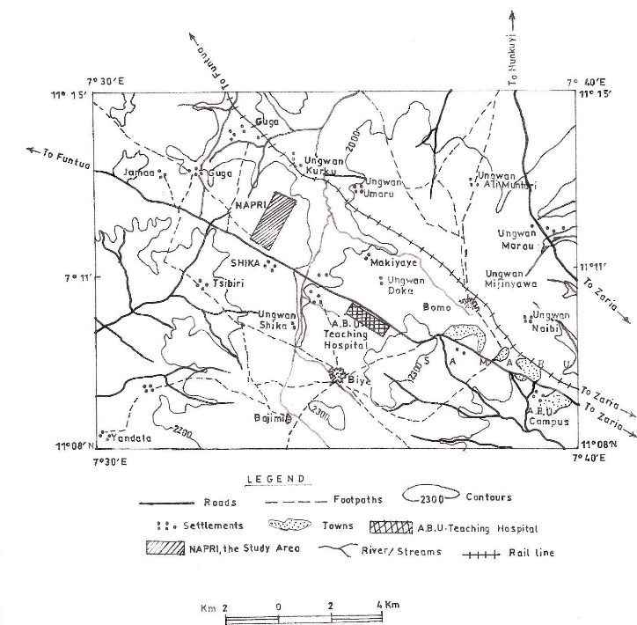

Study area

http://sciencepub.net/newyork

Study area

newyorksci@gmail.com

**Fig 1: Location map the study area (from Northern Nigerian Survey Map)**

**5. Results and Discussion**

New York Science Journal 9494ny_20120523 http://www.sciencepub.net/newyork

The geometric factor, K, was first calculated for all the electrode spacings using the formula; K= π (L2/2b – b/2), for Schlumberger array with MN=2b and 1/2AB=L. The values obtained, were then multiplied with the resistance values to obtain the apparent resistivity, ρa, values. Then the apparent resistivity, ρa, values were plotted against the electrode spacings (1/2AB) on a log-log scale to obtain the VES sounding curves using an appropriate computer software *IPI2win* in the present study. Some sounding curves and their models are shown in Fig 2. Similarly, geoelectric sections are shown in Figs. 3 and 4. Three resistivity sounding curve types were obtained from the studied area and these are the H (ρ1>ρ2< ρ3), A (ρ1< ρ2<ρ3) and KH (ρ1>ρ2< ρ3>ρ4) type curves. However, there are few points which show two geologic layer cases. The results of the interpreted VES curves are shown in Table 1and 2. The modeling of the VES measurements carried out at fifteen (15) stations has been used to derive the geoelectric sections for the various profiles. These have revealed that there are mostly four and three geologic layers beneath each VES station, and two layer cases at three different VES point. The geologic sequence beneath the study area is composed of top soil, weathered basement, partly weathered/fractured basement, and fresh basement. The topsoil is composed of clayey and sandy-lateritic hard pan with resistivity values ranging from 40Ωm to 450Ωm and thickness varying from 1.25 to 7.5 m., thinnest at VES 12 and thickest at VES 13. It is however, observed from the geoelectric sections that VES 1, 2, 7 and 10 are characterized with low resistivity values varying between 40Ωm to 90Ωm suggesting the clayey nature of the topsoil in these areas are possibly high moisture content. The second layer is the weathered basement with resistivity and thickness values varying between 50Ωm and 593Ωm and 1.37 to 20.1 m respectively. This layer is thickest at VES 2, suggesting this point for siting borehole but thinnest at VES 7 and 8. Other points with probable high water potentials suitable for siting borehole include: VES 3, 5, and 9 respectively with appreciable thickness of weathered rock also known as aquifferous zone. The third layer is the partly weathered and

fractured basement with resistivity and thickness values varying between 218Ωm to 520Ωm and 12.9 to 26.3 m respectively. The layer is extensive and thickest at VES 3 and thinnest at VES 2. The fourth layer is presumably fresh basement whose resistivity values vary from 1215Ωm to 2150Ωm with an infinite depth. However, the depth from the earth’s surface to the bedrock surface varies between 2.63 to 34.99 m, deepest at VES 2 and shallowest at VES 7.

**6. Conclusion.**

Geoelectrical investigation using the d.c electrical resistivity method around Bomo area, Kaduna State, Nigeria, three and four geologic layers are delineated at the subsurface composed of top soil, weathered basement, partly weathered or fractured basement and fresh basement. Based on the qualitative interpretation of the VES data, it is deduced that VES Stations 2, 3, 5 and 9 are viable postions for siting boreholes with appreciable thickness of weathered and fractured basement (aquiferrous zone) ranging from 12.71 to 33 m. This geologic layer is characterized by structural features like fractures, fissures or pore spaces that enhance groundwater permeability and storage hence suggesting these points for siting borehole. To ensure safety consumption of groundwater in the area, potential sources of contamination site should be sited far away from viable aquifer units because the area is vulnerable to pollution if there is leakage of buried underground septic tank, sewage channels or infiltration of leachate from decomposing refuse dumps in the area as a result of their shallow depth to the aquifferous zone ranging from 1.25 to 2.63 m. It is also deduced that the area can support low to high engineering structures as a result of the thin clayey nature generally less than 2 m in most of the area underlain by basement rocks at shallow depth. The study area can support low to great engineering structures as a result of their shallow depths to the underlying rock which can serve as pillar supports to the building except for VES 13 and 15 which structural foundation requires little filling because of the thick top soil.

http://sciencepub.net/newyork

newyorksci@gmail.com

**Table 1: The results of the interpreted VES curves**

|  |  |  |  |  |  |
| --- | --- | --- | --- | --- | --- |
| **VES Stations** | **Thickness (m)** | **Layer resistivity (Ωm)** | **Remarks** | **Curve types** | **Numb of layers** |

|  |  |  |  |  |  |
| --- | --- | --- | --- | --- | --- |
| 1 | 1.67  3.33  - | 73  219  2045 | TP  WB  FB | A | 3 |
| 2 | 1.99  20.1  12.90  - | 85  318  218  1396 | TP  WB  PWB  FB | KH | 4 |
| 3 | 1.25  6.05  26.3  - | 245  190  520  1215 | TP  WB  PWB  FB | KH | 4 |
| 4 | 1.24  2.04  - | 245  180  1930 | TP  WB  FB | H | 3 |
| 5 | 2.02  5.51  17.4  - | 304  593  408  2019 | TB  WB  PWB  FB | KH | 4 |
| 6  7 | 2.57  7.6  -  1.26  1.37  - | 135  523  1520  40  114  1230 | TP  PWB  FB  TP  WB  FB | A  A | 3  3 |
| 8 | 1.31  1.37  - | 150  114  1280 | TP  WB  FB | A | 3 |
| 9 | 1.29  12.71  - | 256  391  1450 | TP  WB  FB | A | 3 |
| 10 | 1.50  2.75  - | 90  50  1200 | TP  WB  FB | H | 3 |
| 11 | 3.00  9.50  - | 350  270  1560 | TB  WB  FB | H | 3 |
| 12 | 1.25  4.75  - | 180  90  2150 | TP  WB  FB | H | 3 |
| 13 | 7.50  - | 300  1875 | TP  FB | 2 Layer case | 2 |
| 14  15 | 3.50  -  5.00  - | 265  1900  450  1545 | TB  FB  TB  FB | 2 Layer case  2 Layer case | 2  2 |

|  |  |  |  |  |  |
| --- | --- | --- | --- | --- | --- |
| **VES Stations** | **Thickness (m)** | **Layer resistivity (Ωm)** | **Remarks** | **Curve types** | **Numb of layers** |

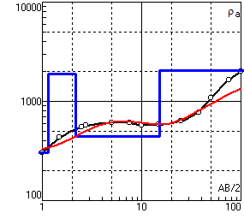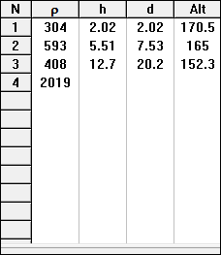

Apparent resistivity (Ωm)

Electrode spacing (m)

Where,

**N** is the number of layers,

**ρ** is the apperent resistivity,

**h** is the thickness and

**d** is the depth to interface of

each layer.

1. VES Station 5 (TYPE KH CURVE)

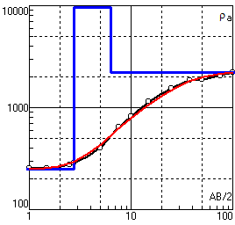 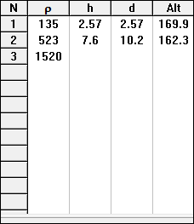

Apparent resistivity (Ωm)

Where,

**N** is the number of layers,

**ρ** is the apperent resistivity,

**h** is the thickness and

**d** is the depth to interface of

each layer.

Electrode spacing (m)

1. VES Station 6 (TYPE A CURVE)

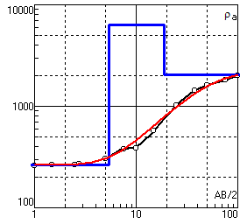 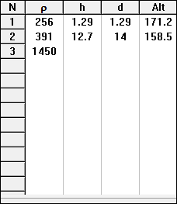

Apparent resistivity (Ωm)

Where,

**N** is the layer number,

**ρ** is the apperent resistivity

in ohm-metre,

**h** is the layer thickness and

**d** is the depth to interface of

each layer

Electrode spacing (m)

1. VES Station 9 (TYPE A CURVE)

**FIG. 2: Typical curve types and models obtained from the study area.**

newyorksci@gmail.com

http://sciencepub.net/newyork

**DEPTH (m)**

VES

1C

VES

2C

VES

3C

VES

4C

VES

5C

VES

6C

VES

7C

VES

8C

VES

9C

10

20

30

40

***73 $Ωm$***



***219 $Ωm$***

***219 $Ωm$***

**84 $Ωm$**

**38 $Ωm$**

**39 $Ωm$**

**452 $Ωm$**

***218 $Ωm$***

***245 $Ωm$***

**196 $Ωm$**

**526 $Ωm$**

**396 $Ωm$**

**1931 $Ωm$**

**190 $Ωm$**

**211 $Ωm$**

**408 $Ωm$**

**1520 $Ωm$**

**520 $Ωm$**

**1520 $Ωm$**

**114 $Ωm$**

**1287 $Ωm$**

**1233 $Ωm$**

**133 $Ωm$**

**120 $Ωm$**

**1329 $Ωm$**

***245 $Ωm$***

**38 $Ωm$**

**1215 $Ωm$**

**1396 $Ωm$**

**55 $Ωm$**

Clayey (Top soil)

Weathered layer

Fresh basement

Sandey Lateritic hard pan (Top soil)

Partly weathered/fractured layer

VES 1

VES 2

VES 3

VES 4

VES 5

VES 6

VES 7

VES 8

VES 9

**A**

**Ai**

http://sciencepub.net/newyork

newyorksci@gmail.com

**B**

**Bi**

Weathered layer

Fresh basement

Lateritic hard pan (Top soil)

VES 10

VES 11

VES 12

VES 13

VES 14

VES 15

VES

1E

VES

VES

VES

4E

VES

5E

VES

6E

10

20

30

40

**600 $Ωm$**

**1540 $Ωm$**

**1870 $Ωm$**

**277.7 $Ωm$**

**750 $Ωm$**

**1875 $Ωm$**

**2150 $Ωm$**

**31 $Ωm$**

**180 $Ωm$**

**350 $Ωm$**

**27 $Ωm$**

**1560 $Ωm$**

**1200 $Ωm$**

**14.1 $Ωm$**

**200 $Ωm$**

**DEPTH (m)**

**FIG. 4: Geoelectric section along profiles B-Bi**

**AND MN**

**AND IJ**

**Correspondence to**

http://sciencepub.net/newyork

newyorksci@gmail.com

newyorksci@gmail.com

**Fadele. S.I. and Sule, P.O**

Department of Physics (Applied Geophysics), Ahmadu Bello University, Zaria, Nigeria. and

**Patrick, N.O.**

Nasarawa State University, Keffi.

([fadeleidowu@yahoo.com](mailto:fadeleidowu@yahoo.com))

**References**

1. Danladi, G.G. (1985). Appraisal of

Hydrological Investigation in Shallow

Basement Area of Zaria. Unpublished

M.Sc. Thesis, Department of Geology,

Ahmadu Bello University, Zaria.

2. Farouq, A.U. (2001). Geoelectric

Investigation of the groundwater potential

in the Institute for Agricultural Research

farm. Unpublished M.Sc. Thesis,

Department of Physics, Ahmadu Bello

University, Zaria.

3. Harold, E.D. (1970). Arid Lands in

Transition. The Hornshafer Company

Division of G.D.W. King Printing Co.,

U.S.A.

4. Klinkenbera, K. (1970). Soil of Zaria

Area, In Zaria and its Region(ed. M. J.

Mortimore), Department of Geography,

Occasional Paper No. 4, Ahmadu Bello

University, Zaria, P. 223 – 238.

5. McCurry, P. (1970). The Geology of

Zaria Sheet 21. Unpublished M.Sc.

Thesis, Department of Geology, Ahmadu

Bello University, Zaria.

6. Oyawoye, P. O. (1964).Geology of

Nigerian Basement Complex. Journal of

Mining and Geology, Vol.1, P. 110-121

7. Saminu, O. (1999). Geophysical

Investigation of Federal College of

Education, Zaria*,* Unpublished M.Sc.

Thesis, Department of Physics, Ahmadu

Bello University, Zaria.

8. Wright, J. B. and McCurry, P. (1970).

The geology of Nigeria Sheet 102 SW,

Zaria and its regions. Edited by M. J.

Mortimore. Department of Geography,

Occasional paper, No. 4, Ahmadu Bello

University,Zaria.

newyorksci@gmail.com

6/8/2012