Mud Stadium

Hesham Gerisha

Department of Architecture, Faculty of Engineering, MUST University-Egypt
Con_develope@hotmail.com

Abstract: Yemen is a wonderful land with a history in the past. The main point in this culture considerate the area of shibam (mud building with about 20 meter lounge). This paper discuss that we didn’t have mud building in the horizontal level with a large span. We rich the highest level in shibam but we didn’t elaborate the horizontal level.
[Hesham Gerisha. Mud Stadium. N Y Sci J 2012;5(5):62-69]. (ISSN: 1554-0200). http://www.sciencepub.net/newyork. 11

Keywords: Yemen; history; shibam; building; span

1. The History
Some might assume it to be a mirage. Rising out of the desert in the South Arabian Peninsula, ancient high-rise apartment buildings made of mud meet the eye. Centuries before the modern age of skyscrapers dawned in Chicago and New York, the Middle East had its own skyscraper city – the oldest on earth. This is Shibam in Yemen, a place thought to have existed since the 2nd century AD.
Constructed out of mud bricks made from local clay, around 500 of Shibam’s buildings are tower houses standing between 5 and 11 story's tall. These are the tallest mud buildings in the world, some of them soaring over 100 feet high. Like the fortified wall that surrounds this fortress city, the building practice was employed to protect inhabitants from attacks by marauding Bedouin tribes.

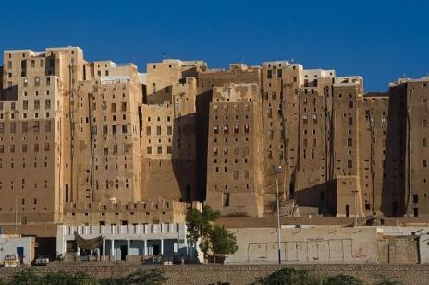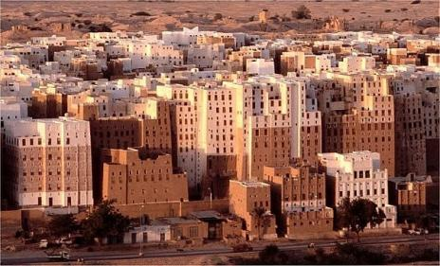
Fig.1: Shibam buildings

The urban planning is such that the streets are too narrow for traffic to pass through, though it seems the lack of cars does not adversely affect Shibam’s 7,000 or so inhabitants who are content with the peace and lack of pollution this provides. The tightly packed nature of the houses also means that from a distance they appear as one block – a fortified design that made attackers think twice.
Mud Architecture is basically studying mud as a building material which has already being tested and tried for thousands of years. The property of this material is very different from the ones which are in used in modern day construction hence the method of using it is very different.
Like all materials this is also have its own limitations which can be overcome but the main advantage is we do not need lot of energy to manufacture it unlike brick, cement, steel, concrete, etc. Hence today when construction is consuming such a large amount of energy, which needs to be conserved, it has become a necessity than a demand to sensibly explore into this alternative material for construction.

2. Why Mud as a Building Material?
2.1 Energy Consumption
In mud construction, minimum fossil fuel energy is consumed and is naturally abundant throughout the world. Where as in brick construction fossil energy is consumed for manufacturing process and transportation.

2.2 Recycling
Recycling of modern materials for building construction results in high cost. Recycling of soil does not need fossil fuel, labour require is also less. The characteristic of recycled soil for construction remains the same whereas in modern building material situ acquires inferior character after recycling.

2.3 Abundance
The abundance availability of soil in large areas help the economically weaker section of the society to afford the mud construction. It is easily adaptable and the technology can be transferred easily.

2.4 Housing Demand
A huge deficit of housing demand in urban and rural areas linked with limited resources on all fronts make it absolutely essential that the housing solution have to be best effective, through optimal and efficient use of all resources of land, finance and building material.

3. Mud brick construction
The mud brick buildings have thick walls often a meter and a half at the bottom tapering to half a meter at the top. The mass of the walls is ideal for keeping the inside of the building cool; window openings are kept small and located to avoid direct sunlight and have ornate wooden lattice which provide shade as well as privacy. Taller buildings also have a shaft adjacent to the main staircase which acts as a chimney for “pulling” a breeze thro’ the building, cooler air at ground level being drawn up thro the building. The layout of the buildings -close together, means they provide shade for one another and also shade the ravine like streets in between. After a long and still continuing experiment with “western” construction the Hadhramis have recognized the inherent qualities of their mud brick buildings, and although the latter are more labour intensive and slower, [in the past a tower house may take five to eight years to build] there is also an inclination to return to the traditional way.

Structural Principle for mud buildings

Fig. 2 Shibam structural system

The earth for the mud bricks comes from the wadi floor ready saturated after the rainy season; concrete construction uses imported cement which takes energy in both the processing and the distribution. The mud is mixed with chopped straw and water and then spread into simple wooden moulds on the ground to bake hard. The bricks are more like flat cakes approximately 45 centimeters long by 30 cm wide, narrower bricks are made for the upper storeys . They are 75 to 100 cm thick. To make a wall they are laid interlocking with a mud mortar and then rendered with a finer mud layer to make the wall smooth. But what stops it being washed away?– It’s a common question. The answer is-the type of earth, which is just the right combination clay and silt and sand – it just sets very hard and although a thin outer layer may get washed off during the rainy season it is basically waterproof. Even the flat roof? The roof and parapet walls at the top of the buildings are the most vulnerable area- an earth building needs “a good hat and boots”-the boots are a stone built plinth, often the first two meters of the building above the ground, which stops moisture in the ground rising up and provides protection from abrasion by people and animals. The hat- the roof- is also covered in mud, with vulnerable parts such as parapets coated with a high quality lime render called “nurah”. A visitor will notice many lime kilns as well as fields of mud bricks drying in the sun. Sometimes nurah is applied to the whole roof surface; it is built up in layers, increasingly more refined and then painstakingly “polished” using a specially shaped stone. The nurah is also used decoratively: around windows and doors and it is also nurah from which the intense decoration of the Tarim palaces is made.
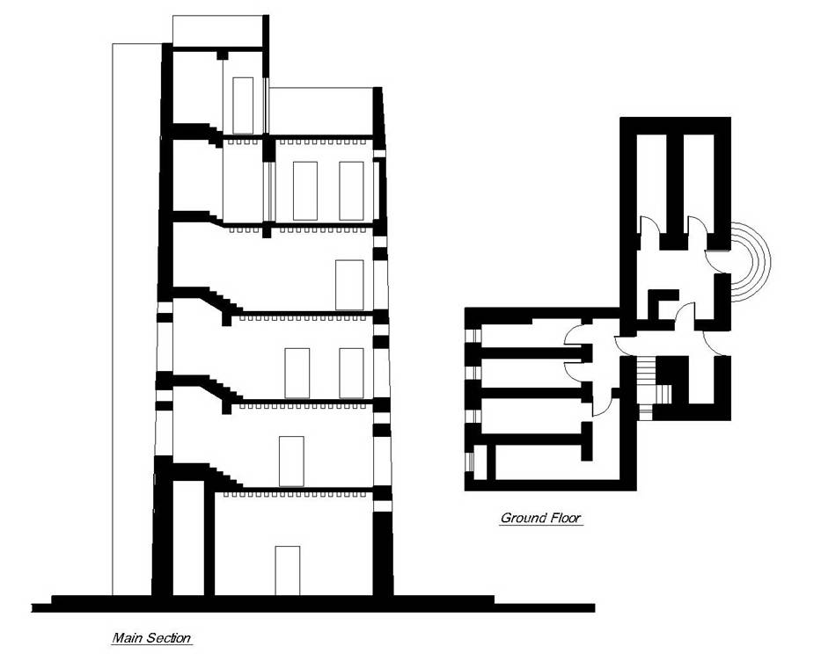
Fig.3:Shibam type in plan and section

3. The wide span units
The hadhramis were very clever by constructing the mud tower, which they have a span from 4 meters. The target in this paper is the design of wide span unit such as a stadium or the recovering of swimming pool unit.
Investigation of structural behaviors has the direct purpose of supporting an informed design of the structures and an assurance as to the safety of the construction with regard to the building occupants.
Structural behaviors may be simple or complex. This quality may derive from the nature of the loads on the structure from simple gravity to the dynamic effects of earthquakes. It may also derive from the nature of the structure itself.

3.1 Stress- Strain members
To avoid bending by 20 meters span we are looking for stress strain members. Palm fiber or palm fronds are the tension part in the system and wood units are the compression part.
Generally stress strain system is bending resistance. Primary considerations for beam stresses and strains have influenced the development of widely used structural products, such as the palm fiber.

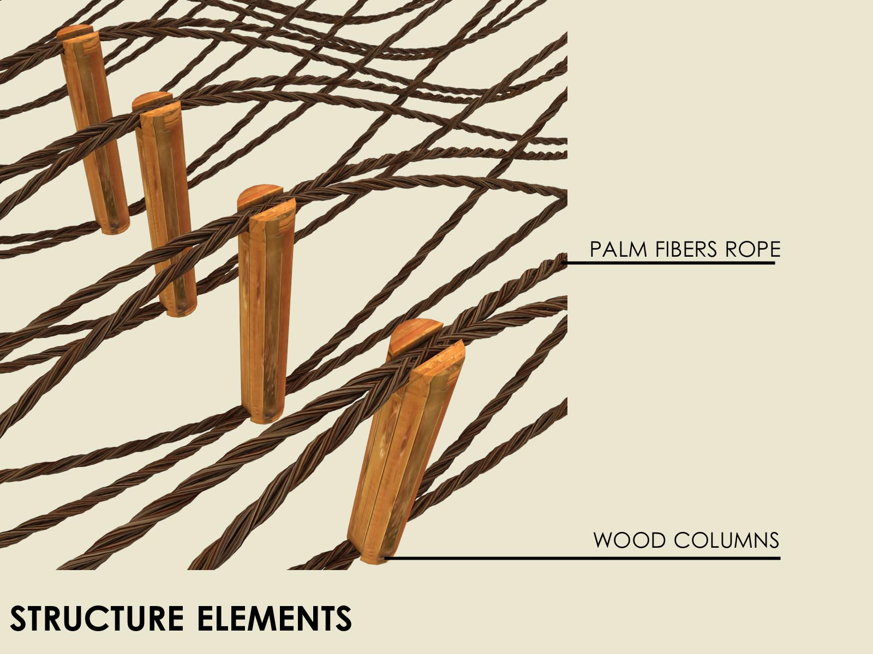
Fig. 4 New concept for the wide spans "mud stadium"

As developed in the preceding systems, bending moment is a measure of the tendency of the external forces on a beam to deform it by bending.

Description of the system
The system content wood columns as a compression member and palm fiber rope as a tension member. This system is connected with wood trusses from the right and left side.

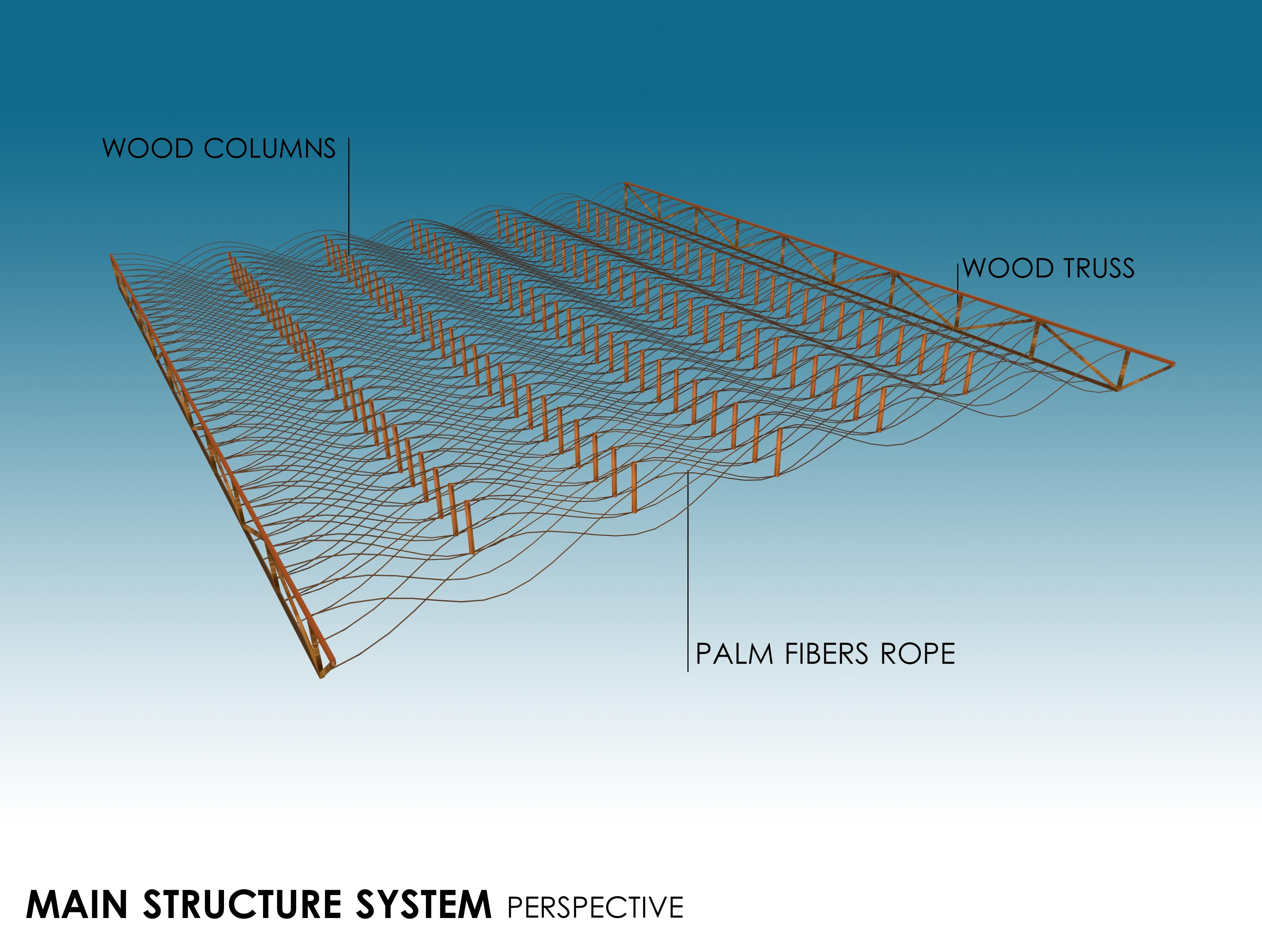
Fig.5 : Structure system

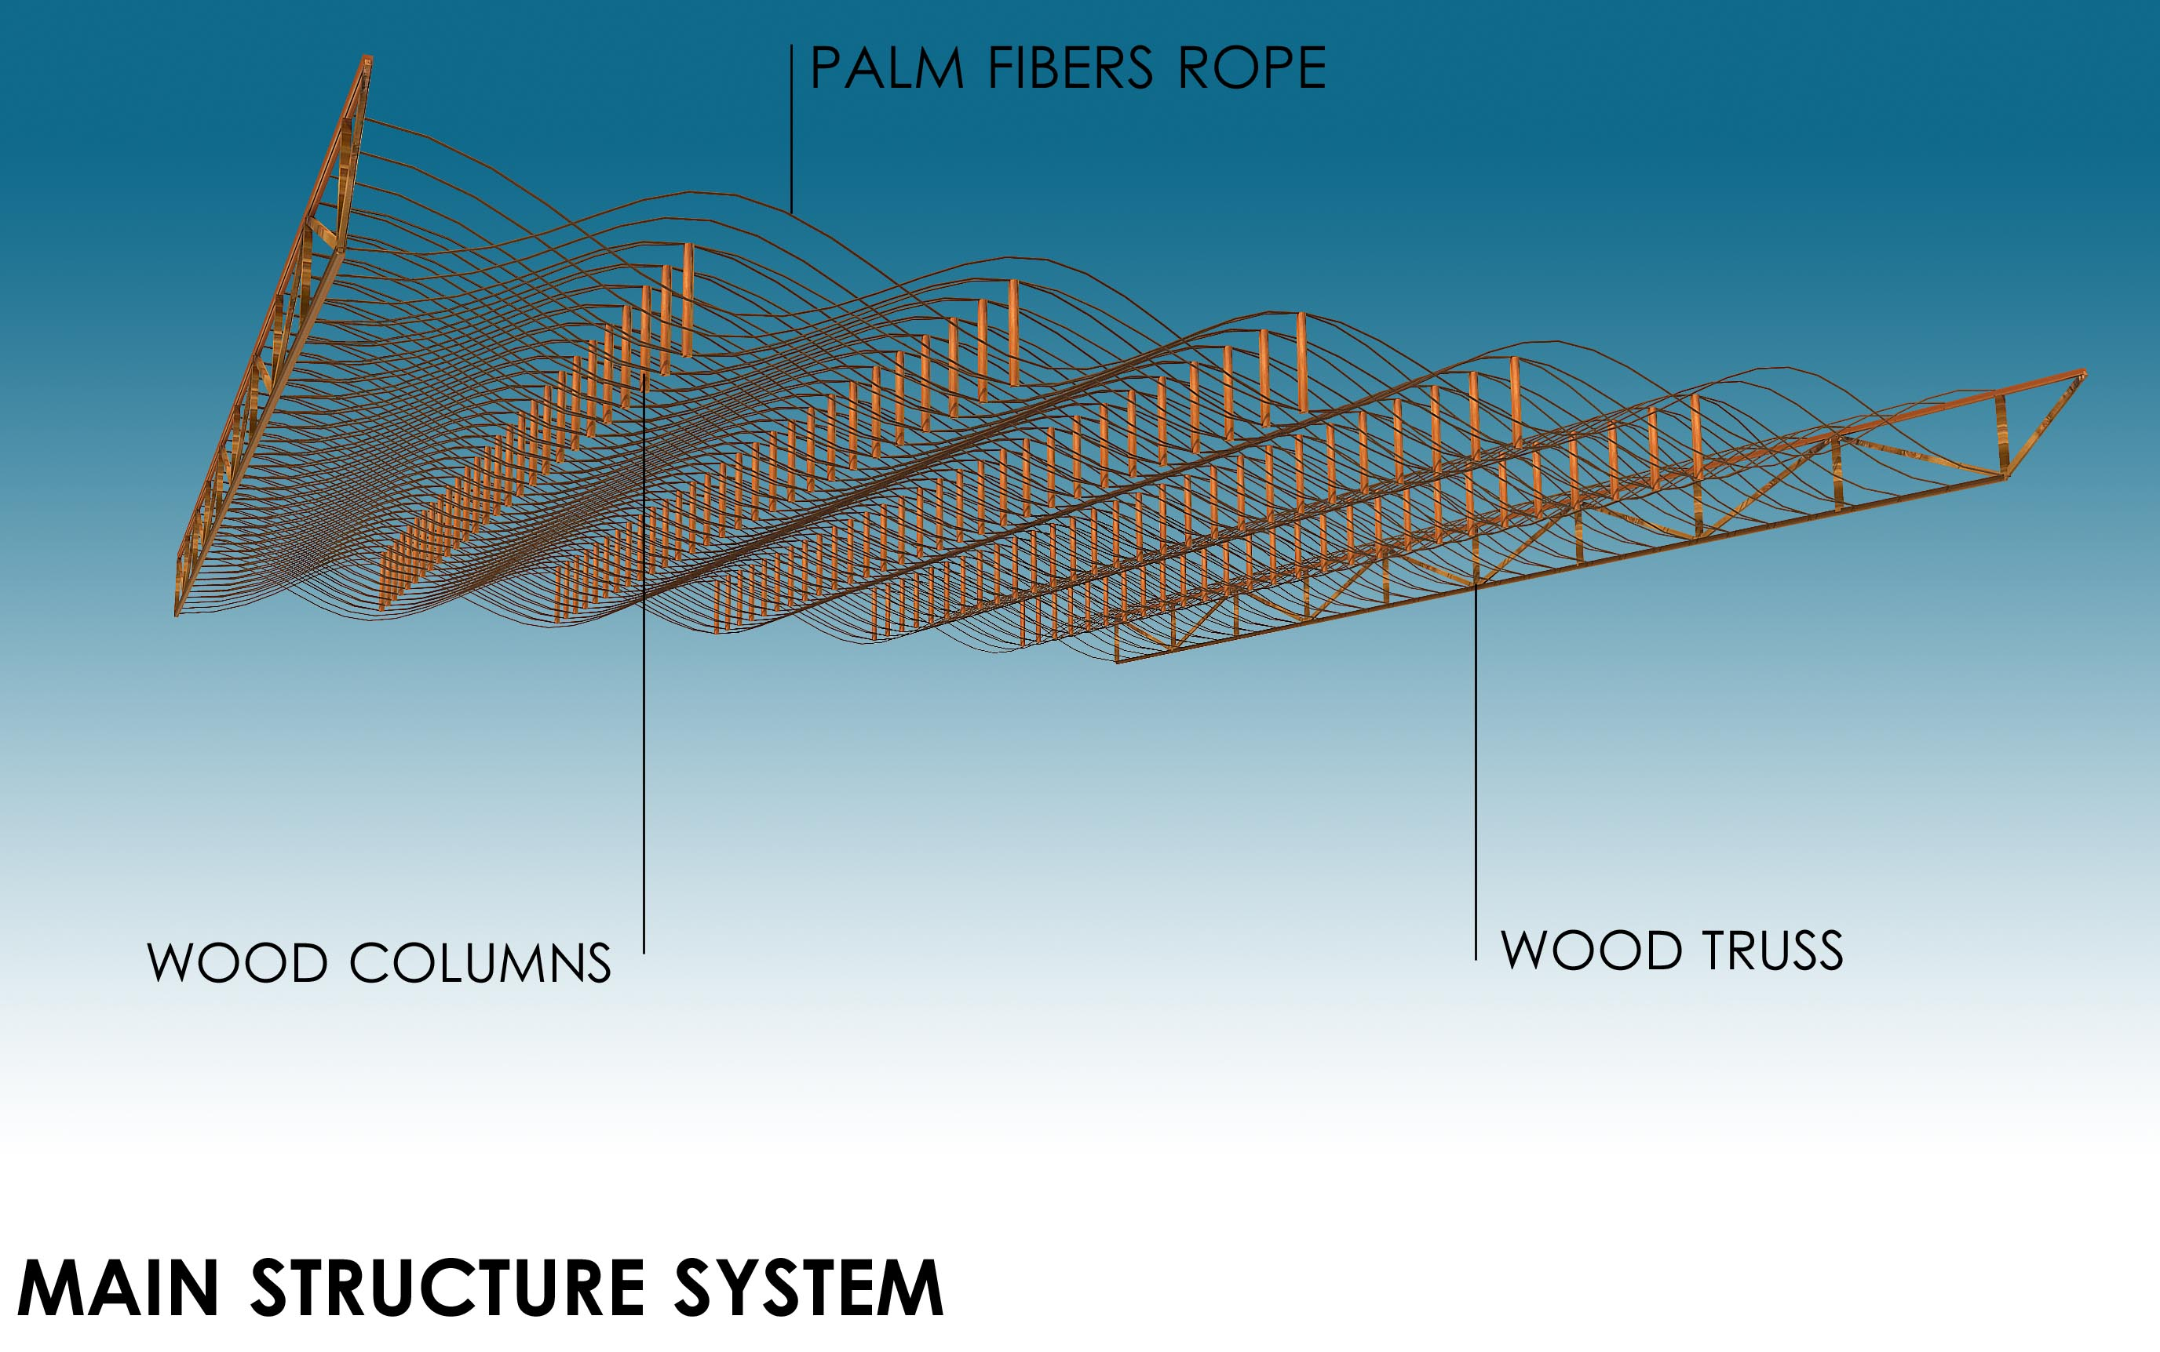
Fig.6:Structure system

The system is designed for a span from 20meter. The recovering for the stadium can be wood tiles or can be polycarbonate tiles based on the stress strain system.

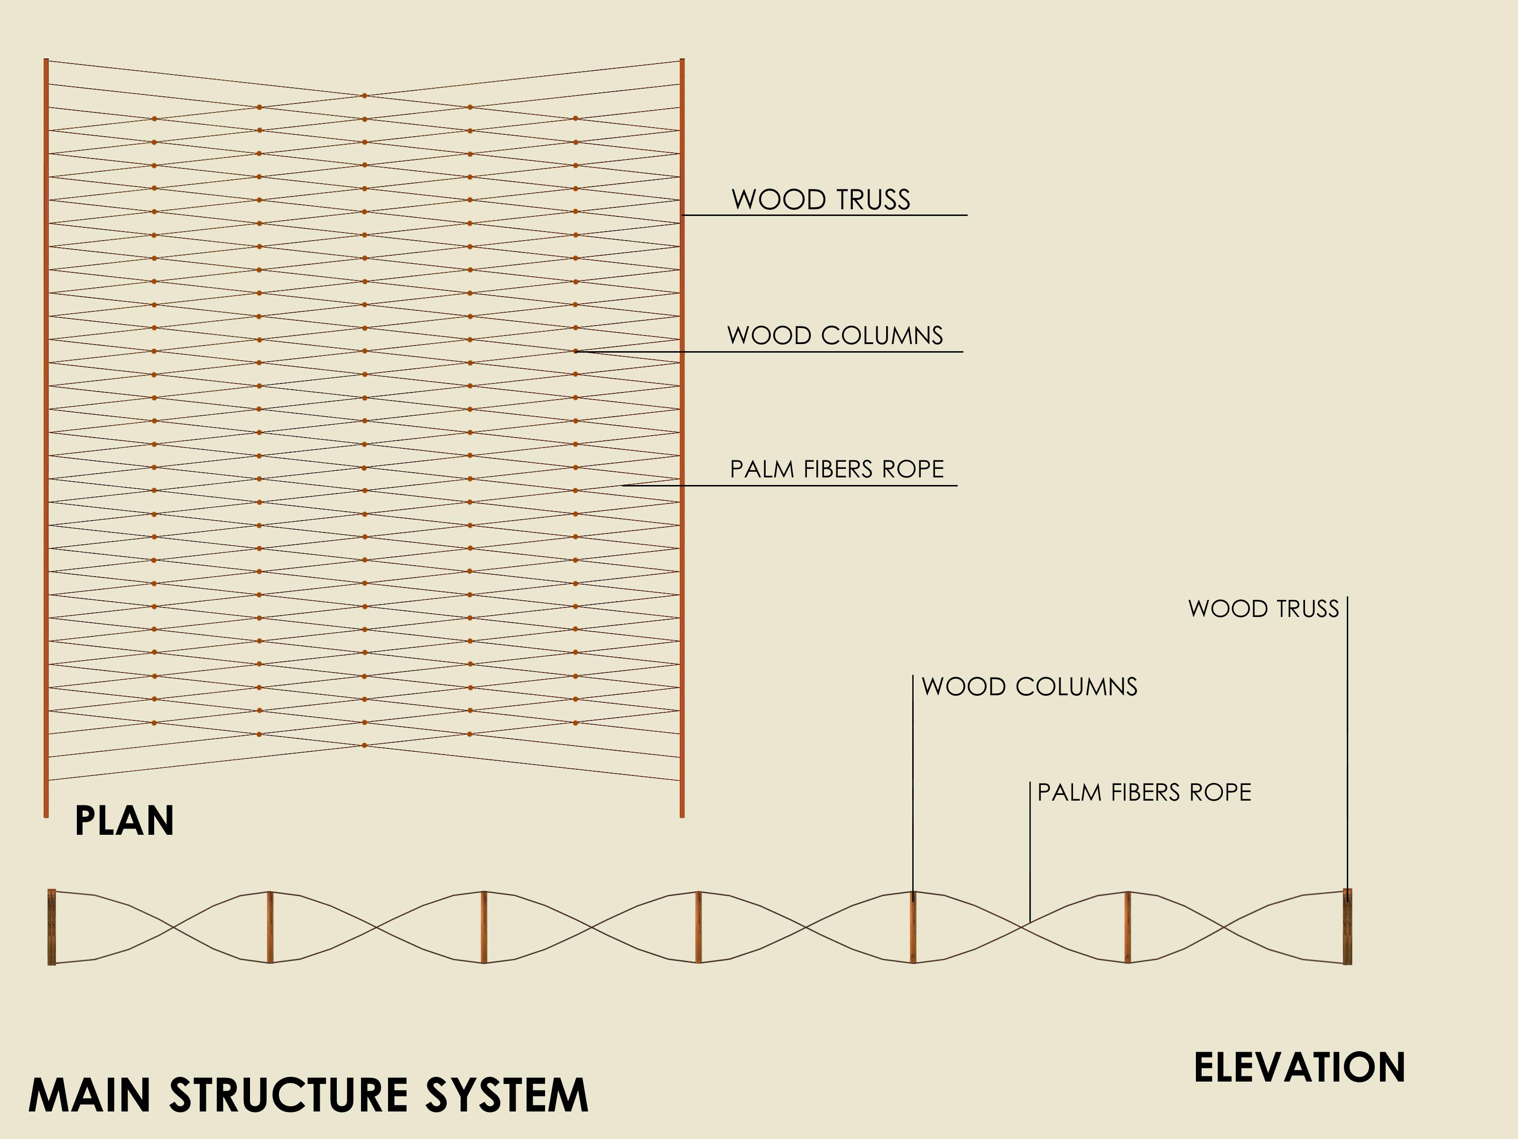
Fig.7 :Structure system
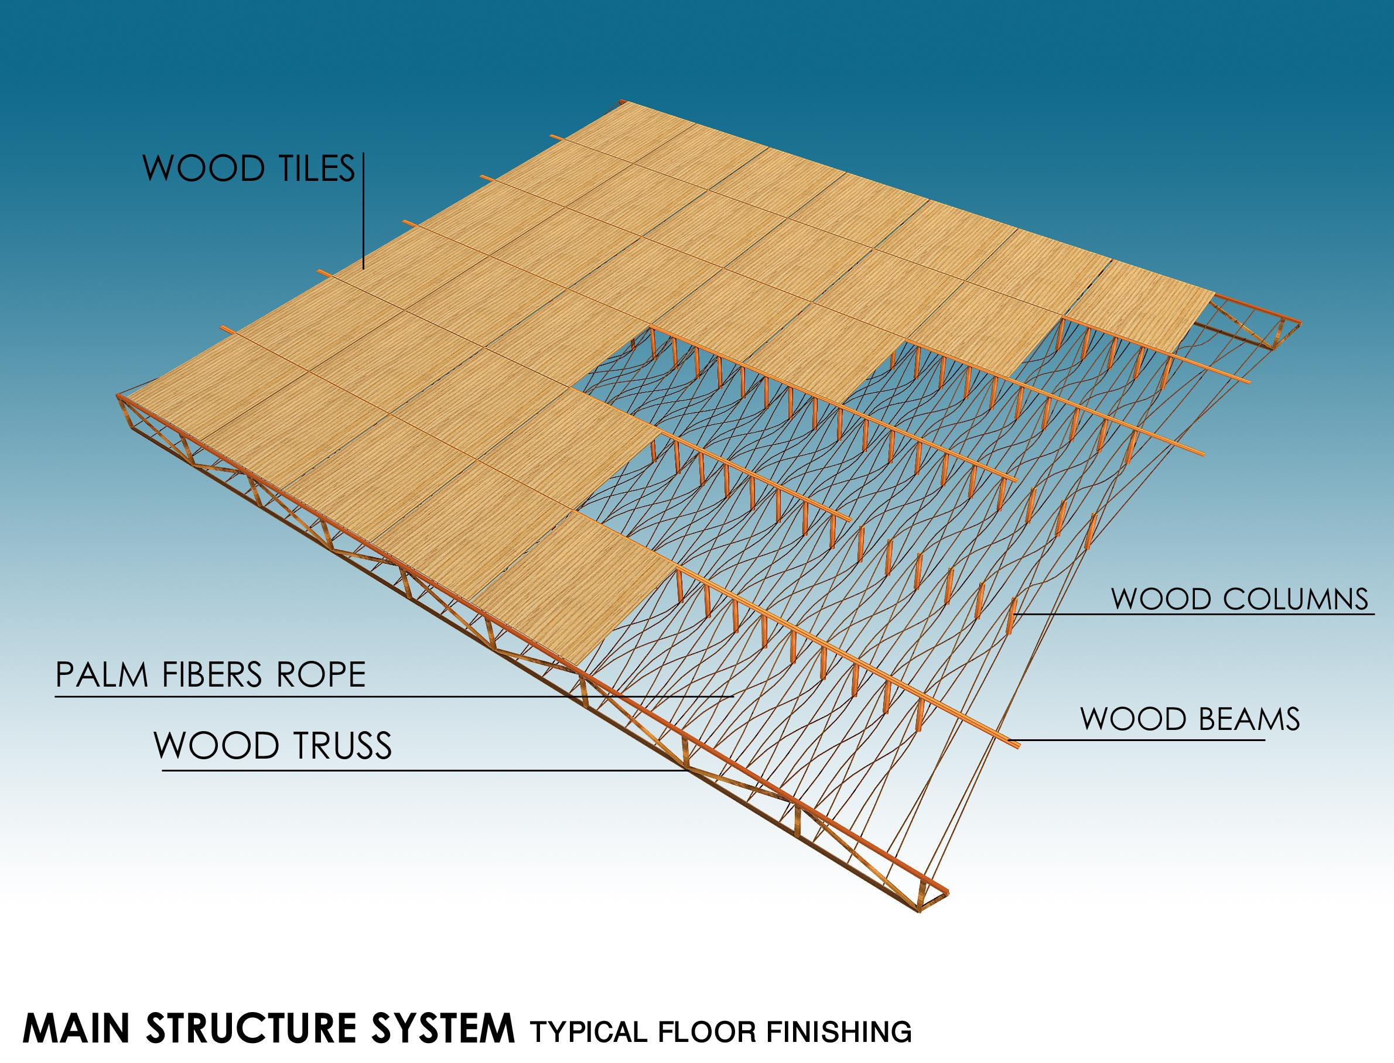
Fig.8 :Structure system
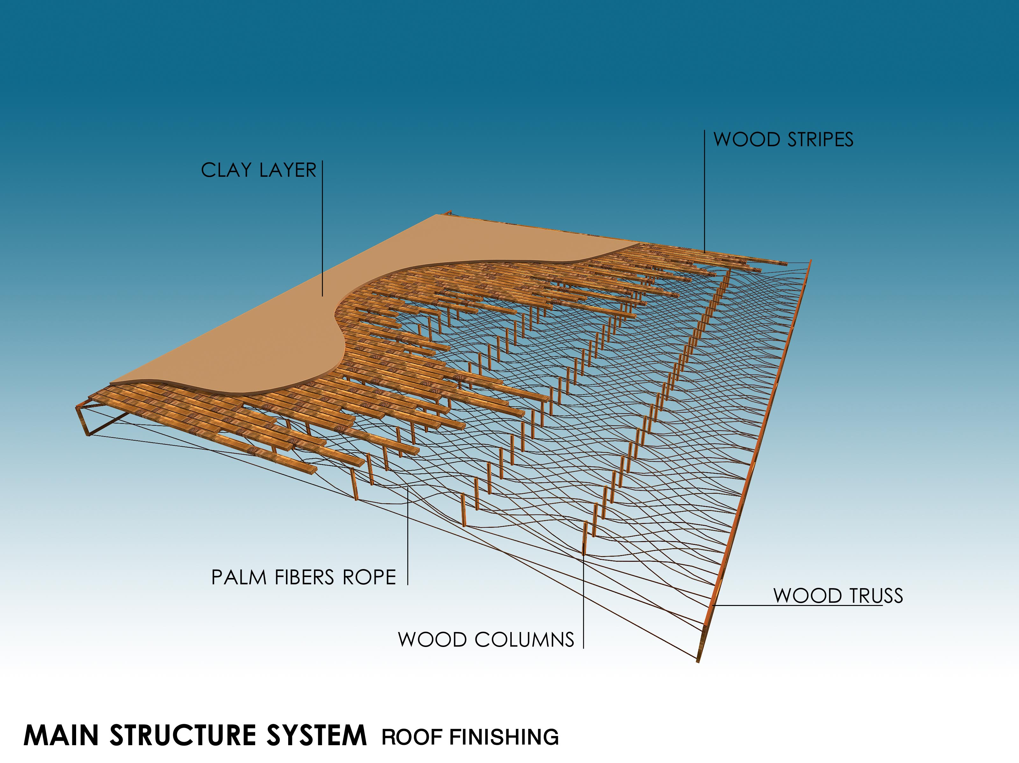
Fig. 9 :Structure system as flooring

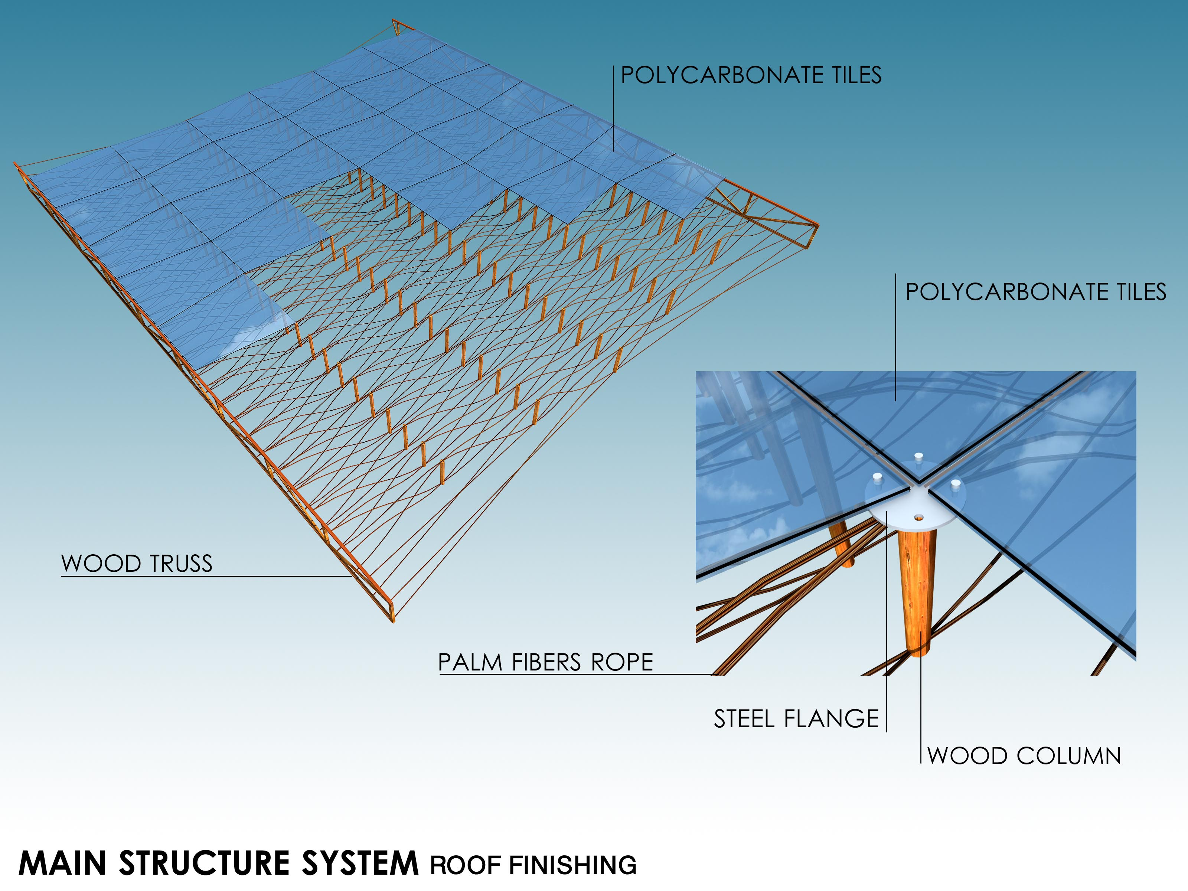
Fig.10: Polycarbonate alternative

The mud stadium is only 10 meters height. The most seats are under-ground designed. The stadium is keeping the style of hadramaut and allow a wide span from 20 meters.

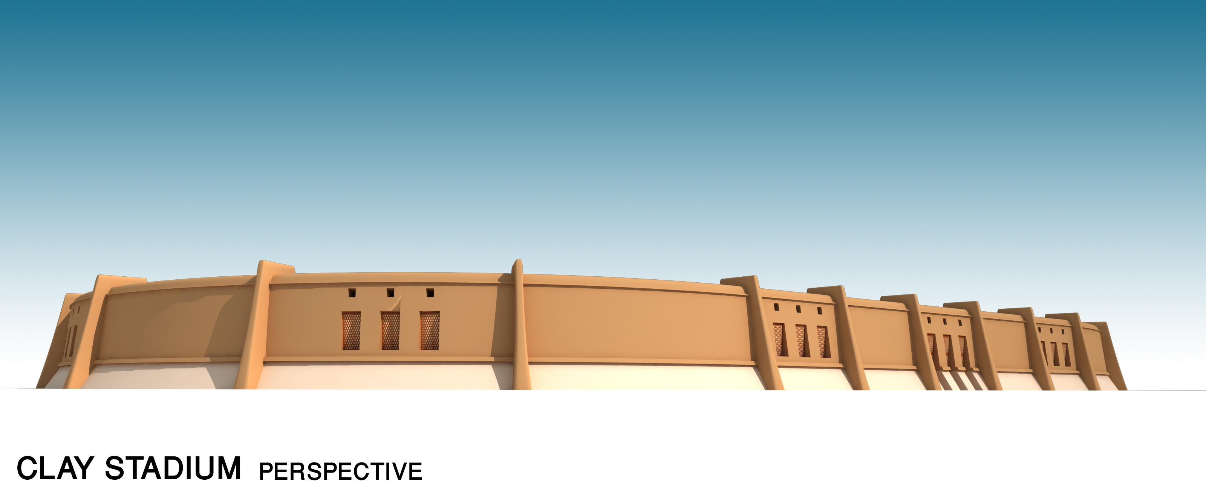
Fig.11 :Main elevation of the suggested stadium

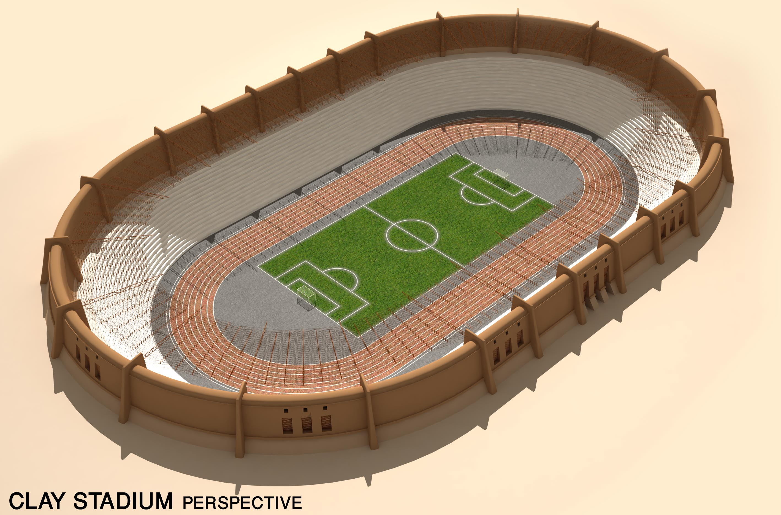

Fig.12 :The suggested stadium

The wood compression member is taking the loads to the palm fiber, which is working in a tension art. The recovering became a very creative solution, which match the modern with the local without mistakes.

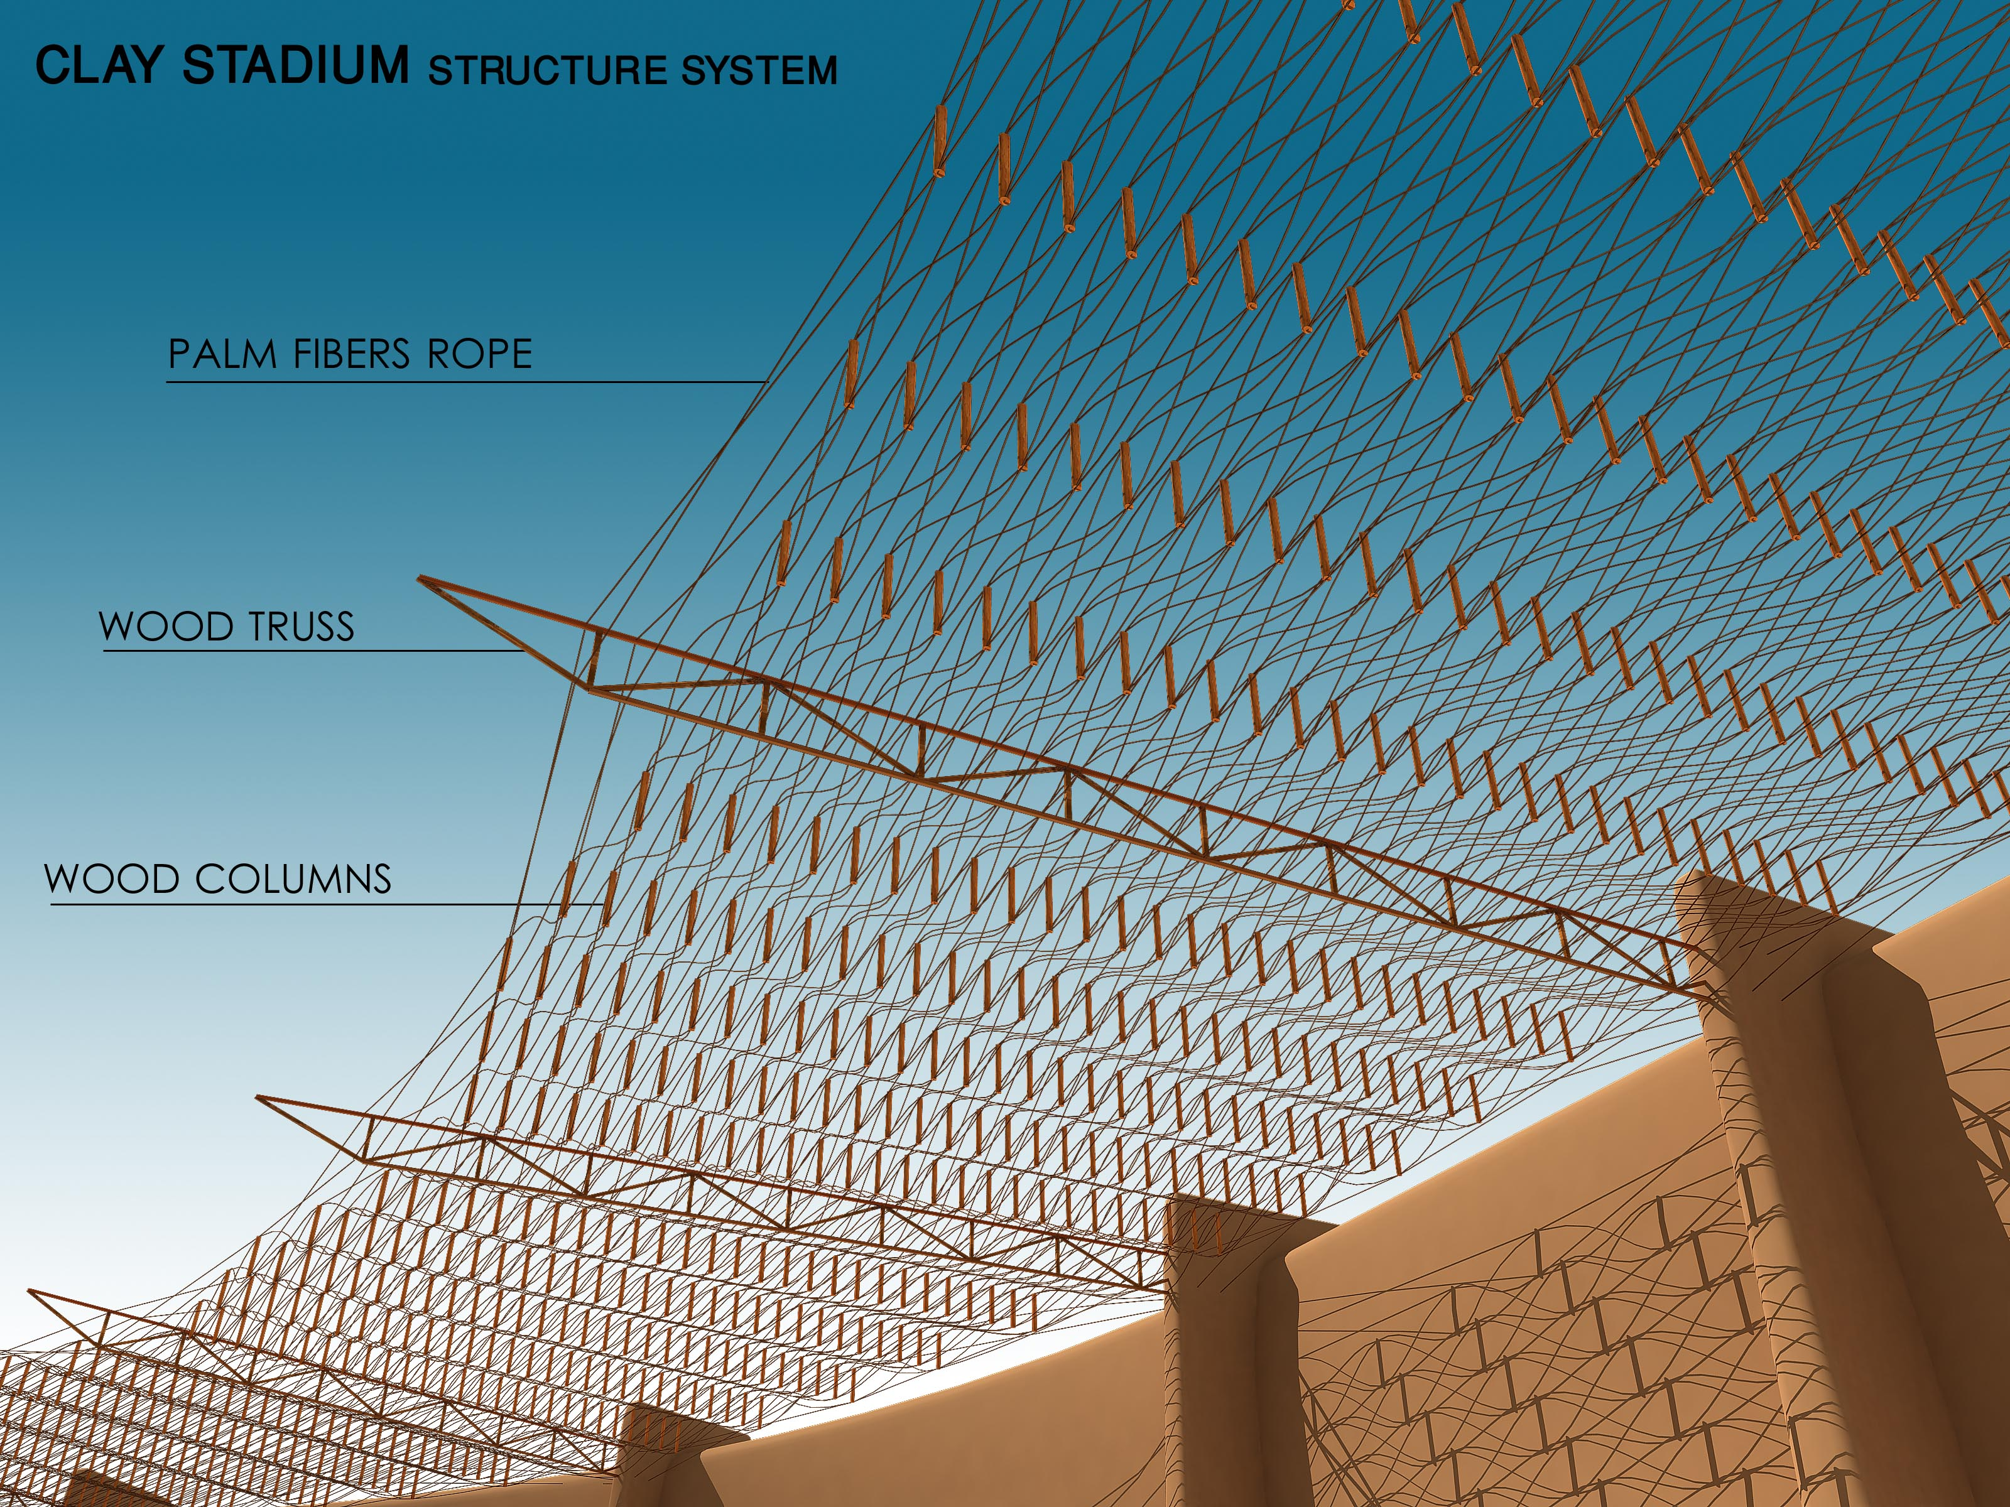
Fig.13:The stadium from inside

  - The system in another function
We can use the stress strain system by designing a swimming pool with the same dimension. The roof design is the same like by the stadium. Only one thing, what we have to think about, is the ventilation in this case.

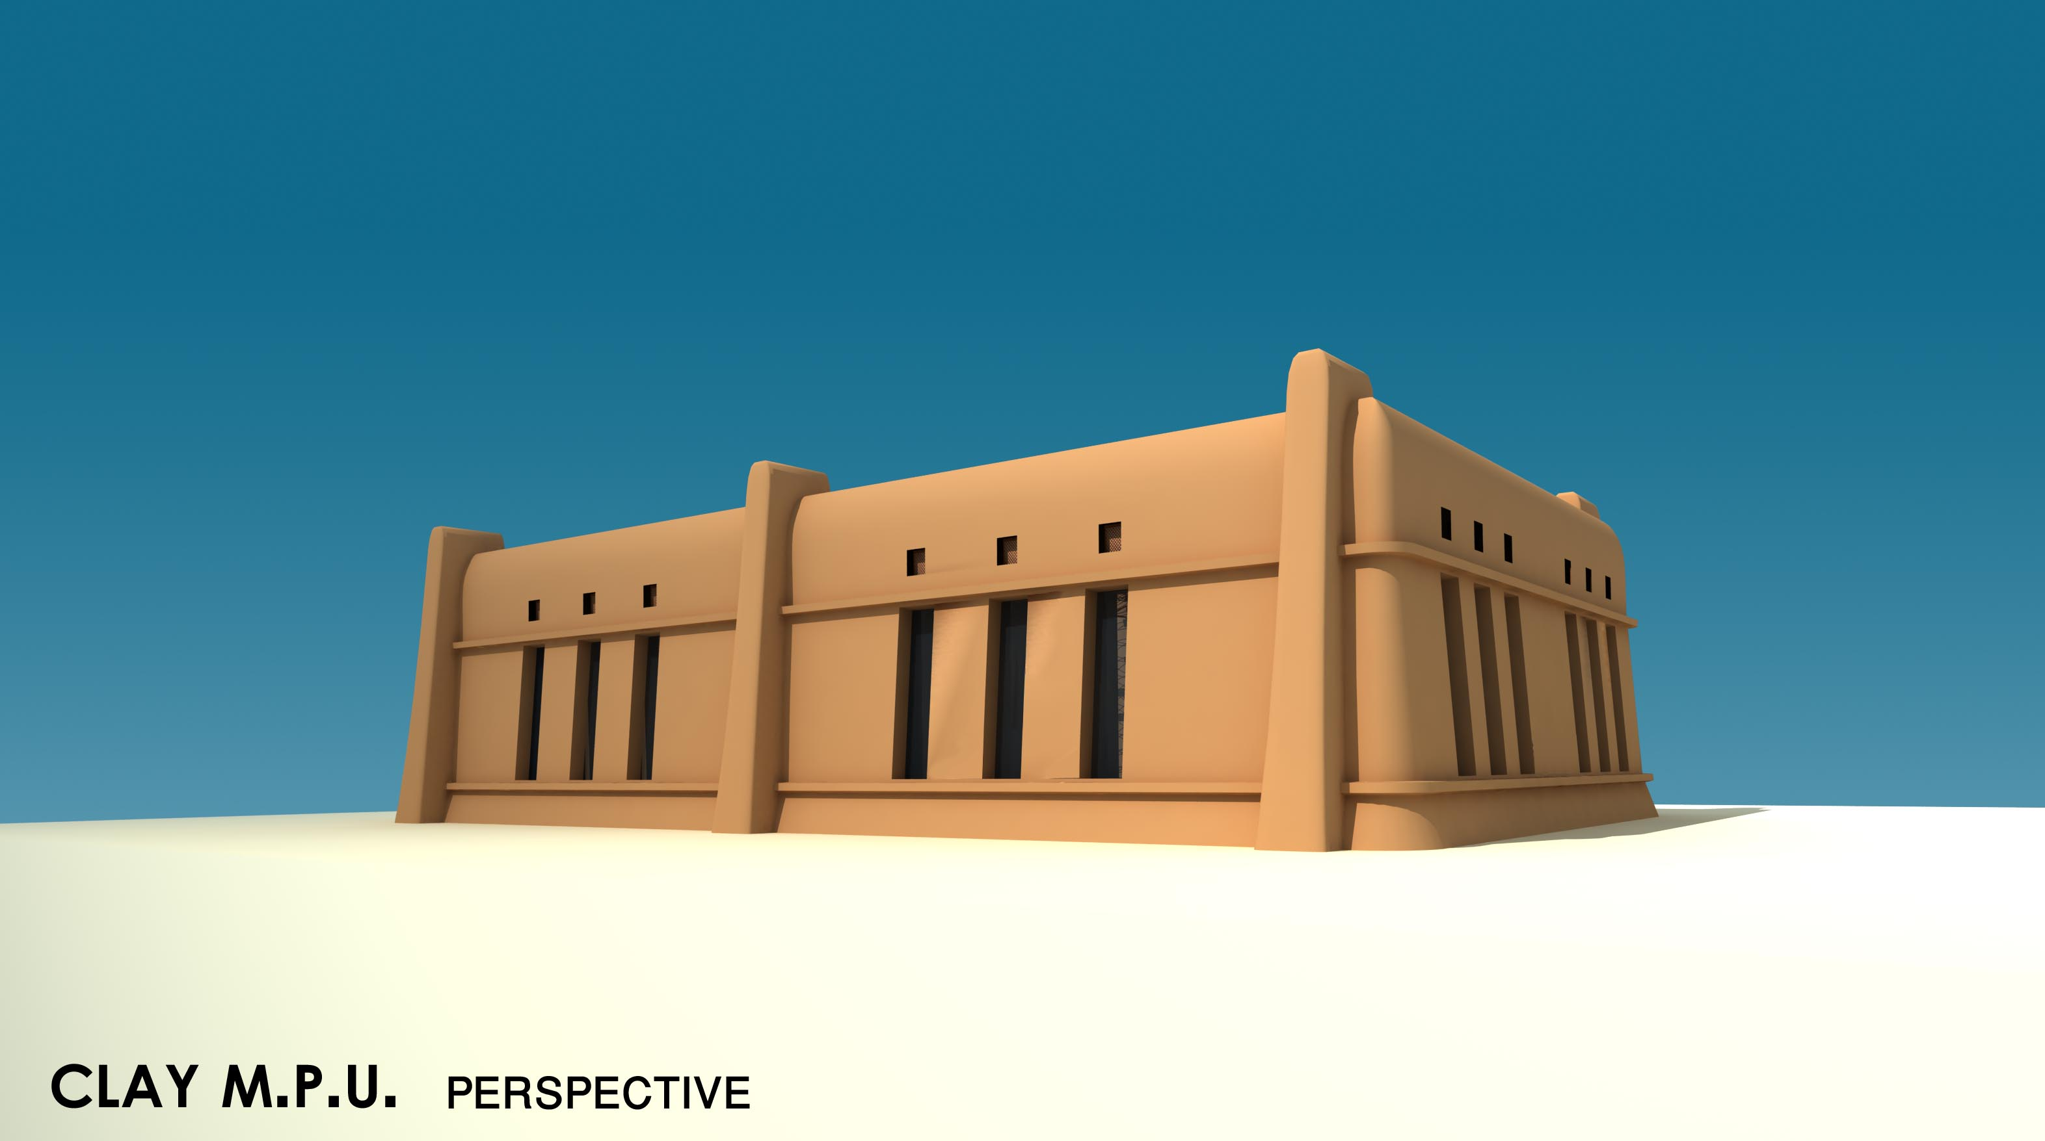

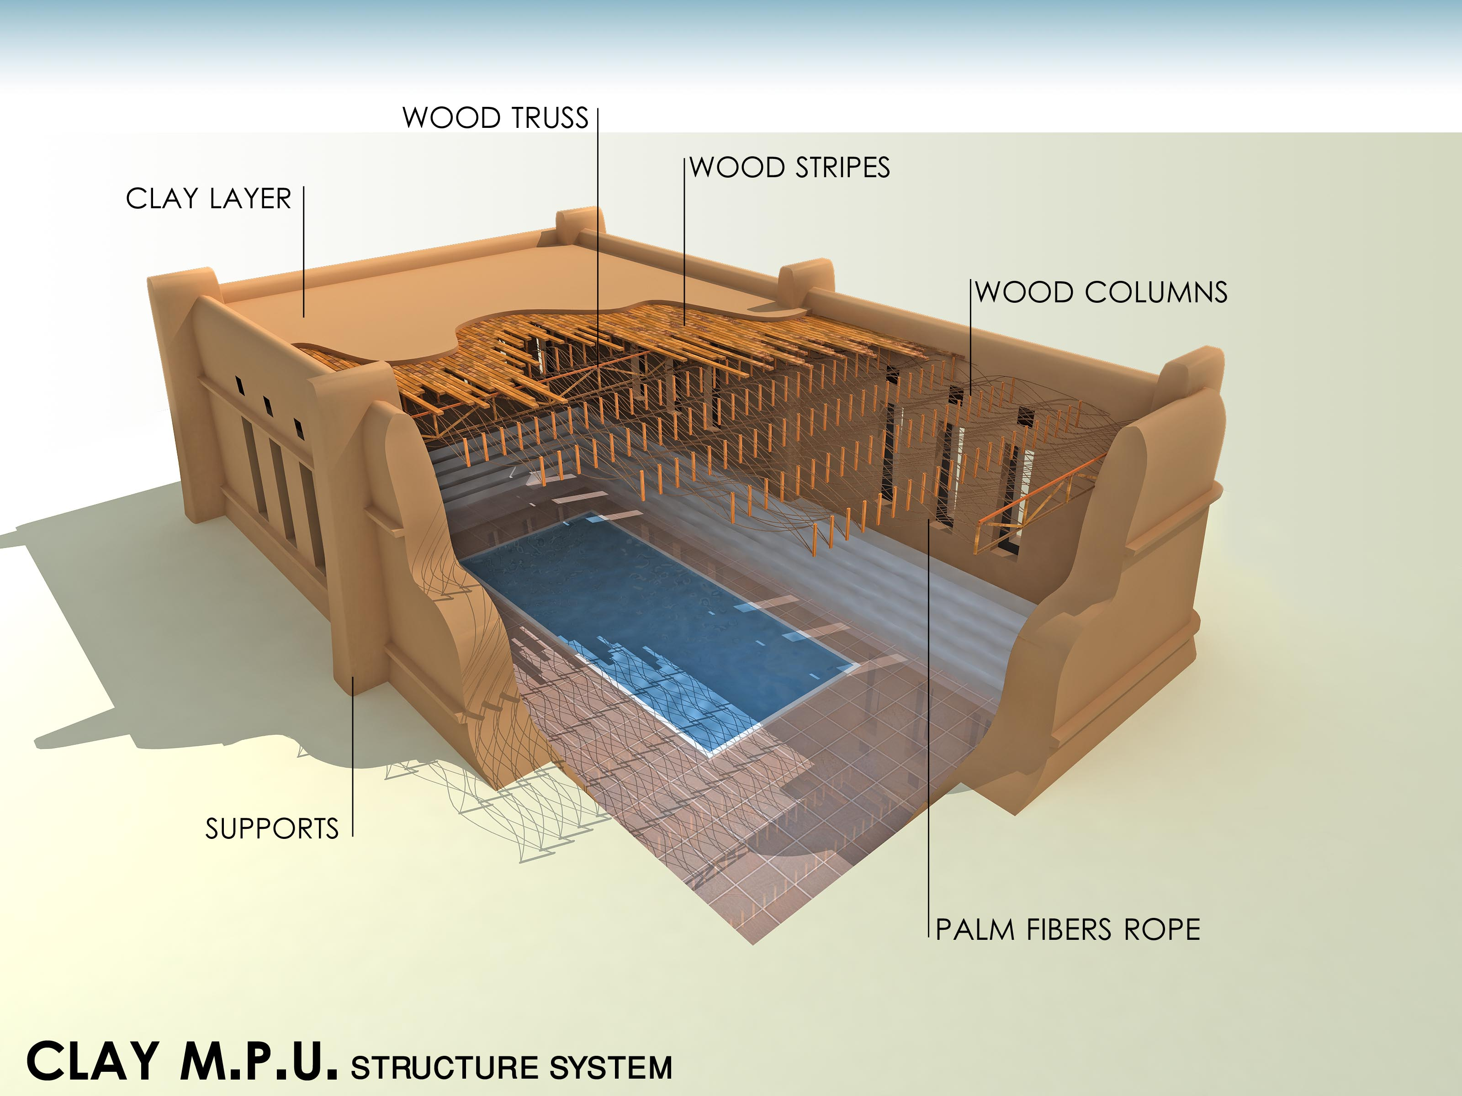

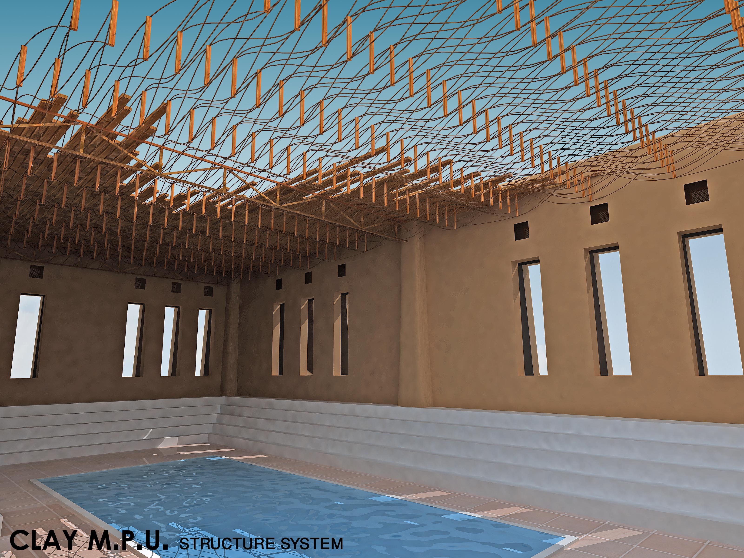

4. The strength in the member of the systems
Strength is probably the most obvious requirement for a structure. Even through it is stabile. The stress strain system is not strong enough to hold the weight of the roof. This has to do party with the material. We have to test the member with the allowed stress through the SAP- Modeling.

5. Conclusion
The system, which is suggested in this paper, allowed to build units with wide span. The next step in this research is to build a SAP-model and to pick the material with the allowed stress. The SAP-model is related to the span of the unit and to the dimension of the tension and compression member.

6. Reference
[1] Encyopida .com
[2] Timber Construction Manual, 3rd ed. American institute of timber construction, Wiley, New York, 1985
[3] Simplified Mechanics and strength of materials, James Ambrose, john Wiley and sons, Inc.

4/23/2012

