Differential diagnosis of Egyptian Fasciola species by deoxyribonucleic acid (DNA) sequences of nuclear ribosomal internal transcribed spacer 1 (ITS1) based on a PCR–RFLP method

* Khaled Abd El-Aziz Mohammad¹, Alaa Abd El-Aziz Mohammad², Mohammad F. Abu El-Nour² and Anwar Husainy Abu-Hashim³

¹Department of Parasitology, Faculty of medicine (Damietta), Al-Azhar University, New Damietta City, Egypt.
²Department of Zoology, Faculty of science (Cairo), Al-Azhar University, Nasr City, Egypt.
³Department of Parasitology, Faculty of medicine (Cairo), Al-Azhar University, Nasr City, Egypt.
*khaledsamn@yahoo.com

Abstract: Fascioliasis is one of the familiar zoonotic health problems of worldwide distribution including Asian, African countries and Egypt. Morphological differentiation between the liver fluke species Fasciola hepatica and Fasciola gigantica is difficult. Molecular characterization is important for discriminating Fasciola specimens having the deoxyribonucleic acid (DNA) sequences of Fasciola hepatica, Fasciola gigantica. We have developed a restriction fragment length polymorphism of amplified DNA (PCR–RFLP) of the nuclear ribosomal internal transcribed spacer 1 (ITS1) region in Fasciola species. The band patterns of the fragments digested with a restriction enzyme, Rsa I, were accurately distinguished between both forms of Fasciola. Amplicons with the sequences of F. hepatica and F. gigantica were divided into fragments of about 360, 100, and 60 bp, and 360, 170, and 60 bp, respectively, and amplicons with the sequences of both Fasciola species yielded fragments of 360, 170, 100, and 60 bp. The results of PCR–RFLP completely coincided with those of sequence analysis, and thus PCR–RFLP is a useful technique for determining the ITS1 type in Fasciola species.
[Khaled Abd El-Aziz Mohammad, Alaa Abd El-Aziz Mohammad, Mohammad Fathallah Abu El-Nour and Anwar Husainy Abu-Hashim. Differential Diagnosis of Egyptian Fasciola species by deoxyribonucleic acid (DNA) sequences of nuclear ribosomal internal transcribed spacer 1 (ITS1) based on a PCR–RFLP method. N Y Sci J. 2012;5(5):46-49]. (ISSN: 1554-0200). http://www.sciencepub.net/newyork. 9

Keywords: DNA; ITS1; PCR–RFLP; Egyptian Fasciola

1. Introduction
Fascioliasis is of well-known zoonotic importance and an increasing human health problem. The causative agents Fasciola hepatica and Fasciola gigantica, which overlap in many regions of Africa and Asia, and in which the differentiation of both species is usually difficult because of the many variations in their morphological characteristics (El-Gozami and Shoukry, 2010). Moreover, in humans, liver fluke classification cannot be achieved by clinical, pathological, coprological or immunological methods. The differential diagnosis between F. hepatica and F. gigantica infection is very important because of their different transmission and epidemiological characteristics. The two Fasciola species have been classified by morphological characters such as body length and width, and they have been shown to be spermic diploid and meiotically functional in cytogenetical characteristics (Sanderson, 1953; Reddy and Subramanyam, 1973). The two species can also be discriminated by deoxyribonucleic acid (DNA) sequences of nuclear ribosomal internal transcribed spacer 1 (ITS1), ITS2, and 28S ribosomal ribonucleic acid genes (Adlard et al., 1993; Itagaki and Tsutsumi, 1998; Marcilla et al., 2002 and Itagaki et al., 2005a). F. hepatica mainly occurs in Europe, Americas and Oceania, while F. gigantica exist in Africa and Asia (Torgerson and Claxton, 1999). On the other hand, Fasciola specimens intermediate between F. hepatica and F. gigantica in morphology have been found in most countries, including Japan (Watanabe and Iwata, 1954; Itagaki and Akane, 1959 and Oshima et al., 1968), India (Varma, 1953), Korea (Chu and Kim, 1967), the Philippines (Kimura et al., 1984), Iran (Ashrafi et al., 2006) and Egypt (Amor et al., 2008 and Allam et al., 2011). These intermediate forms are difficult to identify accurately. Moreover, both Fasciola forms include aspermic diploid and triploid specimens that are meiotically dysfunctional and gynogenic (Moriyama et al., 1979; Sakaguchi, 1980 and Terasaki et al., 1998). Aspermic specimens from Japan, Korea, Vietnam and China exhibited heterogeneity between F. hepatica and F. gigantica in nuclear ribosomal and mitochondrial DNA, suggesting that their origin may be hybridization between the two species (Itagaki and Tsutsumi, 1998; Agatsuma et al., 2000; Itagaki et al., 2005a, b, 2009 and Peng et al., 2009). These findings indicate that Fasciola specimens that are diversified in biological nature should be characterized by spermatogenesis and genetic differentiation as well as morphology. Although DNA types based on sequences of the ITS1 region are of value to discriminate species having characteristics of F. hepatica, F. gigantica, and heterogeneity between the two species (Itagaki et al., 2005a, b, 2009 and Peng et al., 2009), DNA sequencing requires much time and is costly. In this study, we tried to develop a cost-effective PCR–RFLP method to discriminate the ITS1 types of Fasciola spp. more quickly.

2. Material and Methods
We used fourteen Fasciola specimens that were identified on the basis of their ability for spermatogenesis and nucleotide sequences (600 bp) of the ITS1 region. Total DNA was extracted from individual flukes using an E.Z.N.A. mollusc DNA kit (Omega Bio-Tek, Doraville, USA) according to the manufacturer's instructions. DNA samples were stored at −20°C until use. The DNA fragments (about 680 bp) of the ITS1 region including complete ITS1, partial 18S and 5.8S ribosomal deoxyribonucleic acid (rDNA) were amplified by polymerase chain reaction (PCR) according to Itagaki et al. (2005a, b). Although the nucleotide sequence (600 bp) of the DNA fragments has been determined ( Peng et al. 2009), the remaining sequences (about 80 bp) were analyzed in this study to select an appropriate restriction enzyme for discrimination between fragments with the sequences of F. hepatica and F. gigantica. The PCR amplicons were directly sequenced using ABI Prism Big Dye terminator v.3.0 ready reaction cycle sequencing kits (Applied Biosystems) in both directions with the use of the same forward and reverse primers as those used in PCR. The sequencing reactions were run on a PE Applied Biosystems 3100 automated sequencer. As a result, four and five restriction sites (GATC) for Rsa I were found in the nucleotide sequence (680 bp) of F. hepatica and F. gigantica, respectively. The PCR amplicons were precipitated with ethanol/sodium acetate and subjected to digestion overnight at 37°C with the enzyme in a total volume of 50 μl, containing 10 U of Rsa I and a buffer enzyme L (Roche, Mannheim, Germany). The restriction fragments were electrophoresed in 1.8% agarose gels in Tris-acetate-EDTA (TAE) and visualized with ethidium bromide.

3. Results and Discussion
The DNA fragments digested with Rsa I were predicted to be separated into fragments of 367, 104, 68, 59, 54 and 28 bp in the amplicons with the sequence of F. hepatica and into fragments of 367, 172, 59, 54, and 28 bp in the amplicons of F. gigantica (Fig. 1). However, the resultant bands of the fragments were about 360, 100, and 60 bp in F. hepatica amplicons and 360, 170, and 60 bp in F. gigantica amplicons (Fig. 2). The band of 60 bp was thought to include the three fragments of 68 bp (only F. hepatica), 59 and 54 bp, and the small fragment of 28 bp was not detected on agarose gels. These findings showed that the band patterns between the amplicons with the sequences of F. hepatica and F. gigantica were evidently different. Allam et al. and Marcilla et al. (2002) reported that a PCR–RFLP method based on 28S rDNA precisely distinguished the restriction fragments between F. hepatica and F. gigantica when the PCR amplicons (618 bp) of 28S rDNA were digested by the restriction enzyme Ava II or Dra II. Additionally, El-Gozami et al. (2010) and McGarry et al. (2007) showed that a PCR method based on RAPD-derived sequences from F. hepatica and F. gigantica could distinguish the two Fasciola species. However, it unfortunately remains unclear whether those PCR techniques are able to detect the heterogeneity between F. hepatica and F. gigantica, which suggests hybrids or their offspring between the two Fasciola species (Itagaki et al., 2005a, b, 2009 and Peng et al., 2009). The present study showed that amplicons having heterogeneous nucleotides at six variable sites yielded both band patterns of F. hepatica and F. gigantica, which consisted of bands of about 360, 170, 100, and 60 bp (Fig. 2). The ability to detect the heterogeneity of Fasciola species that are widely distributed in most countries will be important for the genetically characterization of Fasciola species. The results of PCR–RFLP analysis were consistent with those of sequence analysis in the Fasciola specimens used in the present study. These findings indicate that the PCR–RFLP method is a useful method for discriminating DNA types of the ITS1 region in Fasciola species.

Acknowledgements
This study was supported by Medical Research Centre (MRC), Faculty of Medicine, Ain-shams University, Cairo, Egypt.

Correspondence to:
Dr. Khaled Abd El-Aziz Mohammad
Department of Parasitology
Faculty of medicine (Damietta)
Al-Azhar University, New Damietta City, Egypt.
Emails: khaledsamn@yahoo.com

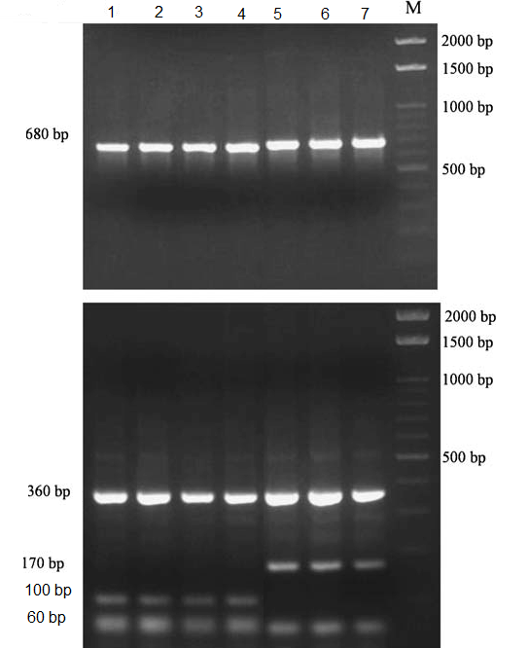

Fig. (1): PCR amplicons (upper) of spermic F. hepatica and F. gigantica and their restriction fragments (lower) produced by the PCR–RFLP method. The numbers 1 – 7 indicate Fasciola specimens that have F. hepatica type and F. gigantica type, respectively, M 100-bp DNA ladder

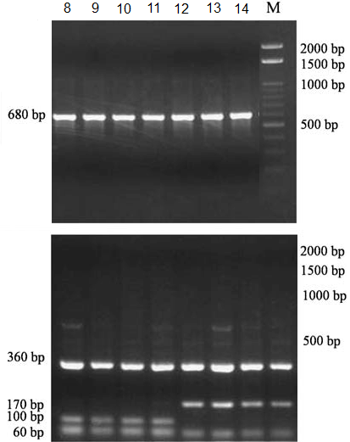

Fig. (2): PCR amplicons (upper) of aspermic Fasciola sp. And their restriction fragments (lower) produced by the PCR–RFLP method. The numbers 8 – 14 indicate Fasciola specimens that have F. hepatica type, F. gigantica type, and Fh/Fg type, respectively, M 100-bp DNA ladder.

References
- Adlard RD, Barker SC, Blair D and Cribb TH (1993): Comparison of the second internal transcribed spacer (ribosomal DNA) from populations and species of Fasciolidae (Digenea). Int J Parasitol, 23: 423–425.
- Agatsuma T, Arakawa Y, Iwagami M, Honzako Y, Cahyaningsih U, Kang S-Y and Hong S-J (2000): Molecular evidence of natural hybridization between F. hepatica and F. gigantica. Parasitol Int, 49: 231–238.
- Allam AF, el-Agamy el-SI and Helmy MH (2008): Molecular and immunological characterization of Fasciola species. Br J Biomed Sci, 59 (4): 191–195.
- Amor N, Farjallah S, Salem M, Lamine DM, Merella P, Said K and Ben Slimane B (2011): Molecular characterization of Fasciola gigantica from Mauritania based on mitochondrial and nuclear ribosomal DNA sequences. Exp Parasitol, 129 (2): 127–136.
- Ashrafi K, Valero MA, Panova M, Periago MV, Massoud J and Mas-Coma S (2006): Phenotypic analysis of adults of Fasciola hepatica, Fasciola gigantica and intermediate forms from the endemic region of Gilan, Iran. Parasitol Int, 55: 249–260.
- Chu JK and Kim YK (1967): Taxonomical study the Fasciolidae in Korea. Kor J Parasitol, 5: 139–146.
- El-Gozami BR and Shoukry MN (2010): Identification of Egyptian Fasciola species by PCR and restriction endonucleases digestion of the nuclear small subunit ribosomal RNA gene. J Egypt Soc Parasitol, 39 (2): 429–438.
- Itagaki H and Akane S (1959): Morphological study on the Japanese liver fluke, compared with the African specimens. Bull Azabu Vet Coll, 6: 115–123.
- Itagaki T and Tsutsumi K (1998): Triploid form of Fasciola in Japan: genetic relationships between Fasciola hepatica and Fasciola gigantica determined by ITS-2 sequence of nuclear rDNA. Int J Parasitol, 28: 777–781.
- Itagaki T, Kikawa M, Sakaguchi K, Shimo J, Terasaki K, Shibahara T and Fukuda K (2005a): Genetic characterization of parthenogenic Fasciola sp. in Japan on the basis of the sequences of ribosomal and mitochondrial DNA. Parasitol, 131: 679–685.
- Itagaki T, Kikawa M, Terasaki K, Shibahara T and Fukuda K (2005b): Molecular characterization of parthenogenic Fasciola sp. in Korea on the basis of DNA sequences of ribosomal ITS1 and mitochondrial NDI gene. J Vet Med Sci, 67: 1115–1118.
- Itagaki T, Sakaguchi K, Terasaki K, Sasaki O, Yoshihara S and Van Dung T (2009): Occurrence of spermic diploid and aspermic triploid forms of Fasciola in Vietnam and their molecular characterization based on nuclear and mitochondrial DNA. Parasitol Int, 58: 81–85.
- Kimura S, Shimizu A and Kawano J (1984): Morphological observation on liver fluke detected from naturally infected carabaos in the Philippines. Sci Rept Fac Agr Kobe Univ, 16: 353–357.
- Marcilla A, Bargues MD and Mas-Coma S (2002): A PCR–RFLP assay for the distinction between Fasciola hepatica and Fasciola gigantica. Mol Cell Probes, 16: 327–333.
- McGarry JW, Ortiz PL, Hodgkinson JE, Goreish I and Williams DJL (2007): PCR-based differentiation of Fasciola species (Trematoda: Fasciolidae), using primers based on RAPD-derived sequences. Ann Trop Med Parasitol, 101: 415–521.
- Moriyama N, Tsuji M and Seto T (1979): Three karyotypes and their phenotypes of Japanese liver flukes (Fasciola sp.). J Parasitol, 28: 23–33.
- Oshima T, Akahane H and Shimazu T (1968): Patterns of the variation of the common liver fluke (Fasciola sp.) in Japan. I. Variations in the sizes and shapes of the worms and eggs. Jpn. J Parasitol, 17: 97–105.
- Peng M, Ichinomiya M, Ohtori M, Ichikawa M, Shibahara T and Itagaki T (2009): Molecular characterization of Fasciola hepatica, Fasciola gigantica, and aspermic Fasciola sp. in China based on nuclear and mitochondrial DNA. Parasitol Res, 105: 809–815.
- Reddy PV and Subramanyam S (1973): Chromosome studies in the liver fluke, Fasciola gigantica Cobbold, 1856, from Andra Pradesh. Curr Sci, 42: 288–291.
- Sakaguchi Y (1980): Karyotype and gametogenesis of the common liver fluke, Fasciola sp., in Japan. Jpn J Parasitol, 29: 507–513.
- Sanderson AR (1953): Maturation and probable cytogenesis in the liver fluke, Fasciola hepatica L. Nature, 172: 110–112.
- Terasaki K, Moriyama-Gonda N and Noda Y (1998): Abnormal spermatogenesis in the common liver fluke (Fasciola sp.) from Japan and Korea. J Vet Med Sci, 60: 1305–1309.
- Torgerson P and Claxton J (1999): Epidemiology and control. In: Dalton JP (ed) Fasciolosis. CABI Publishing, UK, pp 113–149.
- Varma AK (1953): On Fasciola indica n. sp. with some observations on F. hepatica and F. gigantica. J Helminthol, 27: 185–198.
- Watanabe S and Iwata S (1954): Fasciola species in Japan. J Japan Vet Med Assoc, 7: 124–126.

3/28/2012

