**Blood- Significant Clue in Detection of Crime**

1Ajay Kumar, 2SS Chandna, 3Tanu Bamrah and 4Anita Kadian

1Forensic Science Laboratory (Diatomology division), Madhuban, Karnal-132001, Haryana (India)

2,3Forensic Science Laboratory (Serology division), Madhuban, Karnal-132001, Haryana

4Forensic Science Laboratory (Biology division), Madhuban, Karnal-132001, Haryana (India)

1*e-mail-* [**ajayindorakuk@yahoo.com**](mailto:ajayindorakuk@yahoo.com)

**Abstract:** Study has been conducted in serology division of forensic science laboratory, Madhuban, Karnal (29° 40′ 48″ N, 76° 58′ 48″ E), Haryana (27° 39′ and 30° 55′ N latitude, 74° 27′ and 77° 36′ E longitude), India. Two murder cases, one in district Ambala and second in district Jhajjar of Haryana (India) were examined. During the crime scene, blood spotting samples with various exhibits were collected by police and examined in the forensic science laboratory, Madhuban, Karnal (Haryana). Tests were duly applied on the exhibits received in the laboratory were further subjected to recent serological techniques including precipitation reaction for origin of blood and for grouping absorption elution techniques followed by (Ouchterlony immune diffusion technique). In case-I, blood present on all the exhibits were found to be in Human origin (AB blood group) of all three dead body as well as collected exhibits and grouping results obtained from exhibits (4a, lady’s shirt; 4b, salwar; 5a, baby’s t-shirt; 5b, baby’s pyjami; 6a, baby’s shirt; 7, (knife, 8, rope; 9b, banian; and 9c, t-shirt) collected from the crime scene were observed. Similarly, in case-II, blood present on the all exhibits was found to be in human origin (A blood group) of dead body as well as collected exhibits from the crime scene and grouping results obtained from exhibits (second number exhibit i.e., pipe; fifth number exhibit i.e., lathi; sixth number exhibit i.e., kulhari; seventh number exhibits i.e., inner jacket, kurta; ninth number exhibits i.e., lower; tenth number exhibits i.e., kurta. Inconclusive results observed from the rest of exhibits of studied case-I and studied case-II.

**[**Ajay Kumar, SS Chandna, Tanu Bamrah andAnita Kadian. **Blood-Significant Clue in Detection of Crime.** New York Science Journal 2012;5(5):10-15]. (ISSN: 1554-0200). [http://www.sciencepub.net/newyork. 2](http://www.sciencepub.net/newyork.%202)

**Keywords:** Blood, Exhibits, Crime scene, Serology, Blood group, Haryana.

**1. Introduction:**

Blood is a specialized connective tissue in the form [body fluid](http://en.wikipedia.org/wiki/Body_fluid) in [animals](http://en.wikipedia.org/wiki/Animal) that supplements necessary substances such as nutrients and [oxygen](http://en.wikipedia.org/wiki/Oxygen) to the [cells](http://en.wikipedia.org/wiki/Cell_%28biology%29) and transports [metabolic waste](http://en.wikipedia.org/wiki/Metabolic_waste) products away from those same cells. In [vertebrates](http://en.wikipedia.org/wiki/Vertebrate), it is composed of [blood cells](http://en.wikipedia.org/wiki/Blood_cells) suspended in a [liquid](http://en.wikipedia.org/wiki/Liquid) called [blood plasma](http://en.wikipedia.org/wiki/Blood_plasma). Plasma, which constitutes 55% of blood fluid, is mostly water (92% by volume), and contains dissipated proteins, [glucose](http://en.wikipedia.org/wiki/Glucose), mineral ions, [hormones](http://en.wikipedia.org/wiki/Hormone), [carbon dioxide](http://en.wikipedia.org/wiki/Carbon_dioxide) (plasma being the main medium for excretory product transportation), [platelets](http://en.wikipedia.org/wiki/Platelets) and blood cells themselves. [Albumin](http://en.wikipedia.org/wiki/Albumin) is the main protein in plasma, and it functions to regulate the colloidal [osmotic pressure](http://en.wikipedia.org/wiki/Osmotic_pressure) of blood. The blood cells are mainly [red blood cells](http://en.wikipedia.org/wiki/Red_blood_cell) (also called RBCs or Erythrocytes) and [white blood cells](http://en.wikipedia.org/wiki/White_blood_cell) (Leukocytes) and [platelets](http://en.wikipedia.org/wiki/Platelet). The most abundant cells in vertebrate blood are red blood cells. These contain [hemoglobin](http://en.wikipedia.org/wiki/Hemoglobin), an [iron](http://en.wikipedia.org/wiki/Iron)-containing protein, which facilitates transportation of [oxygen](http://en.wikipedia.org/wiki/Oxygen) by reversibly binding to this [respiratory](http://en.wikipedia.org/wiki/Breath) gas and immensely increasing its solubility thrust in blood. In contrast, carbon dioxide is almost entirely transported extra cellular dissolved in plasma as [bicarbonate](http://en.wikipedia.org/wiki/Bicarbonate) ion (Robert et al., 2006).

Blood (a liquid connective tissue) is the most significant clue in establishing heinous crimes of ghastly nature (Bourke, 1981). Blood, while flowing through the closed blood vessels does not clot due to a pigment “heparin” released by the liver of a particular victim but after stabbing/assassination/shooting/accident etc. of the victim the blood quickly oozes and flows from the wounds in downward direction due to gravitational pull (George, 2007). Blood may fall on street, pucca road, field, open ground, pucca floor in a house or shop on the slopes of water channels near wells or on vegetation. Even fountain of blood can be seen ejected upwards even on ceilings of the room, wall and fissures of floors or up to gutters of water. Pressure exerted on the veins or arteries lead to widely different pictures of blood splashing in or around the crime scene. Blood may fall on the earth or objects of vivid nature (Pharma, 2012). Blood may be washed away by torrential rain, shower, floods, hail stones etc. and can be blown or displaced along with the fine exhibits to which the blood was found to be sticking closely by wind/tornadoes. Blood can also be consumed by specific carnivorous birds/rodents and other wild creatures/flesh eaters (Carnivores) and also omnivores, who feed on detritus. Process of egg laying upon blood by humming bees especially bluebottle flies and other lepidopetrans is not an exception.

Several inhibiting enzymes, lysins and saliva which come in contact with oozed blood at the crime scene did not show conclusive result pertaining to analysis of blood. Blood prevalent on the exhibits may become toxic and pose a serious threat to the health of the forensic scientists who remove cuttings of exhibits or their remnants and trigger process of blood analysis. Putrefied blood may be found even contaminated with mycorrhizae and spores of fungi, different type of soil particles (sand, silt, clay), wood and leather etc. Though concrete enzymological findings can be seen in vivo or in vitro but different trends of patterns and forms of blood due to categorically involvement of enzyme reactions cannot be established as specific tests cannot be duly applied at place of occurrence due to lack of infrastructure owing to heavy expanses being incurred on testing.

Due to scanty information available on forensic science related to blood significance in Haryana, particular. So, the present study was planned on blood as a significant vital clue in detection of crime from the samples received at the crime scene and further analysis in Forensic Science Laboratory, Madhuban, Karnal (Haryana, India).

**2. Material and Methods:**

**Study area:**

The present study was planned in forensic science laboratory, Madhuban, Karnal (29° 40′ 48″ N, 76° 58′ 48″ E), Haryana (27° 39′ and 30° 55′ N latitude, 74° 27′ and 77° 36′ E longitude), India (fig. 1). Developed nascent state at Rohtak in Haryana (in the year 1973), this laboratory later shifted to Madhuban (Karnal) in 1976. The forensic science laboratory, Karnal (Haryana) has been making consistent strides in the field of scientific activities. Now a day, it is one    of   the best known laboratories in India. It comprises of eight divisions namely, Chemistry, Physics, Biology, Serology, Ballistics, Documents, Instrumentation and Lie-Detection    and three sections namely, Photo, General and information. The Scientists of the Laboratory have been assisting the training institutes like National Institute of Criminology and Forensic Science, Delhi, Central Detective Training School, Chandigarh, C.I.D. Training School, Panchkula and P.T.C. Madhuban.

During the crime scene visit, spotting blood samples on various exhibits were collected by police and carried in the forensic science laboratory, Madhuban, Karnal (Haryana). Tests were applied on the exhibits received in the laboratory. Tests which were found to be positive for blood were further subjected to recent serological techniques including Precipitation reaction for origin of blood. For grouping Absorption Elution techniques were adopted which were further conformed through ouchterlony immune diffusion techniques. The results were tistically analyzed.

**Case history-I**

Corpses of a lady with her two children were found lying in godown under mysterious circumstances, nearby Ambala, Haryana (India). It was in suspected that the lady was eloping with another person and her is spouse could not tolerate her character assassination. Therefore, her husband devised a trick kill them including embryo in the uterus of lady’s womb. So that he may get rid of illegitimate offspring due to illiciate relation of his wife.

Different kinds of parcels (three in numbers, exhibits of blood stained earth i.e., soil from crime scene; fourth number lady exhibits i.e., lady’s shirt, salwar, chunni/dupatta, underwear, brassier, sandals; fifth number exhibit first baby’s exhibit i.e., t-shirt and pyjami; sixth number exhibit of second baby’s exhibit i.e., shirt and pant; seventh number exhibit knife was found on crime scene; eights number exhibit rope was found on crime scene; ninth number exhibits i.e., jean’s pants, banian and t-shirt) was found near crime scene and on the body of victim were sent in serology division of forensic science laboratory, Madhuban, Karnal, Haryana for detection of crime. Thus, wearing apparels of the victims, lady and her kids and exhibits recovered from the crime scene were duly analysed.

**Case history-II**

A dead body of a adult male was also found under mysterious circumstances in a village of district Jhajjaar, Haryana. According to police history, the prime cause which led to murder was a family dispute for property.

Similarly, different parcels (first number exhibit i.e., brick; second number exhibit i.e., pipe; third number exhibit i.e., cap; fourth number exhibit i.e., brick; fifth number exhibit i.e., lathi; sixth number exhibit i.e., kulhari; seventh number exhibits i.e., inner jacket, jersey, dhoti, kurta, cut piece of dhoti; eighth number exhibit i.e., blood; ninth number exhibits i.e., shirt and lower; tenth number exhibits i.e., kurta and pyjama) were sent in serology division of Forensic Science laboratory, Madhuban, Karnal, Haryana for detection of crime.

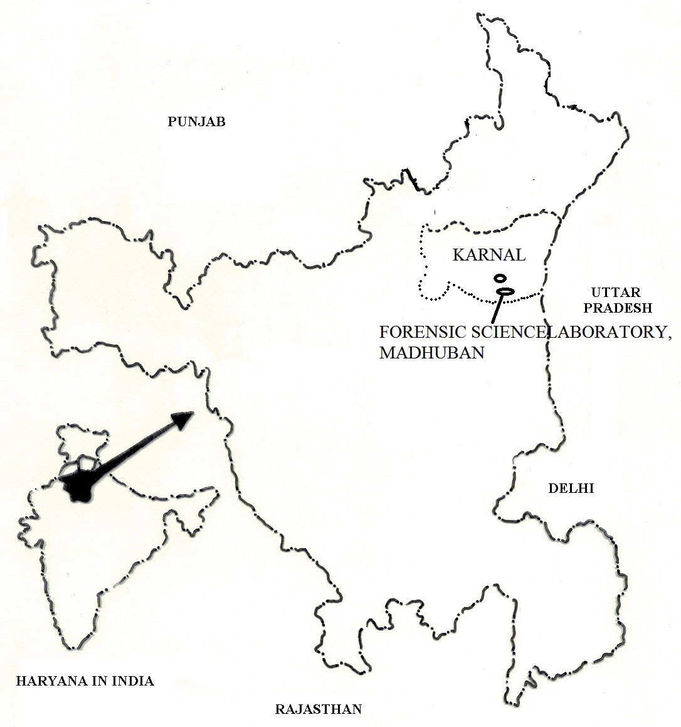

**Fig. 1 Forensic science laboratory, Madhuban, Karnal (Haryana).**

**3. Result and Discussion:**

Forensic serology may be defined as a discipline for determination of the type and characteristics of blood, blood testing, bloodstain examination, and preparation of testimony or presentations of trials are the main job functions of a forensic serologist, who also analyzes semen, saliva, other body i.e. deposing truthful evidence in Hon’ble court fluids and may or may not be involved with DNA typing (Mifflin, 2009). Serological analysis can serve two main purposes in a criminal case. First, and its primary use, is to identify a stain for the presence of bodily fluids. Second, is the use of genetic markers in the fluids to corroborate the evidence sample with a particular group of people. This later purpose is much less frequently used in modern criminal investigations because the discriminatory power of DNA testing is much greater than that of serological analysis (Kim et al., 2001). Presumptive tests, (chemical test, luminol test , confirmatory test etc.) are extremely sensitive, thus requiring very little sample to make a presumptive blood determination. The tests are useful as a searching device, to locate spots and stains that might not be obvious to the naked eye (Peter et al., 1983). Serology allows the forensic scientists to segregate these bodily fluids when found at the scene of the crime and then perform a variety of tests on them in order to identify where these fluids have originated from - or most importantly from whom these came from. One important aspect of Serology is ascertained for determining whether or not stains resembling blood found at a crime scene are actually blood or some other stain that bears a similar resemblance (Lemarini et al., 2002).

Blood evidence is of high value in such crimes especially murder, rape, assault, robbery, burglary, hit-and-run accidents, and game law violations. Blood evidence may aid in investigation by locating the crime scene, by identifying the weapon used, by proving or disproving a suspect's alibi, and by eliminating suspects. DNA profiling can be performed on any biological substance. It can also be used for the identification of bodies when samples from parents and/or children of the missing person are available (Fullah et al., 2011). The death of Marilyn Sheppard in 1954 remains one of the most infamous unsolved murders in the USA. The subsequent arrest of her husband, based on the serological evidences i.e., origin of blood as well as grouping of detected blood on the exhibits (Washington, 1996). Mazloumi (2007)

Blood spotting related various parcel of case-I and case-II were sent in serology division of forensic science laboratory, Madhuban, Karnal, Haryana for detection of crime. In case-I, the results revealed from these parcel, that after applying chemical test, blood was detected on all the exhibits enclosed in various parcels. Blood present on the all exhibits was found to be human origin in -AB blood group- of all three dead bodies as well as collected exhibits from the crime scene was found. Grouping results obtained from exhibits 4a (lady’s shirt), 4b (salwar), 5a (baby’s t-shirt), 5b (baby’s pyjami), 6a (baby’s shirt), 7 (knife), 8 (rope), 9b (banian) and 9c (t-shirt) while inconclusive results obtained from exhibits three numbers exhibits of blood stained earth i.e., soil from crime scene; fourth number exhibit lady exhibits i.e., chunni/dupatta, underwear, brassier, sandal; sixth number exhibit of second baby exhibit i.e., baby’s pant; ninth number exhibits i.e., jeans pants etc. The whole results have been duly explained in table 1.

Similarly, in case-II, results revealed from these parcels that after applying chemical tests blood was detected on all the exhibits (expect 1- brick and 8- blood, due to material disintegrated) enclosed in various parcels. Blood present on the all exhibits was found to be in human origin -A blood group- of dead body as well as collected exhibits from the crime scene was found. Grouping results obtained from exhibits second number exhibit i.e., pipe; fifth number exhibit i.e., lathi; sixth number exhibit i.e., kulhari; seventh number exhibits i.e., inner jacket, dhoti, kurta; ninth number exhibits i.e., lower; tenth number exhibits i.e., kurta while inconclusive results obtained from exhibits third number exhibit i.e., cap; fourth number exhibit i.e., brick; seventh number exhibits i.e., dhoti and cut piece of dhoti; ninth number exhibits i.e., shirt; tenth number exhibits i.e., pyjama etc. The whole results explained in table 2.

It has been critically observed that collection of blood stained soil has not been found to be very much useful but soaking blood in cotton wool swab /cotton thread and cotton gauze pieces could have furnished better results during serological analysis of these blood stained exhibits, if these samples were found to be air dried before packing. Result for blood testing has also been found to be positive in these cases as omnipotent haemopoetic tissue is the resultant factor for giving better output of blood testing. Even during parturition of cattle and other animals, various biological fluids including blood spread on the layer of the soil which may further intrigue with the confirmatory test later on in the processes involved while analyzing blood in the laboratory (Chandna et al., 2012).

In our present study, the major cause for obtainning inconclusive results has been direct out put of packing these exhibits in the polythene envelops and moreover, waering appreals and other vital clves were not satisfactory air dried at room temperture which further led to their disintegration. High embient tempertaure let to denaturation protens involved in analysis of blood.

**Table 1. Results of serological analysis of blood of case-I.**

|  |  |  |  |  |
| --- | --- | --- | --- | --- |
| **S.N.** | **Name of exhibits** | **Chemical test for blood** | **Origin of blood** | **Grouping** |
| 1 | Blood stained earth | Positive | Human | Inconclusive |
| 2 | Blood stained earth | Positive | Human | Inconclusive |
| 3 | Blood stained earth | Positive | Human | Inconclusive |
| 4a | Lady’s shirt | Positive | Human | ῝AB῞ |
| 4b | Salwar | Positive | Human | ῝AB῞ |
| 4c | Chunni/duptta | Positive | Human | Inconclusive |
| 4d | Underwear | Positive | Human | Inconclusive |
| 4e | Brassier | Positive | Human | Inconclusive |
| 4f | Sandal | Positive | Human | Inconclusive |
| 5a | Baby’s T-shirt | Positive | Human | ῝AB῞ |
| 5b | Baby’s Pyjami | Positive | Human | ῝AB῞ |
| 6a | Baby’s shirt | Positive | Human | ῝AB῞ |
| 6b | Baby’s pants | Positive | Human | Inconclusive |
| 7 | Knife | Positive | Human | ῝AB῞ |
| 8 | Rope | Positive | Human | ῝AB῞ |
| 9a | Jeans pants | Positive | Human | Inconclusive |
| 9b | Banian | Positive | Human | ῝AB῞ |
| 9c | T-shirt | Positive | Human | ῝AB῞ |

**Table 2. Results of serological analysis of blood of case-II.**

|  |  |  |  |  |
| --- | --- | --- | --- | --- |
| **S.N.** | **Name of exhibits** | **Chemical test for blood** | **Origin of blood** | **Grouping** |
| 1 | Brick | Negative | M.D. | Inconclusive |
| 2 | Pipe | Positive | Human | ῝A῞ |
| 3 | Cap | Positive | Human | Inconclusive |
| 4 | Brick | Positive | Human | Inconclusive |
| 5 | Lathi | Positive | Human | ῝A῞ |
| 6 | Kulhari | Positive | Human | ῝A῞ |
| 7a | Inner Jacket | Positive | Human | ῝A῞ |
| 7b | Jursey | Positive | Human | Inconclusive |
| 7c | Dhoti | Positive | Human | ῝A῞ |
| 7d | Kurta | Positive | Human | ῝A῞ |
| 7e | Cut piece of dhoti | Positive | Human | Inconclusive |
| 8 | Blood | Positive | M.D. | ῝A῞ |
| 9a | Shirt | Positive | Human | Inconclusive |
| 9b | Lower | Positive | Human | ῝A῞ |
| 10a | Kurta | Positive | Human | ῝A῞ |
| 10b | Pyjama | Positive | Human | Inconclusive |

M.D. - Material disintegrated

**4. Conclusion:**

In the present study, a proper correlation and quardination has been properly stream lined for purpose of investigation as well as prosecution- which further establish connectively links between victims, crime scene and weapons of offense deployed by the accused.

**5. Acknowledgement:**

The authors are highly thankful and indebted to Sh. R.S. Dalal (I.P.S., Director General of Police, Haryana, India) for creating facilities and excellent output in academic field for Research fellows who have been engaged in research work from Universities of India at Forensic Science Laboratory, Madhuban (Haryana).

**6 Correspondence authors:**

3Tanu Bamrah (Scientific Assistant)

Serology Division,

Forensic Science Laboratory, Madhuban

Karnal-132001, Haryana (India)

Mobile no. +91-8685930067

e-mail: [tanu.bamrah@gmail](mailto:tanu.bamrah@gmail)

**References:**

1. Kirk, PL. Crime Investigation-Blood individual factors Hemoglobin. Thornton, Johnl., 1974. p. 205.

2. Devenport, H.E. Biochemist’s Handbook Haematin Compounds in Plants. Cyril long. 1971. p. 1033.

3. Bourke, L. Scatologic rites of all natios. Washington, D.C.: W.H. Lowdermilk. 1981.

4. George, S. Collection and preservation of blood evidence from crime scene. 2007. p.1-7.

5. Pharma, B. Blood clot, blood clot in leg symptom. Human anatomy (5th edition). 2012. p. 220-222.

6. Robert B., Tallitsch L., Martini T., Frederic L., Timmons Y., Michael J. *Human anatomy* (5th ed.). San Francisco: Pearson/Benjamin Cummings. 2006. p. 529.

7. Mifflin, H. The American Heritage® Dictionary of the English Language, Fourth Edition copyright ©2000 by Houghton Mifflin Company. 2009.

8. Washington, J.A. [Principles of Diagnosis: Serodiagnosis. in: Baron's Medical Microbiology,](http://www.ncbi.nlm.nih.gov/books/bv.fcgi?rid=mmed.section.5462) (4th ed.). Univ of Texas Medical Branch. 1996.

9. Peter, R. De Forest, et al., *Forensic Science: An Introduction to Criminalistics*, Chapters 9 (Blood) and 10 (Bodily Fluids), McGraw Hill, New York. 1983.

10. Kim A., Collins, L. and Allan, T. Bennett, Persistence of Spermatozoa and Prostatic Acid Phosphatase in Specimens from Deceased Individuals During Varied Postmortem Intervals, *The American Journal of Forensic Medicine and Pathology.* 2001; 22(3): p. 228-232.

11. Lemarini M, Nejjer R, Partlong F. A new Leishmania tropica zymodeme-causative agent of canine visceral leishmaniasis in northern Morocco, Ann. Trop. Med. Parasitol. 2002 (96): p. 637–638.

12. Fullah, J., Nasereddin, A., Niederwieser, I., Jaffe, C.L., Beck. H.P., Feger, I. Identification and differentiation of Leishmania species in clinical samples by PCR amplification of the miniexon sequence and subsequent restriction fragment length polymorphism analysis, J. Clin. Microbiol. 2011 (41): p. 3147-3153.

13. Mazloumi A.S., Ghazanchaei A., Karimi P, Mohit H., Davies C.R. Practical Approach for Typing Strains of Leishmania infantum by Enzyme polymorphism. A Cross Sectional Study in Northwest of Iran. Pak. J. Biol. Sci. 2007; 10(24): p. 4505-4509.

14. Chandna S.S., Chandna P., Kumar S., Soni R., Passi N. Collection and Examination of Significant Clue- Blood from the Crime Scene. *American journal of science* (proceed). 2012.

4/4/2012