16S rRNA Gene Sequence Detection of Acetic Acid Bacteria Isolated from Tea Kombucha

Soheir S. Abd El-Salam

Botany Dept.Fac. Sci. Benha Univ. Egypt.
aia_hassan20@yahoo.com

Abstract: Kombusha is benefit to people suffering from cancer due to increasing its acidity by the bacterium. This study to isolate and identify the bacterium samples from tea kombusha. Six acetic acid bacteria were isolated from traditional Kombusha fermentation of tea belong to the family Acetobacteraceae, genera Gluconacetobacter and Acetobacter. Acetic acid productivity yielded isolate No.1 that produced higher amount of acid. The isolate was catalase - Positive, oxidase – negative, strictly aerobic, Gram-negative rods, grow on yeast extract with 30% glucose and grow on glycerol variable on maltose but not methanol as carbon sources. The isolates oxidized ethanol of yeast kombucha to acetic acid therefore they were tentatively identified as Acetobacter species. The hight producer of acetic acid (11.2) was selected for identification by 16S rRNA gene sequences and phylogenetic analysis confirmed their position in the genes Acetobacter. On GYC agar, colonies are beige, round, convex, smooth and shiny and approximately 0.8mm in diameter after incubation at 28˚C for 4 days. The PCR product with size of about 1500 bp DNA was amplified. Based on the genotypic and phenotypic data, the isolate represent species of genus Acetobacter for which the name A.aceti is proposed.
[Soheir S. Abd El-Salam. 16S rRNA Gene Sequence Detection of Acetic Acid Bacteria Isolated from Tea Kombucha. New York Science Journal 2012;5(3):55-61]. (ISSN: 1554-0200). http://www.sciencepub.net/newyork.6

Keywords: Acetic acid bacteria Kombusha; Acetobacter; isolation; 16S rRNA gene; PCR

1. Introduction
Kombucha is a traditional fermented tea that has gained popularity in the world as it is increasingly associated with health promoting effects. Throughout the entire body and in particular there are noticeable changes at the cellular level which provide enormous benefits to the individual. Richard (1995) and Soheir Abd El-Salam (2005) found that production from the tea. Is achieved by infusing tea leaves into freshly boiled water and sweetened with about 100g/L Sucrose. After about ten to fourteen days incubation at room temperature. The final product is acidic beverage composed of ethanol, organic acids, Vitamins, antibiotics and minerals. The Kombucha colony / mat represents a symbiotic relationship between Actobacter sp. is the primary with Saccharomyces sp. (Roussin, 1996). Throughout the fermentation, the yeasts breakdown sugar into glucose and fructose (Roussin, 1996). Glucose is used by yeasts to yield ethanol and carbon dioxide Acetobacter, in ilially oxidizes ethanol to acetaldehyde and then to acetic acid and the secondary metabolism of Acetobacter is the oxidation of glucose to different acids as gluconic acid.
This study aims to isolate and identify acetic acid bacteria from Kombusha, characterize and optimize indigenous acetic acid bacteria by 16S rRNA analysis.

2. Material and Methods
2.1. Sampling, isolation, and culture conditions
Samples of Kombusha were obtained from Microbiology Lab.Fac.Science. Benha Univ. And Kindly by Soheir Abd EL-Salam (2005) Mean values of chemical compounds of Kombucha were determined according to Green Walt (1997) and Soheir Abd EL-Salam (2005).
Kombusha was used for isolation of acetic acid bacteria in this study, 1ml fermented sample was put into inoculated in enrichment medium GY (Huong et. al., 2007) (5% D-glucose, 1% Yeast extract) and incubated at 30˚C for 48h. Then, 100 µl was plated onto GYC (5% D-glucose, 1% Yeast extract, 0.5 % CaCO₃, 2% agar w/v). Plates were incubated at 28˚C for 7 to 10 days under aerobic conditions. All the colonies or a maximum of six were isolated and purified. The isolates were then growth for 48h. in the liquid medium described above. As a first screening the isolates that produced a clear halo after acidification in GYC solid medium were selected as purified AAB and analyzed further according to De Ley et. al. (1984). To obtain cell mass for DNA extraction, the isolates were cultivated at 30˚C in 5ml of NBRC 804 broth (g/L) (Polypepton, 5g; Yeast extract, 5g; glucose 5g, MgSO₄. 7H₂O 1g, d.H₂O,1L & PH7.0).
Morphological and cultured characterishes of the isolates were examined by incubation at 30˚C for 2 days on GYC medium. Acetobacter Sp. was distinguished from each other on Carr medium in the presence of bromocresol green. Acetobacter turns the media color into yellow.

2.2. Identification of Acetobacter spp
The following tests were performed to identify the Acetobacter spp. Catalase was determined by using 3% H₂O₂ solution and acids production of medium containing each carbon sources was determined by titration method with 1g/L NaOH (Lisdiyanti et al., 2001). Nitrate reduction was tested from nitrate peptone water (per liter of d.H₂O, pH 7.0; peptone, 10g; KNo₃; 3g) (Franke, 1999). The biochemical identification tests were followed by molecular methods to validate the data obtained thereby.

2.3. DNA extraction from Acetobacter spp
The bacterial isolate was grown in GYC medium for 2-5 days at 30˚C. One ml of bacterial culture was centrifuged at 10.000 rpm for 3 min. The DNA was extracted from the pelleted cells using the Genomic DNA purification kit from promega(Madison, W1,USA) The DNA obtained was visualized and the quantity estimated by gel electrophoresis on 1.0% agarose in IX TBE buffer, separated at 100V for 30 min and then stained with ethidium bromide.

2.4. PCR amplification and analysis of PCR Products
Primers for the PCR amplification of rRNA were selected from conserved regions of sequencing 16S rRNA. The following primers were used for sequencing: Forward: 16S d,5-GCTGGCGGCATGCTTAACACA-3 and 16S r,5-GCAGGTGATCCAGCCGCA-3 according to Ruiz et al. (2000).
The reactions were performed in a total volumes of 25µl containing 10 ng of DNA template; 0.55 pmol/µl of primers ;2mµMg; 0.08 V/µl of Taq polymerase; 2.5 µl PCR buffer and 9.3 µl sterile dd. H₂O. Samples were incubated for 5 min at 94˚C, and then cycled 35 times at 94˚C for 1 min, 58˚C for 1 min and 72˚C for 2 min. The samples were kept at 4˚C until test as described by Ruiz et. al. (2000). PCR amplification products were analysed by gel electrophoresis on an 1.0% agarose in 1X TBE buffer, separated at 100 V for 30 min and then stained with ethidium bromide. The PCR fragment (1.500 bp for 16S rRNA) were purified using a PCR purification kit as per the manufactures̉ s instructions and then sequencer with an Applied Biosystems 310 automatic sequencer (Foster City, CA,USA).
The sequence of bacterial isolate was aligned with reference sequences, in GenBank (DQ123812; DQ 128320; DQ117918 and DQ 117924) Using Sequence match software from Ribosomal Data base Project II website RDPII; http: Irdp.cme.msu.edu/ html/) (Cole et al., 2005).

3. Results
The six isolated Acetbacter produced acid from D.glucose and ethanol were isolated based on physiological characters (Table 1). The isolates showed clear zones on basal agar plates containing CaCO₃. These isolates were distinguished from each other on Carr medium containing bromocresol green. Therefore, they were regarded as Acetobacter spp and used for further study. They were all gram negative, circular or irregular – colonies shaped, aerobes, with non-pigmented colonies and non diffusible pigments in experimental medium.
The isolates were tested for acetic acid production in the basal medium which were then regarded as Acetobacter. The isolates producing acetic acid were selected (Fig. 1) for further processing until one isolate which produced the highest amount of acetic acid was selected. The Acetobacter isolate from tea Kombusha showed the highest acid productively of 11.2 (Table 1 & Fig. 1). The isolate was negative for oxidase and positive catalase.
The preliminary identification from chemical analysis (Table 2) brought about the possibility of having one of the six Acetobacteria. The representative isolate is able to utilize glucose, ethanol, and glycerol but variable to utilize maltose and not methanol as sole carbon source (Table 2).
Hence molecular technique was employed for more successfully amplified by PCR (fig.2). Total DNA is found crucial for PCR. The DNA yield was determined spectrophotometrically as 5.4 Mg/ 1.0 g cells.
The DNA purity as indicated by 260/280 was 1.5 and confirmed by agarose gel electrophoreses (Fig. 2-A).

PCR amplification of 16S rRNA gene
Genomic DNAs were isolated from Acetobacter aceti using a Lysozyme dodecyl sulfate Lysis procedure with high quality and substantially free RNA contamination. The DNA was then used as a template for PCR to amplify the 16S rRNA gene via the OIAGEN PCR system by used of an oligo (dt) 16S rRNA primer sets. Nearly full length 16S rRNA gene could be synthesized. The amplified 16S rRNA gene was used as a template using the internal primer combination (16S d and 16S r) in PCR for conformation its specificity to A.aceti 16S rRNA gene as a PCR product with a size of about 1500 bp DNA was amplified (Fig. 2-B).

Table 1. The percentage of acetic acid(g/L) producing by the Acetobacter isolates at different incubation periods.
Incubation  Period  Isolates | Incubation period (days)
Incubation  Period  Isolates | 1 | 3 | 5 | 7 | 9 | 11 | 13 | 15
Isolate,6 | 2.7 | 4.2 | 4.5 | 5.3 | 7.1 | 8.5 | 8.2 | 9.7
Isolate,5 | 2.2 | 2.5 | 2.9 | 3.7 | 4.5 | 6.5 | 8.5 | 9.5
Isolate,4 | 2.5 | 3.4 | 4.2 | 5.2 | 6.0 | 7.5 | 8.2 | 9.2
Isolate,3 | 2.4 | 3.8 | 4.9 | 5.8 | 6.4 | 7.5 | 8.7 | 10.2
Isolate,2 | 2.6 | 4.3 | 5.4 | 6.5 | 8.5 | 9.2 | 9.7 | 10.5
Isolate,1 | 2.8 | 5.7 | 6.3 | 7.5 | 9.3 | 10.0 | 10.5 | 11.2

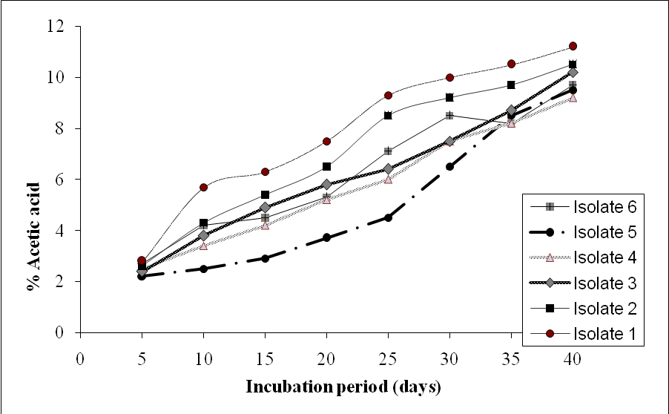

Figure 1.Curve showing the percentage of acetic acid production(mg/400ml) in basal medium by acetobacter isolates

Table 2. Morphological and biochemical characteristics of Acetobacter isolates from tea Kombousha.

Acetobacter  Isolates  Characters | AAB₁ | AAB₂ | AAB₃ | AAB₄ | AAB₅ | AAB₆
Shape | rod | rod | rod | rod | rod | Rod
Gram stain | G-ve | G-ve | G-ve | G-ve | G-ve | G-ve
**Carr medium color | Yellow then green | Yellow | Yellow | Yellow grish | Pale yellow | Pale yellow
Oxidase | - | - | + | - | + | -
Catalase | + | + | + | + | + | +
Carbon source:-
Glucose | + | + | + | + | - | -
Maltose | - | + | + | - | + | +
Glycerol | + | + | + | + | + | +
Nitrate reduction | - | + | + | - | - | -
Growth in thanol | + | - | + | - | + | -
Methanol | - | - | + | - | - | -

Partical nucleoide sequence of 16S Rrna gene
DNA amplified fragment was purified from agarose gel by GEX-DNA gel extraction kit. A. aceti 16S rRNA gene was sequenced and found to be composed of 1451 nucleotides (Fig. 3). A. aceti was aligned with other 16S rRNA gene sequences of six published Acetobacter strains by using DNAMAN program (DNAMAV 5.2.9 package, Madison, Wisconsin USA). A phylogenatic tree of A.aceti isolate presented in (Fig. 4) reveled that the nucleotide sequence has 96% resemblance with other five Aceteobacter 16S rRNA gene sequence strains published in Genbank dccessions, A. aceti (NR_026121); A. cerevisiae (NR_025512); A. malorum (FJ831444); A. pasteurianus (AB 680032); A.indonesiensis (AJ419841) and A. tropicalis (A) 419842). A. aceti isolate reveled that 98% resemblance in nucleotide sequence of A. aceti (NR_026121) strain published in GenBank.

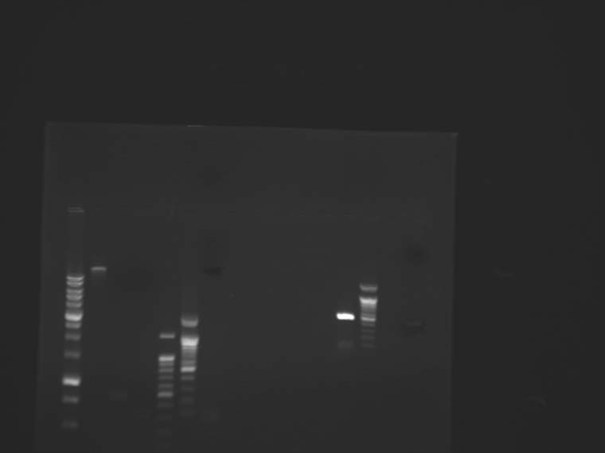
(A)
(B)
1500 bp
A M
M A

Figure 2. Agarose gel(7.5) electrophoresis stained with ethidium bromide. (A) Mini preparation total DNA extracted from cells of Acetobacter aceti. (B) Production of PCR amplification of DNA mini preparation M-DNA leader one kbp; line DNA amplified from A.aceti with expected size 1500 bp.

1 GCTGGCGGCA TGCTTAACAC ATGCAAGTCG CACGAAGGCT TCGGCCTTAG TGGCGGACGG
61 GTGAGTAACG CGTAGGAATC TATCCATGGG TGGGGGATAA CTCCGGGAAA CTGGAGCTAA
121 TACCGCATGA TACCTGAGGG TCAAAGGCGC AAGTCGCCTG TGGAGGAGTC TGCGTTTGAT
181 TAGCTTGTTG GTGGGGTAAA GGCCTACCAA GGCGATGATC AATAGCTGGT CTGAGAGGAT
241 GATCAGCCAC ACTGGGACTG AGACACGGCC CAGACTCCTA CGGGAGGCAG CAGTGGGGAA
301 TATTGGACAA TGGGGGCAAC CCTGATCCAG CAATGCCGCG TGTGTGAAGA AGGTTTTCGG
361 ATTGTAAAGC ACTTTCGGCG GGGACGATGA TGACCCTACC CGCAGAAGAA GCCCCGGCTA
421 ACTTCGTGCC AGCAGCCGCG GTAATACGAA GGGGGCTAGC GTTGCTCGGA ATGACTGGGC
481 GTAAACCGCG TGTAGGCGGT TTGTACAGTC AGATGTGAAA TCCCCGGGCT TAACCTGGGA
541 GCTGCATTTG ATACGTGCAG ACTAGAGTAT GAGAGAGGGT TGTGGAATTC TCAGTGTAGA
601 GGTGTTATTC GTAGATATTG GGAAGAACAC CGGTGGCCAA GGCGGCAACC TGGCTCATTA
661 CTGACGCTGA GGCGCGAAAG CGTCCGGAGC AAACAGGATT AGATACCCTG GTAGTCCACG
721 CTGTAAACGA TGTGTGCTGG ATGTTGGGTA ACTTAGTTAC TCAGTGTCGT AGCTAACGCG
781 ATATGCACAC CGCCTGGGGA GTACGGCCGC AAGGTTGTTT CTCAAAGGAA TTGACGGGGG
841 CGGGCACAAG CGGTGGAGCA TGTGGTTTAA TTCGAAGCAA CGCGCAGAAC CTTACCAGGG
901 CTTGTATGGA GAGGCTGTAT TCAGAGATGG ATATTTCCCG CAAGGGACCT CTTGCACAGG
961 TGCTGCATGG CTGTCGTCAG CTCGTGTCGT GAGATGTTGG GTTAAGTCCC GCAACGAGCG
1021 CAACCCTTAT CTTTAGTTGC CAGCATGTTT GGGTGGGCAC TCTAAAGAGA CTGCCGGTGA
1081 CAAGGGGGAG GAAGGTCCGG ATGACGTCAA GTCCTCATGG CGGTTATGTC CTGGGCTACA
1141 CACGTGCTAC TTTGGCGGTG ACAGTGGGAA GCTAGATGGC GACATCGTGC CGATCTCTAA
1201 AAACCGTCTC AGTTCGGATT GCACTCTGCA ACTCGAGTGC ATGAAGGTCC AATCGCTAGT
1261 AATCGCGGAT CAGCATGCCG CGGTGTTTAC GTTCCCGGGC CTTGTACACA CCGCCCGTCA
1321 CACCATCCGA GTTGGTTTGA CCTTAAGCCG GTGAGCGAAC CGCAAGGACG CAGCCGACCA
1381 CGGTCGGGTC AGCGACTGGG GTGAAGTCGT AACAAGGTAG CCGTAGGGGA ACCTGCGGCT
1441 GGATCACCTC C
Figure 3. Nucleotide sequences encoding the 16S rRNA gene of A.aceti isolate.

Figure 4. Phylogenetic tree constructed from the multiple alignments of the 16S rRNA A. aceti isolate and others Acetobacter strains(NR_026121; NR_025512; FJ 831444; AB 680032; AJ 419841 and AJ 419842.

4. Discussion
The Kombousha colonies used in this study to produce organic acids to increase the total acidity. The amount of acetic acid in this study is 11.2 (g/L).Such findings are in coincidence with the work of Green wolf (1997). In this case, Kombusha fermented tea has 33 g/L total acid (7g/L acetic acid) after nine days of incubation. The acetic acid and gluconic acids produced during the fermentation of tea by kombucha, are similar to that obtained by Asia (1968). He said that Kombucha is symbiosis relation between yeast and bacteria, yeast breakdown sucrose into glucose and fructose, glucose used to yield ethanol while bacteria oxidizes ethanol to acetaldehyde and then to acetic acid and also, the bacteria oxidizes glucose to gluconic acid. Changes in the population or in the physiology of strains, as a result of the lack of alcoholic substrate are reasons for overoxidation (Sokollek et al., 1998). The number of strains able to grow decreases with increase of glucose due to a strong effect of bacterial growth on glucose concentration. In the present study, the isolated bacteria were able to grow at 5% sugar concentration of GYC. Production of 11.2(g/L) acetic acid at the initial stage of isolation was promising. We therefore attempted to characterize to the isolates biochemically, In addition to their ability to oxidize ethanol, Acetobacter species can further oxidize acetic acid to CO₂ and H₂O, generating the so- called acetate overoxidiation , that is carried out by the tricarboxylic acid cycle when there is a high level of dissolved oxygen and no ethanol in the medium . Acetic acid bacteria are characterized by the ability to oxidize alcohols or sugars incompletely, and common feature to most of them is the ability to oxidize ethanol to acetic acid. Acid production from ethanol, generally shown with the method described by Frateur (1950) and Sharafi et. al. (2010) as a clearing of the opacity in the medium around the bacterial growth or with the method described by Carr (1968) as a color change of the indicator bromocresol green in the medium from green to Yellow (Swings, 1992) confirm our finding in the present study that the isolate is Acetobacter. This is further validated by oxidation of acetate to CO₂ and H₂O (Swings, 1992) and ketogenosis from glycerol (Carr, 1968). The isolate grow well in the presence of 3% acetic acid. This finding is in support, of Acetobacter growth in the presence of 0.35% acetic acid (pH3.5) (Lisdiyanti, 2001). The majority of isolated strains were able to grow at 7% of ethanol and some of them at 11% of ethanol. These finding are comparable to these of Gullo et al. (2006) who reported isolation of bacteria strains with ability to grow at 5% v/v of ethanol. Phenotypic characterization methods of AAB are not reliable and very time consuming. Therefore different molecular techniques have been employed, in particular, DNA –DNA hybridizations (Cleenwerck el al. 2002; Dellaglio el al., 2005) and PCR based genomic fingerprinting techniques analysis of PCR amplified 16SrRNA (Gonzalez, 2004) intergenic spacer regions (Yukphan el al., 2004). Routine analysis of large amounts of samples that can be isolated from nature is not possible by these molecular methods and some quick and reliable techniques such as RFLP analysis of PCR amplified 16S rRNA gene have been considered as appropriate technique for the differentiation and characterization of microorganisms. (Carlotti and Funke, 1994). The accurate identification of this isolate required genotypic characterization because phenotypic characteristics are very similar (Dellaglio et al., 2005). Amplified products of the 16S rRNA gene contained with A.aceti (GenBank accession number # NR_ 02612). This analysis confirmed identify of the isolate as A. aceti.

Corresponding Author:
Dr. Soheir S. Abd El-Salam
Botany Dept.Fac. Sci. Benha Univ. Egypt.
E-mail: aia_hassan20@yahoo.com

References
- Asia,T.A.(1968). Acetic acid Bacteria: Classification and Biochemical activities.Tokyo University of Tokyo press.
- Carr,J.G.(1968). Methods for identifying acetic acid bacteria, in Gibbs BM and Shapton, DA, (1968). Identification methods for Microbiologists. London. Academic press. Pp 1-8.
- Carlotti, A.and Funke, G.(1994). Rapid distinction of Brevibacterium species by restriction analysis of rDNA generated by polymerase chain reaction –Syst.Appl. Microbial, 17:380-386.
- Cleenwerck, I: Vandemeulebroecke, K.; Janssens, D. and Sulings,J. (2002). Re-examination of the genus Acetobacter with descriptions of Acetobacter cerevisiae sp. Nov., and Acetobacter malorumsp. Nov., Int. J.Syst. Evol. Microbial, 52:1551-1558. Dellaglio, F.; Cleenwerck, L.; Felis.G.E.; Engelbeen K.; Janssens, D.; Marzotto M.(2005).Description of Gluconacetobacter swingsii sp nov.and Gluconacetobacter rhaeticus sp. nov., isolated from Italian apple fruit. Int.J.Syst Evol Microbiol, 55:2365-2370.
- Cole, I.R.; Chai, B.; Farris, R.J.; Wang, Q.; Kulam,S.A.; Nc Garrell, D.M.;Garrity, G.M. and Tiedje, J.M.(2005). The Ribosomal database project (RDP-11):Sequences and tools for high through put rRNA analysis. Nuclear Acid Res. 18:1251-1255.
- De ley, J.; Gillis, M. and Swings, L(1984). Family VI. Acetobacteraceae. In Bergey´s Manual of Systemic Bacteriology, Vol.,pp 267-278.
- Dellaglio, F.; Cleanwerck, I., Felis, G.E., Engelbeen, K.,Janssens, D. and Marzotto,M. (2005). Description of Gluconacetobacter Swiigsii sp.nov. and Gluconacetobacter rhaeticus sp. Nov., isolated from Italian apple fruit. INT.J.Syst. Evol. Microbial 55:2365-2370.
- Frateur, J.(1950)Essai sur la systematique des acetobacter. Cellule 53:392.
- Franke, I. H; Fegan, M., H ayward, C.Leonard G., Stack abrandt E.and 5 ly, L.I. (1999). Description of Gluconacetobacter sacchari sp-nov species of acetic acid bacterium isolated from the leaf sheath of sugar cane and from the pink sugar cane mealy bug, Int.J.Syst Bacterial 49, 1681-1693.
- Green walt, C.J.(1997). Antibiotic activity of the fermented tea Kombucha. Ms. Thesis . ithaca, NY,: Connell University USA.
- Gullo,M.; Coggia, C.; De Vero .L ; Giudici, P.(2006).Characterization of acetic acid bacteria in traditional balsamic vinegar: INT. J. Food. Microbial. 106:209-217.
- Gonzatez,A.; Hierro,N.; Poblet, M.; Rozes,N., Mas, A .and Guiro, AT.(2004). Application of molecular methods for the differentiation of nucleic acid bacteria in a red wine fermentation J.Appl. Microbial, 96: 853-860.
- Huong,V.T.L.,Molimas T.; Yukphan, Potacharoen, W.; Tanasupawat,S., Loan, L.T.T. Tanticharoon.M. and Yamada, Y.(2007). Identification of thai isolates assigned to the genus Gluconobacter based on 16S-23S rRNA its rostrichtion analysis . J.Gen .Appl-Microbiol. 53:133-142.
- Listiyanti, P.; Kawasaki, H.; Seki, T.; Yamoda, Y.; V chimura,T., and Komagata,K.(2001). Identification of Acetobacter Strains isolated from Indonesian sources, and proposals of Acetobacter syzygii sp. nov., Acetobacter Cibinongensis sp.nov. Acetobacter cibinongensis sp. nov., and Acetobacter orientalis sp. –nov- J.Gen.Appl. Microbiol 47:119-131.
- Richard, J.Epley (1995).Nutrient. A bulletin of nutrition food, and health information, Vol.(9) No.6:
- Roussin,M.R.(1996).Analysis of kombusha ferments: Report on Growers. Salt lake city UT. Information Resources, LC.
- Ruiz,A.;Poblet, M.; Mas , A.and Guillamon, J.M.(2000). Identification of acetic acid bacteria by RFLP of PCR. amplified 16S rDNA and 16S-23S rDNA intergenic spacer. INT.J.Syst.Evol. Microbiol. 50:1981-1987.
- Sokollek, S.J.; Hommes, WP, (1998). Description of Acetobacter oboediens sp.nov. and Acetobacter pomorum sp. Nov. two new species isolated from industry vinegar fermentation ,Int J.Syst Bacterial 48:935-940.
- Sharafi, S.M.; Rasooli, I. and Beheshti- Mall,K-(2010). Isolation characterization and optimization of indigenous acetic acid bacteria and evaluation of their preservation methods. IRAN, J.Microbiol.2(1):-38-45.
- Soheir,S. Abd El-salam (2005). Kombucha mushroom and our life. N. Egypt. J. Microbiol. Vol.12.220-228.
- Swings J.(1992). The genera Acetobacter and Gluconacetobacter in Balows A.; Dworkin, G.M.H. and Schlefer KH (2007). The prokaryotes. A .Handbook on the Biology of Bacteria : Ecophysiology, Isolation identification, Applications. New York., Springer-Verlag Vol: 111, pp2268-2286.
- Yukphan,P.; Malimas, T.; Takahashi, M.; Potacharoen,W.Busqbun, T.; Tanasupawat, S.; Nakayawa,Y.; Tanticharoen, M. and Yamada, Y.(2004). Re. identification of Gluconobacter strains based on restriction analysis of 16S-23S rDNA internal Transcribed spacer regions. J.Gen Appl.Microbial 50:189-195.

2/13/2012

