Insects in Forensic Science for Detection of Crime

S.S. Chandna

Forensic Science laboratory (Serology division), Madhuban, Karnal-132001, Haryana (India)
Email: chandnass@yahoo.com

Abstract: The use of maggots (insects) has provided to be an important factor in death time duration. Estimation of the postmortem interval (PMI) using faunal diversity, development and succession in human death investigations is based on a number of assumptions. Generally, maggots of house fly (Musca domestica), flesh fly (Sarcophaga spp.), skipper fly (Piophila casei) and blow fly (Calliphora vomitoria) was sent in the Forensic Science laboratory, Madhuban, Karnal. For determination of death time duration of a dead body crime solving method (Smith, 1986) was followed. In solving study maggots was measured with scale in millimeters. On the bases the length of maggots the duration of time period of dead body was determined.

[S.S. Chandna. Insects in Forensic Science for Detection of Crime. New York Science Journal 2012;5(2):27-31]. (ISSN: 1554-0200). http://www.sciencepub.net/newyork.

Keywords: Forensic Entomology, Insect Fauna, Blow Fly, House Fly, Flesh fly, Skipper fly, Maggots, Haryana.

1. Introduction:
Maggots are the important tools in the detection of crime (Kumar et.al., 2011). When an animal dies, flies are among the first to find, usually arriving within 10 minutes of death. As the carcass decays, the environmental conditions within it change. It becomes drier, the temperature rises, and tissues break down. The process of colonization of insects and utilization of the body continues until decomposition is complete. The progression of insect life follows a pattern, and the developmental rates of flies are relatively predictable. Therefore, if enough information is known regarding the temperature of the microclimate in which insects occur, the insect community associated with a corpse may be investigated by forensic scientists to estimate the postmortem interval the time between death and discovery of the corpse. When this type of information is used in our legal system, it falls into the category called forensic entomology.
The four development stages through flies and many other insects pass is known as complete metamorphosis. Here, the insect hatches from an egg into a white grub, called a larva (maggot), which crawls like a caterpillar and actively consumes food to grow quickly. The insect will pass through several stages during this process. Every time it completes a stage, it must shed a hard exoskeleton and thus molt. Upon reaching larval maturity, the maggot will darken and turn into an immobile pupa. The pupa may look inactive, but many changes are occurring inside the casing. Soon, a winged adult fly emerges. The adults will then mate, and the females will lay more eggs onto corpses. The adult females often search out the natural body openings for this.

The rate of insect development is influenced by temperature because insects are ectothermic (cold blooded). That means their body temperatures are largely dictated by the outside temperature. Only when the outside temperature warms an insect’s internal body temperature to its critical level can the insect become active (and eat and grow). Any drugs present in the corpse at the time of death can affect the rate of maggot development, as they ingest the drug along with the tissue. A drug like cocaine speeds up development, while some poisons, such as arsenic and glycosides, slow it down. This fact can make estimating the time of death difficult. Sometimes investigators may find large maggots on relatively young corpses and small maggots on relatively old corpses, which is the opposite of what would usually be expected (Carloya, 2006).
The present study revealed that numbers of insects observed in cases and how they death of duration of body was determined.

2. Study area:
The present study was planned in Forensic Science Laboratory, Madhuban, Karnal (29° 40′ 48″ N, 76° 58′ 48″ E), Haryana (fig. 1). Developed from its nascent state at Rohtak in the year 1973, this laboratory later shifted to Madhuban (Karnal) in 1976, the Forensic Science Laboratory, Haryana has been making consistent strides in the field of scientific activities. Now a day, it is one of the best known laboratories in India. It comprises of eight divisions namely Chemistry, Physics, Biology, Serology, Ballistics, Documents, Instrumentation and Lie-Detection and three sections-Photo, General and information. The Scientists of the Laboratory have been assisting the training institutes like National Institute of Criminology and Forensic Science, Delhi, Central Detective Training School, Chandigarh, C.I.D. Training School, Panchkula and P.T.C. Madhuban. They have also been invited to deliver lectures on various subjects of Forensic Science in prestigious institutes like National Police Academy, Hyderabad and Indian Institute of Public Administration, New Delhi. A capsule course on anti-sabotage check for Haryana Police personnel was started in the year 1993 to train NGOs and Constabulary.

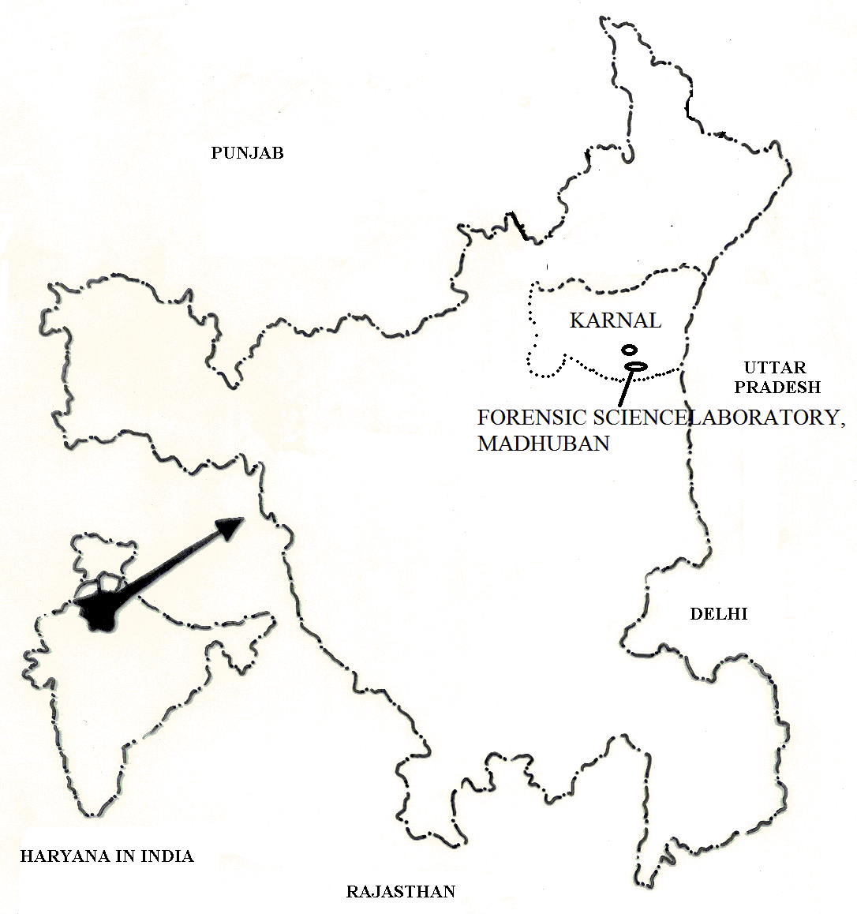

Fig. 1 Forensic Science Laboratory, Madhuban, Karnal (Haryana).

3. Materials and methods:
In present study maggots, were collected from the dead body of person and sealed in the plastic jars. These were sent in Laboratory. For the determination of death time period of a body crime solving methods (Smith, 1986) was followed. The results observed on measure the maggot and pupal evidence (the cut-up, colored pipe cleaners) to determine the life stages and species found at the scene. Species was identified on the bases of maggots.

4. Results and discussion:
The emphasis here will be on the early succession arthropods, primarily blow fly (Diptera: Calliphoridae). Blow fly are generally the most dominant and conspicuous insects in the decomposition process, and their occurrence and biology are used most often in making a post mortem interval (PMI) estimate. At present PMI estimates are drawn from a few baseline studies (Kamal, 1958; Greenberg, 1991). Three patients died, one as a result of an accident, and two as a result of underlying disease (progression of cancer and a haematological disorder). The death time duration of a body determined by applying maggots. Initially, dead body of with the first three patients, maggots were put freely on the wound covered by a net, but after 3–4 days, when maggots grow up to 8–10 mm and these are examined that time duration (Steenvoorde and Jukema, 2004). Nandy (2010) and Dixit (2007) reported peak level in between 36 to 48 hours after death, while Mukherjee (1994) noted the rising titre in the first two to three days after death by using maggots. Reddy (2010) reports 20 times death time duration in 48 hours after death by using maggots.
In the present study, five numbers of cases have been studied. Out of five numbers of cases, three identificated maggots of blow fly was present. It is observed that blow fly maggots are found predominant followed by flesh fly, house fly and skipper fly in a dead body. The maggots of house fly (Musca domestica), flesh fly (Sarcophaga spp.), skipper fly (Piophila casei) and blow fly (Calliphora vomitoria) are observed from a dead body. These flies have variable morphological characters among them (fig. 2). It is also observed that maggots complete their metamorphosis at variable time intervals (table 1).
(Kumar et.al, 2011) studied time duration of two cases. In case-I, maggots varied from minimum 18mm (length of number 1 maggot) to maximum 26mm (length of number 4 maggot) with an average 22.60mm. It is examined average death time duration also varied from minimum 8 day (number 1 maggot) to maximum 10 day (number 4 maggot) with an average 9 day. Similarly, in case-II length of five number of maggots varied from minimum 28mm (length of number 1 maggot) to maximum 32mm (length of number 2 maggot) with an average 29.80mm. It is examined average death time duration also varied from minimum 10 day (number 1 and 4 maggot) to maximum 12 day (number 2 maggot) with an average 10.8 day.
In present study, a dead body of female aged approximately 25 years was recovered from the bushes present near a hotel in Rohtak and it is referred for postmortem nearby PGI Rohtak. The death was in suspected. Parents of dead body explained that this is not a natural death but it is an incident. For identification time duration death of dead body, maggots (Calliphora vomitoria) recovered from the dead body and sent in Forensic Science Laboratory, Karnal.
Here also, length of five number of maggots varied from minimum 8mm (length of number 5 maggot) to maximum 16mm (length of number 4 maggot) with an average 12.5mm. It is examined average death time duration also varied from minimum 2 day (number 1 maggot) to maximum 5 day (number 4 maggot) with an average 3.2 day (fig3).

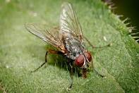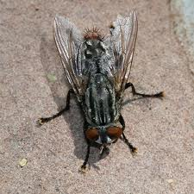
House fly (Musca domestica) Flesh fly (Sarcophaga spp.)
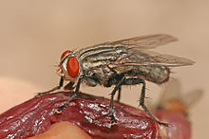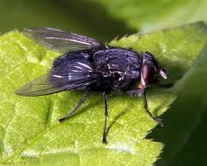
Skipper fly (Piophila casei) Blow fly (Calliphora vomitoria)
Fig. 2 Crime solving insects in Forensic science for determine time duration of a dead body.

Table 1 The development of body length (in millimeters) of some fly species during their metamorphosis at 72º F.
Days after  death | Musca domestica  (House fly) | Piophila nigriceps  (Skipper fly) | Sarcophaga carnaria  (Flesh fly) | Calliphora vomitoria  (Blow fly)
1 |  |  | L 9-11 | Egg
2 | Egg |  | L 12-16 | L 9-11
3 | Egg |  | L 12-16 | L 9-11
4 | L 6 |  | L 21-25 | L 12-16
5 | L 6 | Egg | L 26-30 | L 12-16
6 | L 7-11 | Egg | L 31-35 | L 17-20
7 | L 12-16 | L 3 | L 36-40 | L 17-20
8 | L 17-20 | L 3 | L 41-44 | L 21-25
9 | L 21-25 | L 4-6 | L 44-46 | L 21-25
10 | L 26-30 | L 7-9 | L 44-46 | L 26-30
11 | L 31-35 | L 10-13 | P 38-40 | L 26-30
12 | P 26-29 | L 14-15 | P 38-40 | L 31-35
13 | P 26-29 | P 13-15 | P 38-40 | P 31-35
14 | P 26-29 | P 13-15 | P 38-40 | P 31-34
15 | P 26-29 | P 13-15 | P 38-40 | P 31-34
16 | P 26-29 | P 13-15 | P 38-40 | P 31-34
17 | P 26-29 | P 13-15 | P 38-40 | P 31-34
18 | A 3032 | P 13-15 | P 38-40 | P 31-34
19 |  | A 16-18 | P 38-40 | P 31-34
20 |  |  | P 38-40 | P 31-34
21 |  |  | A 42-45 | A 36-38
L = Larvae, P = Pupae, A = Adult Fly

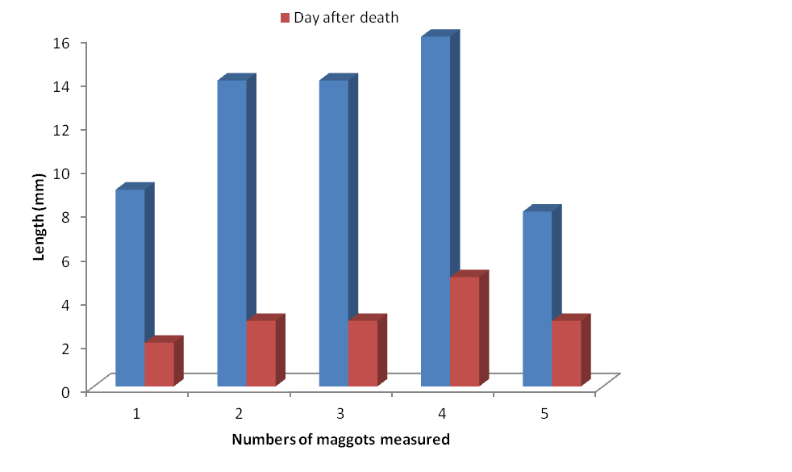
Fig. 3 Showing time duration of a dead body on the bases of length of maggots.

Correspondence author:
Dr. S.S. Chandna
(Assistant Director)
Forensic Science laboratory (Serology division),
Madhuban, Karnal-132001, Haryana (India)
Phone no. +91-9996781030
email-chandnass@yahoo.com

Refrences:
- Carloya, L. Crime solving insects. Washington state University, Stephen Berbara, NC State University, 2006:1-22.
- Carloye L. Of Maggots and Murder: Forensic Entomology in the Classroom. The American Biology Teacher, 2003; 65:360-366.
- Deavers S, Rosborough JP, and McCrady JD. The effects of oleandrin on cardiac contractility in the normal dog. Arch Int Pharmacodyn Ther, 1979;239(2):283-95.
- Greenberg B. Flies and disease. Biology and disease transmission. Prince ton Univ. Press, Princeton, New Jersey, 1991;2:447.
- Kamal AS. The bionomics and digestive enzymology of several species of sarcos aprophagous Calliphoridae and Sarcophagidae. Ph.D. dissertation, Washington State College, Pullman, 1958:86.
- Kumar A., Malik M. and Kadian A. Determination of Death Time Duration of Dead Body Using Maggots. New York Science Journal, 2011; 4(12):61-63.
- Lamm W. Poisonous Plants. TrailBlazer magazine. http://www.horsetrails.com achs, J. S. 1998. A maggot for the prosecution. Discover, 1997;19 (11):102-109.
- Mukherjee JB. Forensic Medicine & Toxicology 2nd edition Arnold Associates, 1994; I:253-254.
- Nandy A. Principles of Forensic Medicine including Toxicology, 2010;(3):280.
- Smith KGV. A Manual of Forensic Entomology. Ithaca, N.Y.: Cornell University Press, 1986.
- Steenvoorde P and Jukema GN. The antimicrobial activity of maggots: in-vivo results JTV Maggots, 2004:1.

1/2/2012

