Chronic Toxicity Of Petroleum Hydrocarbons On Fresh Water Fish Channa Punctatus With Special Reference To Biological Parameters

Preeti Handa Kakkar*, R.M.Saxena and Mamta Pandey

*Department of Zoology, D.A.V. (P.G.) College, Dehradun-248001 (U.K.), India
E-mail: preetisep3@gmail.com; Phone:+919410313630

ABSTRACT: An attempt has been made to study the biological changes like growth rate, mortality, behavior & histopathological changes in the kidney of fresh water fish Channa punctatus caused by chronic exposure of petroleum hydrocarbons viz. petrol. A water soluble fraction of this PHCs is also renaltoxic. During exposure fish skin got much damaged, mucous secretion increased and fish showed restlessness, surfacing, erratic jumping movement, increased opercular beats and loss of balance with the higher concentrations of WSF. It causes peculiar ultrastructural changes viz.necrosis, desquamation of epithelium,haemolysis, hemorrhage, congestion & lymphocytic infiltration and vacuolar degeneration in kidney. It is concluded that even low amount of PHCs can negatively affect fish, causing various disturbances in its health &well being.
[Preeti Handa Kakkar, R.M.Saxena, Mamta Pandey Chronic Toxicity Of Petroleum Hydrocarbons On Fresh Water Fish Channa Punctatus With Special Reference To Biological Parameters. New York Science Journal 2011;4(8):116-120] (ISSN: 1554-0200). http://www.sciencepub.net/newyork.

Keywords: PHCs, WSF, Fish, Mortality, Growth rate, Behaviour, Kidney, histopathology

Introduction
As a result of rapid industrialization and urbanization, increasing quantities of man-produced pollutants including petroleum hydrocarbons (PHCs) have been discharged into the environment. When these pollutants enter water bodies they can have direct or indirect impacts on the biota of aquatic systems. They often interfere with the normal functioning of an organism and its ability to live in harmony with the environment . The changes they cause in behavior, growth, and histopathology of an organism will eventually result in undesirable effects at higher biological organization levels. Therefore, there is a great need for sensitive and reliable methods to assess the impacts of petroleum products to the aquatic environment. Petroleum hydrocarbons(PHCs) such as gasoline, kerosene, jet fuel, home heating oil, lubricants, petrol, diesel and those used in medicines, fertilizers, food stuffs, plastic ware, building materials, paints and textiles are produced from crude oil. They are a complex mixture of hydrocarbons. The lack of scientific information on the toxicity of petroleum products against histopathology of fishes. The current study is aimed at investigating the acute toxicological effect of the water soluble fraction of petrol fuel on Channa punctatus. it seeks to provide some needed toxicological data on the petrol that is in commercial use in India.

MATERIALS AND METHODS
The fresh water fish Channa punctatus were selected for the present study because of their easy availability, moderate sensitivity and easy maintenance in laboratory (OECD, 1993). They were collected live from various sampling stations at river Song in Eastern Doon & Asan in Western Doon with the help of local fisherman employing cast net, gill net, drag net, etc. It was ensured that the fish be in good health and free from any apparent malformation. The size of the experimental fish Channa punctatus of ranged from 12 to 15cm.,weighing 40-70 gm. The test fishes were acclimatized to the laboratory conditions for 15 days, similar to those under which the tests were to be performed, followed by a period of starvation, ranging from 24-36 hours, before their use in the bioassay experiments (Srivastava et.al., 1995). During the acclimatization fishes were fed twice a week on live food containing mosquito larvae, Daphnia and earthworms. The acclimatization was carried out at room temperature which ranged from 20º-27ºC.

Preparation of WSF of PHCs
WSF is that part of petroleum hydrocarbons (petrol) which is soluble in water. WSF was prepared as per the method given by Dede & Kaglo (2001). WSF was prepared by adding one part (1l) of petrol obtained from a filling station to four parts of the water (4l tap water) in a 6l flask. The petrol-water mixture was stirred slowly for 24 hours with a Gallenkamp magnetic stirrer. This was to enhance the dissolution of the water soluble components in petrol. The mixture was then allowed to stand overnight before it was poured into separating funnel, so as to obtain a clear oil-water interphase. The lower layer of water, containing the WSF of petrol was decanted into containers. This process was repeated several times until sufficient quantity of the WSF was obtained to carry out the study. This solution was treated as 100% stock solution .

EXPOSURE OF TEST FISHES
The WSF was made into five concentrations; 3%PF1, 6%PF1, 9%PF3, 12%PF4 and 15%PF5. 10 healthy fishes of uniform size and weight were exposed to various concentrations for 30 days, the mortality and survival of fish was recorded during exposure period. Water was changed at an interval of 24 hrs and also the respective concentration of WSF in order to maintain concentration at a more or less constant initial level throughout the experimental period and also to discard the metabolic products accumulated in the aquaria. The fishes were fed daily after changing the water. The fishes alive after 30 days were carefully removed from the test solution and sacrified immediately. The fishes were dissected to obtain the kidney and then washed in 1% saline solution to eliminate mucous and blood deposits. They were processed for histological examination adopting the standard methods (Gurr, 1956) such as fixation, dehydration, embedding, sectioning and staining. Detailed histopathological studies of control and treatment section (5 microns) were made under microscope and photographs were taken under different magnifications Kurian et.al.,(2003).

RESULTS
The chronic experiment was conducted for 30 days with exposure to different concentration of WSF of petrol fuel. During chronic exposure in control set 2% mortality was observed. At 3%-PF1 treatment 4% mortality (non significant) and at 6%-PF3 treatment 6% mortality (non significant) was observed. A significant change was observed at 9%-PF3 treatment (10%mortality) to 15%-PF5 treatment (25%mortality) (Fig.1).
During exposure reduction in the body weight was maximum. But in control set the body weight was increased. At 3%-PF1 treatment a non significant decrease was observed and significant decrease was observed at 6%-PF2 to 15%-PF5 treatment (Fig.2).
After exposure to test solutions fish show Restlessness, rapid surfacing. fishes showed repeated opening and closing of mouth and opercular covering with partial extentions of fins (cough). WSF did not affect feeding behavior of fish at the beginning of experiments. More expressed changes were observed on the third- fourth day of the studies when mostly fishes swam to meal & fed more slowly as compared to controls. At 6% concentration the fish showed irritation, scales removed and began moving up and down rapidly. Restlessness, rapid surfacing, peeling of skin and colour fading were prominent feature of exposed fishes. This behaviour increased with higher concentration. At 9% fishes showed slightly reduced activity and gradual increase in colour fading. Gill adhension and a thin film of mucous were noticed on gills, operculum and general body surface at this stage. Increaser surfacing and gulping of air was observed also. At 12% fishes showed loss of balance and jerky movements (movement of body sequentially from head to tail) during swimming. Test fishes lost there natural colouration and become almost reddish patches in their body. The feeding activity also decreased and fish did not take any food at 9%PF3 after about 24 hours. The abnormal behaviors displayed by the fish increased with increasing concentrations of WSF in water; it decreased with time of exposure, and then gradually reduced at higher concentrations. Fishes often remained motionless on the bottom before dying. (Fig- 3 & 4)
At light microscopic level, the renal corpuscle was composed of the glomerulus’s and Bowman capsule. The first proximal tubule was composed of cuboidal or low columnar cells with a well developed brush border containing vacuoles and round –based nuclei(Fig.a). The kidney exposed to different concentrations showed lesions of varying degrees. After exposure of 3%-PF1, it was found that blood vessels were damaged and spaces in the tissue were observed. Necrosis of haemopoitic tissue and distended tubules showing desquamation of the epithelium (Fig-b). At 6%-PF2 treatment, severe degenerative and necrotic changes in the renal tubules with focal area of necrosis were observed (Fig-c). After exposure of 9%-PF3, rupture of peritoneal lining, widening of tubules were observed. It has produced rapid abnormalities consisting of rupture of peritoneal lining and Flattening of renal epithelial cells, resulting in the widening of the tubules with hemorrhage and haemolysis in kidney was observed (Fig-d). Further it was found that blood vessels were damaged and space in the tissue was observed. Congestion and lymphocytic infiltration in kidney was observed at 12%-PF4 (Fig-e). After that the uriniferous tubules became wide and migration of epithelium nuclei occurred. The orientation of the nuclei in the cells became irregular and vacuolar degeneration in the epithelium of renal tubules at 10%-PF5 (Fig-f).

Discussion
The change in morphology and behaviour was not observed earlier under the influence of petroleum products. So we correlate these findings with other researches who observed the fish behaviour during exposure of other toxicants. Our results are in agreement with the result reported by many other researchers. Zhang et.al.,(2003) Umejuru (2007) in their investigation of Acute toxicity of WSF of crude oil on the behaviour of the Juvenile crawfish (Procambarus clarki.) reported behavioural changes in fish. They also observed anxiety, swimming upside down, loss of balance, excessive mucus secretion and lightening in colour, gathering at the surface for breathing and hitting to the side walls of aquaria. In present test the feeding behaviour of fishes was very low at lower concentrations and it was slightly reduced at higher concentrations This result is disagreement with Vosyliene (1999) who reported that chemicals had no effect on feeding behaviour at the beginning.
Lee et.al., (2000) reported that exposure of small amount of petroleum leads to chronic toxicity. Toxic effects also depend on the nature of the toxicant, environmental conditions and exposed species. The present investigation states that toxicity of WSF is totally depends upon the nature of toxicant, time duration and varies with species to species.
The WSF did not seem to be more toxic at lower concentrations; however expected growth suppression has occurred at a much higher concentration (Schein et al., 2009). Reduced growth has been observed by Vignier et al., (1992); Wang et al., (1993); Mortensen and Carls, (1994). In present study decrease in growth rate was directly proportional to the WSF concentration and time of exposure. The inhibition of growth reported in this study may therefore be due to a disturbance of normal metabolism by WSF (Ezike and Ufodike, 2008).
The kidney is one of the first organ to be affected by contaminants in water. The necrosis of the renal tubules affects the metabolic activities and promotes metabolic abnormalities in fish (Gabriel, 2007). Similar findings were observed in Menidia beryllina and Trinectes maculatus, exposed to crude oil and its water soluble fractions by Solangi and Overstreet (1982). Camargo (2007) found cloudy swelling degeneration in the epithelium of renal tubules in the kidney of P. lineatus.. Mohamed (2009) also reported severe degenerative and necrotic changes in the renal tubules. Mohamed (2009) who reported haemorrhage, haemolysis and dilation in the capillary tubes of renal tubules and renal blood vessel of kidney of Tilapia zillii. In the present study, kidney of fish showed vacuolar degeneration in tubules cells characterized by the vacuolar hypertrophy. Data regarding histopathological changes in kidney of fish caused by WSF of petrol fuel and diesel fuel are scare. These findings are disagreement in MC Cairn et. al., (1978); Dede and Kaglo, (2001); Gabriel et. al., (2007),. According to Ayoola, (2008) the kidney of Clarias gariepinius exposed to glyphosate concentrations showed dilation of bowman's space and accumulation of hyaline droplets in the tubular epithelial cells of the first proximal tubule. The present study found WSF more toxic with this treatment. It has produced rapid abnormalities consisting of rupture of peritoneal lining and flattening of renal epithelial cells, resulting in the widening of the tubules.

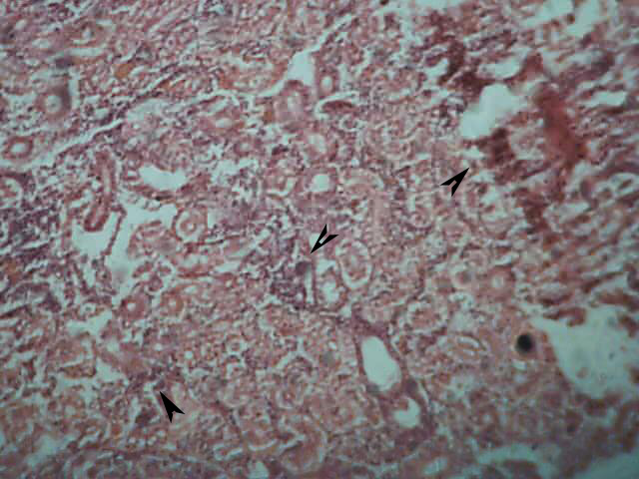
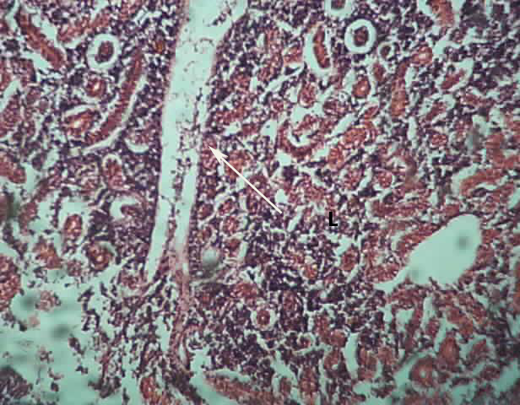

Fig-a Fig-b

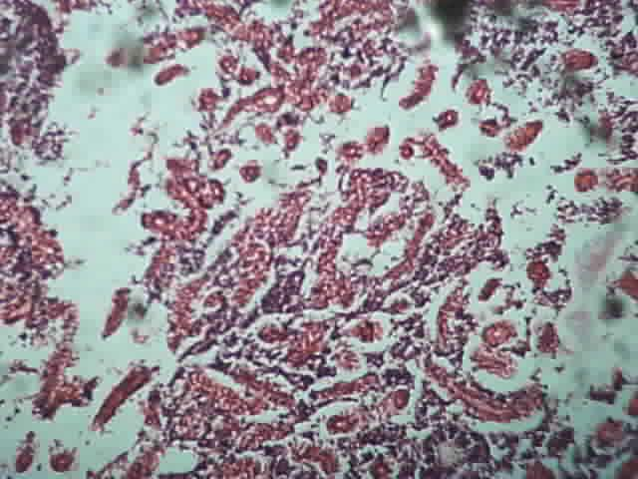
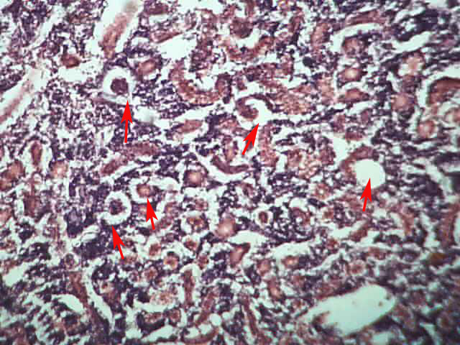

Fig-c Fig-d

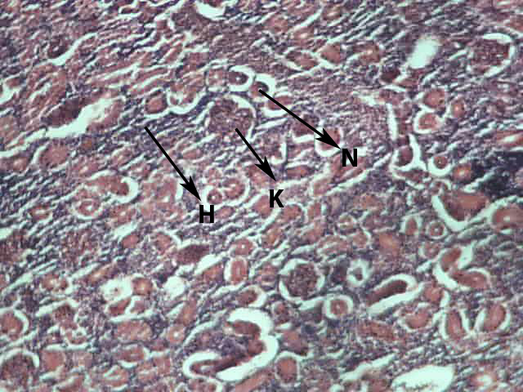
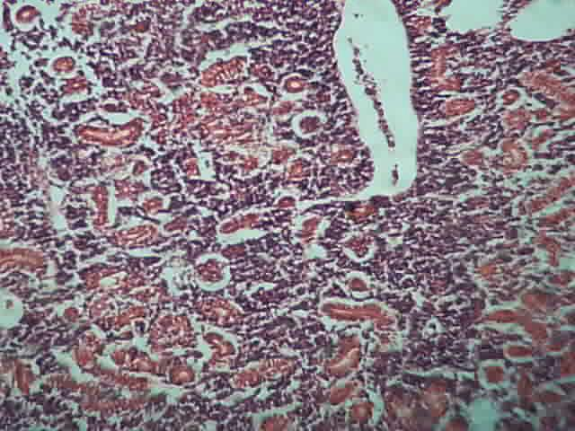

Fig-e Fig-f

Figure 1 (a-c), Figure 2 (d-f). Fig (a) C.punctatus: T.S Kidney (control) showing the haematopoetic tissue (H), kidney tubule (K), & central & round nucleus 100X . Fig.b. (2%-PF1) showing the marked tubular necrosis. Distended tubules showing desquamation of the epithelium 100X. Fig.c. (4%-PF2) showing the severe degenerative and necrotic changes in the renal tubules with focal area of necrosis 100X. Fig.d.(6%-PF3) Showing haemolysis and hemorrhages in kidney & widening of tubules 200X. Fig.e. (8%-PF4) Showing Congestion, and lymphocytic infiltration in kidney 100X. Fig.f. (10%-PF5) Showing wide uriniferrous tubules & vacuolar degeneration in the epithelium of renal tubules 100X.

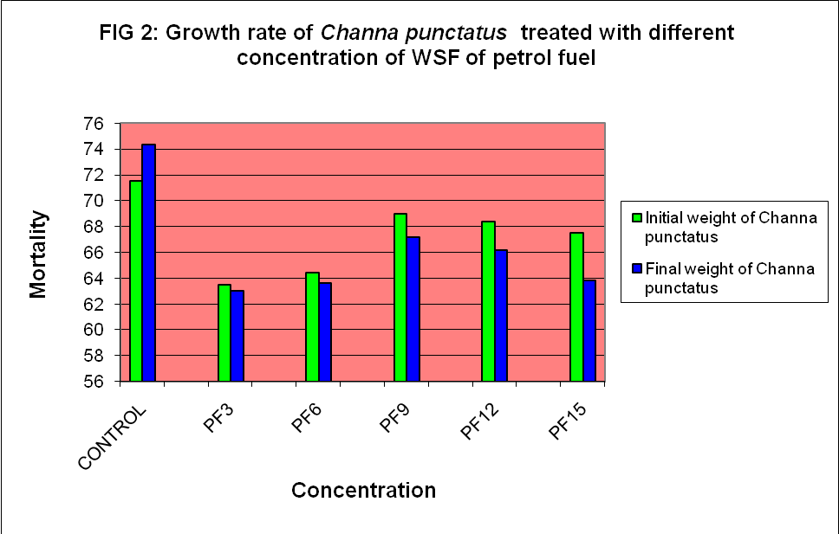

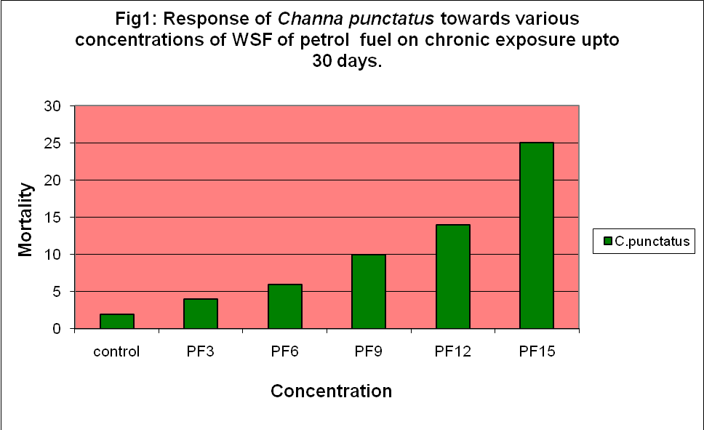

Fig 3- Befor experiment

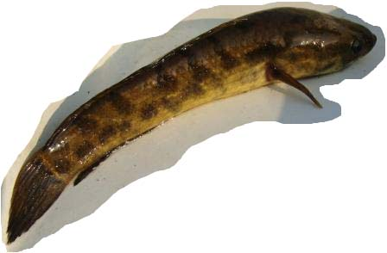

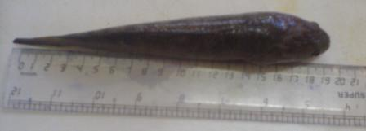
Fig-4 After experiment

References
- Ayoola, S. O,. 2008. Histopathological effects of glyphosate on juvenile African catfish (Clarias gariepinus). Amrican –Esurasian J.Agric.& Environ.Sci., 4(3): 362-367,2008.
- Camargo MMP, Martinez CBR (2007). Histopathology of gills, kidney and liver of a neotropical fish caged in an urban stream. Neotropical Ichtyol. 5(3): 327-336.
- Dede, E.B. and Kaglo, H.D.2001. Aqua-toxicological effects of water soluble fractions (WSF) of Diesel fuel on O. niloticus fingerlings. J. Appl. Sci. Environ.Mgt. 5(1):93-96.
- Ezike, C. and Ufodike, E.B.C. 2008. Plasma glucose and liver glycogen of African catfish (Clarias gariepinus) Exposed to petrol. Journal of fisheries international 3 (2): 46-48. ISSN: 1817-3381.
- Gabriel, U.U., Ezeri, G.N.O. and E.U. Amakiri, 2007. Liver and Kidney Histopathology: Biomakers of No.1 Fuel Toxicosis in African Catfish, Clarias gariepinus. Journal of Animal and Veterinary advances 6(3):379-384.
- Gurr, E.1956. Methods of analytical histology and histochemistry. Leonard Mill Books Ltd- London.
- Kurain, Matheu., Abraham, Thomas., T., Valamparampil., and A, Rekha. 2003. Toxic and histopathological effect of neemax on Anabas testudineus (pisces). Environ. Ecol. T. 14. No.3-4.
- Lee, J.Y; C.H. Lee, K. K. Lee, and J.H. Lee; 2000. Natural attentenuation of petroleum hydrocarbons contaminant in a shallow aquifer, korea. P.481- 488.
- McCain, B.B., H.O. Hodgins, W.D. Gronlund, J.W. Hawkes, D.W. Brown, M.S. Meyers, and J.H. Vandermeulen. 1978. "Bioavailability of Crude Oil from Experimentally Oiled Sediment to English Sole (Parophyrs vetulus) and Pathological Consequences," J. Fisheries Research Board of Canada. Vol. 35, pp. 657-664.
- Mohamed,Fatma, A.S.2009. Histopathological studies on Tilapia Zillii and Solea Vulgaris from Lake Qarun, Egypt.World Journal of Fish and Marine Sciences (1):29-39 ISSN 1992-0083
- Mortensen, D. G. and M. G. Carls. 1994. Effects of crude oil ingestion on growth and microstructure of juvenile pink salmon (Oncorhynchus gorbuscha) Otoliths. Proc. Northeast Pacific Pink Salmon and Chum Workshop, pp. 183-184.
- OECD, 1993. Organization for Economic Co-Operation and Development. OECD Guidelines for Testing of Chemicals, Test No. 203: Fish Acute Toxicity Test, OECD, Paris, France
- Schein, A; Jason, A. Scott; Lizzy Mos; and Peter, V. Hodson.2009 . Oil dispersion increases the apparent bioavailability and toxicity of diesel to Rainbow trout (Oncorhynchus mykiss).J of Environmental Toxicology and Chemistry, Vol 28. No.3, pp. 595-602.
- Solangi M.A. and Overstreet R.M. (1982) Histopathological changes in two etuarine fishes, Menidia beryllina (Cope) and Trinectes maculatus (Bloch and Schneider), exposed to crude oil and its water-soluble fractions. Journal of Fish Diseases 5: 13-35.
- Srivastava, S. K., Jaiswal, R. and Srivastav, A.K. 1995. Acute toxicity of chlorpyrifos to a freshwater catfish Heteropneustes fossilis. J. Adv. Zool. 16 (2): 92-95.
- Umejuru, Okey. 2007. Juvenile Crawfish (Procambarus Clarkii) LC50 Mortality from south Covisiana crude, Peanut & mineral oil. Ph.d Thesis, Lovisiana state University. BS, Agricultural Science, Rivers, state College of Education, Port Harcourt, Nigeria.
- Vignier, V., J. H. Vandermeulen, and A. J. Fraser. 1992. Growth and food conversion by Atlantic salmon parr during 40 days exposure to crude oil. Trans. Am. Fish. Sic. 121:322-332.
- Vosyliene, Milda. Zita. 1999. Distinctive features of changes in biological parameters of rainbow trout exposed to heavy metal model mixture. EKOLOGIJA.. Nr. 2. ISSN 0235-7224 P. 15-20
- Wang, S. Y., J. L. Lum, M. G. Carls, and S. D. Rice. 1993. Relationship between growth and total nucleic acids in juvenile pink salmon, Oncorhynchus gorbuscha, fed crude oil contaminated food. Can. J. Fish. Aquat. Sci. 50:996-1001.
- Zhang, J.F.; Shen, H; Xu, T.L.; Wang, XR’ Li, W.M; Gu, Yf; 2003. Effect of long term exposure of low-level diesel oil on the antioxidant defense system of fish. Bull Environ Contaim Toxicol. 71(2): 234-237.

6/6/2011

