Inhibition of Cell Adhesion and Protein Adsorption onto Biomaterial Titanium by Polyethylene glycol

N.C. Nwokem^{1,*}, C.O. Nwokem², J.A. Lori¹, E.J. Ekanem¹.

- Department of Chemistry, Ahmadu Bello University, Zaria, Nigeria.
- National Research Institute of Chemical Technology, Basawa-Zaria, Nigeria.
*Corresponding Author: nsi19@yahoo.com

Abstract: Biofuctions are required for metals placed in the vicinity of stenotic blood vessels. While compatibility is desired, dilation of blood or prevention of the adhesion of platelets is most important in the circumstance. Biomaterial grade titanium was coated with polyethylene glycol for the studies of cell adhesion and fibrinogen adsorption. The uncoated titanium oxide surface showed a significantly high cell adhesion and fibrinogen adsorption. While for the coated titanium oxide surface, cell adhesion and protein adsorption was very low. The polyethylene glycol coated titanium oxide surface can be deployed prevent surface biofouling by proteins like fibrinogen. This inhibition of protein adsorption prevents tissue growth allowing sliding movements at stenotic blood vessels.
[N.C. Nwokem, C.O. Nwokem, J.A. Lori, E.J. Ekanem. Inhibition of Cell Adhesion and Protein Adsorption onto Biomaterial Titanium by Polyethylene glycol. New York Science Journal 2011;4(7):1-4]. (ISSN: 1554-0200). http://www.sciencepub.net/newyork.

Keywords: Inhibition; Cell Adhesion; Protein Adsorption; Titanium; Polyethylene glycol

- Introduction
Synthetic materials used in the body to provide repair and function are widely referred to as biomaterials (Williams, 1981). The fundamental requirement of a biomaterial is that the material and the tissue environment of the body should coexist without having any undesirable or inappropriate effect on each other. Common medical devices made of biomaterials when placed inside the body are termed implants when they are intended to remain there for a substantial period of time, and as prostheses when they are permanently fixed in the body for a long term application (Dormer and Phelps, 1986).
Titanium has become established as a common implant material because of its exceptional biocompatibility. Protein adsorption from blood or other body fluids takes place on titanium surfaces in an unspecific manner (Dormer and Phelps, 1986). Cellular responses are always mediated through proteins that result in complex interactions with different platelets and cells causing foreign body response, blood coagulation and inflammation (Bodo et al., 1986). The surface properties are therefore of prime importance, particularly in the early stages of implantation.
To eliminate protein adsorption on implant, a new approach is to adsorb a layer of protein resistant co-polymer on the implant surface (Brunette et al., 2003). Polyethylene glycol (PEG), which is non toxic
to the body (Andrade et al., 1995), is the material of choice for imparting protein repellency to surfaces. For this work, the primary culture which consists of a monolayer on one side of flat bottles, prepared by dispersing cells from tissue fragment with trypsin was used.
This work sets out to study the effect of PEG on the adsorption of fibrinogen onto the surface of titanium so as to be able to predict and further study the effect of this modified surface on cell adhesion.

Materials and Methods
Apparatus
A colorimeter (Corning, UK) with absorbance range between 0.000 to 1.999A was used in this study. A micro pH 2000 (Crison, Spain) with a range of -2 to 16 ± 0.001 pH was also used throughout this work.

Reagents
All reagents used were of Analytical reagent grade except where otherwise stated. Distilled water was used in the preparation of all aqueous solutions. All solutions were stored in amber coloured bottles.

Materials
Biomaterials grade titanium metal sample plates of length 1cm, width 1cm and thickness 1mm were used in this study. The titanium surfaces were ultrasonically degreased in benzene, acetone, and ethanol for 10minutes respectively, with deionized water and rinsing between applications of each solvent. A passivation procedure was conducted by exposing the titanium samples to a 40% volume nitric acid solution at room temperature for 30minutes. All samples were then sterilized under UV light for a minimum of 24 hours prior to each experiment.

Modification of Titanium Surface (with PEG).
The liquid polymer (PEG) was stored in a refrigerator until use. Phosphate buffer saline (PBS) with a total ionic strength of 150mM and pH 7.4 was prepared. Before use the polymer liquid was thawed for 3minutes at 37ºC in a water bath and equilibrated at 25ºC for 2minutes. The passivated pieces of metal were then dipped in the PEG solution for 30minutes and subsequently rinsed with PBS. After a second washing with deionized water, they were dried under 1bar filtered nitrogen stream and packed in sterile sealed vials. This resulted in the formation of a layer of the polymer (Connatster et al., 1995).

Measurement of Protein Adsorption
Bovine serum fibrinogen was used as a model protein in this study. 25ml each of protein solution (150µg/ml protein PBS solution) was pipette onto the coated and uncoated metal respectively. The set-up was allowed to remain for a period of 30minutes after which 0.04ml of protein solution was removed. The removed solution was mixed with 2.0ml Bradford reagent and shaken several times to mix properly. The absorbance was taken at maximum wavelength of 610nm using a Corning 253 colorimeter. Measurements were performed in triplicate for each time point. The amount of adsorbed protein was calculated by subtracting the amount of unadsorbed protein remaining from the initial amount of protein present. The mean absorbance obtained for each protein assay was extrapolated against the standard BSA curve to determine the protein concentration.

Determination of Cell Count
Collection of Kidney Sample
A pair of foetal calf kidneys obtained from the abattoir were dipped into cold PBS and kept in the refrigerator at a temperature of 8ºC until the time of use.

Preparation of Invitro Cell Culture.
The outer fat coating of the kidney together with the kidney outer membrane was first removed using a pair of sterile scissors in a petri dish. The kidney was rinsed with PBS and then transferred into a fresh petri dish where it was minced into tiny pieces each of approximately 1mm with the use of a pair of scissors’. The minced kidney was rinsed severally with PBS till the solution was clear and rid of the red blood cells (RBC). Then it was transferred into a trypsinising flask where trysination was carried out. The content of the trypsinising flask was filtered and the filtrate transferred into a test tube and repeatedly centrifuged to completely remove the RBC. The cells, 20mls of minimum essential medium (MEM), 0.1ml bovine serum fibrinogen, 0.1ml each of streptomycin and penicillin were mixed in a conical flask and the contents transferred into six 2cm deep wells, two containing the titanium coated with PEG, two containing the uncoated titanium and the last two contained on titanium and served as the control. The setups were left to incubate for 24hours after which the cell growth in each well was investigated using a haemocytometer.

Results and Discussion
A maximum of 0.06 absorbance was recorded for the uncoated and a maximum of 0.00 for the coated metal surfaces. The result indicates that virtually all the fibrinogen in the 150µg/ml (~100%) was adsorbed onto the uncoated TiO₂ within 180 minutes while there was no adsorption on the coated TiO₂. A number of factors could be responsible for the adsorption of the protein (fibrinogen) used for this study. TiO₂ surfaces have been reported to consist of hydrophilic (polar) and hydrophobic (non polar) components, with the average polar / nonpolar ratio being 0.21± 0.07(Connatster et al., 1995). A positive correlation between surface wettability and protein binding was reported and attributed to the presence of water molecules. Feld and Grinnell (1982) reported that the amount of adsorbed proteins were significantly higher on the hydrophobic surfaces compared to the hydrophilic surfaces.
To address the ability of the polymer brushes to prevent the adsorption of proteins, it has been shown practically by the surface of the PEG forming brush-like structures via attachment unto the TiO₂ metal surface (Feld and Grinnell, 1981).
In addition, protein adsorption leads to the compression of the PEG layer towards the solid surface and is entropically unfavourable (Feld and Grinnell, 1981) thereby repelling the protein and leading to the no adsorption indicated in Figures 1 and 2.

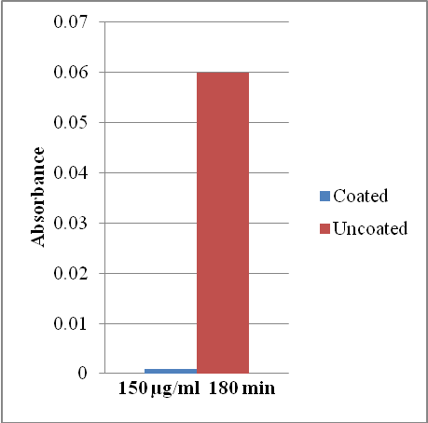
Figure 1: The Adsorption of Fibrinogen on Coated and Uncoated Titanium Metal Surfaces

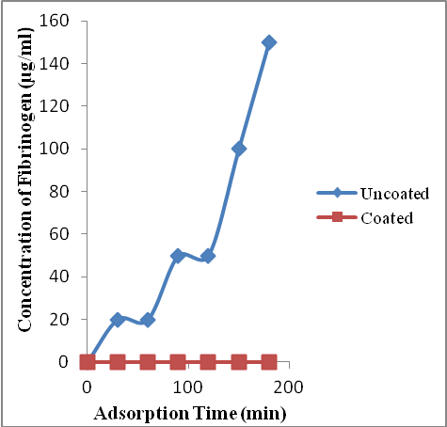
Figure 2: Effect of Incubation Time on the Adsorption of Fibrinogen on Coated and Uncoated Titanium oxide Surfaces.

The level of cell adhesion to the coated and uncoated TiO₂ is shown in Figure 3. Cell adhesion has been associated with glycoproteins (Barenberg, 1991) which are present on the external surface of the cell membrane. Their surfaces serve as receptors facilitating cell adhesion and contraction and determine expression of certain cells. These glycoproteins tend to interact with other proteins, glycoproteins on adjacent cells or with proteins of extracellular matrix (Andrew et al., 1998). The cell membrane is surrounded by a coat called the glycocalyx. The glycocalyx consists of glycolipids, glycoproteins and transmembrane protoglycans.

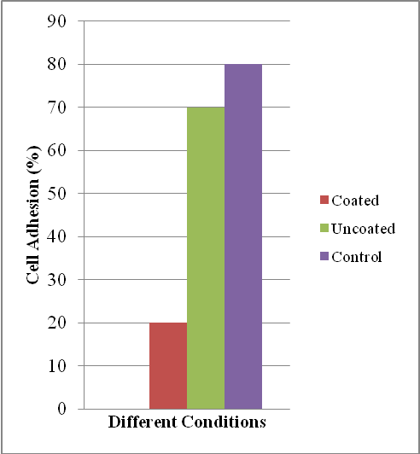
Figure 3: Percentage of Cell Adhesion

The control wells had 70-80% layer formation. This proves the ability of the cells to grow and adhere to the surface to which they were cultivated. The TiO₂ uncoated surfaces showed higher cell adhesion compared with the coated TiO₂ surface. It was suggested (Andrade et al., 1995) that the PEG coating affects cell adhesion by repelling the protein in the external surface of the cell from adsorbing on the metal surface thereby restricting cell adhesion. Also a large number of these glycocalyx molecules contain sugars with negative charge. So the net charge of the glycocalyx is negative. That means that if the culture surface is positively charged there will be an electrostatic attraction between the cell and the culture surface. It has been shown that the attachment to gelatin microcarriers (PEG) compared to charged carriers is slower because the surface charge is not optimal (Christiansen and Silver, 1999).

Conclusion
The interaction of proteins on metal surface and in extension cell adhesion has been under investigation in the past decade because of its importance in areas such as medical implants, biosensor, design and chromatographic interfaces.
The results from this work show that the treatment of TiO₂ surface with PEG will help repel plasma protein (e.g. fibrinogen) from adhering onto the TiO₂ surface. Thus, when such titanium surface- coated implants are placed in the body, the presence of PEG prevents certain plasma protein interaction with TiO₂ and, in extension, resist cell adhesion; thereby reducing the effect of foreign body responses and blood coagulation.

Correspondence to:
Nwokem Nsidibeabasi C.
Department of Chemistry,
Ahmadu Bello University,
Zaria, Nigeria.
Telephone: 07026331858
Emails: nsi19@yahoo.com onyenwokem@yahoo.com,

References
- Andrade, J., Lee, J.H., Lee, J.B. Blood Compatibility of Polyethylene Oxide Surfaces. Progress in Polymer Science, 1995; 20:1043-1079.
- Andrew, L., Davies, J.A., McGill, J.T. Kerrigan, J.J. , Sandy, I.R. Biochemistry, 1998; 43, pp. 223-229. The Royal College Surgeons of Edinburgh, London, England.
- Barenberg, S.A. Biomaterials, Medical Devices and Tissue Engineering. Journal of Biomaterials, 1991; 16: 26-33.
- Bodo P., Lvarssen, B., Lundstrum, I., Sundgren, J.F. Adsorption of Fibrinogen on Titanium and Gold Surfaces Studied by ESCA and Ellipsometry. Journal of Colloid Interface Science, 1986; 113:538-543.
- Brunette, D.M., Texter, M., Tosatti, S. Wieland, M. Use of Molecular Assembly Technique. In Bioimplant Interface Improving Biomaterials and Tissue Reaction, 2003, Ellingsten, J.E. and Lynstadaas, s.p. (Eds.), CRC- Press, London, England. Pp. 341-346.
- Christiansen, D.L. and Silver, F.H. Biomaterial Science and Biocompatibility. 1999, 50: 115-118.
- Connatster, R., Gregory, J.C., Lucas, L.C., Ong, J.L. Raikar, U.N. Spectroscopic Characterization of Passivated Titanium in a Physiologic Solution. Journal of Material Science and Material Medicine, 1995; 6:113-119.
- Dormer, R.A., Phelps, J.R. Handbook of Biomaterials Evaluation, 1986, Macmillan Publishing Corporation. New York, p.503.
- Feld, M.K., Grinnell, D.F. Fibronectin Adsorption on hydrophobic Surfaces Detected by Antibody Binding and Analysed During Cell Adhesion in serum Containing Medium. Journal of Biological Chemistry, 1982, 257:4888-4893.
- Feld, M.K., Grinnell, D.F. Adsorption Properties of Fibrinectin in Relationship to Biological Activity. Journal of Biomedical Material Research. 1981, 15: 363-381.
- Williams, D.F. Fundamental Aspects of Biocompatibility. 1981, CRC- Press, Boca Raton, Fl, pp. 58-94.

5/22/2011

