Neurotoxic effects of organic solvents in exposed workers: Altered expression of some biochemical markers

Noha M Hegazy¹, Nadia B. Abdel Gawad¹, Fateheya M. Metwally¹, Hanaa H. Ahmed³, Ehab R. Abdel Raouf², Khadiga S Abrahim¹, Nevin E. Sharaf¹

¹ Department of Environmental and Occupational medicine, NRC
² Department of Research on Children with Special Needs.
³ Department of Hormones,NRC

Abstract: Background: Organic solvents (OG) are volatile and lipophilic compounds, having great affinity to neuronal tissue that may lead to various neurological findings. Long-term occupational exposure to organic solvents may affect the levels and turnover of neurotransmitters in man. The brain-derived neurotrophic factor (BDNF), has been crucially implicated in many cognitive functioning. Serum B-cell lymphoma 2 (Bcl-2) are responsible for programmed cell death or apoptosis, which is considered to be an important phenomenon that is related to neuron vulnerability to a variety of toxic effects, and it is the fundamental process responsible for the clinical manifestations of many different neurological disorders processes. There is an association between exposure to solvents and damage of the brain, in which oxidative stress is a possible mechanism for that damage influenced by serum total antioxidant capacity (TAC) & Malondialdehyde level (MDA). Materials and Methods: forty-four workers exposed to organic solvents and 45 unexposed, were examined in order to assess possible neurotoxic signs and symptoms related to solvent exposure. In addition, Mini-Mental State Examination (MMSE), was used for quantitative assessment of cognitive impairment, and the Brain-derived neurotrophic factor (BDNF), B-cell lymphoma 2 (Bcl-2), Total antioxidant capacity (TAC) and Malondialdehyde level (MDA) were done to all subjects. Results: Our results showed that, the mean scores of MMSE were significantly lower among the solvent exposed group and this score was considered a mild cognitive impairment. In addition to, stocke and glove hypothesia indicative of peripheral neuropathy (PNN) in 47.7 % of the exposed, versus 11.11% in the control group. The BDNF, Bcl-2, were significantly decreased, while the TAC was not significantly decreased and the MDA was significantly increased. So the previously mentioned markers could be used in assessment of central and peripheral nervous system dysfunction induced by occupational exposure to organic solvents.
[Noha M Hegazy, Nadia B. Abdel Gawad, Fateheya M. Metwally, Hanaa H. Ahmed, Ehab R. Abdel Raouf, Khadiga S Abrahim, Nevin E. Sharaf. Neurotoxic effects of organic solvents in exposed workers: Altered expression of some biochemical markers. New York Science Journal 2010;3(11):171-176]. (ISSN: 1554-0200). (http://www.sciencepub.net).

Keywords: Occupational exposure, solvents, biomarkers, BDNF, Bcl-2, TAC, MDA, MMSE, cognitive impairment, PNN

1. Introduction
Organic solvents are volatile and lipophilic compounds. The lipophilic nature of those compounds makes them having great affinity to neuronal tissue that may lead to various neurological findings ,Chouaniere et al., (2002), particularly where workplace practices are poor.
Chronic exposure to solvents has been studied for many years and is well documented as resulting in abnormal EEG's, altered sense of smell, numbness or weakness in the extremities ,Kutlu et al.,(2009). Emotional problems, including depressive tendencies, anxiety and social withdrawal (Herpin et al., 2008). Also, frequent associations between the sense of well being and the cognitive functioning were reported by many authors ,Hoeck et al., (2001) and Van Hout et al., (2006). Furthermore, Kukull et al., (1995) recorded that exposure to organic solvents may be associated with onset of Alzheimer’s disease.
There was a strong hypothesis that long-term occupational exposure to organic solvents may affect the levels and turnover of neurotransmitters in man. Results of various studies revealed that long-term exposure to organic solvents might increase the rate of dopamine synthesis in the brain (Edling et al., (1997); Gralewicz and Dyzma (2005). Activity-dependent modulation of synapses is critical for brain development as well as many cognitive functions in the adult. So, neurotrophins have a crucial role in synaptic transmission and plasticity, they belong to a family of secretory proteins that include nerve growth factor (NGF), brain-derived neurotrophic factor (BDNF), neurotrophin-3 (NT-3), and NT-4/5 Kawamoto et al., (2000), and BDNF has been crucially implicated in many cognitive processes as it plays a critical role in regulation of neuronal development (Tucker, 2002; Lu, (2003); Li et al., (2004)
In addition, Gotohda et al., (2007) proved that solvents inhalation cause damage of the neurons in the spinal cord of treated rats, and was accompanied by decrease in the neurotrophic factor BDNF
At the cellular level, programmed cell death or neuronal apoptosis in neurodegenerative disorders may be triggered by oxidative stress and disruption of calcium homeostasis. Serum B-cell lymphoma 2 (Bcl-2) are the identified group responsible for programmed cell death. In the central nervous system, programmed cell death or apoptosis is considered to be an important phenomenon that is related to neuron vulnerability to a variety of toxic effects. Degeneration and death of neurons is the fundamental process responsible for the clinical manifestations of many different neurological disorders of aging, including Alzheimer's disease, in addition to the genetic, environmental factors, which contribute to initiation of such neuronal apoptosis. Chronic exposure to environmental toxins affects the expressions of apoptotic-related proteins in the central nervous system (CNS) and peripheral nervous system (PNS). Ge et al., (2004) found that solvent exposure produces significant decrease in Bcl-2, resulting in loss of purkinge neurons in rats by apoptosis.
Moreover, there is an association between exposure to thinner fumes and damage of the brain, in which oxidative stress is a possible mechanism for that damage influenced by serum total antioxidant capacity (TAC). Exposure to OS was found to increase level of (MDA) ,Baydas et al., (2003); Dundaroz et al.,( 2003) and Canatan, et al., (2001).

2.Materials and Methods:
2.1.Materials
2.1.1Studied group
The studied group composed of 44 male workers. All of them were exposed to a mixture of solvents in a paint manufacturing factory. Their ages ranged from 36 to 59 years with a mean of 36.01 + (6.17).
Forty five individuals were randomly selected from service care workers and served as a control group. The subjects of this group have never been exposed to OS or any chemicals at their present employment nor even had a past history of chemical exposure. Their ages ranged from 30 to 50 years with a mean 35.65 + (6.21). Both groups were matched for sex, socioeconomic status and special habits.

* All subjects answered a specially designed questionnaire:
- Information were obtained concerning occupational and environmental chemical exposure,
-Personal data and special inquiries about special symptoms (parathesia, paresis, tremors, headache, depression, disorientation, loss of concentration, sleep, difficulty easy fatigability)
* Mini-Mental State Examination (MMSE), which is used for, quantitative assessment of cognitive impairment in adults was done;( It is the most commonly used cognitive screening test, formed of 30-point questionnaire test that examines orientation, immediate and short-term memory, attention and calculation and language). A MMSE scores ranged from 23-27 or less is generally accepted as indicative of mild cognitive impairment , Bour et al., (2010)Summary scores for the MMSE are given in the form of mean ± SD
* Clinical examination was done for subjects with special emphasis on the neurological system.

2.1.2.Samples:
Venous blood samples were withdrawn from all subjects .The separated sera were subjected to the following biochemical analyses:
- Brain-derived neurotrophic factor (BDNF)
- B-cell lymphoma 2 (Bcl-2)
- Total antioxidant capacity (TAC)
- Malondialdehyde level (MDA)

2.2 Methods:
2.2.1.Serum brain-derived neuro-trophic factor (BDNF)assay:
It was determined by enzyme linked immune-sorbent assay (ELISA) technique using kit purchased from R&D system CO., (U.S.A), according to the method described by Kishino et al., (1997). BDNF present in the sample was bounded by monoclonal antibody specific for BDNF. The enzyme linked monoclonal antibody specific for BDNF was bounded to the BDNF-monoclonal antibody. Unbound antibody- enzyme reagent was removed and a substrate solution formed a color which was in proportion to the amount of BDNF bound in the initial step.

2.2.2.Serum B-cell lymphoma 2 (Bcl-2) level determination:
The level was assayed by ELISA technique using kit purchased from Bender Med Systems Co., (Austria), according to the method described by Barbareschi et al., (1996). Bcl-2 present in the sample was bounded to antibodies. Then, a biotin-conjugated monoclonal anti-Bcl-2 antibody was bounded to Bcl-2 captured by the first antibody. The unbound biotin conjugated anti-Bcl-2 was removed. Streptavidin-HRP was bounded to the biotin conjugated anti-Bcl-2. The unbound Streptavidin-HRP was removed and substrate solution reactive with HRP formed a colored product which was in proportion to the amount of Bcl-2 present in the sample.

2.2.3.Serum total antioxidant capacity (TAc) assay:
It was assayed by colorimetric method using kit purchased from Bio-diagnostic Co., Egypt, according to the method described by Koracevic et al., (2001). The determination of the antioxidative capacity was performed by the reaction of antioxidants in the sample with a defined amount of exogenously provided hydrogen peroxide (H₂O₂). The residual H₂O₂ was determined colorimetrically by an enzymatic reaction which involves the conversion of 3,5, dichloro –2– hydroxyl benzensulphonate to a colored product.

2.2.4.Serum malondialdehyde (MDA) level determination:
The level was determined by colorimetric method using kit purchased from Bio-diagnostic Co., Egypt, according to the method described by Ohkawa et al., (1979). Thiobarbituric acid (TBA) was reacted with malondialdehyde (MDA) in acidic medium at temperature of 95°C for 30 min to form thiobarbituric acid reactive product (colored product) which was equivalent to MDA level in the sample.

2.2.5. Statistical analysis
Statistical analysis was done by a statistical software package (SPSS 12.0 for windows, SPSS Inc.).

3. Results:
Table [1] showed that there was no statistically significant difference among both studied groups, concerning age and smoking habits.

Table [1]: General characteristics of the study population
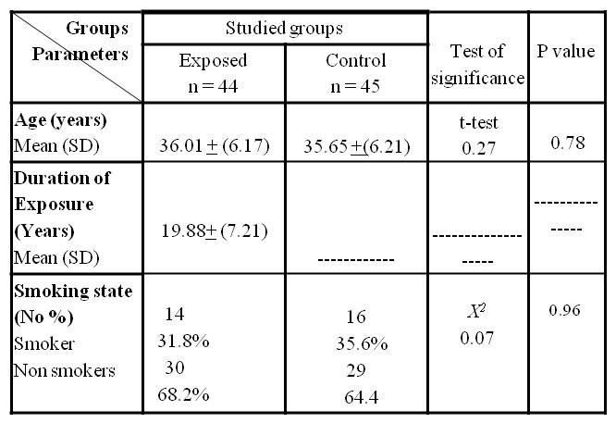NS for P > 0.05

It is quite evident from table 2 that, the mean scores of MMSE were lower among the solvent exposed group (26.78 ± 3.079) with a range varied from 19 to 30, compared to the control (28.2 ±1.6), the difference was statistically significant (p < 0.05).
The neurological examination revealed that the number of exposed subjects (21) with glove and stocke hypothesia indicative of peripheral neuropathy (PNN) is much higher than the control. The difference was highly significant (p < 0.01).

Table [ 2 ]: Mini mental state score and prevalence of peripheral neuropathy (PNN) among the studied groups.
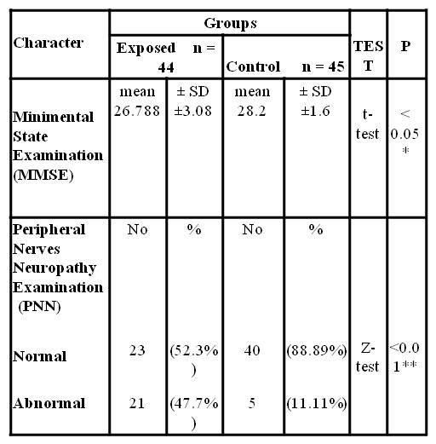
*Significant.
** Highly significant

The results depicted in table 3 showed that the mean value of BDNF and Bcl-2 were much lower among the solvent exposed group compared to those of controls. On the other side MDA was much higher in the exposed than that in control. The differences were highly significant (p<0.01).The mean level of TAC in exposed is lowered than that in controls but the difference is not statistically significant.

Table [3]: Mean values of biochemical markers among the studied groups
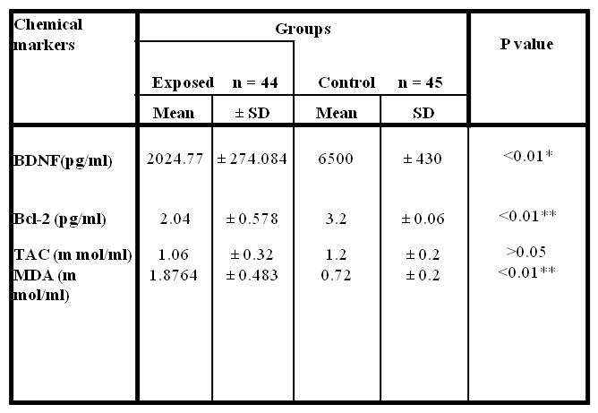

4. Discussion:
There is growing concern that repeated human exposure to organic solvents might result in an irreversible structural damage to the nervous system, resulting in changes in behavioral and neurological functions, Pettersen, (2009).
Several authors, have claimed that prolonged occupational exposure to various solvent mixtures induces irreversible changes in behavioral and neurological functions characterized by personality alteration, memory loss, intellectual decline, autonomic dysfunction, and peripheral neuropathy, Kutlu et al., (2009). In addition, there is a significant association between exposure to solvents and neurobehavioral disorders among workers exposed to solvents. Saddik et al., (2005) concluded that memory and motor dexterity appears to be particularly affected in solvent-exposed workers.
It is likely, that not a single marker but combination of markers allow detection of neuro-behavior changes, where Gothoda et al., (2007) proved that solvents’ inhalation caused damage of the neurons in the spinal cord of treated rats, and was accompanied by decrease in the neurotrophic factor BDNF. The results of Jakab et al., (2010) demonstrated that exposure to formaldehyde induces apoptosis among subjects occupationally exposed to formaldehyde, in addition to the results of Ge et al., (2004) who found that solvent exposure produces significant decrease in Bcl-2, resulting in loss of purkinge neurons in rats by apoptosis. Canatan, et al., (2001); Dundaroz et al., (2003), found that the plasma of people who abused inhalants showed increased level of MDA.
Our results showed that, the mean scores of MMSE were significantly lower among the solvent exposed group (26.78 ± 3.079), compared to the control one (28.2 ±1.6). Bour et al., (2010), reported that, that score was considered a mild cognitive impairment and our results are in agreement with many authors; Saddik et al.,( 2003); Saddik et al.,(2005) and Saddik et al., (2009), in which, he identifies an association between exposure to solvents and lower neurobehavioral performance. In addition, to that recorded by Meyer-Baron, et al., (2008) who investigated and analyzed the neurobehavioral effects of occupational exposure to solvent mixtures and advised to pay greater attention to the measurement of exposure, including measures of confounding for future studies.
In our study, the neurological examination revealed a stock and glove hypothesia indicative of peripheral neuropathy (PNN) in 47.7 % of the exposed versus 11.11% in the control group. This is in agreement with the findings of Pastore et al., (2002)and Puri et al., (2007), who studied the risk of n-hexane neuropathy among screen printers in India, they reported that 92% of patients got sensor motor neuropathy, and it could be reversed after exposure cessation ,Kutlu et al., (2009).
Li et al., (2004) and Gotohda et al., (2007) studied the serum biochemical parameters in solvent exposed group, and they found that BDNF is significantly decreased among their exposed group. Furthermore, Gotohda et al., (2007) proved that solvents like ethanol, could produce molecular changes expressed by the decrease in BDNF. Their results are in accordance with ours.
Also, in this work Bcl-2 was significantly decreased in solvent exposed group, which means that solvent exposure results in loss of neurons by apoptosis as proved by Jakab et al.,( 2010), who demonstrated that exposure to formaldehyde induces apoptosis among subjects occupationally exposed to formaldehyde. Ge et al., (2004) found the same result and emphasized that solvent exposure interrupt the active suppression of apoptosis through decreasing this antiapoptotic marker, these results could be used to support our results in the appearance of PNN.
In this study, MDA which is a biomarker of oxidative stress is increased significantly, while the total antioxidant capacity TAC was decreased in the solvent exposed group. The same was found by Dundaroz et al., (2003) and Canatan et al.,( 2001), who found that the plasma of people who abused inhalants, showed increased levels of MDA. Also, Martinez-Alfaro et al., (2006) insured that MDA increase is correlated with DNA damage, which indicates that that oxidative stress mechanism could be used as another possible explanation in our study for the neural tissue damage caused by the solvent exposure.
So the previously mentioned markers could be used in assessment of central and peripheral nervous system dysfunction induced by occupational exposure to organic solvents.
Further studies using more detailed neurobehavioural test batteries, neurophysiological measurements and advanced neuroimaging techniques are required to detect the "subclinical" dysfunction of nervous systems in workers exposed to organic solvents at low-level.

5. Refrences:
Barbareschi, M.; Caffo, O.; Veronese, S.; Leek, R.D.; Fina, P.; Fox, S.; Bonzanini, M.; Girlando, S.; Morelli, L.; Eccher, C.; Pezzella, F.; Doglioni, C.; Palma, P.D. and Harris, A. (1996): Bcl-2 and P53 expression in node-negative breast carcinoma- a study with long-term follow-up. Human Pathol., 27:1149-1155.

Baydas G, Reiter R, Yasar A, Tuzcu M, Ozveren F, Canatan H (2003): Melatonin protects the central nervous system of rats against Toluene containing thinner intoxication by reducing reactive gliosis. Toxicol. Letters 137, 169-174.

Bour A, Rasquin S, Boreas A, Limburg M, Verhey F (2010). How predictive is the MMSE for cognitive performance after stroke? J Neurol; 257(4):630-7.

Dundaroz MR, Turkabay T, Akay, C, Sarici, SU, Aydin A, Denli M.(2003): Antioxidant enzymes and lipid peroxidation in adolescents with inhalant abuse. Turk. J. Pediatr. 45, 43-45.

Canatan H, Ustandag, B, Ilhan, N, Inan F. (2001): Effect of thinner inhalation on lipid peroxidation and some antioxidant enzymes of people working with paint thinner. Cell. Biochem,Funct. 18, 263-267.

Chouaniere D, Wild P, Fontana JM, et al.(2002): Neurobehavioral disturbances arising from occupational toluene exposure. Am J Ind Med. 41:77–88.

Edling C, Hellman B, Arvidson B, Andersson J, Hartvig P, Lilja A, Valind S and Ge Y, Belcher SM, Pierce DR and Light KE (2004): Altered expression of bcl-2, Bad and Max mRNA occurs in the rat cerebellum within hours after ethanol exposure on postnatal day 4 but not on postnatal day 9, Molecular brain research 129; 124-134.

Gothoda T, Tokunago I, Kitamura O, Kubo S (2007): Toluene inhalation induced neuronal damage in the spinal cord and changes of neurotropic factors in rat. Legal medicine 9; 123-127.

Gralewicz S and Dyzma M (2005): Organic solvents and the dopaminergic system. Int J Occup Med Environ Health. 18(2):103-13.

Herpin G, Gauchard GC, Vouriot A, Hannhart B, Barot A, Mur JM, Zmirou-Navier Dand Perrin PP. (2008): Impaired neuro-motor functions in hospital laboratory workers exposed to low levels of organic solvents”. Neurotox Res. 13(3-4):185-96.

Hoek V.JA, Verberk MM, van der Laan G, Hageman G. (2001): Solvent-induced chronic encephalopathy; the 'solvent team' project. Ned Tijdschr Geneeskd. 145(6):256-60.

Jakaba MG., Kluppa T, Besenyei K, Biroa A, Tompaa A. (2010): Formaldehyde-induced chromosomal aberrations and apoptosis in peripheral blood lymphocytes of personnel working in pathology departments. Mutation Research 698, 11–17.

Kawamoto Y, Nakamura S, MatsuoaA,AkiguchiI, Shbasaki H.(2000): Immuno-histochemical localization of Glial cell line derived neurotrophic factor in the human central nervous system. Neuroscience; 100(4). 701-12.

Koracevic, D.; Koracevic, G.; Djordjevic, V.; Andrejevic, S. and Cosic, V. (2001): Method for the measurement of antioxidant activity in human fluids. J Clin Pathol., 54:356-61.

Kukull WA, Larson EB, Bowen JD, McComick WC et al., (1995): Solvent exposure as a risk factor for Alzheimer’s disease : a case-control study. Am. J. Epidemiol. 141 (11): 1059-71.

Kutlu G, Yasemin B, Gomceli, TS and Inan LE (2009): Peripheral neuropathy and visual evoked potential changes in workers exposed to n-hexane. Journal of Clinical Neuroscience. 16: 1296–1299.

Kishino, A.; Ishige, Y.; Tatsuno, T.; Nakayama, C. and Noguchi, H. (1997): BDNF prevents and reverses adult rat motor neuron degeneration and induces axonal outgrowth. Exp Neurol., 144:273-86.

Li Z, Ding M, Thiele CJ and Luo J(2004): Ethanol inhibits brain derived neurotropic factor-mediated intrracellullar protein-1 activation in signaling and activator cerebellar granules neurons, neuroscience 126149-162.

Lu B (2003): BDNF and activity dependant synaptic modulation. Learn mem 10:86-98.

Martinez-Alfaro M, Palma-Tirado L, Sandoval-Zapata F, CarabezTrejoA (2006): Correlation between formamidopyrimidine DNA
+6glycosylase(fpg)- sensitive sites determined by a comet assay, increased MDA and decreased glutathione during long exposure to thinner inhalation.Toxicology Letters 163, 198-205.

Meyer-Baron M, Blaszkewicz M, Henke H, Knapp G, Muttray A, Schäper M, van Thriel C. (2008): The impact of solvent mixtures on neurobehavioral performance: conclusions from epidemiological data. Neurotoxicology.; 29(3):349-60

Ohkawa, H.; Ohishi, N. and Yagi, K. (1979): Assay for lipid peroxides in animal tissues by thiobarbituric acid reaction. Anal Biochem.. 95:351-8

Pettersen B., (2009): The neuropsychological diagnosis of chronic solvent induced encephalopathy (CSE)--a reanalysis of neuropsychological test results in a group of CSE patients diagnosed 20 years ago, based on comparisons with matched controls. Neurotoxicology. ; 30(6):1195-201.

Pastore C, Izura V, Marhuenda D, et al. (2002):Partial conduction blocks in n-hexane
neuropathy. Muscle Nerve ;26:132–5.

Puri V, Chaudhry N and Tatke M. (2007): N-hexane neuropathy in screen printers.
Electromyogr Clin Neurophysiol ;47:145–52.

Saddik B, Nuwayhid I, Williamson A, Black D.(2003): Evidence of neurotoxicity in working children in Lebanon. Neurotoxicology.; 24(4-5):733-9.
Saddik B, Williamson A, Nuwayhid I and Black D (2005). The effects of solvent exposure on memory and motor dexterity in working children. Public Health Rep. 120(6):657-63

Saddik B, Williamson A, Black D, Nuwayhid I.(2009): Neurobehavioral impairment in children occupationally exposed to mixed organic solvents. Neurotoxicology.; 30(6):1166-71.

Tucker KL. ( 2002): Neurotrophins and the control of Axonal outgrowth Panminerva Med 44:325-333.

Van Hout MS, Schmand B, Wekking EM, Deelman BG (2006): Cognitive functioning in patients with suspected chronic toxic encephalopathy: evidence for neuropsychological disturbances after controlling for insufficient effort. J Neurol Neurosurg Psychiatry. 77(3):296-303

10/2/2010

