Hydrolytic Enzymes of Moulds Involved in Bread Spoilage

Ahaotu, N. N., *Ogueke, C. C. and Ahaotu, I.

Department of Food Science and Technology, Federal University of Technology, Owerri. PMB. 1526 Owerri, Nigeria.
e-mail: nnaya78@yahoo.com ;chikaogueke@yahoo.com
*Author for correspondence and proof

Abstract: The activities of hydrolytic enzymes of moulds isolated from bread were studied using milk, starch and olive oil agars while proximate composition of bread and the pH, titrable acidity and total mould counts during storage were determined using standard analytical procedures. Aspergillus niger produced the highest hydrolytic activity on milk and starch agars (13.18 mm²/day and 8.27 mm²/day respectively) while Rhizopus stolonifer had the highest activity on olive oil agar with a value of 13.29 mm²/day. The culture supernatants of A. flavus had the highest activity on milk, starch and olive oil agars with values of 4.5 mm, 5.5 mm and 3.0 mm respectively. The pH of bread stored at ambient and refrigeration temperatures decreased as days of storage increased while the total titrable acidity increased. Bread stored at refrigeration temperature had the highest mould counts of 1.0x10⁵ cfu/g at the end of storage. Proximate analysis showed that bread has 56.75% carbohydrate, 2.96% protein, 3.40% fat, 0.98% crude fibre and 1.74% ash. [New York Science Journal 2010;3(11):27-36]. (ISSN: 1554-0200).

Key words: enzyme; proteolytic; amylolytic; lipolytic; bread; moulds.

Introduction
Bread is a food produced from wheat flour or other composite flours made of wheat and other flours such as cassava and maize at varying ratios. The dough formed is allowed to ferment and then baked in an oven (Canvian and Young, 1998). Bread is a very important source of nutrients as it contains proteins, carbohydrates, fats, various vitamins and minerals (Potter and Hotchkiss, 1995). Enriched bread ranks as an energy food and as a source of many nutrients (Barret, 1990).
However, various microorganisms are found to cause the spoilage of bread, especially the moulds. Mould spoilage of bakery products is a serious and costly problem for bakeries and use of preservatives is therefore an attractive means to diminish spoilage and ensure safety (Suhr and Nielsen, 2004). Major moulds involved in the spoilage of bread are Rhizopus stolonifer, Mucor sp., Penicillium sp., Aspergillus sp. and Monilia sitophila (Northolt et al., 1995; Lund et al., 1991; Adams and Moss, 1999; Frazier and Westhoff, 2003; Jay, 2004). Spoilage can also be due to the growth of rope-causing, heat resistant endospore-forming Bacillus subtilis (Earle and Putt, 1984) and some yeasts (Legan and Voysey, 1991).
Spoilage of bread by these microorganisms will involve the production of various hydrolytic enzymes that will enable them utilize the nutrients in the product. Various moulds are commercially used for enzyme production (Olempska-Beer et al., 2006) and it is believed that the ability of these moulds to grow and proliferate, and subsequently cause spoilage will depend on their ability to produce the requisite hydrolytic enzymes to breakdown the bread components. This work was therefore undertaken with the view to isolating the moulds involved in bread deterioration and determining the hydrolytic activities of the isolated moulds and their enzymes.

Materials and Methods
Source of samples:
Freshly baked bread samples were bought from different locations in Benin City, Nigeria. The samples were shared into three portions and kept at three different storage conditions [ambient temperature (30-32^{O}C); refrigeration temperature (10-15^{O}C); freezing temperature (0^{O}C)] for five days. Samples were taken on daily basis to determine the total mould counts, total titrable acidity and pH.

Determination of mould counts and isolation of moulds:
20 g of bread was homogenized in 180ml of sterile distilled water. The homogenate was serially diluted and 0.1ml of the selected dilutions were plated out on Sabouraud Dextrose Agar (SDA) using the method as described by Ogueke et al. (2010). The plates were incubated at 28^{O}C ± 2^{O}C for 24-72h.
After incubation discrete colonies were counted and their numbers noted. This was followed by the isolation of the organisms into pure cultures on SDA. Each isolate was stained with lactophenol cotton blue and identified based on their morphological features, spores and hyphae (Rhode and Hartmann, 1980).
All the mould isolates were stored on SDA slants at 4^{O}C until required.

Determination of hydrolytic activities of mould isolates:
The mould isolates were tested for their individual ability to hydrolyze casein (protein), starch and lipid by direct plating on milk agar, starch agar and olive oil agar respectively. The isolated moulds were point inoculated at the centre of the solidified agar plates and were incubated at 28^{O}C ± 2^{O}C for 120 h. Proteolytic, amylolytic and lipolytic activities were estimated by measuring the annular zone of clearance around the mould colonies on daily basis. The annular zone of clearance was calculated as follows;
π(D + d)(D – d)
4
Where D = diameter of clearance zone
D = diameter of mould colony

Determination of total titrable acidity:
20 g of each bread sample was homogenized in 180 ml of distilled water and filtered. 10.0ml of the filtrate was titrated with 0.1N NaOH using phenolphthalein as indicator. The citric acid equivalent was calculated from the titre values (Obilie et al., 2004).

Determination of pH:
pH of each bread sample was determined using a pH meter with glass electrode (Fisher Scientific, England. Model AR50). 20.0 ml of the filtrate obtained from the homogenization of bread with distilled water was transferred into a 50 ml conical flask and the pH determined by dipping the electrode into the liquid.

Preparation of culture supernatant:
Spores of five day old mould plates were harvested using the following method. First a drop of tween 80 was added to 25ml of distilled water and then used to flood the mould plates. The plates were swirled carefully to make sure spores were collected. The solution was then filtered with sterile cheesecloth to remove mould hyphae, leaving only the solution containing spores. The spore solution was standardized using a haemocytometer (made in Germany).
To appropriately labeled 250ml conical flasks, 20g of fresh bread samples were placed and sterilized in a hot air oven (Thermo Scientific Heraeus Series 6000) at 100^{O}C for 10 min. Samples were then plated out on SDA to be sure that sterilization was complete. After cooling, the flasks and their contents were made up to 200ml with distilled water.

Then 1.0ml of the standardized spore suspension (2.0 x 10² spores/ml) was added to each flask and incubated at a temperature of 30^{O}C for three days on an orbital shaker at 120 rpm. Then they were centrifuged at 10,000 rpm at 5^{O}C for 30 min. The supernatant obtained was used for study as the culture supernatant.

Determination of hydrolytic activity of culture supernatant:
A sterile cork borer of 5 mm diameter was used to make wells of equal depth on the solidified starch agar, milk agar and olive oil agar plates. Then 0.1ml of the culture supernatant was introduced into the wells. The plates were incubated at 28 ± 2^{O}C for 96h. The diameter of clearance zones was measured in mm and recorded as the enzyme activity.

Determination of proximate composition of bread samples:
The proximate analysis was carried out according to the methods described in AOAC (1990). The components analyzed for were total protein, total carbohydrate, fat content, ash content and moisture content.

Analysis of data:
The data obtained from the study were analyzed statistically using Analysis of Variance (ANOVA). The means were separated using Fisher’s Least Significant Difference (Sanders, 1990).

Results:
Fig. 1 shows the annular zone of clearance of the mould isolates on milk agar at 28^{O}C ± 2^{O}C. After four days of incubation, largest clearance was observed with Aspergillus niger (13.18mm²/day) while the least was observed with Fusarium sp. (1.27mm²/day). However, on the second day Mucor rouxii had the largest clearance of 4.60mm²/day.
Fig. 2 shows the annular zone of clearance of mould isolates on starch agar at 28^{O}C ± 2^{O}C.A. niger also had the largest zone of clearance (8.27 mm2/day) at the end of incubation and Fusarium sp. had the least value (4.90mm²/day). All through the period of incubation A. niger had the largest zone of clearance on daily basis except on day 1 when Rhizopus stolonifer had the largest value of 2.33 mm²/day.
Fig. 3 shows the annular zone of clearance of mould isolates on olive oil agar at 28^{O}C ± 2^{O}C. R. stolonifer produced the largest zone clearance of 13.29mm²/day and is followed by M. rouxii with a value of 10.56mm²/day. Fusarium sp. produced the lowest value (3.75 mm²/day) at the end of incubation. R. stolonifer also produced the largest zone of clearance on daily basis except on day 2 when M. rouxii produced the highest value of 4.15mm²/day.
Fig. 4 shows the diameter of clearance zone of culture supernatant of mould isolates at 28^{O}C ± 2^{O}C. The culture supernatant of A. flavus produced the largest clearance of 5.5mm after four days of incubation. The zone of clearing increased tremendously on day 1 to 5.0mm and gradually increased afterwards to 5.5mm. The least value after incubation was produced by A.niger (1.10mm) and did not produce any clearing on day 1. Fusarium sp., however, produced a value of 3.5mm at the end of the incubation.
Fig. 5 shows the diameter of clearance zone of culture supernatant of mould isolates on milk agar at 28^{O}C ± 2^{O}C. A. flavus also produced the largest zone clearing after 4 days of incubation. M. rouxii produced a zone clearing of 2.0mm at the end of the incubation. At day 1 A. niger and M. rouxii did not produce any clearance zone on the milk agar.
Fig. 7 shows the clearing produced by the culture supernatants of the mould isolates on olive oil agar at 28^{O}C ± 2^{O}C. A. flavus and A. niger produced clearance zone measuring 3.0mm at the end of incubation while M. rouxii produced the least zone of clearing measuring 1.8mm at the end of incubation.
Figs. 7 – 9 show the results obtained for the total mould counts, titrable acidity and pH of the bread samples stored at ambient, refrigeration and freezing temperatures respectively. After five days of storage at these temperatures the highest mould counts were obtained from samples stored at refrigeration temperatures with counts of 1.0 x 10⁵ cfu/g. The least counts were obtained from samples stored at freezing temperatures with counts of 4.0 x 10³ cfu/g. The total titrable acidity obtained from samples stored at ambient and refrigeration temperatures were 1.0% at the end of storage while samples stored at freezing temperatures had a value of 0.60%. The pH of the samples stored at ambient and refrigeration temperatures dropped from 5.4 and 5.47 at day 0 to 5.1 and 5.13 respectively at the end of storage. The pH of samples stored at freezing temperatures fluctuated throughout the storage, dropping from 5.47 at day 0 to 5.43 at day 2. It then increased to 5.50 at day 3 and eventually dropped to 5.47 at the end of storage.
Table 1 shows the results of the proximate analysis of the bread samples. The carbohydrate content was 56.75%, protein 2.96%, fat 3.40%, crude fibre 0.98% and ash content of 1.74%.

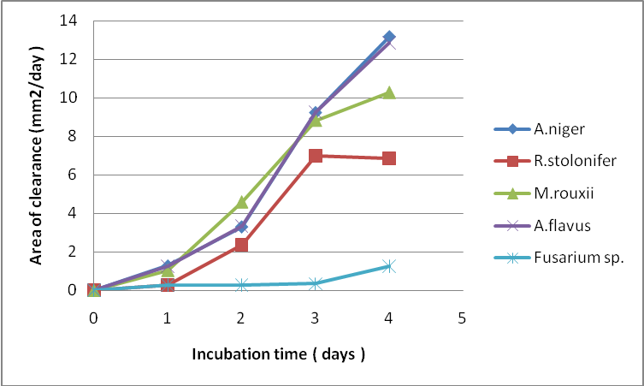
Fig. 1: Annular zone of clearance of mould isolates on milk agar at 28^{O}C.

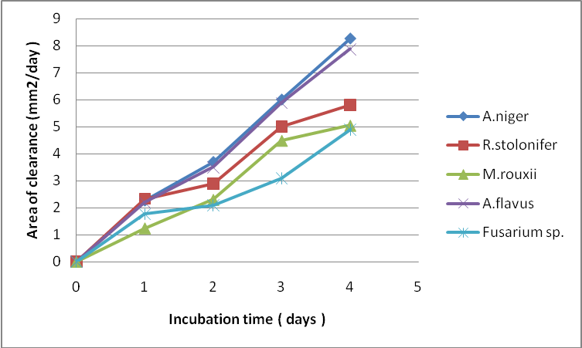
Fig. 2: Annular zone of clearance of mould isolates on starch agar at 28^{O}C.

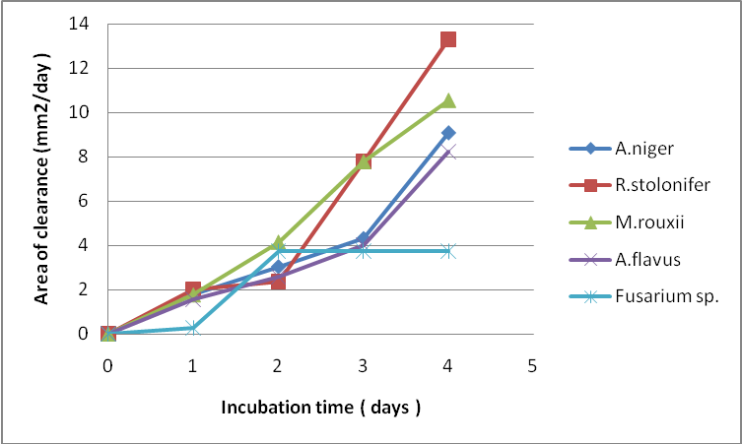
Fig. 3: Annular zone of clearance of mould isolates on olive oil agar at 28^{O}C.

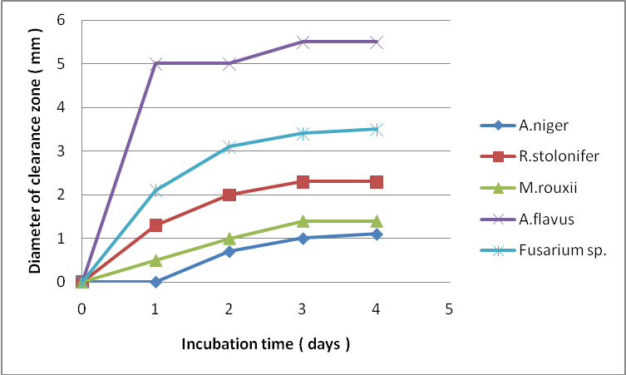
Fig. 4: Diameter of clearance zone of culture supernatant from mould isolates on starch agar at 28^{O}C.

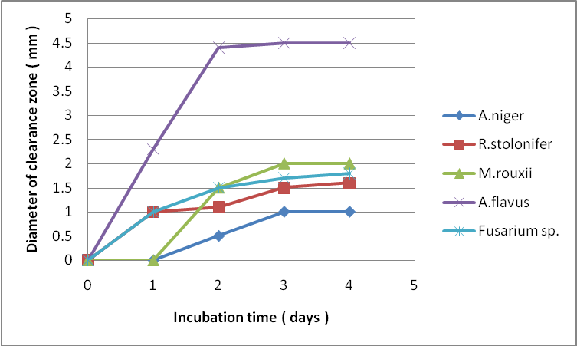
Fig. 5: Diameter of clearance zone of culture supernatant from mould isolates on milk agar at 28^{O}C.

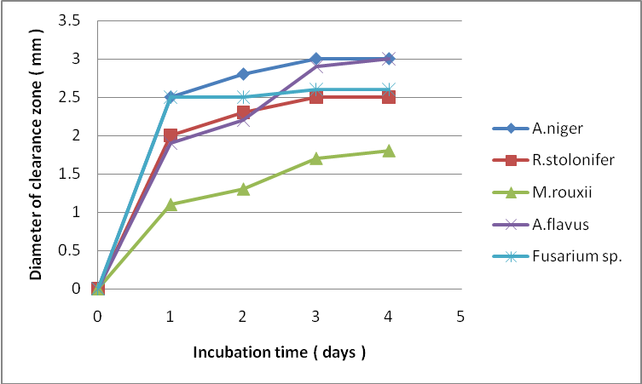
Fig. 6: Diameter of clearance zone of culture supernatant from mould isolates on olive oil agar at 28^{O}C.

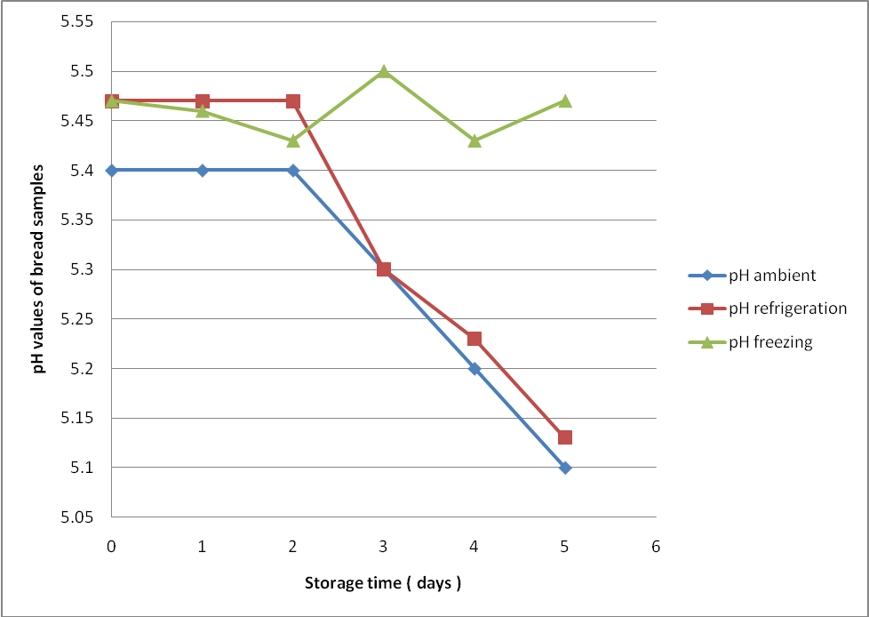
Fig. 7: pH of bread samples stored at different temperatures.

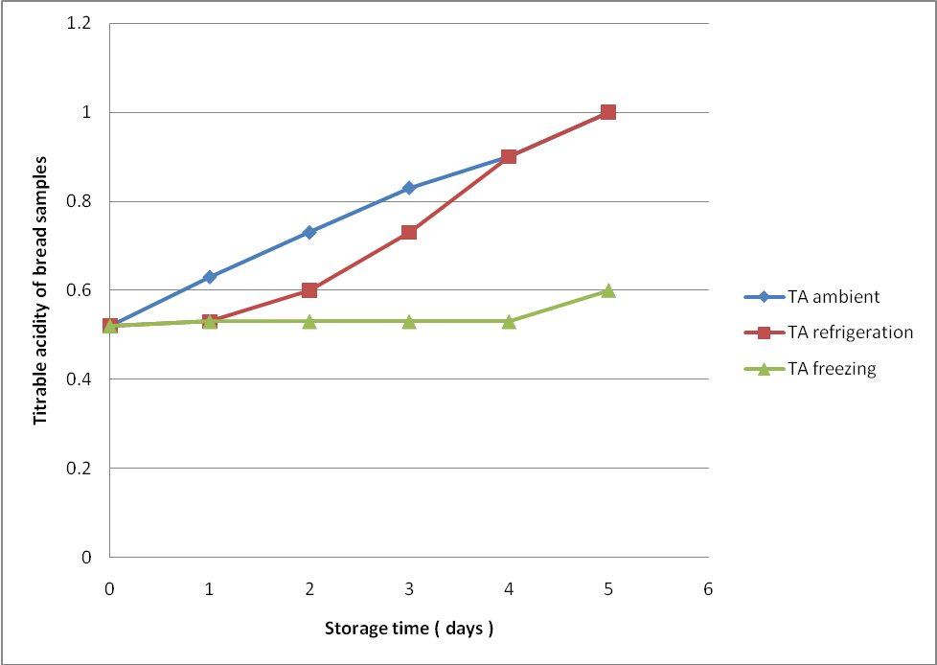
Fig. 8: Total titrable acidity of bread samples stored at different temperatures.

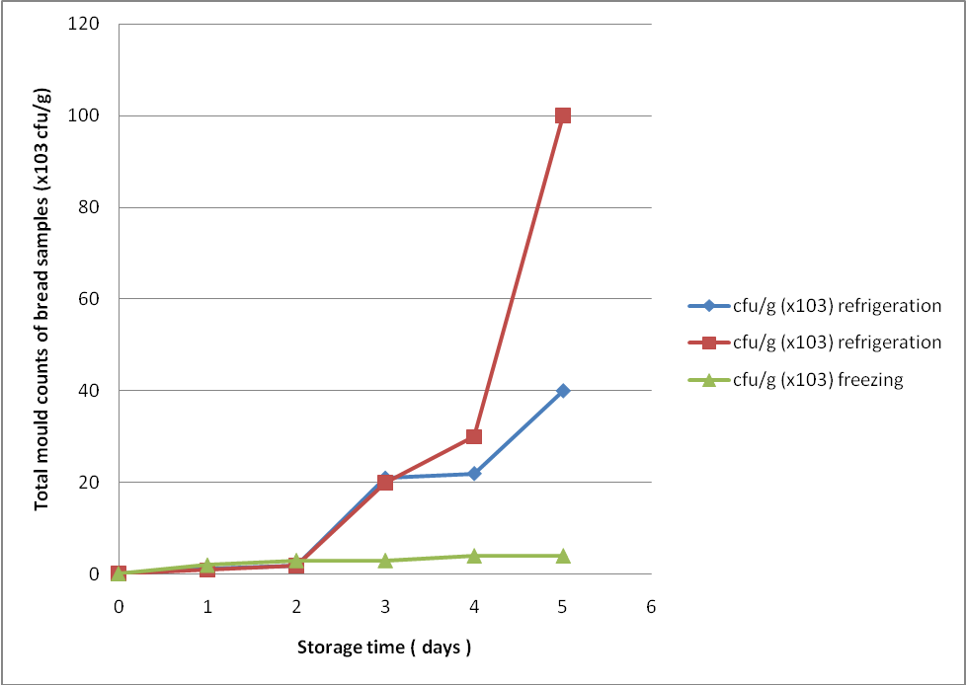
Fig. 9: Total mould counts of bread samples stored at different temperatures.

Table 1: Proximate composition of bread
Parameter | Values (%)
Moisture content | 33.70
Protein | 2.96
Fat | 3.40
Carbohydrate | 56.75
Crude fibre | 0.98
Ash | 1.74

Discussion
The results obtained from the study showed that A. niger, A. flavus, M. rouxii, R. stolonifer and Fusarium sp. are the predorminant moulds in bread and are responsible for its spoilage. This is in agreement with the findings of Abellana et al. (1997b). Aspergillus spp. are commonly responsible for the black and light green colours often observed on spoilt bread.
Studies on the hydrolytic activities of the isolates showed that the Aspergillus sp. used in the study have strong hydrolytic ability, especially to breakdown proteins and starch. This ability may have made them the organisms of importance in the spoilage of bread since they have the advantage of producing more enzymes for degrading the components in bread. Ikenebomeh and Chikwendu (1997) have also shown that Aspergillus spp. exhibit high amylolytic activity when grown on a starch substrate. Results of the proximate composition of bread show that bread contains 2.96% protein, 3.40% fat and 56.75% carbohydrate. This therefore implies that they will be able to degrade at a faster rate, and utilize the carbohydrate and protein components of bread. Aspergillus spp. especially A. oryzae have been used for the industrial production of enzymes through fermentation (Frazier and Westhoff, 2003; Olempska-Beer et al., 2006). M. rouxii and R. stolonifer produced appreciable levels of protease and amylase, thus indicating that they are equally of significance in bread spoilage. However, R. stolonifer and M. rouxii exhibited higher levels of lipolytic activity. The results of the hydrolytic enzyme activities therefore indicate that the proximate composition of bread may determine the type(s) of mould that would predominate and eventually cause the spoilage of the bread. For example, Aspergillus spp. which have shown high proteolytic and amylolytic activities may predominate in bread with high protein and carbohydrate content while M. rouxii and R. stolonifer would probably predominate in high fat breads. There is also need to study the effect of the presence of these major components in bread on the domination of a particular species since it is possible that the interaction of these components and other factors could influence the type(s) of moulds that would possibly grow and eventually cause spoilage.
Fusarium sp. showed poor proteolytic, amylolytic and lipolytic activities as indicated by this study. They are usually common contaminants of cereals in the field and can grow, proliferate and cause spoilage when moisture levels and water activity are high. Fusarium sp. have minimum water activity for growth at about 0.89, much higher than that of Aspergillus sp. (about 0.75 – 0.78) (Adams and Moss, 1999). Thus at the moisture level of bread ( 33.70% as found in this study) it may not be able to compete with Aspergillus sp. that are capable of growth and proliferation at low moisture levels.
The hydrolytic activities of the culture supernatants were found to be very poor although the culture supernatant of A. flavus produced the highest proteolytic and amylolytic activities. It could be that because spores were used to produce the culture supernatants, not much enzymes were produced that could hydrolyse the components to a high degree. The period of incubation may have too short for the germination of the spores and enzyme production. The volume of extractant used may be too much, thus the concentration of the enzymes in the final supernatant for the study may be too low to effect any appreciable level of hydrolysis.
Results obtained from the storage of bread at different temperatures show that the least mould counts were obtained from those stored at freezing temperatures. This, however, is expected since such low temperature prevents the growth of several microorganisms, and the moulds commonly found on bread are usually mesophilic in nature. It is, however, surprising that higher mould counts were obtained from bread samples stored at refrigeration temperature. The higher counts obtained could be attributed to some factors which include the initial fungal load on the bread before storage, the level of contamination of the packaging materials and handling (Jay, 2004). The drop in pH and resultant increase in the total titrable acidity in these bread samples could be attributed to the activities of the moulds which increased as the days of storage increased. Moulds, especially Aspergillus spp., produce organic acids when they grow on carbohydrates. In fact A. niger is used industrially for the production of citric acid (Frazier and Westhoff, 2003).
The incidence of A. flavus in the bread samples is of great health concern to the public. A. flavus produces aflatoxin in foods when they grow and are implicated in liver cancer in humans (Adams and Moss, 1999; Torrey and Marth, 1977). There is therefore need for more concerted efforts at preventing the contamination of bread by such organisms.
More work is needed to actually determine the interaction of the various components in bread and their influence on the moulds that may predominate during storage and cause spoilage.

Corresponding author:
Ogueke, C. C.
Department of Food Science and Technology, Federal University of Technology, Owerri, Nigeria.
e-mail: chikaogueke@yahoo.com

References
Abellana, M., Torres, L., Snachis, V. and Ramos, A. J. 1997. Characterizacion de diferentes productos de bolleria industrial: II. Estudio de la microflora. Alimentaria. 287: 51 – 56.

Adams, M. R. and Moss, M. O. 1999. Food Microbiology. The Royal Society of Chemistry, Cambridge.

AOAC. 1990. Official Method of Analysis. 15th edition, Association of Official Analytical Chemists, Washington DC.

Barret, F. 1990. Extending the keeping quality of bakery product. Baker’s Digest. 44(4); 48 – 49.

Canvian, S. P.and Young, L. 1998. Technology of bread making. Blackie Academy and Professional, London. pp31 – 73.

Earle, M. D. and Putt, G. J. 1984. Microbial spoilage and use of sorbates in bakery products. Food Technology New Zealand. 11; 25 – 36.

Frazier, W. C. and Westhoff, D. C. 2003. Food Microbiology. Tata McGraw-Hill Co. Ltd., New Delhi. pp674.

Jay, J. M. 2004. Modern Food Microbiology. 4th edition, CBS Publishers, New Delhi. pp620.

Legan, J. D. and Voysey, P. A. 1991. Yeast spoilage of bakery products and ingredients. Journal of Applied Bacteriology. 70; 361 – 371.

Lund, F., Filtenborg, O., Westall, S. and Frisvad, J. C. 1996. Associated microflora of rye bread. Letters of Applied Microbiology. 23; 213 – 217.

Northolt, M. D., Frisvad, J. C. and Samson, R. A. 1995. Occurrence of food-borne fungi and factors for growth. In: Introduction to food-borne fungi 4th, Samson, R. A., Hoekstra, E. S., Frisvad, J. C., Filtenborg, O. (eds). Centraalbureau voor schimmel-cultures, Baarn, Holand. pp243 – 250.

Obilie, E. M., Tano-Debrah, K. and Amoa-Awua, W. K. 2004. Souring and breakdown of cyanogenic glucosides during the processing of cassava into akyeke. International Journal of Food Microbiology. 93; 115 – 121.

Olempska-Beer, Z. S., Merker, R. I., Ditto, M. D. and DiNovi, M. J. 2006. Food-processing enzymes from recombinant microorganisms – a review. Regulatory Toxicology and Pharmacology. 45; 144 – 158.

Ogueke, C. C., Chikwendu, C. I., Iwouno, J. O. and Ogbulie, J. N. 2010. Effect of crude extract of Nauclea latifolia on some clinical isolates of food importance and its toxicological potentials. New York Science Journal. 3 (9); 97 – 105.

Potter, N. N. and Hotchkiss, J. H. 1995. Food Science. 5th edition. Chapman and Hall, New York. pp381 – 406.

Rhode, B. and Hartmann, G. 1980. Introducing Mycology by Example. Schering Aktiengese Illschaft, Hamburg. pp111.

Sanders, D. H. 1990. Statistics; A fresh approach. 4th edition. McGraw-Hill Inc., Singapore.

Suhr, K. I. and Nielsen, P. V. 2004. Effect of weak acid preservatives on growth of bakery product spoilage fungi at different water activities and pH values. International Journal of Food Microbiology. 95; 67 – 78.

Torrey, G. S. and Marth, E. H. 1977. Isolation and toxicity of moulds from foods stored in homes. Journal of Food Protection. 40; 187 – 190.

8/2/2010

