Retanning Agents for Chrome Tanned Leather based on Emulsion Nano-Particles of Styrene/Butyl Acrylate Copolymers

EL-Shahat H.A. Nashy ^{(a)*}, Ahmed I. Hussein ^{(b)} and Mohamed M. Essa ^{(b)}

Chemistry of Tanning Materials and Leather Technolog^{(a)}, Polymers and Pigments^{(b)} Departments, National Research Center, Dokki, Giza 12622, Egypt
E mail: Ismaelahmed1@yahoo.com

Abstract: Retanning process is one step of wet-finishing operations and is very important operation which overcomes the disadvantages of chrome tan. For this purpose two different nano-emulsions of styrene/acrylate copolymers have been prepared to be used as retanning agents. The main difference and characters of the two nano - copolymers were studied. The particle size of the two prepared co-polymers was proved by transmission electron microscope (TEM). The influence of the two prepared copolymers on chrome tanned leather as retanning agents was also studied. The properties of the retanned leather, namely, tensile strength and elongation at break were measured. Thermal stability and texture of grain surface and fibers were examined using thermal gravimetric analysis (TGA) and scanning electron microscope (SEM), respectively. All these parameters were the main target of this work and used to evaluate the applicability of copolymers as efficient ratannang agents. The retanned leather was achieved with an improvement of mechanical properties, enhancement of thermal stability, uniform dyestuff, softness and firmness grain. [New York Science Journal 2010;3(11):13-21]. (ISSN: 1554-0200).

Key words: Retanning agent, Chrome tanned leather, Nano-particles, Copolymers, Emulsion, Scanning electron microscope, Thermal stability, transmission electron microscope, Mechanical properties, Color difference.

1. Introduction
The tanning process is considered as one of the main processes in the tanning industry in which the raw hides and skins are transferred into leather. It is well known that chrome tan is still the major tanning agent ⁽¹⁾, and widely used over the world. It accounts over 80% of the activities in the tanning industry used for the production of the great majority of leather ⁽²⁾. Chrome tanned leathers are characterized by their light weight and high tensile strength ⁽³⁾. Chrome tan cross-links with polypeptide chains by principle valencies through coordination bonds with the acidic amino acid side chains of the collagen. The cross-links induce physical and mechanical properties that give the chrome tanned leathers its high quality ⁽⁴⁾. Although, there are some disadvantages of chrome tanned leather such as lack of fullness and course nap especially in suede leather. Chrome tannage is still the most widely used method in the tanning industry. In addition, hexavalent chromium was determined in mixture of Cr (III) and Cr (VI) in some Egyptians tanneries in wet finishing bath ⁽⁵⁾.
Therefore, many retanning agents were developed to improve the chrome tanned leather properties. In general, the most retanning agents are vegetable tan and phenolic synthetic/organic tanning materials. In addition, many trials of Acrylate polymers derivatives to be used as retanning agents ⁽⁶⁾ which are suitable for filling, softening, and even water proofing ⁽⁷⁾, air permeability ^{(8, 9)} or which combine all these properties. Many researches focused on grafting of different monomers onto the leather such as styrene ⁽¹⁰⁾ and acrylate derivatives ^{(11, 12, and 13)}.
But the grafting process needs a special procedure, which is not suitable for application in leather industry. The most suitable procedure must be applied in aqueous medium. Since, the leather industry has brought forward requirements for reagents which be used in leather industry must be applied in aqueous medium, non-pollutant, clear pore and fine grain of leather finished ⁽¹⁴⁾.
In this work, it is of interest to develop the conditions of retanning process in wet finishing operation to overcome the disadvantages of chrome tanned leather. For this purpose, nano-emulsions of styrene/butyl acrylate copolymers are prepared using different emulsion systems and applied as retanning agents for chrome tanned leather. The mechanical properties, thermal stability, dyeability in terms of color measurements and the texture of grain and fibers of the retanned leather were studied.

2. Material and Methods
2.1. Raw materials
- Styrene (St), butyl acrylate (BuA) were supplied by Aldrich and distilled with reduced pressure before use.
- Potassium persulphate, nonyl phenyl ethoxylated (NP9), sodium lauryl sulphate (SLS), sodium bicarbonate, ammonia water, methacrylic acid (MAA), acrylic acid (AA) were supplied from Sigma chemicals. Distilled water was used.

- Egyptian bovine hides were worked up in the tanning operation as usual in the conventional method by chrome tan (BCS).
- Sodium acetate, sodium chloride and other chemicals for leather processing were used without further purification.

2.2. Sample Preparation
a- Neutralization process
- The pH of chrome tanned hides was adjusted to be 5.5 using 0.25% sodium acetate (CH₃COONa) and 0.5% sodium bicarbonate (NaHCO₃).

b- Retanning process
- Retanning process was carried out on the neutralized leather with 8% of each of the prepared copolymer emulsions. Then, the retanned leather was washed with water and left to dry in fresh air by hanging at room temperature.

c- Dying process
- Dying process was done on retanned leather with acidic dye type (5%).

2.3. Pre-emulsion
Distilled water, emulsifiers, (St) and (BuA) were added into the flask equipped with high speed homogenizer for 30 min (in three time portions). The acid monomer (AA and/or MAA) is added during continuous homogenization.

2.4. Seeded emulsion polymerization
Polymer lattices based on (St), (BuA) as well as (AA) and/or (MAA) were prepared by semi batch emulsion polymerization technique with solid content of 50%. Distilled water, residual emulsifiers, NaHCO₃, part of initiator and part of pre-emulsion were added into the four-neck flask equipped with continuous stirring under reflux. The polymerization reaction was carried out at 80ºC using thermo stated water bath for 30 min under an inert atmosphere of N₂. When the reaction mixtures appeared blue and no evident back flow existed in the reactor, the remaining pre emulsion and initiator were step wise added into the reactor within 3 h. The recipe used for preparation of different compositions of polymer lattices is given in Table (I).

2.5. Mechanical Properties
Dumbbell shaped leather specimens, of 50 mm length and 4mm (neck width), were prepared used for the measurement of the tensile strength and elongation at break. These tests were carried out using a Zwick-1425 tensile tester 25 at 25ºC and cross-head speed of 50 mm min⁻¹ at room temperature. The test was carried out according to ASTM D 412.

2.6. Scanning electron microscope examination (SEM)
Specimens for this study were cut from the samples. Specimen size was 10 mm diameter and it was circular in shape. These samples subjected to sputter coating (Edwards’s model S 140A) of gold ions to have a conducting medium. Sputter coated samples were scanned with JEOL Model JSM-T20 SEM.

2.7. Thermal analysis
Thermal gravimetric analysis of the leather samples was carried out using Shimadzu TGA-50 apparatus to estimate the weight loss of the leather samples as a function of temperature ^{(15, 16)}. Thermal degradation was studied by heating the samples from ambient temperature up to 1000ºC.

3. Result Analysis
3.1. Characteristics of the prepared copolymer
Stable emulsions against salts, chemicals, storage stability and low coagulum during preparation were the main demand in production of styrene/butyl acrylate carboxylic acid emulsion. Many trials were carried out to get the optimum formulation for preparing styrene/butyl acrylate and carboxylic acid with stable properties for a period of six month.
Equation No. (1) represent the reaction of the two monomers.

Equation (1): Chemical reaction of the two monomers to form co-polymer

Different surfactant systems were also used as well as the initiator to get the optimum formulas. Table (1) represents the optimum formulations of the prepared emulsions.

Table (1): Recipe of optimum styrene/butyl acrylate emulsion co-polymers containing different ratios of styrene, butyl acrylate, acrylic acid or meth acrylic acid.
Ingredients (gm) | A | B
Styrene monomer | 30 | 23
Butyl acrylate monomer | 20 | 27
Acrylic acid | 2 | -
Meth acrylic acid | -- | 2
The emulsion recipe contain H₂O (54)gm, Potassium per sulfate (0.2) gm, NP9 (0.4) gm, Sodium lauryl sulfate (1.8) gm and Sodium bicarbonate (0.1) gm.

The physical, chemical as well as mechanical properties of the prepared copolymer emulsions were examined according to international standard as shown in Table (2). Also, pencil hardness test, bending test, washability of the film and adhesion to different substrate were examined to dried film and recorded in Table (2).

Table (2): Characteristics of the prepared two copolymer emulsions
Properties | Standard | Value
Properties | ASTM | A | B
pH⁽¹⁷⁾ |  | 8.2 | 8.1
Solids by weight, (%) | D 2369. | 49.1 | 49.8
Conversion, (%)⁽¹⁷⁾ |  | 99.8 | 99.8
Wet coagulum 100 mesh, (g/l) ⁽¹⁸⁾ |  | 1.1 | l.2
Particle size, (nm) | TEM | 93 | 63
Brookfield Viscosity RV #50 rpm, (cps) | D 2196 | 50000 | 40000
Surface Tension, (dynes/cm) | FTMS 2141 | 47.3 | 46.2
Chemical Stability | D 1308 | Excellent | Excellent
Stability Against CaCl₂ | D 3912 | Pass | Pass
Freeze Thaw -15°C pH 9.0, (cycles) | D 2243 | 4 | 5
Pencil Hardness test | D 3363 | HB | 2B
Bending test | D 522 | Pass | Pass
Washability (Cycle) | D 3450 | >5000 | >5000
Adhesion to PVC sheet | D 3359 | Gt_{o} | Gt_{o}
Adhesion to metal | D 3359 | Gt_{o} | Gt_{o}

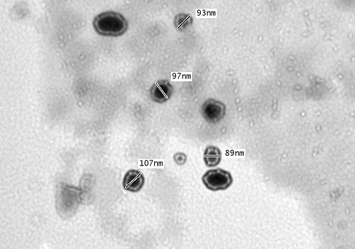
Fig. (1): TEM of the prepared emulsion co-polymer (A)
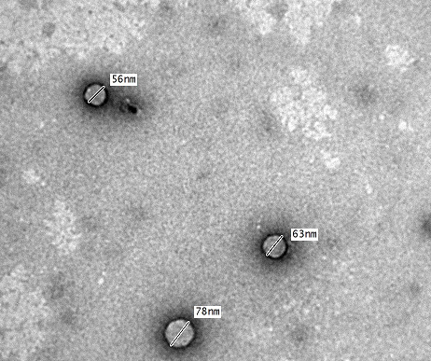
Fig. (2): TEM of the prepared emulsion co-polymer (B)

Figures (1, 2) show the TEM of the prepared emulsion lattices. It is clear from the above figures that the particle size of the prepared lattices was about 100 nm for copolymer (A) which prepared with high content of styrene and acrylic acid while the particle size of copolymer (B) was about 65 nm which prepared from high content of butyl acrylate and meth acrylic acid.
Also, the figures represent that the prepared lattices had homo dispersed particles with a shell of the carboxylic acid. It has also been reported that the hydrophobic/hydrophilic character of the monomer(s) used in emulsion polymerization has a decisive influence on particle morphology: according to some authors, macromolecules with an increase in hydrophilicity facilitate carboxyl ionization, resulting in higher particle swelling (increase in viscosity), particles with high contents of AA and/or MAA being completely solubilized⁽¹⁹⁾.
Usually, carboxylic acids are added to improve the mechanical, freeze-thaw, and pigment (dye) -mixing stability of the lattices. Carboxylic acid monomers are often completely soluble in water; however, they will still distribute to vary extents into the organic phase depending on their relative hydrophobicity. The most frequently studied acid monomers copolymerized with styrene are itaconic acid (IA), acrylic acid (AA) and methacrylic acid (MAA), listed in order of increasing hydrophobic nature.
Copolymerization of (IA), (AA) and MAA with styrene in separate reactions, the copolymerization rates were found to increase with the presence of carboxylic monomers in the order (IA) < (AA) < (MAA). The rate increased as the hydrophobicity of the monomer increased⁽²⁰⁾.
The use of AA tends to produce significant amounts of water-soluble polymer, and that portion of the acid copolymer that is in the particles is usually located near the outer surface of the lattices particles. With MAA, there is significantly less water-soluble polymer formed and the MAA copolymer in the particle is somewhat more evenly dispersed within the particle.

3.2. Mechanical properties
Strength properties have generally been given the greatest consideration in the evaluation of leather. The mechanical characters include the measurement of the tensile strength and elongation at break.
These characters were carried out according to the Egyptian standard method (ES – 123) and official methods, and an average value of at least five tests was taken for each item. Figure (3, 4) showed, in general, an improvement in the mechanical properties of treated leather by two copolymers than untreated leather one this may be due to the good adhesion effect of the copolymer on the fiber of the leather and also due to the filling of grain layer.
It was also noticed that the copolymer (B) improve the elongation comparing with copolymer (A). However, the tensile strength was improved by copolymer (B) than copolymer (A).
This can be attributed to the lubricating effect of copolymer (B) (higher ratio of acrylate which had elastic properties than styrene and also had smaller particle size) compare with copolymer (A).

3.3. Color Measurements
Leveling of the treated dyed leather samples were assessed by measuring the color difference calculated from the CIELAB coordinates (L*a*b*) and the k/s values of the treated dyed leather relative with untreated one. The CIELAB (L*a*b*) coordinates and the k/s values were measured using Ultra Scan PRO Spectrophotometer with D65 illuminant at 10º standard observer, Table (3).

Table (3): Color measurements of the treated leather samples in comparison with untreated one.
Type of Sample | L* | a* | b* | k/s
Without treatment | 43.99 | 12.80 | 30.16 | 9.77
Copolymer (A) | 40.42 | 11.53 | 22.22 | 8.70
Copolymer (B) | 42.17 | 11.00 | 23.68 | 8.49

The results listed in Table (4) showed that, the dye of the treated samples with copolymer (B) is characterized by a non significant decrease in lightness (L*), a more decrease in redness (+ a*), while the treated samples with copolymer (A) produced a significant decrease in lightness and the decrease in yellowness (+ b*) compared with the untreated one is greater than sample treated by copolymer (B). Moreover, it can be concluded that the treatment with copolymer (B) is preferable than that of using copolymer (A). In general, acrylate polymer in most cases can affect towards brightness of the dyed leather ⁽²¹⁾.
Hence, in the present work we use acrylate copolymers with styrene in different ratios to study the suitable ratio which can overcome the disadvantage of acrylate one.
The colorimetric data of the sample treated with copolymer (B) remains slightly unchanged relative to the untreated (blank) sample and also greater uniformity across the leather surface. This means that, the copolymer (B) can not affect on the color shade of the dyed leather.
3.4. Thermal Study (TGA)
The TGA and Dr-TGA curves Fig. (5 a, b and c) and Table (4) show that, the decomposition temperature of the copolymer- retanned leather is higher degrees than that of chrome tanned leather one. Thus, the incorporation of the copolymer into leather increases the thermal stability of the chrome/copolymer leather over that of the chrome tanned leather.
This improvement in thermal stability can be attributed to the formation of polymer – collagen composite.
Which can be explained by brought about multiple weak hydrogen bonding between the numerous carbonyl groups (C=O) of the copolymers and the countless hydrogen atoms of (NH) peptide groups, which support of the junction between the grain and corium.
These results indicate that copolymer filling up the empty parts of leather and lubricate the leather fibers.

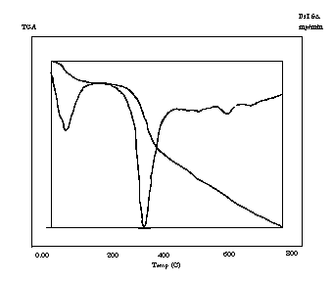
Fig. (5a)TGA & Dr-TGA of chrome tanned leather
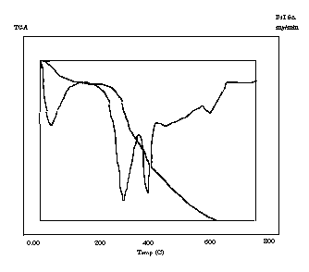
Fig (5c):TGA & Dr-TGA of retanned leather by copolymer (B)
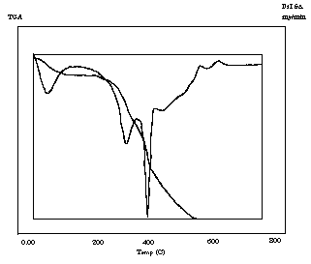
Fig. (5b): TGA & Dr-TGA of retanned leather by copolymer (A)
Table (4): TGA of chrome tanned leather and retanned leather by two co-polymers (A & B)
Temperature  weight loss (%) at | Chrome tanned leather | Chrome/polymer (A) | Chrome/polymer (B)
70 | 12.8 | 9.1 | 9.6
310 | 32.9 | 27.6 | 24.3
390 | 45.8 | 31.5 | 32.5
750 | 96 | 95.2 | 85.9

3.5. Scanning electron microscope (SEM)
A morphological study was carried out for the chrome tanned leather in comparison with retanned leather by two co-polymers (A&B). SEM of the grain surface (X50) and the cross-section of the (X1000) of the skin with and without copolymers were carried out to show the effect of the prepared copolymers on the grain and fiber bundles as retanning agents (Fig.5 a:c). SEM can be used to assess the penetration of the copolymer through the leather and into the hierarchy of the structure and is thus a useful technique for evaluating the effects of various treatments on the skin.
From the cross section micrographs in (Fig. 6 a:c) , it is clear that the chrome tanned leather fibers were completely separated from one another, but in the case of retanned leather fibers aggregates could be noticed.
In addition, SEM of the cross section of the leather fibers before and after retanning by the two copolymers showed a significant lubrication of fiber bundles (Fig. 6 a:c) and surface grain is of fine (Fig. 5b).
It was observed that the SEM of the samples retanned by copolymer (B) has a smooth fiber, firmness grain and modified handle, which are good evidence for the penetration and lubrication of two co-polymers onto the leather fibers and grain surface.
At the same time, the polymers don’t have any ill-effect on the grain surface with respect to finishing. The treated chrome tanned leather by two copolymers gives better grain smoothness, soft fibers, filling and modified handle. The filling of the grain layer improve buff ability for uses as corrected grain leather.

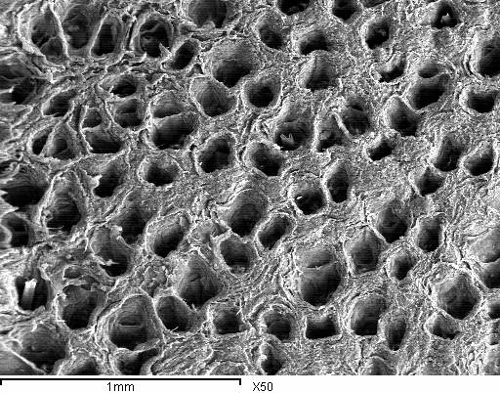 | 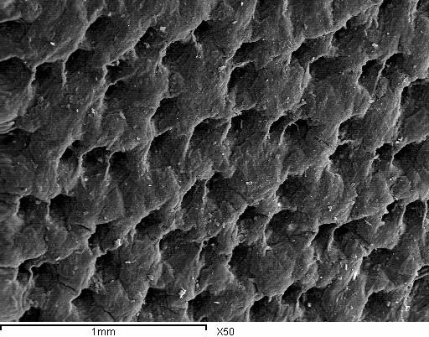
Fig (5a): SEM of grain surface of chrome tanned leather. | Fig. (5c): SEM of grain surface of chrome tanned leather retanned by copolymer (B).
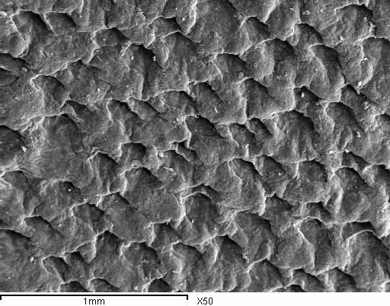 |  | 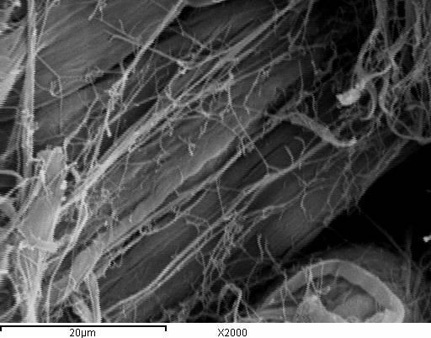
Fig. (5b): SEM of grain surface of chrome tanned leather retanned by copolymer (A). |  | Fig. (6a): SEM of fiber bundles of chrome tanned leather
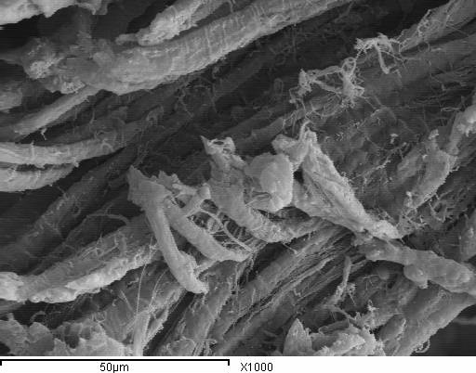 |  | 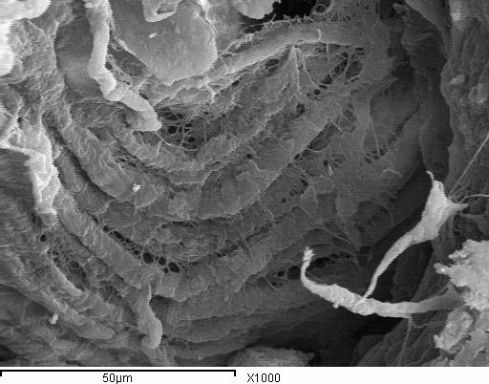
Fig (6b): SEM of fiber bundles of chrome tanned leather retanned by copolymer (A). |  | Fig. (6c): SEM of fiber bundles of chrome tanned leather retanned by copolymer (B).

4. Conclusions
The results of this work indicated that, the character of the finished leather is improved in the following respects:

*-Fullness and tight grain obtained due to the filling action of nano-particles copolymer by simple soaking in small amount of polymer .
*-The increasing of the styrene monomer content decrease the elongation with respect to the butyl acrylate due to its crystallinity.
*-Softness and improving the mechanical properties depend upon its lubrication.
*-Don't have side effect on uniform dyestuff especially with respect to copolymer (B).
*-Enhancement the thermal stability of treated leather.

5. References
1 Wachsmann H.; "Retannang or combination process"; World Leather, April, 64-65, (2001).
2 Hauber, C. and Germann, H. P.; "Investigation on a possible formation and voidance of chromate in leather"; World Leather, October 73-80 (1999).
3 Kiysztof Bieniewics: "Physical chemistry and leather making". Robert E. Malabar, Florida 32950, Chapter 4, (1983).
4 Srearam, K. J. and Ramasami, T.; "Sustaining tanning process through conservation, recovery and better utilization of chromium"; J. Resources Conservation and Recycling, 38, 185-212, (2003).
5 Eid, M. A., Nashy, E.H.A.; "Speciation of chromium ions in tanning effluents and subsequent determination of Cr(VI)"; ICP-AES, J.A.L.C.A., 97, 451, (2002).
6 Anton El-A'mma; "Structure property relationship of polyacrylate retanning agents"; J.A.L.C.A., 93(1),1-15 (1998).
7 A. El-A'mma, J. Hodder, P. Lesko, "A new lubricating acrylic syntan"; J.A.L.C.A., 86,1-7 (1991).
8 Jing Hu, Jianzhong Ma, Weijun Deng; "Synthesis of alkali-soluble copolymer (butyl acrylate/acrylic acid) and its application in leather finishing agent"; European Polymer Journal, 44, 2695–2701, (2008).
9 Jing Hu, Jianzhong Ma, Weijun Deng ; "Properties of acrylic resin/nano-SiO2 leather finishing agent prepared via emulsifier-free emulsion polymerization"; Materials Letters 62, 2931–2934, (2008).
10 O. A. Mohamed, A. B. Moustafa , M. A. Mehawed , N. H. El-Sayed; "Styrene and butyl methacrylate copolymers and their application in leather finishing"; Journal of Applied Polymer Science, 111, 3, 1488-1495, (2009).
11 M. A. Abd El-Ghaffar, N. H. El-Sayed, R. A. Masoud; "Modification of leather properties by grafting. I. Effect of monomer chain on the physico-mechanical properties of grafted leather"; Journal of Applied Polymer Science, 89, 6, 1478–1483 (2003).
12 Klásek, A. Kaszonyiová, F. Pavelka; "Grafting of 2-hydroxyethyl methacrylate and methyl methacrylate onto chrome tanned collagen fibers"; Journal of Applied Polymer Science, 31, 7, 2007–2019 (2003).
13 A. Klásek, J. imoníková, A. Kaszonyiová, F. Pavelka, L. Janda; "Grafting of 3-chloro-2-hydroxypropyl acrylate onto chrome tanned collagen"; Journal of Applied Polymer Science, 31, 7,2021-2033 (2003).
14 T. J. Madera-Sa; M. J. Aguilar-Vega; "Production of leather-like composites using chemically modified short leather fibers. (I): chemical modification by emulsion polymerization"; Polymer Composites,. 23,. 1; (2002)
15 H. Träubel;, R. Goffin, "Polyurethane retanning materials";, J.A.L.C.A., 130, 261-273 (1985).
16 Lakashminarayana, Y., Reddy, C.R. and chatlerjea, J. N.; Leather science, 31, 4 (1984).
17 Irja Piirma; "Emulsion polymerization"; Academic Press; New York London -Toronto Sydney San Francisco, 82 (1982).
18 Zhaoquan Ai, Rui Deng, Qilong Zhou, Shuijiao Liao, Hongtao Zhang; "High solid content latex: Preparation methods and application"; Advances in Colloid and Interface Science, 59, 1, 45-59(2010).
19 Snuparek J., Quadrat O, Horsky J.; "Effect of styrene and methyl methacrylate comonomers in ethyl acrylate/methacrylic acid latex on particle alkali-swellability, film formation and thickening with associative thickeners"; Prog Org Coat; 54(2), 99–103, (2005).

20 P. H. Wang and C.-Y. Pan.; "Preparation of styrene/acrylic acid copolymer microspheres: polymerization mechanism and carboxyl group distribution"; Colloid Polymer Science 280, 152–159 (2002).
21 Freeman, F. S. and Carrol; "The application of thermoanalytical techniques to reaction kinetics: the thermogravimetric evaluation of the kinetics of the decomposition of calcium oxalate monohydrate"; B., J. Phys. Chem., 62, 394-397 (1958).

8/1/2010

