PRELIMINARY REPORT ON THE EFFECTS OF DIFFERENTS SAUCES ON POUCHED TILAPIA PRODUCTS.

Omojowo Funso Samuel and Ihuahi Josiah Adoga

NATIONAL INSTITUTE FOR FRESHWATER FISHERIES RESEARCH (NIFFR), P.M.B. 6006, NEW-BUSSA, NIGER-STATE, NIGERIA.

omojowofs@yahoo.com, joeihua@yahoo.co.uk,

ABSTRACT: High quality stunted tilapia of the same size procured from Private pond in NIFFR were used for pouch studies. The fish samples were scaled, gutted, knobbed, washed, brined and pre-cooked. Ninety gram (90 g) of the pre-treated tilapia was added to 30g of either Tomato sauce or the Ginger-garlic sauce prepared and packed in a local pouch. The pouches were hermetically sealed using manual impulse sealer and sterilized in an Autoclave. Six hundred pouches were produced out of which 42% of the total production did not burst in the autoclave. From the pouch tilapia that did not burst and studied for six weeks, 47.4% of those in Ginger sauce were sterile while those in the tomato sauce have only 39.2% sterile. Shelf-life studies revealed that the non-sterile Pouch tilapia in ginger–garlic sauce had a longer shelf life of 5 weeks compared with a Tilapia-n-tomato sauce with a shelf life of 3 weeks. Organoleptically, results of overall acceptability, taste, colour and texture of the products shows that pouch tilapia in Ginger-garlic sauce at the fifth week had a better acceptance and significantly different (P<0.05) when compared to pouch tilapia of the third week of storage. [New York Science Journal 2010; 3(5):83-86]. (ISSN 1554 – 0200).

Key words: Tilapia, tomato sauce, ginger-garlic sauce and pouch.

INTRODUCTION
The advantages of packaging food products in the retort pouch includes reduction in processing times by as much as 50% as compared to a comparable sized can, jar, or other cylindrical container. There are also additional advantages which include reduced shipping costs and storage space for the empty containers. The pouch also has good shelf appeal and a growing acceptance by consumers (Michael, 2006). Retort pouches guarantee hermetic closure and permit ease of opening. They can withstand high sterilization temperature, pressure, and provide excellent oxygen and flavor barrier (Brody, 2003). The choice of tilapia is due to the fact that tilapia is a prolific breeder, and has been found to be a good candidate for canning by previous studies. However, due to the enormous cost of establishing a cannery and the recent attention to retort pouch processing, this study is intended therefore at carrying out a preliminary packaging of Tilapia in pouches using different sauces, with the aim of exploiting its abundance, and making it available to consumers all year round.

OBJECTIVES
- To develop different sauces for tilapia products.
- To develop and produce pouch Tilapia products that is shelf stable

MATERIALS AND METHODS
High quality stunted tilapia of the same size are selected for this processing. The processing was carried out in a step-by-step procedure as follows;

Raw Material Handling: There is a direct, and unavoidable, relationship linking raw material quality and end product quality, and this holds as much for the production of pouch fish product as it does for fish which is bought fresh and prepared in the home. Fish samples were trimmed to remove bruises and other localized flesh defects. Fish of uniform and good quality stunted tilapia were used, so that the finished product is of a constant standard.

Pre-treatment: The fish samples are scaled, gutted, and knobbed. They samples were later washed in clean water and brined. It can be frozen at this stage if not used immediately. These operations were carried out manually. Though it is better to use machines rather than rely on manual operations (machines of such are not available). All of the pre-treatments (particularly those in which flesh is cut.), were carried out under conditions of good manufacturing practice.

Pre-cooking: Pre-cooking was carried out in water for the following reasons:
1. To partially dehydrate the flesh and prevent release of those fluids during retorting which would otherwise collect in the container;
2. To remove natural oils, some of which have a strong flavour;
3. To coagulate fish protein and loosen meat from the frame;
4. To develop desirable textural and flavour properties.

Preparation of Sauce: Tomato sauce and Ginger-garlic sauce were prepared differently to provide an alternate source of sauce to the tilapia and to evaluate which is better in their keeping quality.

Filling: Filling operations was carried out manually. About 90 g of the tilapia and 30g of either the Tomato sauce or the Ginger-garlic sauce as the case may be, were packed in a retort pouch. Samples of this pouch tilapia are shown in Plate1below.

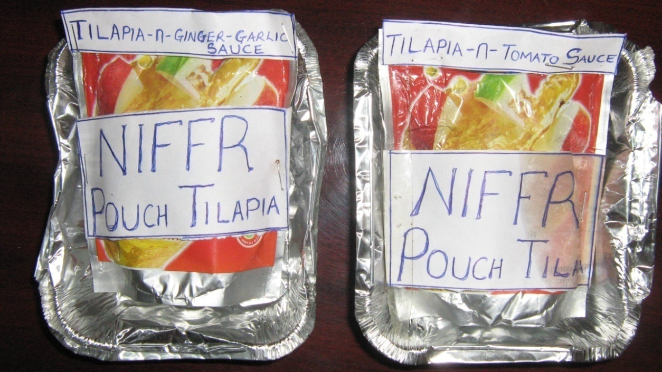
PLATE1: SAMPLE OF THE POUCH TILAPIA.

Sealing: Central to the success of the entire fish retort pouch processing is the hermetic sealing. Ninety gram (90 g) of the tilapia and 30g of sauce were hermetically sealed in a three-layer configuration of polyester, aluminium and cast polypropylene pouch. The sealing was done using manual Qlink Advanced pro-series impulse sealer. Model no QNS 3200HI, item no LB032.

Sterilization: A Retort pouch machine was not available for this experiment. However, the sealed pouches were sterilized in an Autoclave at 115º for 30mins.

Microbial analysis
Total viable count (TVC), Coliform and Staphylococci were evaluated according to the methods described by Harrigan and McCance 1976; and Sneath et. al., 1986). All samples were done in duplicates. Sensory evaluation was carried out according to the method of Afolabi et. al., (1984). Statistical analysis was according to SAS, Institute, Inc, (1992) at P < 0.05.

RESULT AND DISCUSSION
Microbial Analysis
A study for the determination of the Total viable Count (TVC), coliforms and Staphylococcus of the pouch tilapia is required to evaluate the level of contamination (FDA, 2001) of the pouch after the hermetic seal and sterilization of the pouch. Six hundred batches were produced out of which 252 batches representing 42% of the total production did not burst. 240 pouches were selected of which 120 pouches contain Ginger-garlic and 120 contain Tomato sauce respectively. Out the 120 Ginger-garlic sauce pouch tilapia studied for six weeks, 47.4% of it were sterile while those in the tomato sauce have 39.2% sterile as shown in Table 1. Summarily 43.3% was sterile at the end of the six weeks. This higher percentage in ginger-garlic sauce may not be a coincidence since Ginger and garlic have been reported to have antimicrobial properties (Ihuahi and Omojowo, 2008; Idris et.al, 2010).
All the samples were sterile immediately after autoclaving. However, after a week there are presence of contaminants which may be due to aerobes gaining access to the sealed pouch. In the microbial analysis, no coliforms and staphylococcus was detected in the pouch tilapia samples. The TVC of the pouch tilapia is shown in Table 2, where the Tilapia-n-tomato sauce reaching a bacterial load of 8.6x10³ cfu/g. This corresponds to the point of spoilage and rejection, as shown by the taste panel results in Table 3. However, the Tilapia-n-Ginger-garlic sauce was only spoilt and rejected at the sixth week reaching a bacterial load of 6x10³ cfu/g, as shown below in Table 2.

Table 1. Percentage of Sterile and Non-Sterile Tilapia Pouch in Two Different Sauces Per Batch of Production at the End of Sixth Weeks of Storage.
Duration | Number of pouch per sauce | Ginger-garlic sauce |  | Tomato sauce
 |  | Sterile | Non-Sterile | Sterile | Non-Sterile
Week 1 | 20 | 9 | 11 | 9 | 11
Week 2 | 20 | 8 | 12 | 8 | 12
Week 3 | 20 | 10 | 10 | 8 | 12
Week 4 | 20 | 10 | 10 | 7 | 13
Week 5 | 20 | 9 | 11 | 8 | 12
Week 6 | 20 | 11 | 9 | 7 | 13
TOTAL | 120 | 57 | 63 | 47 | 73
Percentage |  | 47.4% | 52.6% | 39.2% | 60.8%

Average Percentage Successful = 47.4 + 39.2%/2
= 43.3%

Table 2: Total Viable Count (TVC) of Non-sterilized pouch tilapia in Log cfu/g
Products | Day 0 | Week 1 | Week 2 | Week 3 | Week 4 | Week 5 | Week 6
Tilapia - n - tomato sauce: in cfu/g | 0 | 0.24± 0.2  cfu/g | 1.53± 0.6  cfu/g | 1.72± 0.7  cfu/g | 3.46± 1.2  cfu/g | 4.23± 0.5  cfu/g | 6.37± 0.3  cfu/g
Tilapia -n- Ginger/ garlic sauce: | 0 | 0.10±1.1  cfu/g | 0.10±0.2  cfu/g | 1.26±0.3  cfu/g | 1.42±0.6  cfu/g | 1.60±1.0  cfu/g | 3.6± 0.2  cfu/g

ORGANOLEPTIC ASSESSMENT
The qualities of the Pouch tilapia-n-sauces were evaluated on a weekly basis for 5 weeks on appearance, taste, flavour, texture, and overall acceptability. The pouch overall score was given to pouch tilapia in both sauces using a hedonic scale of 1- 5 (5= like much, 4 = like, 3 = neither like nor dislike, 2 = Dislike and 1= dislike. Fish scoring 2 or less being regarded as unacceptable. Sensory assessment scores on the quality of pouch Tilapia stored in the shelf are shown in Table 2. I will like to point here that probably due to the equipment available as at now and the manual methods employed throughout the processing, about 60% of the pouch Tilapia assessed were contaminated. These contaminations have been known to be due to post process leaker spoilage. However, Pouch Tilapia in Ginger–garlic sauce kept on shelve were organoleptically acceptable to the taste panel till the 5th weeks while Pouch Tilapia in tomato sauce kept on shelve were organoleptically acceptable to the taste panel till and 3rd weeks of storage.

Table 3: Mean and standard Deviation of the Organoleptic Assessment of Pouch Tilapia with Different Sauces.
 | Appearance | Taste | Flavor | Texture | Acceptability
Week1: pouch A  Pouch B | 5.0 ± 0.0  5.0 ± 0.0 | 5.0± 0.0  4.7± 0.3 | 4.8± 0.2  4.5± 0.6 | 5.0± 0.0  4.7± 0.02 | 5.0± 0.0 ª  4.6± 0.3^{bc}
Week2: pouch A  Pouch B | 5.0 ± 0.0  4.8 ± 0.2 | 4.8± 0.2  4.2± 0.01 | 5.0± 0.0  4.5± 0.05 | 4.9± 0.3  4.1± 0.4 | 4.8± 0.1 ^{ab}  4.4± 0.2 ^{c}
Week3: pouch A  Pouch B | 4.8± 0.2  3.6± 0.4 | 4.6± 0.3  3.9± 0.5 | 4.8± 0.3  3.7± 0.6 | 4.6± 0.4  3.5± 0.1 | 4.6± 0.4 ^{bc}  3.5± 0.7 e
Week4: pouch A  Pouch B | 4.2± 0.6  2.4± 0.3 | 4.1± 0.0  **** | 3.9± 0.07  2.3± 0.3 | 4.8± 0.2  3.0± 0.2 | 4.0± 0.5 ^{d}  2.6± 0.2 ^{f}
Week5: pouch A  Pouch B | 4.0± 0.2  1.2± 0.01 | 3.8± 0.0  **** | 3.9± 0.2  1.1± 0.1 | 3.4± 0.3  1.0± 0.2 | 4.1± 0.03^{d}  1.0± 0.1^{g}
Week6: pouch A  Pouch B | 1.5± 0.0  **** | ****  **** | 1.3± 0.0  **** | 1.2± 0.0  **** | 1.0± 0.0 ^{g}  ****
**** = Not Assessed, Mean with different superscript ^{a-g} under the acceptability column is significantly different.
Pouch A = Pouch Tilapia-n-Ginger garlic sauce
Pouch B = Pouch Tilapia-n-Tomato sauce

Constrains
- Pouch machine not accessible and available.
- Standard and imported packaging materials were not available

Conclusion and recommendation
This project stands a greater chance of giving National Institute For Freshwater Fisheries Research, New-Bussa, Nigeria; a breakthrough, since 43.3% of the pouch tilapia maintain a sterile state. This project also have the potentials of improving the welfare of the artisanal fishermen since the low priced and often discarded stunted tilapia will now be sold at a valuable price and utilized in project of this magnitude. Though, the ultimate aim of hermetic sealing is for the pouch to be in sterile state. Notwithstanding, among those that were not sterile, and stored for shelf-life studies revealed that Pouch tilapia in ginger–garlic sauce had a longer shelf life than those in tomato sauce. This experiment is at the preliminary stage, and if the right materials and equipment are assessed there is great chance of high success.

5.0 Acknowledgement.
The author is grateful to Dr Aminu Raji, The Executive director of NIFFR, New-Bussa, Niger-state, Nigeria for sponsoring this research work. Other Technologist in Fish Technology division are acknowledged.

Correspondence to:
Omojowo Funso Samuel,
National Institute for freshwater Fisheries Research (NIFFR). P.M.B. 6006, New-Bussa, Niger-State, Nigeria.
E-mail: jowosam@yahoo.com,
G.S.M:08073536126

REFERENCES
- Afolabi OA, Arawomo OA, Oke LO. Quality changes of Nigerian traditionally processed freshwater fish species. I. Nutritive and organoleptic changes. Journal of Food Technology, 1984 19, 333-340.
- Brody AL. Stand up and cheer. Food Technology, 2003, Vol. 57(11). Pp 73-75.
- FDA, Department of Health and Human Services. FDA & EPA Safety levels in regulations and Guidance. In Fish and fisheries Products, Hazards & controls guidance: Third Ed. 2001. Appendix 5, p. 285.
- Harrigan WF, McCance MF. Laboratory Methods in Food and Dairy Microbiology, 2nd Edn. 1976, London: Academic Press.
- Idris GL, Omojowo FS, Omojasola PF, Adetunji CO, Ngwu EO. The Effect Of Different Concentration Of Ginger On The Quality Of Smoked Dried Catfish (Clarias Gariepinus). In: Nature and Science Journal, 2010: Vol. 8 (4); 58-63. Accepted for publication.
- Ihuahi JA, Omojowo, FS. Anti-Oxidative Effect of a Mixture of Pepper and Garlic Spices on the Quality of Hot-Smoked Catfish (Synodontis nigrita). In: Biological and Environmental Science Journal for the Tropic.2008. Vol. 5(2):104-109.
- Michael B. Processing Pouches - an overview. 2006 (c) Copyright, Allpax Products, Inc, 2003.
- SAS Institute, Inc. SAS User’s Guide: Statistics. SAS Institute Inc. 1992, Cary, NC.
- Sneath PHA, Mair NS, Sharpe ME, Holt JG. Bergey’s Manual of Systemic Bacteriology, 1986, Vol. 2. Baltimore: Williams and Wilkins.
- United States Food and Drug Administration (USFDA). Bacteriological Analytical manual, 1998. 8th Edition.

2/1/2010

