Development of an Ion Emitter with Hollow Cold Cathode

Djamel Boubetra
Laboratoire des Matériaux et Systèmes Electroniques
Centre Universitaire de Bordj Bou Arréridj 34000, Algeria

Abstract: Ion physics forms the basis for numerous modern technologies and research directions such as microelectronics, material research, analytics or high-energy physics.
The reason for the broad range applications of ion physics lies in the ions characteristics:
-The ions possess a mass, which makes a direct energy transfer possible to the solid atoms (flexible energy transmission);
-The velocity of the ions can be multiplied by multiple ionisations in usual electrostatic accelerator installations.
-The ions interact also with the electrons of the target material; this reciprocal effect is speed dependent and particularly effective, if the particle speeds are comparable;
-The ions transporting characteristics with itself, which correspond to their chemical elements, from which were produced;
-The ions can overcome the Coulomb barrier at high speeds with the impact with the target atoms and cause a nuclear fusion, whereby it comes afterwards to a nuclear explosion and to sending of elementary particles;
-The ions can be bundled to particle beams with high energy and impulse density and be used thus as tool for metalworking.
Although ion physics is a basic science in the most diverse fields, it exists mostly not as independent Discipline, but as application method within other science ranges.
The development in this area carried of some specialists, who are active in different specialist areas.
The most important sub ranges of ion physics are the ion production, the ion beam forming and the ion beam guidance.
These aspects are gathered in the Monograph from I.G. Brown (Aitken, 1989). In addition a number of other recapitulate works over ion sources was published
For the sub ranges of ion physics it is characteristic that progress in this area is obtained by skill and experience by specialists and the results in the connection a physical reason experiences. This applies in particular to the ion source development (Domonkos, 1999; Pessoa et al. 2006). With the beam forming and guidance come more computer simulation into the play, in order to before-compute favourable geometrical arrangements.
Because of the procedures complexity in the combustion chamber of an ion source and the sensitive dependence of the ion source points on the kind, geometry and fuel parameters of the ion source often the task exists to optimize parameters, to the beam forming empirically in ion physics, which we want to examine with a cold cathode discharges.
The aim of the present studies was to obtain experimental observations about the main features of hollow cold cathode discharge in order to evaluate its capability of generating compounds in the plasma medium, by reaction between sputtered species from the cathode and radicals from the gas discharge.
[New York Science Journal. 2008;1(4):4-13]. (ISSN: 1554-0200).

Keywords: Ion physics, Ionization process, Cold cathode, Ion emitters

INTRODUCTION

Cold cathode discharge is an independent gas discharge, i.e. the transformation of energy in discharge guarantees the constant reproduction of a discharge cycles. The current-voltage- characteristic is negative in the range of the glow discharge. The operating tension decreases with increasing current flow.
If not a current limiting the process of the nuclear chain reaction in the discharge would stop, it would come to the destruction of the arrangement or outside operating devices.
The characteristics of a gas discharge against to current transportation in Solid and liquid exists in the existence of ions and electrons, which are involved in current transport at the same time.
The large mass difference between ions and electrons with same charge, those on behalf different polarity of their charges and their different reciprocal effect mechanisms with the electrodes discharges lead to some peculiarities, which we will soon represent , like the ionization process, potential and field process in a gas discharge, the pressure dependence, the influence of magnetic fields, the extension of the ionization way, the plasma compression, plasma compression by magnetic field, and the geometrical plasma compression.
At the ion accelerators investigations would be accomplished for the reciprocal effect by ions with solid surfaces (Boubetra, 2007).
The ion beam serves thereby as measuring x-ray for ion metric investigations as Rutherford bakes scattering, ion-induced X-raying and Auger electron emission, as suggestion probe with defined suggestion for the observation of optical, acoustic or thermal signals, or as work jet for the layer mixing, alloy formation and defective generation with the ion implantation. The application types of such plant are determined crucial by the characteristics of its ion source.
Interest is the service life of the ion gun in continuous operation, the composition of the ion beam, the amperage, the power requirement, the charge-states of the produced ions etc....
Under this aspect was necessary the occupation with development of new ion source types.

Lately turned out in addition, the need to have a low-energy ion emitter, which could be used for various applications in the laboratory, like layer demolition, layer solidification, atomization, etching or similar surface processing (Boubetra et al., 2007).
In addition it could dedicate oneself to questions by employment of a low-energy ion emitter in combination with the accelerator to the dynamics of the energy and particle transport by the ion bombardment of solids. From this broad application field derived as most important demands on the characteristics of the ion gun:
- Cold Cathode Ion Source
- Small power conversion for the avoidance of complicated cooling devices;
- Small gas charges of the vacuum installation by the ion gun services.
- High current density and probe current density with small extract tensions;
- High service life ;
- Simple handling and optimization;
- Exclusive service with permanent gases, predominantly with noble gases.

MATERIALS AND METHODS

Cold Cathode Ion sources are based on the effect of the field emission (Beckey, 1971), high frequency of a plasma (Valyi, 1977), the glow - or hollow cathode discharge (Mingxiu et al., 1987), or Penning discharge (Penning, 1937).
The field ion source is unsuitable for the production of high ion stream.(Valyi, 1977), it must to produced electrical field intensity of 10⁷V/cm within the ionization region, e.g. in order to ionize noble gas atoms. also with macroscopic small distances high service tension is necessary, so that those power conversion takes place essentially at the anode needle; Although the emission current densities are high, the total value of current is small ( nA ).
In the last years were developed liquid metal ion sources according to this principle (Swanson et al., 1989).
Lately the microwave plasma as ion source is used frequently. It makes possible the ions production with small gas pressure (10⁻⁵mbar) with high emission streams.
By suitable magnet traps in the source area it can produce very effectively multi charged ions (so-called ECR sources (Jongen et al., 1989))..
The sources are usable as stationary instruments in the laboratory, but unmanageably for the meant application domains and from safety reasons are unsuitable for routine works.
The glow- and hollow cathode ion sources work at high gas pressure between 0,1 and 1 mbar.
With these gas pressures the gas flow is large by the outlet of the ion source, and the gas charge of the vacuum systems is considerable, a compression phase with separate evacuation distance becomes mostly necessary. By this vacuum-technical expenditure is unsuitable also this type of source for the general, uncomplicated employment in the laboratory.
The Penning sources (Fig. 1) bring with itself favourable conditions.
With this type of source is the cylindrical anode of the gas discharge between two parallel to each other-lying cathodes. Perpendicularly through the cathode metal sheet and parallel to the anode cylinder axles, runs a magnetic guide fields of approx. 0,1T magnetic induction. The ion source burns with gas pressures under 10⁻³mbar, and related to the discharge stream it supplies a high emission current. The power conversion in the source is around 10W, and the small discharge current is determined by the ions. Because the electrons will be prevented from the charge transfer in a kind magnetic case and served predominantly only for the ionization of the gas atoms in the source. Disadvantage of the source is the small service life; there due to the atomization of the cathode materials, the function is temporally limited by pollution of the insulators in the source and by atomization of the cathodes. In addition the absolute emission stream is small and can be increased only by gas pressure increase and slightly of the Burning voltage.

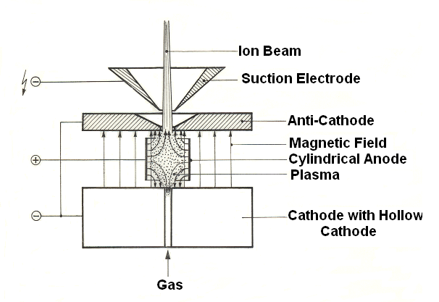
Figure 1. Schematic of a Penning source with axial ion extract:
With the Penning ion source the ions are produced in the plasma area, because the Gas reinforcement is not sufficient for the production of the necessary charge carriers density in the cathode fall area.
The life span of the electrons and concomitantly their ionization probability in the gas volume are very large by the oscillating motion between cathode sheet metals. It is sufficient for the maintenance of the currents conduction.

An interesting suggestion for the development of a cold cathode ion source supplies the Magnetron Sputtering arrangement (Fig. 2).
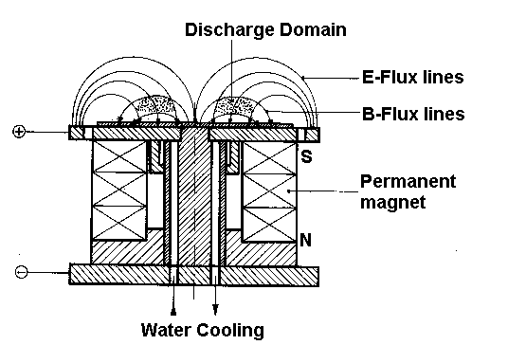
Figure 2. Schema of a Magnetron sputtering assembly. The electrical and magnetic flux lines process is schematically represented.
As accumulation point is marked the place, which is characterized by an intensive luminescent appearance and can be considered as ions source for
the substrate atomization (plasma range).

It consists of a magnets pot arrangement with a target as cover plate, which is switched as glow discharge cathode. The environment (recipient) or a cylindrical outer cover around the pot magnet forms the anode, the discharge burns already with low pressures between
5.10⁻³ and 10⁻²mbar, whereby are possible the discharge stream of more than 1A during a burning voltage of 400V, The conversion power at the cathode requires therefore a water cooling, whereby at the same time takes place a strong atomization of the target material. Characteristic of this sputtering arrangement is a circular glow fringes in the range of the magnetic scattering field between the magnetic poles. From also is the main part of the ion stream originates, which causes the atomization of the target.

PRESSURE DEPENDENCE

With high gas pressure p the electrical field force E must be high, so that on the mean free path λ the electrons receive still sufficiently much energy, in order to be able to ionize gas atoms at the collision. Thus the conditions e₀.λ.E = e₀.U_{i} must be fulfilled for similar discharges, where U_{i} means the ionization energy. From this follows the Paschen law E/p=cte. for independent gas discharges (Valyi, 1977), since λ ~1/n ~1/p is in reverse proportional to the particles densities and thus the gas pressure p. if the gas pressure becomes small, then the mean free path of the electrons becomes comparable with the container dimensions. The ionization distance d is too short for a sufficient Gases reinforcement. Z is the minimum number of the successive impact events of an ionization cascade for the necessary gases reinforcement of a discharge, then λ.Z must be smaller than the container dimensions. At a hollow cathode discharges the gas reinforcement takes place within the hollow cathode, and the plasma is enough into the opening inside of the hollow cathode, how fig.3 shows. So that the discharge conditions remain constant in a hollow cathode on change of the gas pressure, all cathode wall distances to the opening of the hollow cathode must change in the same way. i.e. the hollow cathode would have to possess sphere forms of the radius R = λ.Z.

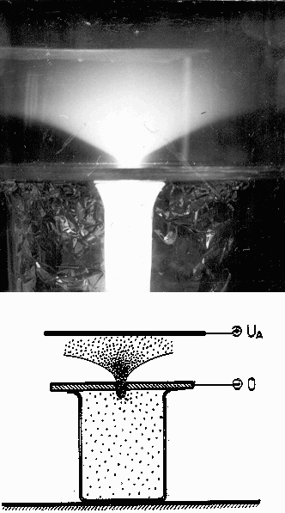

Figure 3. Photography and Schema of a hollow cathode discharge.
A beaker was on the inside deflected up to a slot with aluminium foil.
By a cover made of metal with a drilling in the centre it became the hollow cathode discharge. One recognizes clearly, how the plasma pulls itself in into the hollow cathode and the cathode fall extends itself thereby in the total interior of the hollow cathode.
The experiment shows that actually for same discharge parameters with pressure decreases a sphere form volumes is necessary, its size goes up inversely proportional to the pressure (see Fig.4).
The exact evaluation of the experiment results in however that even with very large volume stills another pressure of 5.10³ mbar is necessary. The explanation for the fact consists that the gas reinforcement runs off particularly within a critical range in the proximity of the plasma boundary layer.
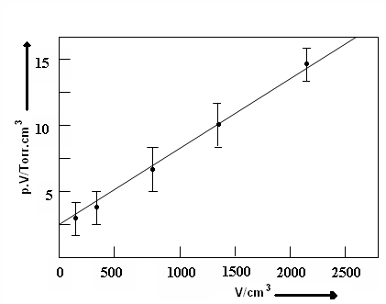
Figure 4. Pressure dependence of the volume of a hollow cathode for same discharge conditions.
As characteristic size the pressure was determined, with which discharge under same electrical conditions expired. Therefore small discharge pressures require large volumes of the hollow cathode.

Outside of this critical distance takes place any more gas reinforcement, because then the electrical field force becomes too small, because of the quadratic distance laws just from the source point (opening of the hollow cathode). The situation is here comparable with a counter, where the substantial contributions are reached for Gas reinforcement because of the high gas pressure within the range of the counting wire (anode). In addition the ions lose energy by gas dispersion, which is not completely replaced by the weak electrical field close of the cathode surface. Thus also the electron yield sinks at the cathode. Both effects require therefore a minimum gas pressure for a glow discharge. If the mean free path of the electrons and their energy gain on this distance

is smaller than the ionization energy for the gas atoms, it comes to no training of discharges (ranges of high gas pressures or low field strengths). It comes to the training of ionization streams, however without ignition of a gas discharge, if the anode- cathode distances lie in the order of magnitude of the mean free path of the electron. Loads flow, however their current contribution is small, because the gas
Reinforcement is missing (obstructed discharge). This effect can e.g. also obtain, if one makes the mean free path comparable with the electron distances by dilution of the gas (obstructed discharge in low pressure: High vacuum range). To a disruptive discharge it can come then only by adsorption or field emission processes due to high electrical field strengths at the electrodes.

THE EXTENSION OF THE IONIZATION WAY

The magnetic guide field plays a crucial role in numerous ion sources. With electron collision ion sources for the mass spectrometry (Ewald et al., 1953) a magnetic field parallel to the flux electrical lines provides for a bundling of the electron-beam, and thus for a high yield, a spatially fixed developing place of the ions.
With the Freeman ion source (Aitken, 1982) the glow cathode is arranged axially in a cylindrical anode, and an axial magnetic field ensures for the fact that the electrons do not arrive directly at the anode, but describe the way between cathode and anode in cycloid courses.
With the Calcutron-Ion source (Aitken, 1982) the electrons are emitted by a laterally appropriate cathode and sucked through an opening into the anode region. A magnetic guide field holds together the electron-beam; at the opposite side is a second heater that it works electrically as reflector,
and contains a reserve cathode , which with cathode break will be switched. One reaches an increase of the electron density in the ionization volume by the reflection of the electron-beam. The effect principle is similar to the Heil ion source (Heil, 1973). All mentioned ion gun types are glow cathode sources.
Special an efficient cold cathode source is the Penning-source. It consists of two each opposite sheet metals cathode, between which is a cylindrical anode (Fig.1). Parallel to the cylinder axle of the anode runs a magnetic field with a magnetic induction of approx. 0,1T. An ion extracts an electron by impact on one of the two cathodes, thus this is sucked by the electrical field hitting perpendicularly to the cathode toward the magnetic lines.
The further the electron departs from the cathode, the more strongly it undergoes a transverse attraction force through the anode, however again decreases, if the electron is almost free-field of the cylindrical anode areas. Thereby is the caused drift movements by the magnetic field converted into a circular movement. The radius of this circular path is everywhere large, where the transverse speed is large. While the electron in axial direction describes an oscillating motion, it experiences an almost homogeneous acceleration in transverse direction, i.e. the speed and the elliptical radius grow. At the same time, the focus of the rotary movement shifts, because the circulation path speed is not constant. The electrons go through perpendicularly to the magnetic field lines in cycloid courses, their radius and drift movement grow according to the transversal accelerations. Therefore electrons, which move near the anode ring, possess a smaller duration of stopover than axially led electrons; lastly they haven a large duration of stopover and pendulum frequency, because they move along the anode cylinder axle. From this range on use of a Penning discharge as ion source also the ions are sucked.
From$\vec{f}=q⋅\left(\vec{v}×\vec{B}\right)$, the course radius of one electron is approx. 1mm with transverse energy of 10⁴eV, if the magnetic field amounts to 0,1T. Due to geometry in a Penning ion source are converted about 10% of the acceleration energy into transverse energy. An electron can do unimpaired more than 100 oscillating motion would drive out, without reaching the anode, if it developed sufficiently axially in the cylinder-symmetrical arrangement. Such pendulum factors are practically also reached. This principle of the maintenance of the gas discharge by extension of the ionization way is used with the ion getter pumps. They work as atomizer pumps into the pressure range of 10⁻⁸mbar inside.

The high electron density in the magnetically led electron-beam can be maintained only by the fact that a part of the negative electron charge is compensated by ion charges. Otherwise could space charge effects bring the entire oscillating motion to succumbing and transform the arrangement into a stationary circling electron gas. Actually neutral gas atoms, which cross the way of the electrons, are lively or ionized, whereby new electrons develop and for ions, which contribute to the dismantling of the electron space charge. Since the ions have one about 10⁴ times larger mass than the electrons, their course radius is already 1cm with energy of 100eV. They are affected thus only slightly by the magnetic field and held by electron space charge and by axial electrical field in the cylinder axle and accelerated only longitudinal to one of the cathodes. With the impact one of the cathodes they are ruled out for current transport. The discharge current, which drifts to the anode, is comparable to the ion current. The middle drift of the electrons to the anode is obstructed by the longitudinal magnetic field. Since the plasma is separate from the anode normally potential-moderately only by the anode fall, thus almost anode potential possesses, arises the question whether under the influence of an axial magnetic field the potential of the plasma is substantially changed opposite the anode. The Penning discharge represents an extreme case of anisotropic suppleness of the electrons in the plasma. Therefore the Energy spectra by the ion current of a Penning ion source in a measure-spectrometric arrangement were compared with those a glow cathode ion source, in order to determine the potential of the plasma.

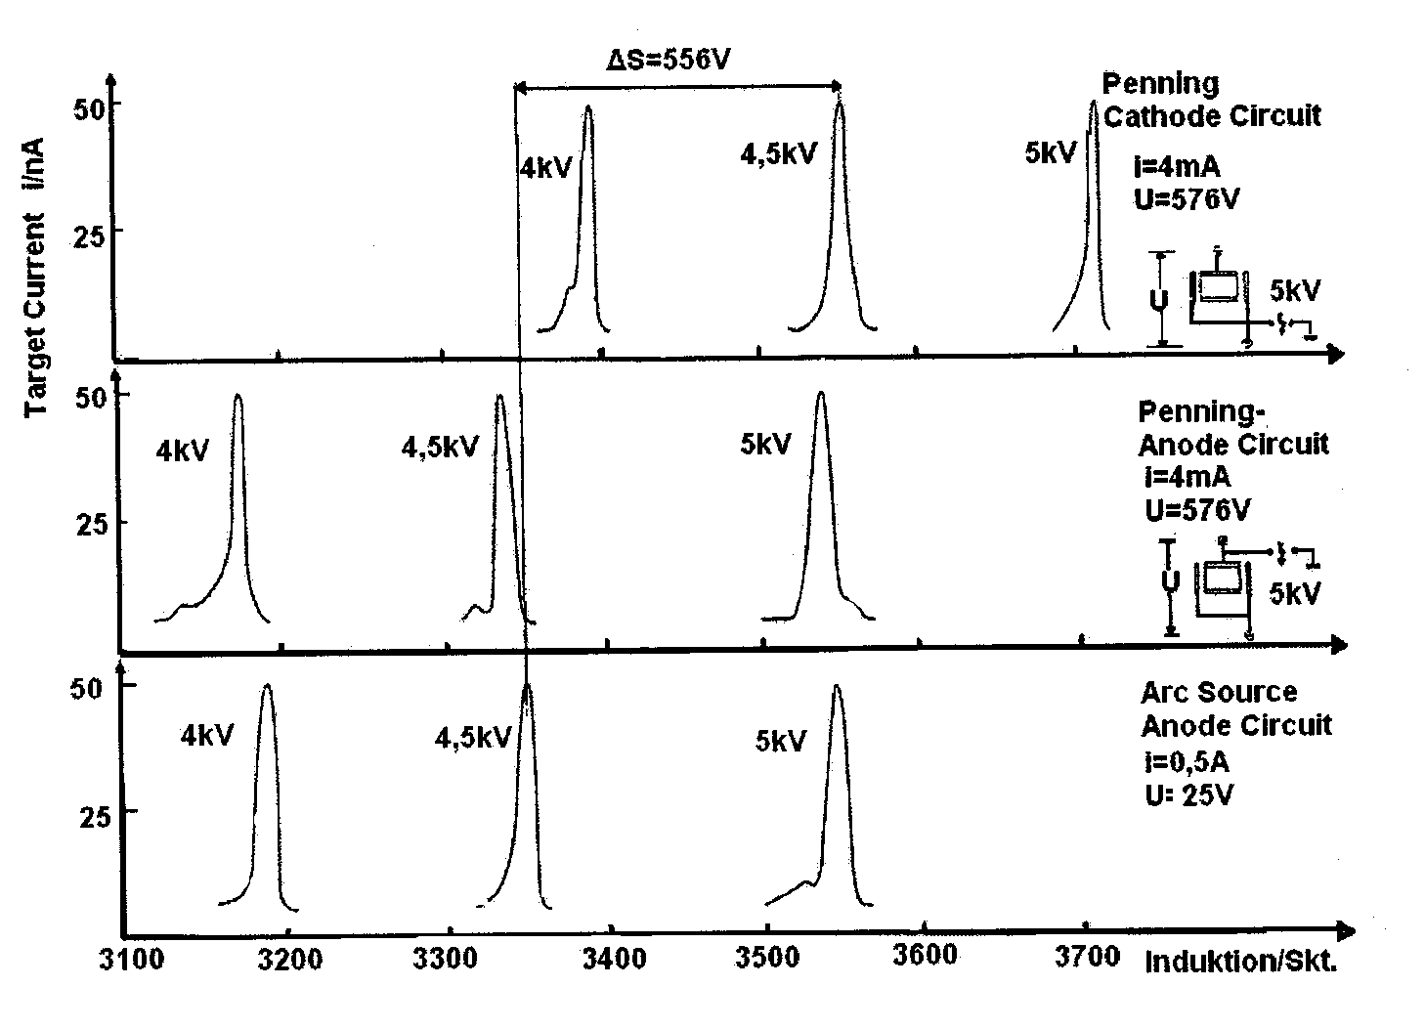

Figure 5. Energie spectra of the ion current of a Penning ion source.
In a measure-spectrometric arrangement with 5 KV Argon ions from the ion source were sucked off and analyzed with a magnet.
The mass line of the Argon isotopes situation with the same magnetizing force as those, which were produced with a glow cathode sheet ion source with a sheet tension by 25V.
If the accelerating voltage increases to the cathode, then the magnetizing force according to the ion energy higher around the fuel tension of the Penning ion source.

In the Fig.5 the results are gathered.
If one applies the accelerating voltage to the anode of Penning discharge, then appears the Argon mass line in the same place, which is found also with a glow cathode ion source. If one applies against it the accelerating voltage to the cathode, then the discharge tension adds itself for accelerating voltage. Hence it follows that the ions come from a range, which possesses practically anode potential. However due to geometry of the ion source this can be only the plasma thread of discharge. Thus the plasma has almost anode potential under the conditions of the obstructed movement of the electrons toward anode.
The mobility of the electrons is comparable by the magnetic field in transverse direction or still higher than those of the ions in longitudinal direction.
The decrease of potential between anode and plasma is still small in relation to the cathode fall.

INFLUENCE OF MAGNETIC FIELDS ON MOVED ELECTRICAL CHARGES

If a charged particle of the charge Q with a speed v flies to a magnetic field of the induction B perpendicularly to the flux line, then it experiences a Lorentz force.
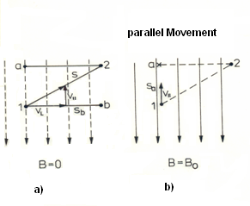
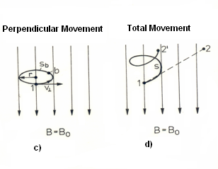
Figure 6. the magnetic field influence on the electrons trajectories in an electrical discharge
While the parallel speed component to the magnetic flux lines has the same course of electrons motion, to the consequence as without magnetic field, the perpendicular speed component leads to a circular motion.

Thus the geometrical distance (1,2) is reduced to the shorter distance (1.2 '), although the way remains in its total length. By creation of a magnetic field an electron can put larger ways back in a smaller volume.

$\vec{F}=Q\text{.}\left(\vec{v}×\vec{B}\right)$ (4)
By the inertia of the mass particle m, the acceleration remain however finite and the inertia force (arranged radially outward ) equilibrate with the Lorentz force , from which for the curvature radius of the circular paths follows:
$r=\frac{m\text{.}v²}{Q\text{.}v\text{.}B}$ (5)

if the particle flies diagonally to the flux lines of the magnetic field, then one can divide its speed for the description of the trajectory into one parallel (v//) and one perpendicular (v┴) component.
The particle moves itself accordingly to (v//) along the flux lines and synchronously to it describes unhindered circular path according to the component (v┴).
The superposition of both movements results in a screw course, how is in Fig. 6a to d schematically represented.
To it is remarkable that the points originally separated by the straight distance $\left(\overline{1,2}\right)$are separate by a shorter space straight line $\left(\overline{1,2'}\right)$, the screw-shaped way however is just as long as the original distance $\left(\overline{1,2}\right)$.
If the movement of the particle would consist alone of v┴, then it would move on a circular path and would not come from the place. One can use this effect meaningfully to the construction of ion sources. In the following are discussed some possibilities in principle of the use of magnetic fields for gas discharges.
Another example of the stabilization of the developing place of a gas discharge is the shining distribution at a permanent magnet, if it is used as cathode.
Fig.7 shows the observable shining distribution.
With low gas pressures reduces itself the shining seam, which first surrounds the whole magnet , to a shining seam within the crossing range of the electrical and magnetic fields.
The shining seam is appropriate thus in the magnet centre between the north and the south pole, where the magnetic leakage flux runs tangential to the magnet cylinder surface ,
Before however some construction variants of a ExB-hollow cathode are presented, possibilities of the plasma compression are to be discussed (Boubetra, 2007; Domonkos, 1999; Pessoa et al., 2006), because for an ion source it depends not only on the kind of the cathode, but on the plasma density and the extract from the plasma range.
construction of cathode geometry, which supplies a spatially stable developing place for an plasma discharge, which in an appropriate way the ions can to be extracted.
This principle of the crossed electrical and magnetic fields should form the basis of the
which however the electrical field lines stand perpendicularly to the leading magnet surface.

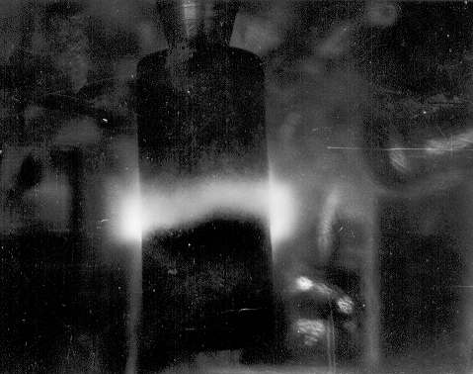

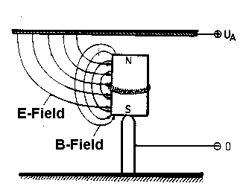

Figure 7. Photography and Schema of the shining distribution around a permanent magnet as cathode of a glow discharge.
With low gas pressures remains a circular discharge around the permanent magnet in the centre. At this place stands electrical and magnetic lines of flux to each other perpendicularly.

PlASMA COMPRESSION

The middle impacts number δ of gas atoms
on a wall with a gas pressure P amounts to
$δ=\frac{p}{\sqrt{2\text{mKT}}}$ (6)

Where m is the mass of the atom; K the Boltzman constant and T the absolute temperature.
if all atoms would be ionized, the current density would amount to$j=e_{0}⋅δ$.
Fig.8 shows the relation which can be expected, and it is to be recognized clearly that the ionization degrees in a cold cathode ion source amounts to only little per cent.

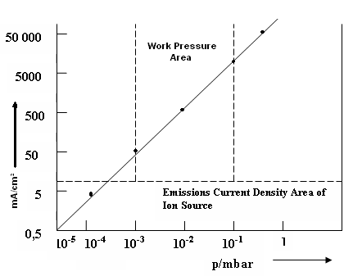
Figure 8.Computed emission current density for ion guns. With a given gas pressure in an ion source a certain number of gas atoms meets the wall of the ion source per second and square centimetre. If one accepts an ionization of all gas atoms, then the represented linear connection between gas pressure and emission stream results substantially smaller than the neutral gas flow from the ion source opening.

The reason for the fact lies above all in the fact that discharge cannot be arbitrarily highly increased, The reason for the fact lies above all in the fact that unloading cannot be arbitrarily highly increased, since otherwise the power losses at the electrons would not to be controlled, if one sinks on the other hand the gas pressure, then the discharge geometry changes, because the mean free path of the discharge particles grows. if it reaches discharge geometry, then the discharge expires. The plasma of a gas discharge is therefore a small disturbance of the essentially neutral gas, which is intending for the impact-kinetic processes of the energy transmission. for the increase of gas discharge ion yields a plasma compression is necessities. One can reach these in two different ways:
By an inhomogeneous magnetic field and by geometrical restricting of discharge.

CONCLUSION

Compared with glow cathode or HF-ion guns the technological expenditure is comparatively small to cold cathode ion source. Their disadvantage is however the high gas pressure discharge and the smaller ion yield. In cold cathode ion source the Gas reinforcement is crucial in the cathode falls range for the size of the discharge current. It determines the gas pressure in the discharge with being certain discharge geometry. In the case of use of a magnetic hollow cathode one can achieve a compression by inhomogeneous magnetic fields within the plasma range or a homogeneous discharge transfer either up to the anode. The plasma follows the Magnet field lines in its density and direction.

REFERENCES

1. Aitken D. The Freeman Ion Source, in I.
G. Brown “The Physics and Technology
of Ion Sources”. N.Y. 1989.
- Aitken ,D.: Ion Sources, in “Ion
Implantation Techniques” von H. Ryssel
and H. Glawisching, Springer Verlag
Berlin Heidelberg , N. Y., S.23-70,
(1982).
3. Beckey, H. D.: Field Ionization Mass
Spectrometry, Akad. Verlag Berlin
(1971).
4. Boubetra, Dj., Entwicklung einer
Ionenquelle, Dissertation Humboldt
University, Berlin (1992).
5. Boubetra Dj. Development of ion
source with cold cathode, Journal
of engineering and applied sciences
2(6), 985-987, (2007)
6. Boubetra Dj.,Surfaces characterization
by ionic bombardment, Journal of
Engineering and Applied Sciences
2(8), 1274-1278, (2007).
7. Boubetra Dj., Bouafia M., Ion
Implantation damage in GaN Layers
investigated by an ellipsometric
method, Nature and Science, 5(4),29-
33, (2007).
8. Boubetra Dj. Bouafia M., Development
of magnetic hollow cold cathode for
ion source, journal of American
science 3(4), 15-19,(2007).
9. Brown I.G.; The physics and
Technology of Ion Sources, J. Wiley
& Sons, New York (1989).
- Domonkos, M.,T., Evaluation of Low-Current Orificed hollow cathodes, PhD thesis, university of Michigan (1999).
- Ewald ,H., H. Hinterberger: Methoden
und Anwendungen der
Massenspektrometrie, Weinheim ( 1953).
- Heil H.: Über eine neue Ionenquelle, Z. f. Phys. 120, 212( 1973).

- Jongen ,Y., C. M. Lyneis: Electron
Cyclotron Resonance/Ion Sources, in I.G.
Brown „ The Physics and Technology of
Ion Sources“ S. 207, J.Wiley&Sons New
York (1989).
- Mingxiu, Ma, Li Junping, Zhou
Fengsheng: A Hollow Cold Cathode
Multipurpose Ion Source, Nucl. Inst.
Bd 21, 182-187 (1987).
15. Penning, F.M: “ Ein neues Manometer
für niedrige Gasdrucke insbesondere
zwischen 10⁻³ und 10⁻⁵ mm“, Physica Bd
4, 71 1937.
16. Pessoa R.S., G. Murakami, G.
Petraconi, H.S. Maciel, I.C. Oliveira,
and K.G. Grigorov; Hollow Cathode
Magnetron Deposition of AIN thin
Films: Crystalline Structure and
Morphology; Brazilian Journal of
Physics, vol. 36 2A (2006).
- Swanson ,L. W. and A. E. Bell: Liquid
Metal Ion Sources, in I. G. Brown “ The
Physics and Technology of Ion
Sources”, S. 313, J. Wileey&Sons, New
York (1989).
- Valyi, L.: Atom and Ion Sources, S. 191,
Budapest (1977).

