A grid based rainfall-runoff model based on rainfall satellite images at TK5 watershed

Iman Mahmoud Elazizy¹, Sherien Ahmed El-Sayed Zahran², Naglaa Mohamed El-Bendary³
1Professor of Hydraulics and Water Resources, Hydraulics & Irrigation Department, Faculty of Engineering, Ain Shams University.
2Director of Climate and Environment Risk Assessments laboratory (CERAL), ECRI, NWRC, MWRI.
3Senior Water Resources Engineer- Planning Sector, MWRI, Egypt
nm_bendary@hotmail.com

Abstract: This research aims to understand the hydrological response of a watershed by estimating outlet basin discharge using the Gridded Surface and Subsurface Hydrological Analysis (GSSHA) model for the Tekezebasin, the simulation inputs are almost satellite images instead of time series data. Most of researches and studies input rainfall data as time series present measured rainfall stations, in this research the rainfall data assigned to the model in a 2D gridded format (RFE2 satellite images). Using of remote sensing data (RFE2) is a powerful tool to simulate watershed for unreachable areas. The studying watershed is a part of Atbara basin and it situated in the north part of Ethiopia and not far from the Eritrean borders. The GSSHA model is a continuous, physics based, distributed hydrologic model intended for general hydrologic/hydraulic analysis. The model is divided into equal cells which allow to define the different parameters for each cell according to different features in the watershed as the land cover or the soil type, and flows are routed from cell to another using differential equations. The pre and post processing of the model have been done under a graphical user interface WMS (Watershed Modeling System). The model tested for one year on Tekeze basin which covers around 46,025Km2, the basin was simulated with grid size 8Km * 8 Km to be compatible with rainfall data resolution.
[Iman Mahmoud Elazizy, Sherien Ahmed El-Sayed Zahran and Naglaa Mohamed El-Bendary. A grid based rainfall-runoff model based on rainfall satellite images at TK5 watershed] Nat Sci 2018;16(9):111-121]. ISSN 1545-0740 (print); ISSN 2375-7167 (online). http://www.sciencepub.net/nature. 16. doi:10.7537/marsnsj160918.16.

Key words: Hydrological simulation, remote sensing, hydrologic modeling, rainfall, GSSHA Model, RFE

Introduction
The rainfall-runoff process is mainly developed according to elements of topography such as slope, flow direction, flow accumulation, drainage density, soil texture and depth, and surface roughness condition. The effective use of spatial data in the runoff modeling helps to understand the state of a watershed especially during a storm event. With this perspective, during the past couple of decades, many grid-based, hydrological models have been developed and their value demonstrated in the spatial information usage, visual identification and improved understanding of hydrological components during the runoff process. The well-known distributed models are SHE, TOPMODEL, AGNPS, MIKE-SHE, THALES, CASC2D, Hydro-BEAM, GSSHA, and VfloTM. Recently, several researchers have attempted to develop GIS-based, distributed models.(In-Kyun Jung, 2010).
The alternative of using satellite rainfall products become a necessity instead of using ground-based stations especially in hydrological applications for wide regions which not covered by sufficient data because of huge extent or unreachable locations.
Distributed hydrologic models are those which divide the entire watershed into grid cells and flows are routed from one grid cell to another using the differential equations that describe the physics of flow. Distributed models attempt to simulate both the spatial heterogeneity and the physical processes occurring within a watershed (Paudel, 2010).

Data Description

2.1. Study area
Atbara basin consists of two main tributary Tekeze with length of 760 Km, and upper Atbara with 293 Km length. Figure 1 shows the location of Tekeze basin relative to Atbara basin.
The area of interest at this research is Tekeze basin which extend from latitude 11º 40' 0'' N to 15º 12' 0'' N and from altitude 36º 30' 0'' E to 39º 50' 0'' E. The basin elevation varies from 839 m to 4517 m as shown in Error! Reference source not found. which illustrate the Digital Elevation Model classification map (DEM) driven from DEM 90m spatial resolution.(Tekeze River Basin Master Plan, 1998).
It is bordered by the Mereb River basin and by Eritrea in the north, the Atbara River plains in Sudan in the west, the Abbay River basin in the south and Danakil basin in the east (Initiative, 2008).
Tekeze basin is located in the northern part of Ethiopia and it receives a mean annual rainfall of 976.4 mm which is 80.9BM³. The mean annual actual evapotranspiration is 9.5BM³ or 11.8% of the mean annual rainfall of the basin. The mean annual surface runoff that leaves from the basin is 7.8BM³ which corresponds to 93.97 mm. Out of the mean annual rainfall of 80.9BM³; the remaining 40.1BM³ is lost due to percolation for the recharging of the aquifer and 23.5BM³ as lateral flow or subsurface flow.(Getu, 2015).
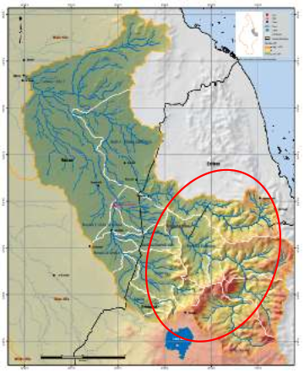
Figure 1 Tekeze basin relative to Atbara basin and main tributaries
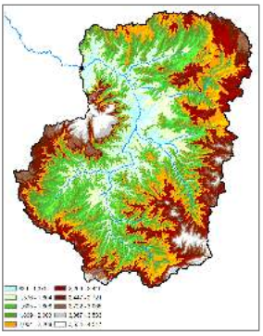
Figure 2 Tekeze basin topography

2.2. Satellite images and remote data description

Digital elevation Model DEM90
The NASA Shuttle Radar Topographic Mission (SRTM) has provided digital elevation data (DEMs) for over 80% of the globe. This data is currently distributed free of charge by USGS and is available for download. The SRTM data is available as 3 arc second (approx. 90m resolution). The data is projected in a Geographic (Lat/Long) projection, with the WGS84 horizontal datum and the EGM96 vertical datum.

Soil Data (Harmonized World Soil Database)
Soil Map of the study are obtained as a result of FAO and IIASA cooperate to combine existing regional and national updates of soil information all over the world and integrate these with the information contained within the 1:5 000 000 scale FAO-UNESCO Soil Map of the World (FAO, 1971-1981). This soil data used to assign different soil parameters based on soil region.

Rainfall Estimates (RFE2)
RFE is a Rainfall Estimates produced by NOAA-CPC specifically for Africa. The current version, RFE 2.0 (RFE2), started in January 2001. It replaced the previous version, RFE 1.0 (RFE1), which was operational from 1995 through 2000. RFE2 uses microwave estimates in addition to continuing the use of cloud top temperature and station rainfall data that formed the basis of RFE1. Meteosat geostationary satellite infrared data is acquired in 30-minute intervals, and areas depicting cloud top temperatures of less than 235Kare used to estimate convective rainfall. WMO Global Telecommunication System (GTS) data taken from ~1000 stations provide accurate rainfall totals, and are assumed to be the true rainfall near each station. RFE1 used an interpolation method to combine Meteosat and GTS data for daily precipitation estimates, and warm cloud information was included to obtain decadal estimates. RFE2 obtains the final daily rainfall estimation using a two part merging process, then sums daily totals to produce decadal estimates at about 10km spatial resolution.

Methodology
This research methodology mainly depends on remotely sensed data to illustrate and simulate the hydrological cycle.
Figure 3 shows overland grid element behavior and different processes that accrue in this king of cells such as rainfall as overland inflow, infiltration as subsurface inflow and percolation as accumulation of percolated water. On other hand how those overland grid elements go to stream grid element.

Figure 3 Simplification of base flow through the saturated soil layer to the stream

The used data in this study are 1) Digital Elevation Model which used to create slop, flow direction and flow accumulation grids and drives streams and basins areas. Each cell for water balance component has input and output flow that goes to next cell as shown in
Figure 3.2) Soil data used to distinguish each soil zone and assign proper parameter such as Surface roughness, Land-surface albedo, Initial moisture, Hydraulic conductivity, Capillary head, Porosity, Pore distribution index, Residual saturation, Field capacity and Wilting point. Soil parameters govern water flow from cell to the other and calculate amount of water goes as runoff and amount goes as subsurface flow and the amount of percolated water as shown in
Figure 3. Finally3) Rainfall data in daily base used to apply precipitation into the model. Figure 4 illustrate the typical steps should be followed for modeling rainfall runoff process and Figure 5 illustrate the executed sequential steps for this research simulation such as data preparation, model setup and assigning parameters.

Figure 4 Steps for modeling rainfall runoff
Figure 5 sequential steps for preparing data, model setup and assigning parameters.

Data Download
This study depends on remote sensing data which downloaded free from internet and used worldwide in the researches and studies. In this study four types of data has been used to estimate runoff based on rainfall data Digital Elevation Model (DEM), Rainfall Estimates (RFE), Soil Data and Land use data.

Data Preparation

DEM data preparation
DEM data processed using ArcGIS package through three by three window analysis and delineate watershed area and streams, flow direction map could be produced as shown in Figure 6. The Hydrology tools are used to model the flow of water across a surface. Before delineation of the watershed the following two steps should be applied on DEM data
- Extract DEM according to study area by using predefined shape file.
- Set projection parameters according to study area zone which is WGS-84 Zone 36N.

Figure 6 Example of determining the outflow direction and inflow cells based on the flow direction code

RFE data preparation
Rainfall data preparation was done using ArcGIS package model builder to speed up the processing time. The model consist of four steps (data importing, data extraction, data projection and data conversion)Figure 7illustrate the model sequence and used tools to build this automatic model. This model could be executed on huge number of data through one step with the graphical user interface as shown in 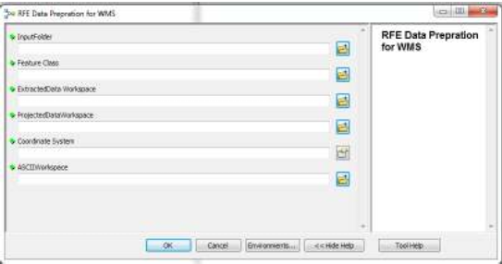
Figure 8.

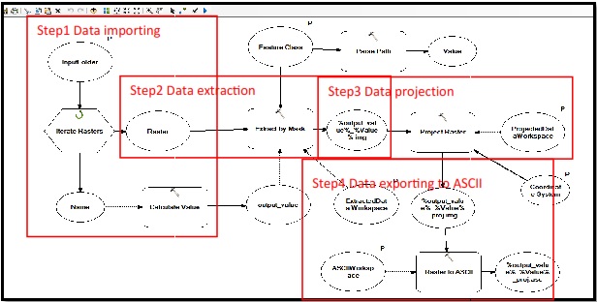
Figure 7 Data preparation customized model
Figure 8 Automation Model graphical user interface

Model setup
The most important stage in modeling is to define boundary conditions, primary constrains and limitation which is defined as model setup steps. The first step in creating a Gridded Surface/Subsurface Hydrologic Analysis (GSSHA) model is using Watershed Modeling System (WMS)in order to delineate a watershed and obtain watershed boundary polygon from digital elevation model. WMS interpolates cell elevations from the DEM when building a 2D grid. WMS uses the watershed boundary polygon to select whether 2D grid cells are active (inside the basin) or inactive (outside the basin). Following steps have been done to run GSSHA model for Tekeze Basin

Define project bounds
The study area sites within zone 36 North, Table 1 shows the properties of DEM and boundaries.
Table 1 Digital Elevation Model (DEM90) Parameters.
Item | Value
Northern Boundary | 1,716,985.79 m
Southern Boundary | 1,267,590.49 m
Eastern Boundary | 1,264,930.28 m
Western Boundary | 974,067 m
X Cell Spacing | 90 m
Y Cell Spacing | 90 m
Number of Rows | 4,785
Number of Columns | 3,097
Max Elevation | 4,508.71
Min. Elevation | 622.78

Watershed delineation
TOPAZ computes flow direction and accumulation grids which are used to delineate watershed based on the DEM data. TK5 dam location considered as outlet of the study basin and it is predefined in standalone shape file with coordinate (X= 1063103.00, Y=1524469.00, Z=849.2)the delineated watershed is shown in Figure 9. TOPOZ application has a sequential steps listed below.
- Converting the DEM streams to arcs.
- Defining the basin from the DEM.
- Converting the basin boundary to a polygon.
- And then computing the basin data.

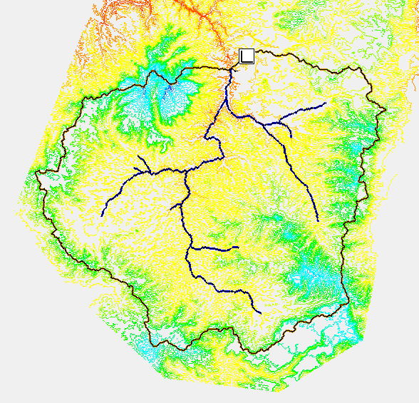
Figure 9 Delineated watershed and streams

The basin data could be display on different formats such as:
- Flow distance map as shown in Figure10illustrates the distance from the cell to the outlet cell along streams
- Basin parameters as shown in

- Table 2

Figure10Distance map (m) for Tekeze basin upstream TK5 Dam

Table 2 Delineated Basin Characteristics
Parameter | Value
Basin Area | 46025.81 Km²
Basin Slop | 0.2405 m/m
Basin Length | 241.31 Km
Parameter | 1586.40 Km
Shape Factor | 1.27 mi²/mi²
Mean Average Elevation | 2045.09 m
Max Flow Distance | 439.34 Km
Max Flow Slope | 0.007 m/m
Max Stream Length | 367.01 Km
Max Stream Slope | 0.0029 m/m
Distance From Centroid to Stream | 7.82 Km
Centroid Stream Distance | 138.85 Km
Centroid Stream Slope | 0.0017 m/m

By settings of Min flow accumulation threshold to 1000 Km2, thegenerated network streams consists of 23 streams with Total length 931,210.711 m and total plan length 928,920.076 m. For simulation this study considered that streams have the same cross section which is trapezoidal cross section with 0.07 as Manning’s coefficient and 3m, 5m and 2m for depth, bottom width and side slope.

Create 2D grid
One of advantage of using GSSHA model is to present watershed by grid which helpful in assigning different values and parameters to each cell to simulate reality as much as possible. At this step the boundary polygon (delineated watershed) and the DEM are used to create a 2D grid that conforms to the watershed boundary and has elevation data values that are interpolated from the DEM. Based on input data resolution in this case study the suitable 2D grid size supposed to be 8km* 8 Km which combatable with rainfall image data (RFE2). Generated 2D grid use to assign different values on pixel bases, the first grid have elevation values for each cell as shown in Figure 11

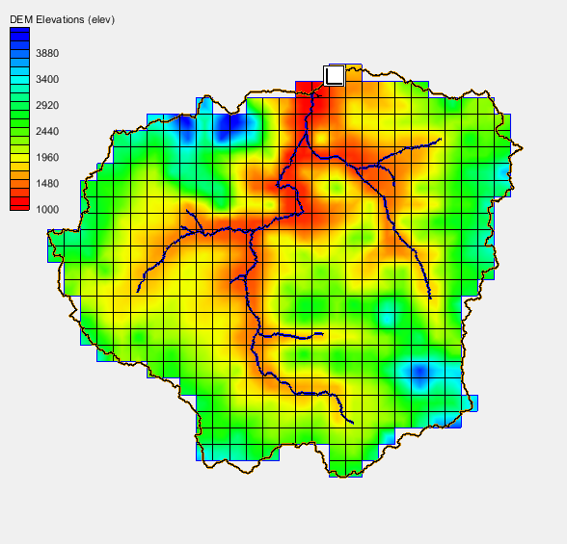
Figure 11Elevation values at 2D grid by meter

Job Control
At any simulation it’s necessary to define the boundaries conditions and limitations which control simulation. In GSSHA model it’s mandatory to set start time, start date, end time, end date and time interval for simulation. For this study that job control parameters are used as the follow: Starting Date = 01/01/2006, Starting Time = 12:00:00, Ending Date = 31/12/2006, Ending Time = 12:00:00 and for time interval = 86400 Sec (24*60*60). The governing equations which are used to calculate runoff based on rainfall data, soil data, and land use data have to be defined in this section (Job control) by selecting desired as in this study over flow and channel routing could be unused and for evapotranspiration parameters it should calculated based on Deardoff Method and for infiltration it should be calculated based on Green + Ampt soil moisture redistribution

Define Land use and Soil Data
The most differentiation layer used to assign different value or parameter for each cell is soil layer which in reality the essential factor governs the rainfall runoff process. In this study Harmonized World Soil Database is used to defining different zones for each soil types. Soil data produced by FAO The study area has four classes of soil as shown in Figure 12 loam, clay loam, sandy clay loam and clay (light).
To assigning different soil parameter for each cell the model create grid for different soil types as shown in Figure 13.

Figure 12Soil classification based on Harmonized World Soil Data Base at Tekeze

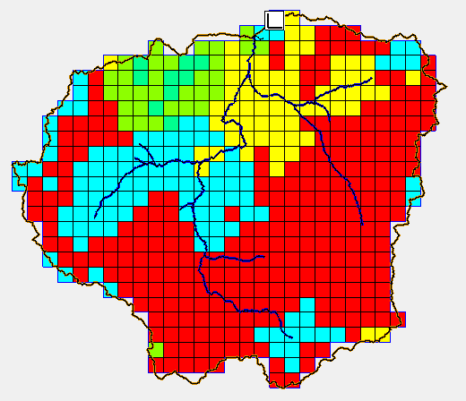
Figure 13Soil gridded data for study basin

Compute Index Mapping Table
Compile single or multi input coverage to generate Index Maps (Uniform – Varian) which should be used to assign several values regarding to simulation parameters. Each considered phenomena (Evapotranspiration, infiltration) in this study use some parameters to solve governing equation, the parameters and its values shown in

Table 3 for roughness parameters and Table 4 for infiltration parameters, the values distributed over watershed area based on soil index map distribution.

Table 3 Roughness parameters
Soil Type | Surface roughness | Land-surface albedo | Initial moisture
Loam | 0.031000 | 0.325000 | 0.30
Clay Loam | 0.030000 | 0.325000 | 0.30
Sandy Clay Loam | 0.032000 | 0.325000 | 0.30
Sand | 0.030000 | 0.325000 | 0.30
Clay | 0.330000 | 0.325000 | 0.30

Table 4 Infiltration parameters
Soil Type | Hydraulic conductivity  (cm/hr) | Capillary head  (cm) | Porosity  (m3/m3) | Pore distribution index  (cm/cm) | Residual saturation (m3/m3) | Field capacity  (m3/m3) | Wilting point  (m3/m3)
Loam | 1.32 | 8.89 | 0.55 | 0.24 | 0.434 | 0.27 | 0.117
Clay Loam | 0.23 | 20.88 | 0.59 | 0.24 | 0.309 | 0.309 | 0.197
Sandy Clay Loam | 0.43 | 21.85 | 0.50 | 0.24 | 0.330 | 0.255 | 0.148
Sand | 21.00 | 4.95 | 0.42 | 0.24 | 0.417 | 0.091 | 0.033
Clay | 0.06 | 31.63 | 0.60 | 0.24 | 0.385 | 0.396 | 0.272

Define Precipitation
At this research rainfall data for the year 2006 has been used as input for base rainfall data definition. Before entering Rainfall data it needs some preprocessby using GIS and remote sensing software to project, extract, convert its units from mm to inch and finally convert its format to ASSCI files which is the required format for GSSHA model. For saving time and effort all steps (project, extract, convert units to inch, convert format to asci files) are compiled together into automatic model customized using ArcGIS package. The customized model run over all files per tear. Meanwhile After converting rainfall data into incremental distribution rain gage using conversion tool imbedded in GSSHA model, software generate text file contain incremental depth (mm) and cumulative depth (mm) corresponding to every time step and this shown in Figure 14andFigure 15for year 2006.
By analyzing incremental depth curve as shown in Figure 14the maximum rainfall depth is founded 41.3 mm occurs in 31 July.

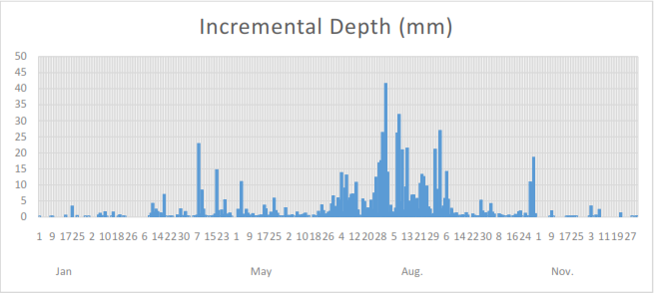
Figure 14 Incremental Depth of rainfall (mm) generated from 2006 RFE rainfall data

Wherever for cumulative depth curve that shown at Figure 15 at the period from January to March was being within small values for accumulation and it increases gradually from March to June, with rapid increase occurs from July to August. After august the accumulation curve trends was found almost constant.

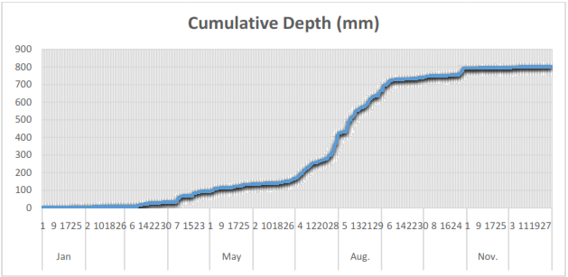
Figure 15Cumulative Depth of rainfall (mm) generated from 2006 RFE rainfall data

Results and Discussions
GSSHA software summarize applied event or storm into simple format that show main characteristics of simulated event which could be pointed as follow:
- Event began on 01/01/2006 at 00:00
- With rain gage data using inverse-distance squared interpolation.
- Elevation and grid size are in meters
- Time step 1Day
- Number of time steps with rain: 21420
- Elapsed time when rain began: 359.00
- Peak occurred on strict Julian date: 2453747.00000000 cubic meter
- Date/time of peak discharge: 1/11/2006 12:00:00
- Event peak discharge (cubic meters per second): 6215.0103

Depending on input data and soil characteristics
Table 5 shows that the volume of precipitation is 24.8 MC and divided into two main components one of them is infiltration which calculated as 22.4 MC and the rest which is 2.4 MC goes as discharge. As shown in Table 5other process are neglected as in model job control only evapotranspiration and infiltration parameters are taken into consideration.
Table 5 Tk5 basin results as volume of water in each process
Result | Value
Initial volume of overland flow | 0
Initial liquid-equiv. volume of snow | 0
Volume of rainfall to overland | 24,790,279,093.8
Volume of interception | 0
Volume of direct evaporation | 0
Volume of infiltrated water | 22,365,094,282.5
Volume of water ex-filtrated | 0
Volume of discharge | 2,425,184,811.3
Volume of groundwater recharge | 0
Volume from overland point sources | 0
Volume remaining on surface | 0
Final volume of snow (cu. m) | 0
Mass conservation error | 0

The simulation main result is outlet flow which reaches to maximum value at 18th August with 69.94 cubic meters per second as shown in Figure 16.

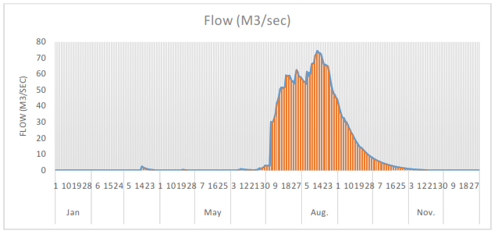
Figure 16Discharge at the outlet of TK5 Basin

Conclusions
Depending on DEM data TK5 basin has been delineated with 46025.81 Km²in area, 0.24 for basin slop, and 1.27 mi²/mi² for shape factor, the delineation done through WMS, TOPOZ model.
For the delineated watershed, Rainfall satellite data (RFE) for year 2006 is used in grid format to assign rainfall data to GSSHA model. Fromyear 2006 Rainfall images the model calculated accumulative rainfall depth with 800 mm. Based on gridded rainfall data, GSSHA model estimated the TK5 discharge by 2,425,184,811.3 cubic meter, and peak flow was 69.94 cubic meters per second and accrues at 18th August.
Also one of the achieved goals by this research is assigning different values for different parameter along study basin depending on cell characteristics. As cell changes in soil formation as the used parameters change.

References
- Getu, S. A. (2015). Assessment of Surface Water Potential and Demands in Tekeze River Basin, Northern Ethiopia. Addis Ababa University: Addis Ababa University.
- Initiative, N. B. (2008). Eastern Nile Power Trade Program.
- In-Kyun Jung, J.-Y. P.-A.-S.-J. (2010). A grid-based rainfall-runoff model for flood simulation including paddy fields. Paddy Water Environ.
- Jain MK, K. U. (2004). A GIS based distributed rainfall-runoff model.
- Paudel, M. (2010). An Examination of Distributed Hydrologic Modeling Methods as Compared with Traditional Lumped Parameter Approaches. Provo. (1998). Tekeze River Basin Master Plan.

